Neuron

Last updated: April 20, 2019

Neuron 1

Immunohistochemical markers for neurons 2

Cell body (soma, perikaryon) 2

Processes 3

Functional neuron classification (basic plan of nervous system) 5

Neurotrophins 7

Excitation & Conduction 7

Resting Potential 8

action potential 8

Electrotonic Potentials & Local Response 10

Local current flow 11

cable properties of membrane 12

Neuronal polarization 13

Properties of mixed nerves 15

Nerve fiber types 16

Neuron

**Nerve** – one of the four basic tissues.

* > 50% human genome codes for genes that are nervous system specific.
* absence of conventional lymphatic system - limited immunologic surveillance.

Nerve tissue:

1. Neurons – parenchymal cells of nervous tissue.
2. Supporting cells:
   1. **CNS** – glial cells.
   2. **PNS** – Schwann cells & satellite cells.

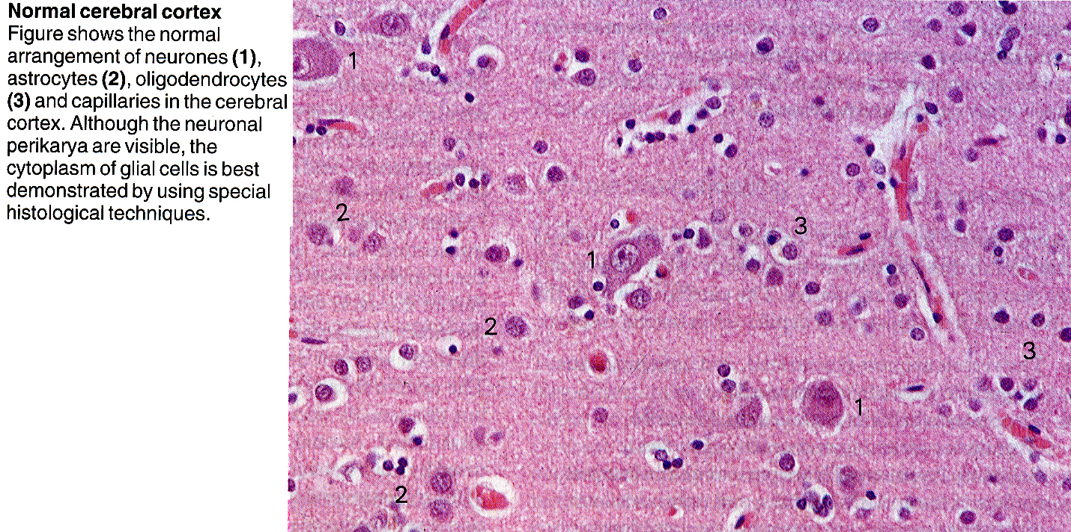

* ≈ 100 billion (1011) neurons.
* greatest variation of size and shape (iš visų kūno ląstelių).
* single (isolated) neuron is functionally useless! – to function, nerve impulse must affect next cell in circuit:

1. another neuron
2. effector cell: muscle cell (striated, smooth, cardiac), gland cell



Immunohistochemical markers for neurons

1. neurofilament protein
2. neuron-specific enolase
3. synaptophysin

Cell body (soma, perikaryon)

size – larger than most nearby cells; size up to 125 μm – seen with naked eye!!!

shape – round, ovoid, stellate (spinal motoneuron).

nucleus (karyon) – large, euchromatic*, prominent nucleolus*

cytoplasm – large Golgi apparatus*, developed rER (Nissl bodies)*, neurofilaments, abundant mitochondria*, lysosomes; some neurons also contain neuromelanin.

*metabolically and synthetically active cells! protein synthesis!

**Nissl substance (s. basophilic, tigroid substance)** = **stack of rER cisternae** + **polyribosomes**

* extensive; stains intensely with ***basic dyes***.
* polyribosomes are *attached* to rER membranes or *free* in intercisternal space.
* extends from body to dendrites (but not into axon!)

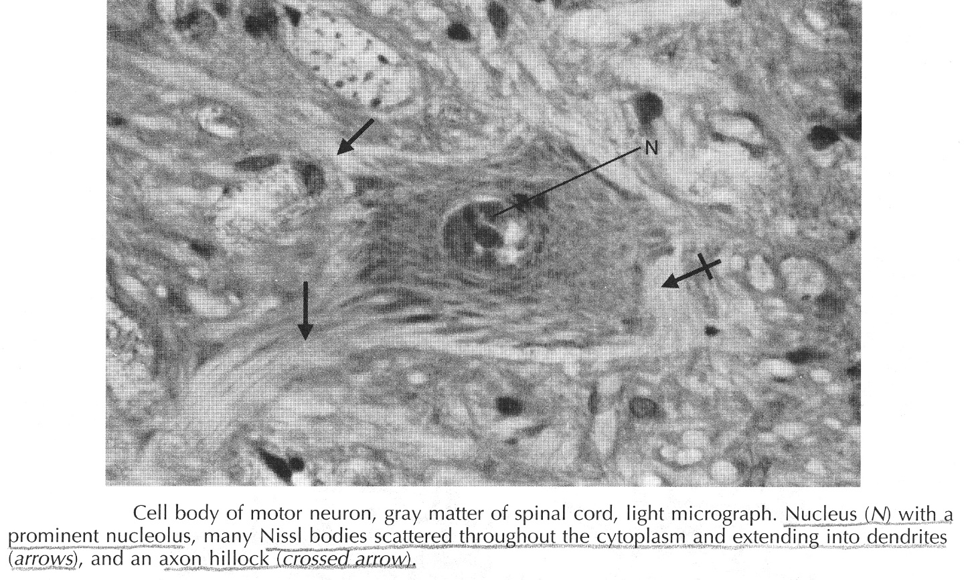

**Golgi apparatus** – extensive system of agranular membranes; never extends into axon!

Processes

* single unifying characteristic of neurons.
* gali būti > 1 m ilgio!
* total volume of processes may be >> volume of cell body.

e.g. if cell body of spinal motoneuron was size of tennis ball, dendrites would fill large room and axon would be up to 1.6 km long although only 13 mm in diameter.

* in electron microscopy (stebima nevisada):

axon – contains synaptic vesicles

dendrite – contains rER

* pagal ataugas neuronai skirstomi:
  1. **(pseudo)unipolar** – afferent neurons (for ***general senses*** – dorsal root ganglia) – abi ataugos vadinamos aksonais, nes yra ilgos ir mažai šakojasi (nors periferinė šaka ir atlieka dendrito funkciją)!
  2. **bipolar** – afferent neurons (for ***special senses*** – olfactory mucosa, retina, inner ear).
  3. **multipolar** – interneurons, efferent neurons.

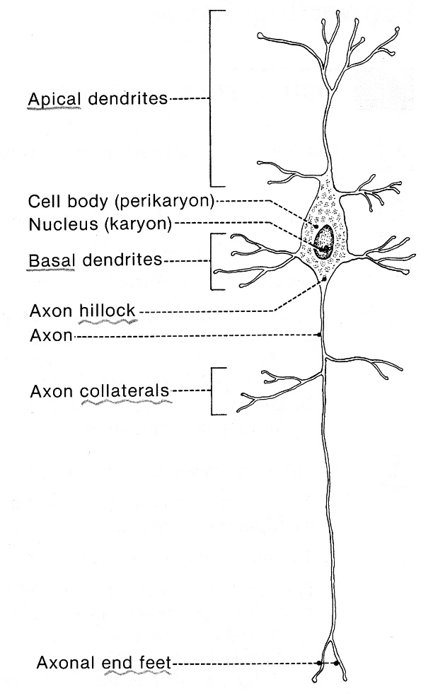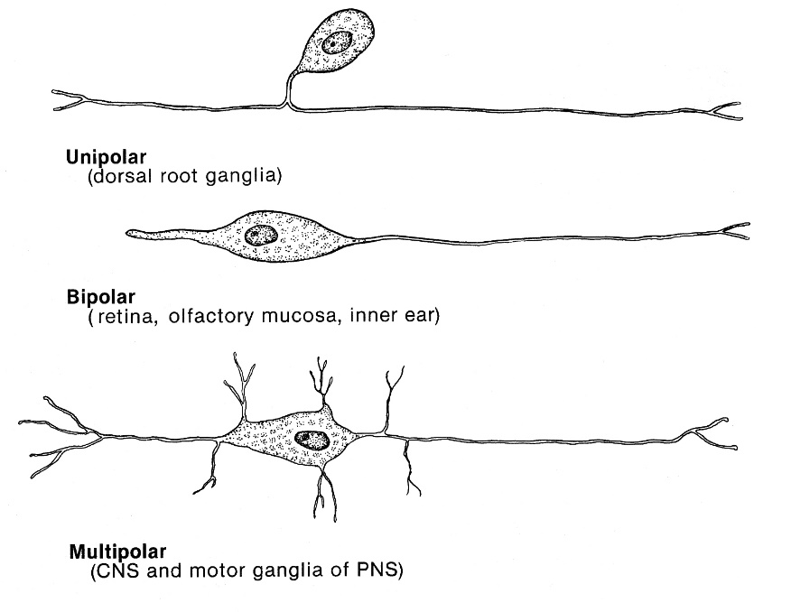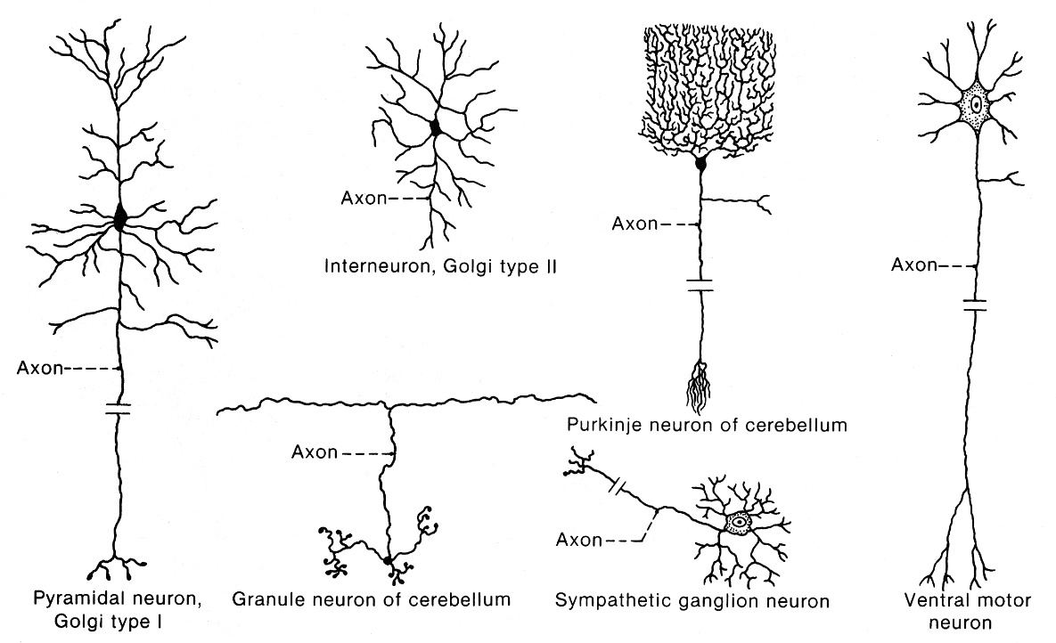

# Dendrites - receptor processes

* trumpesni negu aksonas.
* larger diameter than axon at their sites of origin (from cell body).
* unmyelinated
* distinctly tapered (small knobby projections called **dendritic spines**)
* gali būti daug ir gausiai šakotis (*dendritic tree*).
* specialized to receive nerve impulses

# Axon – effector process:

* 1. neša impulsą iš kūno į kitą neuroną arba efektorinę ląstelę
  2. neša peptidinius hormonus iš kūno į kapiliarus (neurohipofizė)
* retai šakojasi (collaterals); axon branching is most extensive in vicinity of its target.
* esti tik vienas.
* plonesnis negu dendritas.
* storesni (> 1 μm) aksonai esti mielinizuoti, plonesni – nemielinizuoti.
* pagal aksono ilgį:
  1. **Golgi type I neurons** (*projection neurons*) – aksonai **ilgi** (> 1 m); aksono tūris gali būti net 2000 kartų didesnis negu perikaryon tūris; e.g. cortical pyramidal cells, spinal motoneurons.
  2. **Golgi type II neurons** (*local circuit neurons*) – aksonai **trumpi**, šakojasi pilkojoje medžiagoje; e.g. interneurons.
  3. **amacrine neurons** – **neturi** aksono; e.g. interneurons in retina, olfactory bulb.
* **axon hillock** – point of origin of axon from cell body:
* free of Nissl substance (riba staigi!)
* praeina mikrotubulės ir neurofilamentai.
* initial segment of axon (tarp apex of hillock ir beginning of myelin) – site of action potential initiation.
* *axolemma* – aksono membrana.
* **axon telodendron** – terminal axon arborization.
* axons (and their collaterals) terminate as **end feet** (s. **synaptic knobs**, **terminal buttons**)

axonal transport – because axons lack most of organelles necessary for cell metabolism.

* + bidirectional:

1. **antegrade** (body → distal axon)
2. **retrograde** (distal axon → body): nerve growth factors, recycled membrane, viruses, toxins.
   * greitis:
   1. **slow transport** (axoplasmic flow) 0,01-1 cm/d

* only *antegrade*;
* transport of structural elements (e.g. subunits of microtubules).

dendritic flow also occurs!

* 1. **fast transport** (axoplasmic transport) 20-40 cm/d
* transport of neurotransmitters, membrane components;
* vyksta *vezikulėse* mikrotubulių pagalba *abiem kryptim*; microtubule motor proteins:

**kinesin** – antegrade transport

**cytoplasmic dynein** – retrograde transport

* + eksperimentuose panaudojant tracer materials galima išaiškinti neuronal pathways (*nedestrukciniu būdu*!)

Functional neuron classification (basic plan of nervous system)

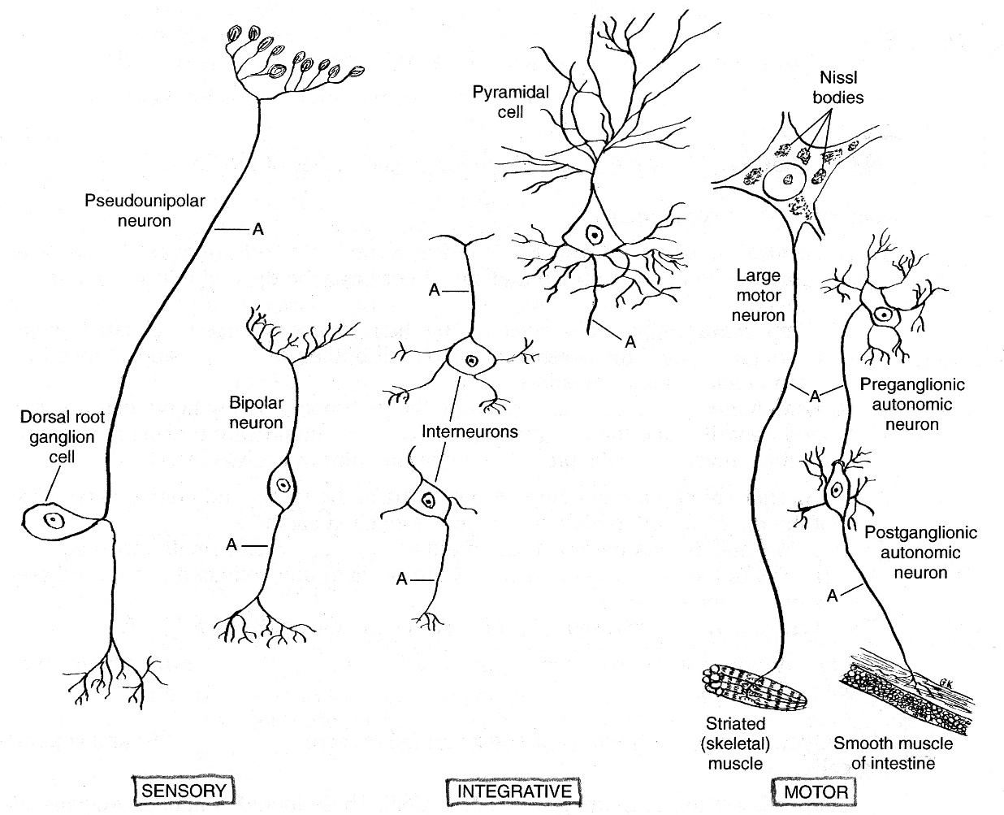

I. Sensory neurons – perduoda aferentinius impulsus į CNS.

* + **receptor** (C. Sherrington terminas) – *sensory nerve ending* in skin, deep tissues, viscera, or special sense organs;

receptors may be **free** or **encapsulated** by cells (*end organ*)

* + perikarya esti in ganglia outside CNS (išsk. retina)!

N.B. in **sensory ganglia** esti įsikūrę neuronų kūnai, tačiau ***skaidulos čia nepersijungia***!!! (vs. in **autonomic ganglia**)

* + all primary sensory neurons are:
  1. **bipolar** – for special senses; occur only in end organs
  2. **(pseudo)unipolar** – for general senses.

II. Integrative neurons (s. interneurons, intercalary, internuncial neurons) (99,98% visų neuronų!!!) – ***form circuits in CNS***.

* + **multipolar** neurons.
  + esti pilnai in CNS – neuronų kūnai ir dendritai sudaro *gray matter*, aksonai (neišeina iš CNS ribų!) sudaro *white matter*.

III. Motor neurons – ***perduoda eferentinius impulsus į efektorius***.

* + **multipolar** neurons.
  + kūnai sudaro *gray matter*.
  + aksonai išeina iš CNS ribų ir keliauja pas efektorių:

1. tiesiai (***one-neuron pathway***) – į skersaruožius raumenis.
2. persijungdami motoriniuose (autonominiuose) ganglijuose į **secondary motoneurons** (***two-neuron pathway***) – į lygiuosius raumenis, miokardą, liaukas.

behavioral psychology

1. analyzes **behavior per se** – *observable change* produced by **motoneural** activation of effector.

Nerve impulses can produce behavior in only two ways:

1. by causing muscles to shorten
2. by causing glands to secrete
3. behavioral psychologists disregard mental activity (thought processes and emotions – *private and unobservable*) produced by **interneuronal** pool of brain.

Neurotrophins

- proteins that are necessary for growth & survival of neurons (esp. preventing apoptosis)

Produced by:

* 1. **muscles** (or other structures) that neurons innervate, **astrocytes**.
     + bind to receptors at neuron endings → internalized → transported *retrogradely* to perikaryon.
  2. **neurons** → transported *anterogradely* to nerve ending → maintain integrity of postsynaptic neuron.

|  |  |
| --- | --- |
| **Neurotrophin** | **Receptor** |
| NGF (nerve growth factor) | Trk A |
| BDNF (brain-derived growth factor) | Trk B |
| NT-3 (neurotrophin-3) | Trk C (less on Trk A and B) |
| NT-4/5 (neurotrophin-4/5) | Trk B |

* each of these **Trk receptors** dimerizes → autophosphorylation in cytoplasmic tyrosine kinase domains.
* **NGF** - first neurotrophin to be characterized;
  + found in many different tissues; present in broad spectrum of animal species, including humans.
  + NGF is picked up by neuron endings and transported in retrograde fashion to their cell bodies.
  + necessary for sympathetic neurons and some sensory neurons;
  + *antiserum against NGF* in newborn animals leads to near total destruction of sympathetic ganglia (***immunosympathectomy***).

Other Factors Affecting Neuronal Growth

* Schwann cells and astrocytes produce **ciliary neurotrophic factor** (CNTF) - promotes damaged and embryonic spinal cord neurons.
* **glial cell line-derived neurotrophic factor** (GDNF) maintains midbrain dopaminergic neurons in vitro.
* **leukemia inhibitory factor** (LIF) enhances growth of neurons.
* neurons (as well as other cells) respond to **insulin-like growth factor I** (IGF-I), various forms of **transforming growth factor** (TGF), **fibroblast growth factor** (FGF), **platelet-derived growth factor** (PDGF).

Excitation & Conduction

|  |  |
| --- | --- |
| **Cathode ray oscilloscope** system for registering membrane potentials: | D:\Viktoro\Neuroscience\A. Neuroscience Basics\A3-5. Neuron, Synapsis, Neurochemistry\00. Pictures\Catode ray oscilloscope.jpg |

Resting Potential

* ramybės būsenoje neurono membrana esti poliarizuota (about –70 ÷ –80 mV), i.e. inside negative relative to outside.

N.B. resting membrane potential is found in almost all body cells.

* **hyperpoliarization** – ramybės potencialo padidėjimas (į neigiamą pusę).

**stimulus** – any change that elicits nerve impulse

* neurons have low threshold for excitation.
* stimulus may be **electrical**, **chemical**, **mechanical**.
* two types of physicochemical disturbances are produced:
  1. local ***nonpropagated*** potentials (**electrotonic, synaptic, generator** **potentials**)
  2. ***propagated*** potentials (**action potentials**).

action potential

* stimulus excites neuronal surface – resting negative potential drops to zero (or even overshoots into positive range) – **depolarization**.
* ***action potential*** is depolarization wave propagating along surface membrane.

Nerve impulse (passage of neuronal message) = *electrical events* (action potential) + *biologic events*

* conduction is ***active, self-propagating*** process - impulse moves along nerve at **constant amplitude** and **velocity**.
  + nerves are not "telephone wires" that transmit impulses passively;
  + conduction of nerve impulses, although rapid, is much slower than that of electricity;
  + nerve is relatively poor passive conductor - it would take potential of many volts to produce signal of fraction of 1 V at other end of 1-m axon in absence of active processes.

Registration of action potential

|  |  |
| --- | --- |
| **D:\Viktoro\Neuroscience\A. Neuroscience Basics\A3-5. Neuron, Synapsis, Neurochemistry\00. Pictures\Action potential phases.jpg** | *Proportions are intentionally distorted!*  **stimulus artifact** - ***brief irregular baseline deflection*** due to current leakage from stimulating electrodes to recording electrodes.   * occurs despite careful shielding; * marks point at which stimulus was applied.   **latent period** (follows stimulus artifact) - ***isopotential interval*** **-** time impulse travels along axon from stimulation site to recording electrodes.   * duration is proportionate to *distance (between stimulating cathode and recording intracellular electrode)* and inversely proportionate to *speed of conduction*. * if duration of latent period and distance are known, axon **speed of conduction** can be calculated. |

Action potential parts:

* 1. First manifestation - slow initial 15 mV depolarization.
  2. After potential reaches **firing level** (s. **threshold**), depolarization rate suddenly increases (**upstroke**).
  3. Potential rapidly reaches and ***overshoots*** isopotential (zero potential) line to approximately +35 mV.
  4. Potential reverses and falls rapidly toward resting level (**downstroke**)

2-4 (sharp rise & rapid fall) are called **spike potential**

* 1. When repolarization is about 70% completed, rate of repolarization decreases (**after-depolarization**).
  2. After reaching resting level, potential overshoots slightly in hyperpolarizing direction - small (1-2 mV) but prolonged (≈ 40 ms) **after-hyperpolarization** (s. ***undershoot***).

5-6 are called **after-polarizations**

* changes may occur in after-polarizations without changes in rest of action potential (e.g. if nerve has been conducting repetitively for long time, after-hyperpolarization is usually quite large).

|  |  |
| --- | --- |
| * complete action potential ***without time or voltage distortion*** - to show real proportions of components: | D:\Viktoro\Neuroscience\A. Neuroscience Basics\A3-5. Neuron, Synapsis, Neurochemistry\00. Pictures\Action potential (nondistorted).jpg |

**“all or none” law**

* **threshold intensity** - minimal intensity of stimulating current that, acting for given duration, will just produce action potential.
* threshold intensity varies with duration - with weak stimuli it is long, and with strong stimuli it is short (seen in **strength-duration curve**).
* **accommodation** - slowly rising currents fail to fire nerve because nerve adapts to applied stimulus.
* once threshold intensity is reached, full-fledged action potential is produced; further increases in stimulus intensity produce no increment (or other change) in action potential.

action potential **fails to occur** if stimulus is subthreshold in magnitude; action potential occurs with **constant amplitude & form** if stimulus is ≥ threshold intensity (regardless of stimulus strength).

N.B. nervinis impulsas visada toks pats (depoliarizacijos banga).

Electrotonic Potentials & Local Response

|  |  |
| --- | --- |
| Diagram: changes in membrane potential following application of stimuli of 0.2, 0.4, 0.6, 0.8, and 1.0 times threshold intensity (stimulus of threshold intensity was repeated twice - once it caused propagated action potential, and once it did not). | D:\Viktoro\Neuroscience\A. Neuroscience Basics\A3-5. Neuron, Synapsis, Neurochemistry\00. Pictures\Electrotonic potentials.gif |

* although ***subthreshold stimuli*** do not produce action potential, they do have effect on membrane potential (**electrotonic potentials**):
* stimulating cathode leads to localized depolarizing potential change that rises sharply and decays exponentially with time (**catelectrotonic** potential);
* stimulating anode produces hyperpolarizing potential change of similar duration (**anelectrotonic** potential).

N.B. electrotonic potentials do not propagate – diminish in size along axon!

With **weak stimuli** (producing **≤ 7 mV** depolarization or hyperpolarization), electrotonic potential size is proportionate to stimulus magnitude (i.e. purely *passive changes* in membrane polarization caused by addition / subtraction of charge by particular electrode).

With **stronger stimuli**, this relationship remains true for anode responses but not for cathode responses - ***cathodal responses are greater than would be expected***:

* at **7-15 mV** depolarization, **voltage-gated Na+ channels** begin to open and add to potential magnitude - **local response** (i.e. *slight active contribution* to depolarizing process); however, repolarizing forces are stronger than depolarizing forces, and potential decays.
* when cathodal stimulation is great enough to produce **15 mV** depolarization (i.e. **firing level** of -55 mV membrane potential is reached), propagated **action potential** occurs, i.e. depolarizing forces overwhelm repolarizing processes.

N.B. stimulation normally* occurs at cathode!

*hyperpolarizing anodal currents inhibit impulse formation. However, cessation of anodal current may lead to potential overshoot in depolarizing direction - this rebound is sometimes large enough to cause ***nerve to fire at end of anodal stimulus***.

|  |  |
| --- | --- |
| Nerve Excitability (Threshold) Changes  N.B. excitability is reciprocal of threshold!   * **anelectrotonic** responses elevate threshold; **catelectrotonic** potentials lower it (as they move membrane potential closer to firing level). * during **local response**, threshold is ↓ (excitability is ↑). * during **spike potential**, neuron is refractory to stimulation:   + ***absolute* refractory period** (from firing level is reached until repolarization is 1/3 complete) - *no stimulus*, no matter how strong, will excite nerve! | D:\Viktoro\Neuroscience\A. Neuroscience Basics\A3-5. Neuron, Synapsis, Neurochemistry\00. Pictures\Nerve excitability changes.jpg |

during upstroke, Na+ channels are maximally open; during downstroke Na+ channels are inactivated.

* + ***relative* refractory period** (lasting to start of after-depolarization) - *stronger than normal* stimuli can cause excitation (i.e. threshold ↑).

some Na+ channels are still inactivated; more K+ channels are open than in rest – jeigu ir pavyksta išgauti action potential, tai upstroke greitis ir overshoot esti mažesni.

* during **after-depolarization**, threshold is again ↓ (**supernormal period**).
* during **after-hyperpolarization**, threshold ↑ (**subnormal period**).

Local current flow

|  |  |
| --- | --- |
| At rest membrane is polarized - positive charges outside of membrane and negative charges along inside.  During action potential, this polarity is for brief period reversed.   * **positive charges flow** from membrane ***ahead of*** and ***behind*** action potential into area of negativity represented by action potential ("**current sink**"). | D:\Viktoro\Neuroscience\A. Neuroscience Basics\A3-5. Neuron, Synapsis, Neurochemistry\00. Pictures\Local current flow (unmyelinated).jpg |

* by drawing off positive charges, this flow decreases polarity of membrane ahead of action potential - such **electrotonic depolarization** initiates **local response** → **propagated response** that in turn electrotonically depolarizes membrane in front of it (***self-propagating nature*** of nerve impulse).
* moving impulse does not depolarize area behind it to firing level, because this area is refractory!

Saltatory Conduction

|  |  |
| --- | --- |
| * conduction in **myelinated** axons also depends on circular current flow. * myelin is effective insulator - current flow through it is negligible. * depolarization **jumps from one node of Ranvier to next** (≈ 100-500 μm) with current sink at active node electrotonically depolarizing node ahead of action potential. * jumping depolarization (saltatory conduction) is rapid process (myelinated axons conduct up to 50 times faster than fastest unmyelinated fibers!). | D:\Viktoro\Neuroscience\A. Neuroscience Basics\A3-5. Neuron, Synapsis, Neurochemistry\00. Pictures\Saltatory current flow (myelinated).jpg |

cable properties of membrane

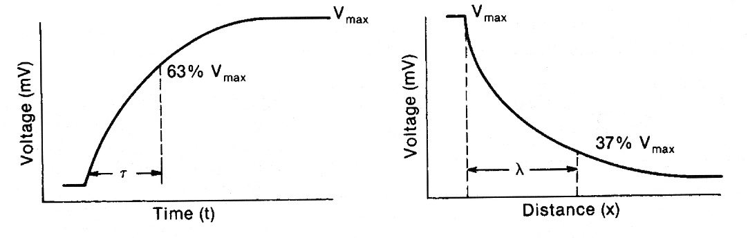

**Time constant (τ)** – laikas, per kurį elektrotoninis membranos potencialas pasiekia 63% savo galutinio maksimalaus dydžio – reflects membrane capacitance.

* lower capacitance, smaller charge needed to depolarize membrane → conduction velocity↑.
* if **τ** is ↑ (e.g. demyelinating disease) – action potential is generated slower and conduction velocity↓.

**Space constant (λ)** – atstumas, per kurį elektrotoninis membranos potencialas nusilpsta iki 37% savo pradinio lygio – reflects membrane resistance.

* **receptor potentials** (produced by sensory stimulus on receptor), **synaptic potentials** (produced by neurotransmitter on postsynaptic membrane) do not propagate (because these membranes do not have necessary voltage-dependent channels) – these electrotonic potentials must spread passively to patch of membrane that is able to produce action potential.
* lower membrane resistance, more charge leaks out of cell → conduction velocity↓.
* if **λ** is ↓ (e.g. due to inhibitory neurotransmitter), electrotonic potential (when it arrives at necessary place) may be already to small to trigger action potential.

**Monophasic & biphasic action potentials**

**monophasic** action potential (deflection primarily in one direction) - when recorded with ***one electrode in cell***.

**biphasic** action potential - ***both*** recording electrodes ***on membrane outside***:

|  |  |
| --- | --- |
| D:\Viktoro\Neuroscience\A. Neuroscience Basics\A3-5. Neuron, Synapsis, Neurochemistry\00. Pictures\Biphasic action potential.jpg | * no potential difference *at rest* (N.B. extracellular recordings register only action potentials but not resting potentials). * as depolarization wave *reaches first electrode*, it becomes negative relative to other electrode. * when impulse passes *between two electrodes*, potential returns to zero (duration of isoelectric interval is proportionate to conduction speed and distance between electrodes). * as impulse *passes second electrode*, first electrode becomes positive relative to second. * it is conventional to connect leads in such a way that when first electrode becomes negative relative to second, upward deflection is recorded. * body fluids contain large quantities of electrolytes - nerves function in conducting medium (often called **volume conductor**); potential changes observed in volume conductor are basically similar, but there are positive deflections before and after negative spike. |

* useful in clinical examinations (EEG, EMG, ECG).

Neuronal polarization

* **axon** can conduct in either direction.
* in living animal, **sinapsių** dėka (act as one-way valves) nervinis implsas (tiek pačiu neuronu, tiek in circuit) plinta tik viena kryptimi: dendritai → aksonas (**orthodromic** conduction).
* conduction in opposite direction (**antidromic**) fails to pass first encountered synapse and dies out at that point.
* afferent / efferent – nervinio impulso plitimo ***kryptis*** ***kieno nors atžvilgiu***.

Neurons have four **functionally important zones**:

|  |  |
| --- | --- |
| 1. **Receptor (dendritic) zone** – multiple nonconducted local potential changes (generated by synaptic connections) are integrated. 2. **Site of origin of propagated action potentials** (e.g. *initial segment* in spinal motor neurons, *initial node of Ranvier* in cutaneous sensory neurons).   in some special situations propagated action potentials may be generated in dendrites.   1. **Axonal process** - transmits propagated impulses to nerve endings. 2. **Nerve endings** - release synaptic transmitters.  * **cell body** is often located at dendritic zone end of axon (multipolar neuron), but it can be within axon (bipolar neurons) or attached to axon side (unipolar neuron).   N.B. functionally cell body location makes no difference! | D:\Viktoro\Neuroscience\A. Neuroscience Basics\A3-5. Neuron, Synapsis, Neurochemistry\00. Pictures\Functional neuron organization.jpg |

**Ionic Fluxes during resting potential** also see 508a p. (biochemistry)

**Na+/K+-ATPase** **actively transports** – 3 Na+ out, 2 K+ into cells.

|  |  |
| --- | --- |
| **Ion channels**: also see 20a p. (cytology)   * most **m gates** (in Na+ channels) and **n gates** (in K+ channels) are closed; **h gates** (in Na+ channels) are open (Na+ channels are ready to activation): * however, some channels are open - slow diffusion occurs through **ion channels**:   + K+ **diffuses** out of cells and Na+ diffuses in;   + K+ channel permeability > Na+ channel permeability* + membrane is impermeable to most anions (K+ efflux is not accompanied by equal flux of anions) → membrane is maintained in polarized state. | D:\Viktoro\Neuroscience\A. Neuroscience Basics\A3-5. Neuron, Synapsis, Neurochemistry\00. Pictures\F-16.JPG |

\****external Na+ concentration*** does not affect resting potential!

vs. increasing ***external K+ concentration*** decreases resting potential.

**Ionic Fluxes during action potential**

|  |  |
| --- | --- |
| D:\Viktoro\Neuroscience\A. Neuroscience Basics\A3-5. Neuron, Synapsis, Neurochemistry\00. Pictures\K and Na conductance during action potential.jpg | * slight depolarization (< 7 mV) in resting membrane → increased **K+ efflux** and **Cl- influx** → restored resting potential. * if depolarization exceeds 7 mV, **m gates** in **voltage-gated Na+ channels** start to open at increased rate (Na+ channel activation) adding to depolarization (***positive feedback***); * when firing level is reached, Na+ influx (along its inwardly directed concentration & electrical gradients) is so great that it temporarily swamps repolarizing forces. |

* **Na+ equilibrium potential** (calculated by Nernst equation) is +60 mV; action potential does not reach it, because:

1. ***electrical gradient for Na+ is reversed*** during overshoot (limits Na+ influx → Na+ influx becomes equal to K+ efflux* – no net current);

*membrane potential at which ion movement are equal and opposite is called **reversal potential** (i.e. maximum depolarization that can be achieved);

tai reikia skirti nuo **equilibrium potential** – membrane potential, kuomet jono elektrinis gradientas yra lygus ir priešingos krypties negu koncentracijos gradientas (jonas nejuda per membraną)

1. ***increase in Na+ conductance is short-lived*** – **h gates** rapidly enter closed state (inactivated state); after few milliseconds (due to started repolarization) Na+ channels return to resting state (h gates open, but m gates close).
2. ***repolarization begins***.

* repolarization - opening of **n gates** in **voltage-gated K+ channels** (due to membrane depolarization);
  + this opening is ***slower*** (than opening of Na+ channels) - increase in K+ conductance comes after increase in Na+ conductance.
  + this opening is ***more prolonged*** (than opening of Na+ channels) - explains occurrence of:

1. after-hyperpolarization
2. accommodation (opening of K+ channels balances gradual opening of Na+ channels, and action potential does not occur)

Net movement of positive charge out of cell (K+ efflux) completes repolarization.

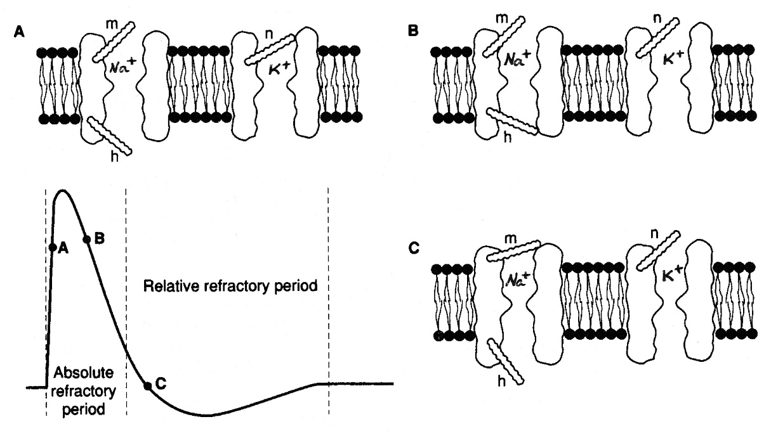

N.B. number of Na+ & K+ ions involved (in action potential) is minute relative to total numbers present!

* 70% of nerve energy requirement is used to maintain membrane polarization (by Na+-K+ ATPase).
* during maximal activity, metabolic rate of nerve doubles (vs. metabolic rate of skeletal muscle increases 100-fold).

N.B. action potential in ***neurons*** has **no plateau phase** (maintained by Ca2+ influx), vs. action potential in ***cardiac muscle cells***.

Extracellular ion concentrations

* ↓***external Na+ concentration*** decreases action potential size (vs. resting potential).
* ↓***external K+ concentration*** increases resting potential (due to K+ gradient↑).
* ↓***external Ca2+ concentration*** increases excitability (of nerve and muscle cells - tetany) by decreasing resting potential;

↑extracellular Ca2+ concentration "stabilizes membrane" (by decreasing excitability).

**Distribution of ion channels**

**Voltage-gated Na+ channels** are highly concentrated in nodes of Ranvier and initial segment in myelinated neurons (initial segment and, in sensory neurons, first node of Ranvier are sites where impulses are generated); Na+ channels are flanked by **K+ channels**.

* number of Na+ channels / μm2 of membrane:
  1. in **myelinated** neurons: 50-75 in cell body, 350-500 in initial segment, < 25 on myelin surface, 2000-12000 at nodes of Ranvier, 20-75 at axon terminals.
  2. in **unmyelinated** axons ≈ 110.

Properties of mixed nerves

* + - recorded potentials represent ***algebraic summation*** of all-or-none action potentials of many different axons.

1. When stimuli are ≈ of threshold intensity, axons with *low thresholds* fire and small potential is observed; stimulus that produces excitation of all axons is **maximal stimulus**.

|  |  |
| --- | --- |
| 1. Mixed nerve is made up of fibers with *various conduction speeds* - when all fibers are stimulated, activity in fast-conducting fibers arrives at recording electrodes sooner than activity in slower fibers → multiple peaks in action potential (**compound action potential**); farther away from stimulating electrodes action potential is recorded, greater is separation between fast and slow fiber peaks (↑number of peaks, ↑duration of compound potential): | D:\Viktoro\Neuroscience\A. Neuroscience Basics\A3-5. Neuron, Synapsis, Neurochemistry\00. Pictures\Compound action potential.jpg |

Nerve fiber types

Nerve fibers klasifikuojamos:

1. **Anatomiškai** – pagal:
   1. ilgį
   2. diametrą (0,2-20 μm) N.B. diametras matuojamas kartu su mielinu!
   3. mielino buvimą (mielinizuota ≈ 20% visų PNS aksonų)
   4. neuronų kūnus
   5. centrinės / periferinės
2. **Funkciškai** - pagal:
   1. conduction velocity (0,2-120 m/s)
   2. conduction direction (afferent / efferent)
   3. type of sensory modality served
   4. type of structure innervated (visceral / somatic)
   5. type of neurotransmitter

Erlanger and Gasser classification:

|  |  |  |  |  |  |
| --- | --- | --- | --- | --- | --- |
| Fiber type | Function | Fiber diameter (μm) | Conduction velocity (m/s) | Spike duration (ms) | Absolute refractory period (ms) |
| Myelinated | | | | | |
| **Aα** | proprioreception, motor (somatic) | 12-20 | 70-120 | 0,4-0,5 | 0,4-1 |
| **Aβ** | touch (discriminative), pressure | 5-12 | 30-70 |
| **Aγ** | motor (to muscle spindles) | 3-6 | 15-30 |
| **Aδ** | pain, cold, touch (crude) | 2-5 | 12-30 |
| **B** | preganglionic autonomic | < 3 | 3-15 | 1,2 | 1,2 |
| Unmyelinated | | | | | |
| **C** | dorsal root – pain, temperature, some mechanoreception, reflex responses | 0,4-1,2 | 0,5-2 | 2 | 2 |
| postganglionic sympathetic | 0,3-1,3 | 0,7-2,3 |

**A** – storos mielinizuotos somatinės skaidulos

**B** – plonos mielinizuotos preganglinės skaidulos

**C** – nemielinizuotos (pagrinde postganglinės) skaidulos

* larger axon – thicker myelin (greater *diameter* of nerve fiber) - greater its *speed of conduction* (nes, kuo storesnė skaidula, tuo didesnis atstumas tarp gretimų nodes of Ranvier).
* all fibers **conducting > 3 m/s** are **myelinated**!
* in **myelinated** fibers:

conduction velocity ≈ 6 × diameter

* in **unmyelinated** fibers:

conduction velocity ≥ diameter

* various classes of fibers differ in their sensitivity to hypoxia, pressure and anesthetics (i.e. conduction block produced by these agents):

|  |  |  |  |
| --- | --- | --- | --- |
| **Susceptibility to:** | **Most susceptible** | **Intermediate** | **Least susceptible** |
| Hypoxia | B | A | C |
| Pressure | A | B | C |
| Local anesthesia | C | B | A |

* *local anesthetics* depress pain transmission before they affect touch fibers.
* *pressure on nerve* (Saturday night / Sunday morning paralysis) causes loss of conduction in motor, touch, pressure fibers while pain sensation remains relatively intact.

Bibliography for ch. “Neuron, Synapsis, Neurochemistry” → follow this [link >>](http://www.neurosurgeryresident.net/A.%20Neuroscience%20Basics\A.%20Bibliography.pdf)

NMS Neuroanatomy 1998, Histology 1997

Cotran “Robbins Pathologic Basis of Disease”, 6th ed., 1999 (p. 1293-1297)

Ganong “Review of Medical Physiology”, 2002

[Viktor’s Notes℠ for the Neurosurgery Resident](http://www.neurosurgeryresident.net/)

[Please visit website at www.NeurosurgeryResident.net](http://www.neurosurgeryresident.net)