Hypothalamic Function
Last updated: April 20, 2019

HUNGER, FOOD INTAKE 2
Neuropeptides that increase food intake 3
Neuropeptides that decrease food intake 3
Afferent mechanisms in food intake control 3
THIRST, DRINKING 4
Thermoregulation 5
Physical mechanisms of heat dissipation 5
Heat production 5
Normal Body Temperature 6
Fever 7
Fever of Unknown Origin (FUO), s. Fever Without Localizing Signs 8
Poikilothermy 9
Hereditary periodic fever syndromes 9
Familial Mediterranean Fever 9
Hyper-IgD Syndrome 10
TNF Receptor–Associated Periodic Syndrome (Familial Hibernian Fever) 10
Hypothermia, hyperthermia - see p. 3909 >

Levels of autonomic integration within CNS are arranged, like their somatic counterparts, in hierarchy:
- simple reflexes (e.g. contraction of full bladder) are integrated in spinal cord.
- complex reflexes: respiration, blood pressure - medulla oblongata; pupillary responses - midbrain.
- complex autonomic mechanisms (chemical constancy and temperature of internal environment) - hypothalamus.
- insular and medial prefrontal cortices (paralimbic areas) and amygdala nuclei are higher centers of processing visceral information:
insular cortex - primary viscerosensory cortex (receives viscerotopically organized sensory information).
ventromedial prefrontal and anterior cingulate cortices - initiate autonomic responses associated with affective behavior.
amygdala - receives exteroceptive and interoceptive information and provides it with emotional significance.

Hypothalamus is most important area for integration of behavior with autonomic responses and with neuroendocrine control of anterior and posterior pituitary glands

- hypothalamus is not concerned with regulation of visceral function per se; autonomic responses triggered in hypothalamus are more complex phenomena (such as eating, rage, other emotions).
- stimulation of various parts of hypothalamus (esp. lateral areas) produces diffuse sympathetic discharge and increased adrenal medullary secretion.
- very little evidence that localized "parasympathetic center" exists - hypothalamic stimulation causes very few parasympathetic responses (occasionally causes contraction of urinary bladder).

Hypothalamus is functionally divided into three longitudinal zones:
periventricular zone - circadian rhythms and endocrine responses;
medial zone - sexual function, osmoregulation, thermoregulation;
lateral zone - behavioral arousal.

- hypothalamic autonomic pathways descend predominantly ipsilaterally in dorsomedial and ventrolateral tegmentum of brain stem.

Schematic illustration of functional organization of hypothalamus:
General and visceral sensory, limbic, and local interoceptive (e.g. osmolality and temperature) information is compared against homeostatic set-point by integrative cell groups in preoptic area and tuberal hypothalamus. Efferent autonomic responses from paraventricular nucleus (PaV) and lateral hypothalamic area are then integrated with anterior pituitary control via periventricular (PeV) and arcuate (AR) nuclei and posterior pituitary control via supraoptic (SO) and paraventricular nuclei, and with behavioral regulation exercised mainly by lateral hypothalamic area.
MAM = mamillary body; OC = optic chiasm.
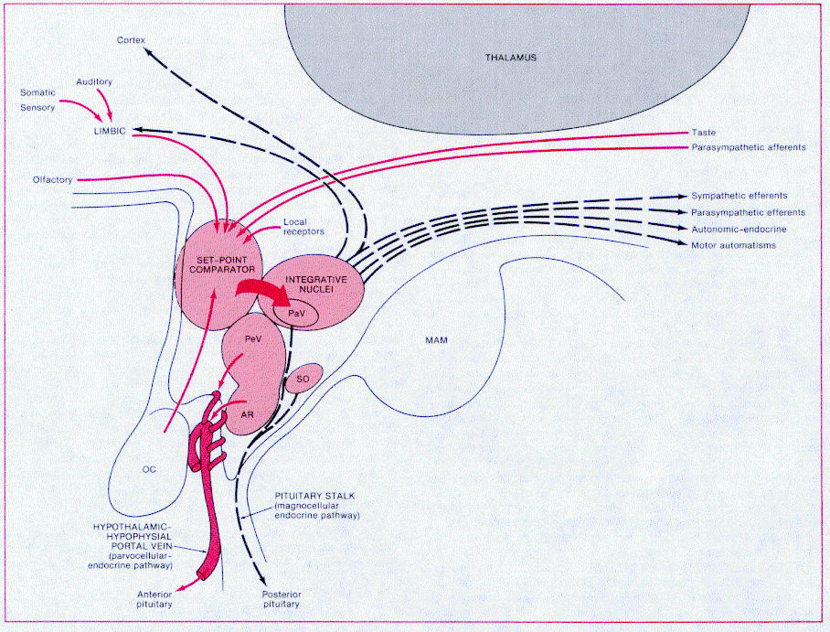

HUNGER, FOOD INTAKE
Food intake is regulated on SHORT-TERM (meal-to-meal basis) + LONG-TERM (body weight at given set point):
- if animals are made obese by force-feeding and then permitted to eat as they wish, their spontaneous food intake decreases until their weight falls to control.
- if animals are starved and then permitted to eat freely, their spontaneous food intake increases until they regain lost weight.
- human dieters can lose weight when caloric intake is reduced but when they discontinue their diets, 95% of them regain weight they lost.
- during recovery from illness, food intake is increased in catch-up fashion until lost weight is regained.

Energy output is also regulated.
- energy output is increased after meals by specific dynamic action (SDA) of food + increase in sympathetic discharge.
- fasting decreases metabolic rate over period of days, conserving energy.

Hypothalamic regulation of appetite depends primarily upon interaction of two areas:
  - Lateral "feeding center" (in bed nucleus of medial forebrain bundle at its junction with pallidohypothalamic fibers) - stimulation evokes eating behavior; destruction causes severe, fatal anorexia.
  - Medial "satiety center" (in ventromedial nucleus) - stimulation causes eating cessation; destruction causes hyperphagia → hypothalamic obesity.
    - satiety center functions by inhibiting feeding center (destruction of feeding center in rats with lesions of satiety center causes anorexia).
    - feeding center is chronically active; activity is transiently inhibited by satiety center after food ingestion.
N.B. it is set point for body weight rather than food intake per se which is regulated by hypothalamus (e.g. rats with ventromedial lesions gain weight for while, but their food intake then levels off - appetite mechanism operates to maintain their new, higher weight).

Neuropeptides that increase food intake
  - Neuropeptide Y
- neuropeptide Y-containing neurons are in arcuate nuclei and project to paraventricular nuclei.
- neuropeptide Y exerts its effect through three receptors-Y1, Y2, Y5 (all coupled to G proteins).
- knockout of neuropeptide Y gene does not produce marked effects on feeding, but knocking out neuropeptide Y gene in leptin-deficient mice causes them to eat less and expend more energy.

  - Orexins
- orexin-A and orexin-B - derived from same gene by alternate splicing.
- synthesized in lateral hypothalamus.

  - Melanin-concentrating hormone
- found in lateral hypothalamus and zona incerta.

Neuropeptides that decrease food intake
  - Pro-opiomelanocortin (POMC) derivatives.
  - CART (cocaine- and amphetamine-regulated transcript).
  - CRH.
  - Catecholamines (amphetamine and related drugs used clinically to suppress appetite act by releasing norepinephrine in CNS).

Afferent mechanisms in food intake control
    - Lipostatic hypothesis – adipose tissue produces humoral signal (proportionate to amount of fat) – leptin – decreases food intake (via act on hypothalamus) + increases energy expenditure (via uncoupling proteins in brown adipose tissue); i.e. negative humoral feedback loop by which size of body's fat depots regulate food intake. see also 2765 (2) p.

    - Gut peptide hypothesis - food in GI tract releases polypeptides (gastrin-releasing peptide, glucagon, somatostatin, cholecystokinin) - act on hypothalamus to inhibit food intake - short-term (meal-to-meal) control.

    - Glucostatic hypothesis – increased glucose utilization in satiety center in hypothalamus produces sensation of satiety → feeding center is inhibited (hypoglycemia is appetite stimulant!).

    - Thermostatic hypothesis – fall in body temperature below given set point stimulates appetite and rise above set point inhibits appetite (food intake is increased in cold weather and decreased in warm weather).

      - GI tract distention inhibits appetite; hunger contractions of empty stomach stimulate appetite.
N.B. denervation of stomach and intestines does not affect amount of food eaten!
      - cultural factors, environment, past experiences related to sight / smell / taste of food affect food intake.

THIRST, DRINKING
Drinking is regulated by separate ways:
- Plasma osmolality - via osmoreceptors (in organum vasculosum of lamina terminalis)
- ECF volume - via renin-angiotensin system (angiotensin II acts on subfornical organ and organum vasculosum of lamina terminalis) and baroreceptors (in heart and blood vessels).
  - hemorrhage causes increased drinking without change in plasma osmolality.
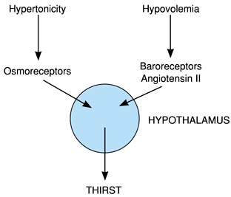
- Psychologic and other factors
  - intake of liquids is increased during eating (prandial drinking) - learned or habit response; some evidence that GI hormones stimulate same subfornical neurons that respond to angiotensin II.
  - dryness of pharyngeal mucous membrane causes sensation of thirst (patients in whom fluid intake must be restricted sometimes get appreciable thirst relief by sucking ice chips or wet cloth).
  - some dehydrated animals (dogs, cats, camels) rapidly drink just enough water to make up their water deficit; they stop drinking before water is absorbed (while their plasma is still hypertonic) - pharyngeal gastrointestinal "metering"; humans also have similar not well developed metering ability.

Lesion of hypothalamic pre-optic area → essential (neurogenic) hypernatremia:
    - deficiency of thirst
    - deficit in vasopressin response to increased osmolality (vasopressin response to hypovolemia may be maintained)
      - preservation of habitual drinking (often related to meals) may be sufficient to maintain serum osmolality under normal conditions; in hot weather, patients may suffer attacks of fatigue, fever, muscle cramps and tenderness, and even myoglobinuria (associated with hypokalemia).
      - if [Na] reaches > 180 mEq/L, patients may die.
      - treatment - training patient (to drink adequate amounts of fluid) + spironolactone, chlorpropamide, and thiazide diuretics (to reduce serum sodium).

Thermoregulation
Physical mechanisms of heat dissipation
- radiation (≈ 60% heat loss in cool environment) – infrared electromagnetic waves - transfer heat from one object to another at different temperature.
- individual can feel chilly in room with cold walls even though room is relatively warm.
- in sunny day, heat reflected from snow makes it possible to ski in fairly light clothes even though air temperature is below freezing.

- evaporation (≈ 25% heat loss in cool environment; but remains the only mechanism if ambient temperature is above body temperature); evaporation depends on relative humidity: higher the humidity, less efficient the heat loss.
- vaporization of 1 g H₂O removes 0.6 kcal of heat.
- insensible water loss amounts 50 mL/h; during muscular exertion in hot environment, sweat secretion reaches 1600 mL/h (heat loss from 30 to over 900 kcal/h).
- environmental temperature > body temperature (radiation↓↓↓) + high ambient humidity (cooling effect↓ of sweating) + prolonged strenuous exertion (heat production↑ by muscle) → heat disorders.

- conduction (≈ 3%; but may increase up to 100% in water) – heat exchange between objects at different temperatures that are in direct contact with one another.
convection (≈ 10% heat loss in cool environment) – aid to conduction (movement of molecules away from area of contact):
- respiration - adds to heat loss (2-9%) by warming exhaled air.
- fans.
- horripilation (erection of hairs/feathers) increases thickness of trapped air layer → heat losses (or, in hot environment, heat gains) are decreased.
- some mammals lose heat by panting (rapid, shallow breathing)

  - small amounts of heat are lost in urine and feces.
  - tissue conductance - rate at which heat is transferred from deep tissues to skin (via warm blood flow).

Heat production
  - muscular contraction - major source of heat!
  - food assimilation (specific dynamic action of food)
  - basic metabolic processes that contribute to basal metabolic rate.
- source of considerable heat (esp. in infants) is brown fat.

Heat production can be varied by endocrine mechanisms:
- epinephrine & norepinephrine produce rapid but short-lived increase in heat production;
- thyroid hormones produce slowly developing but prolonged increase.

- balance between heat production and heat loss determines body temperature.
- žmogaus kūnas generuoja 50-60 kcal/val/m² šilumos - staiga išjungus “aušinimą” kūno temperatūra didėtų 1.1°C/val.; sunkus fizinis krūvis šiuos dydžius gali padidinti iki 20 kartų.
- normal body function depends upon relatively constant body temperature (speed of chemical reactions varies with temperature; enzyme systems have narrow optimal temperature ranges).

Thermoregulation in animals:
Invertebrates - cannot adjust body temperatures.
Reptiles, amphibia, fish - thermoregulation mechanisms are relatively rudimentary - body temperature fluctuates over considerable range - "cold-blooded" (poikilothermic).
Birds, mammals - "warm-blooded" (homeothermic) - reflex responses integrated in hypothalamus maintain body temperature within narrow range (actual temperature varies from species to species and, to lesser degree, from individual to individual).
- hibernating mammals - homeothermic while awake; during hibernation, body temperature falls.

Normal Body Temperature
- rectal temperature represents temperature at core of body (varies least with changes in environmental temperature).
- oral temperature (normally 0.5 °C lower than rectal) is affected by many factors - ingestion of hot / cold fluids, gum-chewing, smoking, mouth breathing, etc!
- 95% young adults have morning oral temperature 36.3-37.1 °C
- thermoregulation is less precise in young children - may have temperatures > 0.5 °C above established norm for adults; vaikams normali rektalinė temperatūra (po pietų, po treniruočių) gali siekti 38°C.
- various body parts are at different temperatures (varies with environmental temperature):  - extremities are cooler than rest of body.  - scrotum temperature is carefully regulated at 32 °C.  - core temperature undergoes regular circadian fluctuation of 0.5-0.7 °C (lowest during sleep, slightly higher in awake but relaxed state, rises with activity):  lowest at ≈ 6 AM  highest in evenings |  | 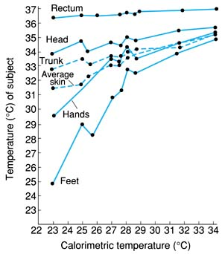
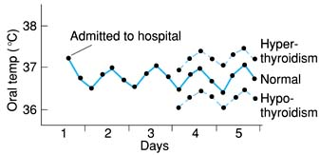 | hospitalized patient who does not have febrile disease - slight rise in temperature, due to excitement and apprehension, at time of admission to hospital, and regular circadian temperature cycle.
- in women, there is additional monthly cycle of temperature variation (basal temperature rise at time of ovulation).
- body temperature rises:
  - during exercise (rectal temperature as high as 40 °C).
  - during emotional excitement (unconscious tensing of muscles).
  - in hyperthyroidism.
  - in some normal adults (constitutional hyperthermia).

Fever
- oldest and most universally known hallmark of disease (esp. infectious), but no direct correlation between height of fever and seriousness of cause.
N.B. senukams, kūdikiams, alkoholikams galima hipotermija!
- fever occurs in mammals, birds, reptiles, amphibia, fish.
- in homeothermic animals, thermoregulatory mechanisms behave as if they were adjusted to maintain body temperature at higher than normal level (i.e. "as if thermostat had been reset" to new point above 37 °C).
N.B. vaikams fever laikoma rectal temperature > 38°C
- temperature rise:
in cold environment - mostly due to increased heat production (e.g. shivering producing shaking chill).
in warm environment - mostly due to decreased heat loss (e.g. chilly sensations due to cutaneous vasoconstriction).

Fever pathogenesis scheme
exogenous pyrogens (bacterial endotoxins, inflammation)
↓
Monocytes, macrophages, and Kupffer cells
↓ endogenous pyrogens – cytokines (IL-1B, 6; β, γ-IFN; TNF-α)
Preoptic area of hypothalamus (organum vasculosum laminae terminalis)
↓ prostaglandins (e.g. PGE₂)
Thermoregulatory centers in hypothalamus
↓
Fever

- any physical injury to brain (e.g. trauma, intracranial surgery, stroke) that allows entry into brain of macrophages or activates microglial cells to produce cytokines induces febrile response as well - "central neurogenic fever".
- of course, cytokines may also be produced by CNS cells stimulated by infection - act directly on thermoregulatory centers.
- fever produced by cytokines is due to local release of prostaglandins in hypothalamus:
  - intrahypothalamic injection of prostaglandins produces fever;
  - aspirin acts directly on hypothalamus (inhibits prostaglandin synthesis).
- fever benefit is uncertain (presumably beneficial):
- many microorganisms grow best within relatively narrow temperature range (kad karščiavimas padeda kovoti su infekcija, jokios klinikinės studijos to neįrodė).
- antibody production is increased (before advent of antibiotics, fevers were artificially induced for treatment of neurosyphilis).
- hyperthermia slows growth of some tumors.
- indikacijos temperatūros mažinimui:
- Children at risk for seizures
- Cardiopulmonary insufficiency (1°C↑ → O₂ consumption↑ 13%)
- Very high temperatures - rectal temperature > 41 °C for prolonged periods may cause permanent brain damage; if > 43 °C, heat stroke → death.
- karščiavimas simptomiškai mažinamas vaistais, slopinančiais CNS ciklooksigenazę (acetaminophen, ibuprofen).

Fever of Unknown Origin (FUO), s. Fever Without Localizing Signs
- fever > 3 week duration*, kai priežasties nerandama po > 1 sav. klinikinio tyrinėjimo.
*some suggest > 1-2 week for children
FUO dažniausiai esti unusual presentation of common disorder (negu common presentation of rare disorder)

Etiologija labai įvairi ir priklauso nuo amžiaus: N.B. HIV can cause FUO
50% FUO cases – infection:
< 2 yrs. – most commonly upper respiratory or GI infection; children < 2 yr (esp. infants ≤ 3 mo) are at special risk of occult bacteremia (esp. if > 39°C)
N.B. some vaccinations can cause fever!
N.B. URI cannot be definitively considered source of fever until 3 months of age!
> 6 yrs. – endocarditis, infectious mononucleosis
Teething does not cause fever!
adults – tbc, occult abscesses

20% FUO cases – connective tissue diseases:
children – most commonly inflammatory bowel disease (rečiau SLE, RA)
Ask for family history of autoimmune disease!

10% FUO cases in children (20% in adults) – neoplasia:
children – most commonly lymphoma, leukemia
adults – most commonly solid tumors.

10-20% FUO cases in children (5-10% in adults) – no cause is found.

Evaluation:
- WBC differential count
- urinalysis and urine culture
- blood culture – as screening only for patients < 2 yrs of age (for older – only if WBC is < 5 or > 15).
- lumbar puncture:
- children < 2 mo - LP mandatory for all;
- children 2-3 mo - opinions vary about need for LP;
- children > 3 mo - LP indicated if child looks ill (irritable, lethargic) but has no localizing signs (if infant is well appearing and vaccinated against pneumococcus, risk of bacteremia / meningitis is very low).
- also consider head CT.
- chest X-ray
- throat swab & culture – for Str. pyogenes
- stool swabs for WBCs and stool cultures
- tuberculin test
- dentist consultation
- acute-phase reactants (ESR, C-reactive protein, procalcitonin)
- radionuclide scanning with Indium-111-labeled granulocytes
  - evaluation must be especially thorough in infant ≤ 3 mo regardless of other signs and symptoms - serious infection (e.g. sepsis, meningitis) may occur without other manifestations!
  - in children, explore tympanic membranes (pneumatic otoscopy + tympanometry), throat, chest, abdomen, lymph nodes, neck flexibility, and skin.

Empyriškai antibiotikai skiriami, jei yra didelė infekcijos tikimybė:
- newborns (fever gali būti vienintelė sepsis / meningitis manifestacija!) - hospital admission and IV antibiotics (esp. if WBC is < 5 or > 15):
ceftriaxone or cefotaxime + ampicillin ± vancomycin (if penicillin-resistant Streptococcus pneumoniae is suspected) ± acyclovir (if herpes simplex is likely).
- children < 3 yrs with intoxication
  - well-appearing patients > 2 yrs of age require only symptomatic outpatient treatment with close follow-ups.

Poikilothermy
- fluctuation in body temperature > 2° C with changes in ambient temperature.
- lesions in posterior hypothalamus
- lesions in midbrain (that damage hypothalamic pathways for autonomic as well as behavioral thermoregulation).
- metabolic disorders (e.g. sedative drug ingestion, hypoglycemia, hypothyroidism)
- old age (mild form of poikilothermy).

Hereditary periodic fever syndromes
- inherited disorders characterized by recurrent fever and other symptoms in absence of secondary causes.
  - > 90% develop symptoms during childhood.

Familial Mediterranean Fever
- recurrent bouts of fever (up to 40°C) and peritonitis* (95%), sometimes with pleuritis (30%), skin lesions, arthritis (25%), and, very rarely, pericarditis.
*cannot be differentiated from perforated viscus on physical examination → many patients undergo urgent laparotomy
  - renal amyloidosis may develop (most significant long-term complication).
  - descendants of inhabitants of Mediterranean basin are most affected.
  - 50% patients have family history.
  - autosomal-recessive mutations in MEFV gene (short arm of chromosome 16);
    - MEFV gene codes pyrin (marenostrin) expressed in circulating neutrophils - presumed action is to blunt inflammatory response (by inhibiting neutrophil activation and chemotaxis).
    - gene mutations cause defective pyrin molecules → minor, unknown triggers to inflammation that are normally checked by intact pyrin cannot be suppressed → bout of neutrophil-predominant inflammation in abdominal cavity (as well as at other sites).
    - genetic testing is available.
  - attacks have no regular pattern of recurrence and vary in same patient;
    - usually last 24-72 h (some last ≥ 1 wk).
    - frequency ranges from 2 attacks/wk to 1 attack/yr.
    - despite severity of attacks, most patients recover swiftly and remain free of illness until next attack.
    - spontaneous remissions may last years.
  - laboratory - nonspecific findings include elevated WBCs with neutrophil predominance, ESR, C-reactive protein, and fibrinogen
  - prophylactic colchicine prevents acute attacks and renal amyloidosis → excellent prognosis (85% patients).

Hyper-IgD Syndrome
- recurring attacks of chills and fever begin during 1st yr of life.
  - additional features: abdominal pain, vomiting or diarrhea, headache, arthralgias, cervical lymphadenopathy, hepatosplenomegaly, arthritis, skin lesions, orogenital aphthous ulcers.
  - episodes last 4-6 days;
    - triggered by physiologic stress (such as vaccination or minor trauma).
    - episodes diminish in frequency after adolescence.
  - serum IgD level > 100 IU/mL.
  - specific (but insensitive) findings - urinary neopterin↑ and mevalonic acid↑.
  - mutations in gene coding mevalonate kinase, enzyme important for cholesterol synthesis.
  - no known treatment.

TNF Receptor–Associated Periodic Syndrome (Familial Hibernian Fever)
- recurrent fever and painful, migratory myalgias with tender overlying erythema.
  - males are prone to develop inguinal hernias.
  - renal amyloidosis is possible complication.
  - mutations in gene coding TNF receptor → defective shedding of this receptor → unchecked TNF signaling → inflammation.
  - attacks begin before age 20.
    - last 1 day ÷ > 1 wk.
  - diagnosis - low levels of type 1 TNF receptor (< 1 ng/mL) when measured between attacks.
  - treatment - corticosteroids and etanercept (binds and inactivates TNF).

Bibliography for ch. “Hypothalamus” → follow this link >>
Ganong “Review of Medical Physiology”, 2002
NMS Neuroanatomy 1998

Viktor’s Notes℠ for the Neurosurgery Resident
Please visit website at www.NeurosurgeryResident.net

