Spinal Cord Development
Last updated: April 20, 2019

Distal Spinal Cord development (secondary neurulation)
- formation of neural tube below caudal neuropore (caudal neuropore is located in lower lumbar region)
- after neurulation (primary neurulation) is complete, distal (sacrococcygeal) spinal cord begins to form as caudal end of neural tube blends into caudal cell mass (large mass of undifferentiated pluripotential cells that eventually give rise to components of nervous, urogenital, and digestive systems - common association of anomalies in these systems).
- canalization - within caudal cell mass, small vacuoles form, coalesce, and eventually connect with central canal of spinal cord.
- distal spinal cord then begins retrogressive differentiation (continues for ≈ 7 weeks), leaving conus medullaris and filum terminale.

Formation of caudal spinal cord: vacuolization (A) and coalescence of caudal cell mass (B); formation of filum terminale (C):
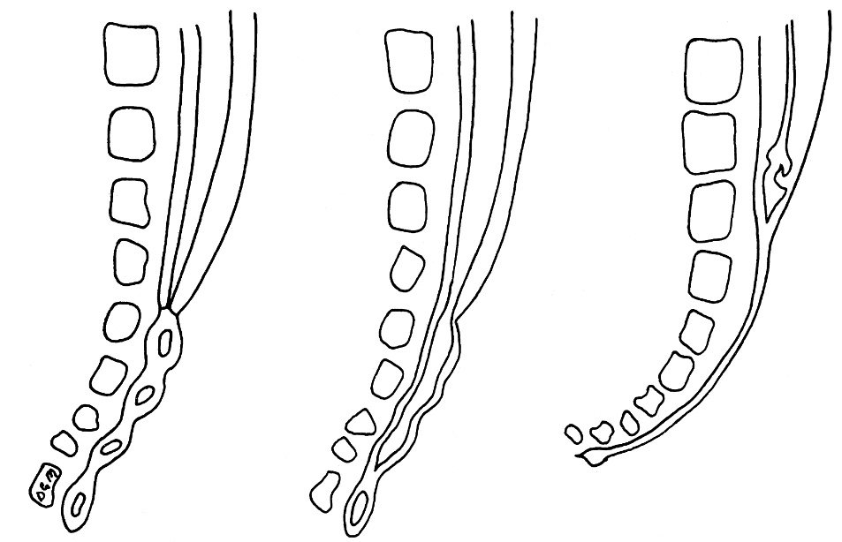

Disorders of secondary neurulation (e.g. tethered filum) → occult dysraphic states (abnormalities of sacrococcygeal segments beneath intact dermal elements; no exposed neural tissue). see p. Dev5 >>
- these anomalies (sacral agenesis, conus hypoplasia) may be associated with other abnormalities (imperforate anus, malformed genitalia, renal dysplasias, etc) - as part of broader caudal regression syndrome.

Bibliography for ch. “General Development” → follow this link >>

Viktor’s Notes℠ for the Neurosurgery Resident
Please visit website at www.NeurosurgeryResident.net

