Olfactory Physiology
Last updated: April 20, 2019
Smell functions a
Odor-producing molecules a
Olfactory Thresholds & Discrimination a
Signal Coding b
Sniffing c
Vomeronasal Organ c

Smell functions
- Warning - spoiled foods, leaking natural gas, polluted air, smoke.
- Basic communication (e.g. mother-infant interactions).
- Food flavor sensations (from retronasal stimulation of olfactory receptors)

Odor-producing molecules
- generally small (contain 3-20 carbon atoms).
- molecules with same number of carbon atoms but different structural configurations have different odors.
- substances with strong odors characteristically are volatile and have high water and lipid solubility.
- olfactory stimuli are terminated by enzymes (of supporting cells*) - catalyze covalent modification of molecules.
*vs. olfactory receptor cells (unlike other epithelial cells) have little xenobiotic-metabolizing capacity - primary route of invasion of neuroviruses and toxic agents.

Olfactory Thresholds & Discrimination
- olfactory receptors respond only to substances that are dissolved in thin layer of mucus.
- olfactory thresholds - remarkable sensitivity!!!
thresholds are different for different substances
(e.g. methyl mercaptan, substance in garlic, can be smelled at concentration < 500 pg/L of air).
- olfactory discrimination – remarkable! (humans can recognize more than 10,000 different odors); even dextro- and levo- rotatory forms, cis- and trans- forms can be distinguished.
- determination of odor intensity – poor (concentration of odor-producing substance must be changed by 30% before difference can be detected; vs. ≈ 1% in visual discrimination).
- determination of direction from which smell comes:
    - slight difference in time of molecule arrival in two nostrils.
    - head turning
- single olfactory receptors (vs. olfactory mucous membrane as whole) have relatively high thresholds and long latencies + lipophilic odor-producing molecules must traverse hydrophilic mucus to reach receptors.
Hypothesis - olfactory mucus contains odorant-binding proteins (OBP) that concentrate odorants and transfer them to receptors.
- when one is continuously exposed to even most disagreeable odor, odor perception decreases and eventually ceases - due to very rapid adaptation (desensitization).
    - it is specific for particular odor being smelled (threshold for other odors is unchanged).
    - at least partly central in origin (hyperpolarization of cortical neurons).

Olfactory bulbs
- axons contact primary dendrites of mitral cells & tufted cells - to form complex globular synapses (olfactory glomeruli).
- tufted cells are smaller than mitral cells, but both are similar from functional point of view.
- ≈ 26,000 receptor cell axons converge on each glomerulus.

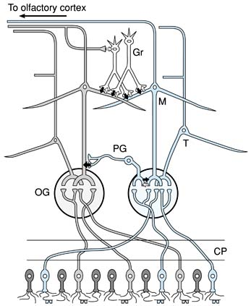  Note: olfactory receptor cells with one type of odorant receptor project to one olfactory glomerulus (OG) and olfactory receptor cells with another type of receptor project to different olfactory glomerulus.  CP, cribriform plate; PG, periglomerular cell; M, mitral cell; T, tufted cell; Gr, granule cell. | 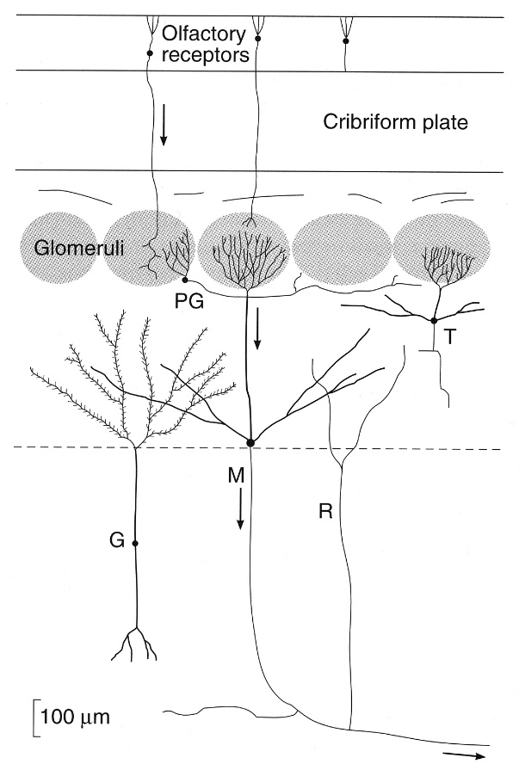

inhibitory neurons of olfactory bulbs:
- periglomerular cells - inhibitory neurons in glomerular layer - connect one glomerulus to another.
- granule cells - have no axons; make reciprocal synapses with lateral dendrites of mitral / tufted cells - at these synapses neurons interact (mitral / tufted cell releases glutamate, and granule cell inhibits the mitral / tufted cell by releasing GABA).

- periglomerular / granule cells mediate lateral inhibition - sharpens and focuses olfactory signals.
- in addition, in each glomerulus extracellular field potential oscillates (helps to focus olfactory signals reaching cortex) - granule cells regulate oscillation frequency.

Signal Coding
- there are ≈ 1000 different odorant chemoreceptors (since human genome contains 50,000-100,000 genes, up to 1% of genome is devoted to odorant receptors - largest gene family in mammals!).
- all odorant receptors are coupled to G proteins (cAMP↑ or IP₃ → opening Ca²⁺ channels → Cl⁻ channel activation → membrane depolarization).
- humans can discriminate 10,000 different odors - additional mechanism is involved - olfactory glomeruli acting as feature detectors:
  - each glomerulus receives input from only one type of olfactory receptor;
  - each olfactory receptor responds to multiple different odorants, and single odorant can be recognized by multiple receptor types; no two receptor cells have identical responses to series of stimuli;
  - given receptor cell projects to only one glomerulus.
N.B. each odorant produces different pattern of activated glomeruli - brain recognizes that as different odors.

Sniffing
- short, forceful inspirations (turbulent airflow) with contraction of lower nares on septum (to deflect airstream upward) → olfactory mucosa exposed to inspired air.
- semi-reflex response that occurs when new odor attracts attention.
- greatly increases amount of air reaching olfactory region.
- sniffing activates piriform (olfactory) cortex → limbic system (emotions, memories).
- smells with or without sniffing activate orbitofrontal cortex (lateral and anterior orbitofrontal gyri) – conscious smell perception.
orbitofrontal activation is greater on right side (cortical representation of olfaction is asymmetric!).

Vomeronasal Organ
- another patch of olfactory mucous membrane located along nasal septum.
- well-developed in mammals (except humans – small pit in anterior 1/3 of nasal septum).
- concerned with perception of pheromones.
- projects to accessory olfactory bulb → amygdala, hypothalamus.
- regulates reproduction and ingestive behavior (e.g. close relationship between smell [perfumes, etc] and sexual function).
- sense of smell is more acute in women (most acute at time of ovulation).
- smell (and, to lesser extent, taste) has unique ability to trigger long-term memories.

Bibliography for ch. “Olfactory System” → follow this link >>
Ganong “Review of Medical Physiology”, 2002
NMS Neuroanatomy 1998, Physiology 2001

Viktor’s Notes℠ for the Neurosurgery Resident
Please visit website at www.NeurosurgeryResident.net

