Amygdala
Last updated: September 13, 2019
Anatomy 1
Imaging 3
Connections 3
Function 4
Lesions 4

Anatomy
- almond-shaped structure.
- average size in humans 1.24-1.63 cm³
- one portion is a ventromedial extension of the striatum, a second part comprising the caudal olfactory cortex, and a third region representing the ventromedial extension of the claustrum.
- amygdala has been subdivided based on its histological characteristics into 2 major areas (anterior amygdaloid area and corticoamygdaloid transition area), 6 nuclei (central, medial, cortical, accessory basal, basal, and lateral), and 1 intercalated cell group.

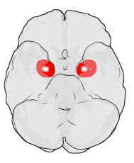

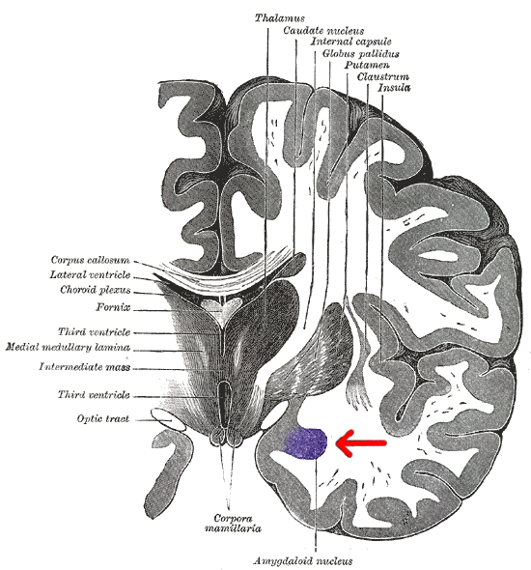

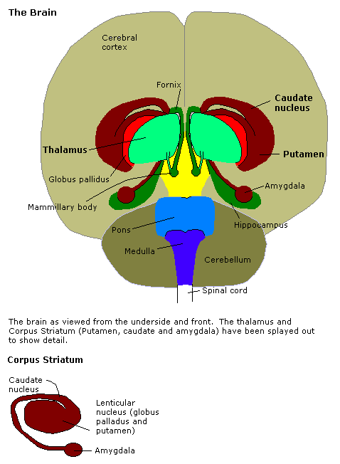

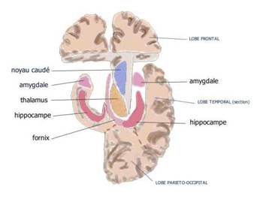

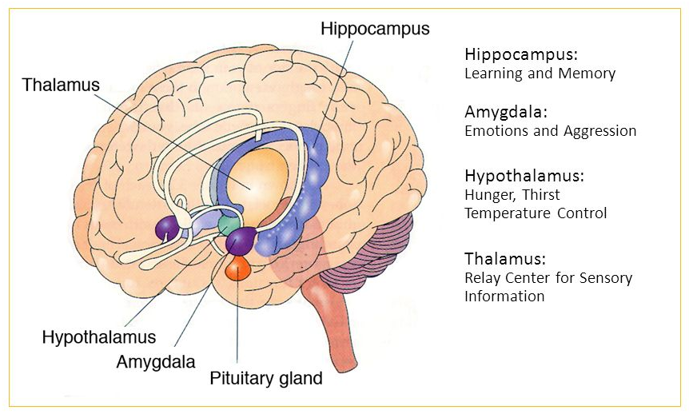

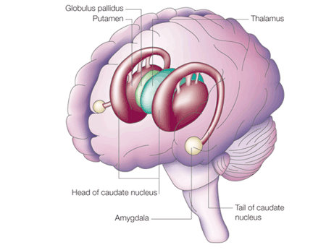
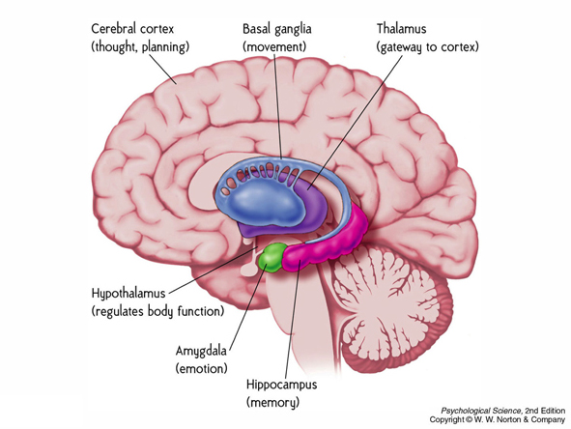

Imaging
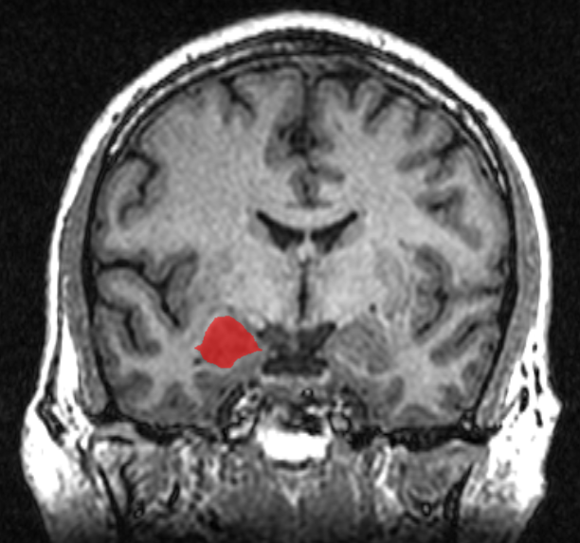

Connections
Schematic representation of the main connections of the central, medial, basolateral, and basomedial amygdala nuclei. Acb: nucleus accumbens; AH: anterior hypothalamic area; AHN: anterior hypothalamic nucleus; AI: agranular insular cortex; AO: anterior olfactory nucleus; AOB: accessory olfactory bulb; Arc: arcuate nucleus of the hypothalamus; BNST: bed nucleus of the stria terminalis; Cl: claustrum; CM: central medial thalamic nucleus; CnF: cuneiform nucleus; DB: nucleus of the diagonal band; DM: dorsomedial hypothalamic nucleus; DR: dorsal raphe nucleus; En: endopiriform nucleus; Ent: entorhinal cortex; GP: globus pallidus; IL: infralimbic cortex; IMD: intermediodorsal thalamic nucleus; LC: locus coeruleus; LDTg: laterodorsal tegmental nucleus; LH: lateral hypothalamic area; LPO: lateral preoptic area; MD: mediodorsal thalamic nucleus; MG: medial geniculate nucleus; MPO: medial preoptic area; OB: olfactory bulb; Pa: paraventricular hypothalamic nucleus; PAG: periaqueductal gray; PaS: parasubiculum; PB: parabrachial nucleus; Pe: periventricular hypothalamic nucleus; PeF: perifornical nucleus; PFC: prefrontal cortex; Pir: piriform cortex; PM: premammillary nucleus; PoMn: posteromedial thalamic nucleus; PP: peripeduncular nucleus; PRh: perirhinal cortex; PrL: prelimbic cortex; PT: paratenial thalamic nucleus; PV: paraventricular nucleus of the thalamus; PVA: paraventricular nucleus of the hypothalamus; Re: reuniens thalamic nucleus; SG: suprageniculate thalamic nucleus; SI: substantia innominate; SN: substantia nigra; Sol: nucleus of the solitary tract; SPF: subparafascicular thalamic nucleus; Su: subiculum; SuM: supramammillary nucleus; Te: temporal cortex; TuLH: tuberal region of lateral hypothalamus; VMH: ventromedial hypothalamic nucleus; VTA: ventral tegmental area.
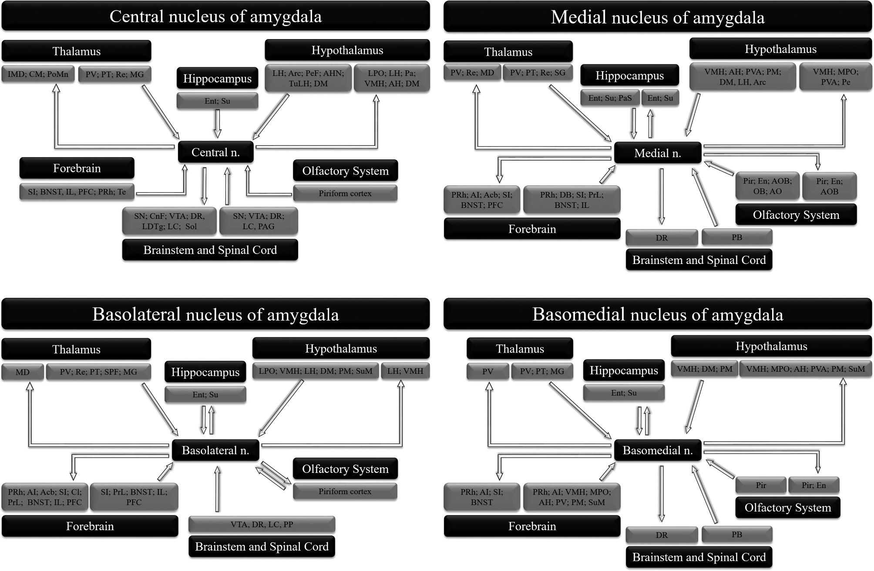

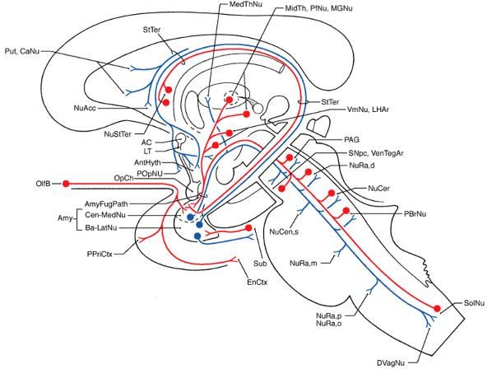

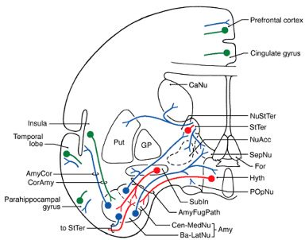

AC – Anterior commissure
Amy – Amygdaloid nuclear complex
AmyCor – Amygdalocortical fibers
AmyFugPath – Amygdalofugal pathway
AntHyth – Anterior hypothalamus
Ba-LatNu – Basal and lateral nuclei
CaNu – Caudate nucleus
Cen-MedNu – Central, cortical and medial nuclei
CorAmy – Corticoamygdaloid fibers
DVagNu – Dorsal motor vagal nucleus
EnCtx – Entorhinal cortex
For – Fornix
GP – Globus pallidus
Hyth – Hypothalamus
LT – Lamina terminalis
LHAr – Lateral hypothalamic area
MedThNu – Medial thalamic nuclei
MGNu – Medial geniculate nucleus
MidTh – Midline thalamic nuclei
NuAcc – Nucleus accumbens
NuCen, s – Nucleus centralis, superior
NuCer – Nucleus ceruleus
NuRa, d – Nucleus raphe, dorsalis
NuRa, m – Nucleus raphe, magnus
NuRa, o – Nucleus raphe, obscurus
NuRa, p – Nucleus raphe, pallidus
NuStTer – Nucleus of the stria terminalis
OlfB – Olfactory bulb
OpCh – Optic chiasm
PAG – Periaqueductal (central) gray
PBrNu – Parabrachial nuclei
PfNu – Parafascicular nucleus
Pi – Pineal
POpNu – Preoptic nucleus
PPriCtx – Prepiriform cortex
Put – Putamen
SepNu – Septal nuclei
SNpc – Substantia nigra, pars compacta
SolNu – Solitary nucleus
StTer – Stria terminalis
Sub – Subiculum
Subln – Substantia innominata
VenTegAr – Ventral tegmental area
VmNu – Ventromedial hypothalamic nucleus

Function
- amygdala plays a critical role in processing threatening stimuli and mediating autonomic, neuroendocrine, and behavioral responses that enable an organism to adapt to social and environmental challenges.

Lesions
Etiology of lesions:
- trauma to temporal lobes
- herpes simplex encephalitis
- bilateral temporal lobe epileptic surgery
- CNS degenerative disorders (e.g. Alzheimer disease, Pick disease).

Clinically - behavioral changes - Klüver-Bucy syndrome:
- visual, tactile, and auditory agnosia → hypermetamorphosis (intense desire to explore immediate environment) → hyperorality
- hyperphagia or other dietary manifestations
- placidity
- hypersexuality (in form of comments, suggestions, and attempts to make sexual contact (e.g. touching) rather than in actual intercourse or masturbation).

Bibliography for ch. “Limbic System” → follow this link >>

Viktor’s Notes℠ for the Neurosurgery Resident
Please visit website at www.NeurosurgeryResident.net

