Sensory Receptors
Last updated: April 20, 2019

Sensory receptors - transducers that convert various forms of energy in environment into action potentials in neurons.
- sensory receptors may be:
  - neurons (distal tip of peripheral axon of sensory neuron) – e.g. in skin receptors.
  - specialized cells (that release neurotransmitter and generate action potentials in neurons) – e.g. in complex sense organs (vision, hearing, equilibrium, taste).
- sensory receptor is often associated with nonneural cells that surround it, forming sense organ.
- to stimulate receptor, stimulus must first pass through intervening tissues (stimulus accession).
- each receptor is adapted to respond to one particular form of energy at much lower threshold than other receptors respond to this form of energy.
- adequate (s. appropriate) stimulus - form of energy to which receptor is most sensitive; receptors also can respond to other energy forms, but at much higher thresholds (e.g. adequate stimulus for eye is light; eyeball rubbing will stimulate rods and cones to produce light sensation, but threshold is much higher than in skin pressure receptors).
- when information about stimulus reaches CNS, it produces:
  - reflex response
  - conscious sensation
  - behavior alteration

Sensory Modalities
Sensory Modality | Receptor | Sense Organ
Conscious Sensations
Vision | Rods & cones | Eye
Hearing | Hair cells | Ear (organ of Corti)
Smell | Olfactory neurons | Olfactory mucous membrane
Taste | Taste receptor cells | Taste bud
Rotational acceleration | Hair cells | Ear (semicircular canals)
Linear acceleration | Hair cells | Ear (utricle, saccule)
Touch-pressure | Nerve endings | Various
Warmth | Nerve endings | Various
Cold | Nerve endings | Various
Pain | Naked nerve endings
Joint position & movement | Nerve endings | Various
Unconscious Sensations
Muscle length | Nerve endings | Muscle spindle
Muscle tension | Nerve endings | Golgi tendon organ
Arterial blood pressure | Nerve endings | Stretch receptors (carotid sinus, aortic arch)
Central venous pressure | Nerve endings | Stretch receptors (walls of great veins, atria)
Lung inflation | Nerve endings | Stretch receptors (lung parenchyma)
Blood temperature in head | Neurons | Hypothalamus
Arterial P_{O2} | Glomus cells | Carotid and aortic bodies
pH of CSF | Receptors | Ventral surface of medulla oblongata
Plasma osmotic pressure | Cells | Organum vasculosum of lamina terminalis
A-V glucose difference | Cells | Hypothalamus (glucostat)

N.B. listing is arbitrary (e.g. there are different cones for each of three primary colors; there are four different modalities of taste and each is subserved by distinct type of receptor; sounds of different pitches are heard because different groups of hair cells are activated maximally by sound waves of different frequencies).
- in elementary school we learn that there are "five senses".
- future research will undoubtedly add to list of "unconscious senses".

Classifications of Sense Organs
According to stimulus source:
- Exteroceptors - concerned with external environment.
  - teleceptors ("distance receivers") - concerned with external events at distance (e.g. light, sound).
- Interoceptors (s. enteroceptors) - concerned with internal environment (e.g. chemoreceptors, baroreceptors, proprioceptors).

According to stimulus energy:
- Mechanoreceptors (e.g. skin deformation, pressure, sound).
- Photoreceptors
- Thermoreceptors
- Chemoreceptors - receptors that are stimulated by chemical environment composition (e.g. taste, smell, level of O₂, pH, osmolality).
- Nociceptors - pain receptors.

skin receptors HAtlas-359
- cutaneous senses for which separate receptors exist:
- touch (pressure is sustained touch, vibration is rhythmic pressures) – via Aβ fibers
pallesthesia – sensation of vibration
- cold (i.e. temperatures below body temperature) – via Aδ fibers
- warmth (i.e. temperatures above body temperature) – via C fibers
- pain – via Aδ and C fibers
- itch – via C fibers
- touch sense is conveyed via large myelinated axons (Aβ);
other senses – via small myelinated (Aδ) and unmyelinated (C) axons.
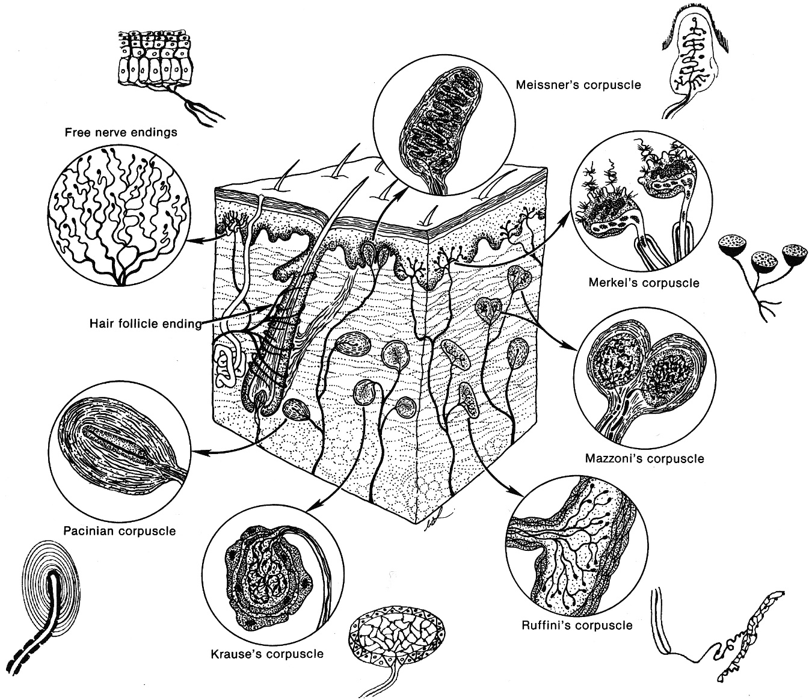

A. naked (s. free) endings – pain, temperature, itch & tickle.
- terminal nerve filaments ending freely in tissue (epithelia, connective tissue).
- there are discrete cold-sensitive and warmth-sensitive receptors (šalčio receptorių yra 4-10 kartų daugiau).
- at < 20 °C and > 40 °C, there is no adaptation, but at 20-40 °C there is adaptation (sensation produced by temperature change gradually fades to one of thermal neutrality).
i.e. jei priglausto daikto t-ra didesnė negu odos, trumpam padidėja šilumos receptorių firing rate ir sumažėja šalčio receptorių firing rate - tai suvokiame kaip šilumą; jei priglausto daikto t-ra < odos t-ra, viskas vyksta priešingai → šalčio pojūtis.
- at > 45 °C, tissue damage begins to occur, and sensation becomes one of pain (paradoksiškai sužadinami ir šalčio receptoriai – todėl kartu jaučiama ir šaltis, ir skausmas).
- capsaicin receptors may mediate warmth responses in 43-50 °C range.

B. expanded endings on sensory nerve terminals - slowly adapting touch receptors:
Merkel disk (s. tactile meniscus) – (stimulus location) - terminal cuplike expansion of intraepidermal axon in contact with base of single modified keratinocyte (Merkel cell).
- Merkel cell acts as transducer and makes synapse with nerve ending.
- receptive field is small with distinct borders (only skin region lying just above receptor) – ideal for stimulus location determination.

Ruffini corpuscle – (stimulus magnitude & duration – i.e. pressure) - ovoid capsule within which sensory fiber ends with numerous collateral knobs.
- present in finger subcutis.
- receptive field is large with obscure borders.
- responds to planar skin stretch – participation in proprioception.

C. encapsulated endings – have connective tissue capsule.
Meissner corpuscle (s. tactile corpuscle) – rapidly adapting touch receptors (speed of stimulus application) – oval connective tissue capsule in which axon fibrils terminate around and between pile of wedge-shaped epithelioid cells.
- found in dermal papillae (esp. fingers & toes) – sense texture of objects, vibration.
- receptive field is small with distinct border (only skin region lying just above receptor).
- frequency of receptor discharge is proportional to speed of stimulus application.

Pacinian corpuscle (s. lamellated corpuscle) – very rapidly adapting touch receptors (vibration) – oval concentric layers of connective tissue (“minute cocktail onion”) with soft core in which axon splits into number of fibrils (that terminate in bulbous enlargements).
- found in skin, deep dermis, tendons, joint capsules, internal organs (function here is not known).
- receptive field is large with obscure borders.
- frequency of receptor discharge is proportional to vibration frequency.

Krause end-bulb (s. bulboid corpuscle) – cold – laminated capsule connective tissue enclosing branched, convoluted ending.

Mazzoni corpuscle – tactile corpuscle apparently identical with Krause end bulb.

N.B. none of expanded / encapsulated endings are necessary for cutaneous sensation – all four cutaneous sensory modalities can be elicited from areas that contain only naked nerve endings!

- any given ending signals one and only one kind of cutaneous sensation.
- increase in stimulation intensity has very little (if any) effect on quality of sensation produced.
- punctate representation - sensations are evoked only from spots overlying touch receptors (none is evoked from intervening areas).
- touch receptors are most numerous in fingers & lips and relatively scarce in trunk.
- many receptors end around hair follicles - when hair is moved, it acts as lever (with its fulcrum at follicle edge) - slight movements of hairs are magnified into relatively potent stimuli (e.g. stiff vibrissae on animal snout are highly developed hairs that act as levers to magnify tactile stimuli).

Touch
Discriminative touch (two-point discrimination, touch localization, kinesthesia, stereognosis, graphesthesia) – Meissner corpuscles, Pacinian corpuscles.
Crude touch – Meissner corpuscles, Merkel disk.
- distal sites have lower thresholds than proximal ones.
- in decreasing order of sensitivity: thumbs, palms, plantar surface of foot, proximal arm.

Vibration
< 40 Hz – Meissner corpuscles
> 40 Hz – Pacinian corpuscles
- threshold for vibratory perception is lower in arms than in legs (distal sites more sensitive than proximal ones).
- order of most sensitive to least sensitive areas:
  - palm
  - pad of finger
  - dorsum of finger
  - dorsum of hand
  - dorsum of great toe
  - sternum and malleolus
  - lip, tongue, forehead, mastoid, and patella
  - forearm
  - sacrum.

Proprioception
- information about body position (postural, positional, kinetic) in space at any given instant; provided by receptors in muscles, tendons, joints, and skin.
N.B. conscious proprioception ("body image") is actually synthesized from information coming not only from proprioceptors but also from cutaneous touch and pressure receptors.
- three elements of proprioception:
  - perception of limb movement ← muscle spindle receptors, joint receptors, cutaneous mechanoreceptors*;
  - perception of limb position ← muscle spindle receptors and cutaneous mechanoreceptors*;
  - perception of force of muscular contraction ← corollary discharges and tendon organ receptors.
*Ruffini corpuscles - respond to planar stretch of skin

Itch & Tickle
- can be produced:
  - relatively mild mechanical stimulation (esp. something that moves across skin).
  - chemical agents – histamine, kinins, bile salts.
- seniau buvo manoma, kad niežulį sukelia silpnas nociceptorių dirginimas; dabar įrodyta atskiros sistemos egzistavimas.
- occurs only in skin, eyes, and certain mucous membranes (not in deep tissues or viscera!).
- conducted through C fiber system & spinothalamic tracts.
- scratching relieves itching (it activates large, fast-conducting afferents that gate transmission in dorsal horn in manner analogous to inhibition of pain).
- tickling sensation is pleasurable, itching is annoying, pain is unpleasant.

Generator (receptor) potentials
Studied in detail in Pacinian corpuscles (straight, unmyelinated nerve terminal; myelin begins inside corpuscle - first node of Ranvier is also located inside, whereas second is near point at which nerve fiber leaves corpuscle):
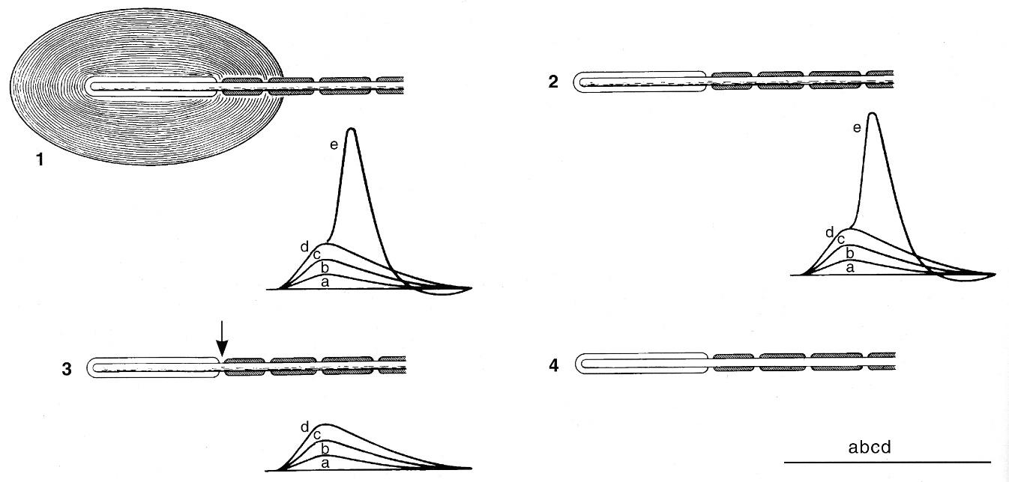
1 - when small pressure is applied, nonpropagated depolarizing potential (resembling excitatory postsynaptic potential [EPSP]) is recorded (in transducer region*) - generator (receptor) potential; as pressure is increased, generator potential increases; when generator potential is ≈ 10 mV, action potential is generated in spike generator region* of sensory nerve; as pressure is further increased, generator potential becomes even larger and nerve fires repetitively.
*generator potential spreads passively from transducer region to spike generator region; in some organs, transducer and spike generation functions are served by different cells.
2 - removal of connective tissue lamellas does not abolish generator potential (responses are prolonged due to partial loss of adaptation).
3 - if first node of Ranvier is blocked (by pressure or narcotics), generator potential is unaffected but action potential do not occur.
4 – if sensory nerve is sectioned and is allowed to degenerate, no generator potential is formed (i.e. all responses disappear).

- generator potential is produced in unmyelinated nerve terminal.
- receptor converts mechanical energy into electrical response (generator potential magnitude proportionate to stimulus intensity).
- if generator potential is great enough, neuron fires again as soon as it repolarizes (action potential frequency proportionate to stimulus intensity).

IONIC BASIS OF EXCITATION
- pacinian corpuscles, hair cells (hearing and balance): mechanical distortion opens epithelial sodium channels (ENaC) in receptor membrane → Na⁺ influx produces generator potential; number of channels opened is proportionate to stimulus intensity.
- rods and cones: responses depend on heterotrimeric G proteins and cyclic nucleotides.

Adaptation (s. desensitization) - when maintained stimulus of constant strength is applied to receptor, frequency of action potentials declines over time.
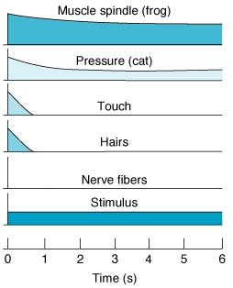 | Adaptation degree varies with type of sense organ:  - rapidly adapting receptors (phasic / dynamic receptors), e.g. pacinian corpuscles (mechanism - lateral displacement of connective tissue lamellas, lessening pressure on nerve ending).  - very slowly and incompletely adapting receptors (tonic / static receptors) - generator potential decays very slowly; e.g.:  - carotid sinus and aortic receptors (continuous regulation of BP)  - muscle spindles (prolonged postural adjustments)  - organs for cold, pain (warning value for noxious stimuli)  - lung inflation receptors
curve height in each case indicates discharge frequency in nerve fibers at various times after beginning sustained stimulation.
- functions of adaptation:
  - encoding information about rate of stimulus application (e.g. too slow stimulus application, action potential never produced due to adaptation).
  - decreasing amount of information reaching brain.
- adaptation mechanisms:
    - transducer fails to maintain generator potential
    - spike generator fails to sustain train of action potentials

“CODING" OF SENSORY INFORMATION
N.B. action potentials are similar in all nerves! – how sensations are discriminated in modality, intensity, location?
Stimulus modality / quality coding - doctrine of Specific Nerve Energies (Müller, 1835)
- sensation modality / quality evoked by impulses depends upon specific part of brain they ultimately activate; i.e. sensation evoked is that for which receptor is specialized no matter how or where along pathway activity is initiated.
e.g. if sensory nerve from pacinian corpuscle in hand is stimulated by pressure at elbow or by irritation from tumor in brachial plexus or if electrode is inserted into appropriate fibers of dorsal columns of spinal cord, thalamus, or postcentral gyrus, sensation produced would be touch.
- more complex mechanisms also exist:
  - temporal pattern coding (e.g. cutaneous cold receptors indicate temperatures below and above 30°C by firing with or without bursts, respectively).
  - spatial pattern coding (e.g. three neurons may be required to encode different tastes: all three neurons activated – sour taste, only two neurons fire – salty taste).
  - feature detectors – brain neurons that integrate information from variety of sensory fibers (e.g. to perceive 3D depth of object, information from both eyes must be integrated).

Stimulus location coding - law of Projection
- no matter where particular sensory pathway is stimulated along its course to cortex, conscious sensation location is referred to location of receptor.
e.g. neurosurgical procedures on conscious patients - when cortical receiving area for impulses from left hand is stimulated, patient reports sensation in left hand, not in head.
e.g. amputees may complain, often bitterly, of pain and proprioceptive sensations in absent limb (phantom limb) – neuromas may discharge spontaneously or when pressure is put on them.

Stimulus intensity coding - Intensity Discrimination
- variation in frequency of action potentials generated by given receptor.
- variation in number of receptors activated.
The same proportionality exists between:
stimulus intensity - generator potential size – firing frequency – consciously perceived intensity.
- old concept - sensation magnitude is proportionate to log of stimulus intensity (Weber-Fechner law):  V = k × log I / I_{o} | V – generator potential size and sensation felt  k, a – constants for any specific sensory modality  I – stimulus intensity  I_{o} – threshold
- modern concept - power function more accurately describes this relation (Steven power law):
V = k × (I – I_{o})ª

- in CNS, relation between stimulus and sensation is linear (i.e. for any given sensory modality, relation between sensation and stimulus intensity is determined primarily by properties of peripheral receptors themselves).

“Sensory Unit” - single sensory axon and all its peripheral branches (may be numerous, especially in cutaneous senses).
- receptive field - area served by sensory unit (e.g. in cornea ≈ 50-200 μm²).
- smaller receptive field, more precise stimulus localization.
- generally, receptive fields interdigitate.
- recruitment of sensory units:
  - as stimulus strength is increased, it tends to spread over large area and generally not only activates sense organs immediately in contact with it but also "recruits" those in surrounding area (more units are activated).
  - weak stimuli activate receptors with lowest thresholds, whereas stronger stimuli also activate those with higher thresholds (impulse frequency↑ in unit).
- lateral inhibition – helps to localize stimuli more precisely:  Two stimuli are applied to skin; sensory task is to discriminate – one or two stimuli are present?  A (without lateral inhibition) – two stimuli are recognized as separate only if they are separated by nonstimulated receptive field; if stimuli are closer they are interpreted as one large stimulus.  B (with lateral inhibition) – neuron in central field is presynaptically inhibited by collaterals from neuron with receptive fields located laterally → central field neuron does not fire (i.e. improved two-point threshold). | 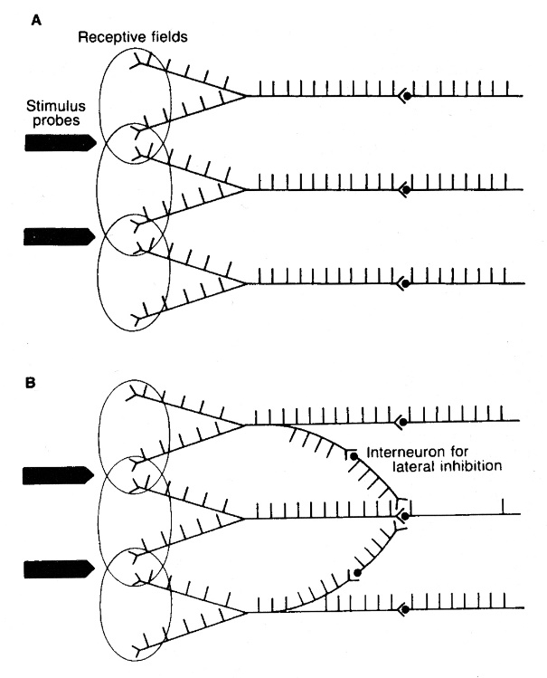

Bibliography for ch. “Sensory Receptors” → follow this link >>
Ganong “Review of Medical Physiology”, 2002
NMS Physiology 2001
Goetz “Textbook of Clinical Neurology”, 1st ed., 1999 (315-331 p.)

Viktor’s Notes℠ for the Neurosurgery Resident
Please visit website at www.NeurosurgeryResident.net

