Embryogenesis of CNS blood vessels

Last updated: October 6, 2023

CNS kraujagyslės vystosi iš *neural tube supančios mezenchimos*;

* *pradžioje* tai *random network of coalescing channels*.
* *vėliau* dalis kanalų nyksta, dalis vystosi toliau – išryškėja viena stambi išilginė arterija, einanti per visą neuraxis ilgį – **ventral median artery** (this artery splits and reunites rostrally).

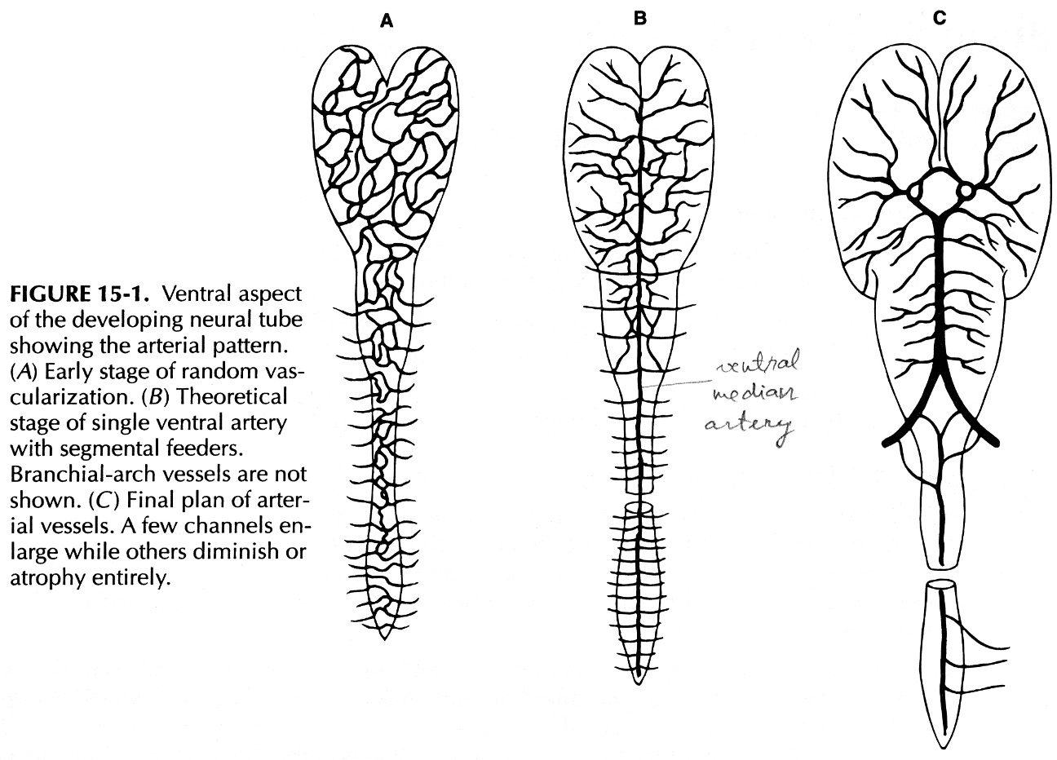

Ventral median artery **receives blood**:

1. at **spinal levels** – from *somite arteries* (branch regularly from aorta)
2. at **cerebral level** – from *carotid and vertebral arteries*; brain stem šiek tiek mitybos gauna ir iš *branchial arches arterijų* (per kranialinių nervų kamienus).

Ventral median artery **branches**:

1. **Paramedian arteries** – atsišakoja stačiu kampu ir iš karto perforuoja neural tube.
2. **Circumferential arteries** (circumnavigate neuraxis and send perforating branches):
   1. short circumferential arteries
   2. long circumferential arteries – gaubia cerebral & cerebellar hemispheres dar prieš pasibaigiant fissuration (t.y. dar neprasidėjus sulcation) – vystantis žievės paviršiui, arteries follow contour of cortical surface.

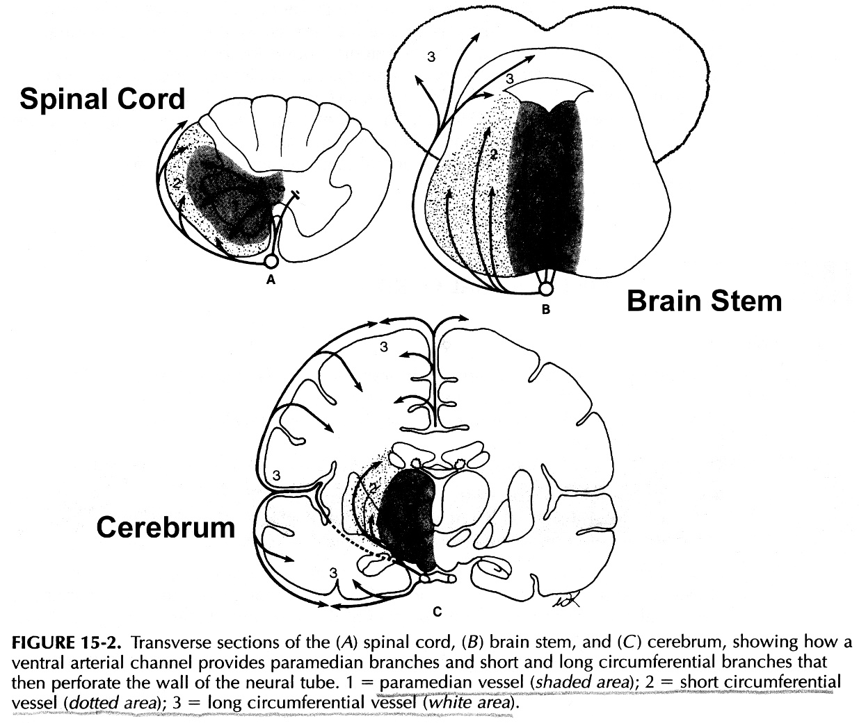

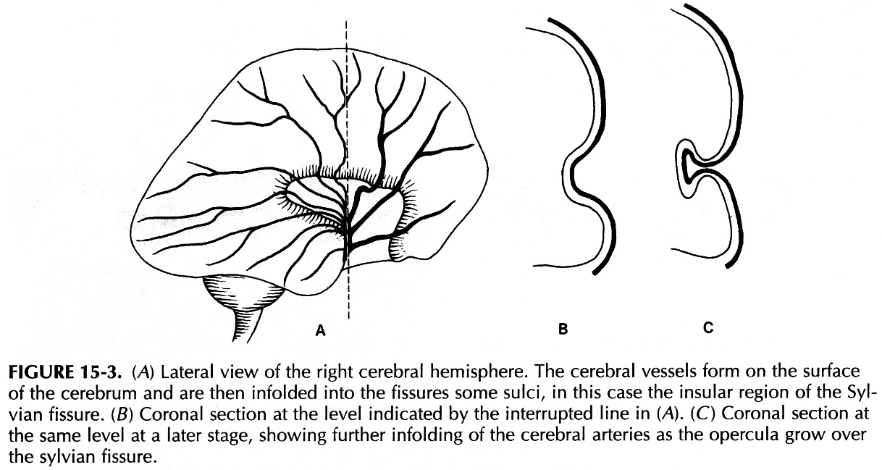

Anatomical Variants

Fenestration

(differs from duplication!) - persistent segment of embryonic intersegmental arteries (hypoglossal or proatlantal).

* usually asymptomatic.
* most fenestrations (>70%) are extracranial and occur at C1-C2 level.

Hypoglossal nerve traversing fenestrated right vertebral artery, just proximal to vertebrobasilar junction:



Anomalous Origins

PICA – see [p. A205 >>](http://www.neurosurgeryresident.net/A.%20Neuroscience%20Basics\A201-211.%20Vascular\A205.%2520Blood%2520Supply%2520of%2520BRAIN%2520(arteries).pdf#PICA)

Bibliography for ch. “Vascular” → follow this [link >>](http://www.neurosurgeryresident.net/Vas.%20Vascular\Vas.%20Bibliography.pdf)

[Viktor’s Notes℠ for the Neurosurgery Resident](http://www.neurosurgeryresident.net/)

[Please visit website at www.NeurosurgeryResident.net](http://www.neurosurgeryresident.net)