Cerebrovascular PHYSIOLOGY
Last updated: October 6, 2023

CNS metabolic demands 1
Cerebral blood flow (CBF) 1
Factor that regulates regional CBF 2
Factors that regulate total CBF 2

- CNS has 400 miles of vasculature associated with BBB (overall exchange surface area ≥ 12 m²).

CNS metabolic demands
Nors smegenys sudaro tik 2% kūno svorio (≈ 1400-1500 g) ir neatlieka jokio mechaninio darbo, bet elektrofiziologiniam aktyvumui palaikyti tenka didelės sąnaudos:
- gauna 14-20% cardiac output (i.e. 700-1000 ml/min);
  - kidney – 420 ml /100 g /min
  - myocardium – 84 ml /100 g /min
  - liver – 58 ml /100 g /min
  - brain – 53 (50-60) ml /100 g /min.
- sunaudoja 18-20% viso deguonies (in resting state):
O₂ consumption – 46-49 ml/min (3.0-3.8 ml or 156-160 μmol/100 g/min; ≈ 72 L/d);
a-vO₂ difference – 62 ml/L (myocardium – 114 ml/L).

- smegenys išekstrahuoja iš pratekančio kraujo: ≈ 50% O₂ ir tik ≈ 10% gliukozės (i.e. ratio 5 : 1).
N.B. brain is highly aerobic tissue, with oxygen rather than metabolic substrate serving as limiting substance!
N.B. with focal cortical activity, local CBF increases ≈ 30% while O₂ consumption increases only 5% (luxurious oxygen supply) – venous blood has more oxygen = foundation of fMRI.
- brain uses glucose as exclusive fuel (badaujant prisitaiko naudoti ir ketone bodies) ≈ 5.5 mg or 30-33 μmol glucose/100 g/min (150 g glucose/d) – patenkina ≈ 90% smegenų energijos poreikio.
Aerobic glucose metabolism – main source of energy.
N.B. insulin is not required for CNS!
N.B. smegenys tik 70-80% gliukozės oksiduoja energijos gavybai; 10-15% gliukozės metabolizuojama į laktatą (ir grįžta atgal į kraują); likę 5-20% panaudojama įvairių medžiagų (pvz. neurotransmiterių) sintezei – todėl iš 1 molio gliukozės gaunama 30 mol (o ne 38) ATP.
  - glucose uptake from blood mechanizmo pajėgumas normoje viršija smegenų gliukozės poreikį 2-3 kartus; tačiau glucose uptake mechanizmo pajėgumas labai priklauso nuo blood [glucose] (e.g. hypoglycemic coma).

- ammonia (very toxic to neurons – e.g. hepatic coma) removal from brain:
glutamate uptake from blood → coupling with ammonia → glutamine secretion into blood.

Cerebral blood flow (CBF)
In normal, conscious* human CBF ≈ 53 (50-60) ml /100 g /min
(grey matter ≈ 69-75, white matter ≈ 25-30)
*i.e. it is relative (e.g. it is lower during anesthesia, higher in epileptic cortex)
- normal blood volume is 3-4 ml/100 g of brain tissue.
- smegenys praktiškai neturi „degalų“ atsargų - turi pastoviai gauti O₂ ir gliukozę (brain relies on sizable and well-regulated blood flow to satisfy its immediate needs for energy).
- nutrūkus kraujotakai, sąmonės netenkama po 8-10 sekundžių, neuronai žūti pradeda jau po 5 minučių! glikogeno atsargos (≈ 1.6 mg/g) sunaudojamos per 2 minutes
N.B. vegetative centers in brainstem are more resistant to hypoxia / hypoglycemia than cerebral cortex – patients may recover from prolonged hypoxia / hypoglycemia with normal vegetative functions but severe intellectual deficiencies!

CBF in ischemia with clinical correlates → see p. Vas3 >>

Factor that regulates regional CBF
- synaptic activity:
- nors smegenys pasiima tik ¹/₂ patiekiamo O₂ ir tik ¹/₁₀ patiekiamos gliukozės, tačiau tai pačių smegenų uptake mechanizmo galimybių riba – norint paimti daugiau, reikia didinti patiekiamus kiekius (i.e. blood vascular reserves for both O₂ and glucose are small) – bet koks sinaptinio (metabolinio) aktyvumo pokytis keičia to regiono blood flow (coupling of CBF to regional synaptic / metabolic activity), bet nekeičia oxygen extraction;
  - all changes of synaptic activity (thinking, talking, directing muscular activity, etc) are tightly coupled, both temporally and anatomically, to almost instantaneous, proportional change in regional CBF → ever-changing mosaic of regional metabolic/blood flow values that reflect moment-to-moment changes in electrophysiologic activity – this allows exploration of functional networks working in synchrony even in resting state (resting state fMRI).
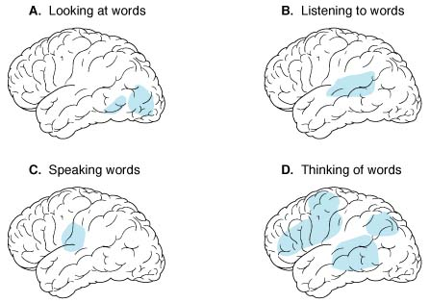
  - in awake subject at rest, blood flow is greatest in premotor and frontal regions.
  - in anticipation of cognitive task, brain areas that will be activated during task are activated beforehand, as if brain produces internal model of expected task.

Factors that regulate total CBF
N.B. total blood flow does not depend on (regional) brain function!
- Metabolic regulation
  - PaCO₂ – most potent regulator!
- linear relationship with PaCO₂ values 20-80 mmHg:
PaCO₂↓ 1 mmHg → diameter of cerebral vessels↓ 2-3% → CBF↓ ≈ 1.1 ml/100 g/min.
- used clinically (via controlled hyperventilation) to treat intracranial hypertension. see p. S50 >>
  - cerebral vessels also respond to PaO₂, H⁺ ions: PaO₂↓ or [H⁺]↑ → vasodilatation.

- Cerebral perfusion pressure (CPP) - pressure gradient across brain:
CPP = mean arterial pressure - mean venous pressure = mean arterial pressure - mean ICP*
*ICP is transmitted to compliant cerebral veins;
CSF pressure ≈ mean ICP ≥ venous pressure (any change in venous pressure promptly causes similar change in ICP)
- during Valsalva or downward acceleration, increase of arterial pressure at head level is compensated by increase of venous pressure* at head level and ICP↑**.
*maintains unchanged CPP
**protects intracranial vessels form rupture
- to calculate actual CPP both MAP and ICP need to be zero-calibrated to the same level; it is common practice to calibrate blood pressure to the right atrium and ICP to the level of the foramen of Monro (ear tragus as external landmark) - this introduces substantial difference, dependent on the size of patient and the degree of head of bed elevation.

Pressure autoregulation - brain arterioles maintain relatively constant CBF over range of systemic blood pressures;
- CBF remains constant when CPP is 50-160 mmHg (outside this range, CBF varies linearly with MAP):

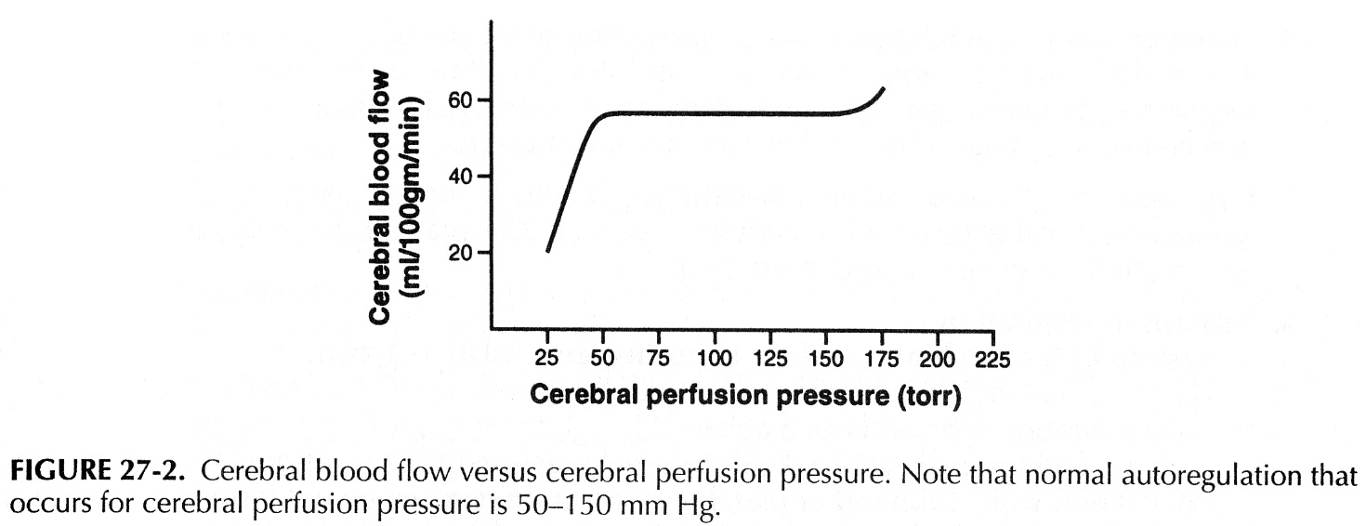

- MAP > 150 mmHg → autoregulation is lost (vasoparalysis with massive dilatation) → CBF↑, capillary pressure↑ (→ brain edema, hypertensive encephalopathy, intracerebral hemorrhage).
- CPP < 40 mmHg (MAP < 50 mmHg) (due to ICP↑* or systemic hypotension) → autoregulation is lost → CBF declines → ischemia.
*repeated ICP↑ per se may damage autoregulation – increasing MAP won’t help restore CPP
- in patients with chronic hypertension, graph is shifted to right (illustrates risk of rapid hypertension correction to apparently normal levels!) – possibly by sympathetic vasoconstrictive discharge on cerebral arteries; chronic antihypertensive treatment (esp. with vasodilators – ACE inhibitors, hydralazine) readjusts autoregulatory curve:
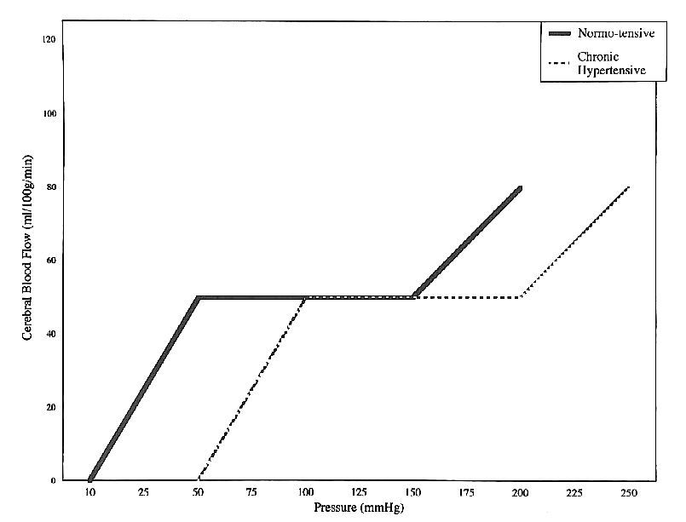
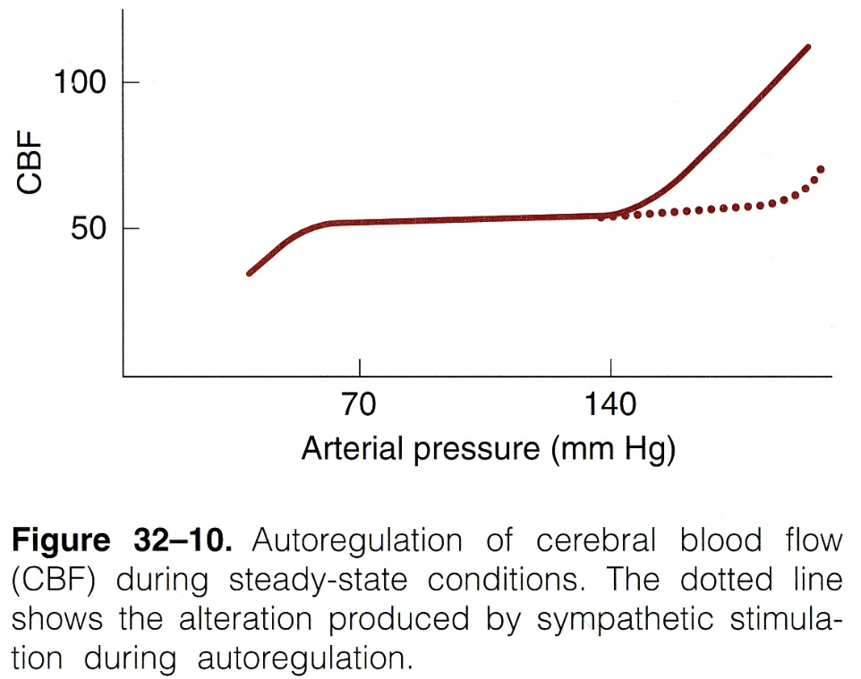

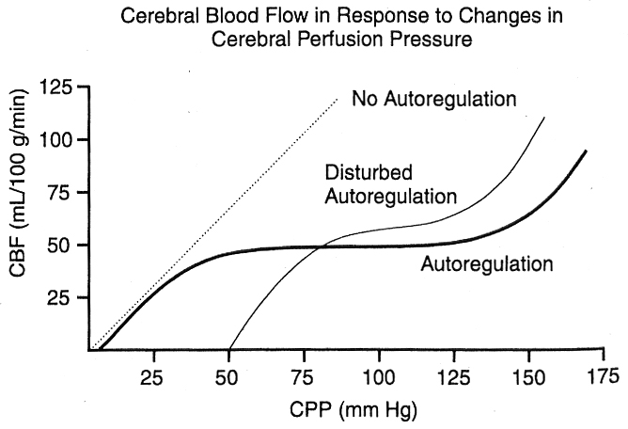

- most likely autoregulation mechanism - intrinsic sensitivity of vascular smooth muscle cells to tension across vessel wall (but some authors believe that myogenic mechanism serves only in dampening of arterial pulsations).
- it is unlikely that innervation (cholinergic-, noradrenergic-, neuropeptide) to vasculature contributes significantly to autoregulation (although certainly contributes to CBF).

- Cushing reflex – systemic hypertension (in response to medullary hypoxia due to ICP↑) – maintains CPP.

Bibliography for ch. “Vascular” → follow this link >>

Viktor’s Notes℠ for the Neurosurgery Resident
Please visit website at www.NeurosurgeryResident.net

