Meninges
Last updated: April 20, 2019

Arachnoid
Liliequist membrane
- arachnoid membrane.
- attachments: from diaphragma sellae to anterior edge of mammillary body and laterally attached to CN III.
- separates three cisterns:
- chiasmatic cistern – LM forms floor for this cistern
- perimesencephalic (interpeduncular) cistern – LM forms “curtain” for this cistern
- prepontine cistern – LM forms roof for this cistern
- LM separates supratentorial and infratentorial CSF compartments.
- very thin - not routinely visualized in imaging studies (can be visualized on MRI CISS heavily T2 weighted 3D sequences).
- described by Key and Retzius in 1875, but rediscovered by Liliequist in 1956 in his pneumoencephalographic studies of cadavers.

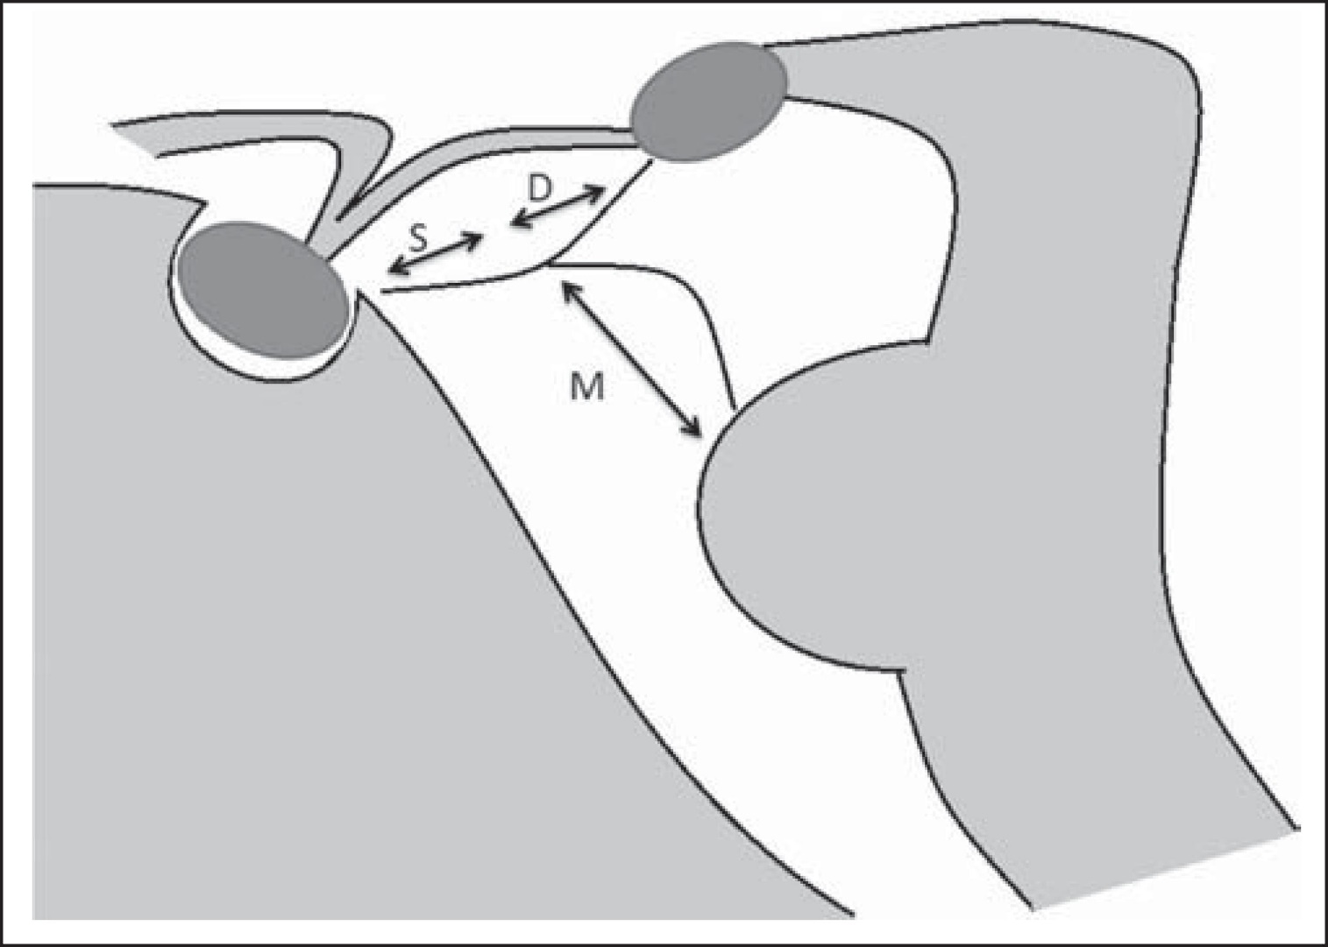
D - diencephalic segment, M - mesencephalic segment, S - sellar segment.

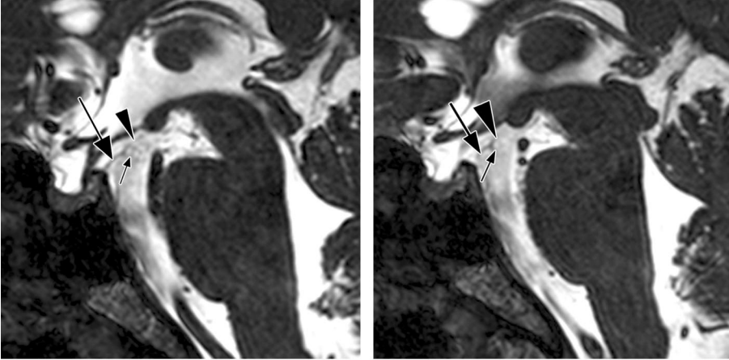

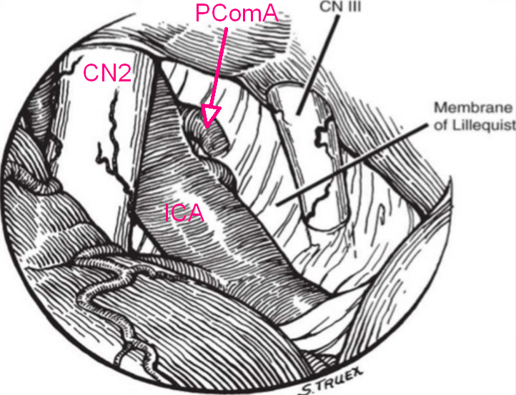

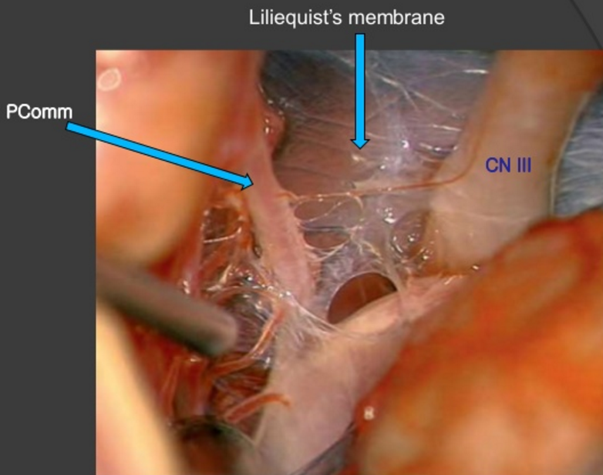

Bibliography for ch. “Neuroscience Basics” → follow this link >>

Viktor’s Notes℠ for the Neurosurgery Resident
Please visit website at www.NeurosurgeryResident.net

