Blood-brain barrier (BBB)
Last updated: September 5, 2017
blood-nerve fiber barrier – see p. A14 (2)

BBB – selective mechanism (functional & morphological barrier) that restricts free passage of all but few lipid-soluble materials from circulation to CNS parenchyma → constant (within narrow limit) microenvironment of brain tissue.
  - anilino dažai i/v nudažo visus organizmo audinius, išskyrus CNS – BBB darbas.
  - water, O₂, CO₂, gliukozė*, kai kurios amino r., lipofilinės medžiagos – laisvai praeina BBB.
*highly polar molecule – enters via facilitated diffusion (glucose transporter GLUT 1); then other transporters (GLUT 3, GLUT 5 distribute glucose to neurons and glia)
  - dauguma jonų, didelės masės molekulės nepraeina pasyviai BBB – reikalingas aktyvus transportas.

- BBB makes neuronal surface privileged site – tik reikiamos medžiagos pasiekia neurono membraną, nesutrikdydamos poliarizacijos.
Pagrindinė BBB funkcija – apsaugoti neurono membranos poliarizaciją
- BBB tiksliau gal būtų vadinti blood-neuronal barrier.
- constant extracellular ionic & molecular composition is more important for normal function of brain than for any other organ!
- small changes in extracellular concentrations of, for example, Na⁺ or neurotransmitters (glutamate, norepinephrine) greatly alter neuronal function.
- BBB is unidirectional; movement of substances from brain to blood is almost unrestricted (due to bulk flow of CSF to venous system).
- BBB is not absolute – in circumventricular organs (neurohypophysis, area postrema, etc) BBB is less effective. see p. A118 (2-3)

Anatomical structures of BBB
    - Dauguma šaltinių teigia – BBB resides in vascular endothelium – unique endothelial cells (in neural capillary):
      - overlapping (nonfenestrated)
      - very tight junctions
      - very few pinocytotic vesicles (little bulk flow)
        - panašūs kapiliarai randami – retina, iris, inner ear, endoneurium.

Kitos galimai svarbios struktūros:
    - Basement membrane of capillary.
    - Astrocytic end feet – form continuous covering (although 20 nm gaps may be present) of external capillary wall; taip pat glaudžiai supa neuronų kūnus (ypač izoliuoja sinapses), smegenų paviršių; astrocytic cytoplasm forms functional “extracellular” space in CNS.
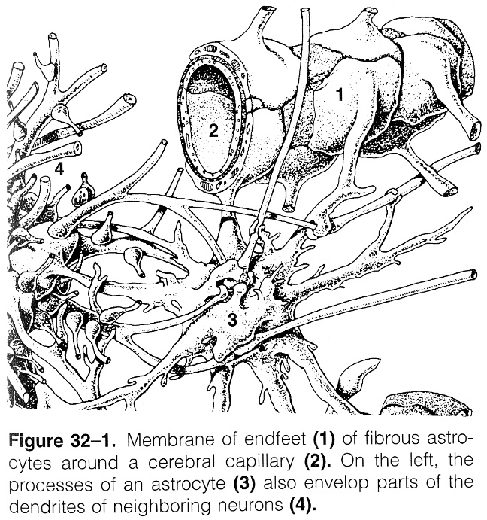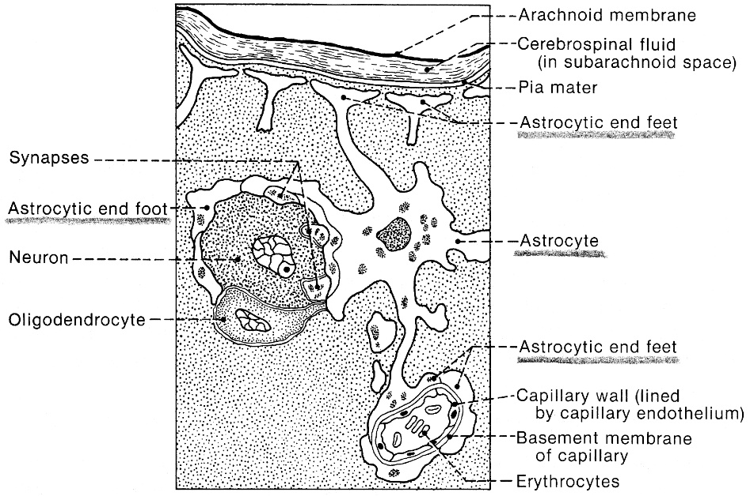

    - Perineuronal satellite cells (astrocytes, microglia, oligodendrocytes).
    - Surface covering of neuronal membrane (glycoprotein, sialic acid, etc) – final censor!

Blood-CSF barrier – resides in choroidal epithelium (tight junctions); features similar to BBB.

Under pathologic conditions
- BBB breaks down → sequelae:
          - neuronal intoxication (neuronal discharge inhibited or excited).
          - vasogenic cerebral edema (plasma leakage directly into CNS tissue).
          - IV contrast nudažo audinį.
          - drugs may reach CNS tissue (e.g. antibiotics, neuroprotective drugs) – “window of opportunity”.
N.B. when BBB is intact, drug ability to penetrate into brain tissue depends on its lipid solubility (or presence of carrier proteins).

- pathologic conditions that break down BBB: inflammation, trauma.
- neovessels of brain tumors have no BBB (capillaries are fenestrated, without tight junctions, not surrounded by astrocytic feet).

Bibliography for ch. “General Histology, Myelination, BBB” → follow this link >>

Viktor’s Notes℠ for the Neurosurgery Resident
Please visit website at www.NeurosurgeryResident.net

