Postural Control
Last updated: April 20, 2019

Normal Control 1
Disorders 2
Spinal Transection (pontomedullary dysfunction) 2
Cerebellum destruction 2
Decerebration (diencephalic-midbrain dysfunction) 2
Midbrain animal 4
Decortication 5

Normal Control
see p. Ear17-Ear20 (vestibular system) >>
- maintained static reflexes - sustained contraction of musculature
- dynamic, short-term phasic reflexes - transient movements.

Principal postural reflexes
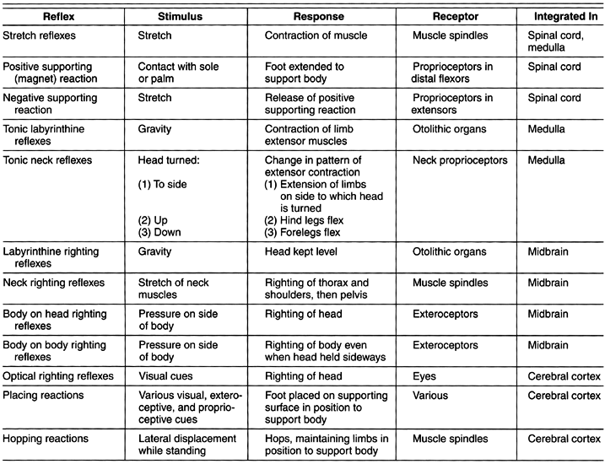

- major factor in postural control and muscle tone is variation in threshold of stretch reflexes:
- changes in general excitability of motor neuron pool
- changes in rate of discharge in γ-neurons.
- brain has areas that facilitate / inhibit stretch reflexes.
- various destructive processes / transections can disconnect these areas from spinal cord → shift in balance of facilitatory and inhibitory impulses.

Disorders
- kuo kaudalesnė decerebracija (plačiąja prasme), tuo labiau sutrikdoma toninė (posturalinė) descendentinė moduliacija į nugaros smegenis.

Spinal Transection (pontomedullary dysfunction)
see p. Spin1 >>
- all spinal reflex responses profoundly depressed, muscles atonic (spinal shock).
- after some time (in humans ≥ 2 weeks), reflex responses return and become relatively hyperactive.
  - Hyperactive withdrawal reflexes - generalization can cause mass reflex.
  - Hyperactive stretch reflexes:
    - if finger is placed on sole of foot (stimulates proprioceptors in distal flexors + tactile receptors), limb extends, following finger as it is withdrawn - magnet reaction (s. positive supporting reaction) - transforms limb into rigid pillar to resist gravity and support animal (spinal cats & dogs can be made to stand, albeit awkwardly, for 2-3 minutes).
    - magnet reaction disappearance is also in part active phenomenon (negative supporting reaction) initiated by stretch of extensors.
- due to locomotion generators in spinal cord, spinal animals can be made to stand, and even to produce walking movements when stimulated in suitable fashion; in humans brain stem generators are more important - spinal locomotion pattern generator has to be turned on by tonic discharge of discrete area in midbrain (mesencephalic locomotor region) - this is only possible in incomplete spinal cord transections.

Cerebellum destruction
- net effect in humans is hypotonia.

Decerebration (diencephalic-midbrain dysfunction)
- transection of midbrain at midcollicular level or at upper pons (i.e. above pontine reticular formation that is excitatory to extensor antigravity muscles):
- surgical, traumatic
- transtentorial herniation
- bloodless (perrišus aa. carotes com. ir a. basilaris ties pons viduriu)
- sunki hipoksija, hipoglikemija
N.B. defects that produce decerebration are usually incompatible with life!

Dingsta aukštesnių centrų kontrolė ir suaktyvėja antigravity system → decerebrate rigidity (individual is in coma!) - marked spasticity of body musculature (static postural reflex - "caricature of normal standing position"):
- jaw clenched
- neck extended, opisthotonus
- rankos prispaustos prie šonų, rotuotos į vidų iš peties, rigidiškai ištiestos per alkūnes*, dilbiai pronuoti, sulenkti riešai ir pirštai.
*žemiau filogenezėje (keturkojams) fiziologinis ekstenzorius yra m. triceps brachii
- kojos rigidiškai ištiestos ir nerotuotos (arba rotuotos į vidų), ryški plantarinė fleksija:
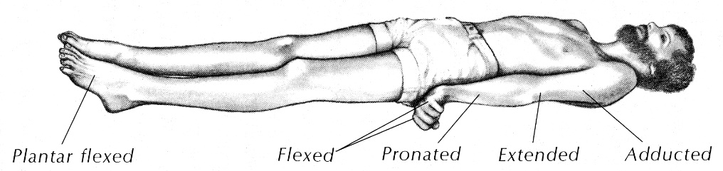
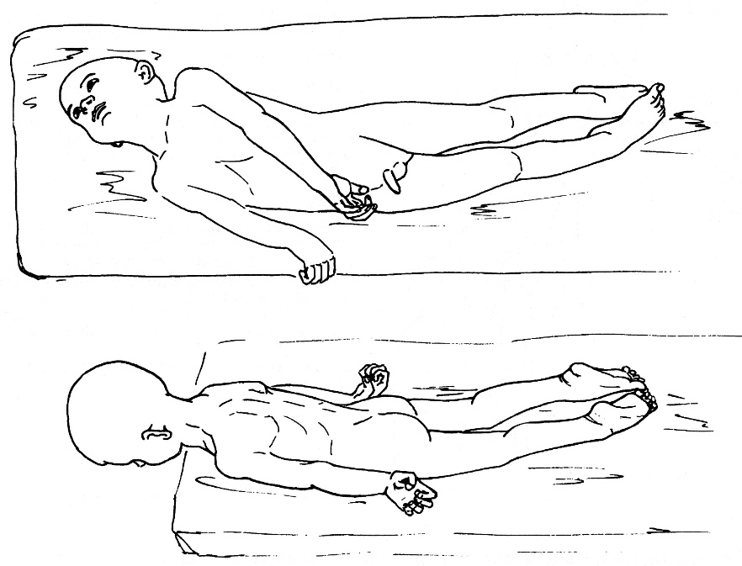
- rigidity develops as soon as brain stem is transected.
- rigidity may be only paroxysmal (often in response to external stimuli) - decerebrate posturing.
- it is reflex activity (diffuse facilitation of stretch reflexes) - driven by:
    - reticulospinal system – via stimulation of γ-motoneurons (more abundant for extensor muscles) – so called gamma rigidity; gamma rigidity disappears if dorsal roots are cut!!!
    - vestibulospinal system – via direct action on α-motoneurons (so called alpha rigidity) to increase their excitability (so not abolished by deafferentation!)
normally, cerebral cortex and cerebellum inhibit both reticulospinal and vestibulospinal systems.

Tonic Labyrinthine Reflexes
- in decerebrate animal, no righting responses occur (animal stays in position in which it is put).
- pattern of rigidity in limbs varies with position:
  - if animal is placed on its back, extension of all four limbs is maximal;
  - if animal is turned to either side, rigidity decreases;
  - when animal is prone, rigidity is minimal though still present (rather surprising in view of role of rigidity in standing!)
- initiated by action of gravity on otolithic organs → effected via vestibulospinal tracts.

Tonic Neck Reflexes - reflex change in muscle tone and posture (esp. in extremities) when relationship of head to body is changed.
- not usually seen in normally functioning humans and animals! – counterbalanced by labyrinthine reflexes (produce effects on muscle tone and posture that are exactly opposite of neck reflexes).
- seen in ¹decerebrate animals, ²human infants, and ³children with cerebral palsy - if head is moved (relative to body), rigidity pattern changes:
- if head is turned to one side, limbs on that side ( "jaw limbs") become more rigidly extended while contralateral limbs become less so - position assumed by normal animal looking to one side (“fencer’s posture”).  - head flexion causes flexion of forelimbs and continued extension of hind limbs - posture of animal looking into hole in ground.  - head extension causes flexion of hind limbs and extension of forelimbs, posture of animal looking over obstacle.  - initiated by stretch of proprioceptors in upper neck (can be sustained for long periods). | 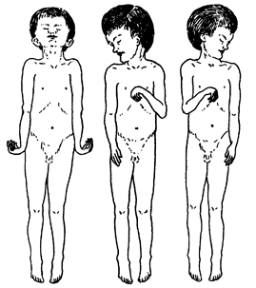

Midbrain animal
- section at superior border of midbrain.
- chronic midbrain animals can rise to standing position, walk, and right themselves.
- rigidity (static postural reflex) is modified by phasic postural reflexes (vs. it is not possible in decerebration):
  - extensor rigidity is present only when animal lies quietly on its back.
  - in phasic activities (e.g. walk), static phenomenon of rigidity is not seen!

Righting Reflexes
- maintain normal standing position and keep animal's head upright.
- integrated for most part in midbrain.
- labyrinthine righting reflex - when midbrain animal is held by its body and tipped from side to side, head stays level (stimulus is tilting of head, which stimulates otolithic organs → compensatory contraction of neck muscles to keep head level).
- body on head righting reflex - if animal is laid on its side, pressure on that side of body initiates reflex righting of head (even if labyrinths have been destroyed).
- neck righting reflexes - if head is righted by either of these mechanisms (labyrinthine or body on head) and body remains tilted, neck muscles are stretched - initiates wave of similar stretch reflexes that pass down body, righting thorax, abdomen and hindquarters.
- pressure on side of body may cause body righting even if head is prevented from righting (body on body righting reflex).

Visual cues can initiate optical righting reflexes that right animal in absence of labyrinthine or body stimulation.
N.B. unlike other righting reflexes, these responses depend upon intact cerebral cortex.

In intact humans, operation of righting reflexes maintains head in stable position and eyes fixed on visual targets despite movements of body and jerks and jolts of everyday life.

Grasp reflex
- when primate (in which brain tissue above thalamus has been removed) lies on its side, limbs next to supporting surface are extended.
- upper limbs are flexed, and hand on upper side grasps firmly any object brought in contact with it (supporting reaction that steadies animal and aids in pulling it upright).

Vestibular placing reaction
- if blindfolded animal is lowered rapidly, its forelegs extend and its toes spread (prepares animal to land on floor).

Decortication
- cerebral cortex disconnection (e.g. global anoxia).
Animals
- little motor deficit in many species of mammals; in primates, deficit is more severe but movement is still possible.
- decorticate animals are easier to maintain than midbrain animals because temperature regulation and other visceral homeostatic mechanisms integrated in hypothalamus are present.
- most striking defect is inability to react in terms of past experience (no conditioning, learning).
- two postural reactions are seriously disrupted by decortication:
  - Hopping reactions - keep limbs in position to support body when standing animal is pushed laterally.
  - Placing reactions - place foot firmly on supporting surface; examples:
    - blindfolded animal held suspended in air → touch supporting surface with any part of foot.
    - when snout or vibrissae of suspended animal touch table, animal immediately places both forepaws on table.
    - if one limb of standing animal is pulled out from under it, limb is promptly replaced on supporting surface.
    - limbs are extended to support body when animal is lowered toward surface it can see.

Humans
- loss of cortical area* that inhibits γ efferent discharge via reticular formation - humans assume driven position dictated by increased tonus of antigravity muscles (t.y. fiziologiniai ekstenzoriai; pvz. biceps brachii yra anatominis fleksorius, bet fiziologinis ekstenzorius, nes veikia prieš gravitaciją).
* may be anterior edge of precentral gyrus (area 4s or suppressor strip)
- decorticate rigidity - bilateral Vernike-Mano poza (bilateral spastic hemiplegia - abipusis tr. pyramidalis pažeidimas):
- jaw clenched.
- flexion of upper extremities - visi rankų sąnariai sulenkti, alkūnės prispaustos prie šonų (adduction and internal rotation), dilbiai supinuoti.
- rigid extension of lower extremities - kojos ištiestos, rotuotos į vidų, plantarinė fleksija.
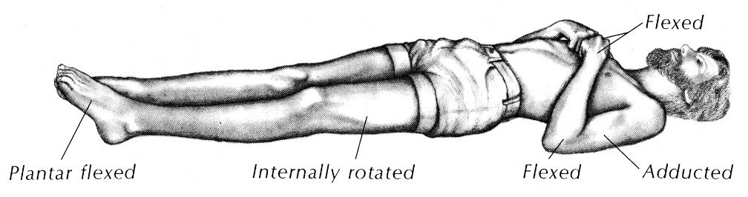
- seen unilaterally on hemiplegic side in humans.
- it is reflex activity (diffuse facilitation of stretch reflexes) - driven by rubrospinal tract.

Main difference between “decorticate” and “decerebrate” is tonic upper extremity position - flexion or extension;
lower extremities in both conditions ≈ the same (tonic extension, adduction, and internal rotation).

Bibliography for ch. “Muscle Coordination, Postural Control” → follow this link >>
Ganong “Review of Medical Physiology”, 2002
NMS Physiology 2001

Viktor’s Notes℠ for the Neurosurgery Resident
Please visit website at www.NeurosurgeryResident.net

