Trigeminal Nerve

Last updated: April 20, 2019

Supraorbital, infraorbital, and mental branches of CN5 - bony foramina of these nerves lie roughly in straight line passing through pupil and lateral commissure of lips:

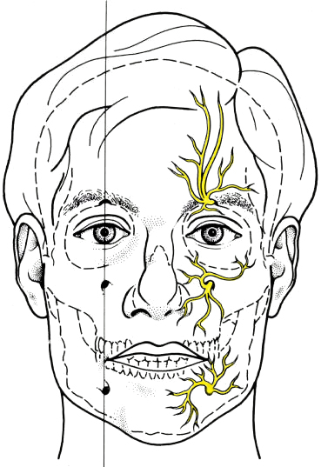

Bibliography for ch. “Cranial Nerves” → follow this [link >>](http://www.neurosurgeryresident.net/A.%20Neuroscience%20Basics\A.%20Bibliography.pdf)

[Viktor’s Notes℠ for the Neurosurgery Resident](http://www.neurosurgeryresident.net/)

[Please visit website at www.NeurosurgeryResident.net](http://www.neurosurgeryresident.net)