Taste Physiology
Last updated: April 20, 2019

taste buds (sense organs for taste) see 1826 (2-4) p.
- total ≈ 10.000 taste buds.
- each taste bud is innervated by ≈ 50 nerve fibers; each nerve fiber receives input from ≈ 5 taste buds.
- if sensory nerve is cut, taste buds it innervates degenerate and eventually disappear;
if nerve regenerates, epithelial cells in neighborhood become organized into new taste buds.

Taste Pathways
Tongue:
anterior two-thirds → chorda tympani branch of facial nerve.
posterior third → glossopharyngeal nerve.
Areas other than tongue → vagus nerve.

- all taste fibers (myelinated but slowly conducting) unite in rostral third of nucleus tractus solitarii (in medulla oblongata); further way:
  - axons cross midline and join medial lemniscus → specific sensory relay nuclei of thalamus.
  - gustatory lemniscus - uncrossed ascending fibers; some switch in parabrachial nuclei (rostral pons) and continue to thalamus, hypothalamus, amygdala.
  - some axons connect to adjacent RF and dorsal motor nucleus n. vagi – salivatory and lingual reflexes.
- taste projection area is in foot of postcentral gyrus (parietal operculum).
N.B. taste does not have separate cortical projection area and is represented in face area.
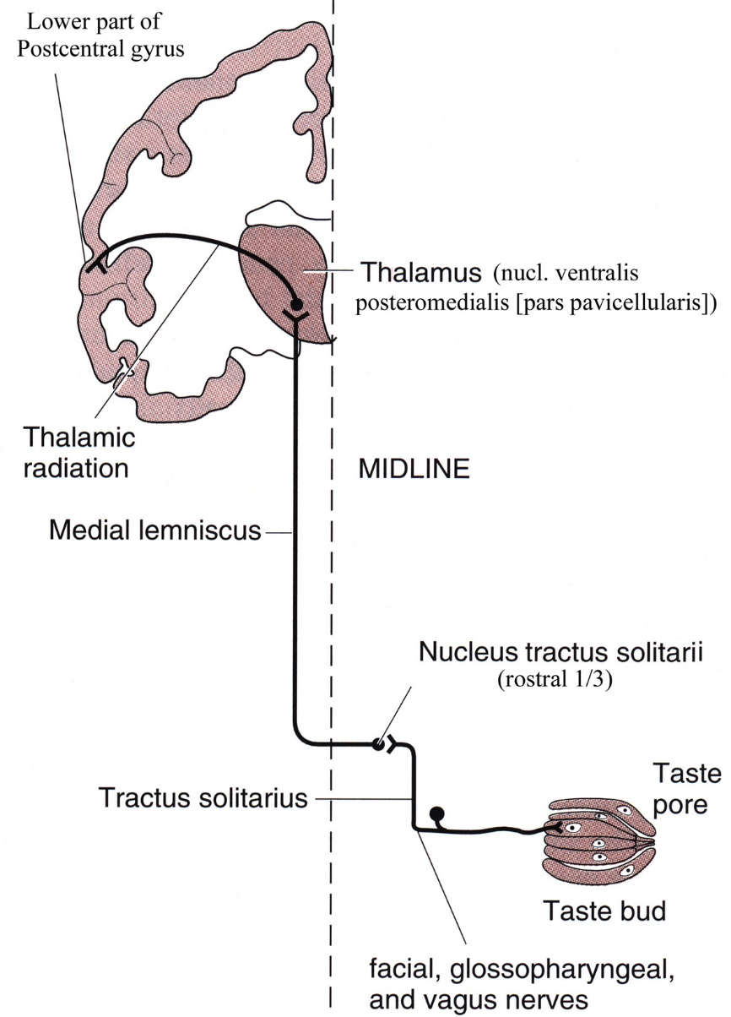

Basic Taste Modalities
- gustatory chemoreceptors (located on microvilli of taste cells) respond to sapid (taste-producing) substances dissolved in oral fluids bathing them.
- concentrating & transporting protein (delivers taste-producing molecules to receptors) is produced by Ebner glands.
sweet - at tongue tip.  - most sweet substances are organic: sucrose, maltose, lactose, glucose, polysaccharides, glycerol, some alcohols and ketones, chloroform, beryllium salts, various amides of aspartic acid.  - artificial sweeteners (saccharin and aspartame) produce satisfactory sweetening without calorie burden.  - thaumatin and monellin (proteins isolated from African berries) are 100,000 times as sweet as sucrose; structures of these two proteins are very different, yet antibodies to one cross-react with antibodies to other (some sort of common 3D structure).  - receptor activation: sweet substances act via G_{S} protein → cAMP↑ → reduced K⁺ conductance → depolarization. | 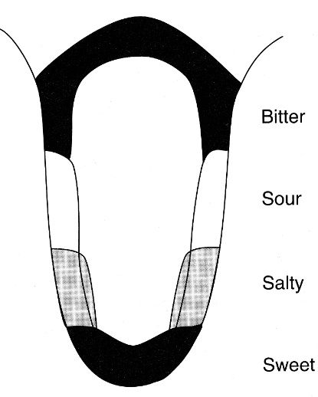
sour - along posterior half of tongue side (also on palate).
- sourness is proportionate to H⁺ concentration.
- receptor activation: acids depolarize sour receptors by activating H⁺-gated cation channels.
salt - along anterior half of tongue side.
- salty taste is produced by Na⁺ (and anions of ionizable salts).
- receptor activation: Na⁺ depolarizes salt receptors via Na⁺ channel related to amiloride-sensitive epithelial sodium channel (ENaC).
- some organic compounds also taste salty (e.g. dipeptides lysyltaurine & ornithyltaurine are more potent than NaCl).
bitter - mostly on tongue back (also on palate).
- no apparent common molecular feature of substances that taste bitter.
- organic compounds (esp. alkaloids): quinine sulfate, strychnine hydrochloride, morphine, nicotine, caffeine, urea.
- inorganic salts of magnesium, ammonium, calcium.
- receptor activation: bitter substances reduce cAMP (via G protein*) and increase IP₃ and DAG.
*novel G protein (α-gusducin) has been cloned - it activates phosphodiesterase, but exact role remains unsettled.

- all four modalities can be sensed on pharynx and epiglottis.
- additional taste modality named umami has been postulated to exist - taste of (monosodium) glutamate.
- taste cells are not different histologically; each nerve fiber responds to more than one taste stimulus (but responds best to one of four primary taste qualities).
- intensity discrimination is relatively crude (like in olfaction) - 30% change in concentration of substance being tasted is necessary before intensity difference can be detected.
- taste threshold concentrations vary with particular substance:
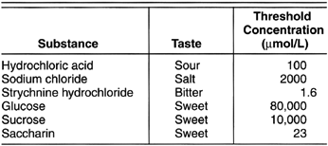

Flavor components:
- combinations of four basic taste components.
- smell – nn. olfactorii
- may include element of pain stimulation (e.g. "hot" sauces) – n. trigeminus
- consistency (texture) – n. trigeminus
- temperature – n. trigeminus
N.B. taste is component of flavor!

After-Effects
- taste exhibits after-reactions and contrast phenomena (similar to visual after-images and contrasts) - some are chemical "tricks," but others may be true central phenomena.
- miraculin - taste modifier protein discovered in plant - when applied to tongue, makes acids taste sweet.
- animals and humans form particularly strong aversions to novel foods if eating food is followed by illness (survival value of avoiding poisons).

Taste Abnormalities
ageusia (absence of taste sense); e.g. drugs which contain sulfhydryl groups (e.g. captopril, penicillamine) cause temporary ageusia.

hypogeusia (diminished taste sensitivity) - many different diseases.

dysgeusia (disturbed taste sense).

Bibliography for ch. “Taste” → follow this link >>
Ganong “Review of Medical Physiology”, 2002
NMS Neuroanatomy 1998, Physiology 2001

Viktor’s Notes℠ for the Neurosurgery Resident
Please visit website at www.NeurosurgeryResident.net

