Trigeminal Disorders

Last updated: December 22, 2020

Trigeminal Neuralgia (Tic Douloureux, Fothergill disease) 1

Epidemiology 1

Etiology 1

Pathology-Pathophysiology 1

Clinical Features 1

Classification 2

Burchiel 2

BNI (Barrow Neurological Institute) scoring system 2

Diagnosis 2

Medical therapy 2

Surgical therapy 2

1. Distal (peripheral) procedures 3

2. Gasserian ganglion procedures (percutaneous trigeminal gangliolysis) 3

Radiofrequency (RF) thermocoagulation 3

Glycerol (percutaneous retrogasserian glycerol rhizotomy, PRGR) 3

Balloon (percutaneous balloon compression, PBC) 4

3. Posterior fossa (root entry zone) procedures 4

Microvascular decompression (MVD), s. Jannetta procedure 4

Vasculopexy 4

Radiosurgery (gamma-knife) - retrogasserian rhizolysis 4

Rhizotomy 7

Postoperative 7

Surgical Therapy – Results 7

Geniculate Neuralgia 7

CN5 deafferentation pain 7

Treatment 7

Gradenigo syndrome 7

Onion-skin pattern face anesthesia 8

Raeder paratrigeminal syndrome 8

**Schwannoma of CN5** → see [p. Onc62 >>](http://www.neurosurgeryresident.net/Onc.%20Oncology\Onc62.%20Schwannomas%20of%20Cranial%20Nerves.pdf)

Trigeminal Neuralgia (Tic Douloureux, Fothergill disease)

- paroxysmal disorder of excruciating, lancinating painful spasms.

* most common neuralgia!!!
* one of the most excruciating pain syndromes!!! (may drive sufferers to suicide)
* *Aretaeus of Cappadocia* - first indication of trigeminal neuralgia.
* first adequate clinical description - *Fothergill in 1773*.

Epidemiology

* incidence 4-5 / 100.000 population; prevalence 155 / 1 mln.
* slight **female** predominance (3:2).
* incidence peaks in middle age (> 50% cases onset in sixth or seventh decade), but occasionally may affect children.

N.B. appearance in young patient - suspicion of *demyelinating disease*!

Etiology

* 1. **secondary** (intrinsic and extrinsic ***tumors*** near gasserian ganglia, ***multiple sclerosis*** plaques*, syringomyelia, infarction, aneurysm, cholesteatoma, basilar impression).

*2-8% patients have MS; 4% MS patients have TN; denuded axons promote *ephaptic transmission*

Trigeminal neuralgia related to MS is more difficult to manage pharmacologically and surgically!

* 1. **idiopathic**

N.B. most idiopathic cases are due to *pulsations of aberrant vascular loop* compressing root at its entry zone! – **NVC (neurovascular contact)**

* + - most commonly - superior cerebellar artery (75%) or anterior inferior cerebellar artery; less commonly – vein.
    - with aging, blood vessels can become ectatic and atherosclerotic; case reports of compression by ectatic basilar artery.

Vascular compression syndromes:

1. trigeminal neuralgia
2. CN9 neuralgia
3. hemifacial spasm
4. torticollis

Pathology-Pathophysiology

* biopsy - ***focal demyelination*** but no inflammatory cells.
* **ephaptic (nonsynaptic) neurotransmission** between demyelinated trigeminal axons - physiological substrate for paroxysmal pain (esp. if initiated by cutaneous stimuli).
* frequently, ectopic impulses are generated in trigeminal nerve secondary to ***vascular compression***.

Clinical Features

* brief **lightning-like series of jabs (spasms)**; jab lasts **fraction of second**, episode lasts **seconds ÷ few minutes**.
* pain is reported as: lancinating, stabbing, searing, burning, electrical.
* intensity is such that patient winces or grimaces (hence the name *tic douloureux*).
* **unilateral** (in ≈ 5% bilateral*, but simultaneous bilateral spasms are quite atypical).

*most often in MS patients!

* strictly affects divisions of CN V (in 15% all three divisions):

3rd (70%) > 2nd > 1st (5%)

vs. postherpetic neuralgia most frequently affects CNV1

* pain occurs (throughout day and night):
  1. ***spontaneously***
  2. ***precipitated*** by stimuli (cutaneous, auditory, even draft of air); often *temporal summation* of stimuli is necessary to invoke response.
* > 90% have demonstrable **trigger point** - small area (on cheek, lip, nose) that can reproduce pain when stimulated (by facial movement, chewing, touch).
* *between attacks, there are no symptoms*, but patient is anxious about having another attack.
* some patients are unable to chew, eat, drink, shave, or brush their teeth for fear of triggering spasm (patients may appear emaciated, males disheveled).
* *no neurologic deficits*!!! (*subjective hyper- / hypo-esthesias* over face may be reported).

N.B. sensory disturbances, constant pain are atypical for trigeminal neuralgia!

Significant sensory loss suggests that the pain syndrome is secondary to another process

* after paroxysm, there is relatively **refractory phase** (2- min) during which is it difficult to trigger attack.
* disease lasts indefinite years (severity steadily increases – pain intervals shorten, pain becomes atypically constant, medically intractable).
* *psychological problems* may occur secondary to chronic pain (up to suicide).

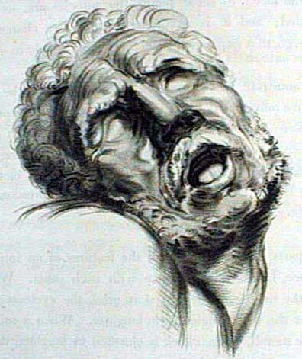

Classification

Burchiel

**type 1** (> 50% episodic pain)

**type 2a** (> 50% constant pain with history of episodic pain)

**type 2b** (constant pain with no history of episodic pain)

TN1 Idiopathic, sharp, shooting, electrical shock–like, episodic pain lasting several seconds, with pain-free intervals between attacks

TN2 describes idiopathic trigeminal facial pain that is aching, throbbing, or burning for more than 50% of the time and is constant in nature (constant background pain being the most significant attribute). There may be a minor component of sharp, episodic pain

* natural history of trigeminal neuralgia includes gradual transition from Type 1 to Type 2

BNI (Barrow Neurological Institute) scoring system

I: No pain, no meds

II: Occ. pain, no meds

III: Some pain, controlled by meds

IV: Pain, not adequately controlled

V: Severe pain, no relief

Diagnosis

* diagnosis can usually be made by history alone.
* **MRI** is only test always indicated (even if there is no loss of sensation or other abnormality on neurological examination!) - identifying etiologies of **secondary cases**! (in 15% cases tumor is found!); techniques:

1. *coronal 3D time of flight MRA is centered on vertebral-basilar system; collapsed MRA is then superimposed on routine spin echo T1 images, which show cisternal portions of fifth nerve – vascular loop compression is accurately identified.*
2. *CISSS sequence (white CSF and black nerves)*

* **trigeminal reflex testing** can be screening to identify **secondary cases** (*trigeminal sensory deficits* identify **secondary cases**, but poor specificity - absence of these deficits cannot rule out **secondary cases**).
* laboratory studies are normal.

Medical therapy

(many require lifelong medication!):

1. carbamazepine!!! – first-line & most effective medication; the only medication approved by FDA

* started gradually; max daily dose 1200 mg;
* follow serum levels, liver function tests, and white blood cell counts to avoid toxicity.
* dose may be tapered once pain is controlled, since remission may occur.
* 90% of patients experience reduction in number of episodes, but the therapeutic window is relatively small and side effects are common.

1. oxcarbazepine!! – alternative.
2. gabapentin – efficacious as carbamazepine but with profoundly fewer side effects!
3. pregabalin
4. baclofen!!
5. lamotrigine!!
6. phenytoin; intravenous fosphenytoin (250 mg) is useful for acute severe attack.
7. valproic acid, clonazepam, pimozide

* 50% patients eventually have some kind of surgical procedure!

*many experts believe that patients failing to respond to first-line therapy are unlikely to respond to alternative medications and suggest early surgical referral.*

Surgical therapy

Many options available – ***patient characteristics*** are important.

N.B. no treatment exist for anesthesia dolorosa (vs. tic doloreaux)

With the exception of microvascular decompression (MVD), all other modalities involve interrupting the transmission in the nerve by temporarily or permanently destroying a segment of the nerve (i.e. reducing the critical number of axons to abort ephaptic transmission).

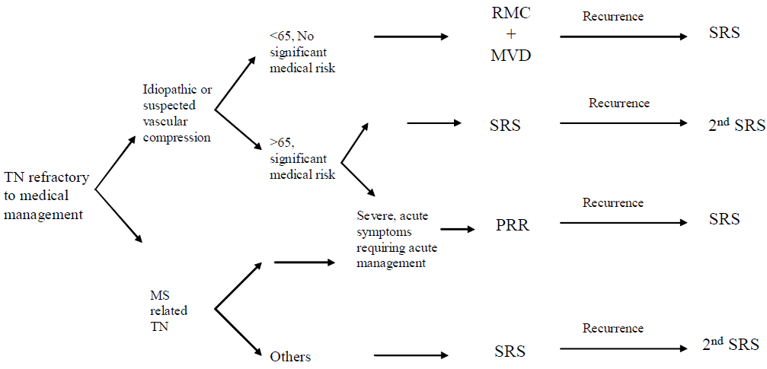

**RMC** = Retro-Mastoid Craniotomy,

**MVD** = Microvascular Decompression,

**PRR** = Percutaneous Retrogasserian Rhizotomy (Glycerol / Radiofrequency / Balloon Compression)

**SRS** = Stereotactic Radiosurgery

1. Distal (peripheral) procedures

1. **Neurectomies** - partial or complete sectioning of peripheral nerve
2. **Cryotherapy** - surgically exposed nerve is exposed to 3 two-minute freeze – thaw cycles
3. **Absolute alcohol** - highly neurotoxic; after injecting 0.5 – 1.5 mL EtOH, inject small air bubble to avoid sinus tract.

* generally not recommended - high incidence of early recurrence (no long term studies, only retrospective case series) - average pain free interval about 2 years
* local anesthesia - medical fitness not required - indicated for patients with limited life span.
* pain must be localized to nerve branch.

2. Gasserian ganglion procedures (percutaneous trigeminal gangliolysis)

Idea: to *selectively destroy A-delta and C fibers (nociceptive)* while preserving A-alpha and beta fibers (touch).

AANS videos:

<http://www.neurosurgicalatlas.com/grand-rounds/percutaneous-procedures-for-trigeminal-neuralgia-radiofrequency-and-balloon>

**Procedure details**

Foramen ovale cannulation – see [p. Op310 >>](http://www.neurosurgeryresident.net/Op.%20Operative%20Techniques\300-399.%20Cranial\Op310.%20Brain%20Biopsy.pdf#FORAMEN_OVALE_CANNULATION)

* limited ***neuro­leptic analgesia*** (patient is easily arousable) or ***general anesthesia***.
* lesioning is carried out:

1. thermally
2. chemically
3. mechanically

Radiofrequency (RF) thermocoagulation

* + introduced in 1965 by Sweet and altered by Tew in 1982.
  + used in MS / tumor patients and for those who are not suitable for / do not want general anesthesia.
  + electrode position should be manipulated until *paresthesias (upon stimulation) are confined to distribution in which pain is located* – can ablate selective branch (V1 or 2 or 3).
  + must produce *hypoesthesia*\* in pain distribution (if complete anesthesia - risk of postoperative anesthesia dolorosa) - *continuous sensory testing is ideal* (but some patients need general anesthesia again due to strong pain produced).
  + electrical current supposedly ***ablates small pain fibers*** while preserving heavily myelinated touch and proprioception fibers!
  + lowest recurrence rates of all percutaneous procedures!

*in case of cancer pain *anesthesia* must be attained to achieve adequate pain relief.

Glycerol (percutaneous retrogasserian glycerol rhizotomy, PRGR)

Risk counselling:

procedure typically causes an episode of bradycardia

risk of a cheek hematoma

risk of not being able to get through the foramen (approx. 10%)

risk of the general anesthetic.

Procedure

* introduced by Håkanson in 1981.

Håkanson S. Trigeminal neuralgia treated by the injection of glycerol into the trigeminal cistern. Neurosurgery. 1981;9(6):638–646

* patient on stretcher, supine, intubated.
* foramen ovale cannulation using 18G ***foramen ovale needle*** (Dr. Holloway uses18G size 3.5 in ***spinal needle)***  – see [p. Op310 >>](http://www.neurosurgeryresident.net/Op.%20Operative%20Techniques\300-399.%20Cranial\Op310.%20Brain%20Biopsy.pdf#FORAMEN_OVALE_CANNULATION)
* needle is left in place and patient is seated upright with head flexed.
* verify that needle is in Meckel’s cave – see [p. Op310 >>](http://www.neurosurgeryresident.net/Op.%20Operative%20Techniques\300-399.%20Cranial\Op310.%20Brain%20Biopsy.pdf#FORAMEN_OVALE_CANNULATION)
* some experts empty Meckel’s cave by letting CSF drip.
* sterile anhydrous **glycerol** injection into trigeminal cistern with tuberculin syringe; volume – glycerol fills Meckel’s cave from bottom up: if treating V3 – enough 0.2 cm3, for V1 – need 0.4 cm3 (Meckel’s cave volume is approx. 0.4 cm3); Dr. Broaddus injects 0.5 cm3 in all cases.
* patient is extubated sitting and seated upright with head flexed for **2** hours after procedure.

N.B. if neck is extended at any time, glycerol is lost – procedure is in vain

Postoperatively

* *check for corneal reflex* (usually just mild decrease) – if impaired, needs eye protection*.

*glycerol is best for CNV1 cases (because of corneal denervation risk with other methods).

* neuralgia relief is immediate; if onset is delayed for > 7 days, likely result will be poor.
* relief may last for many months without any signifi­cant neurological deficit; but hypoesthesia / dysesthesia is common (up to 60%).
* longest / largest study showed recurrence rate at 54 months to be 74%.

Fujimiki T, Fukushima T, Miyazaki S. Percutaneous retrogasserian glycerol injection in the management of trigeminal neuralgia: long-term follow-up results. J Neurosurg. 1990; 73:212-216

Balloon (percutaneous balloon compression, PBC)

* original description by Mullan and Lichtor and later by Bergenheim et al.

Mullan S, Lichtor T. Percutaneous microcompression of the trigeminal ganglion for trigeminal neuralgia. J Neurosurg. 1983;59(6):1007–1012

Bergenheim AT, Asplund P, Linderoth B. Percutaneous retrogasserian balloon compression for trigeminal neuralgia: review of critical technical details and outcomes. World Neurosurg. 2013;79(2):359–368.

* + usually done under general anesthesia, supine
  + 13-gauge needle with a semisharp stylet inserted through a stab incision 2 to 3 cm lateral to the angle of the mouth, directed into the oval foramen
  + 4F Fogarty balloon catheter inserted 17 to 19 mm beyond the tip of the needle → balloon inflated with 0.3-0.8 mL iohexol at 300 mg/mL – “pear-shaped” configuration (reflects shape of Meckel’s cave) → pressure held for 1-6 minutes before the contrast is aspirated.
  + mechanism of action unclear – combination of ***massaging*** and ***lesioning*** actions.
  + instant pain relief (with associated sensory loss; *temporary masseter weakness* is common).
  + lowest risk of corneal anesthesia; highest risk of hearing loss.
  + 6-14% recurrence in first year; troubling dysesthesias occur in 6-15%.

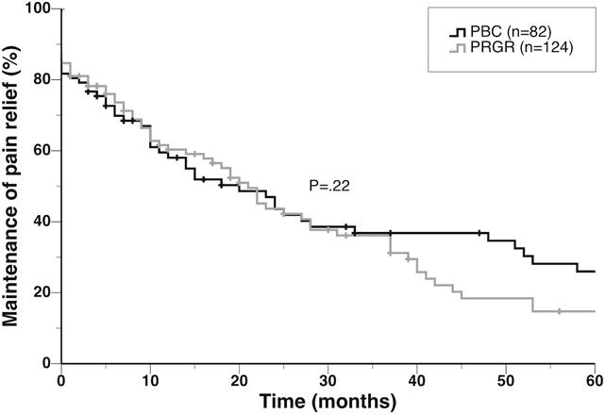

3. Posterior fossa (root entry zone) procedures

Root entry zone:



Source of picture: Neurosurgery 58:666-673, 2006

Microvascular decompression (MVD), s. Jannetta procedure

– classic, most effective procedure! (addresses etiology!); durable and nondestructive; risks associated with craniotomy and general anesthesia

Operative and postoperative details, outomes – see [p. Op350 >>](http://www.neurosurgeryresident.net/Op.%20Operative%20Techniques\300-399.%20Cranial\Op350.%20Cerebrovascular%20(open%20techniques).pdf#MVD)

* Dandy originally described vascular compression as a cause of pain in 1925.
* landmark study:

Barker FG , Janetta PJ , Bissonette DJ , PAC , Larkins MV , Jho HD . The long-term outcome of microvascular decompression for trigeminal neuralgia. N Engl J Med 1996; 334 : 1077 – 1083.

* indicated for *younger, healthier patients* (without MS – low response rate) with life expectancy > 5 years.

Gold standard treatment for most TN patients unless they have significant comorbidities!

Vasculopexy

* in cases of compression caused by a *severely ectatic and tortuous basilar artery*; treatment (standard decompression technique may not be effective) - **vasculopexy** of the ectatic basilar artery to the tentorium.

Basilar Artery Ectasia Causing Trigeminal Neuralgia: An Evolved Technique of Transpositional Suture-Pexy. Harminder Singh, MD Harley Brito da Silva, MD Mehdi Zeinalizadeh, MD Turki Elarjani, MD David Straus, MD Laligam N Sekhar, MD Operative Neurosurgery, Volume 14, Issue 2, 1 February 2018, Pages 194–199

* subtemporal transtentorial approach
* basilar artery mobilized away from the trigeminal nerve.
* suture is passed through the wall of the basilar artery (tunica media) and secured to the tentorial edge, to keep the artery away from the nerve.

Radiosurgery (gamma-knife) - retrogasserian rhizolysis

- least invasive safe procedure with low morbidity (often used in poor surgical candidates).

Avoid for patients with atypical features!

Methodology

* standard (posterior) approach: single dose of 86 (75-90) Gy at 100% isodose (or 43 Gy at 50% isodose) to trigeminal root (single 4-mm isocenter at 5-14 mm distance anterior to emergence of nerve*, so 50% isodose is next to but does not touch brainstem).

*i.e. 5-14 mm segment of nerve treated

* concentric 4 & 8 mm shots do not increase response, but increase complications.
* linear placement of shots do not increase response, but increase complications.
* increasing dose to 90 Gy increases response and complications.



Dose and Complications

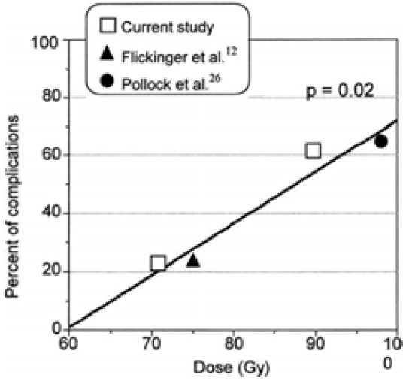

Tawk RG et al. J Neurosurg 102:442-449, 2005

12. . Flickenger JC et al. JROBP 51:449-454, 2001

26. Pollock BE et al. Neurosurgery 49: 58–64, 2001

* alternative (anterior) approach: target trigeminal nerve, distal cisternal portion, 4 mm collimator, may use higher dose (maximum dose that delivers no more than 12 Gy to 10 mm3 of brainstem); high response rate (> 95% at 6 months, 80% at 2 years), 10% trigeminal neuropathy.

Comparison of two targeting methods:

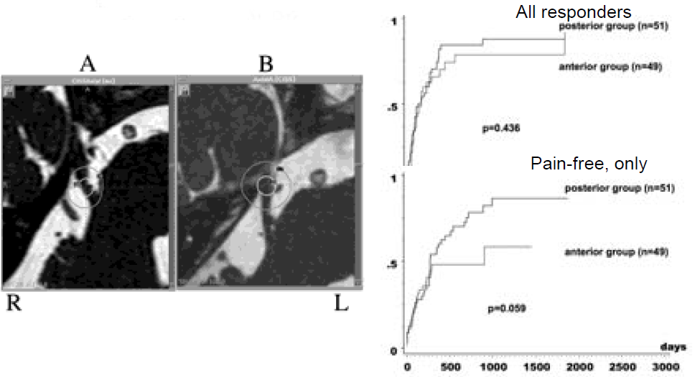

* pre-radiosurgery pain medications are continued at the same doses until pain relief is obtained → medications gradually tapered off if the patient remains pain free.

Methodology for recurrences after SRS:

Radiosurgery Practice Guideline for Intractable Typical Trigeminal Neuralgia that Failed Medical Management (Guideline Report #1-03, original guideline 2009):

* target is placed anterior to the first target so that the radiosurgical volumes at the second procedure overlap with the first one by 50%.
* use lesser radiation dose (50–70 Gy) - a higher combined dose would lead to a higher risk of new facial sensory symptoms.
* generally safe interval between first and second radiosurgeries is 6 months.
* Pollock et al. suggested a greater radiation dose to the same target at the second procedure - rate of bothersome numbness was relatively high (16%).
* published results of 3 SRSs per patient.

Complications: hypesthesia, troubling dysesthesias.

Increasing volume (to include more of nerve root) increases complications but does not provide better pain relief!

Outcome

* rate of success 24-60% (takes time, mean 4 weeks, up to 7 months, to reach effect).
* 55% excellent relief, 35% good relief (Kondziolka D et al. J Neurosurg 84: 940-945, 1996).
* 49% patients extremely happy with procedure (Cleveland Clinic).
* 1 month follow up - **acute toxicity**:

Facial numbness (15-47%)

Dysesthesia (10-16%)

Corneal keratitis (5-7%)

Radiosurgery Practice Guideline for Intractable Typical Trigeminal Neuralgia that Failed Medical Management (Guideline Report #1-03, original guideline 2009):

Facial numbness < 10%

Neuropathic pain < 1%

Motor weakness < 1%

* at 2 years failure rate is ≈ 35-40%; patients can be treated with repeat SRS (see above).

Time to pain relief

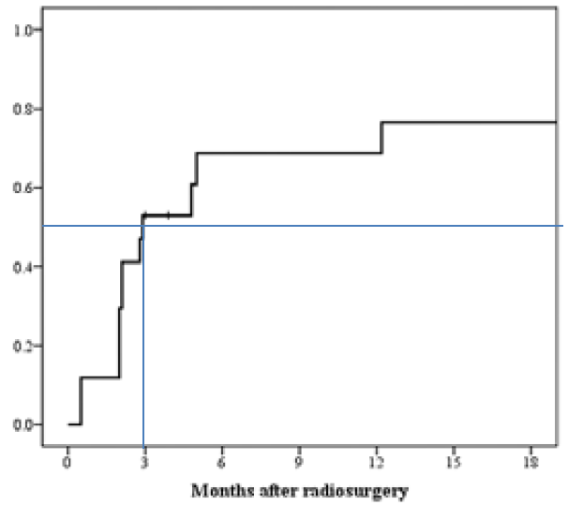

Kano H et al. J Neurosurg 2010

Predictive Factors

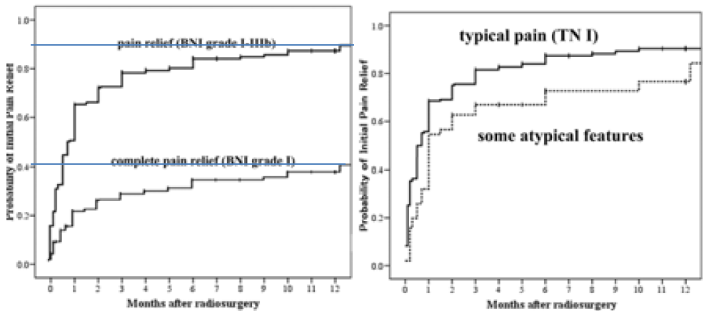

Kondziolka D et al. J Neurosurg 112:758-765, 2010

Predictive Factors

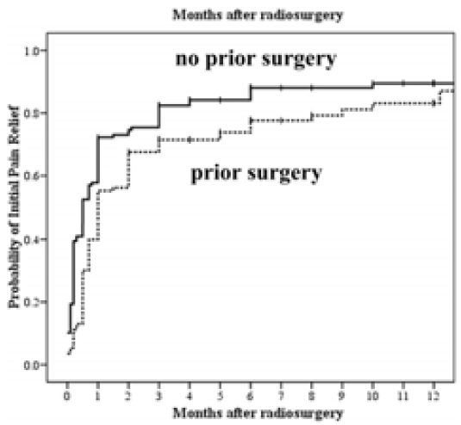

Kondziolka D et al. J Neurosurg 112:758-765, 2010

Predictive Factors - Durability

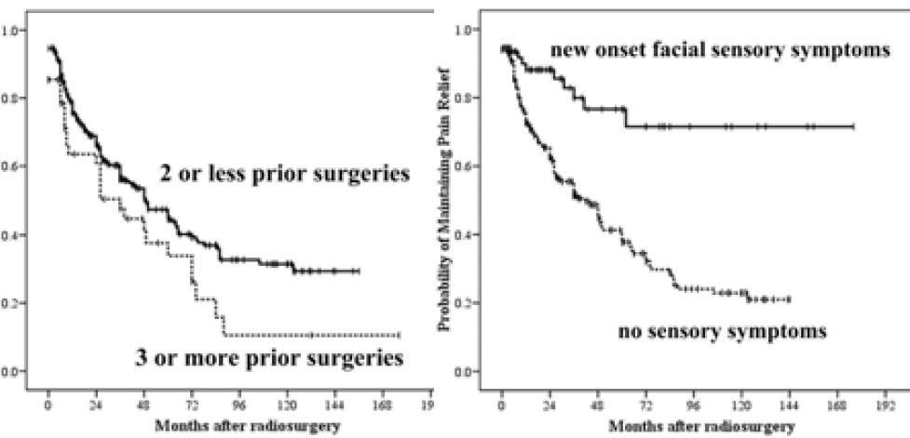

Kondziolka D et al. J Neurosurg 112:758-765, 2010

Predictive Factors - Durability

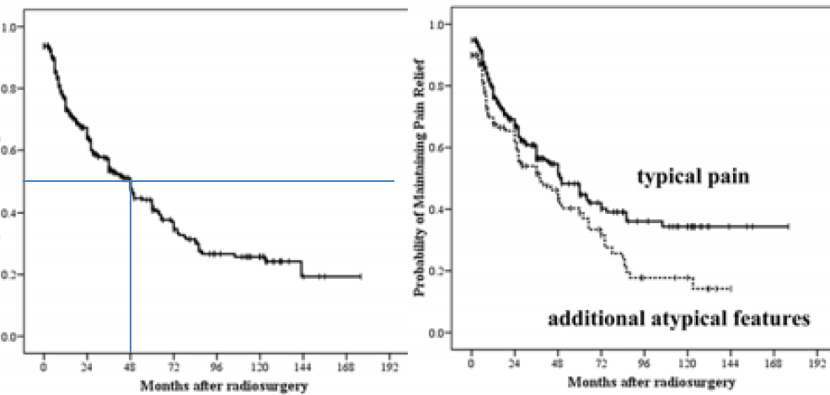

Kondziolka D et al. J Neurosurg 112:758-765, 2010

Durability or Response

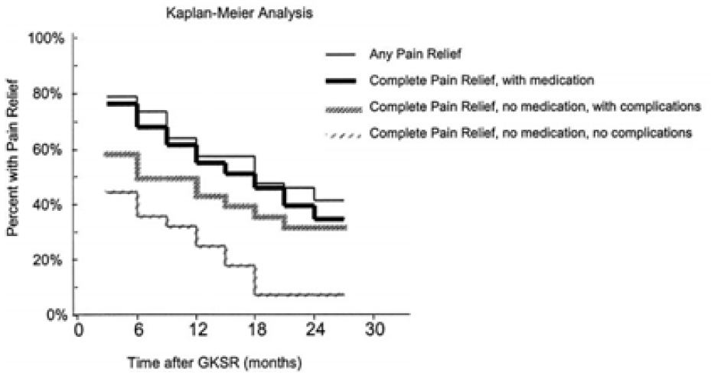

Tawk RG et al. J Neurosurg 102:442-449, 2005

**Outcomes of Trigeminal Neuralgia Radiosurgery:**

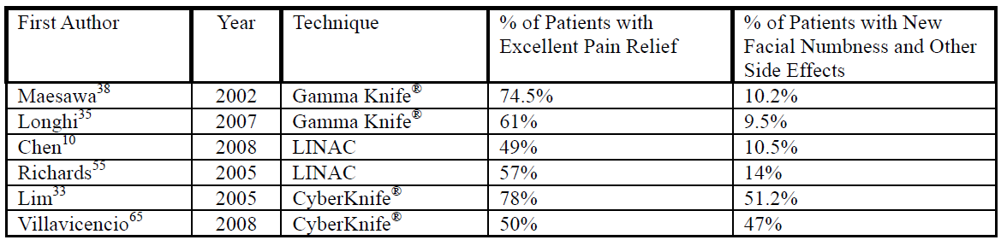

MVD vs. Gamma Knife

|  |  |  |
| --- | --- | --- |
|  | **MVD** | **Gamma Knife** |
| Initial success | 89-100% | 57-77% |
| 5 years | 61-80% | 33-56% |
| Cost | slightly more costly |  |
| Numbness and dysesthetic pain |  | much more common |

* GKT might seem to be an attractive alternative first line treatment devoid of major surgical morbidity with MVD reserved only for those in whom the noninvasive procedure fails to provide relief.

N.B. preoperative symptom duration and whether MVD is the primary or secondary treatment are important independent predictors of the success of MVD (i.e. trying GKT initially might lead to reduction in the efficacy of MVD tried after longer delay as a secondary treatment modality) - MVD must be used as the first line therapy in majority of patients including elderly unless general physical status precluded general anesthesia.

Rhizotomy

* **approach** (and patient characteristics) are *similar to that of MVD*.
* whole or part of **sensory division** is sectioned.
* results are comparable with MVD, however:
* higher recurrence rate
* sensory loss is more common
* painful dysesthesia / anesthesia dolorosa occur in about 8 %

Postoperative

* check for facial numbness, jaw opening weakness / deviation.
* taper meds (e.g. Tegretol) every 2-4 weeks and stop

Surgical Therapy – Results

For MVD – also see [p. Op350 >>](../Op.%20Operative%20Techniques/300-399.%20Cranial/Op350.%20Cerebrovascular%20(open%20techniques).pdf#TN_outcomes)

|  |  |  |  |  |
| --- | --- | --- | --- | --- |
|  | **RF** | **Glycerol** | **Balloon** | **MVD** |
| Initial success | 91-99% | 91% | 93% | 85-98% |
| Recurrence 2-6 yrs | 19%  6 yrs | 54%  4 yrs | 21%  2 yrs | 15%  5 yrs |
| Recurrence >10 yrs | 80%  12 yrs |  |  | 30%  10 yrs |
| Facial numbness | 98% | 60% | 72% | 2% |

* treatment failure occurs in most of **MS-related** TN patients independently of type of treatment.
* ***balloon compression*** had highest rate of initial pain-free response (IPFR), duration of pain-free intervals (PFIs) compared with other modalities in initial treatment of MS-related TN.

*Mohammad-Mohammadi, Alireza “Surgical Outcomes of Trigeminal Neuralgia in Patients With Multiple Sclerosis”, Neurosurgery: December 2013 - Volume 73 - Issue 6 - p 941–950*

Geniculate Neuralgia

CN5 deafferentation pain

Treatment

Best option – trigeminal tractotomy. [see p. S20 >>](http://www.neurosurgeryresident.net/S.%2520Symptoms,%2520Signs,%2520Syndromes\S20-29.%2520Pain,%2520Headache,%2520Opioids,%2520Sensory%2520Disorders\S20.%2520Pain.pdf#Trigeminal_tractotomy)

* motor cortex stimulation is ineffective.

Gradenigo syndrome

– ***apical petrositis*** (osteomyelitis) with localized meningitis involving **CN5 & CN6**:

1. facial sensory loss
2. facial pain (e.g. in temporal region), headache.
3. abducens paralysis
4. may also involve CN7 (facial palsy), CN8 (deafness)

* in children, following suppurative otitis media or mastoiditis.
* pain worse at night, aggravated by jaw or ear movement.
* multiple approaches to infected petrous cells are possible:

1. if it is complication of otitis media: ***simple mastoidectomy*** → air cell track containing granulation tissue can be followed into petrous apex and adequate drainage can be obtained.
2. ***middle cranial fossa approach***.

Onion-skin pattern face anesthesia

– caused by ***damage to spinal tract of trigeminal nerve*** in high cervical region.

Raeder paratrigeminal syndrome

1. intense pain in CN51 distribution
2. lacrimation, conjunctival injection, rhinorrhea
3. ipsilateral mydriasis (postganglionic Horner's syndrome).

* idiopathic or ***pathology of carotid sympathetic plexus*** (near Meckel cave).
* may not actually represent distinct clinical entity.

Bibliography for ch. “Cranial Neuropathies” → follow this [link >>](http://www.neurosurgeryresident.net/CN.%20Cranial%20Neuropathies\CN.%20Bibliography.pdf)

[Viktor’s Notes℠ for the Neurosurgery Resident](http://www.neurosurgeryresident.net/)

[Please visit website at www.NeurosurgeryResident.net](http://www.neurosurgeryresident.net)