Pediatric Neurologic Examination
Last updated: June 3, 2019
History 1
Objective Examination 1
Motor examination 1
Sensory examination 3
Cranial nerves 3
Reflexes 3
Head 3
newborn 3
infants 3
Spine 4
Infantile automatisms (Primitive Reflexes) 4
“Soft” Neurologic Signs 6
Meningeal signs 6
Spasmophilia signs 6
Psychomotor Development 6
Motor 7
Vocal 8
Sensory 8
Social 9

History
- review of pregnancy, labor, delivery.
- history of Apgar score, birthweight, length, head circumference.
- jaundice, feeding difficulties, sleep & cry patterns.
for further details → see p. Exam11 >>

Objective Examination
see also p. Exam11 >> for general examination tips!
- the more examination seems like a game, the greater will be degree of cooperation.

CNS at birth is underdeveloped – functions at subcortical level – cortical function cannot be tested in its entirety until early childhood!
- in newborn ÷ early infancy period, normal brainstem and spinal functioning do not ensure intact cortical system; vice versa - abnormalities of brainstem and spinal cord may exist without concomitant cortical difficulties!

Determine hand preference (right or left dominance should not be present until age 2 - before this it suggests problem with neglected hand)!

Motor examination
- most infants have excess of body fat - muscle fasciculations & atrophy are best demonstrated in tongue.
- tremors at rest after 4 days signal CNS disease!

- Put each major joint through its range of motion – determine muscle tone.
N.B. kūdikiams iki 3 mėn. raumenų tonusas fiziologiškai yra padidėjęs, bet prematūrai esti hipotoniški (scarf sign, popliteal angle > 80°):
- premature infant of 28 wk tends to extend all extremities at rest, but by 32 wk there is evidence of lower extremities flexion;
- normal full-term infant's posture is flexion of all extremities.
Hypotonic infant:
- assumes frog-leg posture in supine position.
- when suspended in prone position, limbs and head all hang limply "like rag doll" (“floppy infant”).
normally, arms and legs move out, and head is held in line with body
Head lag (when infant is pulled to sitting position from supine) is sign of weakness, not of low tone! Must not be present in 6 month-old-infant!
Observe newborns for asymmetry of spontaneous movements!

- Muscle strength
  - shoulder girdle strength - support baby by axillae - patient with weakness will be unable to support body weight and will "slip through" examiner's hands.
  - distal power - palmar grasp.
  - are sucking and swallowing impaired?
  - observe gait (walking & running); unequal wear of soles and heels on child’s shoes may indicate hemiparesis.
  - pelvic girdle strength - observe rising from floor from supine position:

normal – patient assumes squatting position:
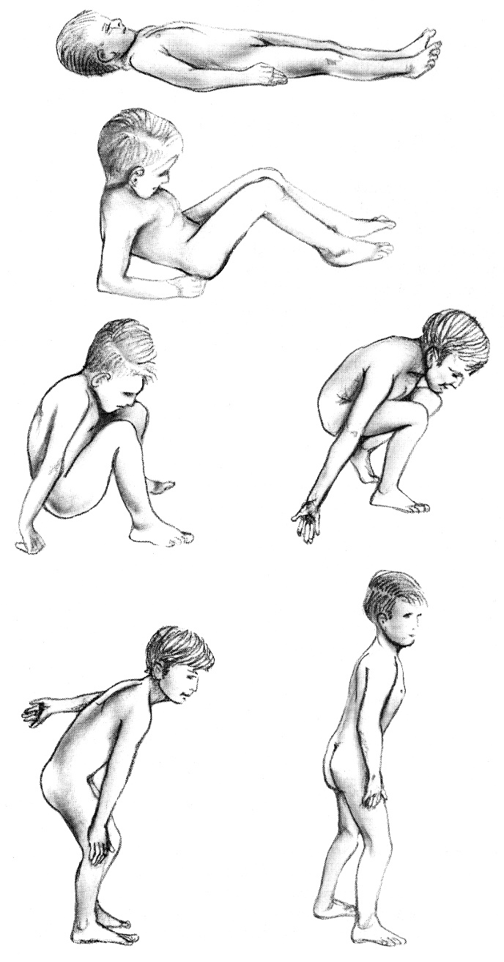

Gowers sign (“climbing up himself”) – pelvic girdle weakness (e.g. Duchenne muscular dystrophy) - patient turns prone, kneels (forming arch with buttocks at apex), pushes against knee with nonfloor hand, and then slowly pushes erect by using his hands to climb up his thighs.
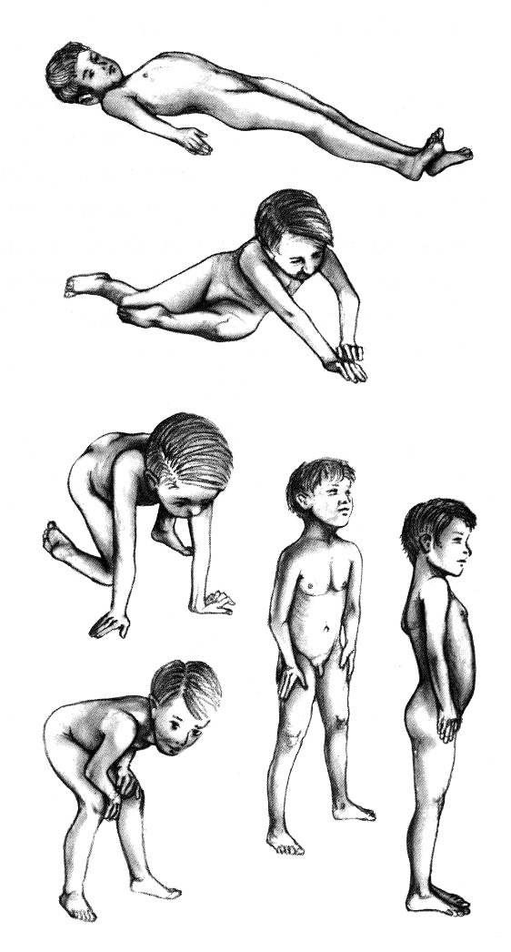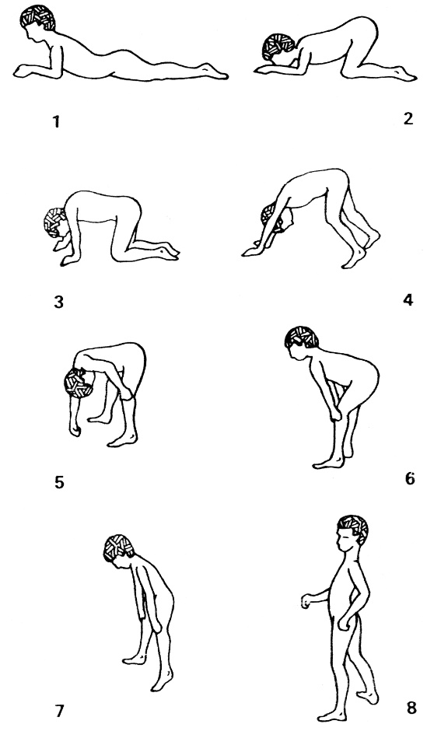

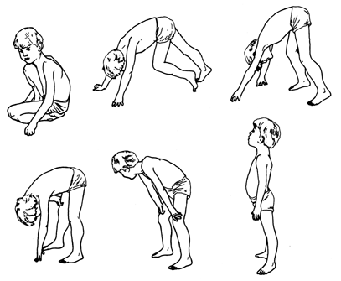

Erb's palsy - right arm is medially rotated and wrist is flexed:
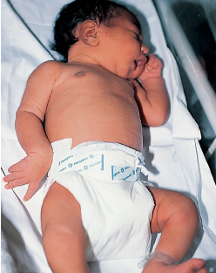

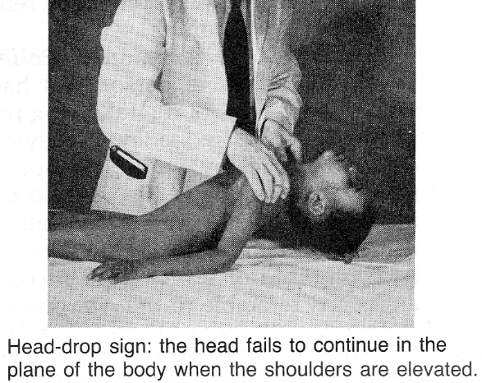

Sensory examination
Infants:
  - thresholds higher, reactions relatively slow;
  - screening – gently touch arms and legs with pin – observe movement of stimulated extremity and concomitant facial expression change;
UMN paralysis - facial change without extremity movement
spinal cord lesion - extremity movement without facial change
- child quickly loses patience and soon begins to disregard stimuli.

Cranial nerves
- tested as in adults; see p. D1 >>, p. D1eye >>, p. D1ear >>

Reflexes

are variable in infancy (underdeveloped corticospinal pathways!) - reflex↑ or ↓ has very little diagnostic significance unless asymmetric.
  - in infants use semiflexed index (or middle) finger instead of reflex hammer.
- Babinski sign (ir kiti pažeistų piramidinių laidų refleksai) - norma vaikams iki 2 metų amžiaus, o iki 6 mėn. jie pasireiškia spontaniškai!
- unsustained ankle clonus (8-10 rapid, rhythmic plantar flexions in response to eliciting ankle reflex or abrupt foot dorsiflexion) is common in newborns; sustained ankle clonus indicates severe CNS disease.
- triceps reflex, abdominal reflexes are absent until after 6 months (anal reflex is present in newborns!).
- crossed adductor response (tapping patellar tendon in one leg causes contraction in opposite extremity) is not abnormal until 6-7 months of age.
- oralinio automatizmo & griebimo refleksai yra norma ankstyvoje kūdikystėje (infantile automatisms – žr. žemiau)!

Head
newborn
- size & shape.
- head circumference - occipitofrontal circumference (OFC). see below >>
- molding, caput succedaneum, subgaleal hematoma, cephalohematoma
→ see p. Ped9 >>

infants
- dilated scalp veins – long standing ICP↑, thrombosis of superior sagittal sinus.
- craniotabes (syphilitic or rachitic) – localized areas of osteoporotic thinning in outer table of cranial flat bone; by pressing firmly on such area you may feel momentarily give (as ping-pong ball would respond to similar pressure).
- direct finger percussion over parietal bones will produce “cracked-pot” sound prior to closure of sutures.

Assess fontanelles (soft concavities) - baby is quietly sitting or being held upright:
posterior fontanelle (1-2 cm at birth – admits finger tip) closes at birth or by 2 months; persistence suggests hydrocephalus or congenital hypothyroidism.
anterior fontanelle (4-6 cm in largest diameter at birth) closes at 9 ÷ 26 months (average – 18); best evaluated when infant is held upright and is asleep or feeding - normally slightly depressed and pulsatile.
- anterior fontanelle pulsations reflect peripheral pulse.
- anterior fontanelle tenseness & fullness reflects ICP:
  - bulging - ICP↑, but also in normal crying, coughing, vomiting.
  - depression - ICP↓, dehydration.
N.B. palpate anterior fontanelle before proceeding with any other part of physical examination on acutely ill baby!

Assess sutures (slightly depressed ridges) – palpable ridging resolves by ≈ 6 months.

Occipitofrontal circumference (OFC) (greatest head circumference) – obtain at every examination during first 2 years (± biennially thereafter) - should be recorded on suitable chart.
e.g. from Centers for Disease Control and Prevention - www.cdc.gov/growthcharts/
- place non-extendible tape over occipital, parietal and frontal prominences:
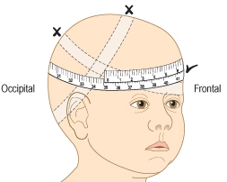
- measure three times and note largest measurement.
- normal head circumference of term infant:
at birth - 34-35 cm
at 6 months - 44 cm
at 12 months - 47 cm
if ↓ - suspect premature closure of sutures, microcephaly;
if ↑ - suspect hydrocephalus, subdural hematoma, brain tumor.
- children who are above 90-98th percentile or below 5th percentile (as well as those who cross percentiles rather than growing along curve) require evaluation for cerebral pathology.
- value for head circumference should be related to age, sex, body length.
e.g. head circumference of +3SD, is not abnormal unless body length is < +1SD.
- for objective confirmation of hypertelorism / hypotelorism – measure interpupillary distance (vs. intercanthal distance)!

Assess cranial vault and face for asymmetry.
- in utero positioning may result in transient facial asymmetries (e.g. micrognathia due to head flexion on sternum).
- head of premature infant at birth is relatively long in occipitofrontal diameter and narrow bitemporally; this continues for first year.
- plagiocephaly (cranial vault asymmetry) occurs when infant sleeps constantly on one side; disappears as baby becomes more active and spends less time in one position.

Skull transillumination (not routinely used since advent of CT) – in completely darkened room, with standard 3-battery flashlight (with soft rubber collar).
- in normal infant 2 cm halo of light is present around flashlight when placed over frontoparietal area, and 1 cm halo – over occipital area;  - uniform transillumination of entire head – thinned / absent cortex, advanced hydrocephaly (+ “setting sun” sign):  - decreased area of transillumination - acute subdural hematoma. | 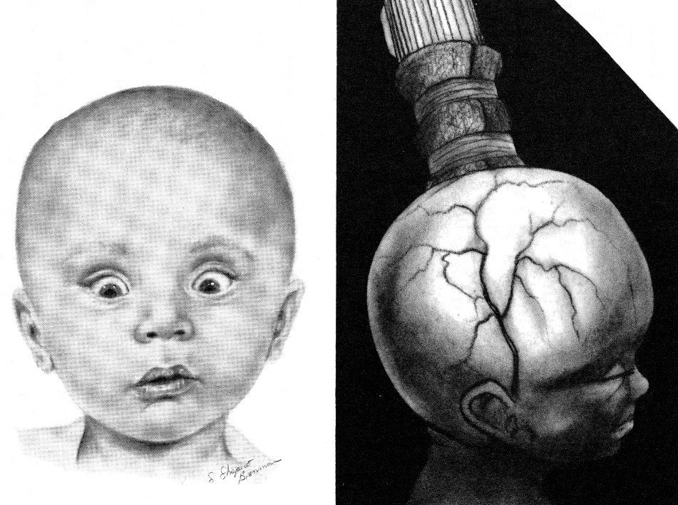

Auscultation (with stethoscope diaphragm) over anterior fontanelle and temporal areas:
systolic / continuous bruit is normal in < 5 years;
bruit after 5 years – significant anemia, ICP↑, AV malformation.

Spine
- turn baby over and feel along length of vertebral column starting at neck
- note that sacrum and coccyx are present (sacral agenesis is associated with maternal diabetes).
- hairy / pigmented patch over lower spine may indicate spina bifida occulta.
- if you find sacrococcygeal pit → visualize bottom of it by separating surrounding skin in good light (if pit is lined with dry skin, it excludes pathological communication with spinal cord).

Infantile automatisms (Primitive Reflexes)
- normal developmental reflex phenomena present at birth and disappearing in early infancy.
N.B. absence in neonate, asymmetry, or persistence beyond expected disappearance time (delayed neuromaturation) – nonspecific indicator of severe CNS dysfunction!
Not fully developed in premature infants!

In preferred order:

- Blinking (dazzle) reflex – eyelids close in response to bright light.
  - disappears after 1st year.
  - absence may indicate blindness.

- Acoustic blink (cochleopalpebral, audiopalpebral) reflex for details → see p. D1ear >>
  - difficult to elicit during first 2-3 days.
  - may disappear temporarily after it is elicited (habituation).
  - disappearance time variable.
  - absence may indicate decreased hearing but it is crude test and does not indicate deafness!

- Darwinian (grasping) reflex
- palmar grasp: with baby’s head positioned in midline and arms semiflexed, place your index fingers from ulnar side into baby’s hands and press against palmar surfaces → flexion of all baby’s fingers to grasp your fingers and hang suspended; you can enhance reflex by offering bottle (sucking facilitates grasping).
  - starts at 28 wk gestation and is well established by 32 wk.
  - disappears at 3-4 months; persistence beyond 4 months suggests cerebral dysfunction.
N.B. newborns normally hold hands clenched, but persistence of fisted hand beyond 2 months suggests spastic diplegia.
  - light stroking of hand ulnar surface and 5th finger → finger extension (digital response reflex).
- plantar grasp - stroke sole → toes will flex and curl round your examining finger.

N.B. make sure response is not inhibited by inadvertently stimulating dorsal aspects of feet and hands!

- Pull to sit - hold baby's hands and gently pull to sit - watch sternocleidomastoid muscles which should bilaterally anticipate pull to sit; head flexes for moment before head lag occurs:
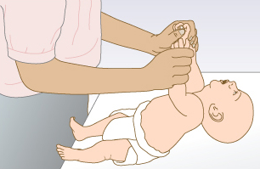
- Galant (trunk incurvation) reflex - gulint krūtine ant tiriančiojo delno pusiau vertikalioje padėtyje, braukiant pirštu lygiagrečiai stuburui (≈ 1 cm nuo midline) per visą liemens ilgį → mažylio kūnas išsilenkia į dirginamąją pusę.  - disappears at 2 months.  - used to detect transverse spinal cord lesions. |  | 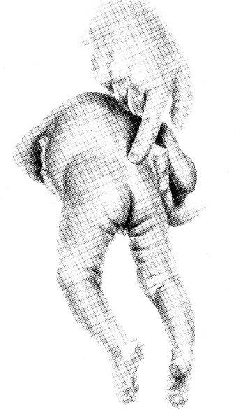
- Rotation test – hold baby under axillae, at arm length facing you, and rotate him in one direction and then the other → baby’s head turns in direction in which you turn baby; if you restrain head with your thumbs, his eyes will open and turn in direction in which he is turned.  - disappearance time variable.  - early detection of strabismus; absence indicates vestibular dysfunction. | 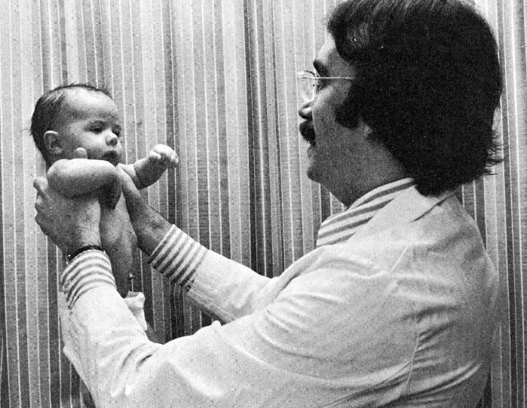

- Vertical suspension positioning - už pažastų paėmus naujagimį (rodomaisiais pirštais ir nykščiais prilaikant galvą) ir pakeliant jį vertikaliai, mažylis sulenkia kojas per kelio ir klubo sąnarius, o nuleidžiant ant atramos, jis atsiremia visa pėda ir "stovi" ant pusiau sulenktų kojų ištiesęs liemenį.  - disappears after 4 months.  - fixed leg extension and adduction (“scissoring”) indicates spastic paraplegia: | 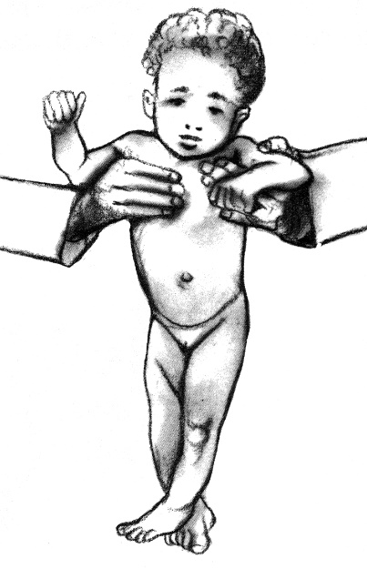

- Placing response - laikant naujagimį iš nugaros už pažastų (rodomaisiais pirštais ir nykščiais prilaikant galvą):
- allow dorsal surface of one foot to touch undersurface of table top (do not plantarflex foot!) → baby flexes hip & knee and places stimulated foot on table top. | - pastačius ant stalo ir šiek tiek palenkus jo kūną į priekį, kojos atlieka žengimo judesius.
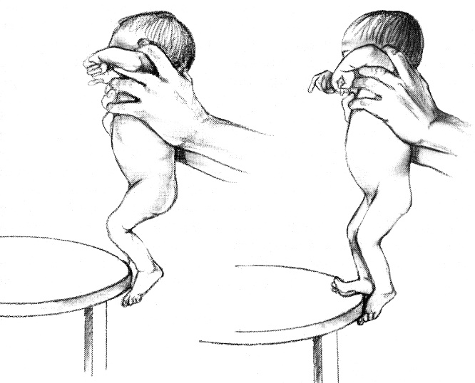 | 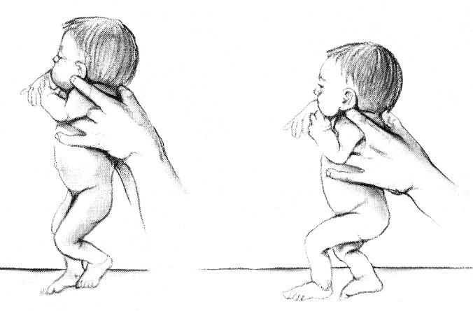
- best after the first 4 days; disappearance time variable (replaced by voluntary action).
- absence indicates paresis or breech delivery.

Here is also convenient to test Moro reflex. see below >>
- Rooting reflex – with baby’s head positioned in midline and his hands held against his anterior chest, stroke with your index finger perioral skin:  at mouth corners → mouth will open and turn to stimulated side;  at midline of upper lip → head will retroflex;  at midline of lower lip → jaw will drop.  - disappears at 3-4 months; may be present longer during sleep.  - absence may indicate cerebral dysfunction. | 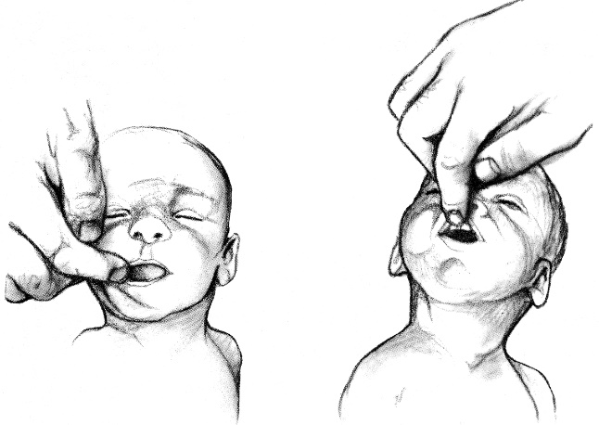

- Straubliuko - stuktelėjus pirštu per lūpas.
- Sucking – įdėjus į burną pirštą ar čiulptuką, pradeda čiulpimo judesius.

- Tonic neck reflex – baby in supine position; turn head to one side (holding jaw over his shoulder) → arm & leg on this side extend, while opposite arm & leg flex.
- present at birth (from 37th week gestation); most intensive at 1 month; disappears at 6 months.  N.B. reflex normally must not occur each time it is elicited!!!  - if persists beyond 6 months or occurs each time is elicited (at any age) or is asymmetric or is obligatory (posture maintained beyond 30 sec.) – major cerebral damage. | 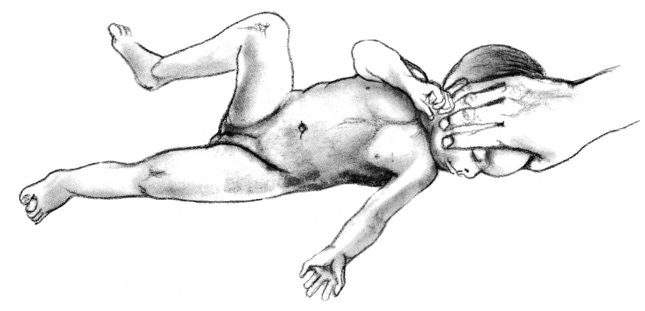

- Babkino (delnų-burnos) - paspaudus delną, naujagimis išsižioja.
- Galvos posūkio - paguldžius ant pilvo, jis pasuka galvą į vieną arba kitą pusę, išlaisvindamas kvėpavimo takus.
- Bauerio (šliaužimo) - gulint ant pilvo ir pridėjus prie kojų atramą, naujagimis ima šliaužti.

Mass reflexes:
  - disappear by 3rd month.
  - absence indicates cerebral ÷ muscular lesion.
absent Moro reflex + “setting sun” sign + opisthotonus = kernicterus
  - persistence beyond 6 months – clearly abnormal (neurologic disease).

- Perez reflex - padėtis kaip Galanto, spaudžiant nykščiu perbraukti per stuburą nuo uodegikaulio iki kaklo → head & spine extension, truputį sulenkia galūnes, pravirksta ir pasišlapina (tinka naujagimiams paimti šlapimo mėginiui!).

- Startle reflex (s. Moro reflex) - baby’s arms briskly abduct and extend with hands open and fingers extended + legs flex slightly and abduct (but less so than arms); arms then return forward over body in clasping maneuver (sukryžiuoja, lyg apglėbdamas krūtinės ląstą);
  - it is phylogenetic remnant of movements used by subhuman primate infants to cling to their mothers.
  - reflex begins by 28-32 wk gestation and is well established by 37 wk; may occasionally occur in term newborns during handling.
  - reflex is elicited by any stimulus that suddenly moves head in relation to spine:
    - lift supine baby by supporting his head at angle ≈ 30° → suddenly release your grip by allowing head to fall ≈ 1 cm backward (into your hand):
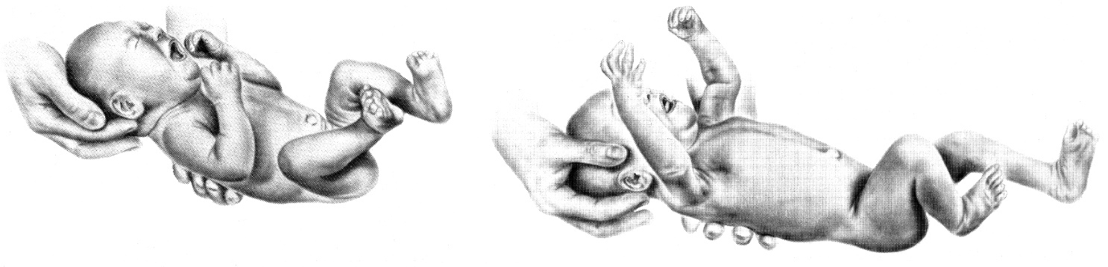
    - hold baby in supine position (supporting head, back and legs); suddenly lower entire body ≈ 2 feet and stop abruptly;
    - support baby in vertical position; suddenly tip upper body downward (as if child were to fall) - child spontaneously extends upper extremities (as protective mechanism) - parachute reflex.
    - produce sudden loud noise (e.g. strike examining table with palms of your hands on either side of baby’s head).

“Soft” Neurologic Signs
- considered normal in younger children, but when still present in school-aged child suggest neuromaturational delay.
N.B. specific soft signs lack association with particular disability and can occur in normal child - it is unwise to label child who manifests several soft neurologic signs!
  - Dystonic posturing of arms & hands when walking on heels.
  - Mirror movements of opposite hand while performing rapid alternating movements with thumb & fingers.
  - Substantial movements of tongue or mouth while writing.

Meningeal signs
- nuchal rigidity is most reliable sign of meningeal irritation; infants may lie in opisthotonus position:
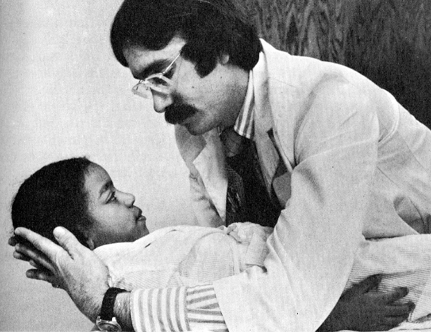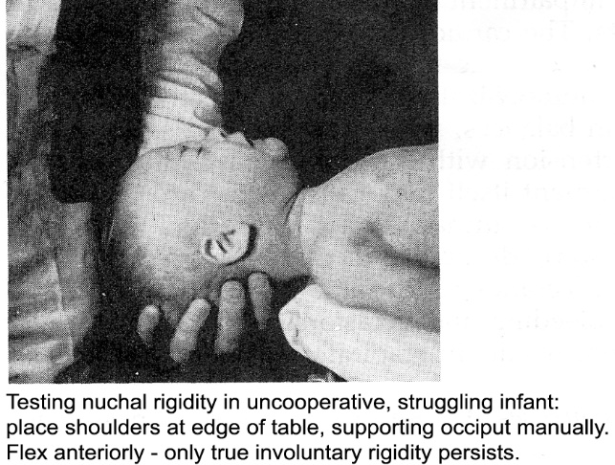
- ask child to sit with legs extended; normally he is able to sit upright and touch chin to chest (padėk žaisliuką ant sternum – vaikas pats į jį pasižiūrės); in meningeal irritation child assumes tripod position:
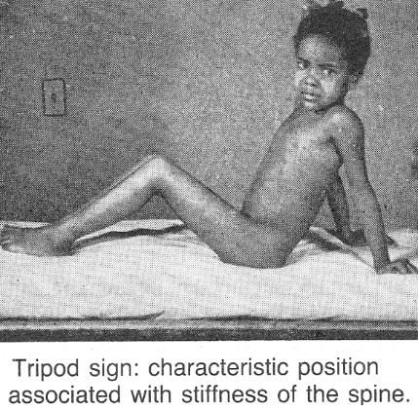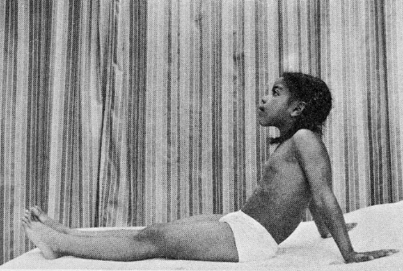

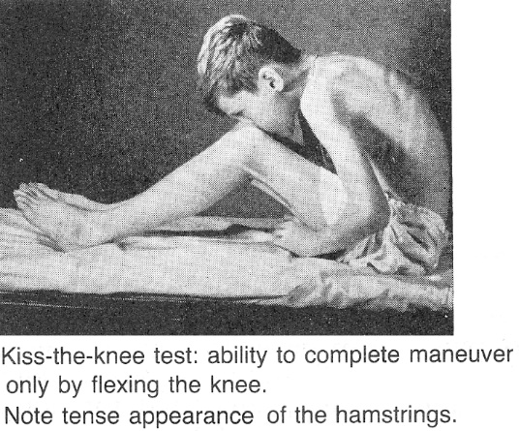
- kūdikių didžiojo momenėlio išsipūtimas ir pulsacija!
- Lesažo - pakeltas už pažastų vaikas pritraukia ir laiko kojas prie pilvo.

Neonates - 25-75% will not have nuchal rigidity*; tense bulging fontanel is more reliable sign (but may be absent in dehydration).
*Kernig's and Brudzinski's signs appear at or shortly after 1st year of life

Spasmophilia signs
      - Chvostek sign – plaktuku / pirštu sudavus tarp skruosto lanko ir lūpos kampo, just aterior to auditory meatus (n. facialis), toje pusėje trukteli burnos, nosies, voko raumenys.
Normal in newborns and some infants!
      - Trousseau sign - 3 min užspaudus a. brachialis plaštaka įgauna "akušerio rankos" formą (carpopedal spasm - flexion of wrists and metacarpophalangeal joints and extension of phalangeal joints; feet are dorsiflexed at ankles and toes plantar flexed).
      - Liusto - stuksenant n. peroneus sritį, pėda įgauna "arklio pėdos" formą.

Psychomotor Development
Išvados daromos tik apžiūrėjus pakartotinai! (wide variations in normal development are rule!)

Screening of infant - ability to:
- Reach toy
- Transfer cube from one hand to other
- Use thumb and forefinger pincer grasp in picking up small object

Screening in early childhood - ability to:
- Build tower with blocks
- Play ball with examiner
- Perform hop, skip, jump

Screening for early schoolchildren:
- Orientation to time and place
- Language and numbering skills
- Tie shoelaces
- Button shirt fronts
- Writing skills
- Using scissors
- Right-to-left discrimination: for self (attained at 6-7 yrs), for examiner (attained at 8-9 yrs).

Kūdikis vertinamas gulintis ant pilvo, po to ant nugaros:
- stebimas spontaninis aktyvumas.
- kaip reaguoja į žmogaus ar daiktų, patekusių į regėjimo lauką, judėjimą bei į jo artimiausią pasiekimo zoną pakliuvusius stambius daiktus.

≥ 7 mėn vaikams paduodami kubeliai, sviedinukai arba pieštukas ir popieriaus lapas - ar sugeba pakartoti gydytojo veiksmus.

> 2.5 metų vaikų galima paprašyti nupiešti žmogų, kitą figūrą.

Screening Scheme for Developmental Delay (Upper Range of Normal Skills):
Age (Months) | Gross Motor | Fine Motor | Social Skills | Language
2 | Lifts head/chest when prone | Tracks past midline | Recognizes parent, social smile | Alerts to sound, coos
3 | Supports weight on forearms | Opens hands spontaneously | Smiles appropriately | Coos, laughs
4-5 | Rolls front to back, back to front (5 months) | Grasps rattle | Enjoys looking around | Orients to voice, “ah-goo”, razzes
6 | Sits momentarily unassisted | Transfers objects, raking grasp | Shows likes and dislikes, stranger anxiety | Babbles
9-10 | Pulls to stand, crawls | 3-finger pincer grasp | Plays patty-cake, peek-a-boo, waves bye-bye | Imitates sounds, mama/dada (nonspecific)
12 | Walks with one hand held, cruises, walks alone | 2-finger pincer grasp, releases object on command | Comes when called, imitates actions | 1-2 meaningful words, mama/dada (specific)
15 | Walks backward | Uses cup | Temper tantrums | 4-6 words
18 | Walks upstairs / downstairs with assistance, runs, kicks ball | Feeds from spoon, Builds tower of 2-4 blocks | Copies parent in tasks (e.g. sweeping) | ≥ 6 words, names common objects
24 |  | Builds tower of 6 blocks | Plays in solitary, parallel play.  Follows 2-step command | 2 word phrases
36 | Rides tricycle, climbs stairs with alternating feet | Copies a circle, uses utensils, brushes teeth with help, washes/dries hands |  | 3 word sentences
48 | Hops | Copies cross | Cooperative play | close to adult speech competence; counts to 10

- review family's baby book (milestones for child may have been dutifully recorded).
- neurodevelopment of girls is more accelerated for many motor tasks.

Motor
Birth | Sleeps much of time; sucks, clears airway
2-4 weeks | Moves head from side to side when lying on stomach; reflex grasp
1-2 months | Lifting head up 45-90° from prone position
2 months | Lifting chest up from prone position
3 months | Holds head steady on sitting; opens and shuts hands; pushes down when feet are placed on flat surface; swings at and reaches for dangling toys
4 months | Sitting with support; rises body on arms when prone; brief purposeful grasp
5-6 months | Rolls over (usually from stomach to back); reaches for objects
7 months | Sitting without support; bears some weight on legs when held upright; transfers objects from hand to hand; holds own bottle
8-10 months | Standing without support
9-10 months | Creeping on hands and knees; gets into sitting position from stomach; pulls self up to standing position
11 months | Walking when led by hand
12 months | Walks by holding furniture (“cruising”); may walk 1-2 steps without support; stands for few moments at time; drinks from cup; has pincer grasp
15 months | Adept at independent locomotion
18 months | Descends / climbs stairs holding on (may slide on belly); turns several book pages at time; partially feeds himself; throws ball overhand
2 years | Can reproduce circle; climbs up and down stairs alone; runs well; turns single book pages; puts on simple clothing; kicks ball; holds cup securely
3 years | Can reproduce cross, climbs up stairs alone, can stand on one foot, builds tower of 9-10 cubes; rides tricycle; dresses well except for buttons and laces
4 years | Alternates feet going up and down stairs; throws ball overhand; hops on one foot; copies cross; washes hands and face
5 years | Can reproduce square; catches bounced ball; dresses and undresses without help; walks on tiptoes
6 years | Can skip, tie shoelaces
7 years | Can reproduce diamond
8 years | Can hop twice on one foot and then smoothly alternate to hop twice on opposite foot
10 years | Can stand in feet tandem (heel-to-toe) with eyes closed for 15 seconds; can crumple paper into ball without using table surface (5 seconds for dominant hand; 7 seconds – nondominant)

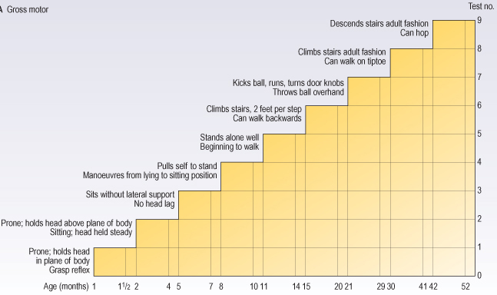
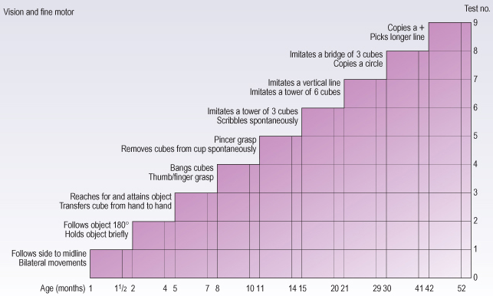

Vocal
Birth | Responds with crying to discomforts and intrusions
6-8 weeks | Cooing, precursor to later babbling and speech
2 months | Development of 7 phonemes*
6 months | Development of 12 phonemes
9 months | Says “mama” or “dada” (possibly appropriately in reference to parents)
12 months | Development of 18 phonemes
18 months | 10-50 words
2 years | ≈ 50% of child’s speech should be intelligible; makes 2-3-word sentences; verbalizes toilet needs; questions “what’s this”; uses pronouns (me, you, I)
3 years | More than 1000 words; ≈ 75% of child’s speech should be intelligible; counts to 10 and uses plurals; uses “me” and “you” correctly; questions constantly
4 years | Style of adult language is established; almost 100% of child’s speech should be intelligible; can tell someone his name, discuss simple aspects of daily life; uses some plurals and past tenses
5 years | Can tell simple story
*adult American speech has 35 phonemes (distinct sounds)
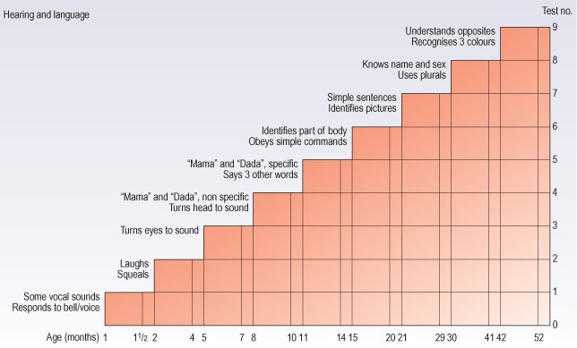
- at 3-5 years, average child learns two new words daily.
- articulation errors (e.g. substituting “w” for “r” in rabbit, or “d” for “th”) are common and normal in toddler age group.

Sensory
Birth | Can discriminate sound and visually follow light; capacity for visual fixation within several hours after birth
10 days | Can differentiate smell of mother versus nonmother
4 weeks | Follows object as it is moved 90° to either side from midline about 15 cm above face; responds to noise with startling, crying, or quieting; may turn toward familiar sounds and voices
6-8 weeks | Regards objects in line of vision; follows object as it is moved from side-to-side in 180° arch (i.e. past midline); turns head and eyes to sound
3 months | Watches faces intently
4 months | Can fully accommodate visually; visual fixation is increased if pattern is complex and especially if it resembles human face
5-6 months | Recognizes people at distance; listens intently to human voices
7 months | Looks for dropped object
12 months | Looks for object hidden in his presence
3 years | Recognizes at least 3 colors
5 years | Knows 4 colors

Social
6 weeks | Begins to smile when spoken to
3 months | Smiles at sound of caretaker's voice
5-6 months | Smiles spontaneously
7-8 months | Plays peek-a-boo
9 months | Objects if toy is taken away; plays pat-a-cake; responds to own name; understands “no” and waves “bye-bye”
2 years | Engages in solitary or parallel play (not capable of sharing)
3 years | Shares playthings, plays interactive games; sibling rivalry begins; ½ of children can take care of toilet needs
4-5 years | Fixed and stable concept of gender; has imaginary friend
Time of school entry | Easily separates from mother

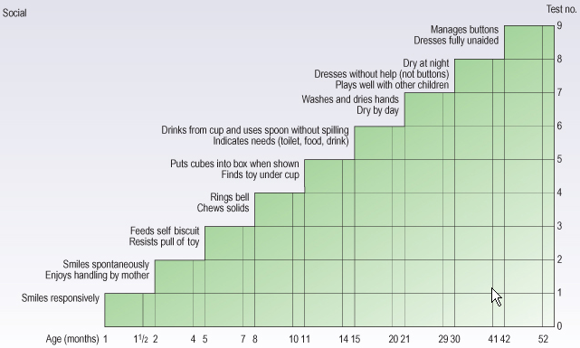

Denver II developmental monitoring tool (identifies children at risk for possible developmental problems and confirms subjective suspicions of delay):
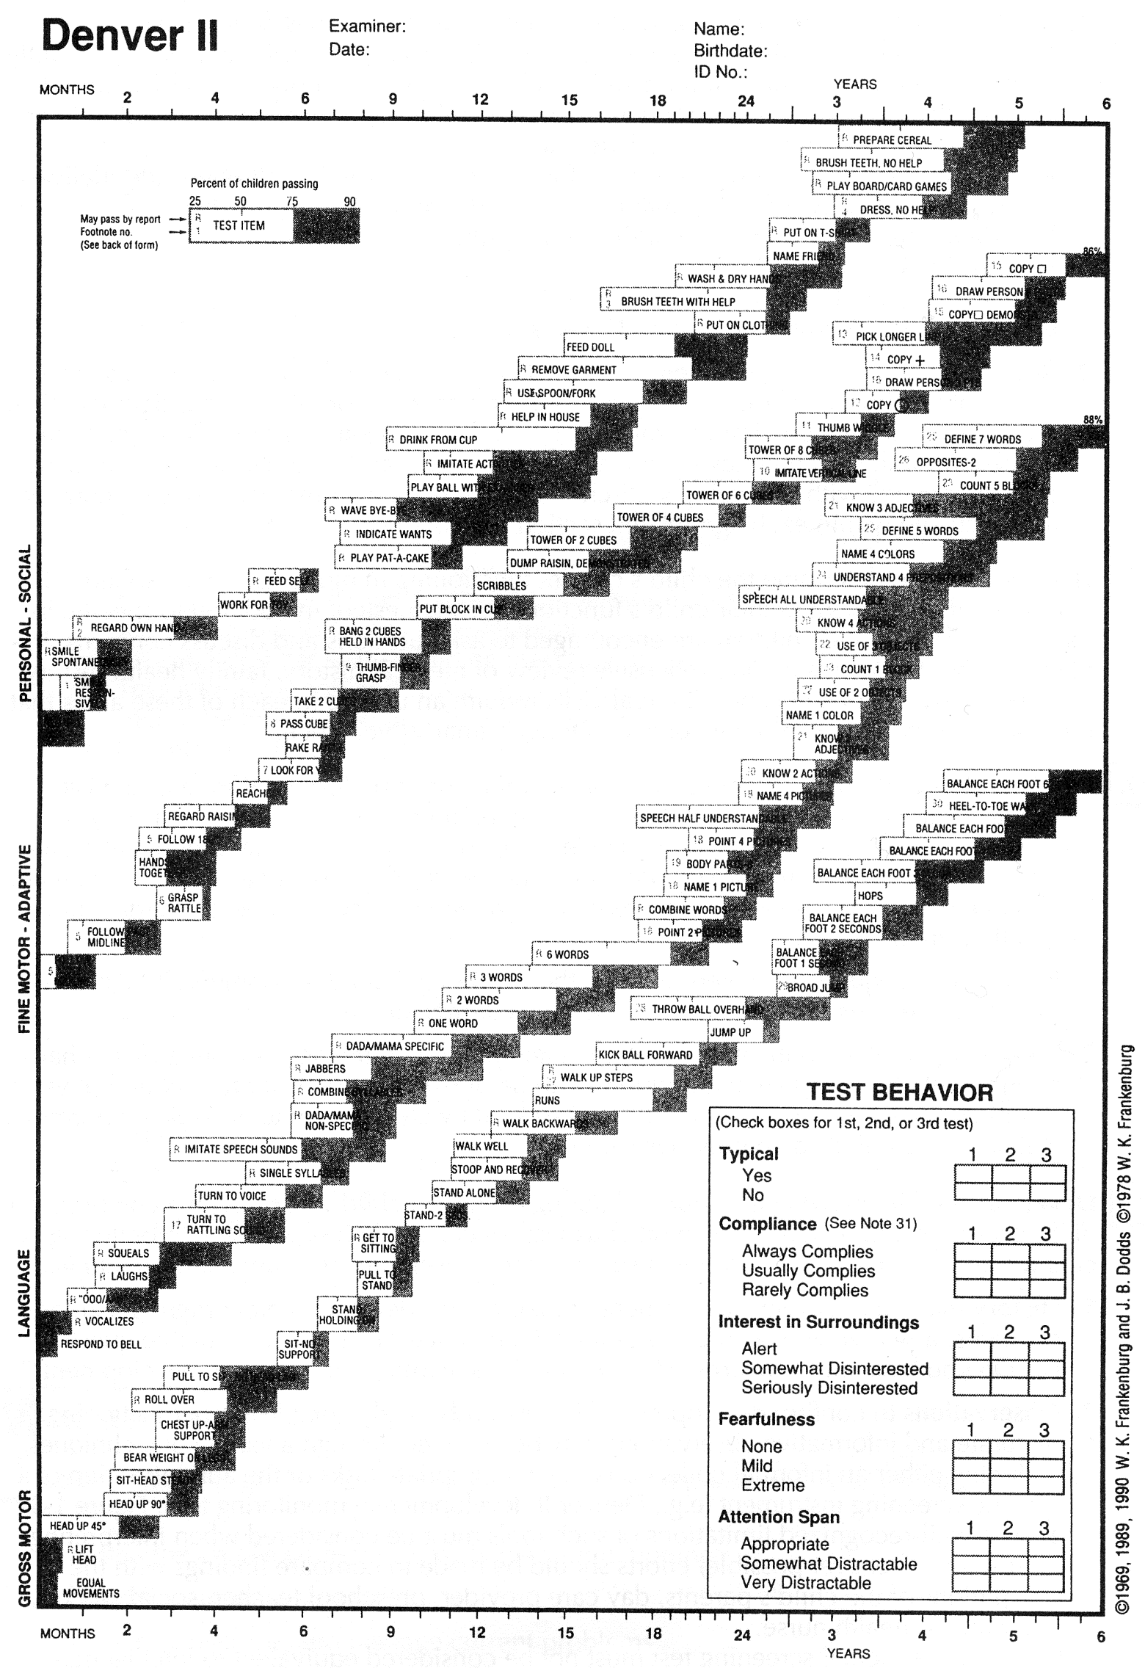

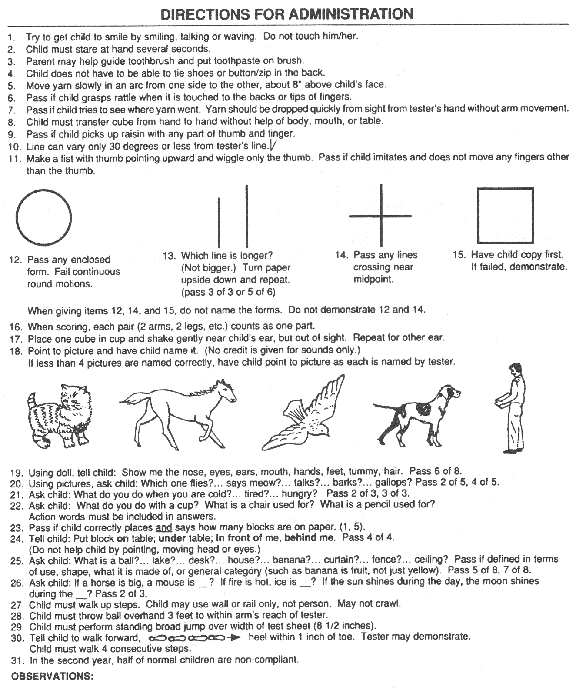

Bibliography for ch. “Diagnostics” → follow this link >>

Viktor’s Notes℠ for the Neurosurgery Resident
Please visit website at www.NeurosurgeryResident.net

