Electromyography (EMG)
Last updated: June 3, 2019
Normal EMG 1
Abnormal EMG 1
Prolonged insertion activity 2
Abnormal spontaneous activity 2
Abnormalities of motor unit action potentials 3
Single-fiber EMG 3
EMG according to disorder 4

EMG - extracellular electrical activity recorded from muscle.

Methodology
- spontaneous electrical activity and individual motor units cannot be seen with surface electrodes.
- needle electrode placed within muscle.
  - monopolar needle electrode
  - concentric needle electrode (most popular) - fine silver (or platinum) wire, insulated except at its tip, that is contained within pointed steel shaft - potential difference between outer shaft and inner wire is recorded.
upward deflection indicates that active electrode is negative with respect to reference one
- potentials are amplified → evaluated visually (on oscilloscope screen) and aurally (over loudspeaker).
- motor unit pathology can be localized to nerve*, muscle, or neuromuscular junction.
*EMG also permits lesion to be localized to spinal cord, nerve roots, plexuses, or peripheral nerves – by topographic pattern of affected muscles.

Usefulness of EMG:
- support of diagnosis (e.g. myopathy vs. neuropathy)
N.B. specific etiologic diagnoses cannot be made!
- confirming clinical phenotype of muscle involvement established on neurologic examination (i.e. confirming muscle weakness in individual muscles)
- guiding muscle biopsy

Normal EMG
Needle electrode is inserted → brief burst of activity for ≤ 2-3 seconds → no spontaneous activity*.  *except in endplate region - endplate "noise" (nonpropagated miniature endplate potentials generated by spontaneous Acch release). | 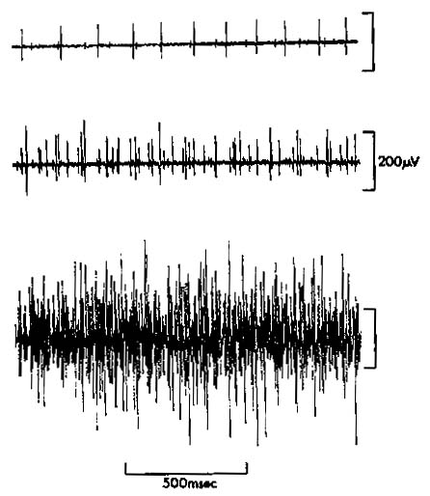
  - slight voluntary contraction is initiated → few motor units are activated - fire irregularly at low rate.
  - increasing effort → fire more rapidly; at certain firing rate, additional units are recruited.
  - maximal effort → so many units are recruited that individual potentials cannot be distinguished – “complete interference pattern”.
- normal recruitment pattern on maximal effort is dense with no breaks in baseline;
- amplitude of envelope (excluding single high-amplitude spikes) is 2-4 mV (using concentric needle with standard recording area 0.07 mm² ).

Normal extracellularly recorded individual motor unit action potentials are biphasic or triphasic.
- duration 2-15 msec.  - amplitude 200 µV - 3 mV.  - polyphasic potentials (> 4 phases) are nonspecific findings:  - occur in both neurogenic and myogenic disease;  - also are found in small numbers (10-15%) in all normal muscles.  A. Normal triphasic potential.  B. Long-duration, high amplitude polyphasic potential (shown twice) – neuropathic potential.  C. Short-duration, low-amplitude, polyphasic potential – myopathic potential. | 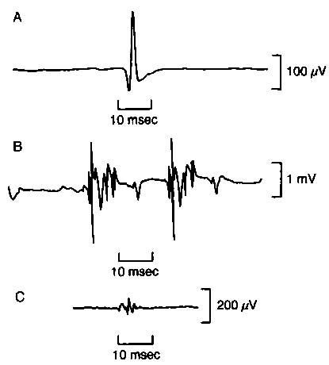

Abnormal EMG
Evaluate:
- insertional activity
- spontaneous activity
- voluntary activity:
  - motor unit form (individual action potentials - amplitude, duration, number of phases) - during minimal volitional activity.
  - density of motor units (recruitment pattern) - during maximal volitional activity.

- EMG requires patient cooperation for full relaxation and maximal voluntary muscle contraction – EMG is less useful in pediatrics.

Prolonged insertion activity
- acute denervation
- active (usually inflammatory) myopathy

Abnormal spontaneous activity
Denervated muscle fibers discharge spontaneously! → fibrillation potentials and positive sharp waves.

Fibrillation potential - biphasic (or triphasic) discharge with positive onset (except in endplate region);
- represents action potential generated in single muscle fiber (so cannot be detected by clinical examination).
- amplitude up to 300 µV, short duration ≤ 5 msec, frequency ≤ 20 Hz.
- usually fire rhythmically - reflect oscillations of resting membrane potential of muscle fibers.
- etiology - increased muscle irritability:
  - denervated muscle:
    - may not appear even for 3-4 weeks after acute neuropathic lesion.
    - found earlier in proximal muscles (in distal muscles may appear only after 4-6 weeks).
    - once present, persist indefinitely unless reinnervation occurs or muscle completely degenerates so that no viable tissue remains.
  - occasionally in some active myogenic disorders (inflammatory, muscular dystrophies, muscle trauma, certain metabolic disorders [e.g. acid maltase deficiency]).

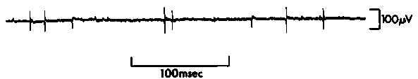

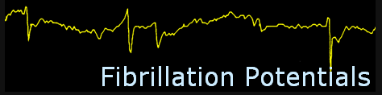

Positive sharp waves - initial positive* deflection → slow deflection in negative direction.
* traveling wave terminates at point of needle recording, so there is no upgoing negative phase.
- found in association with fibrillation potentials.
- amplitude up to 300 µV, duration ≥ 10 msec, frequency up to 100 Hz.
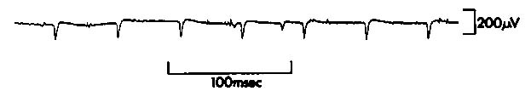

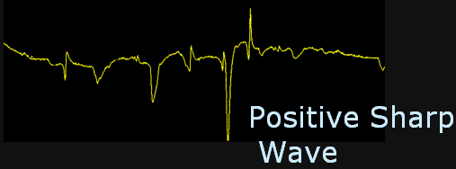

Spontaneous fibrillation potentials + positive sharp waves:

Fasciculation potential - spontaneous activation of all muscle fibers in motor unit.
- indistinguishable from normal motor unit action potentials!
- amplitude & duration greater than fibrillation potential.
- sudden dull thump over loudspeaker.
- etiology - disease of anterior horn cells*, very occasionally certain myopathic disorders (e.g. thyrotoxicosis), sometimes as isolated phenomenon without pathological significance (benign fasciculations).
*may arise at any site along motor axon or motoneuron body.

Myotonic discharges - spontaneous repetitive high-frequency trains of action potentials derived from single muscle fibers; decreasing amplitude and frequency.
- etiology - myotonic disorders, acid maltase deficiency.
- sound myographically like "dive bomber".
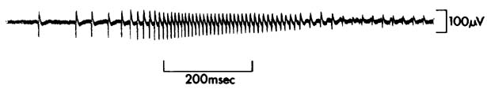

Complex repetitive discharges - constant high frequency and amplitude; starts and stops abruptly and does not wax and wane (vs. myotonia) - sounds like “jack hammer”.  - etiology - chronic partial denervation, certain muscular dystrophies or inflammatory muscle disorders.  - arise in muscle itself - initiated by fibrillating fiber that depolarizes adjacent fibers by ephaptic transmission. | 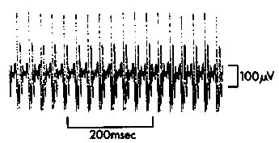

Myokymia - spontaneous grouped pattern of firing of motor units (double, triple, or multiple discharges → period of silence → another grouped discharge).
- etiology – see p. Mov3 >>
EMG myokymia may be found in some individuals without any clinically visible twitching!

Nascent polyphasic potentials - indicative of muscle reinnervation. see p. PN7 >>

Abnormalities of motor unit action potentials
Needle electrodes record only from portion of motor unit, but change in amplitude and duration is diagnostic.
Myopathies (↓number of muscle fibers in individual motor units; number of motor units is normal):
- myopathic potentials - ↓duration & amplitude (i.e. recruitment density is normal, but envelope amplitude is reduced);
pathognomonic finding of myopathy: full recruitment in weak, wasted muscle.
- ↑incidence of polyphasic potentials.
- because individual motor units generate less tension than normal, increased number is recruited for any given degree of voluntary activity (rapid recruitment).

Neuropathies (↓number of motor units):
- ↓recruitment density, s. decreased recruitment (reduced interference pattern);
sometimes only one unit can be recruited by maximal effort, and this unit may fire faster than 40 Hz (discrete recruitment).
- during voluntary activity, there is compensatory increase in rates at which individual remaining units begin firing and at which they fire before additional units are recruited.
- after reinnervation, surviving axons branch to innervate adjacent muscle fibers, thus enlarging number of muscle fibers per unit → ↑duration & amplitude (> 10 msec, > 5 mV) of motor unit action potentials (neuropathic potentials) which frequently are polyphasic.

Diseases of neuromuscular transmission (reduced safety factor for neuromuscular transmission → variation in number of muscle fibers firing with each discharge of unit):
- motor unit action potentials vary in amplitude & area;
- excess of small, short-duration potentials.
- increased jitter at single-fiber EMG. see below >>

Quantitative motor unit potential analysis provides more reliable correlation with muscle and nerve disease than muscle biopsy!

Contracture (involuntary, sustained muscle contraction in phosphorylase deficiency) - electrical silence.

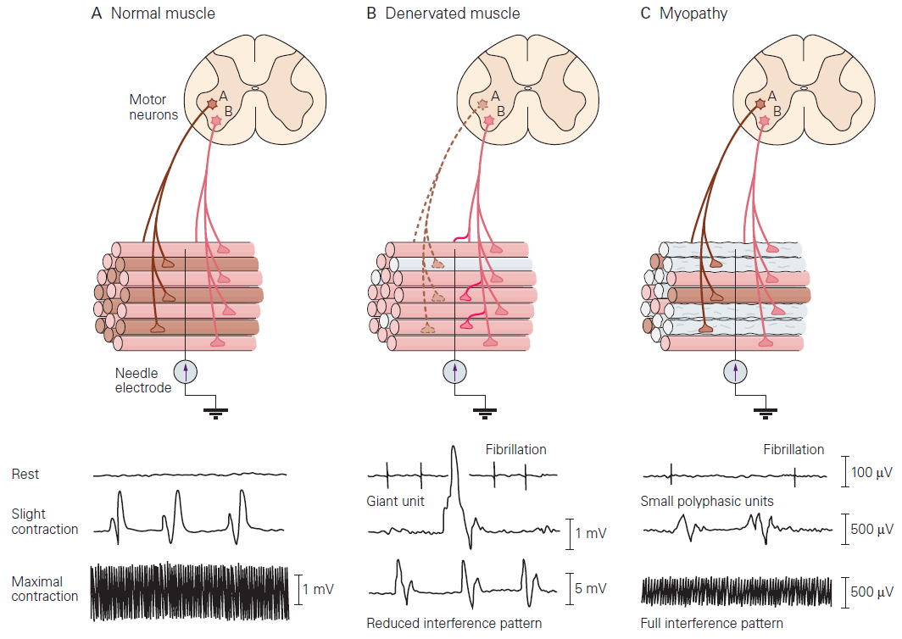

Single-fiber EMG
- action potentials recorded from two or more muscle fibers belonging to same motor unit.
- special electrode.
- temporal variability (jitter) between two action potentials at consecutive discharges is measured.
- jitter reflects variation in neuromuscular transmission time in two motor endplates involved (i.e. variation in latency between nerve stimulus and resulting muscle action potentials).
- normal jitter is 10-50 μsec.
- main clinical application - diseases of neuromuscular transmission - increased jitter, impulse blocking (failed muscle fiber activation).
  - clinical muscle weakness correlates with impulse blocking.
  - normal single-fiber EMG rules out disorder of neuromuscular transmission!
  - single-fiber EMG is more sensitive than repetitive nerve stimulation or determination of acetylcholine receptor antibody levels in diagnosing myasthenia gravis!

Normal: Increased jitter:

EMG according to disorder
Denervation
- insertional activity - increased (e.g. bizarre high frequency discharges).
- spontaneous activity - fibrillations, positive sharp waves, fasciculations, complex repetitive discharges; increased polyphasic action potentials.
- voluntary activity - neuropathic potentials (↑duration & amplitude); ↓recruitment density.
- other studies - prolonged "F response", lost H reflex. see p. D22 >>

Myopathy
- insertional activity - increased (e.g. bizarre high frequency discharges).
- spontaneous activity - complex polyphasic motor unit potentials; some myopathies (e.g. polymyositis, muscular dystrophies) may show fibrillations, positive sharp waves.
- voluntary activity - myopathic potentials (↓duration & amplitude); rapid recruitment.

Neuromuscular junction disorders
- abnormal repetitive motor nerve stimulation results. see p. D22 >>
- increased jitter, blockings on single fiber EMG.

Myotonia
- spontaneous hyperexcitability: repetitive high-frequency trains of action potentials; wax and wane in amplitude and frequency.

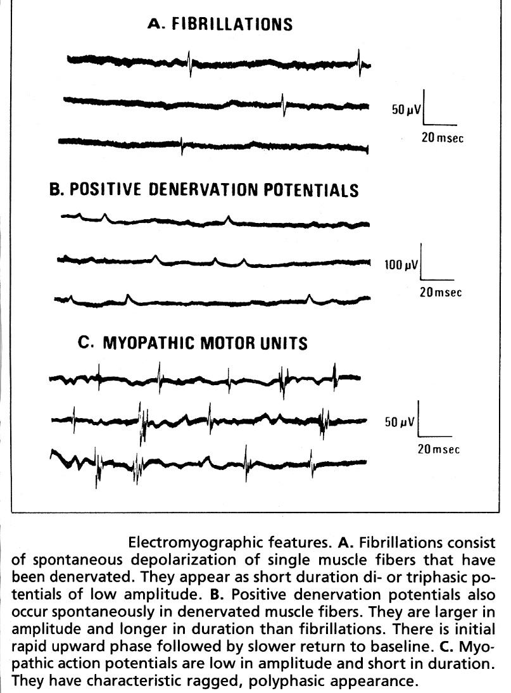
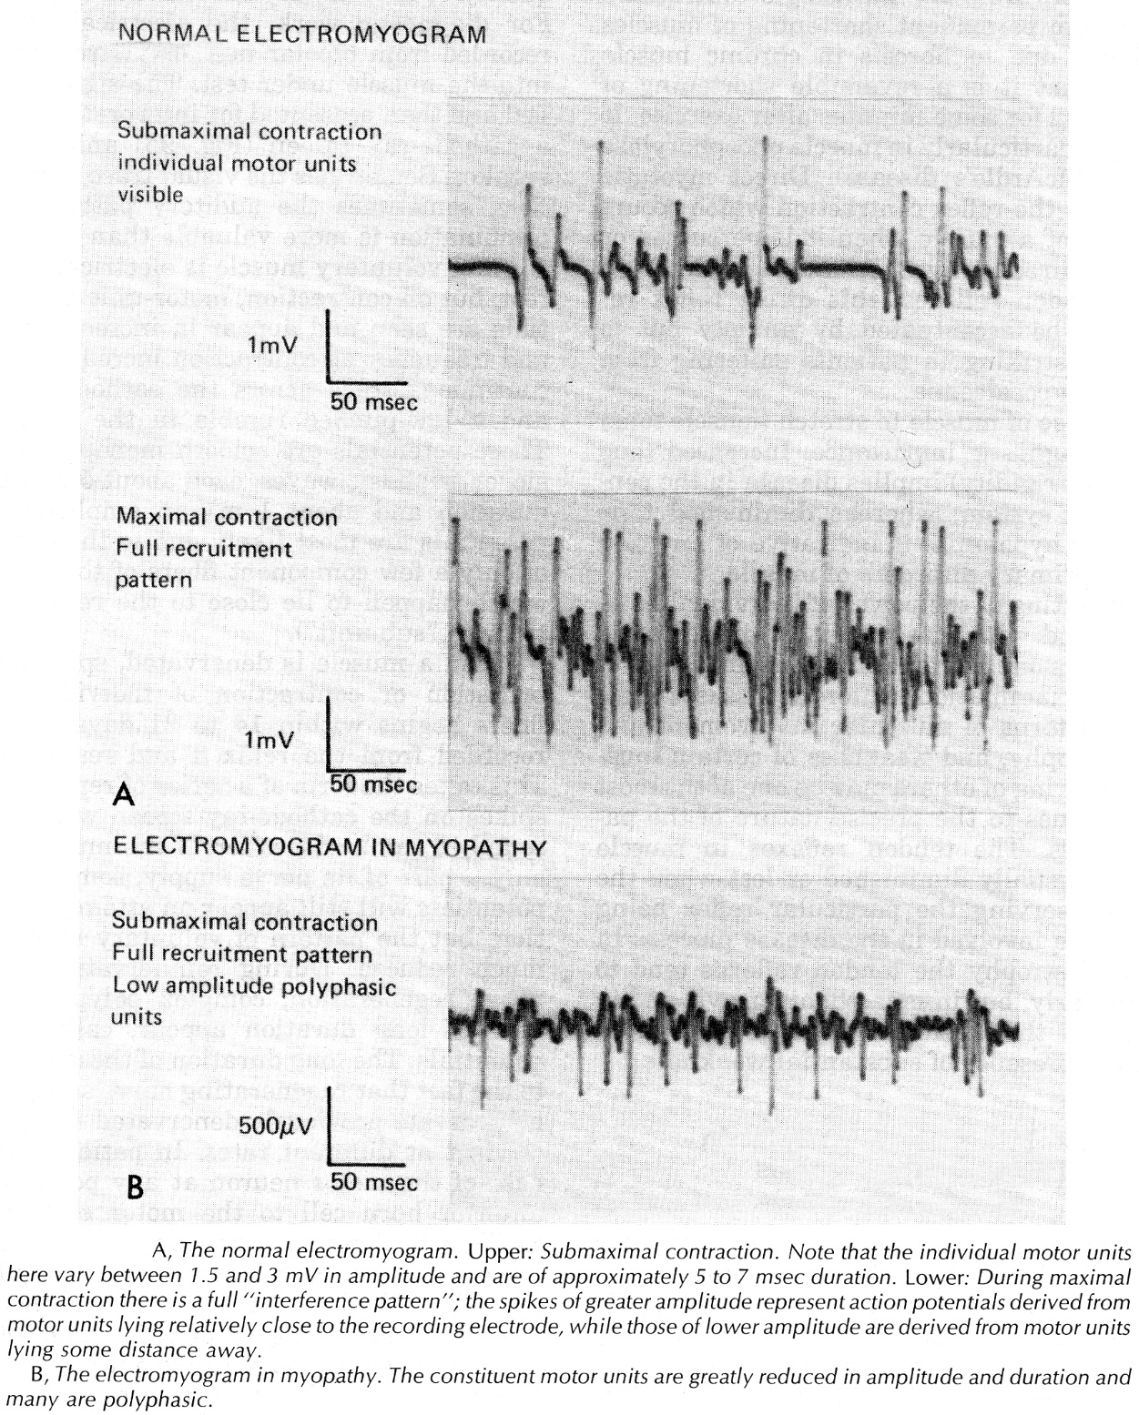
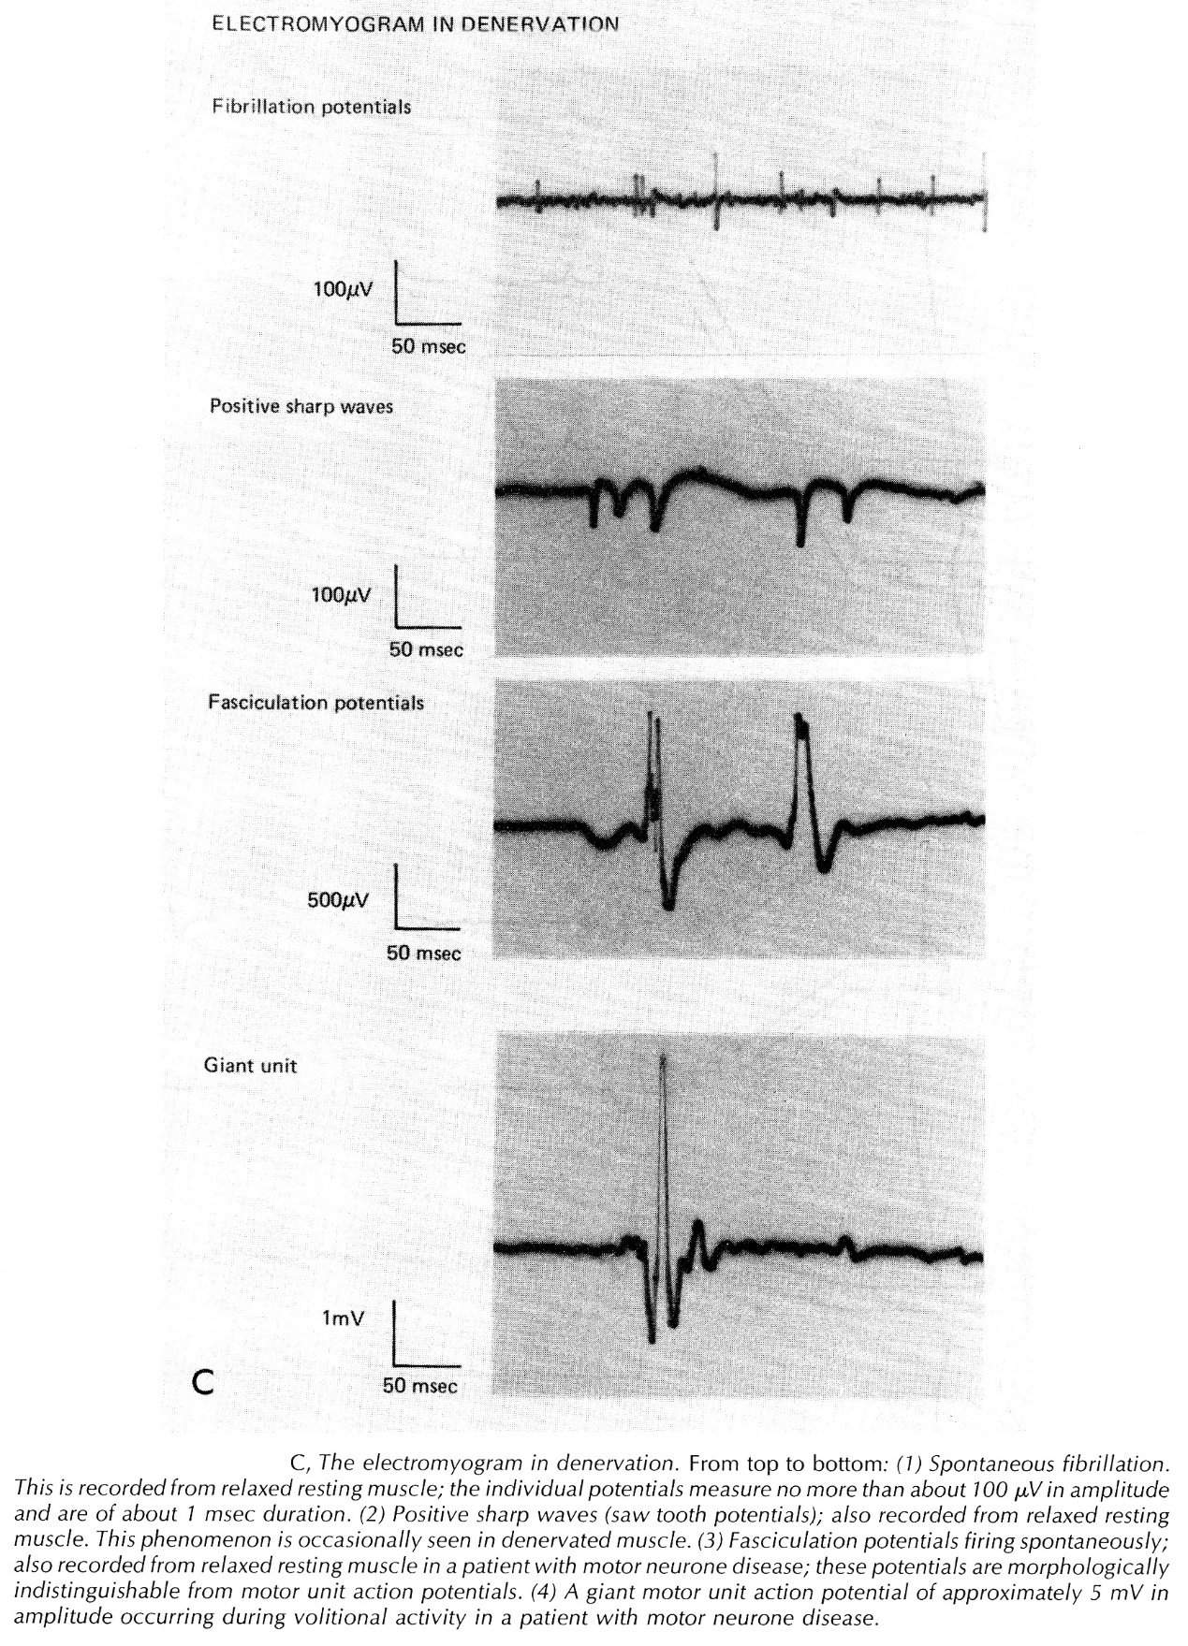

Bibliography for ch. “Diagnostics” → follow this link >>

Viktor’s Notes℠ for the Neurosurgery Resident
Please visit website at www.NeurosurgeryResident.net

