Evoked Potentials
Last updated: April 12, 2020
Clinical Uses 1
Somatosensory Evoked Potentials (SSEP) 1
Clinical Uses 2
Trigeminal Evoked Responses 3
Magnetic Stimulation, Motor Evoked Potentials (MEP) 3
Cognitive Evoked Potentials 3
Intraoperative monitoring (IOM) 4
Indications 4
Anesthesia considerations 4
MEP 4
SSEP 4
Sensitivity, specificity 4
Stagnara test 5
CN3-7, 10 monitoring 5
Brain Stem Auditory Evoked Response (BAER) → see p. Ear30 >>
Visual Evoked Potentials (VEP) → see p. Eye60 >>
Olfactory Evoked Potentials → see p. CN1 >>

Electrical brain activity is either spontaneous or event-related (i.e. elicited by stimulus).
Evoked Potential (EP) - electrical response recorded from CNS, elicited by external stimulus.
synonyms: event-related potential (ERP) or event-related response (ERR)

Clinical Uses
    - Assessing functional integrity (and detecting lesions) in afferent pathways under study.
- most useful when identify subclinical abnormalities (esp. in multiple sclerosis) or confirm abnormalities corresponding to vague or equivocal symptoms.
- may reveal abnormalities missed by MRI, and vice versa.
- precise localization on basis of electrophysiological findings may not be possible (because generators of many components of EP are unknown).
- changes produced by disease states:
  - delayed responses - reflect conduction delays in responsible pathways.
  - attenuation / loss of component waveforms – reflect conduction block or dysfunction of responsible generator.

    - Cortical mapping (accurate identification of speech, sensorimotor, visual cortex) – for preservation of functional cortex during resection of intracerebral tumors and vascular malformations.

    - Evaluating patients in coma, suspected brain death for BAER role - see p. Ear30 >>
Somatosensory evoked potentials (SEPs) are most accurate in assessment of neurologic outcome:
- patients with absent cortical SEPs bilaterally are unlikely to recover cognition (esp. bilateral loss of N20 response after median stimulation is associated with fatal outcome or development of persistent vegetative state).
- presence of normal SEPs does not predict useful recovery.

    - Determining completeness of lesion in spinal cord injuries.
      - absence of any cortical response in acute stage doesn’t mean that lesion is complete;
      - preserved responses (or their early return) indicate better prognosis.

    - Determining auditory acuity in patients whose age / mental state precludes their cooperation for behavioral testing. see p. Ear30 >>

    - Intraoperative monitoring see below >>

Somatosensory Evoked Potentials (SSEP)
Stimulation of sensory systems leads to generation of cortical evoked potentials - can be recorded with exploring electrode (connected to another electrode at indifferent point some distance away):
- over scalp (surface electrode)
- over pial surface of cortex (samples activity to depth of only 0.3-0.6 mm)
- microelectrode (inserted in layers 2-6 of underlying cortex)
  - best seen in animals under barbiturate anesthesia (eliminates background electrical activity).
  - in unanesthetized animals / humans, evoked potential is obscured by spontaneous brain activity (i.e. not apparent in ordinary EEG); evoked potential can be demonstrated by superimposing multiple traces - signal averaging technique (signals that are time locked to stimulus are enhanced, whereas background EEG activity is averaged out).

1. First positive-negative wave sequence is primary evoked potential  - latency 5-12 ms; latency and morphology depends on eliciting stimulus.  - highly specific in location (can be observed only over primary receiving area for particular sense).  - primary response is negative-positive when it is recorded with microelectrode (indicates depolarization on dendrites and somas in cortex, followed by hyperpolarization). | 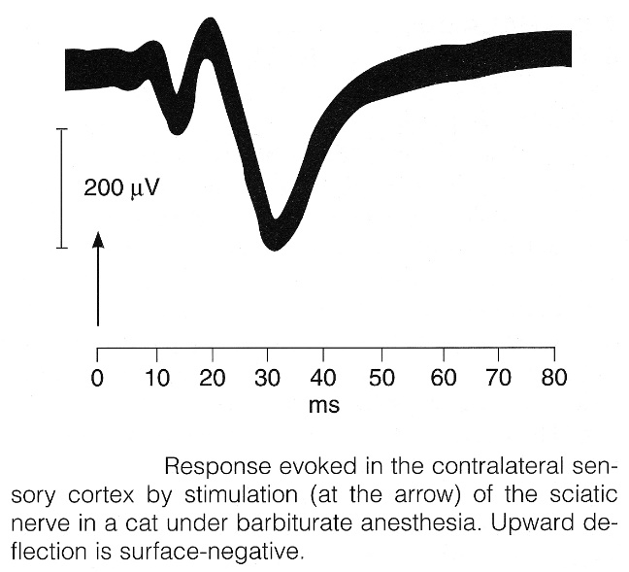
2. Second positive-negative wave sequence is diffuse secondary response
  - larger, more prolonged; latency 20-80 ms.
  - not highly localized - appears at same time over most of cortex - due to activity in projections from midline and related thalamic nuclei (not due to lateral spread of primary potential!).

- 3-5 Hz electrical stimulation of peripheral nerve:
  - sufficient to produce slight muscle twitch (when mixed nerve is stimulated)
  - sufficient to generate sensory nerve action potential that is ≈ 50% of maximum (when sensory nerve is stimulated).
- best recorded with surface electrodes:
  - bipolar derivation (both recording electrodes placed on scalp - over posterior and lateral regions);
  - referential derivation involving noncephalic reference electrode:
- over cervical spine, Erb point (for median nerve stimulation at wrist);
- over lumbar spine, popliteal fossa (for peroneal or posterior tibial nerve stimulation at ankle).
- response is small - necessary to average 2000 responses in arm or 4000 responses in leg.
N.B. physiological transmission must be distinguished from electrical conduction!

SEP components are defined by polarity (P/N) and latency (number); obligate components:
in arm nerve stimulation:
P9 - activity at or just beyond brachial plexus.
P13-P14 - activity in medial lemniscus (P13 in cervical cord, P14 in lower brain stem).
N18 - rostral brain stem.
N20 - primary somatosensory cortex.
in tibial nerve stimulation at ankle:
P38 - primary somatosensory cortex.

Most important features:
- presence or absence of obligate components; amplitude size is not so important.
- absolute and interpeak latencies of components (N.B. absolute latency of individual components, but not interpeak latency, varies with limb length!).

Clinical Uses
  - Intraoperative monitoring see below >>
  - Detecting lesions of somatosensory pathways within CNS (esp. dorsal column-medial-lemniscal system).
    - SEP is abnormal in multiple sclerosis (≈ 80%) - loss (or marked attenuation) of cervical response after median stimulation, increase in central conduction time.
    - abnormally large amplitude SEP (enhanced cortical excitability) are seen in progressive myoclonus epilepsy, photosensitive epilepsy, late infantile ceroid lipofuscinosis.
  - Little value in evaluating peripheral nervous system (except functional integrity of nerves that are not easily accessible for conventional nerve conduction studies); e.g. SEPs to evaluate radiculopathies;
    - stimulation of polysegmental nerve trunk would not cause abnormal SEP in isolated root lesions;
    - cutaneous nerve or dermatomal stimulation gives conflicting results.

Median-elicited SEP
(EP - Erb's point; CV5 - 5th cervical spine; i - ipsilateral; c - contralateral):
A. Normal subject.
B. Multiple sclerosis (Erb point potential is present but responses over cervical spine and scalp are absent).
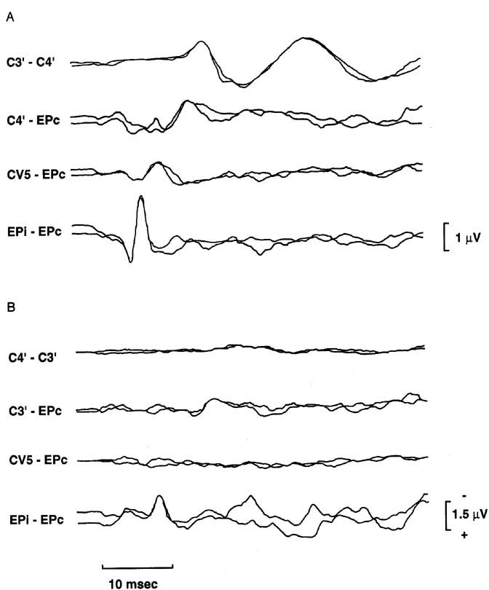

Tibial-elicited SEP
(PF - popliteal fossa; L1 - 1st lumbar spine; L3 - 3rd lumbar spine; d - distal; p - proximal):
A. Normal subject.
B. Multiple sclerosis (no response over scalp).
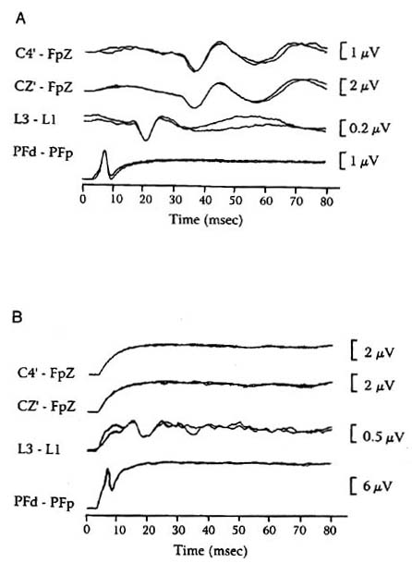

Trigeminal Evoked Responses
- infraorbital nerve is stimulated with electrode inserted into infraorbital foramen.
- recording electrodes are placed at Cz with reference to C7 vertebral spinous process (Cv7).
- bilateral studies provide opportunity for evaluation of control and determination of symmetry.
- waves 1 (entrance of maxillary division into gasserian ganglion), 2 (root entry zone into pons), and 3 (trigeminal tract within pons) have latencies of 0.88, 1.80, and 2.44 ms, respectively.
- interwave latencies 1-2 and 2-3 are 0.90 and 1.55 ms, respectively; increase in wave 1 latency > 0.32 ms (when compared to normal side) is considered abnormal.
- absence of waves 2 and 3 is after successful surgery for trigeminal neuralgia.
- evoked responses may also be obtained from stimulation of supraorbital nerve (harder to obtain, need to anesthetize scalp).

Stylized and actual normal trigeminal evoked responses:
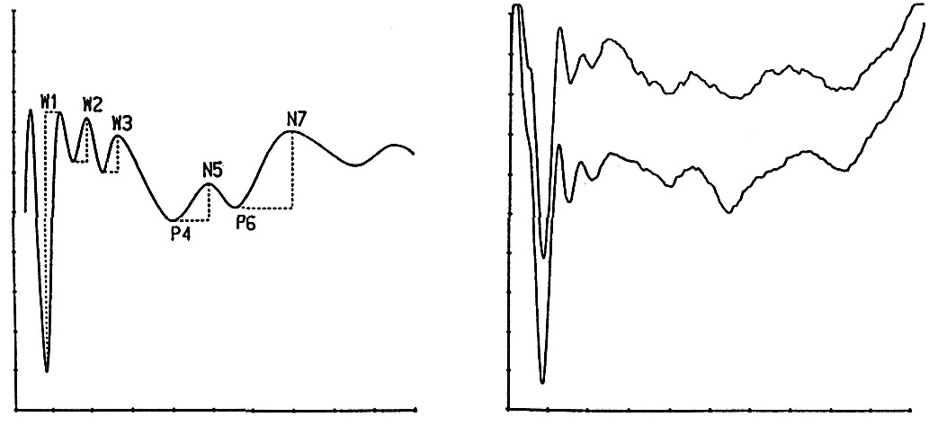

Magnetic Stimulation, Motor Evoked Potentials (MEP)
Magnetic stimulation of brain / spine elicits motor evoked potentials (i.e. compound muscle action potential over appropriate target muscle).
- assesses descending motor pathways!

Magnetic stimulation of peripheral nerves elicits somatosensory evoked potentials.
- assesses ascending sensory pathways!

- magnetic stimulation effects are similar to electrical stimulation.
- magnetic impulses travel through tissues painlessly and without attenuation* (vs. electrical impulses).
*but magnetic impulses decrease in relation to inverse square of distance from stimulator coil
- procedure is noninvasive (!), painless and apparently safe.
- latency of motor responses can be measured.
- central conduction time can be estimated by comparing latency of cerebral and spinal stimulation.
motor latencies↑↑↑ - in MS, cervical myelopathy, cervical spondylosis, spinal cord trauma, hemiplegia, hereditary spastic paraparesis, etc.
- clinical utility is investigational.
- with development of accurate focal stimulation, cortical mapping could be done noninvasively!

Electrical stimulation (painful in alert patients) may be preferable for intraoperative monitoring where patient is anesthetized and paralyzed, since equipment is less complicated to organize in operating room environment;
- response is best recorded from peripheral nerves, using needle electrodes.

Cognitive Evoked Potentials
- evoked potential components depending upon mental attention of subject and setting in which stimulus occurs (rather than on physical characteristics of stimulus), i.e. such endogenous "event-related" potentials (ERP) are related to cognitive aspects of distinguishing infrequently occurring target stimulus from other stimuli occurring more frequently (usually randomly alternating low and high pitch auditory stimuli).
- most important is P3 component (s. P300 component - because of 300 ms latency after auditory target stimulus).
- P3 latency is prolonged in dementia.
- P3 is normal in depression or other psychiatric disorders (that might be mistaken for dementia).

Intraoperative monitoring (IOM)
IOMs can reliably detect and predict neurological damage but there are 2 major problems:
    - it is too late (damage is done)
    - IOM is not useful if corrective action is not available

- when evoked potential abnormality occurs during surgical procedure, it is hoped that alteration / reversal of procedure will minimize damage; examples:
      - monitoring CN2 (visual evoked potentials) during transsphenoidal removal of pituitary tumor.
      - monitoring CN7 and CN8 (brain stem auditory evoked potentials) during posterior fossa surgery.
      - monitoring spinal cord (somatosensory evoked potentials, motor evoked potentials) during scoliosis* / myelomeningocele / intramedullary tumor / degenerative** cervical spine surgery, repair of coarctation of aorta.
*reduces complications rate 10-fold (because effective corrective action exists if IOM signal changes – popping rod)
**most likely no benefit at all (studies show, IOM does not prevent complications)
- for kids < 4 years old, white matter long tracts are immature – motor evoked potentials, SSEP are unreliable.

Indications
Spine surgery:
- severe spinal cord compression
- deformity correction
- intradural tumor / vascular malformation removal

Avoid use for simpler surgeries (e.g. ACDF without myelopathy, lumbar microdiscectomy).

W.S. James “A socioeconomic analysis of intraoperative neurophysiological monitoring during spine surgery: national use, regional variation, and patient outcomes” Neurosurgical Focus Nov 2014 / Vol. 37 / No. 5 / Page E10
Use of IONM did not strongly correlate with improved patient independence at discharge or prevention of iatrogenic nerve or spinal cord injury.

Anesthesia considerations
- all volatile anesthetics produce dose-dependent reduction in SSEP peak amplitude and increase in peak latency; adding nitrous oxide increases this sensitivity to anesthetic agents.
- helpful anesthesia measures:
      - minimize pentothal dose during induction (produces 30 minutes of suppression of EPs), or use etomidate (which increases both SSEP amplitude and latency)
      - total intravenous anesthesia is ideal; nitrous/narcotic technique is a second choice
      - if inhalational anesthetic agents are required:
- use < 1 MAC (maximal allowable concentration), ideally < 0.5 MAC
- avoid older agents such as Halothane
- nondepolarizing muscle relaxants have little effect on EP (in monkeys).
- long-acting paralytic agents blunt MEPs.
- gases (nitrous oxide) blunt SSEPs
- TIVA (total intravenous anesthesia) - propofol, fentanyl, and etomidate - causes less decline in MEP than inhalational agents at the same depth of anesthesia.
- benzodiazepines have a mild-to-moderate depressant effect on EPs
- continuous infusion of anesthetic drugs is preferred over intermittent boluses
- hypocapnia (down to end tidal CO₂ = 21) causes minimal reduction in peak latencies
- antiepileptic drugs (phenytoin, carbamazepine, phenobarbital) do not affect SSEP.
- run baseline before and after patient positioning (thus, will know if there is a technical problem with wires or baseline patient pathology).

Protocol
- induce anesthesia by using propofol (2 to 3 mg/kg) along with a short-acting or medium-acting paralytic (rocuronium).
- maintain a propofol infusion throughout the case.
- after induction, use 50% of the minimum alveolar concentration of vapor (i.e., isoflurane) and remifentanil (0.1 to 0.25 mg/kg/min) as a narcotic infusion - this combination is least likely to affect SSEPs and MEPs.
- use an arterial line and keep the MAP > 85-90 mm Hg to prevent spinal cord ischemia.

MEP
N.B. MEP (motor evoked potentials) is gold standard but are highly affected by anesthesia and muscle relaxation in particular
- checking MEP causes patient motion - need to pause surgery to run stimulation (bite block is necessary!) – gives warning to surgeon too late!

SSEP
- use dorsal column pathway to assess somatosensory cortex noninvasively.

- frequent* stimulation of bilateral median or posterior tibial nerves → response measurement via contralateral cortical electrodes.
*averages signal over several minutes – gives warning too late
- changes in latency or amplitude of SSEP waveforms indicate disruption of somatosensory pathway.

What changes in SSEP should trigger concern:
- increased signal latency (typically > 10% prolongation)
- decreased signal amplitude (typically > 50% reduction)
- change is called irreversible when it fails to return to baseline before end of procedure.

False-positive SSEP signal change may be caused by:
- blood pressure (mean and diastolic)
- amplitudes of SSEPs are very sensitive to changes in mean arterial pressure, making them useful for detecting ischemia!
- heart rate
- temperature
- partial pressure of alveolar carbon dioxide
- anesthetic drugs

Sensitivity, specificity
      - SSEP sensitivity 99%, specificity only 27%.
      - MEP sensitivity 90-100%, specificity 90-100%.
      - combined SSEP+MEP: sensitivity 83% and specificity 99%

Stagnara test
– awakening patient during surgery (e.g. under remifentanil balanced anaesthesia) and performing neuro exam.

CN3-7, 10 monitoring
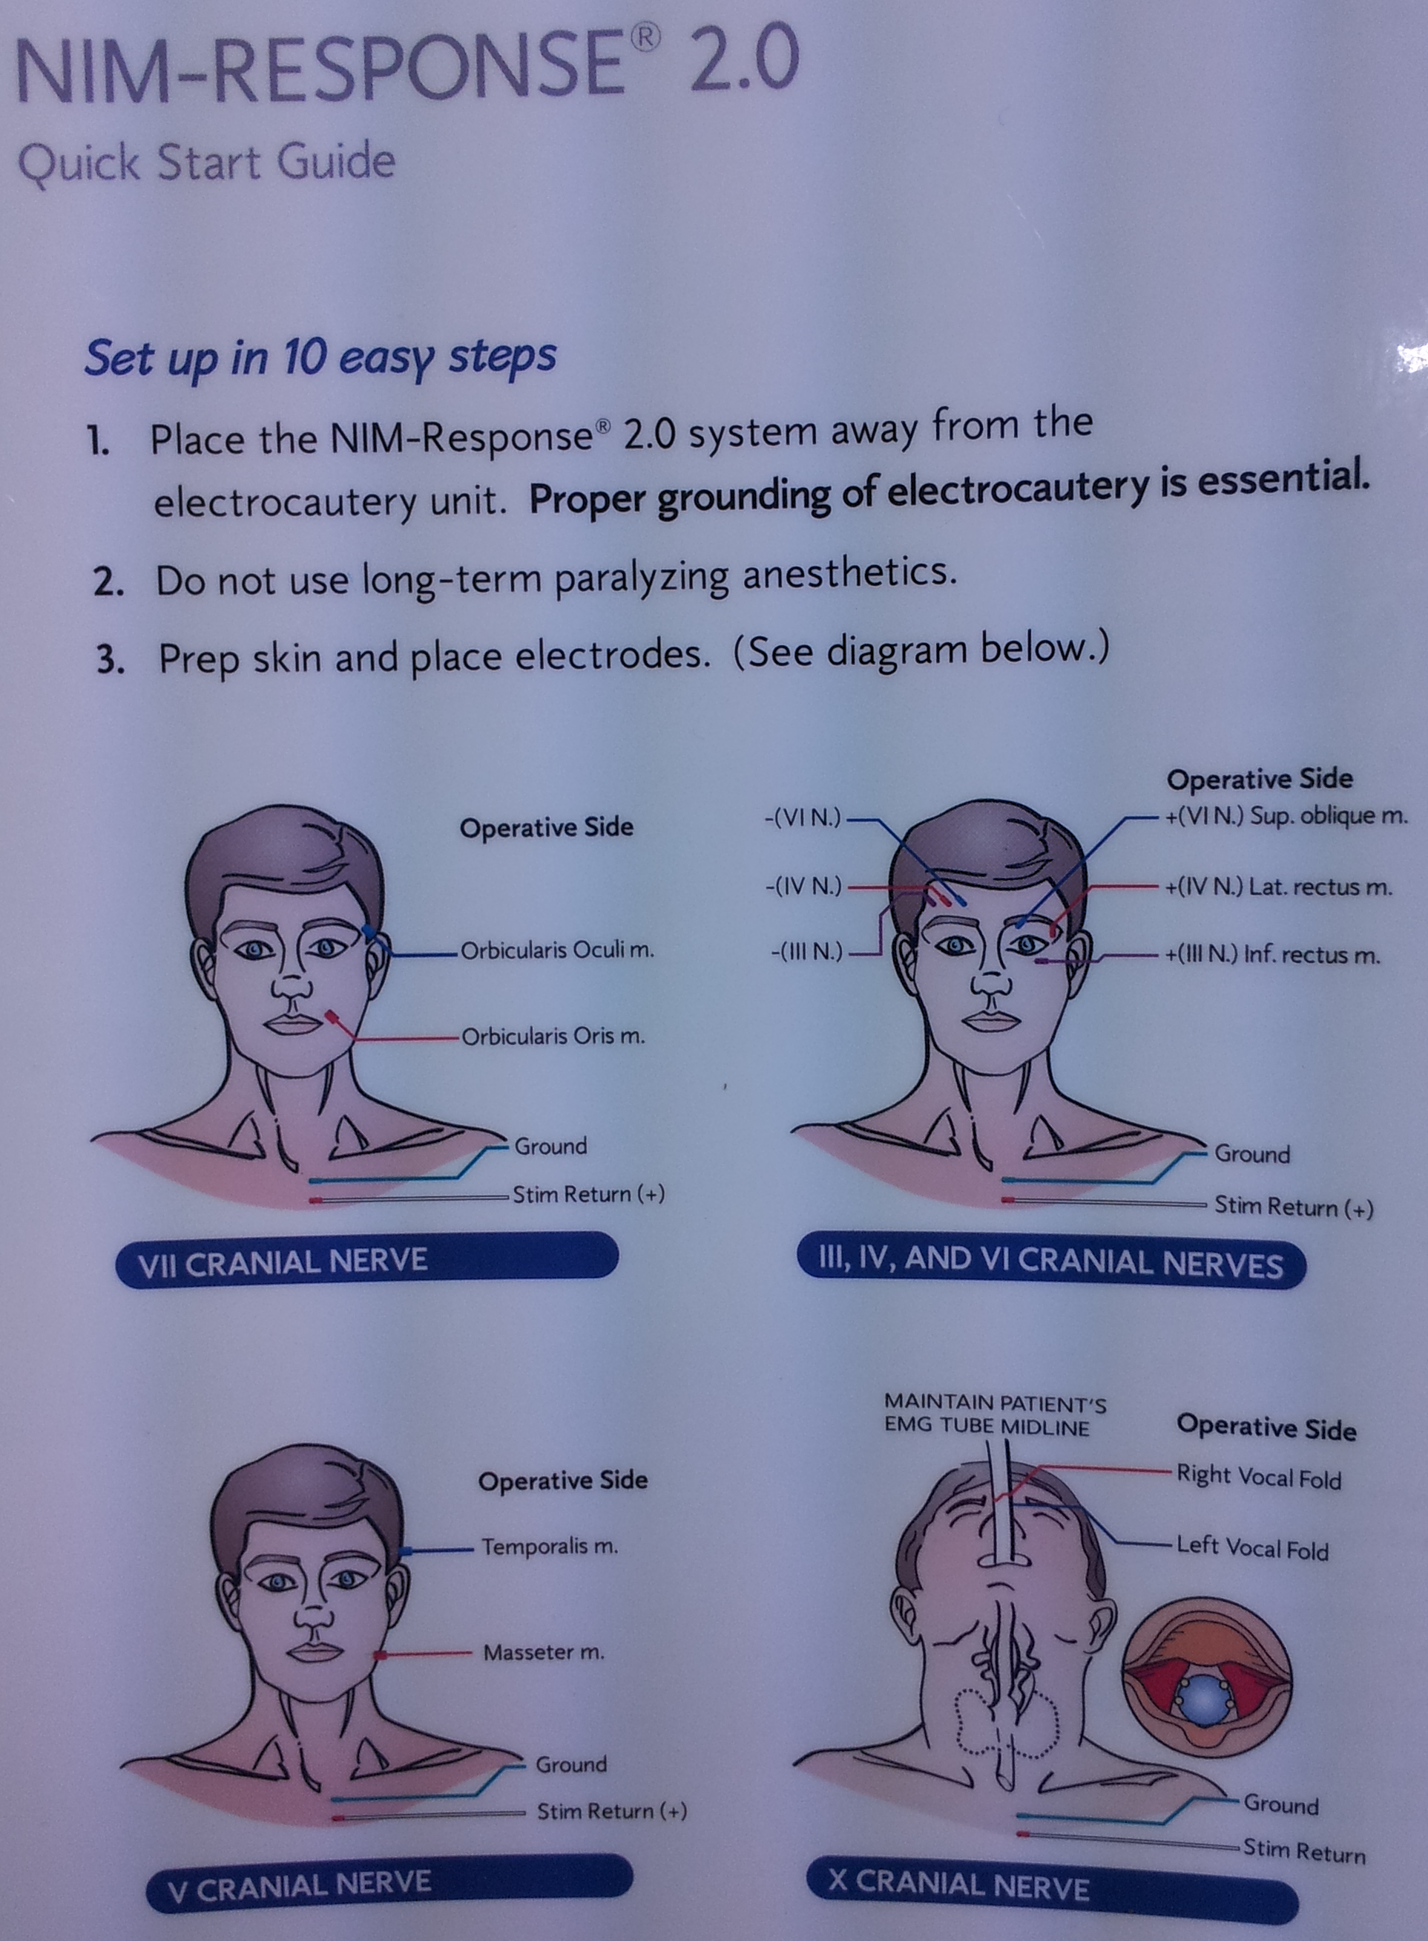

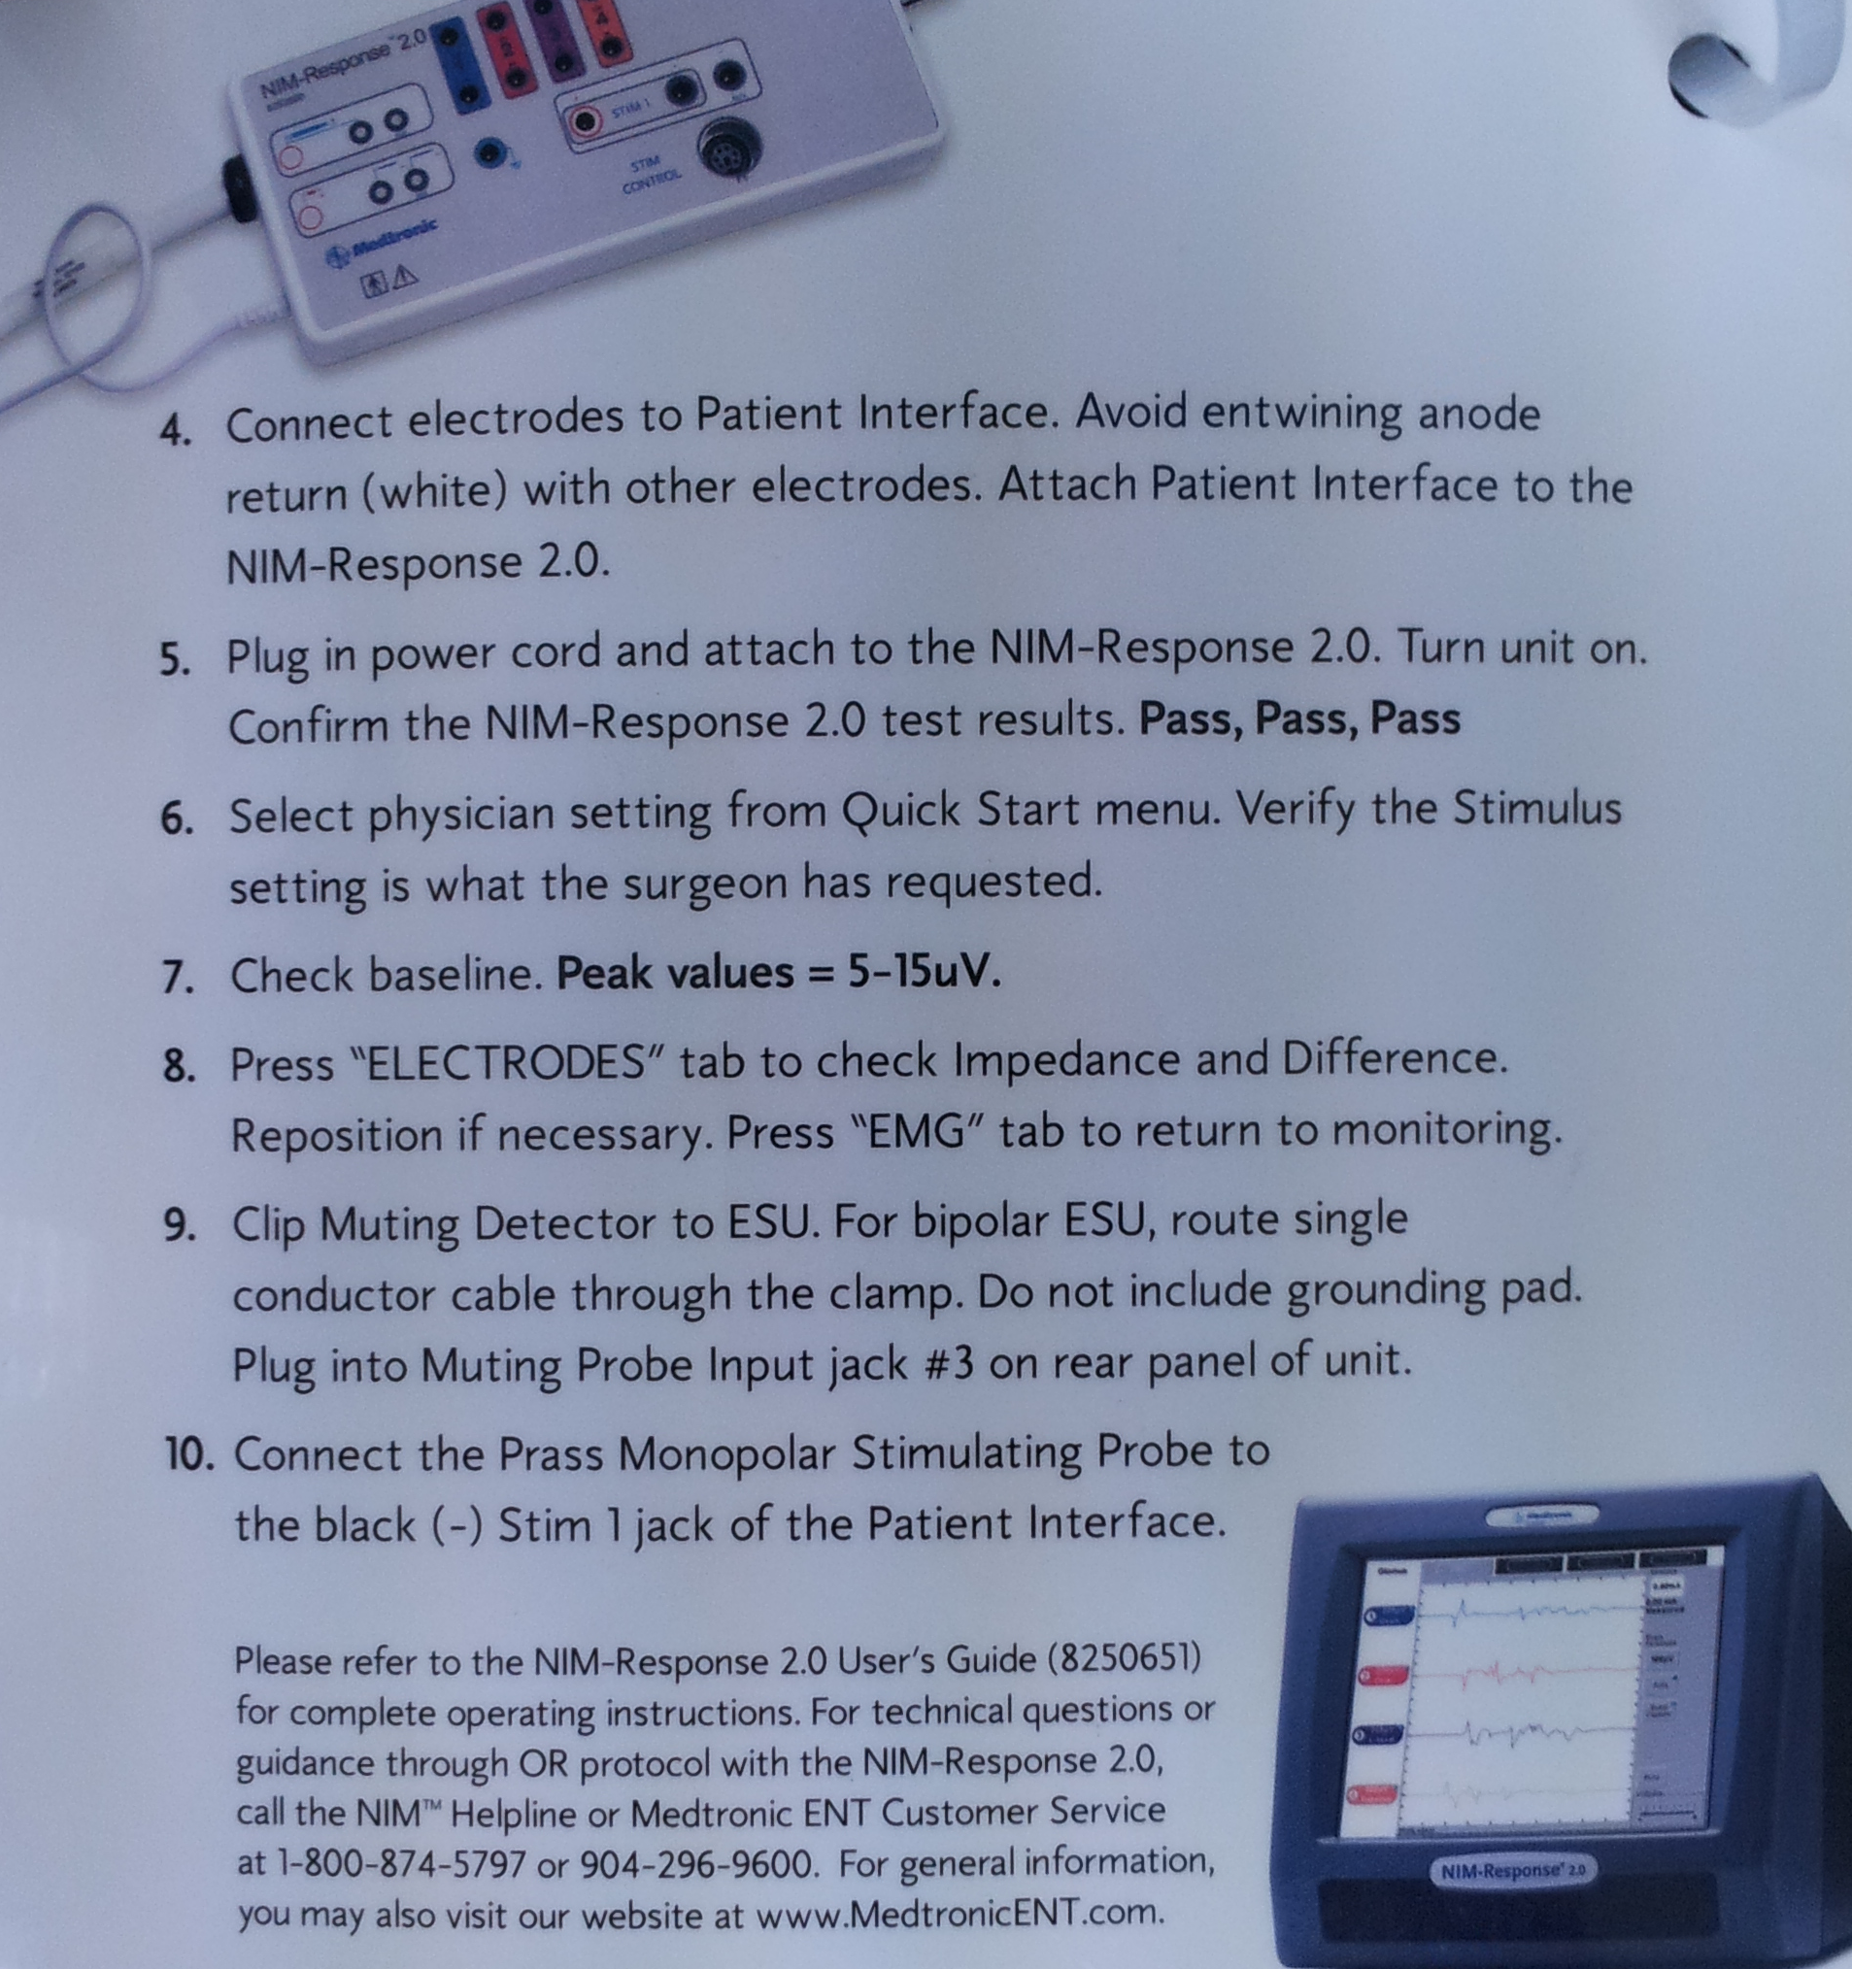

Bibliography for ch. “Diagnostics” → follow this link >>

Viktor’s Notes℠ for the Neurosurgery Resident
Please visit website at www.NeurosurgeryResident.net

