Alertness, Sleep, Electroencephalography (EEG)
Last updated: August 25, 2019
Introduction 1
Electroencephalography (EEG) 2
Montages 2
Rhythms 3
Alpha rhythm 3
Beta rhythm 7
Gamma oscillations 7
Delta waves 8
Theta rhythm 8
Dominant EEG rhythm variations with age 8
Source of EEG waves 9
Cortical Dipoles 9
Thalamocortical Oscillations (thalamic pacemaker) 9
Dense-array EEG (s. HD-EEG) 10
Circadian Rhythms 10
Sleep 11
Non-REM (NREM) sleep 13
Rapid eye movement (REM) sleep, s. fast-wave sleep, dream sleep 21
Distribution of Sleep Stages 23
Sleep Neurochemistry 25
Putative Sleep Functions 26
EEG abnormalities 26
Spikes 26
Sharp waves 27
Ictal run 27
Seizure 28
Slowed activity 29
Activity attenuation 31
Burst-suppression pattern 31
Triphasic slow waves 31
Breach phenomenon 32
EEG artefacts 32
Clinical Uses of EEG 38
Routine for reading EEG 39
EEG review at bedside 39
Sedated patient 39
Signs to localize seizure onset 39

Introduction
- various sensory impulses must be processed in awake brain to be perceived.
- spectrum of behavioral states ranges from deep sleep through light sleep, REM sleep, and two awake states (relaxed awareness and awareness with concentrated attention); there are patterns of brain electrical activity that correlate with each of these states.
about arousal – awareness – attention relationship → see p. S30 >>
- feedback oscillations within cerebral cortex and between thalamus* and cortex may be producers of EEG waves and determinants of behavioral state.
* ”nonspecific” ARAS nuclei (midline and intralaminar nuclei)
- arousal can be produced by sensory stimulation and by impulses* ascending in reticular core of midbrain (i.e. ARAS).
*collaterals of ascending sensory information.
- sleep can be produced by stimulating basal forebrain and other "sleep zones".

Electroencephalography (EEG)
Evaluates brain function – complementary (rather than alternative) to neuroimaging!

Montages
EEG can be recorded:
- noninvasively! - with scalp electrodes.
- with electrodes on pial surface of cortex (subdural electrodes) - sometimes called electrocorticogram (ECoG) – markedly larger amplitudes. see p. E13 >>
- with electrodes within brain (depth electrodes). see p. E13 >>

Location of scalp electrodes, amplification, paper speed of polygraph, etc are internationally standardized.
    - 10-20 system - internationally agreed locations that use standardized percentages of head circumference (i.e. "10/20" refers to interelectrode distances expressed as percentages of anterior-posterior, transverse, and circumferential head measurements):
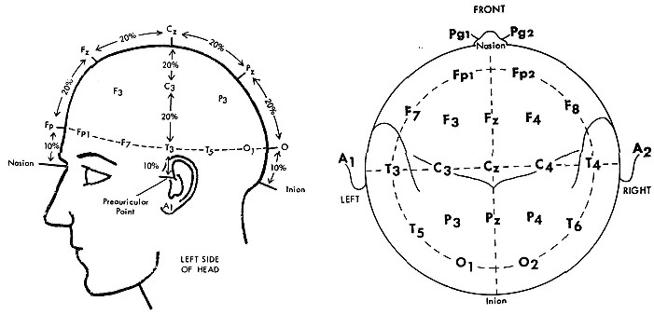

Electrode placements: Fp, frontopolar; F, frontal; C, central; P, parietal; O, occipital; T, temporal; A, earlobe; Sp, sphenoid; V, vertex.
Right-sided placements are indicated by even numbers, left-sided placements by odd numbers, midline placements by Z.

- input from each pair of electrodes is connected to two inputs of amplifier:
active electrode is connected to “input 1”;
reference electrode (or, with bipolar recordings, more posterior or right-sided electrode) to “input 2”.
- upward deflection indicates either increased negativity at “input 1”or increased positivity at “input 2”.
- typical sensitivity - 7 μV per paper millimeter (50-μV calibration signal produces 7-mm deflection).
- recordings are made simultaneously from pairs of electrodes in organized sequence (termed montage):
  - longitudinal orientation (longitudinal montages) - from electrodes in sagittal plane; recordings are displayed in anterior-to-posterior sequence.
  - transverse orientation (transverse montages) - from electrodes in straight coronal plane; recordings are displayed in left-to-right sequence.

- montages may also be:  - bipolar (s. sequential) - show potential fluctuations between two adjacent cortical electrodes.  - unipolar (s. referential, monopolar) - show potential fluctuations between cortical electrode and indifferent electrode on some part of body* distant from cortex.  *e.g. linked ears  Top - referential montage is illustrated on left side of head and sequential montage on right.  Bottom - stylized tracings on left illustrate assumed spike focus at C3 electrode recorded with referential montage and on right assumed spike focus at F4 recorded with sequential montage. | 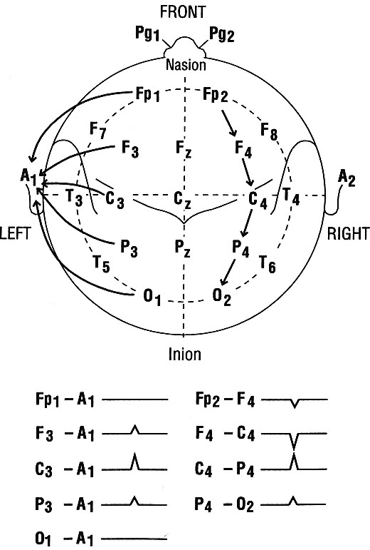

Rhythms
- EEG activity is characterized by its frequency.
- Greek letter names of rhythms reflect temporal order of their discovery.

Alpha rhythm
- dominant rhythm in awake state at rest (with mind wandering and eyes closed).
- most marked in parieto-occipital area.
- regular 8-12 Hz, 20-100 μV waves; normal frequency is age dependent (if frequency is less than normal for age group – it is abnormality!)
- amplitude often waxes and wanes over periods of 1-2 sec ("spindling").
- frequency is decreased by hypoglycemia, hypothermia, glucocorticoid hormones↓, Pa_{CO2}↑.
- frequency is increased by reverse conditions (e.g. forced overbreathing to lower Pa_{CO2} may be used to bring out latent EEG abnormalities).
- absent during sleep.
- attenuated by eye opening; alpha rhythm replacement by fast irregular low-voltage activity (when attention is focused on something) is called alpha block.
  - alpha block is also produced by any form of sensory stimulation or mental concentration (such as solving arithmetic problems).
  - synonyms:
    - arousal (alerting) response.
    - desynchronization (because it represents breaking up of obviously synchronized neural activity necessary to produce regular waves; term is misleading because rapid EEG activity is also synchronized, but at higher rate).

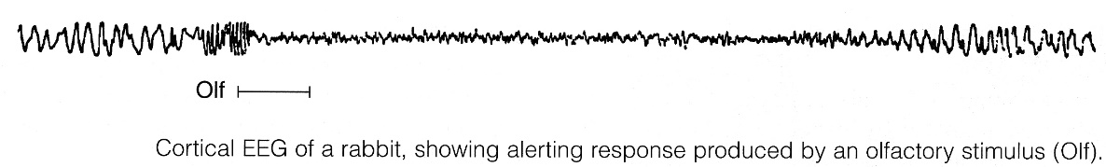

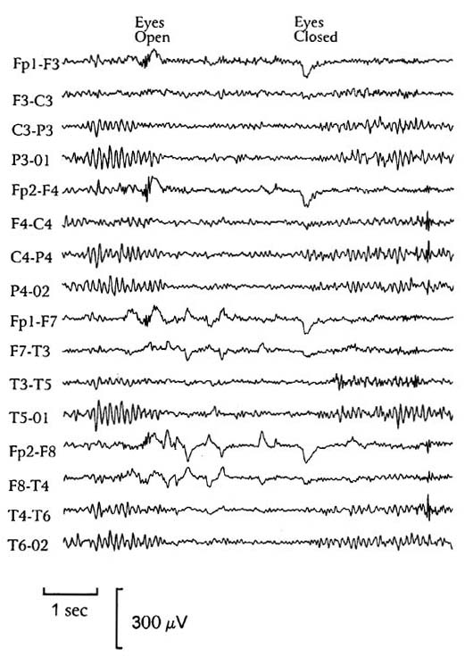

Patient closes eyes → alpha rhythm:
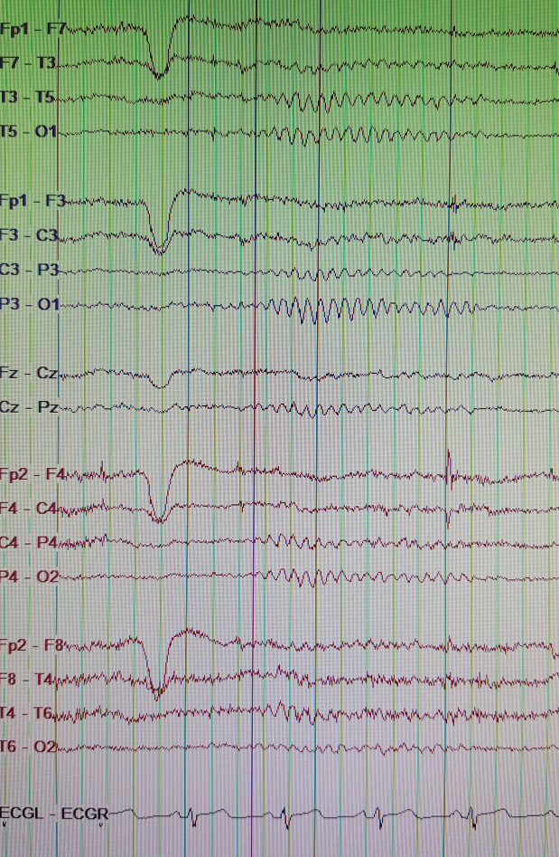

- if eye opening does not cause attenuation, it is called alpha frequency (not rhythm).
- alpha coma (e.g. in hypoxic-ischemic encephalopathy, pontine hemorrhage) - alpha waves are distributed uniformly both anteriorly and posteriorly in patients who are unresponsive to stimuli.

Beta rhythm
– present to variable extent in addition to alpha rhythm.
- maximal in frontal and central regions.
- 13-30 Hz; < 20 µV (lower amplitude than alpha; may be harmonic of alpha).
- enhanced by benzodiazepines, barbiturates.
N.B. high-voltage beta activity suggests presence of sedative-hypnotic medications!

EEG of normal awake adult:
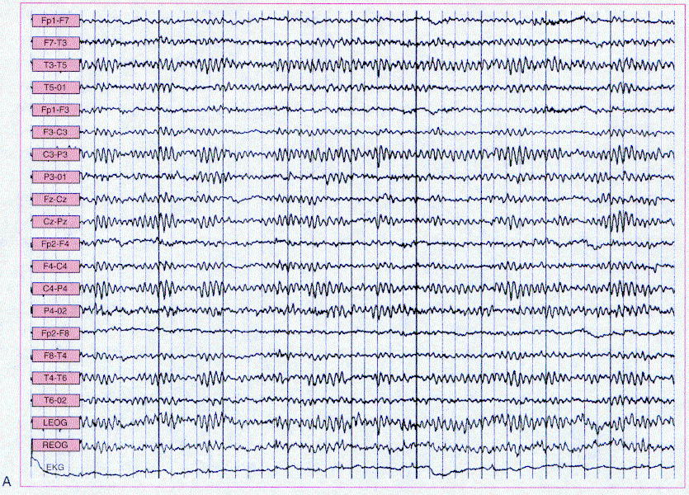
Channels 1-8 and 11-18 represent left- and right-sided bipolar electrode placements, respectively. Channels 9 and 10 represent midline bipolar electrode placements, and channels 19 and 20 represent left and right electro-oculograms (eye movements). Each major horizontal division represents 1 second.

Additional Rhythms
Gamma oscillations
– seen when individual focuses attention on something (basis for passive cortical mapping and also brain-machine interface – active cortical areas exhibit alpha↓ and gamma↑)
- 30-80 Hz somewhat irregular low-voltage activity.
- ascending activity responsible for EEG alerting response following sensory stimulation:
specific sensory systems → midbrain → enters RAS via collaterals → interlaminar thalamic nuclei → nonspecific thalamic projection to cortex
further see p. S30 >>
N.B. there is no electrical technique to determine whether cortex is aware (vs. EEG clearly shows arousal / sleep), but if attention produces alpha block that means that cortex is aware.

Delta waves
- large, slow (< 4 Hz) waves during deep sleep.

Theta rhythm
- occurs in children or in moderately deep sleep.
- large-amplitude, regular 4-7 Hz waves.
- theta and delta waves are known collectively as slow waves.

Examples
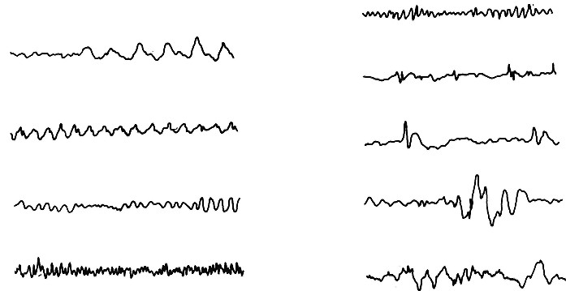
Left - frequency bands (top to bottom): delta, theta, alpha, and beta.
Right - typical waveforms (top to bottom): rhythmic sinusoidal, rhythmic low-voltage spikes, spike and slow wave, polyspike and slow wave, polymorphous waves.

Dominant EEG rhythm variations with age
Premature newborn:
< 30 weeks - discontinuous EEG pattern (prolonged low-voltage periods alternating with brief slow-wave bursts).
30-34 weeks - continuous EEG patterns.
35-37 weeks - distinct EEG patterns that distinguish sleep from wakefulness.
Term newborn (> 37 weeks) - fully developed neonatal sleep patterns of quiet and active sleep.
Infant - fast, beta-like activity + slow 0.5-2 Hz occipital rhythm; then occipital rhythm speeds up:
3-4 Hz at 3 months.
5 Hz at 6 months.
6-7 Hz at 1 year.
7-8 Hz at 18 months.
9-11 Hz during young adulthood.
Adolescence - adult alpha pattern gradually appears;
Theta and delta activity is commonly seen in posterior scalp regions during childhood and young adulthood (posterior slow waves of youth).

Source of EEG waves
- EEG waves indicate that electrical activity is waxing and waning in sampled cortex; if activity were random, discharges would cancel out and no waves would be produced.
- EEG waves are due to:
  - oscillating activity within cortex (cortical dipoles)
  - oscillation in feedback circuits between thalamus and cortex (thalamocortical oscillations)

Cortical Dipoles
- dendrites of cortical cells are forest of similarly oriented, densely packed units in superficial layers of cerebral cortex.  - dendrites are site of nonpropagated hypopolarizing / hyperpolarizing local potential changes.  - as excitatory & inhibitory endings on dendrites of each cell become active, current flows into and out of these current sinks and sources from rest of dendritic processes and cell body - cell-dendrite relationship is therefore that of constantly shifting dipole (current flow in this dipole produces wave-like potential fluctuations in volume conductor).  - cerebellar cortex and hippocampus are two other areas of CNS where many complex, parallel dendritic processes are located subpially over layer of cells - both areas have surface potential fluctuation similar to cortical EEG. | 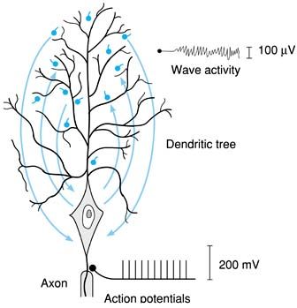  Large cortical neuron: current flow to and from active synaptic knobs on dendrites produces wave activity, while all-or-none action potentials are transmitted along axon.

Thalamocortical Oscillations (thalamic pacemaker)
- reciprocal oscillating activity between midline thalamic nuclei and cerebral cortex.
- during aware state, thalamic neurons are partially depolarized and fire tonically at rapid rates.
- during slow wave sleep, thalamic neurons are hyperpolarized and discharge only in sleep spindle-like phasic bursts.
when neurons are hyperpolarized and firing only on phasic bursts, activity in thalamocortical oscillations prevents cortical neurons from receiving / processing specific inputs.

N.B. EEG reflects summated cortical local potentials (inhibitory / excitatory postsynaptic potentials of vertically oriented pyramidal cells, passive spread of electrical activity into dendrites), not action potentials! (action potentials are of too brief duration to have effect on EEG)

Dense-array EEG (s. HD-EEG)
- done with 256 electrodes (some experts believe that there is not much gain beyond 64-68 channels).
- localizes origin of interictal discharges in 3D.
N.B. possible only if patient has interictal discharges
- analysis done with specialized software: Loretta, Lora, S-Loretta.

Circadian Rhythms
- many physiologic functions (e.g. body temperature, glucocorticoid secretion) fluctuate in diurnal (circadian) rhythms (≈ 24 hrs duration, i.e. matched to solar day-night cycle).
- this rhythmical pattern is generated internally (“biological clock”) but is normally synchronized to environmental factors (called zeitgebers).
- most potent zeitgeber for sleep-wake rhythms is light.
- if individual is completely isolated from environment, circadian cycle lengthens to ≈ 25 hrs.
- synchronization of endogenous circadian pacemaker to 24-h day requires that pacemaker be reset each day (normally by exposure to environmental light-dark cycle).
- properly timed exposure to light of sufficient intensity* can, within 2 to 3 d, reset human circadian pacemaker to any desired hour.
*e.g. outdoor light is more effective than ordinary indoor room light.
- most obvious (and probably most important) diurnal rhythm is sleep-wake cycle.
- most closely correlates with core body temperature - sleep tendency, sleepiness, and REM sleep propensity all peak just after nadir of endogenous circadian temperature cycle (≈ 1-3 h before awakening).
- 85% of all spontaneous awakenings occur on rising slope of temperature cycle.
- misalignment of endogenous circadian pacemaker output with desired sleep-wake cycle is thought to be responsible for certain types of insomnia, as well as for alertness & performance↓ in night-shift workers and after jet lag.

Suprachiasmatic Nucleus (SCN)
- internal circadian rhythm generator (pacemaker)!!!
- SCN neurons discharge rhythmically when removed from brain and cultured in vitro.
- SCN neurons contain clock that is made up of at least six proteins; PER proteins are produced and then phosphorylated by kinases (phosphorylated PERs inhibit production of PERs in regular circadian pattern).
- SCN lesions (or disconnection from rest of brain) in rodents abolish circadian rhythmicity.
- in animals with SCN ablations, transplantation of fetal SCN tissue restores circadian rhythm (it is uncertain whether transplant does this via humoral output or via connections made by neurons that grow out of transplant).
- linking to photoreceptors and external light occurs via two pathways:
    - direct (monosynaptic) pathway - retinohypothalamic tract (RHT)
    - indirect pathway - geniculohypothalamic tract (GHT) – made of collateral RHT processes from lateral geniculate.
- efferents from SCN project to intrahypothalamic areas (preoptic area, paraventricular nucleus, retrochiasmatic area, dorsomedial area) and extrahypothalamic sites (thalamus, basal forebrain, periaqueductal gray) → effector organs for particular biological rhythms.
- light pulses just before or during first half of dark phase produce phase delays, whereas light pulses during second half of dark phase or just after end of dark phase produce phase advances.
- loss of SCN neurons occurs in Alzheimer's disease and may be responsible for "sundowning".

Pineal Gland & Melatonin
- neuroendocrine gland that synthesizes and secretes melatonin. see p. 2717-2718 >>
N.B. melatonin secretion is not dependent upon sleep, persisting in individuals kept awake at night.
- melatonin has phase-shifting properties opposite to bright light effects: melatonin administered in afternoon produces phase advances, whereas melatonin given in morning produces phase delays.

Sleep
- state of unconsciousness in which brain is relatively more responsive to internal than to external stimuli.
- presence of sleep can be assessed by:
  - behavioral analysis (e.g. individual who does not move and does not respond when spoken to or touched is often asleep)
  - EEG

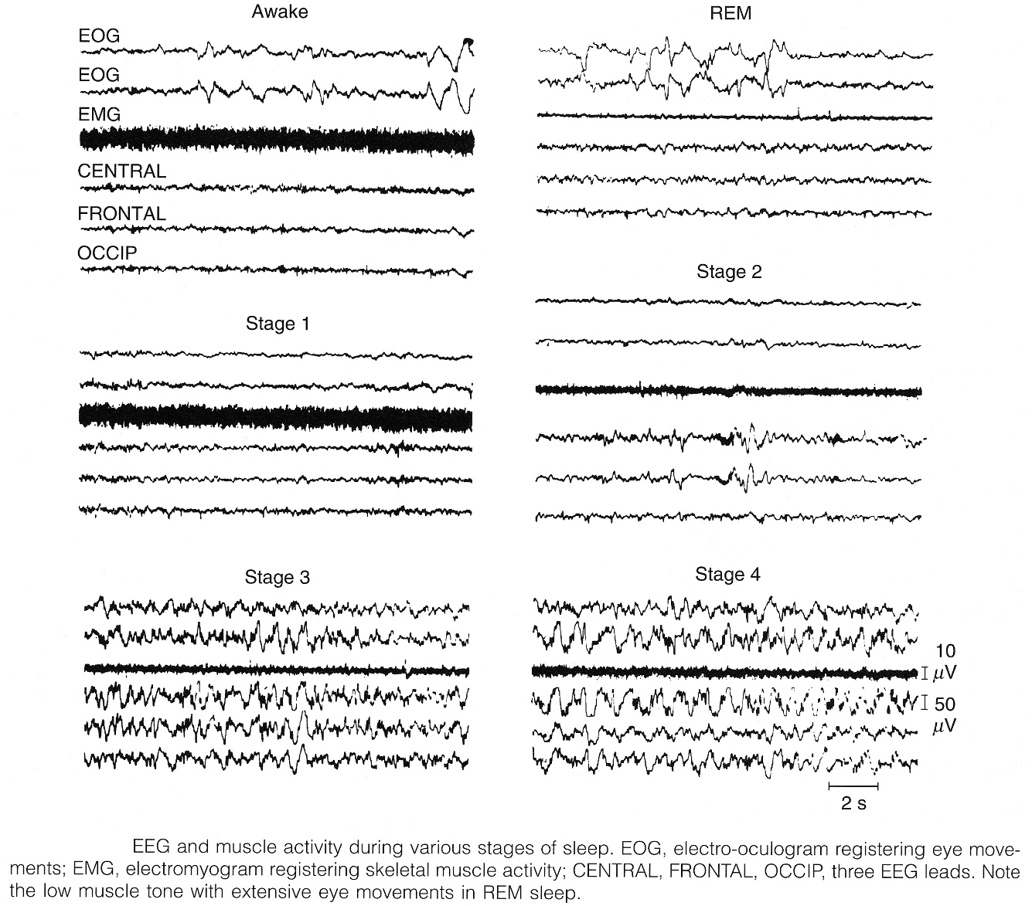

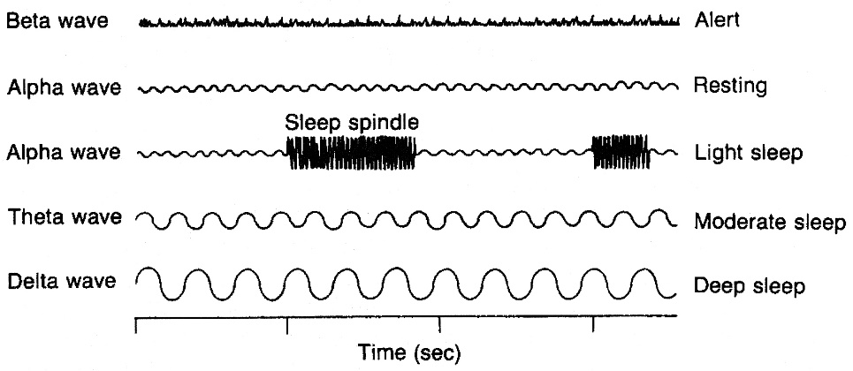

N.B. sleep does not result from passive withdrawal of arousal! Sleep is dynamic active process!

≈ 80% sleep time is NREM sleep; remaining ≈ 20% is REM sleep.

REM sleep and non-REM sleep are caused by different CNS sleep centers!
- there is little evidence for either single, discrete "sleep center" or single, discrete "wake center".
- current hypotheses suggest that capacity for sleep & wakefulness generation is distributed along brainstem-forebrain axis (axial "core" of neurons extending from brainstem rostrally to basal forebrain).
REM centers are better localized neuroanatomically than NREM centers!

Non-REM (NREM) sleep
- divided into four stages:
Stages 1+2 = light sleep
Stages 3+4 = deep sleep, slow-wave sleep, delta sleep

Stage 1 - first stage when falling asleep; occupies 2-5% of total sleep time;
    - alpha rhythm disappears → low-amplitude, slower activity.
    - high-voltage “sharp” negative transients – vertex sharps - recorded maximally at vertex:
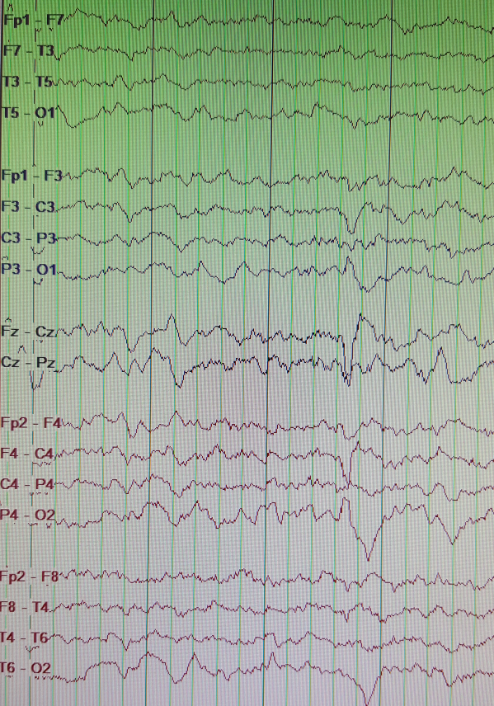
    - characteristic slow rolling lateral eye movements.
    - mentation may occur but is no longer reality oriented.
    - it is possible to continue performing routine and familiar motor tasks, such as driving automobile (individual may be unaware that such sleep intrusion event has occurred).
N.B. dramatic perceptual and cognitive deficits associated with frequent brief intrusions of stage 1 sleep into behavioral wakefulness are major component of impaired psychomotor performance seen with sleepiness.
    - subjects aroused from stage 1 frequently deny having been asleep.
    - low arousal threshold.

Stage 2 - background diffuse theta (and slower); occupies 45-55% of total sleep time;
    - appearance of sleep transients:
- K complexes (high-voltage initial negative sharp component followed by positive slow component):
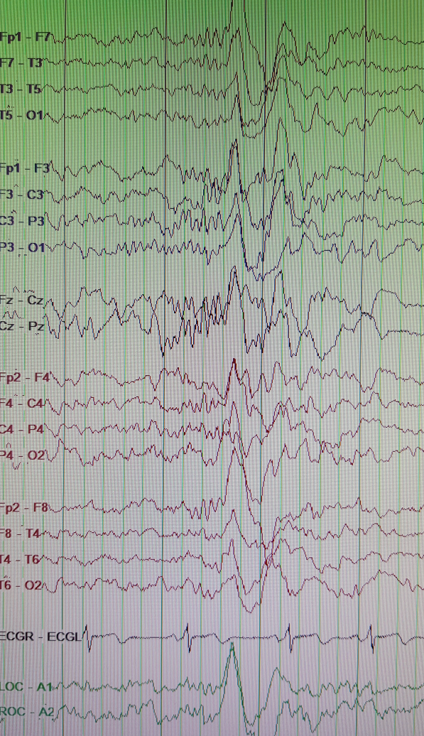

- sleep spindles (0,5-2 sec bursts of symmetric sinusoidal alpha-like, 7-15 Hz, 50 μV waves bilaterally in central regions);
- arise from GABAergic neurons in reticular thalamic nucleus.
- can occur alone or superimposed on K complexes;
- may also be present in stage 3 (and even in stage 4 and REM sleep);
- first appear at age 2 yrs.
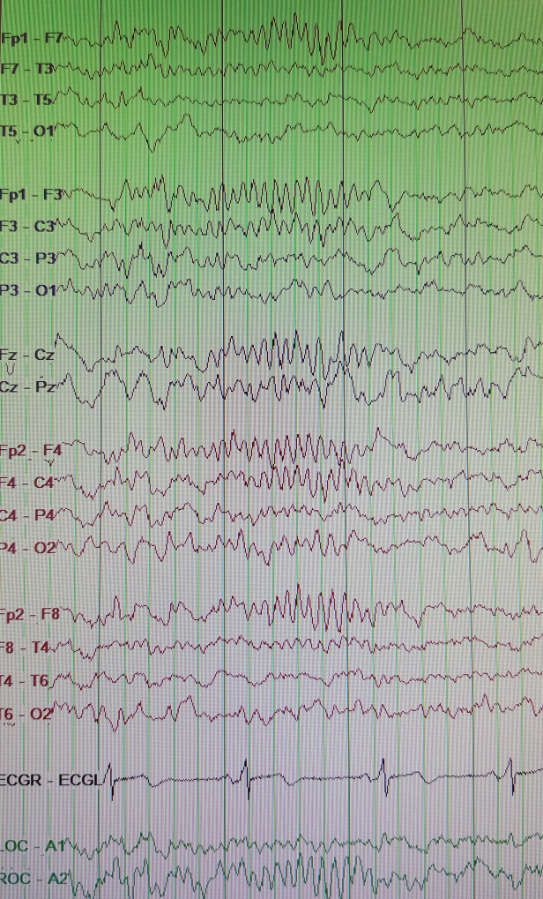
    - eye movements absent (or slow lateral eye movements may persist).
    - heart and respiration rates are regular and slightly slower.

Stage 3 - lower frequency and increased amplitude waves (theta rhythm); occupies 3-8% of total sleep time.
    - eye movements absent.
    - heart and respiration rates are regular and further slowed.

Stage 4 - maximum slowing with largest waves (delta rhythm); occupies 10-15% of total sleep time.
    - stage 3+4 combined percentage (of total sleep time) ≈ 10-20% decreases with age → overall deterioration of sleep, increase in sleep complaints.
    - high arousal threshold.

N.B. deep sleep is most refreshing sleep!
During recovery from sleep deprivation, deep sleep is first to rebound!

sleep delta is < 2 Hz > 75 μV waves:
Stage 1 contains no sleep delta.
Stage 2 contains < 20% sleep delta.
Stage 3 contains 20-50% sleep delta.
Stage 4 contains > 50% sleep delta.
Characteristic of deep sleep is rhythmic slow large waves, indicating marked synchronization

- during progress from stage 1 to 4:
- progressive reduction of consciousness
- increasing resistance to being awakened
- muscle tone reduces
- heart & respiratory rates decrease (but remain regular) → higher Pa_{CO2}
- cough reflex attenuates to absent
- body metabolism slows
- NREM sleep can be produced by stimulation of at least three subcortical (“synchronizing”) regions:
- basal forebrain sleep zone (incl. preoptic area and diagonal band of Broca) - stimulation produces slow wave sleep.
- diencephalic sleep zone (in posterior hypothalamus, nearby intralaminar and anterior thalamic nuclei) - stimulus must be ≈ 8 Hz (faster stimuli produce arousal!)
- medullary synchronizing zone (in medullary RF at level of nucleus tractus solitarii) - stimulation produces sleep if frequency is low but arousal if frequency is high.
- ≤ 10 Hz stimulation of afferents from skin mechanoreceptors produces sleep in animals (apparently via brain stem); regularly repeated monotonous stimuli put humans to sleep.
- disorders associated with NREM sleep (esp. stages 3 and 4): somnambulism, nocturnal enuresis, night terrors, night talking; NREM sleep has activating effect on epileptic seizures.

Stage 2 sleep in normal adult (demonstrating sleep spindles and K complexes):
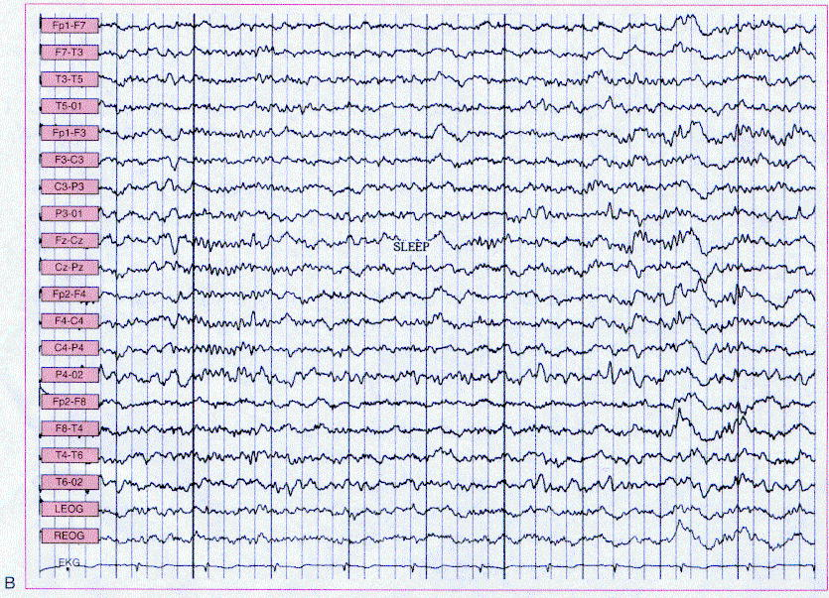

Rapid eye movement (REM) sleep, s. fast-wave sleep, dream sleep
- rapid, low-voltage EEG activity (resembles waking state, but individual is clearly asleep), so sometimes called paradoxical sleep.
- discovered by Aserinsky and Kleitman in 1953.
- REM sleep is generated primarily in pons tegmentum (RF)!!!
- regulation of REM sleep is primarily at level of brain stem (with REM-on and REM-off nuclei).

Tonic REM events
- Cortical desynchronization (fast EEG activity similar to that observed in waking state)
  - replaces slow waves of NREM sleep, but sleep is not interrupted (threshold for arousal is even elevated!!!).
  - intermittent “saw-tooth” waves (moderately high-amplitude, 3-5 Hz triangular waveforms) are unique to REM sleep.
  - origin is mesencephalic reticular formation.
- Hippocampal synchronous theta activity (that also occurs in waking) - generated in dentate and medial entorhinal cortex; involves rostral pontine RF in area of nucleus pontis oralis.
- Muscle atonia - present in all but respiratory and ocular muscles.
  - relative paralysis of voluntary activity - arises at spinal cord level, from centrally mediated hyperpolarization of alpha motor neurons; dependent on locus ceruleus (in cats with locus ceruleus lesions, REM sleep is associated with thrashing about, as if they were acting out their dreams).
  - in narcolepsy, partial paralysis (cataplexy) occurs during wakefulness.
  - in REM sleep behavior disorder, patients suffer from incomplete motor inhibition during REM sleep.

Phasic REM events
- Characteristic rapid, roving movements of eyes, horizontal and vertical, occurring in bursts.
  - PET has shown that REM-related eye movements involve cortical areas similar to those used during wakefulness.
  - lateral saccades are generated in paramedian pontine RF; vertical saccades - in mesencephalic RF.
- Occasional muscle twitches; because general muscle tone is reduced tremendously, twitches do not produce injuries or awaken individual.
- Characteristic ponto-geniculo-occipital spikes (PGO) - large phasic potentials, in groups of three to five, that originate in lateral pontine tegmentum* (discharge of cholinergic neurons**) → pass rapidly to lateral geniculate body → occipital cortex.
  - PGO bursts precede rapid eye movements by several seconds.
  - associated with fragmentary images or dreams.
  - not observable on routine polysomnography.
*N.B. pontine RF triggers REM sleep!
**discharge of noradrenergic neurons (in locus ceruleus) and serotonergic neurons (in midbrain raphe) contributes to wakefulness and these neurons are silent when cholinergic PGO spike discharge initiates REM sleep; i.e. PGO waves are suppressed by norepinephrine and serotonin systems (called REM-off neurons), while cholinergic neurons are stimulatory (called REM-on neurons).
benzodiazepines and barbiturates decrease amount of REM sleep.
reserpine (depletes serotonin and catecholamines) increases PGO spike activity.
- Autonomic nervous system lability - fluctuations in respiratory rate, heart rate, and blood pressure (mediated principally by vagus).
- cardiac dysrhythmias may occur selectively during REM sleep.
- middle ear muscles are active, pupil dilates.
- penile erection occurs several times (not associated with sexual stimulation or dream content) – excludes organic causes of impotence!
- thermoregulatory suspension.
  - NREM sleep causes attenuation of thermoregulatory responses to either heat or cold stress.
  - REM sleep is associated with complete absence of thermoregulatory responsiveness → functional poikilothermy (potential adverse impact of this thermoregulation failure is blunted by inhibition of REM sleep by extreme ambient temperatures).

PET scanning in REM sleep shows:
increased activity - in visual association areas, pontine tegmentum, amygdalae, anterior cingulate gyrus;
decreased activity - in primary visual cortex, prefrontal and parietal cortex, posterior cingulate gyrus.
This is consistent with increased basic emotion and decreased activity in anatomic regions associated with executive functions – i.e. operation of closed neural system cut off from areas that relate brain activity to external world.
N.B. cerebral metabolism and blood flow are increased (as compared with NREM sleep)!

REM sleep and dreaming are closely associated - humans aroused at REM sleep report that they were dreaming and can easily report vivid contents of dream (vs. awakened from slow-wave sleep).
- when awakened from REM sleep, individual is immediately alert and aware of environment (vs. awakened from slow-wave sleep).
- function of dreaming has remained elusive; both physiological (related to memory consolidation and learning*) and psychological roles have been proposed.
*REM sleep time increases following task training
- main difference between REM sleep and wakefulness:
    - dream is characterized by bizarre imagery and illogical thoughts
    - dreams are generally not stored in memory.

Effects of REM deprivation (if patient is awakened every time he shows REM sleep):
  - few following nights show more than normal amount of REM sleep (compensatory?).
  - prolonged REM deprivation does not seem to have adverse psychologic effects.
  - experimental animals completely deprived of REM sleep for long periods lose weight in spite of increased caloric intake and eventually die (REM sleep has some important homeostatic role); on other hand, deprivation of slow-wave sleep produces similar changes!

Disorders associated with REM sleep:
  - bruxism is associated with dreaming.
  - narcolepsy is sudden direct entering REM sleep during wakeful period.
  - nightmares.
  - REM sleep behavioral disorder
  - REM presence in daytime EEG suggests sleep deprivation, withdrawal from REM suppressant drugs, alcohol withdrawal (or narcolepsy).
  - depression produces REM potentiation (earlier REM onset and longer lasting REM sleep); stage 4 sleep is suppressed.

Distribution of Sleep Stages
Sleep evolves during life and changes with maturation and aging!

Normal sleep cycles at various ages (REM is indicated by darker areas):  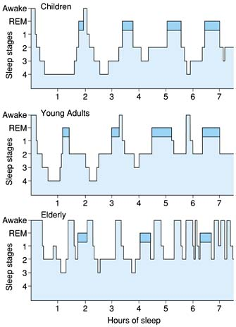 | Changes in human sleep pattern with age:  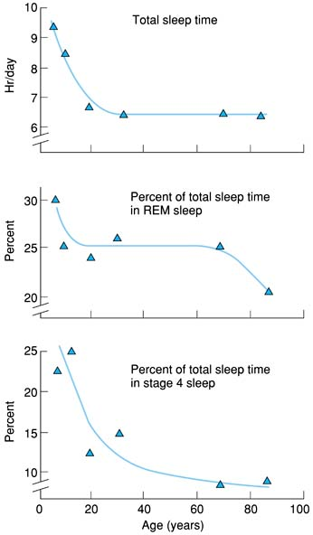

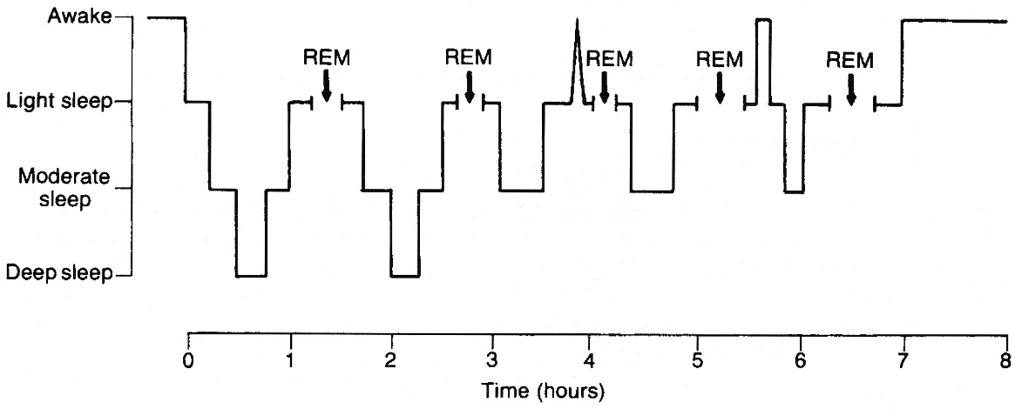

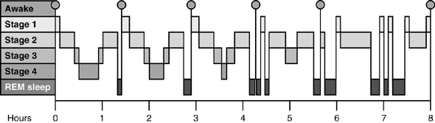

- normal healthy adult typically falls asleep within 10 minutes and first enters NREM sleep (passes through stages 1 → 4); sleep then lightens (stages 4 → 2) and REM follows (≈ 70-100 minutes after sleep onset).
- cycle is repeated at ≈ 90 minute intervals throughout night (4-6 REM periods per night).
- occasional periods of wakefulness occur.
Toward morning deep sleep↓ (stage 3 & 4 sleep↓) and REM sleep↑ (frequency and duration of REM episodes↑*).
*first REM period may be < 10 minutes in duration, while last may exceed 60 minutes.
- total duration of sleep:
infants – 16-18 hours (with sleep periods q 3-4 hrs), children – 10 hours, adults – 7 hours, elderly – 6 hours.
N.B. individual requirements vary widely (ranging 4-10 h q 24 h in healthy adults)!
epidemiologic studies suggest that adults with habitual sleep durations of < 4 or > 9 h have increased mortality rates as compared to those who sleep 7-8 h per night!
- REM sleep proportion of total sleep time:
80% in premature infants and 50% in full-term neonates* → falls rapidly (almost entirely by REM sleep reduction) and plateaus at 25% in puberty → remains ≈ 25% in adults → falls further to ≈ 20% (due to total sleep time ↓ + slow-wave sleep↓↓**) in old age.
*newborns may enter sleep directly through active REM
**in healthy elderly person, slow-wave sleep may be completely absent, particularly in males.
Dementia accelerates changes in sleep pattern that are seen with normal aging!

Sleep Neurochemistry
Putative sleep-inducing transmitters / hormones:
  - serotonin; serotonin agonists suppress sleep and serotonin antagonists increase slow-wave sleep.
REM sleep is associated with cholinergic activity↑ and noradrenergic & serotonergic activity↓.
NREM sleep is associated with serotonergic activity↑ (raphe-serotonin system may facilitate sleep but is not necessary to its expression).
  - adenosine; concentration increases in cholinergic areas of basal forebrain and mesopontine cholinergic nuclei during wakefulness (and decreases during sleep); caffeine (adenosine antagonist) has alerting effects.
  - endogenous ligands of GABA-A receptor complex (hypnotic effect of benzodiazepines and barbiturates).
  - prostaglandins; PGD₂ release in medial preoptic area causes slow-wave and REM sleep; PGE₂ release causes wakefulness.
  - melatonin see p. 2717-2718 >>
  - variety of other sleep-promoting substances have been identified (e.g. delta sleep-inducing peptide, muramyl dipeptide, IL-1, fatty acid primary amides, etc).

Nucleus (neurotransmitter) | Waking | Deep Sleep | REM Sleep
Pedunculopontine nucleus (Acch) | ↑ | ↓ | ↑
Locus coeruleus (norepinephrine) | ↑ | ↑ | ↓
Raphe nucleus (serotonin) | ↑ | ↑ | ↓
Substantia nigra (dopamine) | ↑ | ↓ | ↑

Endocrine system during sleep:
- growth hormone secretion↑ during deep sleep.
- sleep in general is associated with prolactin secretion↑.
- complex effect on LH secretion: during puberty, sleep is associated with LH secretion↑, whereas sleep in mature woman inhibits LH secretion in early follicular phase of menstrual cycle.
- sleep onset (and probably slow-wave sleep) is associated with inhibition of TSH and ACTH.
- melatonin is secreted predominantly at night.

Putative Sleep Functions
- there may be no one single function of sleep but group of different functions.
- functions may vary in importance depending on individual's age or activities, and none of these functions may be unique to sleep.

Sleep conserves energy loss through thermoregulation - during sleep core body temperature decreases, heat loss to environment is minimized.
- sleep may be prime period for anabolic activity → reduced rate of heat production.
- sleep deprivation → energy expenditure increases while temperature and weight drop until body systems begin to fail (beginning with endocrine and immune systems).
- growth hormone is primarily secreted during periods of deepest sleep early in night (disrupted sleep could inhibit growth).

Restorative neural functions
- in brain, overall RNA transcription and protein synthesis is relatively most prominent during deep sleep.
- this activity may have particular importance for synaptic function.
- deep sleep allows recovery from so-called activity debts; hypothesis - brain uses materials produced and stored during deep sleep.
- sleep deprivation → decline of cognitive function.
- deep sleep may be used to restore functional balance, as of emotional states in limbic system.

Continued processing of waking experience
- REM sleep is linked to synaptic changes that consolidate memories.
- that consolidation may depend on earlier processes in deep sleep.

EEG abnormalities
See also p. E1 >>
N.B. spikes and sharp waves are epileptiform discharges and are associated with epilepsy!
Spikes
- wave with sharp contour and < 80 msec duration; amplitude significantly greater than background.
- type of epileptiform discharges.
- caused by increased cerebral cortex excitability.
- more generalized spike-wave bursts depend on thalamocortical projections.
- certain patterns are frequently regarded as abnormal but they are simply normal variants (most common during drowsiness or light sleep): 14- and 6-Hz positive spikes, small sharp spikes (“benign epileptiform transients of sleep”), wicket spikes, 6-Hz spike-wave activity, rhythmical temporal bursts of sharpened theta activity.
- spikes occur alone or followed by slow wave (spike and wave).
- multiple spikes followed by slow wave (polyspike and wave) are associated with generalized seizures.

Sharp waves
- potential with sharp contour and > 80 (i.e. 80-200) msec duration.
- type of epileptiform discharges.
- if wave form not quite sharp but close to it, may call “sharp transient”.
- may occur without any clinical significance but are found interictally with greater incidence than normal in patients with epilepsy.
Vertex sharps – present in in midline in stage 1-2 sleep.
- generalized periodic sharp waves (recur at 0,5-2 Hz on attenuated background):
  - most commonly - following cerebral anoxia.
  - Creutzfeldt-Jakob disease (in 90% patients within 12 weeks of clinical onset):
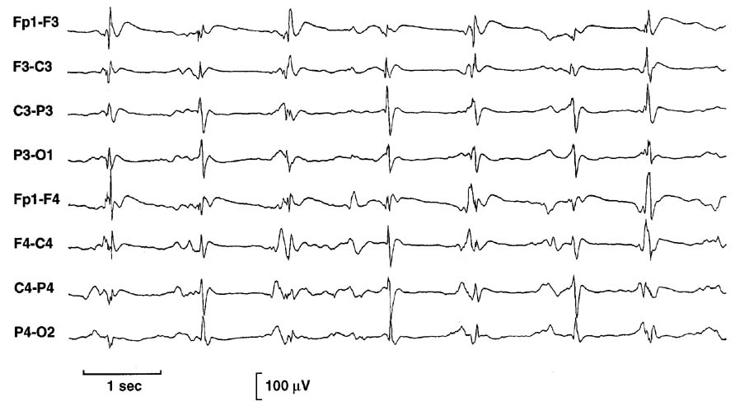

Ictal run
- cluster of epileptiform discharges with duration < 6 seconds.
- frequent ictal runs need to be treated.

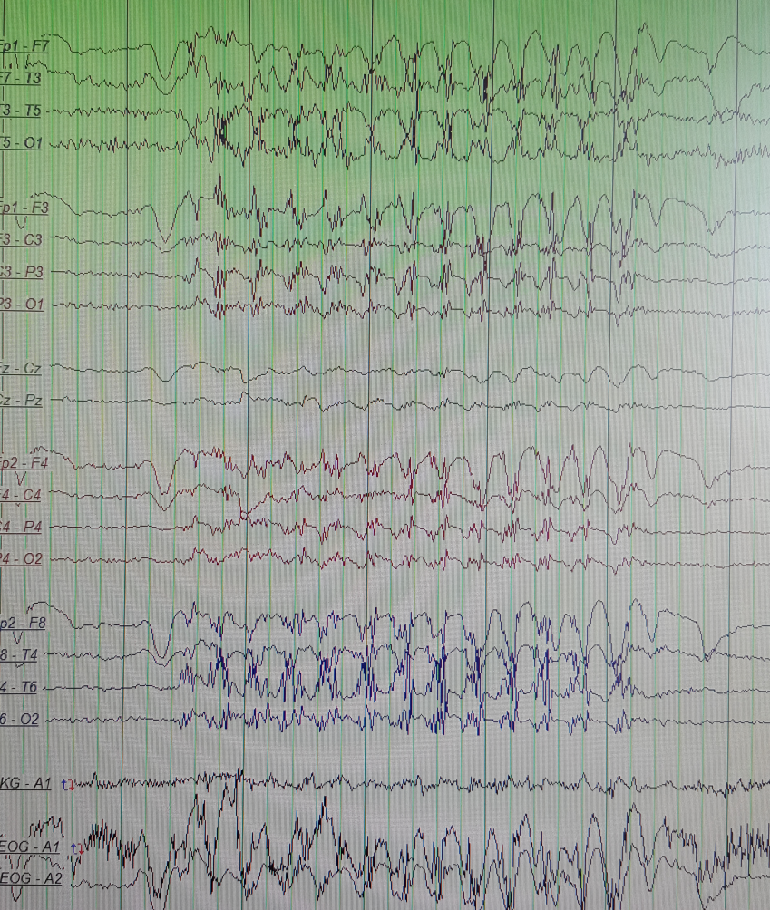

Seizure
- cluster of epileptiform discharges with duration > 6 seconds; usually has evolution stage* (when amplitude steadily increases) and termination stage.

*exception – drop attacks in infantile spasms: large wave → silence.

Slowed activity
Focal (localized) polymorphic (varies in rhythm, rate, and amplitude) slow-wave (delta) disturbance:
- transient - migraine or postictal state after partial (focal) seizure.
- continuous - underlying structural lesion (e.g. tumor, hematoma, abscess, contusion, etc); e.g. focal polymorphic slow-wave disturbance in right frontal glioma:
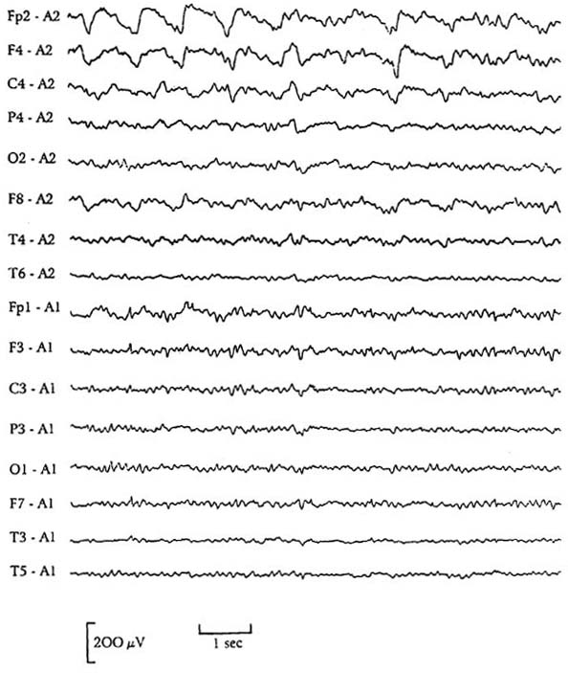

Generalized (diffuse) slowing
- generalized slowing reflects any disturbance in consciousness level. see p. S30 >>
- diffusely slowed activity during wakefulness (most common EEG abnormality!) is nonspecific - seen in diffuse encephalopathic processes (e.g. metabolic, encephalitic, toxic, anoxic, degenerative); e.g. diffusely slowed EEG in obtunded patient with metabolic encephalopathy:
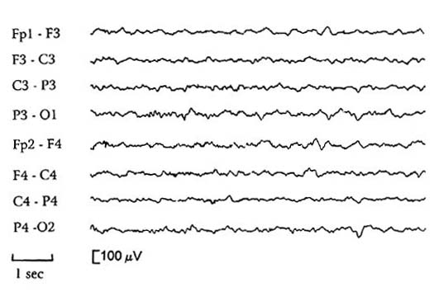

Diffuse encephalopathy (with high-voltage, polymorphic delta waves):
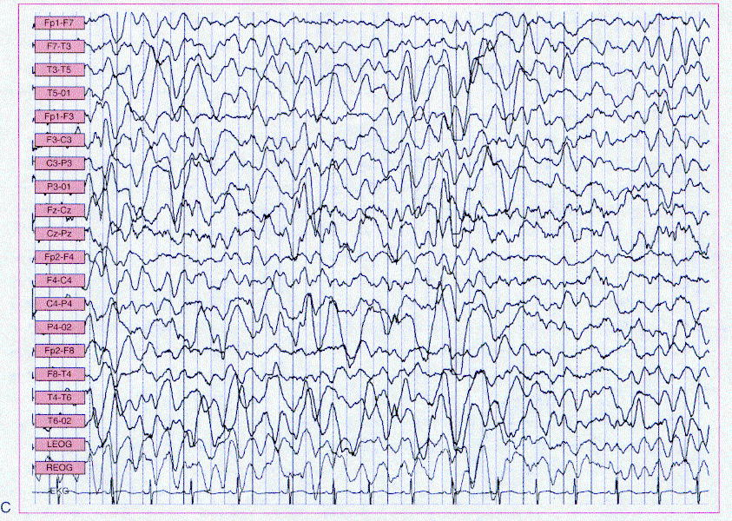

Activity attenuation
- focal - reflects destructive lesion of cerebral cortex (e.g. stroke).
- diffuse - severe encephalopathic processes, certain degenerative disorders (e.g. Huntington disease).
- electrocerebral silence - neocortical brain death, hypothermia, overdose of CNS depressants.

Burst-suppression pattern
- bursts of mixed-frequency activity separated by intervals of relative cerebral inactivity.
- any severe encephalopathy (e.g. severe cerebral anoxia, head trauma, overdose of CNS depressants, anesthesia).
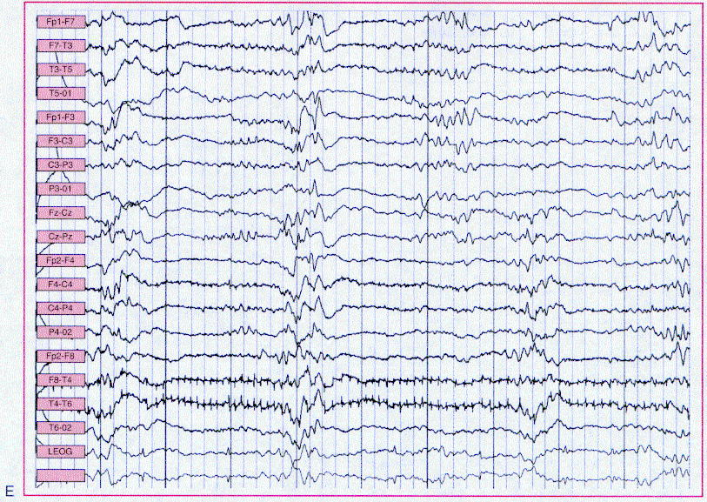

Triphasic slow waves
- generalized synchronous waves occurring in brief runs.
- ≈ 50% cases have hepatic encephalopathy;
- other toxic-metabolic encephalopathies.
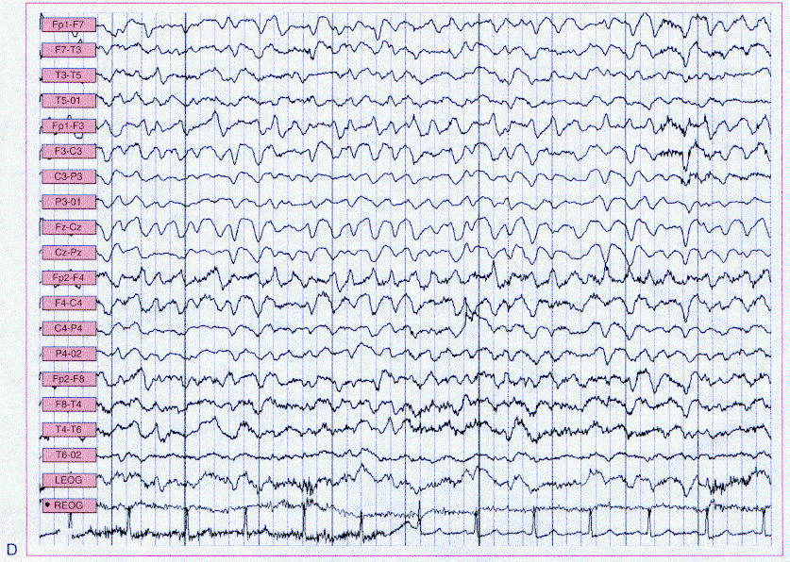

Breach phenomenon
- high amplitudes at craniectomy site

EEG artefacts
Eye blinking – big wave anteriorly:
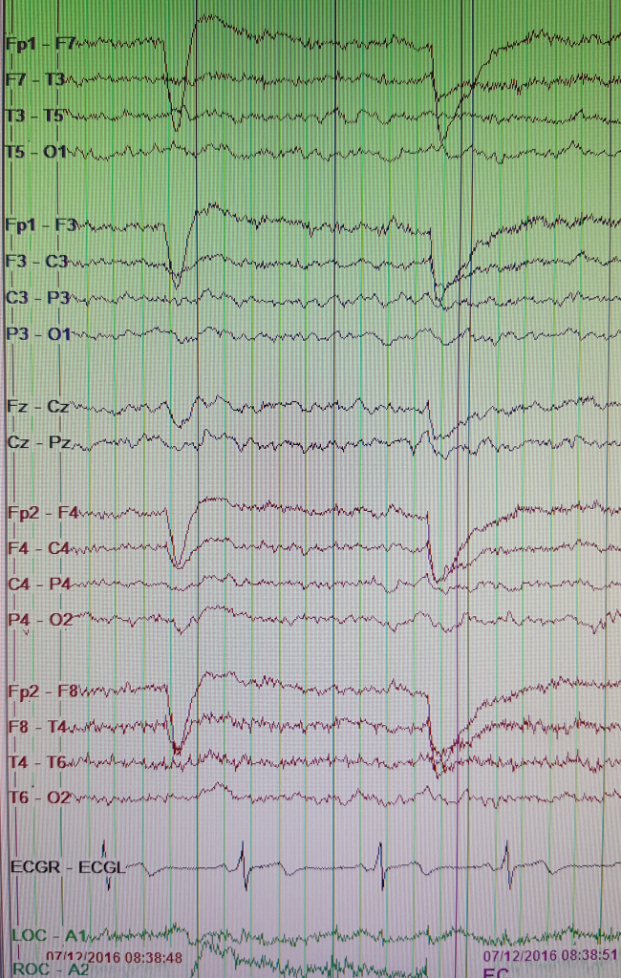

Muscle artefacts:
- may be eliminated by applying HF filter.
- absent in midline (there is no muscle):
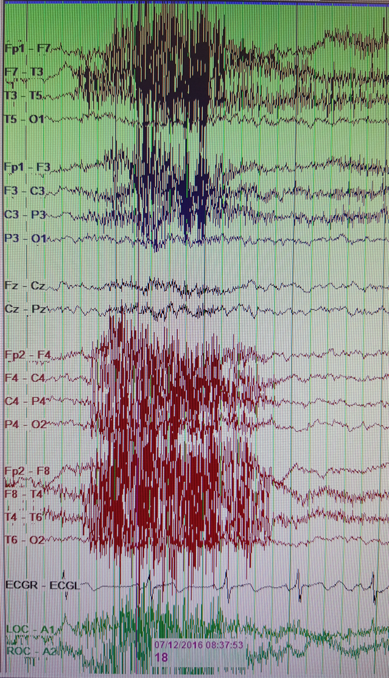

Chewing (tell patients with ambulatory EEG – no chewing gum) – regular muscle artefacts bitemporally:
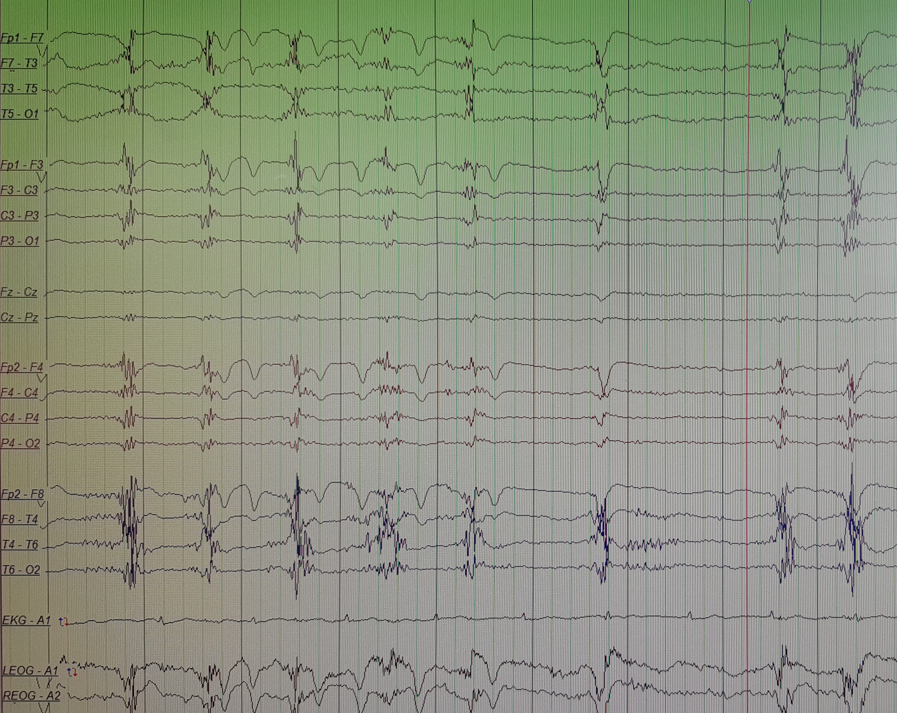

Roving eye movements (sedation) – large slow waves anteriorly (opposite in phase on more posterior lead and also to the other side – dipole moves towards one electrode and away from contralateral electrode):
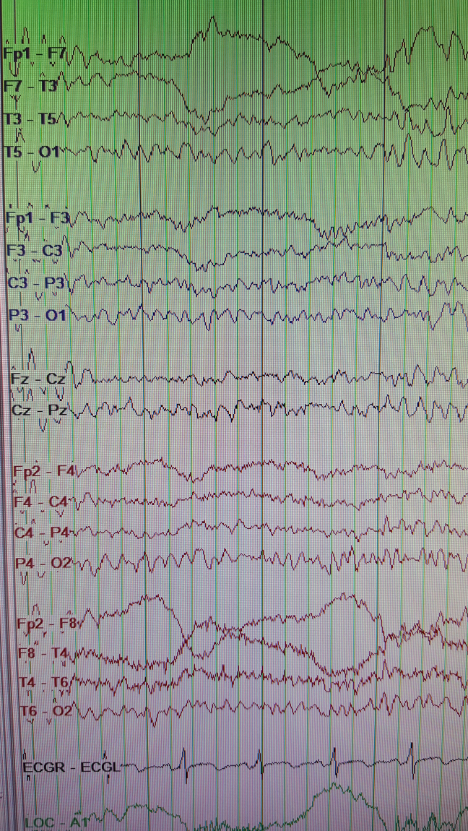

Breach – over craniectomy / craniotomy site:
      - higher amplitudes
      - often slowing from underlying cortical damage
      - phase reversal of sharps / spikes

Clinical Uses of EEG
- standard EEG records 30 minutes of brain activity, both in awake state and in first two stages of sleep.
- traditional method of EEG interpretation depends on visual analysis (subjective, very time intensive); computerized analysis techniques are developed.
- normally, recorded EEG activity should be fairly symmetrical.
- EEG is primarily measure of gray matter neuronal function.
N.B. EEG is usually not abnormal in white matter disease!
- psychiatric diseases have no effect on EEG.

  - Localizing focal cerebral abnormalities (role has declined with advent of new imaging techniques, but EEG is necessary, however, to assess epileptogenic potential of mass lesions) – localized slow-waves or attenuation of background activity, sometimes accompanied by focal spikes or sharp waves:
    - epileptogenic foci sometimes generate high-voltage waves.
    - fluid collection (e.g. subdural hematoma) over portion of cortex, dampens EEG activity over this area.
    - cortical lesions (contusions, tumors, infarctions, even transient ischemic attacks or migraine attacks) cause local irregular or slow waves.
- EEG slowing in hemispheric infarcts gradually improves with time, whereas focal slowing in neoplasms remains same or worsens!
N.B. normal EEG in patient with neurologic deficit strongly suggests lacunar infarction!

  - Diagnosing / characterizing epilepsy; additional features are sometimes necessary:
- ambulatory EEG monitoring for several days;
- activating procedures (to precipitate seizure discharges):
  - hyperventilation for 3-4 minutes (reduces arterial CO₂ → cerebral vasoconstriction):
normal patients → bilateral rhythmic EEG slowing.
patients with absence seizures → paroxysmal rhythmic spike and wave discharges.
  - photic flash stimulation at 20 Hz:
normal patients → rhythmic synchronous posterior activity (photic driving response).
some patients → synchronous myoclonic jerks (photomyoclonic response).
patients with generalized epilepsy → seizure activity (photoconvulsive response).
  - sleep recording
  - sleep deprivation (on night before examination) - increases diagnostic EEG sensitivity for epilepsy (in some patients, it will induce seizures).
  - hydration, alcohol, Metrazol, Amytal, Brevital

  - Investigating alterations of consciousness - generalized slowing (vs. locked-in syndrome simulating unconsciousness - EEG is normal); various additional features may suggest etiology.
see p. S30 >>

  - Confirming brain death - electrocerebral silence with lack of response to all stimuli (exclude hypothermia and sedative intoxication). see p. S34 >>

  - Diagnosing some specific CNS infections:
- herpes simplex encephalitis - periodic lateralizing epileptiform discharges (PLEDs) in temporal lobe.
- Creutzfeldt-Jakob disease - generalized synchronous periodic sharp waves.
- subacute sclerosing panencephalitis - stereotyped bursts of high-voltage delta waves (recurring at regular 4-10 second intervals).

Routine for reading EEG
High-frequency filter = slow pass; eliminates high frequency artefacts
Low-frequency filter = high pass; eliminates slow isoline fluctuations

- Is sleep present? Look for alpha rhythm posteriorly, eye blinking artefacts anteriorly.
- Count frequency of alpha waves – must be not lower than age group normal.
- Background
- Abnormal waves and discharges
- Symmetry between sides; up to 50% alpha rhythm amplitude assymetry is OK
- Stimulation – look for change in background
Photic – start from 3 Hz and increase up to 21 Hz – looking for:
        - “driving” (may or may not be present normally) – alpha wave frequency becomes the same as stim frequency.
        - asymmetry
Hyperventilation (CI: COPD, asthma) – normally produces slowing.

EEG review at bedside
VCU uses “Natus” software: Window → Review current study (opens new window for review); when done, click small x (not big X – this will stop recording)

Sedated patient
- generalized slowing of background.
- sleep spindle presence is a sign of intact cortex (in kids, SS may be asynchronous but symmetric; in adults SS must be synchronous and symmetric).

Signs to localize seizure onset
- localized low-voltage fast activity; it may not appear on the scalp recording, especially if it is well-limited and located deep in the cortex. In such a case, look for well-localized flattening of the EEG trace, or to the disappearance of well-localized interictal EEG abnormalities

Bibliography for ch. “Diagnostics” → follow this link >>

Viktor’s Notes℠ for the Neurosurgery Resident
Please visit website at www.NeurosurgeryResident.net

