Plain Radiography
Last updated: June 3, 2019
Skull X-ray 1
Lateral view 2
AP (fronto-occipital) view 2
PA (occipitofrontal) view 2
Caldwell (s. 25° PA) view 3
Towne (s. half-axial AP, 30° AP) view 3
Submentovertical (s. base, axial) view 4
Sellar region 5
Temporal bone 6
Stenvers view 6
Schüller view 6
Lateral mastoid view 6
Cranial foramina and canals 6
Facial X-ray 7
Waters' (occipitomental) view 7
Lateral view 8
Spinal X-ray – see p. D70 >>

Plain radiography, although still employed, is not routine in initial investigation - insensitive, nonspecific, redundant (even if abnormalities are seen, it is rare that findings provide sufficient information for management).

Retained general indications for X-ray:
skull – calcifications, congenital anomalies, osteolytic / osteoblastic disorders, some trauma cases.
spine – fractures / dislocations, degenerative conditions, evaluation of instability.

Skull X-ray
- about vascular grooves in inner table – see TrH5 p.
- about intracranial calcifications – see S70 p.
- pacchionian depressions extend max 2.5-3.0 cm from midline; any inner table depression beyond that distance should be considered something else (e.g. erosion secondary to neoplasm).
- beyond age 3 yrs., cranial sutures appear similar to adults.

Standard planes & lines:

Lines:
- Anthropological base line:
  - Reid’s or Frankfurt line - from lower margin of orbit to superior border of external auditory meatus.
  - orbitomeatal (OM) line - from outer canthus to centre of external auditory meatus.
- Auricular line: perpendicular to above, drawn vertically through external auditory meatus.
- Interpupillary line: through both pupils.

Planes:
- Medial sagittal plane - anatomical midline.
- Horizontal (Frankfurt) plane - contains both anthropological base lines; corresponding orbitomeatal plane includes both orbitomeatal lines.
- Frontal biauricular (coronal) plane: perpendicular to both preceding planes, passing through external auditory meatus.

Lateral view
- frontal, parietal, temporal, and occipital bones, sella turcica, orbital roofs, mastoid region, lateral aspect of facial bones.
- lateral view is sufficient as single view in many clinical circumstances.

Beam is centred 25 mm anterior to external auditory meatus and 10 mm above orbitomeatal line, thus placing sella turcica in centre of beam; anterior clinoid processes and orbital roofs on two sides should be superimposed.

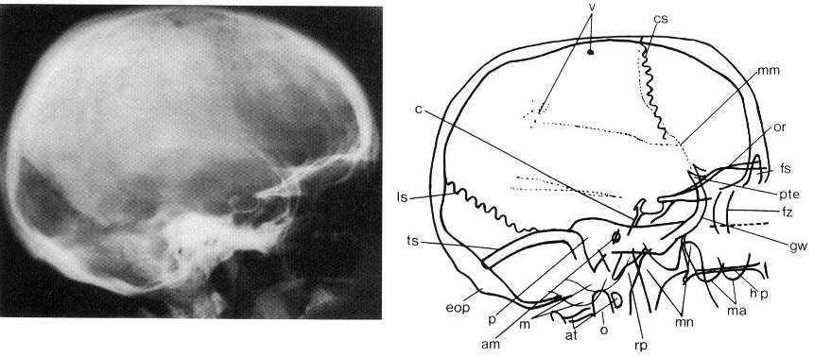
a = alveolus; ac = air cells in petrous bone; at = atlas; c = clivus; cc = carotid canal; co = cochlea; cs = coronal suture; csp = cervical spine; ds = dorsum sellae; eam = external auditory meatus (superimposed on lateral projection); eop = external occipital protuberance; es = ethmoid sinus; eu = Eustachian tube; fm = foramen magnum; fo = foramen ovale; fs = frontal sinus; fsp = frontal spinosum; fz = frontozygomatic synostosis; gw = greater wing of sphenoid bone; h = hyoid bone; hp = hard palate; iam = internal auditory meatus (superimposed on lateral projection); il = innominate line; iof = inferior orbital fissure; iop = internal occipital protuberance; it = inferior turbinate; lo = lateral wall of orbit; ls = lambdoid suture; lw = lateral wall of maxillary antrum; m = mastoid process; ma = maxillary antrum; mm = groove for middle meningeal artery; mn = mandible; mw = medial walls of orbit and maxillary antrum (superimposed); np = nasopharynx; ns = nasal septum; o = odontoid; or = roof of orbit; os = occipital squame; oss = ossicles (auditory); p = petrous bone; pc = posterior clinoid process; pr = petrous ridge; ps = planum sphenoidale; pt = pterygoid plates; pte = pterion; rp = retropharyngeal soft tissue; sg = groove for superior sagittal sinus; sof = superior orbital fissure; sps = sphenoid sinus; sr = sphenoid ridge; ss = sagittal suture; tm = temporomandibular joint; tr = tympanic ring; ts = groove for transverse sinus; tt = temporal tubercle; v = venous markings; z = zygomatic arch.

AP (fronto-occipital) view
- should not be used - causes magnification and blurring of more important anterior structures!

PA (occipitofrontal) view
- frontal and ethmoidal sinuses, frontal bones, nasal cavity, superior orbital rims, mandible.

Rest nose and forehead on cassette - midsagittal and orbitomeatal planes are perpendicular to film; beam centered on nasion.
- many individuals have asymmetrical temporal fossae, and best method of assessing rotation is to identify anterior structure (such as base of nasal septum), and more posterior structure (such as odontoid) - if these are not in same sagittal plane, radiograph is not adequate.

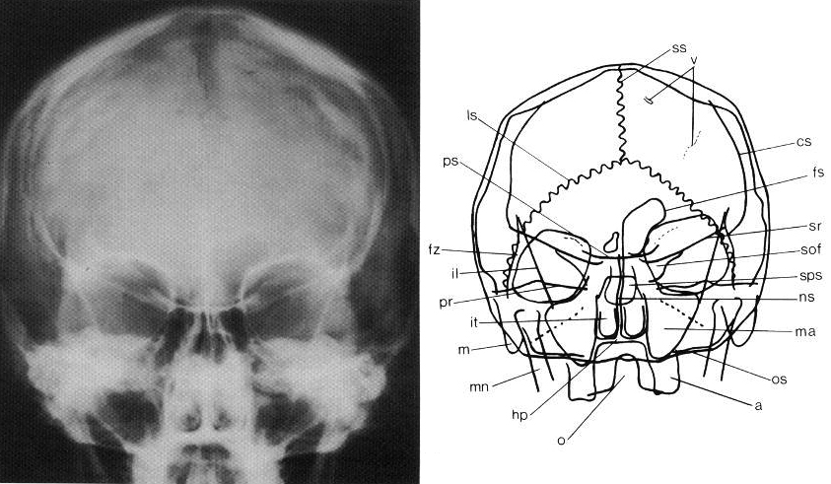
a = alveolus; ac = air cells in petrous bone; at = atlas; c = clivus; cc = carotid canal; co = cochlea; cs = coronal suture; csp = cervical spine; ds = dorsum sellae; eam = external auditory meatus (superimposed on lateral projection); eop = external occipital protuberance; es = ethmoid sinus; eu = Eustachian tube; fm = foramen magnum; fo = foramen ovale; fs = frontal sinus; fsp = frontal spinosum; fz = frontozygomatic synostosis; gw = greater wing of sphenoid bone; h = hyoid bone; hp = hard palate; iam = internal auditory meatus (superimposed on lateral projection); il = innominate line; iof = inferior orbital fissure; iop = internal occipital protuberance; it = inferior turbinate; lo = lateral wall of orbit; ls = lambdoid suture; lw = lateral wall of maxillary antrum; m = mastoid process; ma = maxillary antrum; mm = groove for middle meningeal artery; mn = mandible; mw = medial walls of orbit and maxillary antrum (superimposed); np = nasopharynx; ns = nasal septum; o = odontoid; or = roof of orbit; os = occipital squame; oss = ossicles (auditory); p = petrous bone; pc = posterior clinoid process; pr = petrous ridge; ps = planum sphenoidale; pt = pterygoid plates; pte = pterion; rp = retropharyngeal soft tissue; sg = groove for superior sagittal sinus; sof = superior orbital fissure; sps = sphenoid sinus; sr = sphenoid ridge; ss = sagittal suture; tm = temporomandibular joint; tr = tympanic ring; ts = groove for transverse sinus; tt = temporal tubercle; v = venous markings; z = zygomatic arch.

Caldwell (s. 25° PA) view
- orbital structures (unobstructed by petrous ridges)

Patient position as for PA view, but tube is angled 20-25° caudally → petrous ridges project at or near inferior orbital margins.

Towne (s. half-axial AP, 30° AP) view
- foramen magnum, entire occipital bone, dorsum sellae, petrous & mastoid region.

Place occiput on cassette (with orbitomeatal or anthropological line perpendicular to it).
- angle tube 30° caudally (gives effective caudal angulation of 25–40°) - beam is centered on foramen magnum.
- take care not to exclude anterior temporal and facial regions from film: on nonisocentric units they may appear elongated, because of distortion introduced by angling tube to film.

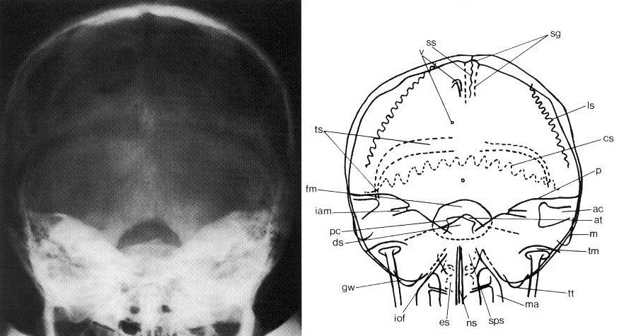
a = alveolus; ac = air cells in petrous bone; at = atlas; c = clivus; cc = carotid canal; co = cochlea; cs = coronal suture; csp = cervical spine; ds = dorsum sellae; eam = external auditory meatus (superimposed on lateral projection); eop = external occipital protuberance; es = ethmoid sinus; eu = Eustachian tube; fm = foramen magnum; fo = foramen ovale; fs = frontal sinus; fsp = frontal spinosum; fz = frontozygomatic synostosis; gw = greater wing of sphenoid bone; h = hyoid bone; hp = hard palate; iam = internal auditory meatus (superimposed on lateral projection); il = innominate line; iof = inferior orbital fissure; iop = internal occipital protuberance; it = inferior turbinate; lo = lateral wall of orbit; ls = lambdoid suture; lw = lateral wall of maxillary antrum; m = mastoid process; ma = maxillary antrum; mm = groove for middle meningeal artery; mn = mandible; mw = medial walls of orbit and maxillary antrum (superimposed); np = nasopharynx; ns = nasal septum; o = odontoid; or = roof of orbit; os = occipital squame; oss = ossicles (auditory); p = petrous bone; pc = posterior clinoid process; pr = petrous ridge; ps = planum sphenoidale; pt = pterygoid plates; pte = pterion; rp = retropharyngeal soft tissue; sg = groove for superior sagittal sinus; sof = superior orbital fissure; sps = sphenoid sinus; sr = sphenoid ridge; ss = sagittal suture; tm = temporomandibular joint; tr = tympanic ring; ts = groove for transverse sinus; tt = temporal tubercle; v = venous markings; z = zygomatic arch.

Submentovertical (s. base, axial) view
- skull base.

With patient supine, neck is fully hyperextended (thick pillow is placed under shoulders) - anthropological line is parallel with film; median sagittal plane is again perpendicular to it.
- beam is centred on biauricular line, halfway between angles of mandible.
- satisfactory radiograph - angles of mandibles lie just anterior to middle ear cavities.

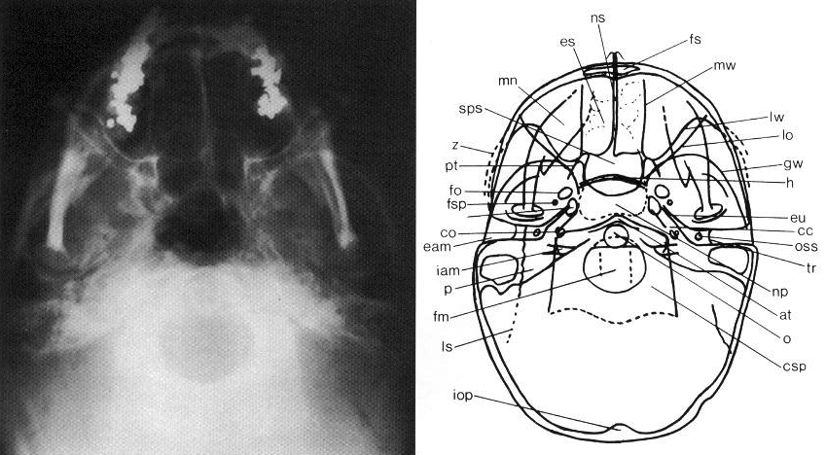
a = alveolus; ac = air cells in petrous bone; at = atlas; c = clivus; cc = carotid canal; co = cochlea; cs = coronal suture; csp = cervical spine; ds = dorsum sellae; eam = external auditory meatus (superimposed on lateral projection); eop = external occipital protuberance; es = ethmoid sinus; eu = Eustachian tube; fm = foramen magnum; fo = foramen ovale; fs = frontal sinus; fsp = frontal spinosum; fz = frontozygomatic synostosis; gw = greater wing of sphenoid bone; h = hyoid bone; hp = hard palate; iam = internal auditory meatus (superimposed on lateral projection); il = innominate line; iof = inferior orbital fissure; iop = internal occipital protuberance; it = inferior turbinate; lo = lateral wall of orbit; ls = lambdoid suture; lw = lateral wall of maxillary antrum; m = mastoid process; ma = maxillary antrum; mm = groove for middle meningeal artery; mn = mandible; mw = medial walls of orbit and maxillary antrum (superimposed); np = nasopharynx; ns = nasal septum; o = odontoid; or = roof of orbit; os = occipital squame; oss = ossicles (auditory); p = petrous bone; pc = posterior clinoid process; pr = petrous ridge; ps = planum sphenoidale; pt = pterygoid plates; pte = pterion; rp = retropharyngeal soft tissue; sg = groove for superior sagittal sinus; sof = superior orbital fissure; sps = sphenoid sinus; sr = sphenoid ridge; ss = sagittal suture; tm = temporomandibular joint; tr = tympanic ring; ts = groove for transverse sinus; tt = temporal tubercle; v = venous markings; z = zygomatic arch.

Sellar region
Diagram of sellar region:
Lateral projection Frontal projection From above

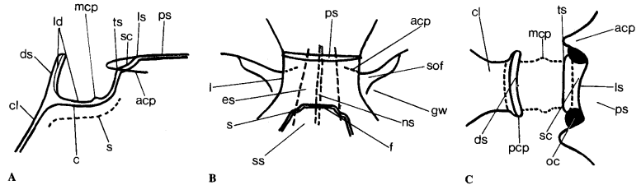
acp = anterior clinoid process; c = cortical bone lining sphenoid sinus; cl = clivus; ds = dorsum sellae; es = ethmoid sinus; f = floor of sella turcica; gw = greater wing of sphenoid; l = lamina papyracea; ld = lamina dura (cortical bone lining sella turcica); ls = limbus sphenoidale; mcp = middle clinoid process (inconstant); ns = nasal septum; oc = optic canal; pcp = posterior clinoid process; ps = planum sphenoidale; s = carotid sulcus; sc = sulcus chiasmaticus; sof = superior orbital fissure; ss = sphenoid suture; ts = tuberculum sellae.

Temporal bone
CT is study of choice for evaluating temporal bone!
- before thin-section high-resolution CT, many X-ray views and modifications were used.

Today, only few views are used:
Stenvers view
– oblique projection (angled 45° forward) to provide unobstructed view of petrous bone, bony labyrinth, internal auditory canal.

Schüller view
– along ear canal – demonstrates mastoid air cells.

Lateral mastoid view
- to confirm diagnosis of acute mastoiditis or substantiate previous mastoid disease.

Lateral (Law) projection;
M, mastoid air cells; DP, dural plate; LS, area of anterior wall of lateral venous sinus; SA, sinodural angle or angle of Citelli (merging of DP and LS); tmj, temporomandibular joint; eac, external auditory canal; iac, internal auditory canal.
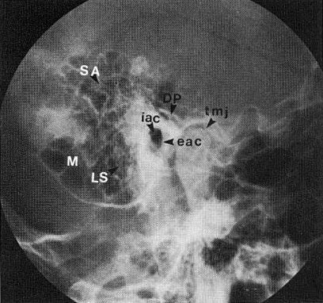

Cranial foramina and canals
Foramen/canal [location] | From → To | Contents | Size | Best projection | Notes
Optic canal  [basisphenoid] | orbital apex → middle fossa | CN2 and sheath; ophthalmic artery | 6 mm ø,  8 mm length | optic canal view (Rhese) | 1 mm difference in size suspicious; keyhole and figure of eight variants
Superior orbital fissure  [between greater and lesser sphenoid wings] | orbital apex → middle fossa | CN3, 4, 5₁, 6; superior ophthalmic vein; middle meningeal artery branch | very variable | occipitofrontal | thin greater wing may simulate erosion of lower border
Foramen rotundum  [greater sphenoid wing] | middle fossa → pterygopalatine fossa | CN5₂, artery of foramen rotundum | 3–4 mm ø | occipitofrontal | may be surrounded by extensive sphenoid sinus
Pterygoid (vidian) canal  [body of sphenoid] | foramen lacerum → pterygopalatine fossa | vidian nerve and artery | smaller than f. rotundum | occipitofrontal
Foramen ovale  [greater sphenoid wing] | middle fossa → infratemporal fossa | CN5₃, accessory meningeal artery; veins | 5 × 9.5 mm | submentovertical | frequently poorly seen; may be confluent with f. spinosum
Foramen spinosum  [greater sphenoid wing] | middle fossa → infratemporal fossa | middle meningeal artery | 2.5–3 mm, rarely 5 mm | submentovertical | may be double
Carotid canal  [petrous temporal] | skull base → middle fossa | ICA and sympathetic plexus | 6–9 mm ø; ≥ 1.5 cm length | submentovertical | runs posteromedial to eustachian tube; rarely passes through middle ear
Internal auditory meatus  [petrous temporal] | posterior fossa → inner ear | CN7-8 and dural sheath; internal auditory artery | 5–6 mm height | Stenvers | height difference of ≥ 2 mm is suspicious
Jugular foramen  [between petrous temporal and basiocciput] | posterior fossa → extracranial jugular fossa | pars nervosa: CN9, inferior petrosal sinus. pars vascularis: CN10-11, internal jugular vein, ascending pharyngeal and occipital artery branches | 11 × 17 mm; right often larger | under-tilted submentovertical | pars nervosa and vascularis may be separate
Foramen magnum  [basiocciput] | posterior fossa → cervical spinal canal | medulla oblongata, meninges and ligaments; CN11 (spinal root); vertebral and spinal arteries and veins | 30 × 35 mm | lateral; submentovertical | shape very variable
Hypoglossal (anterior condylar) canal  [occipital condyle] | foramen magnum → medial to jugular fossa | CN12; branch of ascending pharyngeal artery | 5 mm ø | reversed Stenvers: Stockholm ‘C’

Facial X-ray
Waters' (occipitomental) view
- single http://home.mdconsult.com/das/book/body/0/624/I106.fig - topbest view for initial evaluation of maxilla, maxillary sinuses, floors and inferior rims of orbits, zygomatic bones.

Angled frontal projection - orbitomeatal line at 37° angle from film.

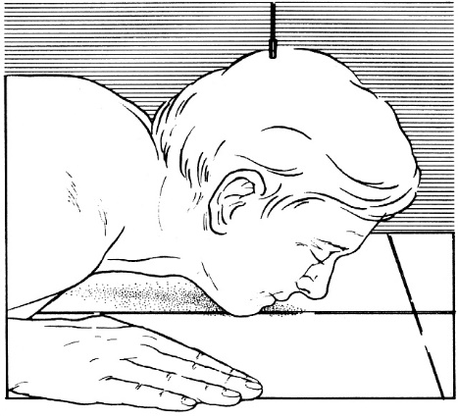 | 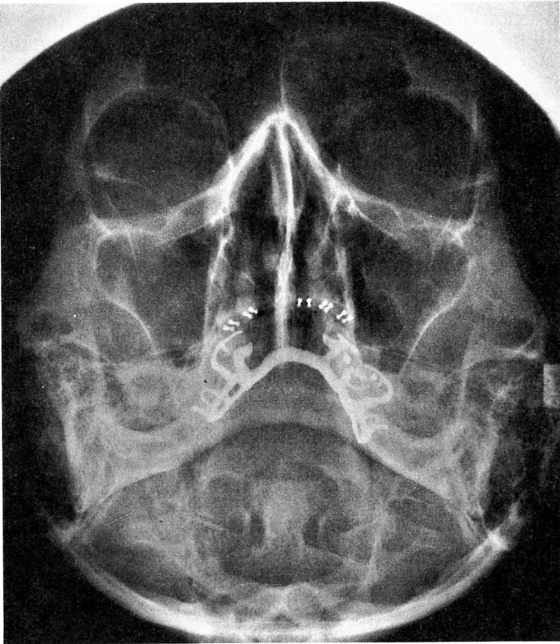

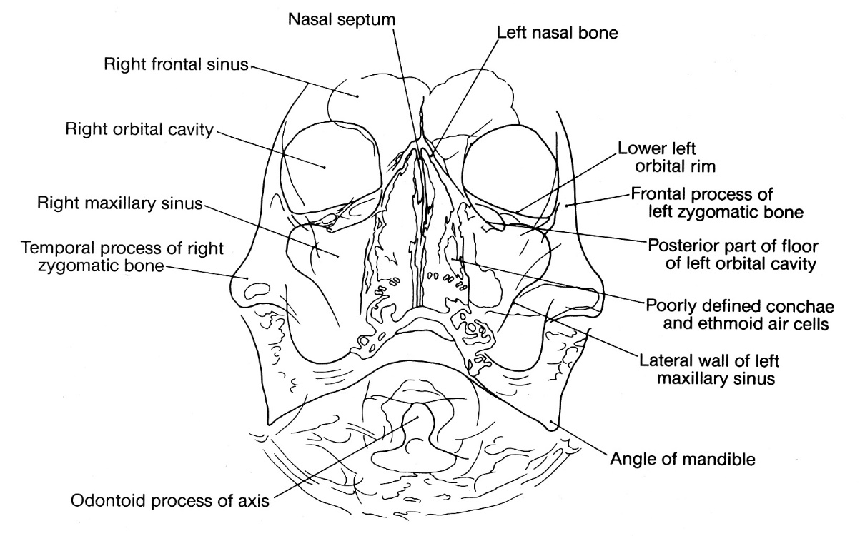

Lateral view
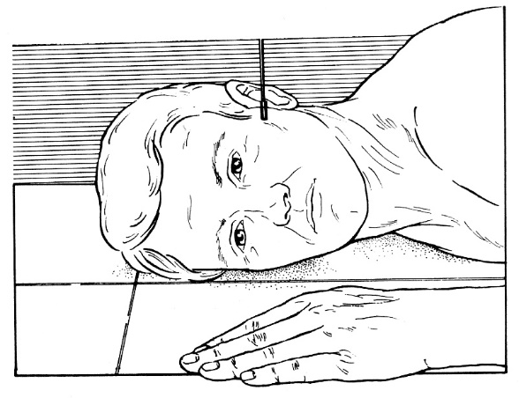

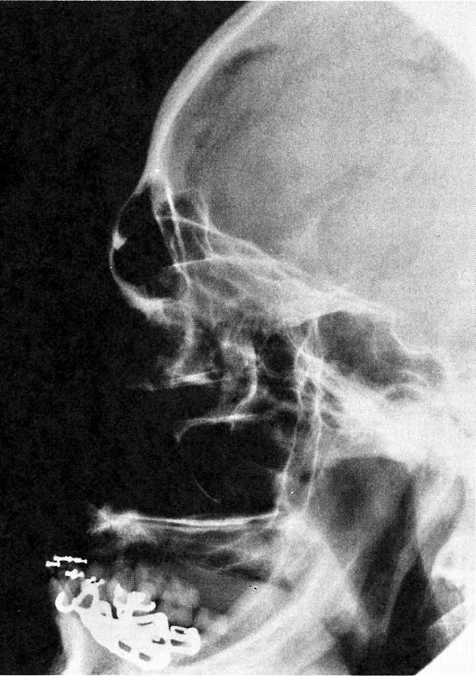 | 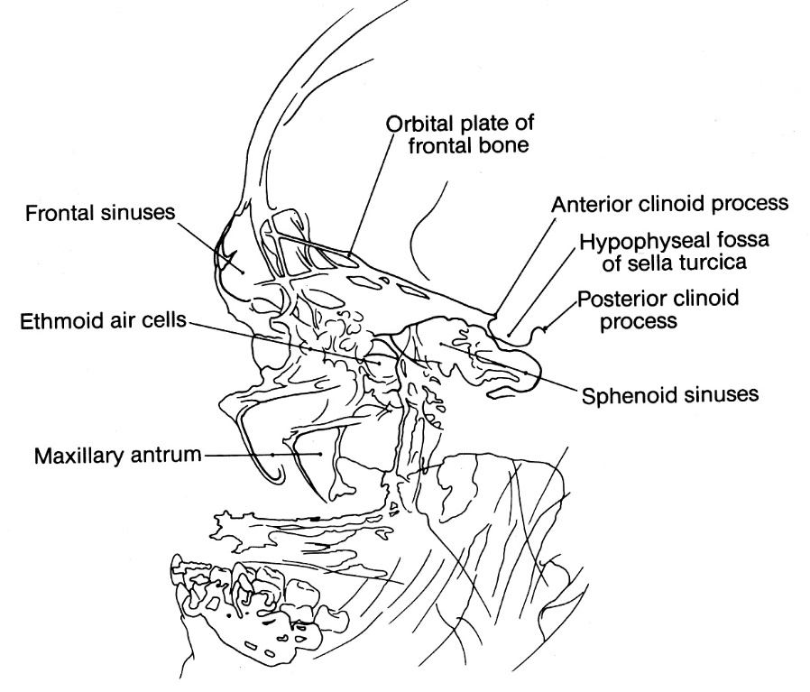

Bibliography for ch. “Diagnostics” → follow this link >>

Viktor’s Notes℠ for the Neurosurgery Resident
Please visit website at www.NeurosurgeryResident.net

