Doppler
Last updated: June 3, 2019

- introduced in 1982 by Aaslid.

Continuous wave Doppler
- simplest Doppler device - matuoja linijinį kraujo tėkmės greitį (LKG).
- passes continuous high-frequency wave sound signal over tissues + receives reflected signals and process them through speaker.
- user listens for sound pitch and makes rough judgment of degree of Doppler shift to infer whether blood moving through artery beneath probe is normal, decreased, or increased (and, if increased, is smooth or turbulent flow).
- little experience is required to separate high-frequency arterial signal from low-frequency venous and to hear extremely high frequencies typical of severe stenosis (more effort is required to quantitate signal to permit its comparison with same test at later date).
- Doppler shift equation depends on cosine of beam versus flowing blood within artery - casual angulation of probe can have major effects on signal production!

Duplex Doppler
- two crystals, one atop other, in single probe head:
one crystal - Doppler shift for spectral analysis (physiologic information);
second crystal - B-mode image of vessel walls (anatomic information).
- assists in proper probe angulation problem.
- crystal design improvements are steadily reducing size of probe (but it remains too bulky to explore carotid artery high up under mandible).

Continuous wave Doppler - no depth resolution - Doppler samples all structures within range of beam so that multiple vascular structures lying within sample area may be indistinguishable.

Range-gated Doppler - probe is gated to receive signals from specific depth - can evaluate individual vessels.
- adjustable range gate - analysis of flow signals from specific depths (eliminating conflicting signals where arteries and veins overlie one another).
- some have two range gates - allowing adjustable “volume” (or “window”) to insonate moving blood column in artery at volumes as small as 0.6 mm (size of tightest stenosis).
- latest models permit color-coded display (color-coded Doppler ultrasound).
- one color (usually red) indicates blood flowing in one direction and second color (blue) indicates blood flowing in opposite direction.
- capacity to interrogate flow pattern from wall to wall across lumen - useful for detecting, measuring, and monitoring degrees of stenosis.
- spectral analysis - frequencies displayed graphically on Y axis:
normal unidirectional, laminar flow - blood cells are moving at similar velocities and in similar directions - frequencies produce narrow waveform;
luminal irregularities (such as plaque) - variations in velocity and direction of cellular blood components → increased peak velocities + increased range of frequencies → broadening of waveform.

Doppler is divided into:
  - extracranial Doppler (s. carotid ultrasound); also allows vertebral artery exam (cervical VA is shadowed by bony spine).
  - transcranial Doppler (low-frequency pulsed transcranial Doppler):
orbital window – carotid siphon, ophthalmic artery, ± ACA
temporal window – ICA, ACA, AComA, MCA, PComA, PCA
foramen magnum window (suboccipital approach) – vertebrobasilar system.
- because procedure is safe, fast, and uses probe and microprocessor of table-top size, device can be taken to bedside even in ICU.
- useful for evaluating residual blood flow in brain death.

Disadvantages
- calcified plaques (calcium absorbs sound waves) can interfere (“shadow”) with visualization of vascular lumen and distal vessel wall.
- B-mode vessel imaging remains disappointingly insensitive to most minor ulcerations (better seen by conventional angiography).
- access to only carotid portion that lies between clavicles and mandible (in 10% patients, carotid bifurcation lies above angle of jaw).
- acute thrombi are echolucent.

Arterial flow (red) in normal ICA and CCA. Sampling for flow velocities and spectral waveform analysis is carried out in center stream of ICA, as displayed on diagram, and waveform is shown below. Peak systolic and end-diastolic velocities are measured on representative wave, and in example, these are 0.58 m/sec and 0.25 m/sec, respectively – well within normal limits.
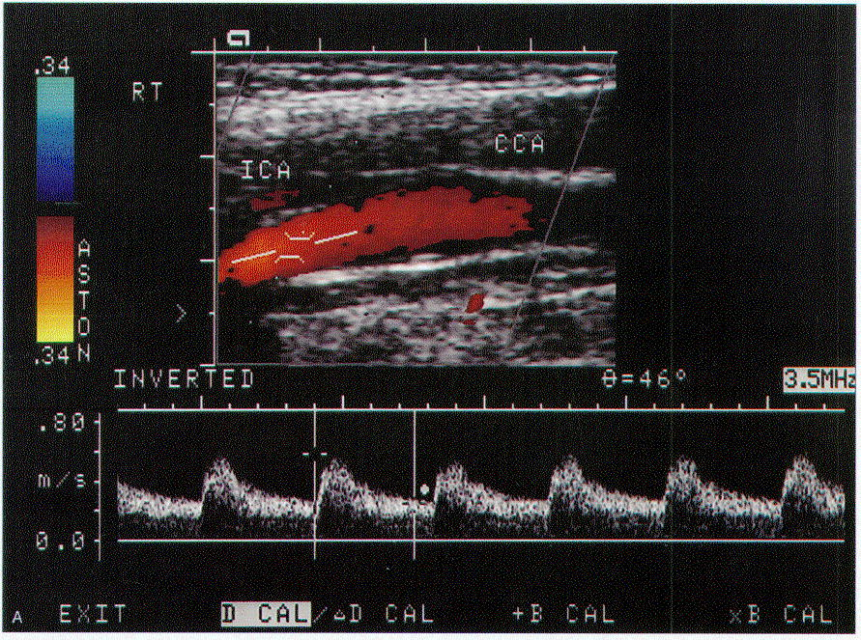

The same area in diseased ICA. The lumen appears narrow and red color becomes variegated and lighter. Arterial flow is sampled in area of maximal disturbance and narrowing, and resultant waveform is displayed below. The peak systolic velocities approach 4 m/sec and end-diastolic velocity is 1.41 m/sec - elevated, indicating abnormally increased flow velocities in area of stenosis. In addition, spectral analysis shows broadening from nonlaminar flow - characteristic of significant stenosis. By applying validated criteria, severity of stenosis can be estimated accurately.
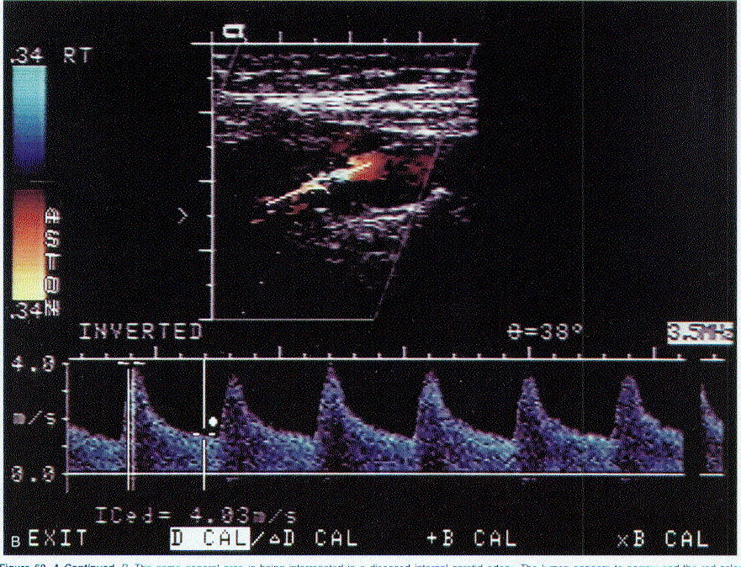

Measures
Gosling index = (sistolinis LKG - diastolinis LKG) / vidutinis LKG.
- in intracranial hypertension, Gosling index > 1.

Lindegaard index = LKG in MCA / LKG in ICA

Normalus vidutinis linijinis kraujotakos greitis (LKG) in MCA ≈ 60 cm/s; in ICA 60-100 cm/s
- LKG in MCA > 100-120 cm/s:
  - vazospazmas (LKG in MCA bent 3 kartus viršija LKG vidinėje miego arterijoje - Lindegaard index↑).
  - smegenų hiperemija (paraleliai didėja LKG tiek MCA, tiek ir ICA).

Bibliography for ch. “Neurovascular Examination” → follow this link >>

Viktor’s Notes℠ for the Neurosurgery Resident
Please visit website at www.NeurosurgeryResident.net

