Spinal Imaging
Last updated: June 3, 2019

Plain X-ray 2
Radiograph Evaluation 2
Signs of instability 2
Cervical spine 2
AP projection 2
Lateral projection 3
Oblique projection 7
Open-mouth (odontoid) projection 7
Closed-mouth (odontoid) projection 8
Swimmer’s view (transaxillary) projection 8
Thoracocervical spine 10
AP projection 10
Lateral projection (“swimmer’s”, “Twining’s” view) 10
Thoracic spine 10
AP projection 10
Lateral projection 11
Lumbar spine 11
AP projection 11
Lateral projection 11
Oblique projection 11
Lumbosacral spine 11
AP projection 11
Lateral projection 12
MRI 12
Choice of MRI 12
Normal MRI anatomy 12
Artefacts in spinal MRI 16
CT 17
Myelography 17
Contrast Medium 18
Routine preprocedure screening 18
Contraindications 18
Procedure 18
Postprocedure 19
Special situations 20
Complications 20
Normal Myelographic Anatomy 21
Cervical region 21
Thoracic region 21
Lumbar region 21
Pathologic myelographic findings 23
Discography 24
Ultrasound of neonatal spine 25
Normal Cord & Spine 25
Radiological approach to common Spinal Problems 26
Acute presentations 26
Chronic presentations 27
Angiography – see p. D61 >>

Inconsistent correlation between anatomic abnormalities and symptomatology:

25% of asymptomatic people have small lumbar disc protrusions visible on MRI;

some patients with disabling clinical symptoms have minimal abnormalities on MRI.

MRI is imaging modality of first choice; other investigations are considered only when MRI is either contraindicated or impossible.

Imaging is ordered by specifying vertebral levels, while neurologic disability is defined by spinal cord level!

Plain X-ray
- still commonest method of imaging.
- most indications are no longer justified.
- specific indications – fractures / dislocations, degenerative conditions, evaluation of instability.

Most episodes of back pain are self-limited and do not require imaging!
American College of Radiology recommendation – do not obtain lumbar spine radiographs for acute low-back pain unless fracture, malignancy, or infection are suspected.

Radiograph Evaluation
ABCS
- Alignment (anterior and posterior vertebral body, posterior spinal canal, spinous processes)
alignment of cervical spine – see below
- Bony changes:
- vertebral body height
- bone contour – trace around each vertebra individually – look for fractures, osteophytes.
- bony density:
- decreased density (rheumatoid arthritis, osteoporosis, osteomalacia, metastatic osteolytic lesions) - weak points that are apt to succumb under stress.
- increased density (acute compression fractures of vertebral bodies, metastatic osteoblastic lesions).
- Cartilages – are intervertebral disc space margins parallel?; slight anterior or posterior widening of intervertebral space (or interspinous spaces) may be only clue to unstable dislocation.
- Soft tissues (mainly in lateral cervical view – see below)

Signs of instability
- subluxation of vertebra
- disruption of posterior vertebral body line
- widening of apophyseal joints / increased interpedicular distance

Cervical spine
AP projection
(least useful from clinical standpoint)  - supine or seated, with baseline extended 20°.  - centering:  - through mouth (which is held open) - for upper vertebrae.  - at sternal notch, perpendicular to film - for lower cervical vertebrae.  - jaw may be moved gently during exposure, to produce autotomogram.  - to show posterior intervertebral joints and lateral masses, use 30° caudal tube angulation.  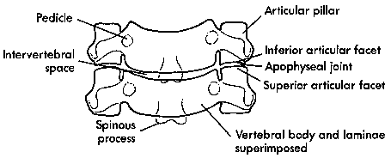  - tracheal and laryngeal air shadows should be within midline.  - straight line should connect points bisecting spinous processes (if not, suspect rotary injuries). | 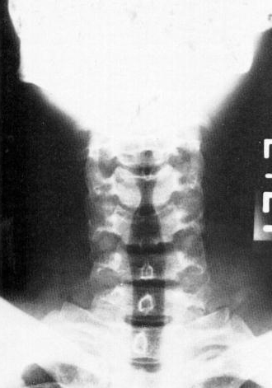

Lateral projection
- erect, neck extended, shoulders forcibly depressed (esp. in obese individuals - weights may be held in hands) to visualize C₇-Th₁.
specificities in trauma - see TrS5 p.
- centered 2.5 cm behind angle of mandible at tube-target distance of 6 feet (2 meters).

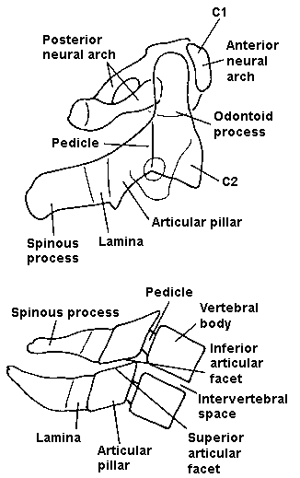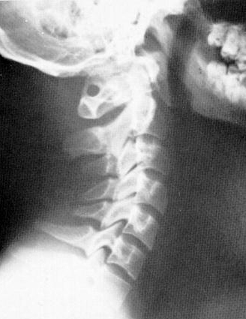

Four lines:
- two imaginary lines are drawn that separately connect anterior and posterior margins of vertebral bodies (anterior and posterior contour lines).  - third line (spinolaminar line) connects bases of spinous processes extending to posterior aspect of foramen magnum.  - each of these three lines should form smooth, continuous lordotic curve; any disruption of these lines suggests bony or ligamentous injury; exception – pseudosubluxation (see below).  - step < 25% of vertebral body implies unifacet dislocation; > 50% - bifacetal dislocation.  - angulation between vertebrae > 10% is abnormal.  - 40% children ≤ 7 yrs have 3-4 mm anterior displacement of C2 on C3 (physiologic* subluxation, s. pseudosubluxation); still present in 20% up to 16 yrs; 15-20% show this with C3 on C4; cause - immature muscular development, with resultant hypermobile spine. |  | 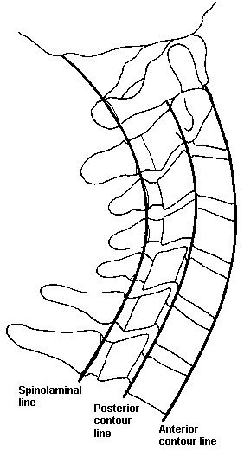
*if high cervical injury is suspected in child – use fourth posterior cervical line (straight line that connects points bisecting bases of spinous processes of C1, C2, and C3) – if base of any of these spinous processes lies > 2 mm anterior or posterior to posterior cervical line, significant pathologic condition at that level should be suspected; in pseudosubluxation posterior cervical line is maintained (and subluxation is reduced during flexion-extension maneuvers; vs. true subluxation - cannot be reduced)  - distance between anterior aspect of odontoid process and posterior aspect of anterior ring of C1 (predental space) should not exceed 3 mm in adult or 5 mm in child (widening of this space indicates transverse ligament disruption). |  | 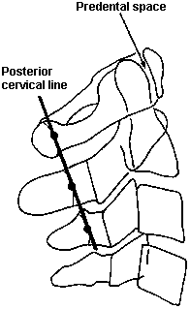
Prevertebral spaces:  1. Retropharyngeal space between lower anterior border of C2 and posterior wall of pharynx should not exceed 7 mm in children or adults; if > 7 mm – suspect retropharyngeal swelling (hematoma, abscess).  - at C3-C4 level, this measurement should not exceed 5 mm (or be less than ½ width of vertebral body at that level).  - in children < 2 yrs, retropharyngeal space may normally appear widened during expiration, and thus inspiratory films should be obtained.  - air in prevertebral space is sign of esophagus or respiratory tree rupture.  - anterior bulging of prevertebral fat stripe is excellent indirect sign of underlying bony or soft-tissue injury.  2. Below C4 level, retrotracheal space (between anterior border of C6 body and posterior wall of trachea) should not exceed 22 mm in adults or 14 mm in children < 15 yrs (i.e. be < 1 vertebral body). | 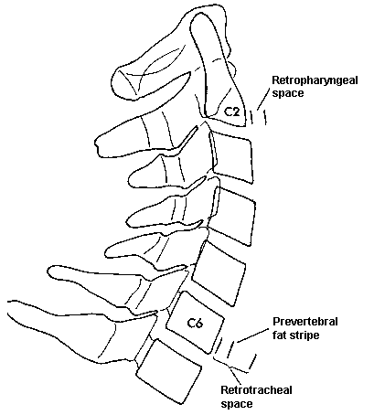

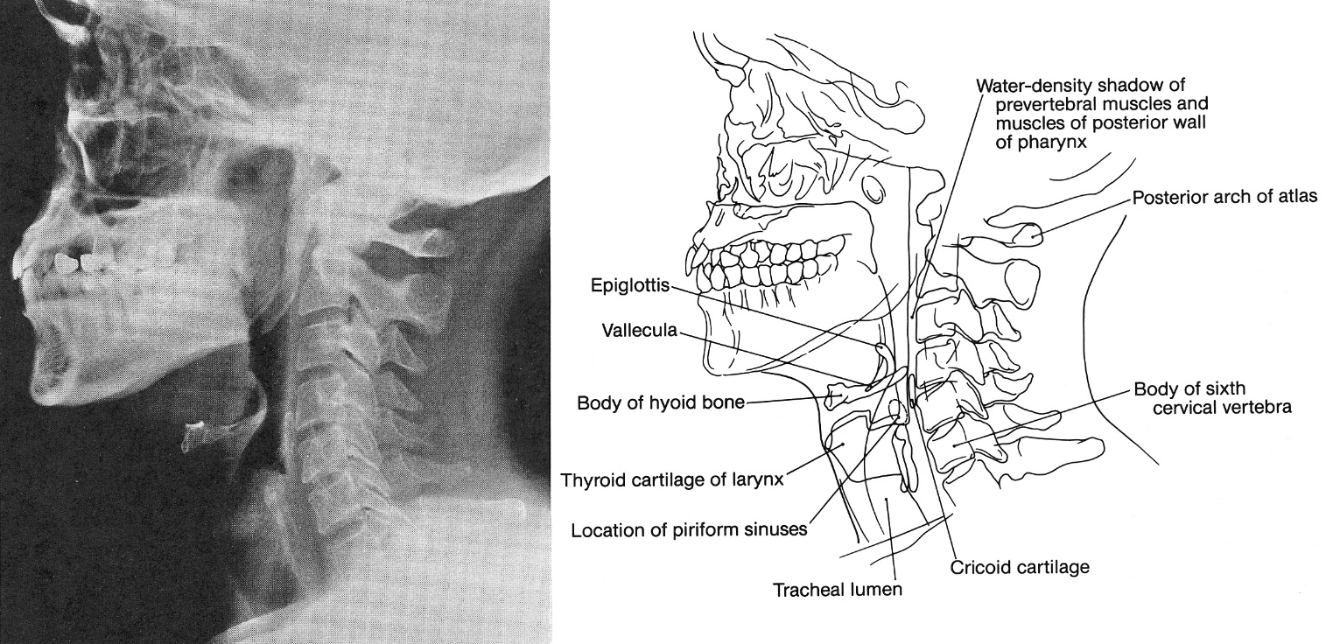

- flexion-extension views – to detect subluxation (in subacute trauma, in presurgical patients): slowly and gently flex and extend neck for X-ray examination but not to point of causing pain or neurologic symptoms (only movement of 10-15° is necessary to identify most unstable ligamentous injuries).

Oblique projection
- anteroposterior, neck and head rotated 45°, with chin depressed.  - centering at midcervical level, with 15° cephalad tube angulation.  - indication - unobstructed views of neural foramina (in lateral projection foramina project anterolaterally and are not visible).  - foramina displayed en face are those away from which head is rotated (cf. lumbar spine).  - to show lower neural foramina, it is often necessary to rotate shoulder as well as neck.  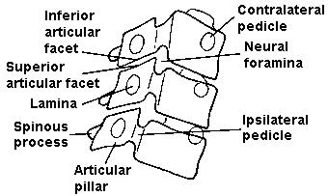 | 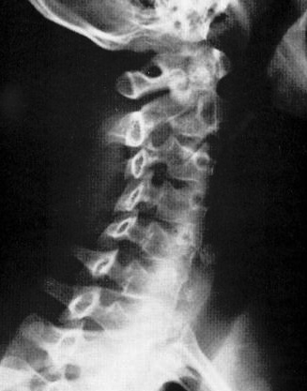  - normal laminae present as intact ellipses (“shingles on roof”).

Open-mouth (odontoid) projection
- vizualizuoja dantį (also occipital and atlantoaxial joints, lateral masses of C₁ and C₂).
- most important structural relationship (assess symmetry!) - alignment of lateral masses of C₁ with respect to odontoid process.
- nonfusion of odontoid in children and congenital anomalies of odontoid in adults may mimic fractures.
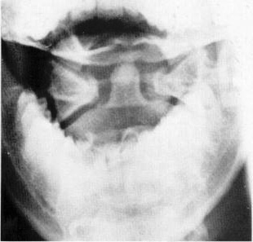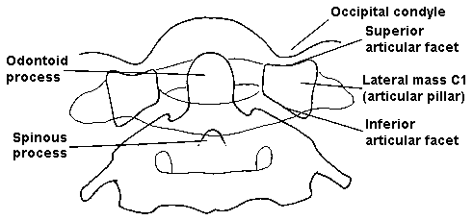

Spence's rule (in coronal CT view) - sum of bilateral distances between dens and lateral mass: if > 7 mm (or > 8 mm on plain XR open-mouth view to consider effects of radiographic magnification) = transverse atlantal ligament rupture

Closed-mouth (odontoid) projection
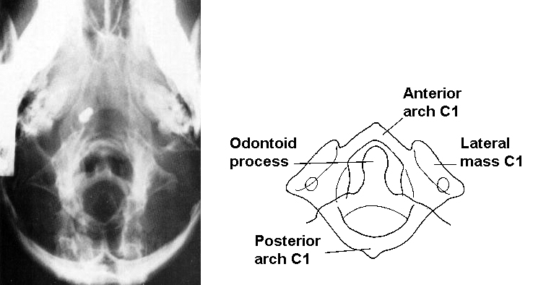

Swimmer’s view (transaxillary) projection
- vizualizuoja C₇-Th₁ jungtį:
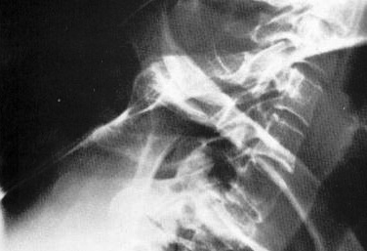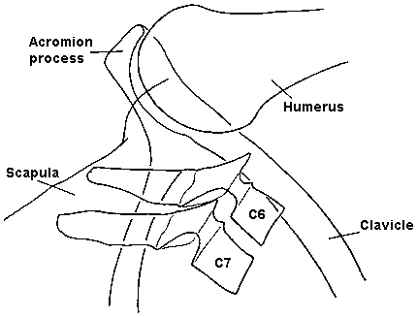

Normal cervical spine:
A: Lateral view - lateral articular masses and facet joints project over normal spinal canal.
B: 45° anterior oblique view - widely patent nerve root foramina; hypertrophy of either facet joints (arrows) or uncinate processes (arrowheads) may encroach on nerve roots as they traverse foramina.
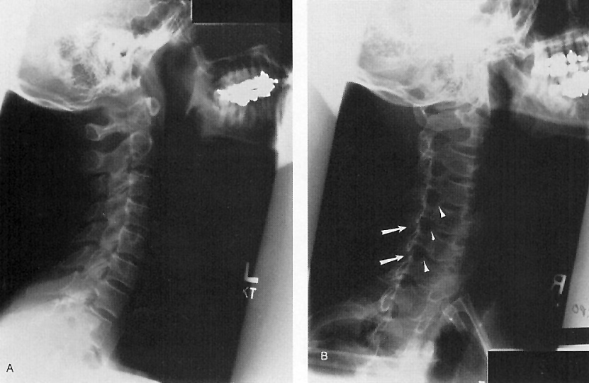

Thoracocervical spine
AP projection
(not often required, but is useful supplement to thoracic spine below).
- centering point - sternal notch.

Lateral projection (“swimmer’s”, “Twining’s” view)
- arm adjacent to film is elevated above head, while other remains down by side.
- centered above shoulder further from film, to opposite axilla, with 15° cephalad tube angulation.

Thoracic spine
AP projection
(entire thoracic portion)  - centering point - midway between cricoid and xiphoid cartilages (i.e. ≈ 2.5 cm below sternal angle).  - mediastinal stripe should be checked; bulging mediastinal stripe - thoracic vertebral body fracture, infection or neoplasm. | 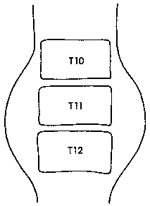
Lateral projection
- centered on 6th thoracic vertebra (i.e. through axilla).
- patient may breathe gently during exposure, blurring out rib cage.
- scoliosis - convexity is placed nearer film, i.e. away from tube (divergent rays are more nearly parallel to disc spaces).

Oblique projection is not helpful (anterior-to-posterior orientation of spinal facet joints)

Lumbar spine
AP projection
- flexion of hips and knees will reduce lumbar lordosis.
- centering - at lower costal margin.

Lateral projection
- centering - 10 cm anterior to 3rd lumbar spinous process.
- convexity of any scoliosis is nearer film.

Oblique projection
– indications:
  - unobstructed view of neural foramina (30–40° obliquity shows en face pedicles and neural foramina towards which trunk is rotated).
  - nondisplaced spondylolysis (obscured by superimposition in lateral projection).

Lumbosacral spine
- lowest disc space is best assessed separately (by coned well-penetrated image) from remainder of lumbar spine.
AP projection
- supine, 20–30° cephalad tube angulation.
- centering - midline (between anterior superior iliac spines).

Lateral projection
- centering - 10 cm anterior to spinous process of 5th lumbar vertebra.

MRI
- best imaging modality for spinal cord and spaces surrounding it!
- structures are of small size – use minimal slice thickness (3-4 mm) and interslice gap (≤ 1 mm).
- spatial resolution is crucial; since contrasts involved between disc, bone, CSF, spinal cord and epidural fat are considerable, it is possible to diminish contrast resolution in interest of spatial resolution.

Typical protocols - sagittal and axial:
cervical spine - gradient-echo images (two- and three-dimensional).
lumbar spine - fast spin-echo (FSE)* T2-weighted.
*CSF motion is minimal in lumbar region, so FSE techniques can be used, allowing excellent visualization of cauda equina.

T2-weighted MRI
- provides myelographic effect (CSF bright, neural tissue dark).
- early detection of disc degeneration. see Spin1 p.

Proton density-weighted MRI
- evaluation of disc margins - sharp contrast between posterior disc aspect and adjacent thecal sac and posterior longitudinal ligament.
T1-weighted MRI
- evaluation of marrow space of vertebrae; normal fatty marrow replacement by tumor, inflammatory cells, blood, or calcification - signal intensity change: white → gray or black.
- if more sensitive marrow imaging is required → fat-suppression imaging (e.g. fast spin-echo short tau inversion recovery [FSE-STIR] and FSE T2-weighted sequences with frequency-selective fat suppression).
- epidural and paravertebral fat provide natural contrast with adjacent bony and neural structures but may reduce conspicuity of enhancement after intravenous gadolinium. H: fat suppression for postcontrast T1-weighted imaging.

Choice of MRI
Myelopathy - T2-weighting using gradient-recalled echo technique is most desirable.
Cord compression (demonstration of internal structure is less important, and thinner sections can be used to improve precision) - T1-weighted spin-echo sequence is best option.
Radiculopathy (spinal root canals are targeted) - T2-weighted gradient-recalled echo sequence.

Normal MRI anatomy
Posterior intervertebral joints
- planar in cervical-thoracic region, slightly concavo-convex in lumbar.
- articular surfaces constitute most of lateral masses of cervical vertebrae, but are carried by well-defined articular processes in thoracic and especially in lumbar region.
- synovial joint spaces often contain fat (esp. near their margins).

Intervertebral discs
- disc margins bulge up to 2–3 mm beyond vertebral margins (esp. in children).
- posterior disc surface is flat or concave (not convex!).
- MRI shows internal disc structure.
vs. CT - shows amorphous texture with relatively high soft-tissue density (clearly distinguishable from fluid-filled thecal sac, epidural fat).
- disc maturation with age:
- sharp distinction between annulus and nucleus progressively diminishes.
- annulus thickens (progressive acquisition of concentric layers of dense, organized collagen).
- nucleus pulposus acquires transverse plate of dense collagenous tissue which bisects it into upper and lower halves.
Midsagittal MRI of lumbar spine; accelerated maturation (degeneration) in L4–5 and L5–S1 discs:
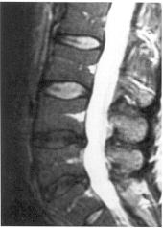

Intervertebral foramina (s. spinal nerve root canals)
Cervical region (below C2):
- inferior boundary of each canal is upward concavity of transverse process, which cradles dorsal root ganglion behind foramen transversarium on each side.
- canals are oriented anterolaterally (nearer coronal than sagittal plane).
- 5 mm wide (can be difficult to image).
Thoracic region - canals are short, well seen on sagittal images.  Lumbar region - canals consist of two parts:  subarticular part - lies medial to pedicle, under superior articular facet in lateral extremity of spinal canal (lateral recess of spinal canal);  infrapedicular part (intervertebral foramen itself) - lies below pedicle.  Parasagittal lumbar MRI: right - root sheaths (arrows), and intervertebral foramina; left - spinal nerves and vessels. | 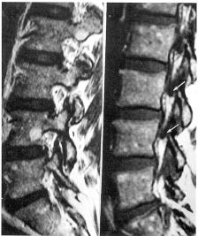
Ligaments and epidural soft tissues
Posterior longitudinal ligament:
- is in direct contact with dura mater.
- blends with intervertebral discs (between discs it is separated from concave posterior surface of vertebral bodies by anterior epidural space* - fat, basivertebral veins, anterior internal vertebral veins; divided into left and right compartments by midline septum).
*well developed only in lumbar region.
Dura mater:
- laterally, dura mater is in contact with medial extremity of each pedicle.
- below and between pedicles, dura is in contact with epidural fat in continuity with intervertebral foramina.
- posteriorly, dura mater is loosely attached to anterior cortex of spinous processes.
- between upper margins of this cortex there are wedges of epidural fat (interlaminar fat pad) separating dura from laminae, posterior joints and ligamenta flava.
- in kyphotic regions (esp. thoracic region) dura is separated from all posterior elements of spinal canal by layer of epidural fat (may be > 5 mm thick) – may be misinterpreted as idiopathic epidural lipomatosis.
N.B. volume of epidural fat can vary greatly (dura may be separated from all walls of canal by fat).
Sagittal thoracic T1-MRI:
A. single arrows: bases of two spinous processes; double arrows: ligamentum flavum.
B. arrows indicate copious epidural fat.
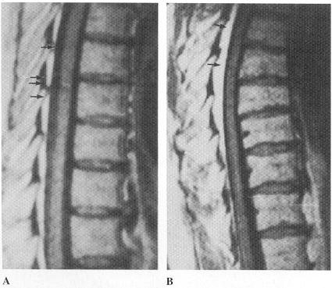

Spinal cord
Anatomy of cord surface – best shown by CT myelography.
Internal cord structure – shown only by MRI.
- cross-sectional area has wide normal variation.

Cervical spine at C5–6; internal structure of spinal cord (surrounded by white CSF):  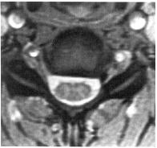 | Cervical spine at C4–5; grey matter (white arrow); vertebral arteries (short white arrow) and dorsal root ganglia (long white arrow); IV gadolinium was used - ganglia show enhanced signal:  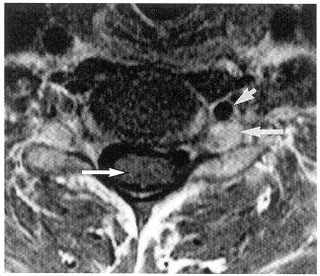

Roots & Spinal nerves
- best shown by CT myelography or T2-MRI.
- anterior and posterior roots penetrate dura through separate ostia, and these form CSF-filled pouches, lateral extremities of which are often called subarachnoid angles of root sheaths (sheaths end proximal to dorsal root ganglia).
- roots of cauda equina appear as bilateral, circular bunches near conus medullaris, as crescentic aggregate in posterior part of thecal sac in midlumbar spine → lateral and very peripheral at L5 → below S1 roots are smaller, very peripheral.
- in lumbar region, anterior and posterior roots align in lateral extremity of thecal sac immediately below sheath of root above.
- L1–L5 nerves run in sub-articular part of spinal root canal (lateral recess) and cross disc space within thecal sac, emerging with their sheaths below and near lower margins of pedicles of same number.
- S1 nerve leaves thecal sac above L5–S1 disc, which it crosses usually enclosed in longest of lumbar root sheaths to reach S1–2 foramen.
- dorsal root ganglia enhance strongly after IV contrast medium (intradural roots do not!).

Lumbar spine using FSE multislice technique - normal distribution of intradural roots; rootlets at each nerve line up in posterolateral part of thecal sac and leave via their root sheaths in anteroposterior orderly sequence; CSF is white.  (A) L3. (B) L3–4 disc. (C) 6 mm below B; arrow - roots entering L4 root sheaths.  (D) L5; arrow - roots visible within L5 root sheaths. | 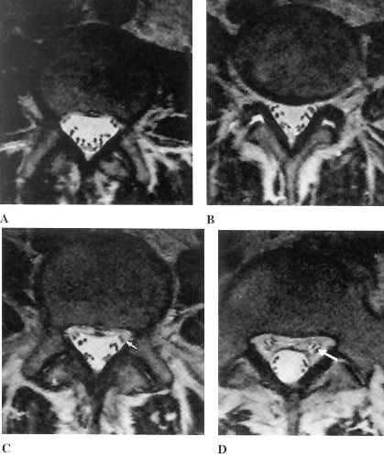

Artefacts in spinal MRI
Motion artefacts  - generated by cardiosynchronous oscillatory motion of CSF (at C2-3, movement is 0.65 mm per cardiac cycle – downwards on systole and upwards on diastole).  - driving force behind intracranial and spinal CSF flow is expansion of brain during systole.  - spinal cord and brain stem also descend slightly on systole and oscillate anteroposteriorly.  - oscillatory motion may generate linear artefacts that could be misinterpreted as intramedullary pathology.  - turbulent CSF flow can result in signal variation simulating intradural masses or enlarged vessels. | Turbulent CSF flow posterior to spinal cord generates areas of signal loss, simulating intradural masses:  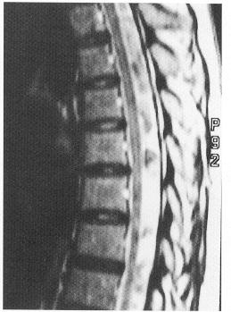
Truncation artefact
- generated at boundaries by image processing.
- particularly significant at CSF/spinal cord interface (e.g. band of high or low signal near centre of spinal cord in mid-sagittal images).

Susceptibility effects (generated by gradient-recalled echo techniques) - mid-sagittal diameter of spinal cord can be artificially reduced by over 2 mm in phase-encoding direction, creating spurious impression of spinal cord flattening or exaggerating degree of compression.

Metallic artefacts - postoperative ferromagnetic substances (even tiny fragments from drills and punches, invisible on plain X-rays) generate major local artefacts and render imaging of spinal canal impossible. H: design of implants (e.g. avoidance of conductive loops, use of titanium).

CT
- excellent for evaluating bony spinal canal as well as certain intraspinal soft-tissue structures.
- patient is instructed not to breathe during scanning, and in cervical region, not to swallow.
- indications:
  - trauma
  - lumbar disc disease
N.B. if bone contributes significantly to pathology, CT can be more useful than MRI.
- adequate assessment of intradural structures requires intrathecal contrast.
- with intrathecal contrast, CT accuracy for degenerative conditions approaches MRI.
- adequate visualization of spinal cord to exclude compression can be achieved without intrathecal contrast on modern equipment.
- intravertebral vascular channels may simulate undisplaced fractures, but are corticated.
- CT disadvantages (over MRI):
  - inability directly image spine in planes other than axial.
  - MRI is more accurate in:
    - specific categorization of disc displacements (e.g. protrusion vs. extrusion);
    - assessment of mass effect on adjacent neural structures;
    - tears of disc annulus (not visible on CT), ligaments.

Normal lumbar CT:
A: Axial image through midportion of L4 vertebral body - pedicles (P), transverse processes (black arrows), spinous process (S), facet joints (curved arrows), ligamentum flavum (arrowheads), thecal sac (TS), and posterior epidural fat (white arrow). Slightly higher-density soft tissue ventral to thecal sac represents posterior longitudinal ligament and epidural veins.
B: Slightly more inferior slice through L4-L5 disc space - slightly higher density of intervertebral disc (arrowheads) relative to that of intrathecal CSF and epidural fat.
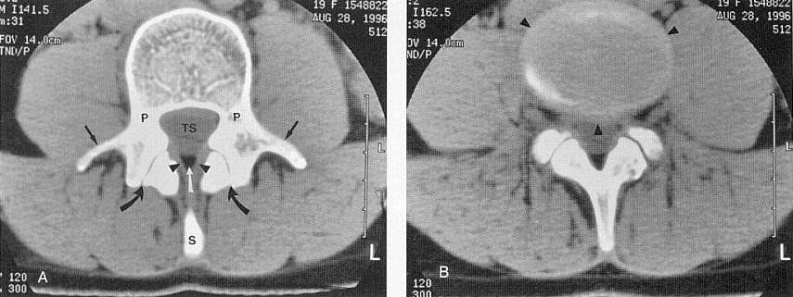

Myelography
- injection of iodinated contrast material within thecal sac → imaging:
- radiography
- CT (CT myelography)
- contrast material outlines surfaces of:
- thecal sac (spinal subarachnoid space)
- neural structures (spinal cord, intrathecal nerve roots)
- any abnormal masses or extrinsic impressions.
- current indications for myelography (rarely indicated nowadays - invasive and less informative than MRI):
  - contraindicated MRI, equivocal or suboptimal MRI (e.g. extensive spinal hardware, obesity).
  - detailed bony evaluation in addition to soft-tissue information.
  - myelography better defines root sleeves.

Contrast Medium
    - Air or carbon dioxide
    - Historical - oil-soluble iophendylate oil (Myodil, Pantopaque) - relative immiscibility in CSF (inability to enter nerve root sleeves); ≥ 20G spinal needle is required; needs removal after myelography (if left behind, Pantopaque is absorbed at rate 1 ml/yr – predisposes to arachnoiditis).
    - Ionic, water-soluble agents (e.g. metrizamide).
    - Nonionic water-soluble contrast media – approved for intravascular use, but not licensed for intrathecal use (since myelography now is less commonly performed, newer agents are unlikely to be licensed); use only following agents:
      - iohexol
      - iopamidol (Isovue) - only mildly hyperosmolar when compared with CSF (413 vs. 301 mOsm/kg H₂O); rapidly excreted in kidneys (undetectable in plasma at 48 hours)
      - iotrolan
- nonionic contrast media minimize side effects (low but not negligible neurotoxicity).
- iodinated contrast has higher specific gravity than CSF.
- pharmacokinetics are similar; T_{1/2} ≈ 12 h; 80–90% excreted via kidneys within 24 h.
- concentration for intrathecal use – 180-300 mg iodine/mL.
- maximum dose - 3 g iodine (8-15 mL total volume).

Routine preprocedure screening
- Serum creatinine, BUN
- Coagulation profile

Contraindications
- LP contraindications – see Op3 p.
- Drugs that lower seizure threshold (MAO inhibitors, tricyclic antidepressants, CNS stimulants) should be withheld for 48 hours before and after procedure.

Procedure
- 22G (or thinner) spinal needle is used.
- contrast material is injected under fluoroscopic control (to ensure subarachnoid placement).
- contrast material is deposited by:
- lumbar L₂₋₃ puncture – adequate for cervical, thoracic, and lumbar studies. see Op3 p.
Avoid L₃₋₄ ÷ L₅-S₁ levels (unless significant disease is known to exist at L₂₋₃) - higher incidence of herniated discs and spinal stenosis!
- lateral cervical C₁₋₂ puncture (indications – ¹unavailable lumbar puncture, ²demonstrating upper limit of total subarachnoid obstruction). see Op5 p.
- patient position for lumbar puncture:
- sitting position - easiest position.
- prone position (folded pillow or bolster under abdomen) - patient does not need to be moved before myelogram; easy to check needle position with fluoroscopy.
- lateral decubitus position - less often preferred.
- injection is performed slowly (over 1-2 minutes)* - to avoid excessive mixing with CSF (and subsequent loss of contrast medium) as well as premature cephalad dispersion; control with fluoroscopy (to avoid subdural / epidural injection).
*usually patient is positioned prone and contrast medium is allowed to drip into subarachnoid space
- ensure even contrast distribution in spinal canal (by modest table tilt and rolling patient).
- contrast medium dilutes at variable rate (in total study, first region to be examined is usually demonstrated best).
- patient may be repositioned during study - to simulate symptomatic postures or to facilitate contrast flow.
- myelography is radiation-intense procedure - radiation exposure 4-8 cGy.
- postmyelography CT is performed immediately or deferred for 4 hours (to reduce degree of contrast* within desired area); before CT, patient is helped to roll over several times (to thoroughly mix contrast medium).
*CT requires much lower contrast concentration

cervical myelogram may be performed by:
- lateral cervical C₁₋₂ puncture. see Op5 p.
- lumbar puncture:
  - prone with at least folded pillow or bolster under abdomen (to minimize lumbar lordosis).
  - firm pad is placed under chin (to promote neck extension) - not comfortable position, and may be harmful if spinal cord is compressed (it is important for study to be completed rapidly!).
  - only 10–20° head-down tilt is required to allow contrast medium to run under gravity into cervical lordosis.
  - lateral film is obtained to include foramen magnum and thoracocervical junction.
  - patient is carefully turned supine and further lateral film is exposed.

Avoided intracranial entry of contrast bolus (can lead to acute neurotoxic effects)!

Thoracic myelogram
- lateral decubitus position with head raised to lateral flexion on high pillow.
- small head-down tilt (to ensure that all contrast medium leaves lumbosacral canal).
- patient is then turned supine and AP and lateral projections are taken.

Postprocedure
  - keep head elevated 30-45° for 12-24 hours.
  - encourage oral fluids.
  - all movements are performed slowly (monitored by hospital personnel) with head maintained in upright position.

Special situations
Severe multilevel degeneration (spinous processes remain closely applied to one another no matter how hard one tries to separate them by spinal flexion) - use oblique approach to spinal canal.
Spinal stenosis - most commonly involves L_{4–5} and L_{3–4} - perform LP at L_{2–3} or L₅–S₁.
Scoliosis - abnormal curvature rarely involves L₅–S₁ interspace – perform LP here.
Post-laminectomy lumbar spine – do not enter spinal canal through laminectomy scar:
- postoperative infection can be chronic and occult.
- adhesion of neural structures and arachnoiditis is common (puncture may be excruciatingly painful experience for patient!).
N.B. puncture 1-2 interspaces away from lumbar laminectomy, even if this means at L_{1–2}!
Dysraphic spine - avoid puncture through defects in neural arches - spinal cord may be low and tethered posteriorly in vicinity of such defects.
- it is safe to perform usual LP above spina bifida (even though spinal cord may traverse entire spinal canal); advisable to direct needle tip few millimeters from midline as canal is entered (to avoid spinal cord transfixion by spinal needle).
Myelocele - puncture away from site of skin closure; avoid lateral cervical punctures (Chiari type II malformation is frequently present).

Myelographic block (obstruction to cranial flow of contrast medium) – use saline ‘push’ technique:

increase intrathecal pressure below blockage by injecting contrast medium or saline through spinal needle while contrast column is held against block by appropriate head-down tilt.

patient experiences discomfort / pain in girdle distribution as obstruction is overcome.

once contrast medium begins to pass, it does so rapidly.

Marker films - level of lesion marked at time of myelography (aids surgical planning):

N.B. marker should be at centre of fluoroscopic screen to avoid errors due to parallax!

indelible skin mark (e.g. scratch on skin)

rib marker (shaft of fine hypodermic needle is embedded in postero-medial portion of appropriate rib and broken off flush with skin).

Complications
  - Allergic reaction;
- history of dye allergy, bronchial asthma, hay fever, food allergies → premedicate with corticosteroids and antihistamines. see p. D49 >>

  - Renal failure due to osmotic load; prophylaxis – good hydration (before and after myelographic procedure) esp. for patients with diabetes, advanced vascular disease, pre-existing renal disease.

  - Lumbar puncture complications see p. Op3 >>

  - Significant headache follows almost every myelogram (contrast penetrates Virchow–Robin spaces and freely enters interstitium of cerebral cortex, even after lumbar myelography)
- maximal 6–12 h later.
- minor mentation disturbances are also frequent.
- prophylaxis – increasing glomerular excretion after myelogram by drinking plenty of water.

- Contrast medium injection into spinal cord – commonest major complication in cervical myelography; deaths have been reported!  Contrast medium injected into spinal cord by C_{1–2} lateral cervical puncture. Axial CT at C_{3–4} shows dense intramedullary contrast medium; some of it has weakly opacified subarachnoid space as well. | 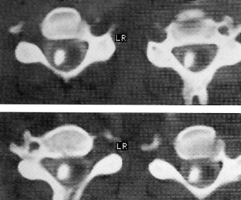

  - Back / radicular pain (30%) – usually transient (not more 1-2 hours).

  - Risk of seizures is virtually eliminated by modern nonionic, water-soluble contrast agents (but nonspecific EEG changes occur in 15% cases); epilepsy and prior medication with psychotropic drugs are no longer contraindication for water-soluble myelography!

  - Adhesive arachnoiditis – due to intradural inflammation after iophendylate (Myodil, Pantopaque) oil myelography.
- modern nonionic water-soluble contrast agents also cause slight increase in CSF protein with appearance of few white cells, but not adhesive arachnoiditis!
N.B. any myelography should be avoided when arachnoiditis is suspected!

Normal Myelographic Anatomy
  - symmetrical filling of nerve root sleeves (no root displacement or root sleeve truncation); occasional perineural cysts (nerve root sheath with bulbous appearance) are not pathological.

Cervical region
  - lateral projection - wide ventral and narrower posterior subarachnoid space (due to moderate extension in which patient is positioned for cervical myelography); AP cord diameter remains rather uniform throughout cervical region.
  - AP projection – slight increase in cord cross-sectional diameter in middle and lower cervical region.

Thoracic region
  - lateral projection - cord (constant AP diameter) adheres closely to normal thoracic kyphotic curvature; posterior subarachnoid space is much wider and remains uniform throughout the region.
  - AP projection - cord cross-sectional diameter remains constant; subarachnoid space is narrowest in midthoracic region and widens in upper and lower thoracic regions; thoracic nerve rootlets are not prominent.

Lumbar region
  - subarachnoid space is uniform in both AP and lateral projections, down to lumbosacral junction; caudal extent of subarachnoid space (considerable variability) most often occurs below S₁ level.
  - conus medullaris taper to blunted point not lower than L₂ level.
  - in lateral projection cauda equina is in posterior third of the lumbar subarachnoid space, with fine linear radiolucencies of individual roots coursing ventrally and caudally.
  - in AP projections, paired nerve roots course caudally and laterally, ultimately turning lateral as they enter neural foramina.

Conjoined root sleeves (normal anatomical variant – present in 1-3% of general population) - two nerve roots at adjacent levels share common sheath as they exit thecal sac (thus giving asymmetrical AP appearance), i.e. they penetrate dura at single intervertebral level (conjoined roots) → one root sheath is missing at adjacent intervertebral level, and thecal sac there shows long smooth lateral concavity (simulation of elongated epidural mass).
- conjoined root sleeves are large, and composite roots are usually clearly visible.
- commonest at L₅ and S₁ roots.

Cervical myelogram by lateral cervical puncture:  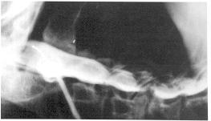 | Cervical myelogram, oblique projection: anterior and posterior rootlets are clearly visible running to and from spinal cord; anterior spinal artery (arrow).  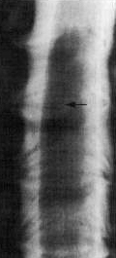
Lumbar myelogram, lateral projection: thecal sac has smooth ventral contour; descending nerve roots are visible as linear, obliquely oriented filling defects; wide ventral epidural space between thecal sac and posterior vertebral margin (arrowheads) is greatest at lumbosacral junction - small disc herniations here may be invisible.  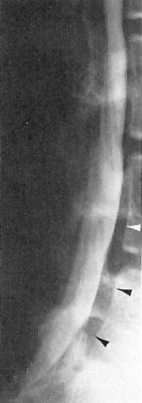 | Lumbar myelogram, oblique projection: L₅ = pedicle of L₅ vertebra; S₁ = sacrum; arrows = root canals of S₁ and S₂ sacral nerves.  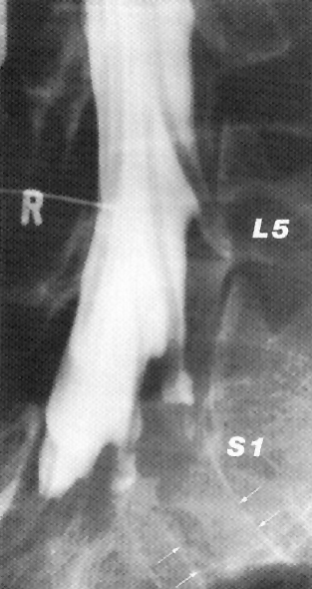
Lumbar myelogram, AP projection: conjoined nerve roots. The left L₄ and L₅ roots penetrate dura mater (arrow) close to pedicle of L₄, resulting in marked asymmetry. Apparent absence of right L₅ root sheath could be confused with pathological compression. | 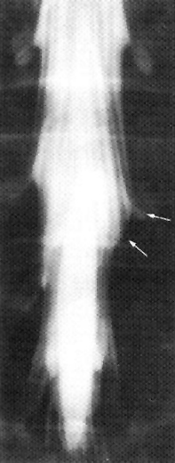

Pathologic myelographic findings
extradural lesions – see p. Onc56 >>
intradural-extramedullary lesions – see p. Onc54 >>
intramedullary lesions – see p. Onc50 >>

Discography
- contrast material injected into nucleus pulposus.

Indication - surgical candidates* who have:
- multilevel disc abnormalities
- indeterminate disc abnormalities detected by CT / MRI.
*mainly as preliminary to spinal fusion for back / neck pain rather than neural compression syndromes
Diagnostic uses:
- internal disc morphology, annulus fibrosus tears (discography adds specificity to indeterminate abnormalities detected by CT / MRI).
- reproduction of patient's typical low-back / lower-extremity pain when pressure within disc space is increased by contrast injection – probably the only diagnostic use of discography!
Discography is unpleasant, painful experience for patient!

Performed by inserting 22G spinal needle into disc centre under fluoroscopic control.
- oblique approach (anteriorly in neck and posteriorly in lumbar spine).
- avoid spinal canal and intervertebral canals!
- small amount of nonionic contrast medium is injected into central disc part (nuclear ‘cavity’); normal disk will accept:
0.25 cc – cervical
0.5 cc – lumbar.
- AP and lateral films → CT.

Findings:
- normal pattern - smooth centrally positioned ellipsoid.
- degenerated disk - flattened disk space with irregular contour; patient's symptoms may be reproduced or exacerbated.
- tears in annulus or fissures in cartilaginous end plates - contrast seepage.

Artefacts due to inaccurate needle placement in nuclear cavity, or contrast leakage along needle track, are frequent.

Complication - diskitis (skin organisms introduced via needle).

Lumbar discography:  L3–4 - norma (nuclear matrix almost completely bisected by collagenous internuclear lamina).  L4–5 - radial tear of annulus fibrosus (contrast extends posteriorly beyond margins of adjacent vertebral bodies).  L5–S1 - norma.  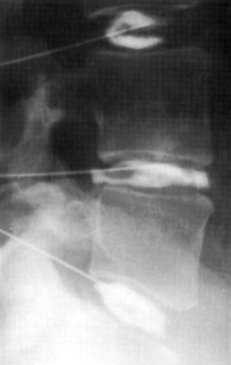 | CT discogram of L4-L5 disc protrusion: contrast within diffuse annular bulge and small amount of air and positive contrast material within central disc protrusion; disc is accessed by posterolateral approach (arrow) passing just posterior to exiting nerve root (arrowhead) and anterior to facet joint:  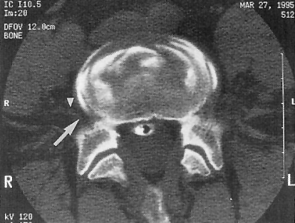

Ultrasound of neonatal spine
- mainly indicated in midline cutaneous / subcutaneous anomalies, suggestive of underlying dysraphism.
N.B. although ultrasound is highly accurate in evaluating neonatal spinal cord anomalies, it cannot completely exclude malformation; if malformation is found, further imaging (MRI) is still indicated.
- high-frequency (7.5–10 MHz) linear probe is used.
- sagittal and axial views are obtained with baby in prone frog leg position.

Normal Cord & Spine
- in infants ≤ 6 months, spinal cord can be evaluated with US because posterior elements are membranous rather than bony.
- spinal cord - hypoechoic tubular structure with hyperechoic borders; conus medullaris tip (at birth) is at L₂₋₃ interspace (97.8%) or overlies L₃ body (1.8%); central bright echo (central echo complex) - central cord canal, ventral sulcus;
    - central echo complex is frequently slightly widened in distal cord (differentiate from hydromyelia).
    - dilated ventriculus terminalis is small ovoid cystic cavity in conus and/or filum.
- subarachnoid space – anechoic.
    - transitorily hyperechoic & narrow subdural space in dehydration.
- roots of cauda equina - parallel lines descending within subarachnoid space as paired, paramedian, echogenic columns; pulsing roots move freely with changes of position, crying and respiration.
- filum - long, thin, double line that courses caudally from conus tip to distal sac behind descending roots.
    - filar fibrolipoma appears as hyperechoic thick filum (< 2 mm).
- ventral epidural space thickens at sacral level; echogenic fat outlines thecal sac which terminates at S₂ level.
- vertebrae - hyperechoic ossification centers; coccyx is cartilaginous; symmetric echogenic lamina are obliquely orientated toward cartilaginous spinous process.

Normal lumbar spine (longitudinal view): normal bulbous enlargement of spinal cord (arrows), central echo complex (CEC), conus medullaris (CM), filum terminale (F), roots of cauda equina (arrowhead):
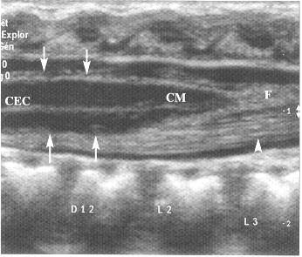

Radiological approach to common Spinal Problems
Acute presentations

Acute back pain
- generally not investigated radiologically (rest and conservative treatment are tried first).
- exceptions (do plain radiographs):
  - significant trauma
  - patients known to develop spinal lesions (metastatic disease, steroid therapy).

Acute root syndromes
- root avulsion is generally not investigated radiologically in acute stage (subsequently may require high-resolution MRI or myelography).
- disc protrusion → plain CT is about as good as MRI.

Acute spinal cord lesions
Traumatic → plain films → MRI.
Non-traumatic (assumed to be compressive until proven otherwise):
- chest film is mandatory (since many cases are neoplastic or infective).
- plain films of area indicated by level of cord damage.
- MRI of clinically involved region - preferred investigation.
- myelography supplemented by CT.
- spinal angiography is not indicated (unless plain film or myelographic findings indicate vascular lesion).

Chronic presentations

Chronic pain
- Chronic pain → plain radiographs (rapid, cheap overall picture).
- Sciatica → CT / MRI is preferred investigation.

Chronic spinal cord lesions
- Extramedullary compressive lesions (spondylosis, disc disease) → plain films (for intraspinal calcification or craniovertebral junction anomalies associated with instability).
  - patients being considered for surgery → CT, MRI, myelography.
- Intramedullary space-occupying lesions (mostly tumors and syringomyelia) → Mri or myelography followed by ct.
- Inflammatory / demyelinating cord disease → brain mri → spinal mri or myelography.
  - if these are negative, it is extremely unlikely that angiography will be revealing; even demonstration of anterior spinal artery occlusion is unreliable (and of academic interest only).

Bibliography for ch. “Spinal Imaging” → follow this link >>

Viktor’s Notes℠ for the Neurosurgery Resident
Please visit website at www.NeurosurgeryResident.net

