Multiple Sclerosis (MS)

Last updated: April 12, 2020

Epidemiology 1

Etiopathophysiology 1

Autoimmunity 1

Infection 2

"Bystander" Demyelination 2

Heredity 2

Pathology 2

Brain 3

Spinal Cord 3

Optic Nerves 3

Clinical Features 5

Sensory symptoms 6

Pyramidal dysfunction 6

Optic neuritis 6

Cerebellar dysfunction 6

Autonomic dysfunction 6

Brainstem dysfunction 7

Affective disorders 7

Fatigue 7

Paroxysmal symptoms 7

Motor paroxysms 7

Sensory paroxysms 7

First episode 7

Clinical Course 8

Kurtzke Expanded Disability Status Scale (EDSS) 8

Diagnosis 9

Clinical Diagnosis 9

MRI 9

Specificity 10

MRI criteria for definite MS diagnosis 10

Longitudinal MRI studies 10

MRI activity of disease 11

Additional MRI techniques 11

CSF 13

Evoked Potentials 13

Optical coherence tomography (OCT) 14

Blood Tests 14

Treatment 14

Lifestyle 14

Acute Exacerbations 14

Alteration of Natural Course - Disease-modifying Drugs 14

Symptomatic Treatment 16

Enhancement of Recovery 17

Pregnancy 17

Prognosis 17

MS – idiopathic chronic, slowly progressive inflammatory-demyelinating disorder of CNS white matter.

Epidemiology

* prevalence ≈ 1 per 1000 persons in USA and Europe (350,000-400,000 patients in USA).
* begins in **young adults** (10-50 yrs; peak – 24 yrs), but any age group can be affected (5% cases are pediatric).

Most common cause (after trauma) of disability in young adults!

* women : men = 2 : 1.
* 1st degree relatives have 15-40-fold increased risk of MS (i.e. 4% of 1st degree relatives develop MS); 15-20% MS patients have at least one affected relative.
* smoking not only predisposes to getting MS but also it predisposes to MS being worse once it develops.
* prevalence increases proportional to *distance from equator*, excluding polar regions:

MS is disease of *temperate climates*

* + predilection for **whites** (esp. northern European heritage).
  + **Asian and black populations** have low risk.
  + virtually unknown among **black Africans** but occurs in African-Americans at half rate of whites (due to racial admixture or environmental factors).
  + ***immigrants*** acquire MS risk inherent to their new place of residence; age at immigration is important (age < 15 yrs is most susceptible to risk changes; individuals migrating after age 15 have risk of country of origin).

Individuals take on relative risk of environment in which they spent *first 15 yrs*

* incidence ranges in different populations 1.5-11 per 100,000 persons per year.
* MS risk also correlates with *high socioeconomic status* (improved sanitation → delayed* initial exposures to infectious agents).

*poliomyelitis and measles neurologic sequelae are more common when age of initial infection is delayed

Etiopathophysiology

- **autoimmune mechanisms**, triggered by **environmental factors** in **genetically susceptible** individuals.

effects of demyelination → [see p. Dem3 >>](http://www.neurosurgeryresident.net/Dem.%20Demyelinating%20disorders\Dem3.%20CNS%20demyelination%20(GENERAL).pdf)

* possible environmental events:
  1. **Viral infection** is most plausible (possibly human herpesvirus); *see below* >>
  2. Vaccination is frequently cited as precipitating event, although evidence is anecdotal.
* patients with MS should be advised against routine influenza vaccination, especially if previous exacerbations have been preceded by vaccination.
  1. Head trauma - studies have not verified any link.
  2. Pregnancy does not alter MS risk, but influences disease activity (relapse rate↓ during last two trimesters, but ↑ in postpartum period).

N.B. pregnancy has no long-term effects on prognosis!

* studies reveal latent period of ≈ 20 years between exposure to environmental factor and development of clinical symptoms (age at exposure is around 15, putative age at acquisition).

**infectious agent** of long latency acquired at time of puberty

Autoimmunity

* ***MBP (myelin basic protein)*** is leading candidate for autoimmune target.
* **molecular mimicry** is relevant in MS (several viral and bacterial peptides share structural similarities with MBP).
* **BBB leakage** (infection or injury) may break tolerance because it gives CNS-reactive lymphocytes easy access to otherwise inaccessible antigens.
* in blood and CSF, ***MBP***-reactive B and T lymphocytes and anti-***MBP*** IgG are often present in patients with MS and other neurological diseases (level of these findings correlates with extent of tissue injury but not necessarily with etiology*).

\****MBP***-specific T and B cells may be secondary to release of sequestered CNS antigens by primary event.

* animal experimental allergic encephalomyelitis (EAE) is induced in genetically susceptible animals by immunization with normal CNS tissue and adjuvant; EAE can also be induced by immunization with ***MBP***.
* chronic relapsing-remitting form of EAE is pathologically similar to MS.
* unlike other autoimmune disorders, MS has no increased risk of other autoimmune conditions (even negative association between MS and RA); no increased risk of brain tumors or hematological malignancies.

Infection

Many ways in which virus may be involved in pathogenesis:

1. Transient or persistent infection outside CNS - activates autoreactive T cells by molecular mimicry or by nonspecific means (e.g. as superantigens).
2. Transient CNS infection: breach BBB → release CNS antigens → autoimmunity.
3. Recurrent CNS infections - precipitate repeated inflammation and demyelination.
4. Persistent CNS viral infection - incites inflammatory reactions detrimental to oligodendrocytes or directly injures them.

* new strain of ***HSV (the MS strain)*** and new virus (***Inoue-Melnick virus***) were first isolated from CSF of MS patients.
* newer molecular techniques have rejected claims to HTLV-I or any retrovirus.
* ***human herpesvirus 6*** (present in 70% brains from both controls and MS patients) is localized to oligodendrocyte ***nuclei*** in MS patients and to oligodendrocyte ***cytoplasm*** in controls - MS may depend on aberrant host response to this “normal” infection or defective virus that lacks ability to evade immune detection may be to blame.
* *minor respiratory infections* precede 27% relapses.
* *measles* occurs at later age in MS patients than controls (but MS incidence is not reduced by immunization against measles!).
* perhaps no single virus is trigger for demyelination in all patients (several different viruses may be involved).

It is possible, that many common viruses may trigger disease in susceptible individuals!

* infections of almost any type increase risk for exacerbation (result of immune system activation).

"Bystander" Demyelination

Immune actions may mediate myelin injury in **nonspecific manner** - many soluble products of immune response (other than Ig) are toxic to myelin and oligodendrocytes.

* ***activated complement*** is capable of lysing oligodendrocytes.
* ***TNF-α*** causes myelin disruption and oligodendrocyte apoptosis in vitro.
* ***arachidonic acid metabolites*** may participate in myelinolysis.
* ***reactive oxygen species*** (released by macrophages) cause lipid peroxidation → myelin damage.

Heredity

* ***multiple independent genes*** each with relatively small contribution to overall risk (polygenic hereditary predisposition).
  + MS rates in adopted relatives of MS patients verified that familial distribution is due to genetic factors rather than shared environment.
  + monozygotic twins are more concordant for MS than dizygotic twins (26% vs. 2.4%), indicating *genetic component*; however, even after following monozygotic twins past age 50, less than 50% are concordant, suggesting role for *environmental factors*.
* only definitively proven genetic association in whites is with ***HLA haplotype DR15, DQ6, Dw2***.
  + risk conferred by this haplotype is small (relative risk of 3-4).
  + this haplotype is neither necessary nor sufficient for development of MS.
* other candidate genes - *T-cell receptor (TCR) genes* on chromosome 7, *Ig heavy chain genes* on chromosome 19, *myelin basic protein gene* (only in Finnish MS population) on chromosome 18..

Pathology

- multifocal areas (disseminated patches) of CNS white matter ***inflammation***, ***demyelination*** with ***loss of oligodendrocytes***, and ***astrogliosis***.

* relative preservation of *axons* – this concept has been refuted! (in severe lesions axons may be entirely destroyed → secondary sclerotic degeneration of long tracts).
* affects *brain*, *optic nerves*, and *spinal cord*.
* inflammatory demyelination occurs in bouts (accompanied by clinical relapses).

MS plaques

* seen on macroscopic examination of brain sections – numerous, irregular, sharply delimitated from surrounding normal white tissue:

grayish - in ***older*** lesions;

pink - in ***acute*** lesions.

* plaque size varies: pinhead (1 mm) ÷ entire section area (e.g. whole hemisphere, entire spinal cord).
* found throughout ***white matter of neuraxis***:
  + *cerebral hemispheres* (esp. in ***periventricular regions*** - follow course of paraventricular veins; white matter that forms superior lateral angle of body of lateral ventricles is characteristically affected!).

N.B. occasionally, plaques are also present in *gray matter* (seen on external brain surfaces!) - myelinated fibers often run through gray matter!

* + not uncommon in *corpus callosum*.
  + also in *brain stem*, *cerebellum*, *spinal cord* (esp. ***cervical***; predilection for ***lateral & posterior columns***), *optic nerves-chiasm-tract*.
* myelin sheath stains - ***areas of demyelination*** in plaque regions; myelin sheaths that remain show swelling and fragmentation.
* borders between histologically normal tissue and demyelinated zones are well-demarcated.

Acute plaques (Edema & inflammatioN)

* earliest event in development of MS lesion is **breakdown of BBB** → marked **hypercellularity**:
  + 1. **perivascular B lymphocyte infiltration** (perivenular cuffing; small active lesions are often centered on small veins).
    2. **T lymphocytes & monocytes infiltrate CNS parenchyma**; types of cells are similar to those found in CSF (i.e. predominant lymphocytes are ***helper-inducer T cells*** CD4+CDw29+).
    3. **astrocytosis** (proliferation of astrocytes); astrocytes, which normally do not express MHC molecules, express class II molecules in active lesions (i.e. astrocytes are involved in antigen presentation to T cells).
       - chemical ***breakdown of myelin***occurs (axons are generally unaffected at this stage).

N.B. it is not yet established whether cellular response leads to, or occurs as result of, myelin breakdown.

* + ***phagocytes*** (macrophages & microglia) invariably occupy sites of active demyelination and are laden with lipid degradation products of myelin.
* ***products of immune response*** (oligoclonal IgGs, interleukins, interferons, tumor necrosis factor) accompany acute MS lesion.
* plaques are typically *more numerous than anticipated* on basis of clinical criteria (for every 8-10 new MRI lesions, only one clinical manifestation typically can be demonstrated).

Many plaques are clinically silent!

With time, plaques become inactive (demyelination & sclerosis)

* tissue edema reaches maximum after ≈ 1 month, after which lesions evolve over several months into permanently demyelinated gliotic scars (“multiple sclerosis”).
* inactive plaques are **hypocellular** and devoid of myelin breakdown products.
* total ***oligodendrocyte loss***, extensive ***gliosis***.
  + - * (nearly) complete *demyelination*.

Gliosis is most severe in MS lesions (vs. other neuropathologic conditions)

* + - * in chronic active plaques, *gradations in histologic findings* from center to lesion edge suggest that lesions expand by gradual concentric outward growth.

Remyelination in plaques (following early acute phase).

* + - * results from differentiation of immature oligodendrocytes.
      * remyelination is aberrant and incomplete (oligodendrocytes are destroyed as infiltration and gliosis progress).
      * ***“shadow plaques”*** - uniform areas of **incomplete myelination** (incomplete remyelination or partial demyelination?) - border (between normal and affected white matter) is not sharply circumscribed.

N.B. oligodendrocyte proliferation and remyelination is insufficient to explain remarkable clinical recovery observed in many patients!

Brain

* gross external appearance is normal (or mild atrophy).

Spinal Cord

* gross external appearance is normal (or slightly shrunken with thickened pia arachnoid).
* *swollen* over several segments in ***acute transverse lesion***.
* focal *atrophy* (myelomalacia) may result when plaques ***"burn out"*** with time.

Optic Nerves

* may be shrunken.
* peripheral nerves, other cranial nerves are normal.

A. Coronal brain slice - several focal areas of sclerosis *(arrows)*.

B. Coronal brain slice (Luxol fast blue stain) - numerous discrete areas of myelin loss.

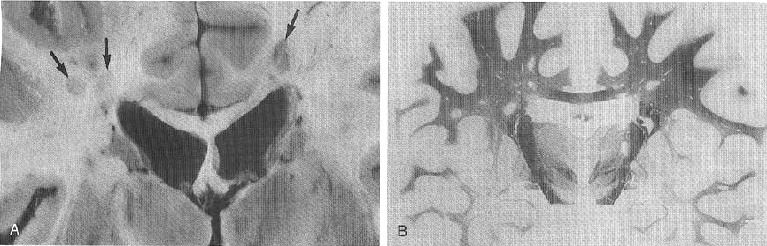

Large grey-tan plaques in white matter:

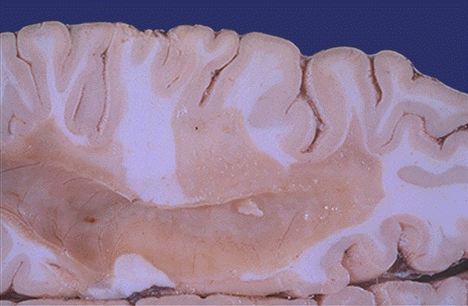

[Source of picture: “WebPath - The Internet Pathology Laboratory for Medical Education” (by Edward C. Klatt, MD) >>](http://library.med.utah.edu/WebPath/webpath.html)

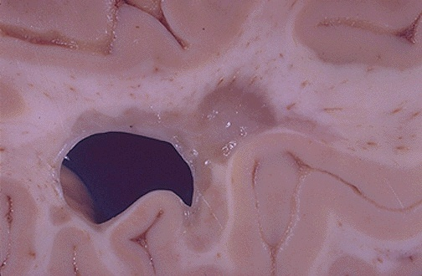

[Source of picture: “WebPath - The Internet Pathology Laboratory for Medical Education” (by Edward C. Klatt, MD) >>](http://library.med.utah.edu/WebPath/webpath.html)

C. H&E - perivascular mononuclear cells and prominent gliosis.

D. Luxol fast blue/periodic acid-Schiff stain - perivascular inflammation and myelin loss.

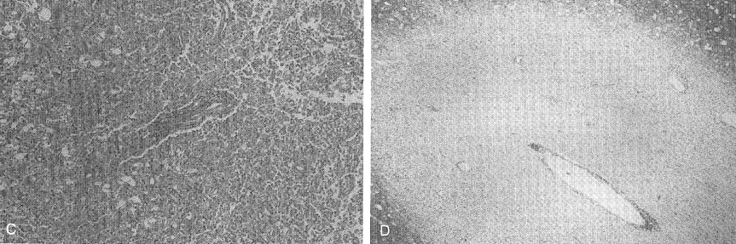

Perivascular infiltration with activated T cells, B cells, and macrophages:

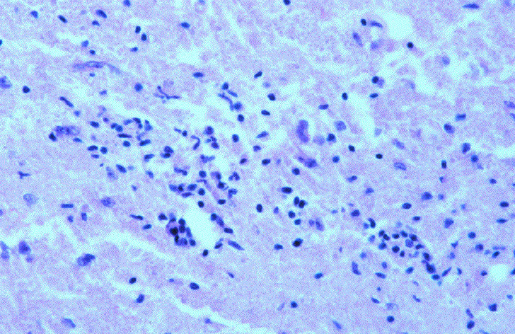

Chronic plaque - demyelination (Luxol fast blue/PAS stain myelin to intense blue), absence of inflammation at edge:

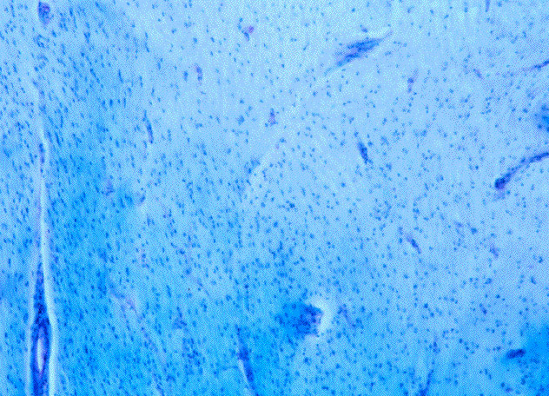

|  |  |
| --- | --- |
| ***Myelin-stain*** - sharp edge of demyelinated plaque and perivascular lymphocytic cuffs:  D:\Viktoro\Neuroscience\Dem. Demyelinating disorders\00. Pictures\MS - histology2.jpg | The same lesion ***stained for axons*** shows relative preservation:  D:\Viktoro\Neuroscience\Dem. Demyelinating disorders\00. Pictures\MS - histology2 (stain for axons).jpg |

|  |  |
| --- | --- |
| Lesions in brain stem are usually numerous; sections stained by ***Weigert method*** have characteristic "Holstein cow" appearance (note sharp demarcation of lesions):  D:\Viktoro\Neuroscience\Dem. Demyelinating disorders\00. Pictures\MS in brainstem (myelin stain).jpg | ***Luxol fast blue PAS stain*** for myelin - unstained regions of demyelination around 4th ventricle:  D:\Viktoro\Neuroscience\Dem. Demyelinating disorders\00. Pictures\MS in brainstem (unstained).jpg |

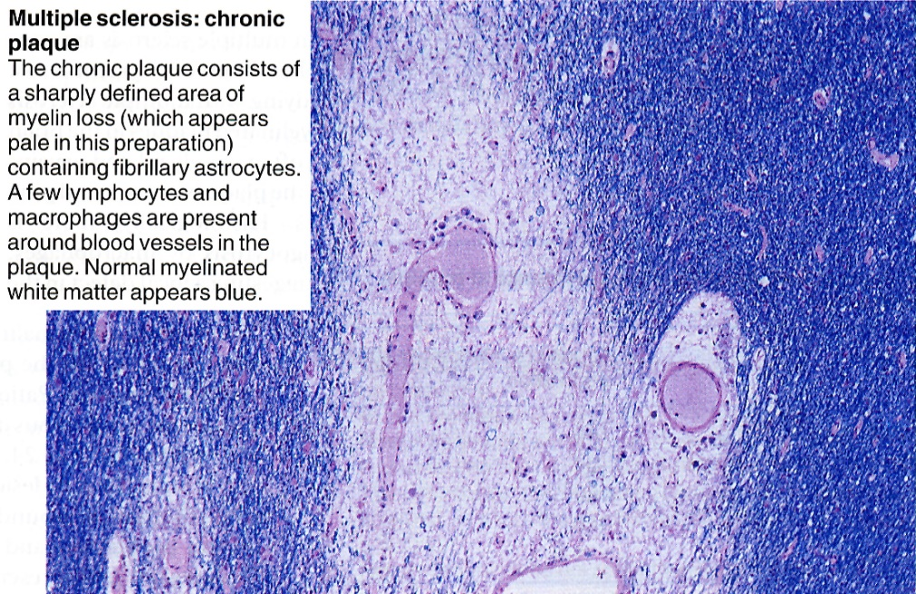

[Source of picture: James C.E. Underwood “General and Systematic Pathology” (1992); Churchill Livingstone; ISBN-13: 978-0443037122 >>](http://www.amazon.com/gp/product/0443068887)

Chronic plaque - sharply defined area of myelin loss (appears pale) containing fibrillary astrocytes; few lymphocytes and macrophages around blood vessels (V) in plaque; normal myelinated white matter appears blue:

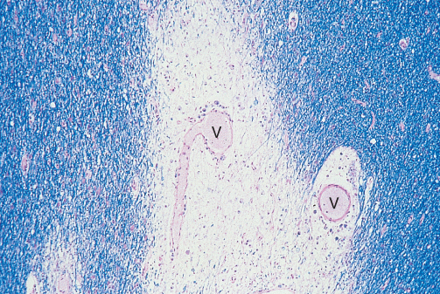

[Source of picture: James C.E. Underwood “General and Systematic Pathology” (1992); Churchill Livingstone; ISBN-13: 978-0443037122 >>](http://www.amazon.com/gp/product/0443068887)

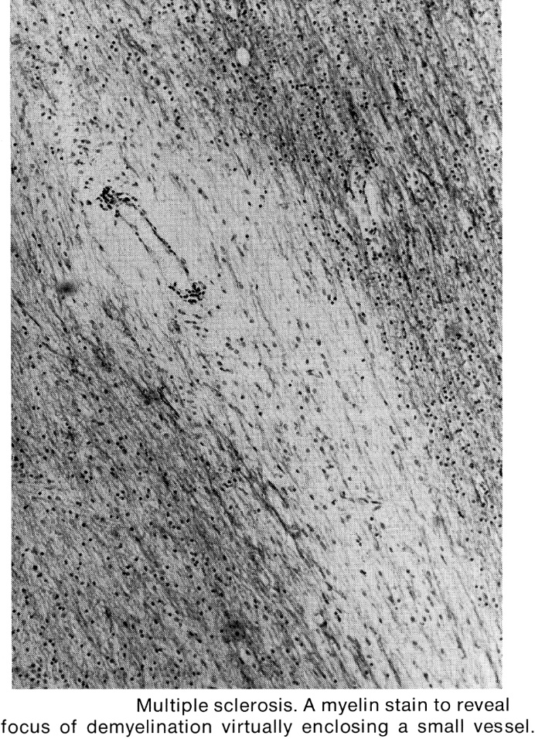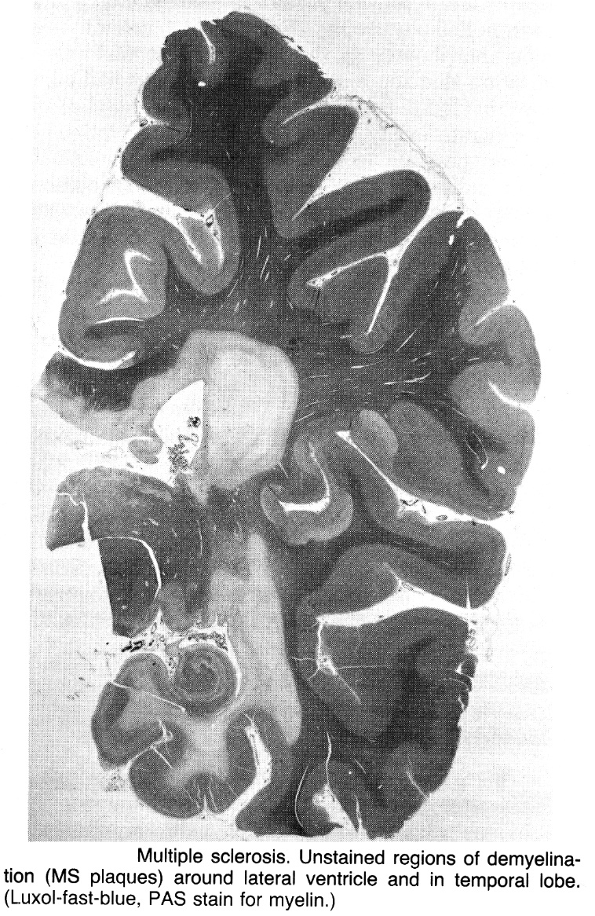

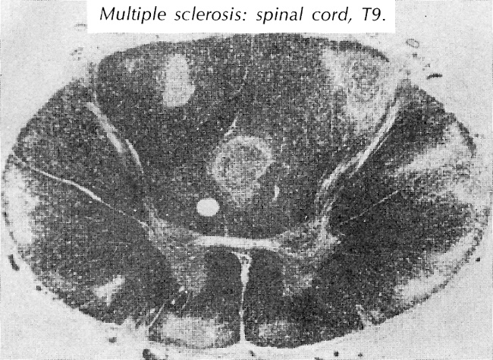 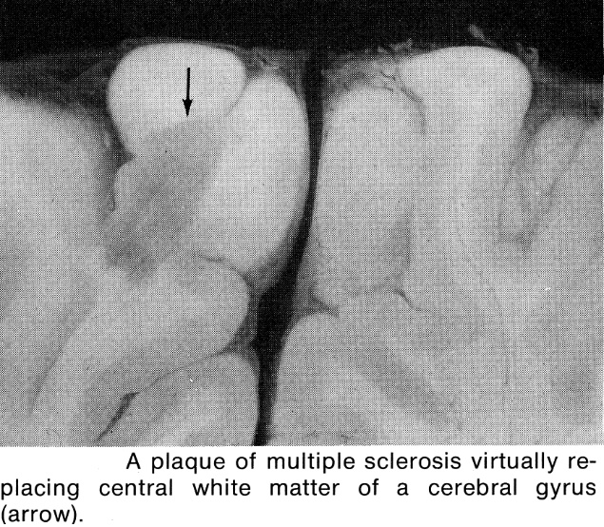



Clinical Features

- distinct *episodes of neurologic deficits*, separated in time, attributable to white matter lesions that are separated in space.

multiple in space + multiple in time

The only predictable factor in MS is its unpredictability in individual patient.

MS can cause wide variety of clinical features

Any symptoms from **any part of neuraxis**\* from spinal cord to cerebral cortex

*predominantly **white matter long tracts** – pyramidal pathways, cerebellar pathways, medial longitudinal fasciculus, optic nerve, posterior columns.

* many signs and symptoms are characteristic, and few are virtually pathognomonic.
* some symptoms are atypical and some are so rare as to suggest different diagnosis.

|  |  |
| --- | --- |
| **Clinical Features Suggestive of MS** | **Clinical Features Not Suggestive**\* **of MS** |
| Onset at age 15-50  Relapsing-remitting course  Diurnal fatigue pattern  Worsening symptoms with heat, exercise  Paroxysmal symptoms | Onset before 10 or after 55 yrs  Continued progression from onset without relapses |
| Optic neuritis  Lhermitte sign  Partial transverse myelitis  Internuclear ophthalmoplegia  Sensory useless hand  Acute urinary retention (esp. in young men) | Early dementia  Encephalopathy  Seizures  Aphasia, Agnosia, Apraxia  Homonymous or bitemporal hemianopia  Extrapyramidal symptoms  Uveitis  Peripheral neuropathy |

*features may be seen in MS, but are atypical and prompt consideration of alternate explanations.

Some clinicians classify MS into *spinal*, *brain stem*, *cerebellar*, and *cerebral* forms.

* these "forms" are often combined, and such classification is of no clinical value.
* in fact, ***combination of anatomically unrelated symptoms & signs*** forms basis for clinical diagnosis of MS.

Sensory symptoms

- most common presenting manifestation in MS; ultimately develop in all patients:

1. Paresthesias (tingling)
2. Dysesthesias (burning) and hyperesthesias.
3. Loss of sensation (proprioception >> temperature, pain, tactile sensation)
   * occur in practically ***any distribution***: limbs, trunk, face, combinations.
   * common scenario - numbness / tingling beginning in one foot, ascending ipsilaterally and then contralaterally; may ascend to trunk, producing sensory level; may involve upper extremities.
   * large portion of patients have persistent proprioceptive sensory loss in distal extremities.
   * distinctive sensory relapses are **sensory cord syndrome** and **sensory** **useless hand**.

**sensory cord syndrome** - evolving lesion in *medial posterior column* ipsilateral to first symptoms.

* common in MS (suggest MS diagnosis when occurs in young persons and remits spontaneously or in response to corticosteroids).
* Brown-Séquard syndrome may occur.

**sensory useless hand** (very specific symptom!) - lesion in *lemniscal pathways* (in cervical spinal cord or brain stem).

* subjective numbness, heaviness, and lost discriminatory & proprioceptive function → difficulty writing, typing, buttoning clothes, holding objects (esp. when not looking at hand).
* can occur bilaterally even without lower extremity symptoms.
* remits over several months.

**Pain** (not major manifestation of MS);

* can be distressing to patient.
* most commonly - lower extremity dysesthetic pain, paresthetic paroxysms, uncomfortable pressure or tightness surrounding leg or trunk.

Pyramidal dysfunction

- common in MS:

1. Loss of dexterity
2. Weakness (esp. limb weakness)
3. Spasticity!!! (legs > arms)
4. Hyperreflexia!, clonus
5. Extensor plantar response
6. Disuse atrophy (lesions of exiting LMN fibers or of anterior horn itself can cause pseudoradiculopathy → segmental weakness, denervation atrophy).
7. Superficial reflexes↓ (esp. upper and lower abdominal).
   * weakness of one limb, paraparesis, quadriparesis, hemiparesis, facial weakness are common.
   * weakness of trunk muscles → abnormal postures, respiratory muscle weakness.
   * subtle deficits are worsened by ***exercise*** or ***heat***.

Optic neuritis

- initial symptom in 17% patients.

Eye is only organ outside nervous system that is sometimes involved in MS

* occurs in > 50% patients during their lifetime; patients without history of optic neuritis often have evidence of optic nerve involvement on funduscopy or visual evoked potentials.
* most common manifestation – **unilateral visual loss** (up to blindness) that evolves over few days.
* ***periocular pain*** (esp. with eye movement) usually accompanies and may precede visual symptoms.
* patients may complain of "patchy loss of vision" with ***cecocentral scotoma***.
* ***afferent pupillary defect*** (Marcus-Gunn pupil).
* bilateral simultaneous optic neuritis is uncommon (except in children and Asians), but formal visual field testing reveals unexpected defects in clinically normal eye.
* **funduscopy** is normal; occasionally, papillitis (optic disc swelling with preserved spontaneous venous pulsations →→→ pallor), venous sheathing*.

*retinal periphlebitis (histologically identical to perivascular inflammation in CNS - it is interesting, because retina has peripheral type of myelin produced by Schwann cells)

* most begin to recover within 2 weeks → ***significant visual recovery***.
* may leave persistent *visual blurring*, *altered color perception*\*, *Uhthoff sign* (visual blurring during strenuous activity or with passive exposure to heat).

*perception of red color as different shades of orange or gray

Cerebellar dysfunction

- uncommon at onset.

* manifestations include dysmetria, dysdiadochokinesia, action tremor, dysrhythmia, breakdown of complex motor movements, loss of balance.
* patients with long-standing MS develop ***"jiggling" gait*** and ***ataxic dysarthria*** (scanning speech).

Gait disturbance is due to spinal & cerebellar **ataxia** + spastic leg **weakness**

Autonomic dysfunction

- frequently encountered in MS patients:

1. Spinal lesions → **detrusor hyperreflexia** → urinary urgency, frequency, urge incontinence (may be transient but are commonly persistent).
2. Interruption of brain stem micturition center input → **detrusor-sphincter dyssynergia** →→→ hydronephrosis → chronic renal failure.
3. Impaired vesicular sensation → high capacity bladder → **bladder atonia** with thinning and irreversible detrusor disruption → overflow incontinence.
4. Perineal sensory loss → **fecal incontinence**.
5. Diminished libido (≈ 66% patients), **erectile dysfunction** (33%), deficient vaginal lubrication (33%).
6. **Abnormal sweating** (40%).
7. Impairment of cardiovascular control is less common and usually minor (most consistently as reduced heart rate variation with deep breathing).

Brainstem dysfunction

1. **Central vertigo with nystagmus**

* *intense vertigo* with nausea and emesis is occasional manifestation of relapse.
* more persistent *mild vertigo* precipitated by movement may be residua after acute relapse.

1. **Internuclear ophthalmoplegia** (lesion in *medial longitudinal fasciculus*) - most common cause of diplopia in MS patients.

* ***bilateral*** internuclear ophthalmoplegias are strongly suggestive of MS!
* cranial nerve impairment is unusual cause of diplopia in MS patients.

1. **Cranial nerve** **nuclei** lesions (esp. CN5, CN7).

**Cognitive disorders** (40-70%)

* **total lesion load** (seen on MRI) correlates with degree of cognitive decline.
* often problems are subtle (not detected on standard mental status evaluation):
  1. memory loss
  2. inattention
  3. slow information processing
  4. difficulty with abstract concepts and complex reasoning.
* transient and patchy distribution of lesions often leads to somatic preoccupation in affected individuals, suggesting *somatoform disorder*.
* ***frank dementia*** may appear late in disease course.
* *general intelligence* is not typically affected.
* *cortical symptoms* (aphasia, apraxia, agnosia) are distinctly unusual!
* *disconnection syndromes* (e.g. alexia without agraphia, conduction aphasia, pure word deafness) have not been reported in MS patients.

Affective disorders

- more frequent than in general population:

1. **anxiety**
2. **depression** & suicide*

*result of reactive depression + brain lesions by itself

* not related to lesion load visualized by MRI.
* interruption of inhibitory corticobulbar fibers → **pseudobulbar affect** (uncontrollable weeping or laughter noncongruent with mood).
* **hysterical hyperbole** (more common in MS than in any other neurologic disease!) - patients exaggerate and extend symptoms that have obvious anatomic basis (e.g. patient with right optic neuritis may complain of difficulty seeing with other eye; numbness of hand may be extended to involve entire arm; true diplopia may be transformed into polyopia, triplopia, quadriplopia, or monocular double vision)

Fatigue

- pervasive symptom among MS patients!!!

* *not related* to physical disability or depression!
* patients lack initiative for both *physical* and *mental* activity and become easily tired.
* **diurnal pattern** is characteristic (follows ***circadian pattern of body temperature fluctuations*** - worse symptoms in afternoon, improvement in late evening).

Paroxysmal symptoms

- characteristic of MS.

* due to ***lateral spread of excitation*** or ***ephaptic transmission*** (between denuded axons).
* **stereotyped**, recurrent phenomena of **brief duration** (seconds ÷ minutes; vs. *relapse* > 24 hours).

e.g. diplopia may last for seconds, paresthesias may last for seconds or hours, diminution of visual acuity may be equally short-lived.

* occur frequently (dozens of times per day).
* occur early in MS course.
* may be precipitated by hyperventilation, certain sensory input, particular postures.

Because of **transient & bizarre nature** of paroxysmal symptoms, they are frequently deemed *hysterical*!

Motor paroxysms

* **tonic spasms** (paroxysmal dystonia) in arm & leg on one side (but face, one limb, or bilateral limbs are sometimes involved); begin during recovery after acute relapse; intense pain and ipsilateral or crossed sensory symptoms may accompany them; remit after few months.
* other paroxysms - facial myokymia and hemifacial spasm, dysarthria and ataxia, dyskinesia, diplopia.
* paroxysmal weakness is uncommon.

Sensory paroxysms

* tingling, prickling, burning, itching.
* sharp neuralgic pain, **trigeminal neuralgia** (trigeminal neuralgia in person < 40 yrs is suggestive of MS).
* **Lhermitte sign** - momentary electric-shock-like feeling that travels down spine or into extremities when neck is flexed (passively or actively) - indicates lesion of *posterior columns in cervical spinal cord*.

Transient symptom worsening (due to conduction block) follows ***elevation of body temperature*** (0,5°C ↑ may be enough).

* + example is ***Uhthoff phenomenon*** after strenuous physical activity in increased ambient temperature.
  + **intercurrent infection** with fever → symptom worsening (may be confused with relapse).
  + symptoms disappear within hours of regaining normal body temperature.

**Seizures** occur in 5-10% patients (most commonly focal motor seizures ± secondary generalization):

1. onset early in course of MS → tend to remit.
2. onset late in course of MS - chronic problem (difficult to control).

First episode

1. *suggestive of MS* if follows ***typical time course of relapse***: progression over < 2 weeks → ± period of stabilization → improvement or resolution (over months).

N.B. onset is acute, but *not apoplectic*!

1. ***insidious progression of deficits localized to single CNS*** ***site*** can also be due to MS, but *other possible causes* must be excluded.
   * most important feature predicting further relapses (i.e. MS) is *presence of MRI lesions* at time of first episode.
   * another predictive feature could be presence of *anti-MBP* and *anti-MOG* antibodies in blood.

MS onset - **monosymptomatic** (45-79%) or **polysymptomatic** (21-55%):

| ***Clinical Feature*** | ***% Frequency*** |
| --- | --- |
| Weakness | 10-40 |
| Paresthesias | 21-40 |
| Sensory loss | 13-39 |
| Optic neuritis (vision blurring) | 14-29 |
| Diplopia | 8-18 |
| Ataxia | 2-18 |
| Bladder dysfunction | 0-13 |
| Vertigo | 2-9 |

Resume: 30% patients present with ***visual*** symptoms, 30% with ***sensory*** symptoms, 20% with ***gait / balance*** disturbance, 20% with various ***other*** symptoms.

Most commonly affected systems are **optic nerves**, **pyramidal tracts**, **posterior columns**, **cerebellum**, **central vestibular system**, **medial longitudinal fasciculus**.

Clinical Course

- varies from *benign, largely symptom-free disease* to *rapidly progressive-disabling disorder*.

MS can progress in different forms:

1. **Relapsing-remitting (RR)** – begins in 85% patients - patients improve after acute attacks (complete remissions occur in at least 70% patients), because relapses represent *reversible edema & inflammation*.
2. **Primary progressive (PP)** – begins in 15% cases (esp. > 40-45 yrs.) – patients accumulate disability without interruption from time of disease onset;

* accumulate disability faster than other patients.
* abnormalities are more diffuse (lower intracranial T2 focal lesion burden).
* greater spinal cord involvement (more weakness of legs as well as incontinence).
* *respond poorly to current therapeutic options*!!!

1. **Secondary progressive (SP)** – follows RR in 50% cases in 10 years from onset;

* gradual disability progression between attacks or after attacks are no longer evident.
* result of *irreversible demyelination-axon loss-gliosis*.

1. **Relapsing progressive (RP)** – rare form – patients have RR, but accumulate disability between and during attacks (i.e. occasional relapses superimposed on progressive course) – may be as subset of PP.

|  |  |
| --- | --- |
| **A, B** - relapsing-remitting  **C, D** - secondary-progressive  **E, F** - primary-progressive  **G** – relapsing-progressive | D:\Viktoro\Neuroscience\Dem. Demyelinating disorders\00. Pictures\MS - clinical course.gif |

N.B. physical & cognitive disability progression may occur in absence of clinical exacerbations! (i.e. all patients have relentless progression of disease, even in absence of clinical attacks)

Most patients have classic **relapsing-remitting course**:

* patients have 5-10 new MRI lesions per year and 1-2 clinical exacerbations.
* relapses are characterized by:
  + duration > 24 hours;
  + reappearance of previous signs (80%) or appearance of new symptoms (20%).

Differentiate from "pseudo-exacerbation" - worsening of old signs/symptoms as result of concurrent infection or fever.

* at first, recovery from relapses is almost complete (remissions may last 10 years), but then neurologic disabilities accrue gradually (frequency of relapses tends to decrease during course of time, but there is steady neurologic deterioration and residual symptoms increase).

Patients reach *clinical threshold* (reflection of irreversible ***axonal involvement***), after which deterioration occurs in continuous course and more ominous MRI signs appear (e.g. T1 hypointensities, brain or spinal cord atrophy - manifestations of neurodegenerative process, indicating that MS is not only inflammatory disease).

**Marburg variant (acute MS)** - fulminant course during several months.

* occurs in young individuals.
* plaques are large and numerous (widespread myelin destruction with some axon loss).

Kurtzke Expanded Disability Status Scale (EDSS)

Score is derived from severity scores in each of six systems (sensory, motor, sphincter, brain stem, vision, cerebral) as well as ambulation and work ability.

**0** - normal neurologic examination (all grade 0 in functional systems [FS]; cerebral grade 1 acceptable).

**1** - no disability, minimal signs in one FS (i.e. one grade 1 excluding cerebral grade 1).

**1.5** - no disability, minimal signs in more than one FS (more than one grade 1 excluding cerebral grade 1).

**2.0** - minimal disability in one FS (one FS grade 2, others 0 or 1).

**2.5** - minimal disability in two FS (two FS grade 2, others 0 or 1).

**3.0** - moderate disability in one FS (one FS grade 3, others 0 or 1), or mild disability in three or four FS (three or four FS grade 2, others 0 or 1).

**3.5** - fully ambulatory but with moderate disability in one FS (one grade 3 and one or two FS grade 2) or two FS grade 3, others 0 or 1, or five FS grade 2, others 0 or 1.

**4.0** - fully ambulatory without aid, self-sufficient, up and about some 12 hours day despite relatively severe disability consisting of one FS grade 4 (others 0 or 1), or combinations of lesser grades exceeding limits of previous steps; able to walk without aid or rest some 500 meters (0.3 miles).

**4.5** - fully ambulatory without aid, up and about much of day, able to work full day, may otherwise have some limitation of full activity or require minimal assistance; characterized by relatively severe disability, usually consisting of one FS grade 4 (others 0 or 1) or combinations of lesser grades exceeding limits of previous steps; able to walk without aid or rest for some 300 meters (975 ft).

**5.0** - ambulatory without aid or rest for about 200 meters (650 feet); disability severe enough to impair full daily activities (e.g. to work full day without special provisions); usual FS equivalents are one grade 5 alone, others 0 or 1, or combinations of lesser grades usually exceeding specifications for step 4.0.

**5.5** - ambulatory without aid or rest for about 100 meters (325 ft); disability severe enough to impair full daily activities; usual FS equivalents are one grade 5 alone, others 0 or 1, or combinations of lesser grades usually exceeding specifications for step 4.0.

**6.0** - intermittent or constant unilateral assistance (cane, crutch, brace) required to walk about 100 meters (325 ft) with or without resting; usual FS equivalents are combinations with more than two FS grade 3+.

**6.5** - Constant bilateral assistance (canes, crutches, braces) required to walk about 20 meters (65 ft); usual FS equivalents are combinations with more than two FS grade 3+

**7.0** - unable to walk beyond about 5 meters (16 ft) even with aid, essentially restricted to wheelchair; wheels self in standard wheelchair full day and transfers alone; up and about in wheelchair some 12 hours day; usual FS equivalents are combinations with more than one FS grade 4+; very rarely pyramidal grade 5 alone.

**7.5** - unable to take more than few steps; restricted to wheelchair; may need aid in transfers, wheels self but cannot carry on in standard wheelchair full day; may require motorized wheelchair; usual FS equivalents are combinations with more than one FS grade 4+.

**8.0** - essentially restricted to bed or chair or perambulated in wheelchair; but may be out of bed much of day; retains many self-care functions; generally has effective use of arms; usual FS equivalents are combinations, generally grade 4+ in several systems.

**8.5** - essentially restricted to bed for much of day; has some effective use of arm(s); retains some self-care functions; usual FS equivalents are combinations, generally grade 4+ in several systems.

**9.0** - helpless bed patient; can communicate and eat; usual FS equivalents are combinations, mostly grade 4.

**9.5** - totally helpless bed patient; unable to communicate effectively or eat/swallow; usual FS equivalents are combinations, almost all grade 4+.

**10** - death due to MS.

Diagnosis

**No specific test for MS is available** - MS remains **clinical diagnosis**, although MRI, evoked potentials, and CSF examination can help clarify less certain cases (e.g. MRI or evoked potentials can detect second silent lesion required for formal MS diagnosis).

* although certain clinical features are characteristic of MS, investigative studies are often needed to confirm clinical suspicion and exclude other possibilities (e.g. recurrent strokes, SLE).

N.B. laboratory tests support diagnosis but are not directly diagnostic!

Clinical Diagnosis

1. onset at **any age** (lower age limit no longer exists).
2. involves **≥ 2 areas of CNS white-matter**.
3. **clinical episodes**
   1. ≥ 2 separate clinical episodes, each lasting ≥ 24 hours, ≥ 1 month apart.
   2. gradual or stepwise progression over at least 6 months (in primary progressive course)

N.B. diagnosis can rarely be made with assurance at time of first attack!

**Clinically definite MS** - at least 2 attacks + 2 separate CNS lesions (clinical or paraclinical*).

*paraclinical = abnormalities on MRI or evoked potential studies

**Clinically probable MS**:

1. 2 attacks + 1 CNS lesion
2. 1 attack + 2 CNS lesions (clinical or paraclinical);
   * to exclude simultaneous development of lesions (as in ADEM!), when using paraclinical evidence it must be known that studies were normal at time of that attack or new MRI lesions have developed (presence of both enhancing and nonenhancing white matter lesions on single MR image is not evidence of dissemination in time as well as space, because these can also be seen in ADEM).

**Laboratory-supported definite MS** - clinically probable MS + supportive CSF findings.

**Laboratory-supported probable MS** - at least 2 attacks + supportive CSF findings, but normal neurological examination and no paraclinical evidence of CNS lesions.

**Possible MS** - suspected cases that do not fit above criteria.

Washington Committee Criteria:

| **Category** | **Attacks** | **Clinical Evidence** |  | **Para-Clinical Evidence** | **CSF oligoclonal bands /IgG** |
| --- | --- | --- | --- | --- | --- |
| **Clinically definite MS** |  |  |  |  |  |
| 1 | 2 | 2 |  |  |  |
| 2 | 2 | 1 | and | 1 |  |
| **Laboratory-supported definite MS** |  |  |  |  |  |
| 1 | 2 | 1 | or | 1 | + |
| 2 | 1 | 2 |  |  | + |
| 3 | 1 | 1 | and | 1 | + |
| **Clinically probable MS** |  |  |  |  |  |
| 1 | 2 | 1 |  |  |  |
| 2 | 1 | 2 |  |  |  |
| 3 | 1 | 1 | and | 1 |  |
| **Laboratory-supported probable MS** |  |  |  |  |  |
| 1 | 2 |  |  |  | + |

If diagnosis of MS cannot be made with certainty, clinician should re-evaluate patient rather than make hasty diagnostic decision.

* in some cases, MS may remain asymptomatic (firm diagnosis only at autopsy).

MRI

– most sensitive study for MS! (positive in 85-95% cases; sensitivity ≥ 10-fold higher than CT)

Focal areas of homogeneously **increased T2-signal intensity** (edema) and **decreased T1-signal intensity** (edema in acute lesion or chronic plaque with gliosis).

T2 hyperintense lesions

* + plaques are circumscribed and lack mass effect (except occasional large plaques, but mass effect is still disproportionally small!).
  + some T2 foci extend outward from ventricular surface, corresponding to pattern of perivenous demyelination that is observed pathologically (“Dawson's fingers”).
  + Central Vein Sign with > 1.5 T MRI
* early histopathologic studies reported that most demyelinating lesions are centered on small parenchymal veins and this is confirmed by high-field MRI (3T and 7T) using T2-weighted sequences.
* CVS refers to a vein visualized inside a white matter lesion on T2 MRI sequences that appears as a hypointensity relative to the surrounding lesion (vein appears as a dot or thin line that is located centrally, running partially or entirely through the lesion).
* CVS has been observed in all clinical phenotypes of MS, including relapsing and progressive forms of the condition.
* CVS has been proposed as an imaging biomarker of great diagnostic value for distinguishing between MS and MS mimics; presence of a CVS can accurately differentiate MS from similar nonMS pathology provided a minimal cut-off between 40% to 50% of lesions with the CVS is reached:

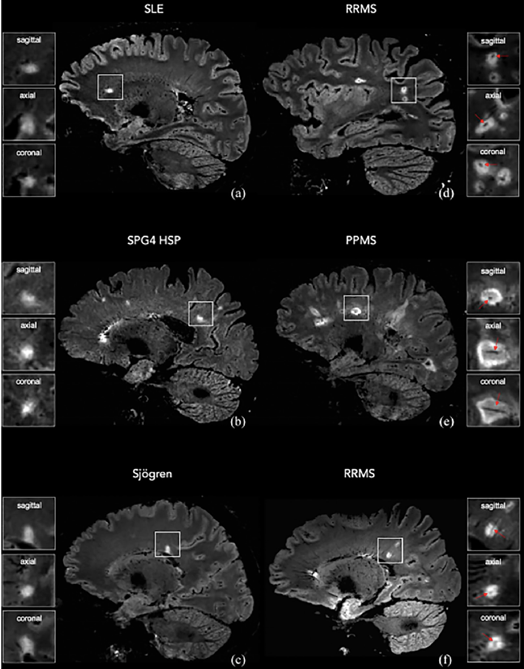

**gadolinium enhancement** indicates ***BBB disruption*** (i.e. acute lesion with ongoing inflammation)

* ***first clinical attack with numerous (> 10) MRI lesions*** + ***gadolinium enhancement in most lesions*** is highly suggestive of simultaneous lesions of ADEM (extremely aggressive MS is much more rare cause of such simultaneous lesions).
* even *old lesion* (low T1) may exhibit ringlike gadolinium enhancement (component of active inflammation at advancing edge of lesion formation).

N.B. CT usually shows no abnormalities (sometimes reveals **hypodense regions** in white matter); CT sensitivity may be increased by giving twice iodine dose and delaying scanning (double-dose delayed CT scan).

Specificity

Similar MRI lesions may be seen in:

1. **normal aging** (esp. > 50 yrs)!!! - "unidentified bright T2 objects".

N.B. correlation of MRI and clinical findings is of paramount importance!!!

1. **ADEM**
2. small penetrating vessel infarcts
3. Lyme disease, tropical spastic paraparesis/HTLV-I associated myelopathy (TSP/HAM)
4. sarcoid
5. SLE, Sjögren’s syndrome, vasculitis
6. mitochondrial cytopathies

* *unaffected family members* sometimes have abnormal MRI.

MRI characteristics strongly suggestive of MS:

1. multiple lesions
2. size > 6 mm
3. oval shape (long axis perpendicular to surface of lateral ventricles)
4. locations in periventricular area, corpus callosum*, posterior fossa (brain stem, cerebellum), spinal cord.

*corpus callosum is frequently involved in MS but not in most vascular disorders

MRI criteria for definite MS diagnosis

3 of 4 features should be demonstrated:

1. ≥ 9 white matter lesions or 1 gadolinium-enhancing lesion
2. ≥ 3 periventricular lesions
3. 1 juxtacortical lesion
4. infratentorial lesion

Alternatively – all must be present:

1. ≥ 4 lesions involving white matter or 3 lesions if 1 is periventricular
2. lesion diameter > 3 mm
3. age < 50 yrs

***For patients > 50 years***, add three criteria:

1. lesion diameter > 5 mm
2. lesion(s) abutting bodies of lateral ventricles
3. lesion(s) in posterior fossa.

Longitudinal MRI studies

- evolution of MS lesions.

* ***gadolinium enhancement*** precedes development of T2-weighted lesions and lasts for 2-4 weeks.
* newT2-weightedlesion has fuzzy border and *enlarges* over few weeks.
* after *period of stabilization*, T2-weighted lesion *regresses* and becomes more sharply delineated from surrounding white matter (as edema resolves).
* *residual abnormality* with increased T2-signal and decreased T1-signal remains (reflects demyelination and gliosis).
* in untreated cases, **total T2-weighted lesion area** increases by ≈ 5-10% annually.

MRI activity of disease

- number of new, recurrent, enlarging lesions or number of gadolinium-enhancing lesions - is much higher than clinical activity!

1. involvement of *asymptomatic CNS areas*.
2. T2-weighted lesions may reflect largely *reversible edema & inflammation*.
3. pathophysiological difference between symptomatic and nonsymptomatic lesions (presence or absence of *axonal dysfunction*).

N.B. *poor correlation between* ***clinical disability*** *and* ***total lesion load*** (volume of white matter abnormalities)!

*MRI is most sensitive measure of disease activity*

- periodic MRI can determine treatment efficacy much more quickly than monitoring clinical disability level (many studies use MRI as secondary outcome).

Additional MRI techniques

**Fluid attenuated inversion recovery (FLAIR)** eliminates CSF signal from T2-weighted images → increased contrast of lesions in brain (but distinctly less sensitivity at brain stem, cerebellum and spinal cord!).

**Short time-inversion recovery (STIR)** suppresses fat signal - useful in detecting optic nerve lesions.

**Magnetization transfer ratio (MTR)** takes advantage of macromolecular environment of protons - can discern early **reversible** edematous lesions (***inflammation***) from chronic **nonreversible** lesions (***demyelination***).

T1-MRI - three plaques on left:

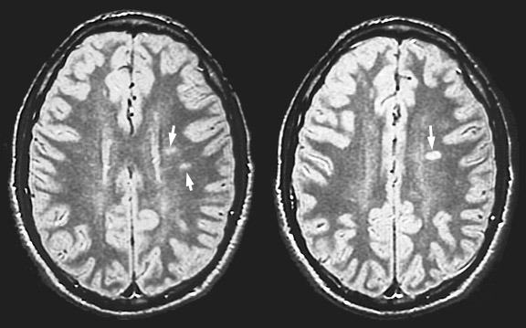

[Source of picture: “WebPath - The Internet Pathology Laboratory for Medical Education” (by Edward C. Klatt, MD) >>](http://library.med.utah.edu/WebPath/webpath.html)

|  |  |
| --- | --- |
| T2-MRI - multiple lesions with high signal intensity; one large lesion mimics brain tumor (because of associated edema and inflammation):  D:\Viktoro\Neuroscience\Dem. Demyelinating disorders\00. Pictures\MS - MRI (2).jpg | 3 months later - dramatic decrease in size of lesions:  D:\Viktoro\Neuroscience\Dem. Demyelinating disorders\00. Pictures\MS - MRI (3).jpg |

|  |  |
| --- | --- |
| A. Normal contrast-enhanced CT:  D:\Viktoro\Neuroscience\Dem. Demyelinating disorders\00. Pictures\MS - CT.jpg | B. T2-MRI in same patient - multiple lesions: D:\Viktoro\Neuroscience\Dem. Demyelinating disorders\00. Pictures\MS - MRI (4).jpg |

A. Section just above bodies of lateral ventricles - numerous high-signal lesions adjacent to bodies of lateral ventricles in deep cerebral white matter.

B. Ovoid lesions extending from lateral ventricles into deep cerebral white matter.

C. Numerous high-signal lesions in pons, cerebellar peduncles, and cerebellum.

D. T1-weighted cervical spinal cord lesion with gadolinium enhancement around lesion periphery.

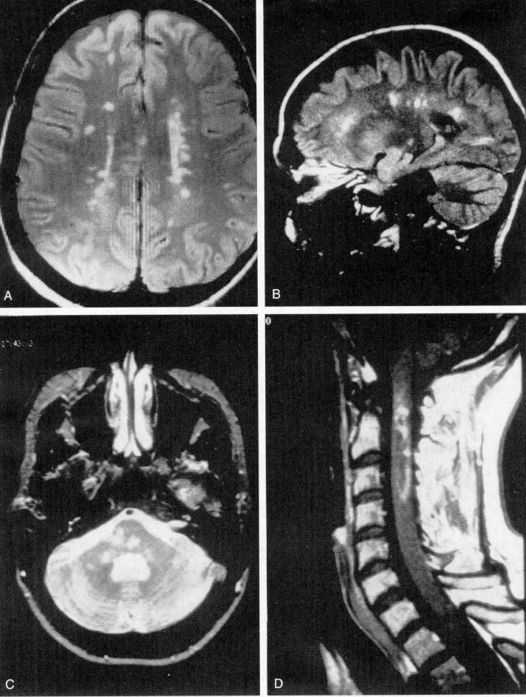

|  |  |
| --- | --- |
| D:\Viktoro\Neuroscience\Dem. Demyelinating disorders\00. Pictures\MS - MRI (7a).jpg | |
| **A**. Midline flair - plaques in genu and splenium of corpus callosum.  **B**. flair through lateral ventricle - typical pattern of plaques radiating outward from ventricular surface.  **C**. Proton density fast spin echo image just above ventricles - plaques in typical axial appearance. | D:\Viktoro\Neuroscience\Dem. Demyelinating disorders\00. Pictures\MS - MRI (7b).jpg |

|  |  |
| --- | --- |
| D:\Viktoro\Neuroscience\Dem. Demyelinating disorders\00. Pictures\MS - MRI (6a).jpg | |
| **A**. T1-MRI - focal cord swelling at level C3-C4, associated with subtle hypointense intramedullary signal.  **B**. FSE-STIR confirms both swelling and increase in abnormal cord signal intensity.  **C**. T2-MRI further confirms extensive amount of increased intramedullary signal. | D:\Viktoro\Neuroscience\Dem. Demyelinating disorders\00. Pictures\MS - MRI (6b).jpg |

|  |  |  |
| --- | --- | --- |
| T2- MRI -multiple areas of bright signal (*black arrows*): | T1-MRI - two discrete areas of contrast enhancement (*white arrows*): | T2-MRI - spinal cord lesion (*arrow*): |
| D:\Viktoro\Neuroscience\Dem. Demyelinating disorders\00. Pictures\MS - MRI (8).jpg | | |

CSF

CSF must show either **≥ 2 oligoclonal bands** or ↑**IgG index**.

* lymphocytic **pleocytosis** is present in 33% cases (particularly in acute phases):
  + 5-20 cells/mm3 (seldom exceeds 50).
  + *T* *helper-inducers* (CD4+CDw29+ cells) constitute most of cells and are found in higher ratios in CSF than in peripheral circulation.
  + number of *suppressor-inducer* T cells (CD4+CD45RA) is decreased.
  + T/B lymphocyte ratio = 80/20, CD4+/CD8+ = 2/1.
* **IgG amount**↑; because only few cell clones are activated, response is **"oligoclonal"** (each **discrete band** demonstrated on electrophoresis represents monoclonal antibody);

Oligoclonal IgG bands

* + at least 2 bands must be present for diagnosis of MS; “oligoclonal” = 3-5 bands.
  + sensitivity 85-95% (but lower early in course).

Absence of bands does not rule out MS!

* + once present, OCBs persist and pattern does not vary, although new bands occasionally appear.
  + it is restricted response to stimulation within neuraxis (i.e. within BBB) - similar oligoclonal IgGs are *not found in serum*!

N.B. *peripheral monoclonal gammopathies* may produce CSF bands, although less intense than in serum.

Compare paired serum & CSF banding patterns! - only unique CSF bands should be reported!

* + antigen for oligoclonal IgG has not been identified (oligoclonal IgGs may be secondary effect, as result of decrease in suppressor-inducer T cells, which allows few clones of Ig-producing cells to escape suppression).
  + oligoclonal IgGs are not specific for MS – also found in other conditions:

1. subacute sclerosing panencephalitis (100%)
2. other inflammatory CNS disorders (CNS lupus, CNS syphilis, sarcoidosis, cysticercosis, viral / fungal / bacterial infections)
3. some brain tumors
4. Guillain-Barré syndrome

* **IgG index**↑, i.e. intrathecal IgG synthesis rate↑ (vs. serum IgG that entered CNS passively across disrupted BBB).

IgG index= [IgGCSF / albuminCSF] / [IgGserum / albuminserum]

* + normal IgG index is < 0.65-0.77.
  + most patients have IgG index > 1.7.
* myelin basic protein:
* normally or during remissions < 1 ng/ml.
* in acute relapses – up to 4 ng/ml (index of disease activity).
* glucose level is usually normal.
* total protein is normal (50%) or mildly elevated (50%); levels > 75 mg/dL require alternative explanation.

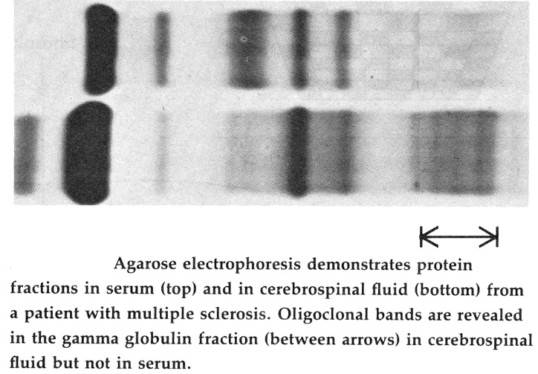

Evoked Potentials

- abnormally delayed because of demyelination.

1. **Visual** (50-90% sensitivity).

* VEP may be abnormal without past history of optic neuritis!
* interocular P100 latency difference is common feature.

1. **Somatosensory** (50-77% sensitivity).

* documents sensory symptoms in patients who have normal clinical sensory examinations.

1. **Auditory** (41-67% sensitivity).

* most useful in suspected pontine lesions.

1. **Magnetically evoked motor potentials** detect lesions in pyramidal pathways.

Indications:

* + 1. detecting clinically silent lesions, i.e. evidence of multifocality (e.g. second paraclinical lesion for establishing MS diagnosis)
    2. documenting organic basis for vague complaints.

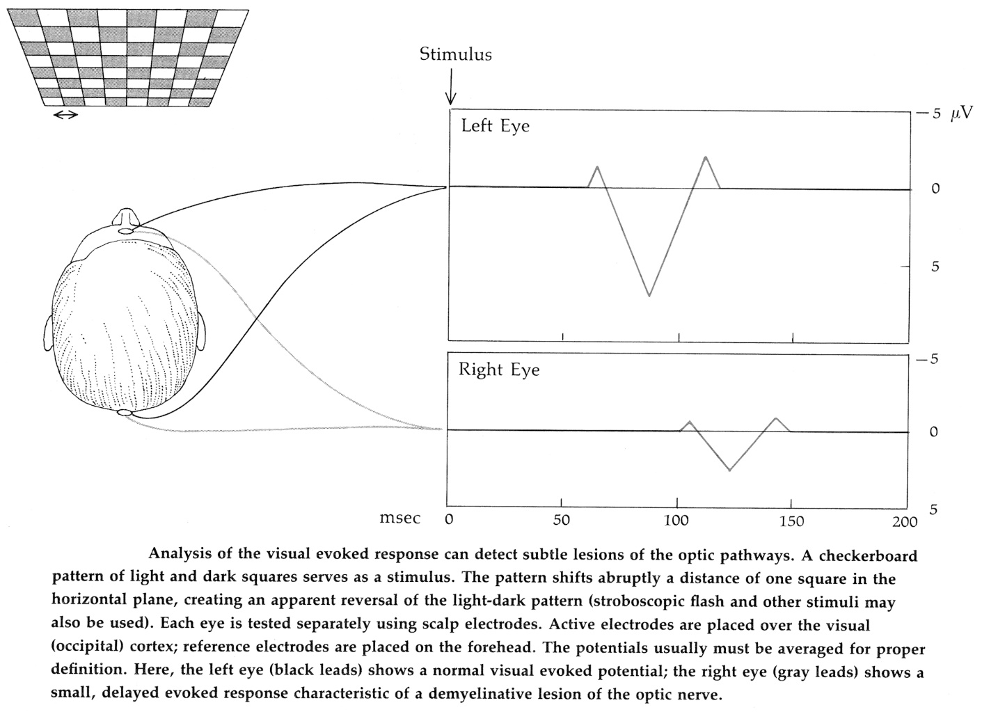

Optical coherence tomography (OCT)

- noninvasive near-infrared scan of retina

Blood Tests

- for excluding other causes.

1. Vit.12 levels!!!
2. antinuclear antibody (ANA) titers (for CNS lupus)
3. ESR
4. RF
5. Lyme titers
6. very long chain fatty acids (for adrenoleukodystrophy)

Treatment

No available prevention or cure for MS!

Lifestyle

* **diet** - no specific restrictions; encourage to eat balanced diet + oral **calcium** and **multivitamins** (esp. vit. D).
* **exercise** regularly; ***swimming*** is ideal (buoyant support + hypothermia).
* avoid hot showers or saunas, excessive sun exposure.
* no good data regarding risk of *vaccinations*.
* patient should be informed about local and national MS societies.

Acute Exacerbations

**Corticosteroids**, **ACTH** speed recovery from exacerbation (but do not affect degree of recovery).

Current recommendation (indicated even for first episode of MS!):

methylprednisolone IV 500-1000 mg/d for 3-5 days ± short tapering dose of oral corticosteroids*.

*over 10-14 days (for patients who worsen on withdrawal of IV methylprednisolone)

* oral alternative - high-dose methylprednisolone or high-dose prednisone.
* **plasma exchange** is beneficial in some severe episodes that fail to improve with intravenous methylprednisolone.

N.B. treatment of acute attacks is reserved for ***functionally disabling symptoms*** (e.g. mild sensory attacks may not warrant acute intervention!)

Do not treat with steroids "pseudoexacerbations" due to heat, stress, or infection!

Alteration of Natural Course - Disease-modifying Drugs

* as soon as possible* after definite diagnosis of MS!; treatment of "presumed MS" is not indicated.

*to stop irreversible axon loss!

* therapy is ***continued indefinitely***.
* movement from one immunomodulating drug to another is permitted.
* patients with benign disease or slowly progressive MS do not need disease-specific treatment.
* long-term steroid therapy is not recommended!!!

FDA approved as first-line therapies for MS - “**ABCR**” immunomodulatory drugs (decrease rate of MS relapses by ≈ 1/3):

**A**vonex (IFN-β 1a IM)

**B**etaseron (IFN-β 1b SC)

**C**opaxone (glatiramer acetate SC)

**R**ebif (IFN-β 1a SC)

FDA- and EMEA-approved Disease-modifying Drugs for Multiple Sclerosis (*as of November 2007*):

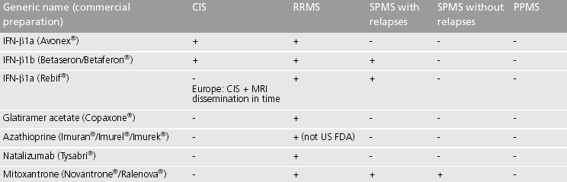

CIS – clinically isolated syndrome EMEA – European Medicines Agency

RRMS – relapsing-remitting MS

SPMS – secondary progressive MS

PPMS – primary progressive MS

1. Interferons-β (N.B. **IFN-γ** increases exacerbation rate!)

Mechanism of action - decrease expression of B7-1 (proinflammatory molecule) on surface of immune cells, increase levels of TGF-β (anti-inflammatory molecule) in circulation.

1. **IFN-β 1b** SC (Betaseron®) - first drug approved by FDA specifically for MS treatment.
   * dosage - 8 million IU every other day.
   * reduces frequency and severity of relapses, patients stop accumulate MRI lesional volumes.
   * *no effect on disability levels* (patients on low dose of IFN-β 1b actually do worse than placebo-treated patients!).
   * 38% patients after 3 years of treatment develop *neutralizing autoantibodies* → failure to respond to drug; neutralizing antibodies may cross react with natural IFN-β!
2. **IFN-β 1a** IM (Avonex®) - same amino acid sequence as natural IFN-β and differs from IFN-β 1b by one amino acid.
   * dosage - 6 million IU (30 mcg) once weekly.
   * effects similar to IFN-β 1b + favorable effect on disability + less common side effects + 50% rarer neutralizing antibodies.
3. **IFN-β 1a** SC (Rebif®)
   * dosage – 44 mcg 3 times per week (tiw).

Side effects of interferons:

* + 1. ***injection site reactions*** (H: topical steroid or cold packs at intended site few hours prior to administration of drug)
    2. ***flulike symptoms*** lasting minutes or hours (H: acetaminophen or ibuprofen 3-4 hours prior and 3-4 hours following injection; lessen after treatment for few months)
    3. ***lymphopenia***
    4. liver enzyme↑ (up to severe hepatitis) – regular monitoring of LFT
    5. depression & attempted suicide.
    6. abortifacients!

1. **Glatiramer acetate**, s. **copolymer 1** (Copaxone®) - **polymer** comprising random sequence of 4 amino acidsproposed to ***mimic MBP (myelin basic protein)*** when presented on surface of antigen-presenting cells (lymphocytes reactive against CNS myelin are diverted to bind to Copaxone in circulation, thus decreasing entry of immune cells across BBB).
   * 30% reduction in relapse rate.
   * dosage – 20 mg SC daily.
   * safest side effect profile of ABCR! (principal side effect is swelling and redness at injection site).
2. **Natalizumab** (Tysabri®) - recombinant humanized IgG4-1C **monoclonal antibody** against α-4 subunits of α-4-β-1 and α-4-β-7 integrins expressed on leukocyte surface - ***inhibits α-4-mediated leukocyte adhesion to their receptors*** → inhibited leukocyte migration across BBB:

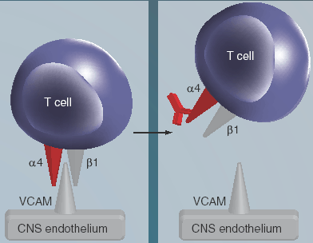

Marketing suspended in US February 28, 2005 to investigate association with *progressive multifocal leukoencephalopathy*.

In February 16, 2006 FDA allowed clinical trials to go forward, but drug is still not being placed back on market.

In June 5, 2006 FDA allowed to resume marketing under special distribution program called “TOUCH”.

Risk of developing PML increases with number of [Tysabri](http://www.drugs.com/tysabri.html) infusions received!

* + used as monotherapy – 66% reduction in relapses!!! (twice as ABCR)
  + dosage – 300 mg IV once a month.
  + common adverse effects: mild infections (UTI, lower respiratory tract, GI, vaginal), headache, mild depression, joint pain, menstrual disorders; reports of significant ***liver injury*** (incl. markedly elevated hepatic enzymes and total bilirubin) as early as 6 days after first dose.
  + also FDA approved (Jan 14, 2008) for Crohn disease.

1. **Cladribine** (Leustatin®) - **purine nucleoside derivative** (2-chlorodeoxyadenosine, s. 2-CDA) - selectively depletes CD4+ and CD8+ T cells (with relative sparing of other bone marrow and immune cells) → lymphopenia (→ decreased relapse rate and slowed progression).
   * also FDA approved for hairy cell leukemia.
2. **Teriflunomide** (Aubagio®) - active metabolite of leflunomide - immunomodulatory drug inhibiting pyrimidine de novo synthesis by blocking dihydroorotate dehydrogenase.
   * once-a-day tablet FDA approved for treatment of adults with relapsing forms of MS.
3. **dimethyl fumarate** (Tecfidera®) - oral Nrf2 pathway activator – FDA approved for treatment of MS relapsing forms.
4. Mitoxantrone (Novantrone®) - modest effects; risk of cardiomyopathy; reserved for ***aggressive forms***; not indicated in primary progressive MS.
   * 10 times more potent than cyclophosphamide in inhibiting experimental allergic encephalomyelitis (EAE).
5. Cyclophosphamide (potent immunosuppressant) - not widely used (inconsistent effect + high potential for serious side effects).
   * reserved for ***aggressive forms*** (esp. males < 40 yrs).
6. Azathioprine - marginal efficacy; used off-label as ***addition to ABCR***.
7. Methotrexate - no effect on traditional measures of disability; used off-label as ***addition to ABCR***.
8. Cyclosporine - no convincing benefit.
9. Bimonthly pulses of methylprednisolone (500 mg/d for 3 days → 10-day tapering of oral methylprednisolone).
10. Acyclovir - reduced relapse frequency in small prospective trial.
11. **Total lymphoid irradiation** - slows chronic progression of MS; not widely used:

* precludes later initiation of immunosuppressant drugs;
* may be associated with higher mortality rate.

1. Monthly IVIg - fewer and less severe relapses, slowed accumulation of disability.
2. Oral myelin as antigen may induce tolerance.
3. Rituximab (chimeric monoclonal antibody that selectively depletes CD20-positive B cells) - encouraging results in *relapsing remitting* MS; poor results in *primary progressive* MS.
4. Alemtuzumab (Lemtrada®) - humanized monoclonal antibody - targets CD52 on surface of both T and B cells – FDA approved for *relapsing remitting* MS; preliminary results much better than IFN-β 1a.
5. Daclizumab (ZINBRYTA) is indicated for the treatment of adult patients with relapsing forms of multiple sclerosis (MS). Because of its safety profile, the use of ZINBRYTA should generally be reserved for patients who have had an inadequate response to two or more drugs indicated for the treatment of MS. ZINBRYTA can cause severe liver injury including life-threatening events, liver failure, and autoimmune hepatitis, and immune-mediated disorders.
6. Ocrelizumab - depletes B cells - ORATORIO trial.

Symptomatic Treatment

**Spasticity** [see p. Mov3 >>](http://www.neurosurgeryresident.net/Mov.%20Movement%20disorders,%20Ataxias\Mov3.%20GENERAL%20-%20UMN%20(pyramidal)%20&%20LMN%20Disorders.pdf#Treatment_of_spasticity)

N.B. all medications have limited efficacy and may produce symptomatic worsening in patients who require stiffness in order to ambulate!

1. dalfampridine (Ampyra®) – FDA approved (Jan 22, 2010 to improve walking in all 4 major types of MS.
   * K+-channel blocker.
   * can be used alone or in combination with immunomodulatory drugs.
   * dosage: 10 mg twice a day
   * adverse affects: seizures (at doses > 10 mg twice a day).
   * CI: moderate or severe kidney disease.
2. **stretching** program (to avoid contractures).
3. baclofen (doses escalated slowly up to 120 mg/day) – drug of choice;
   * abrupt cessation is contraindicated (→ seizures and psychosis).
   * in paraplegics with severe spasticity - *intrathecal baclofen* by s/c implanted pump.
4. evening dose of diazepam
5. clonidine
6. tizanidine (centrally acting α2-agonist) - as effective as baclofen.
7. dantrolene - small therapeutic window (hepatotoxicity); invariably exacerbates weakness.
8. injections of *botulinum toxin*.
9. adductor leg muscle **tendon release**.

**Fatigue**

1. limit activities & schedule rest periods (afternoon naps)
2. amantadine (Symmetrel®) 100 mg × 2/d - standard initial treatment (effective in 50%).
3. modafinil (Provigil®)
4. methylphenidate (Ritalin®)
5. selegiline
6. pemoline (Cylert®) 37.5 mg/d; not recommended by FDA - reports of rare fatal liver damage!
7. **SSRIs**

**Depression:**

1. with concurrent *spastic bladder* - **tricyclic antidepressant** (e.g. amitriptyline).
2. with concurrent *fatigue* - **SSRIs**

**Emotional incontinence** - low dose of **tricyclic antidepressant** (e.g. amitriptyline), **SSRIs**

**Paroxysmal symptoms** are highly responsive to medical treatment!

1. small dose of carbamazepine - often very effective.
2. phenytoin, acetazolamide, baclofen, gabapentin, amitriptyline, misoprostol (for MS-related trigeminal neuralgia).

* after 1 month of treatment, tapering off is reasonable because these symptoms usually remit.

**Heat sensitivity**

1. cooling jacket
2. 4-aminopyridine (K+ channel blocker) improves temperature sensitivity but occasionally causes seizures or disturbing paresthesias.

**Action tremor**

1. clonazepam (tolerance frequently develops)
2. isoniazid, carbamazepine, ondansetron
3. stereotactic **thalamotomy**.

**Dysesthetic pains** - tricyclic antidepressants, carbamazepine, baclofen, gabapentin, tramadone, rhizotomy.

**Seizures**

* start phenytoin after first seizure.

**Urologic problems**

In all patients with urinary symptoms, **urine culture** should be obtained (treatment of infection alone may suffice to relieve new symptoms!) → **assessment of postvoid residual urine volumes**

|  |  |  |
| --- | --- | --- |
| **Pathophysiology** | **Voiding volume** | **Residual volume** |
| **Hyperreflexic bladder** | < 200 mL | < 100 mL |
| **Flaccid bladder** | > 500 mL | < 100 mL |
| **Detrusor-sphincter dyssynergia** | > 500 mL | > 100 mL |

**Hyperreflexic bladder** - anticholinergics (oxybutynin!, propantheline, imipramine, emepronium).

**Flaccid bladder** - bethanechol, intermittent catheterization; UTI prevention - *urine acidifiers* (vit. C, cranberry juice) + *urinary antiseptics* (methenamine mandelate).

**Detrusor-sphincter dyssynergia** - anticholinergics, α-blockers (terazosin, phenoxybenzamine*), intermittent catheterization (if post-void residuals reach 100 ml), supravesical diversion.

*drug of choice for acute urinary retention during MS relapse.

**Calculi** may be prevented by *urine acidification*.

**Sexual dysfunction** (should not be automatically attributed to MS):

* ***spasticity*** may be alleviated by premedication with baclofen;
* fast-acting anticholinergic (oxybutynin) calm ***urinary urgency***.
* lubrication with gel to ***vaginal dryness***.
* ***erectile dysfunction*** – sildenafil group, vacuum devices, intracavernous papaverine, penile prosthesis implant.

**Constipation** - bulk laxatives, stool softeners; in severe cases - osmotic agents, bowel stimulants, anal stimulation, suppositories, enemas.

**Fecal incontinence** is generally unresponsive to treatment (anticholinergics may be tried).

Enhancement of Recovery

* phase II trials - if IVIg can lead to functional improvement in apparently irreversible weakness or optic nerve dysfunction.

Pregnancy

Before initiation of any drug in woman of reproductive age, ***potential for teratogenicity*** must be discussed!

* *none of drugs altering disease course should be used* (they should be stopped if pregnancy occurs).
* treatment of **acute exacerbations** is unchanged (corticosteroids and plasma exchange are relatively safe).
* *breast-feeding* has little if any effect on MS.

Prognosis

Worst prognosis is for ***male patients with primary progressive (PP) MS***!

Factors associated with better prognosis:

1. **young** age (< 35 yrs) at onset
2. **female** gender
3. **RR** course (vs. PP)
4. initial symptoms - **sensory** or **optic** neuritis
5. first manifestations affecting **only one CNS region**
6. high degree of **recovery** from initial bout
7. **longer interval** between 1st and 2nd relapse
8. **low number of relapses** in first 2 years
9. **less disability** at 5 years after onset.

Disability

**10 years** after onset, 50% patients are still able to carry out their household and employment responsibilities.

**15 years** after onset, 50% require cane to walk.

**25 years** after onset, 50% are unable to walk, even with assistance.

* *30% patients occupy extremes* - either clinically silent for lifetime (diagnosed only at autopsy) or having unusually severe limitations (bedridden within months of onset).

Death

* patients have *average life expectancy 7 years shorter* than general population.
* average interval from clinical onset to death is **35 years**.
* patients die of **complications** rather than of MS itself:
  1. sepsis (from UTI or decubitus ulcers)
  2. aspiration pneumonia
  3. suicide.

Bibliography for ch. “Demyelinating Disorders” → follow this [link >>](http://www.neurosurgeryresident.net/Dem.%20Demyelinating%20disorders\Dem.%20Bibliography.pdf)

[Viktor’s Notes℠ for the Neurosurgery Resident](http://www.neurosurgeryresident.net/)

[Please visit website at www.NeurosurgeryResident.net](http://www.neurosurgeryresident.net)