Cns complications of Viral Infections and Vaccines
Last updated: September 5, 2017
Acute Disseminated Encephalomyelitis (ADEM) 1
Acute necrotizing hemorrhagic encephalomyelitis (ANHEM), s. Acute Hemorrhagic Leukoencephalitis of Weston Hurst 2
Acute Cerebellar Ataxia → see p. Mov50 >>

Mediated by autoimmune mechanisms (vs. direct CNS invasion by organism).
- PNS counterpart - Guillain-Barré syndrome.

Acute Disseminated Encephalomyelitis (ADEM)
- monophasic inflammatory demyelinating disorder that begins within 6 weeks of antigenic challenge (infection or immunization).
- considerable overlap in epidemiological, pathological, pathophysiological, clinical, CSF, imaging features between ADEM and MS - difficult to distinguish between two when encountering patients with single demyelinating event.

Pathophysiology
- transient cell-mediated autoimmune response toward myelin (e.g. myelin basic protein).
- infections and vaccinations induce ADEM by molecular mimicry or by nonspecific activation of autoreactive T-cell clones.

Histology - perivenous inflammation-edema-demyelination with relative preservation of axons.
perivenous demyelination !!!
- lesions commonly enlarge and coalesce, forming lesions pathologically indistinguishable from MS.
- repair occurs through remyelination.

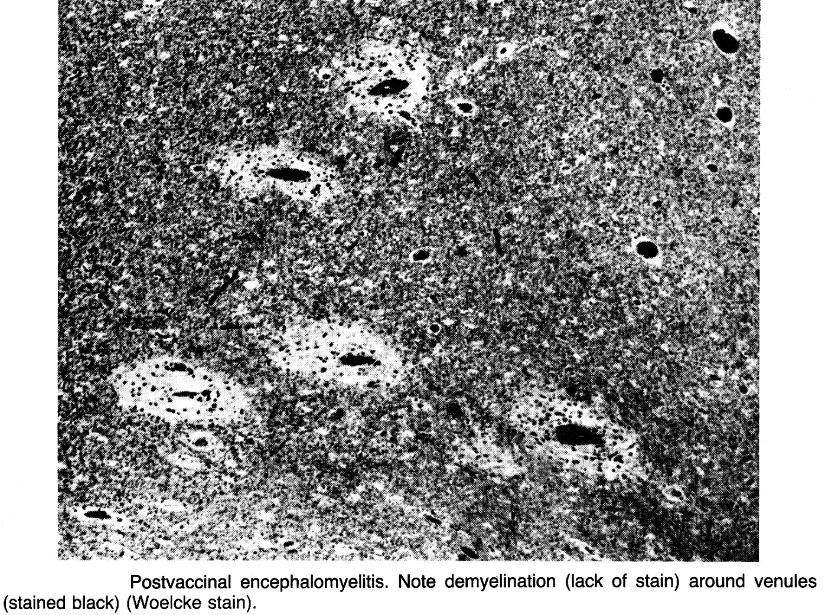

Etiology
  - vaccines - postvaccinal encephalomyelitis (3-6% of all ADEM cases).
    - only epidemiologically and pathologically proven association is with rabies vaccination.
      - original Pasteur rabies vaccine (prepared in rabbit spinal cord - was contaminated with CNS tissue) had ADEM incidence 1 per 3,000-35,000 vaccinations.
      - use of human diploid cell lines (contain no nervous system tissue) for production of rabies vaccine has virtually eliminated risk of ADEM.

  - infections - postinfectious (s. parainfectious) encephalomyelitis
- most commonly nonspecific upper respiratory tract infection.
- measles carries highest risk (1 per 1,000 cases) for ADEM among specific infections; now measles-related ADEM is rare (ADEM is now most frequently associated with varicella-chickenpox infections).

Epidemiology
- any age but most common during childhood – 80% cases during 1st decade, < 20% - during 2nd decade (i.e. earlier than MS), < 3% - adulthood.
- incidence during first-decade ≈ 3 cases per 100,000.
- cases occur in all regions of world.
- males = females.

Clinical Features
    - parainfectious ADEM usually follows onset of infectious illness (often during recovery), but because of latency of some pathogens ADEM may precede clinical symptoms of infection or two may occur simultaneously.

Viral prodrome (few days) - headache, low-grade fever, myalgias, malaise.
Prodrome absent in MS! Also absent in 7-15% ADEM cases!
    - hiatus between onset of viral prodrome and onset of ADEM may range 2-30 days.
    - prodrome and ADEM are typically separated by phase of recovery from fever and other constitutional manifestations.

Neurological symptoms develop very rapidly (hours ÷ several days*) - irritability and lethargy, delirium (encephalopathy of varied degree), changes in mental status up to coma (88%), headache (55%), focal or generalized seizures (25%), meningismus (25%). *rarely up to 6 weeks
Prominence of cortical signs! (vs. MS)
    - fever returns in ≈ 50% cases.
    - variety of multifocal neurological manifestations (brain, brain stem, cerebellum, optic nerves, spinal cord).
ADEM - classically multifocal involvement at onset; vs. MS often presents with monosymptomatic deficits.
- ADEM-associated optic neuritis is usually bilateral (vs. MS).
    - peak severity occurs within several days → recovery begins soon afterward.
ADEM is typically monophasic disease of prepubertal children; vs. MS is chronic relapsing-remitting disease of young adults.

Diagnosis
CSF – although oligoclonal IgG bands occur transiently in 1/3 cases, their persistence implies diagnosis of MS!
- subsequent disappearance of bands is evidence against MS.
- myelin basic protein concentration↑ (reflects demyelination).
- mononuclear pleocytosis of 20-200 cells/mm³.
MRI – identical to MS (basal ganglia or cortical lesions, large globular white matter lesions are more frequent in ADEM; 90% ADEM lesions disappear with time).
- characteristic centrifugal “cotton-ball” lesions at junction of deep cortical gray and subcortical white matter are found in 90% cases.
- classically all ADEM lesions develop simultaneously! (90% lesions enhance with gadolinium – i.e. all lesions are acute monophasic)
Blood - platelet counts↑, ESR mildly elevated (greater elevation suggests vasculitis or infection).
EEG - widespread slowing of background rhythms.

Treatment
- IV methylprednisolone 20 mg/kg/d (maximum 1 g/d) for 3-5 days → oral taper for 3 weeks
  - improvement usually requires several days.
- IVIg 2 g/kg for 2-3 days - preferable when meningo-encephalitis cannot be excluded.
- plasma exchange for severe deficits and little response to corticosteroids.

Prognosis
- mortality < 2% (esp. measles-associated ADEM).
    - 50-90% survivors have marked recovery (complete recovery may be observed even in children who become blind, comatose, and quadriparetic).
risk factors for bad recovery: age < 2 yrs, transverse myelitis.
    - long-term (10-y follow-up) risk for development of MS - 25%.

Acute necrotizing hemorrhagic encephalomyelitis (ANHEM), s. Acute Hemorrhagic Leukoencephalitis of Weston Hurst
- hyperacute variant of ADEM.

- affects mainly children and young adults.
- almost invariably preceded by recent episode of upper respiratory infection.
- immunopathogenesis similar to ADEM (immune sensitization to MBP).
- macroscopy - brain is swollen, with bilateral petechial hemorrhages throughout white matter (hemispheres, brainstem, and spinal cord).
- microscopy ≈ hyperacute EAE with perivenous demyelination and intense infiltration by mononuclear and especially polymorphonuclear cells!
- necrosis of walls of venules → fibrin deposition, petechiae, disseminated necrosis of white and gray matter.
- coalescence of smaller lesions → large necrotic foci.

Clinical Features
- sudden headache → fever, various focal signs (esp. seizures, quadriplegia) → rapid progression (few hours to several days) from lethargy to coma.
- > 80% cases are fatal (within 2-4 days).

Diagnosis
- CT – brain edema, diffuse areas of hypodensity in white matter.
- late MRI – evidence of blood products.
- blood – marked leukocytosis, ESR↑.
- CSF:
  - marked pleocytosis up to 3000 cells/mm³ (preponderance of polymorphonuclears!)
  - evidence of hemorrhage
  - total protein↑.

Therapy
- supportive + methylprednisolone-prednisone regimens.

Bibliography for ch. “Demyelinating Disorders” → follow this link >>

Viktor’s Notes℠ for the Neurosurgery Resident
Please visit website at www.NeurosurgeryResident.net

