Spinal Cord Anomalies

Last updated: January 18, 2020

Abnormal formation of notochord 1

Diastematomyelia, Diplomyelia 1

Embryogenesis 1

Classification 1

Clinical Features 1

Diagnosis 1

Treatment 2

Neuro-Enteric Cyst 3

Nondisjunction of neural ectoderm from cutaneous ectoderm 3

Dorsal dermal sinus 3

Clinical Features 3

Diagnosis 3

Differential 3

Treatment 3

Premature dysjunction of neural ectoderm from cutaneous ectoderm 3

Lipomyelomeningodysplasias (lipomyelomeningocele, lipomyelocele, lipomyeloschisis) 3

Embryology 4

Clinical Features 4

Diagnosis 4

Treatment 5

Subpial Lipoma, Intramedullary Lipoma 5

Disorders of secondary neurulation (s. abnormal retrogressive differentiation) 5

Tethered filum / tight filum / fatty filum 5

clinical features 5

Diagnosis 6

Treatment 6

Prognosis 6

Recurrence in adults 6

Sacral Agenesis 6

Clinical Features 6

Failure To Form Terminal Spinal Cord (s. Conus Hypoplasia) 7

Spinal Meningeal Cysts 7

Abnormal formation of notochord

Diastematomyelia, Diplomyelia

**Diastematomyelia** – *cleft* in spinal cord (one split cord and 1 pair of roots); 80% patients are females.

**Diplomyelia** – *duplication* of spinal cord (two complete cords and 2 pairs of roots)

* much more common in girls (85%).

Embryogenesis

- **abnormal neuro-enteric adhesions** between ***ectoderm*** and ***endoderm*** in embryo (disorder of gastrulation!):

* adhesions prevent proper notochord formation - notochordal cells must split and course around obstacle, resulting in abnormal notochord.
* as notochord induces formation of neural plate and vertebral bodies, these structures are split in sagittal plane:

**neural plate** → two ***hemicords*** often uneven in size, each with central canal and anterior spinal artery, but giving rise to only ipsilateral spinal roots:

* 1. hemicords share *common* arachnoid space and dural sac (60%) with thin sagittal fibrous septum – difficult to diagnose even by imaging.
  2. classic type - arachnoid and dura are *split into two separate* arachnoid and dural tubes (40%) with sagittal bony septum.

associated **vertebral bodies** → ***hemivertebra*** or ***butterfly vertebra***;

* **mesenchyme** moves into space between hemicords and forms ***spur*** or complete ***septum*** (bony, fibrous or cartilaginous; originating from posterior vertebral body and extending posteriorly) which tethers cord.
* if split involves **distal caudal cell mass** → ***double filum terminale***.

Topography:

* any level can be involved (filum terminale ÷ medulla oblongata); **L1-3**in ≈ 50% cases.
* cleavage usually extends over ***several segments***.
* hemicords re-unite caudally.

Classification

[see p. Op250 >>](http://www.neurosurgeryresident.net/Op.%20Operative%20Techniques\200-299.%20Spine\Op250.%20Cord%20and%20Spine%20Developmental%20Anomalies%20(techniques).pdf)

Clinical Features

- closed (occult) dysraphism: May be asymptomatic! (but eventually impaired innervation to lower extremities)

1. **Skin stigmata** (invariably present, esp. hairy patch).
2. **Neurologic signs** result from flexion-extension movements (cord traction and impaling septum at point of reunion of hemicords), i.e. similar picture to tethered spinal cord, however, symptoms may be more strictly unilateral:
3. *most often* - unilateral foot abnormalities (talipes equinovarus, claw toes), loss of pain and temperature sensation, gastrocnemius atrophy in preschool child.
4. *more progressive course* - bilateral weakness and atrophy in lower extremities, absent ankle jerks, urinary incontinence, low back pain.
5. **Associated abnormalities**:
   1. abnormalities of vertebral bodies (fusion defects, hemivertebra, hypoplasia, kyphoscoliosis, spina bifida, myelomeningocele).
   2. hydromyelia
   3. low conus medullaris (75%)
   4. thicker than normal (> 2 mm) and tight filum terminale (50%).

Diagnosis

* **plain X-ray**: focal expansion of spinal canal, narrow intervertebral disc spaces, varying degrees of laminar dysplasia and fusion - combination is very suggestive of diagnosis, whether or not bony spur is shown.
* **MRI** must include sagittal and coronal images of *entire spine*; curved reconstruction may be useful in roto-scoliosis.
* **CT** (preferably axial) must be used to image cleft (bony or cartilaginous spur can easily be missed on MRI, plain X-ray).

Axial MRI of diastematomyelia:

A) two hemicords and two dural sacs (*arrows*), separated by bony septum (*arrowhead*).

B) two unequal hemicords (*arrowheads*) contained in single dural sac.

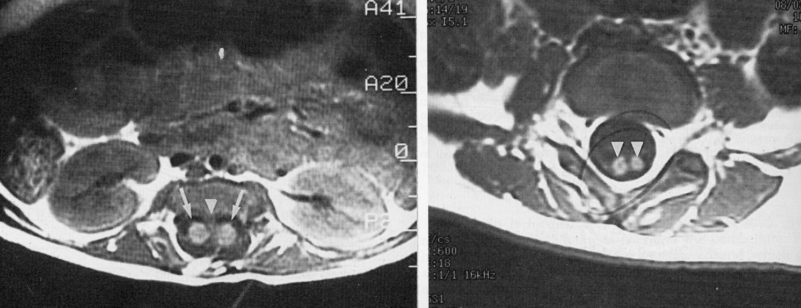

CT of diastematomyelia - bony spur dividing cord:  
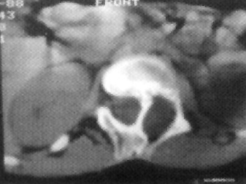

CT myelography of diastematomyelia - central bony septum (*large arrowhead*) dividing dural sac and conus medullaris (*small arrowhead*) into two parts:

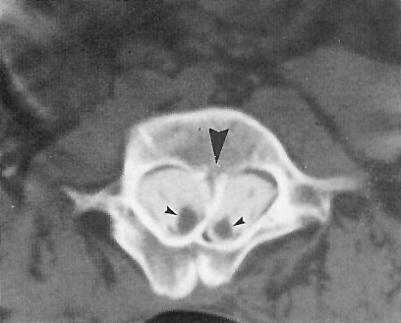

[Source of picture: John H. Juhl “Paul and Juhl’s Essentials of Radiologic Imaging”, 7th ed. (1998); Lippincott Williams & Wilkins; ISBN-10: 0-397-58421-0 >>](http://www.amazon.com/gp/product/0397584210)

CT and MRI:

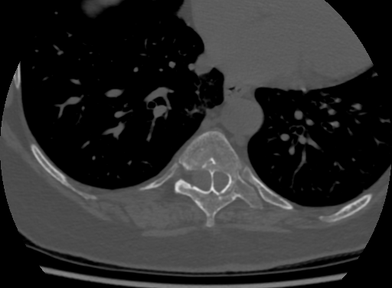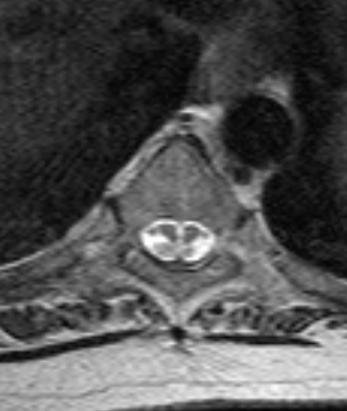

[Source of picture: Viktoras Palys, MD >>](mailto:vpalys@vcu.edu)

Treatment

**Surgery** (for symptomatic patients): [see p. Op250 >>](HTTP://WWW.NEUROSURGERYRESIDENT.NET/Op.%20Operative%20Techniques/200-299.%20Spine/Op250.%20Cord%20and%20Spine%20Developmental%20Anomalies%20(techniques).pdf)

* 1. untethering spinal cord by **removing bony / fibrous septum**.
  2. reconstructing dural sac (create one large dural sac)

Neuro-Enteric Cyst

– due to partial neurenteric canal persistence.

* most commonly - intraspinal **cyst**:
  + usually anterior to spinal cord.
  + intradural.
  + usually unilocular cyst.
  + lined by gastrointestinal or bronchial epithelium.
  + most common in *cervicothoracic region* (near craniovertebral junction or lower thoracic region).
  + ***compresses spinal cord*** and may invaginate into its substance (→ diastematomyelia).
* persistent cutaneous communication results in **dorsal enteric fistula** (from GI tract to dorsal skin).
* often associated with vertebral anomalies (butterfly or hemivertebra).
* diagnosis – **CT myelography** (MRI may not detect cyst) - intradural extramedullary lesion, or abrupt focal cord expansion;
  + delayed postmyelography CT should eventually show contrast layering within cyst.

Nondisjunction of neural ectoderm from cutaneous ectoderm

Dorsal dermal sinus

- focal nondisjunction of **neural ectoderm** from **cutaneous ectoderm** (vs. myelomeningocele - extensive failure of dysjunction) - thin communication between *dorsal skin* and *spinal canal*.

* opening above intergluteal crease!
* small opening in skin sometimes is indicated by **hairy patch** or **vascular nevus**.
* entire epithelium-lined channel may persist but any part of sinus may become atretic or disappear, leaving open sections behind.
* most common in *areas of later closure of neural tube*, i.e. lumbo-sacral and occipito-cervical areas.
* **dermoid / epidermoid tumors** may be found along course of dermal sinus tract (may be intradural and sometimes intramedullary!) – MRI is indicated for sinus openings above gluteal crease!

Formation of dermal sinus through delayed disjunction of neural tube from superficial ectoderm (arrows):

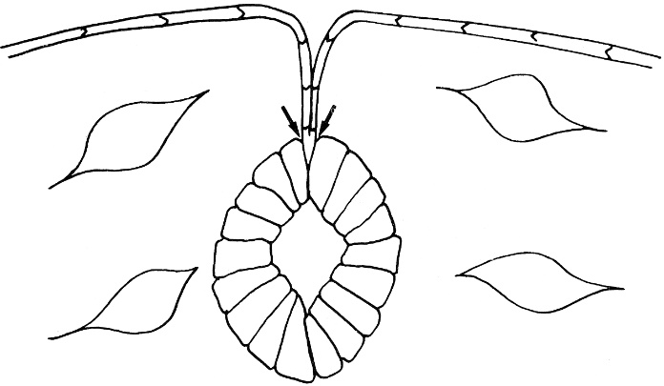

Clinical Features

Most important presentation is **infection** (may be devastating – dermal sinus is serious condition!)

1. Meningitis (esp. recurrent)
2. Epidural abscesses

* ruptured intradural dermoid / epidermoid → chemical meningitis / arachnoiditis.

Diagnosis

Anything in kid’s midline above intergluteal crease is abnormal - needs MRI!!!!!

**MRI**, **CT myelography**\* must concentrate on ***mapping sinus extent*** - to assist surgeon in removing entire malformation.

*always required as complement to MRI before neurosurgical exploration

* careful windowing of T2-weighted images is required - bright signal of subcutaneous fat may obscure thin subcutaneous tract.

Differential

**pilonidal sinus** - fistula or pit in sacral region (i.e. below gluteal crease), communicating with exterior, containing hair (may act as foreign body → chronic inflammation).

Treatment

**Surgery** – excision of *entire* tract (may include laminectomy and opening of dura) ASAP (to prevent infection); dermal sinuses:

1/3 lead to **lamina**

1/3 lead to **dura**

1/3 lead **intradurally** (may cause cord tethering) – need to excise all fat elements from intradural location to prevent further intradural lipoma formation and retethering

Premature dysjunction of neural ectoderm from cutaneous ectoderm

Lipomyelomeningodysplasias (lipomyelomeningocele, lipomyelocele, lipomyeloschisis)

- components:

1. skin-covered **subcutaneous lipoma** connected through fibroadipose stalk to **intramedullary / intradural lipoma**
2. **myelomeningocele**
3. **spina bifida**

Most common form of closed spinal dysraphism!

Embryology

- focal premature disjunction of ***neuroectoderm*** from ***cutaneous ectoderm***, allowing migration of mesenchymal tissue into neural tube (via dorsal surface of unclosed neural tube).

* *mesenchyme prevents neurulation*, leaving neural plate in shape of *placode*.
* ectopic mesenchymal cells give rise to fat.
* this intramedullary adipose tissue remains continuous with subcutaneous tissue (i.e. lipoma is attached to dorsal surface of placode and extends dorsally through dysraphic posterior elements of spine to be in continuity with subcutaneous fat) - results in *spinal cord tethering*\* to lipoma, *vertebral arch nonfusion*.

*in > 80% cases, spinal cord terminates at or below L3.

* ventral surface of placode faces subarachnoid space, where nerve roots exit from placode, usually coursing in cephalad or horizontal direction to their respective neural foramina.
* lipoma often causes rotation of placode (asymmetrical malformation).

Lipomyelomeningocele: neural placode (N) merges into lipoma above dorsal root entry zone (*arrows*); subarachnoid space (S) is also shown:

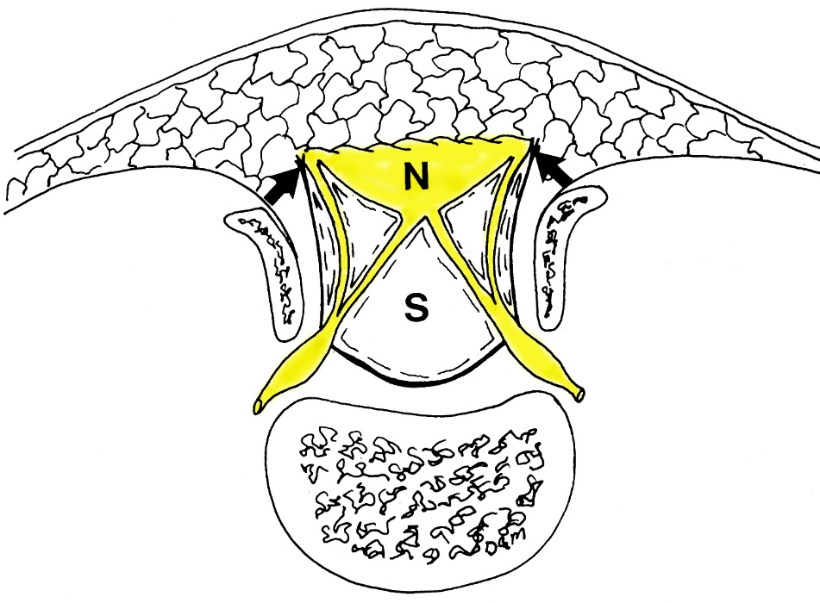

[Source of picture: David C. Sabiston “Sabiston Textbook of Surgery: the Biological Basis of Modern Surgical Practice”, 15th ed. (1997); W.B. Saunders Company; ISBN-13: 978-0721658872 >>](http://www.amazon.com/gp/product/141605233X)

Clinical Features

1. midline soft tissue **mass** (may be minimal or may distort gluteal crease);
   * most commonly in lumbosacral area.
   * dimples & hemangiomas are frequent markings.
2. stretching of tethered spinal cord or vascular compromise → *without treatment, ≈ 90% will develop motor or sensory deficit*, scoliosis, foot deformities, neurogenic bladder.

Diagnosis

**MRI** - spinal cord ending in neural placode, intraspinal lipoma, dysraphic spine.

Sagittal (A) T1- and fast spin-echo (B) T2-weighted and coronal (C) T2-weighted **MRI**: lipoma, low position of spinal cord, cavity in distal spinal cord:

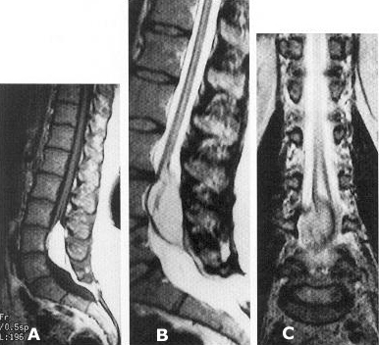

**MRI** (29-year-old female with fatty lump over lower back, with no neurological symptoms):

(A) cord (arrow) is lower than normal and tethered to lipoma in most distal dural (sacral) sac.

(B) communication (*arrow*) between subcutaneous and intraspinal fat.  
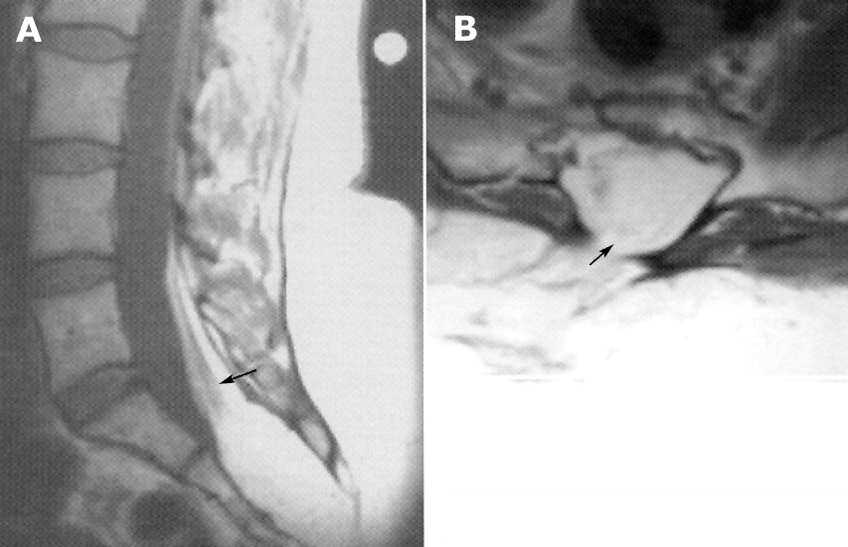

Longitudinal **ultrasound** at lumbosacral level: tethered cord (*arrows*), central echo complex (CEC), intracanalar lipoma (Li), subcutaneous lipoma (scLi), bone defect (*arrowheads*):

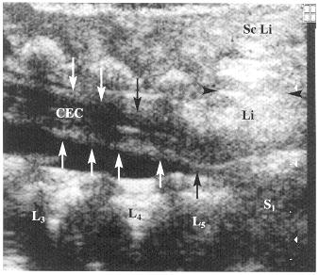

Treatment

1. **releasing tethered cord** before development of neurologic symptoms.
   * nerve roots issuing from apparently thickened filum terminale indicate that it contains significant nervous tissue and therefore should not be divided surgically.
2. **removal of lipomatous tissue**
3. **reconstruc­tion of dural sheath** around spinal cord.

###### Also read:

###### <http://www.medscape.com/viewarticle/772263?src=mp>

Subpial Lipoma, Intramedullary Lipoma

Hypotheses:

1. premature disjunction of neural ectoderm before formation of neural tube is complete → mesenchyme enters open, ependyma-lined central canal from dorsal direction.

* mesenchyme in abnormal location will form fat.

1. after neural tube is formed, disruption occurs and subcutaneous fat herniates into neural tube.

Lipoma tethers cord!

**Subpial lipoma** is located *dorsal to spinal cord*.

* most frequently in cervical and thoracic regions.
* lipoma may cause myelopathy.
* imaging - easily detected with MRI, CT myelography.

**Intramedullary lipoma** is located*between posterior columns*; tongue-like extension along central canal is often found.

* most frequently near thoracocervical or craniovertebral junctions.
* overlying dura mater usually is intact; however, there may be dural defect to which cord and lipoma become adherent.
* imaging - pressure erosion of spinal canal, abrupt expansion of spinal cord, fatty nature of “tumor”.

Intramedullary lipoma (*arrow*) with intact dura:  
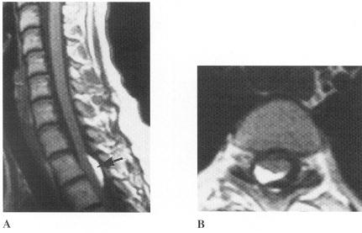

Disorders of secondary neurulation (s. abnormal retrogressive differentiation)

Tethered filum / tight filum / fatty filum

- failure of fibres in filum terminale to lengthen → tethered spinal cord:

1. **lack of normal ascent** of conus medullaris to L1.
2. **ischemic / metabolic** disturbance of caudal spinal cord.

Conus below L2 at any age is abnormal!

* filum terminale is often ***infiltrated with fatty tissue***.
* ***associated spinal anomalies*** are common (spina bifida, diastematomyelia, spinal lipomas, dermal sinuses, fibrolipomas of filum terminale).
* risk factor - genitourinary & anorectal malformations.
* prenatal folic acid reduces incidence by 70-80%.

clinical features

Symptoms may occur at any age (typically in **childhood ÷ adolescence** during periods of rapid growth) - flexion and extension of spine → ***repeated trauma & ischemia*** to conus:

URO → ORTHO → NEURO

* 1. back + lower extremity **pain** (may be asymmetrical and nondermatomal) – usually first symptom!; may suddenly worsen from *stretching of legs* (athletes, ob/gyn procedures)
  2. progressive gait disturbance, lower extremity **spastic weakness**, orthopedic deformities (varus and valgus and cavus changes of foot)
  3. **sensory loss** in sacral dermatomes.
  4. urinary **incontinence**, impotence
  5. *cutaneous stigmata* (50-70%).

if skin dimple below gluteal crease → don’t worry

if skin dimple above gluteal crease → MRI

Diagnosis

**MRI**:

1. *diminished pulsations* of **spinal cord**
2. *low* **conus medullaris** (below bottom of L2 vertebral body), absent cauda equina.

Conus is abnormally low at any age if it is found to end below L2–3 disc space

1. *lack* of**intumescentia lumbalis** - conus tapers gradually into thickened filum (no clear transition - difficult to delineate where conus ends and filum begins).
2. *thickened* (> 1-2 mm in diameter at L5-S1 level) and *fat-containing* **filum terminale**.
3. **conus medullaris** *does not move* forward in spinal canal (when MRI is done in prone position).

**US** in kids is easy but may miss tethered cord! In general, *useless*!

Treatment

- **surgical release** of tethered cord:

1. laminectomy
2. opening of dura
3. **transection of thickened filum terminale** (check with intraop stim probe and EMG before cutting!) – has serpentine vessel running along (vs. nerve roots)

* symptom progression is arrested, and in some patients, symptoms may improve (pain responds best, sphincter dysfunction worst).
* given potential for rapid deterioration with incomplete neurological recovery, even ***prophylactic surgery*** in otherwise asymptomatic child is advisable.

*Treat before symptoms!!!* (ischemic damage [cord strokes] does not recover!)

* if there is diastematomyelia and bone spicule – resect bone first (if opposite, cord bounces against bone upon release and neuro deficits↑)

Prognosis

Pediatric cases (vs. adult): no pain, no neuro deficits at presentation, fresh surgical anatomy (vs. scarred in adults), good operative results.

* **pain** improves in 50% patients (better results for kids).
* 20-25% retether postop (of those, 10-15% retether again after 2nd surgery).
* postop conus ***does not (!) ascend***; recurrence diagnosis – only clinical!
* recurrence prevention:
* create large dural sac (up to alloplasty)
* use metal clips for dural closure (less inflammation than silk)

Recurrence in adults

* + - adult spine stopped growing – symptoms unlikely are related to retethering; greater chances are nerve roots are involved in scar tissue – arachnoiditis (surgery has no real role) – look for:
      * 1. root clumping, absence of anterior root migration in prone MRI
        2. lower motoneuron type urodynamic study results (detrusor weakness)
* **urinary bladder** may worsen in adults postop (discuss that preop!); rather do 3 months of bladder exercises (double voiding, Credé's maneuver) with urology and medications (cholinergic agonists)* (→ re-evaluate with urodynamic study).

*see p. 2590 for Detrusor Underactivity (Atonic Bladder – Overflow Incontinence) >>

**Caudal Regression Syndromes**

* 1. **Sacral agenesis**
  2. **Failure to form terminal spinal cord**
     + additional components:
       - abduction and flexion deformities of lower extremities with ***popliteal webbing*** so that legs cannot be straightened.
       - lower extremities may be fused (***sirenomelia***).
       - ***cloacal malformations***, imperforate anus.

Anomalies of lower spine should *always* be suspected in patients with anorectal and genitourinary anomalies, and vice versa!

Sacral Agenesis

- absence of distal part or all of sacrum.

* usually associated with maternal diabetes.
* spinal cord terminates above T12.
* lumbar enlargement has chisel-like truncated appearance.

Clinical Features

* *high incidence* of **neurogenic bladder**, with vesicoureteral reflux, hydronephrosis, and infection.
* *occasionally*, severe **neurologic deficit** below level of spinal anomaly (→ equinovarus feet, dislocation of hips).

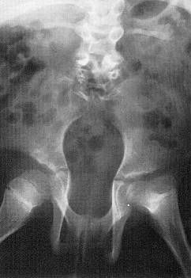

Failure To Form Terminal Spinal Cord (s. Conus Hypoplasia)

* + - **distal cord** is ***blunt***, truncated or wedge-shaped and ***located higher*** than normal.
    - *cord is not tethered* - neurosurgical intervention is rarely indicated.

Spinal Meningeal Cysts

- congenital non-neoplastic extramedullary.

* cyst size variation may be demonstrable with table tilt or changes in posture.

**Type I - extradural meningeal cysts not containing nerve roots** - dural diverticula, sometimes connected to thecal sac by only thin pedicle.

* ball-valve effect and CSF pulsation → increase in size → compression of neural structures, erosion or remodeling of adjacent bone.

Extradural arachnoid cyst (T1-MRI): cyst (*white arrows*) impinges on epidural fat (*black arrows*) above and below:

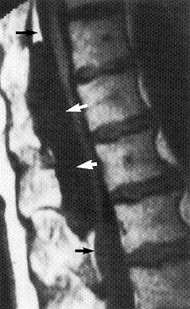

**Type II - extradural meningeal cysts containing nerve roots** (s. **Tarlov cysts**, **perineural cysts**)

* described by Dr Tarlov in 1938 - he noted lymphocytes and plasma cells around some cysts and hypothesized an ***inflammatory etiology*** that sealed off a portion of the perineural space, followed by accumulation of fluid → hydrostatic and pulsatile forces of CSF along with a ball-valve* phenomenon allow for continuous dilation of cyst.

*TCs are not readily compressible intraoperatively, remain filled even when the adjacent thecal sac is opened and CSF is drained and exhibit delayed filling with contrast on myelograms implying unobstructed inflow with restricted outflow

* common (prevalence of 4.6% to 13.2%)
* TCs occur near the dorsal root ganglion, in between the layers of the arachnoid (“perineurium”) and pia (“endoneurium”) of nerve roots.
* almost always asymptomatic (when large may cause nerve root compression; some patients have signs of CSF hypotension*, e.g. positional headaches).

*cyst growth leads to attenuation of its wall, which is associated with CSF leakage, leading to intracranial hypotension

* appear as eccentric cystic expansions of root sheaths.
* common at all levels (largest on S2 roots); may enlarge intervertebral foramen.
* on **CT**, may be mistaken for nerve sheath tumors or sequestered disc fragments.
* at **myelography**, they may or may not fill with contrast medium (H: delayed opacification).
* in one study (Yang et al, 2020) 17% of patients demonstrated cyst growth; no cyst decreased in size across successive MRIs during follow-up.
* treatment options:

1. anti-inflammatory drugs and physical therapy
2. percutaneous aspiration/fibrin glue injection
3. lumboperitoneal shunts
4. open microsurgery (resection or reduction of cyst with or without correction of the presumed cyst connection between the thecal sac and cyst) - patients whose pain symptoms are exacerbated by postural changes and Valsalva maneuvers are most likely to benefit from cyst fenestration and imbrication.

Sacral Tarlov cyst:

**A:** Axial CT through sacrum - enlarged left sacral foramen (*arrowheads*) filled with soft tissue of equal or slightly greater density than adjacent thecal sac.

**B:** Myelogram of same patient (oblique view) - contrast material fills cyst-like dilated nerve root sleeve:  
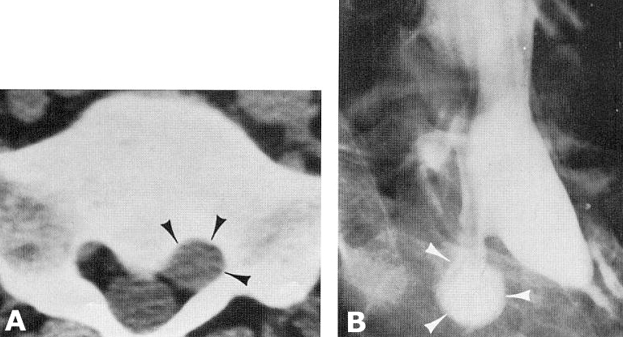

T2-MR demonstrating growth of a Tarlov cyst:



**Type III - intradural meningeal cysts** (s. **arachnoid cysts**) - intradural arachnoid diverticula.

1. usually ***congenital*** arachnoidal duplications
2. ***result of scarring*** induced by surgery, trauma, subdural hematoma, or infection.

* may or may not show persistent communication with subarachnoid space.
* asymptomatic, but cord or nerve root compression can occur (cyst aspiration → dramatic improvement).
* do not to overdiagnose intradural arachnoid cysts in *thoracic region*:
  + retromedullary subarachnoid space in thoracic spine is commonly wide, and partly loculated by usually incomplete septae;
  + spinal cord usually is closely applied to anterior margin of bony canal, and may have flattened appearance over exaggerated kyphosis.

Bibliography for ch. “Developmental Anomalies” → follow this [link >>](http://www.neurosurgeryresident.net/Dev.%20Developmental%20anomalies\Dev.%20Bibliography.pdf)

[Viktor’s Notes℠ for the Neurosurgery Resident](http://www.neurosurgeryresident.net/)

[Please visit website at www.NeurosurgeryResident.net](http://www.neurosurgeryresident.net)