Multiple Subpial Transections (MST)

Last updated: September 9, 2021

– developed for epileptogenic zone involving eloquent cortex

* special indication - **Landau-Kleffner syndrome**, EPC in **Rasmussen’s encephalitis**.
* seizure propagation occurs along long axis of gyri.
* nonresective surgical technique - ***horizontal*** *intracortical association fibers* (important for intracortical seizure propagation) are interrupted at 5-mm intervals; ***vertically*** *oriented projection fibers – columnar organization* (important for function) and pial nutrient vessels remain intact - ideal for treating epileptogenesis while preserving intrinsic cortical function!
* permanently disrupts side-to-side intracortical synchronizing neural networks and excitatory interneuronal conduction.
* because neocortex is organized in functional columnar units, cuts perpendicular to pial surface do not disrupt cortex-subcortical input-output interactions.
* cortical redundancy allows to sacrifice 20% of neurons without affecting function.

History

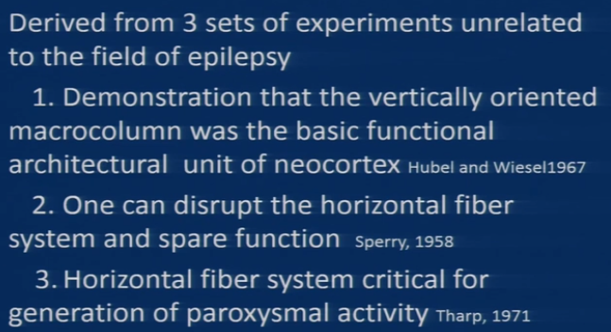

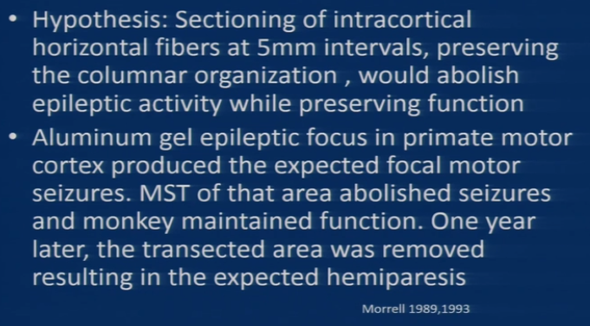

Procedure

* as with all surgery for partial epilepsy, margins of epileptic focus must be defined clearly (using ***subdural grid electrode***).
* most cases involve *junction of central sulcus with Sylvian fissure*.
* entire region of ictal onset should undergo MST + 1-2 cm bordering ictal zone.
* **specially designed MST knife** ([AD-TECH](http://www.adtechmedical.com/multiple-subpial-transectors/), Racine, Wis) with point angled downwards rather than upwards as originally described:
* two different 0.55 mm diameter tip styles (dull & sharp).
* bent distal portion of all tips is 5 mm long

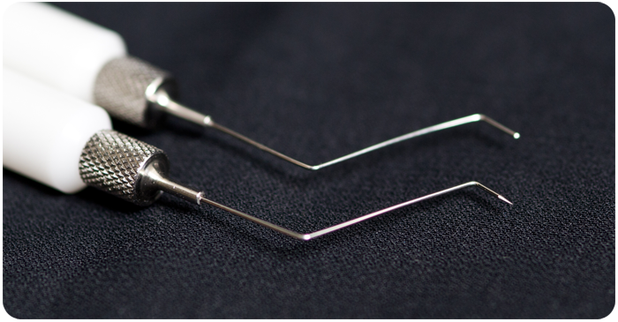

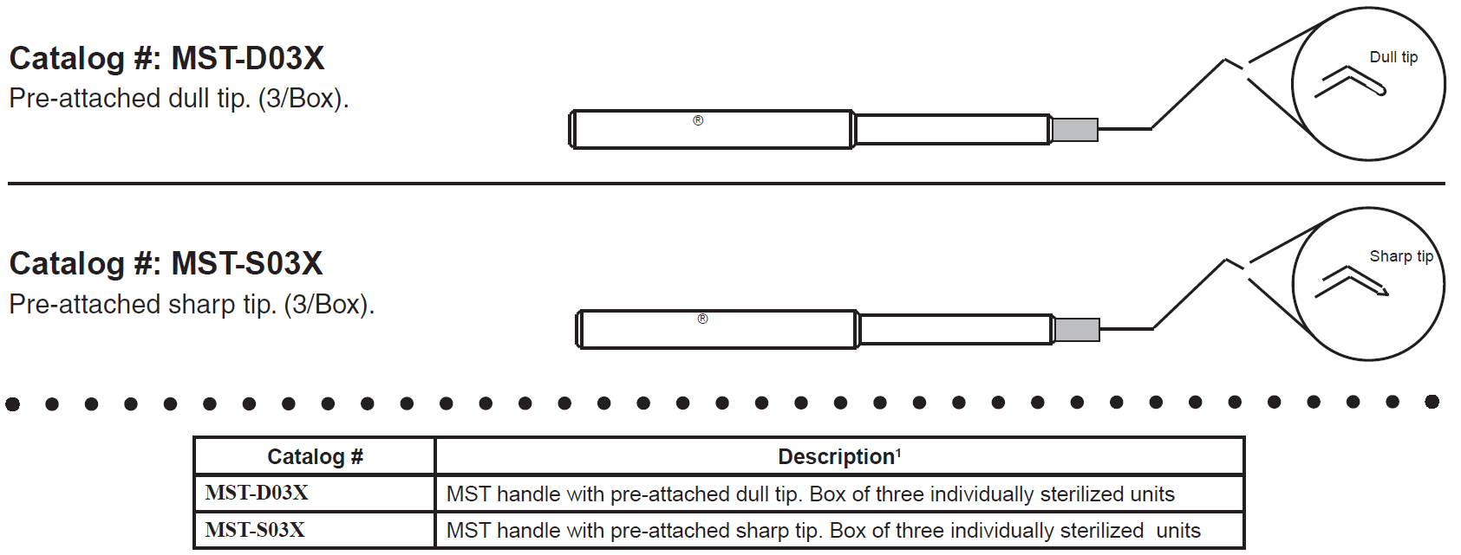

* cutting portion of knife is sharpened to blade - to minimize excessive damage from using blunt instruments such as right-angled dissector.
* actual cuts should be performed ***under direct vision through operating microscope***.
* after protecting surrounding cortex with cotton patties, insertion point can be either at side or at crest of gyrus.
* after small pial spot is cauterized, knife blade is inserted and pushed subpially towards gyrus edge, making right-angled cut to long-axis of gyrus.
* cortex on average is 5 mm thick.
* horizontal arm to blade should be barely visible through pia at all times. If insertion point is centered in gyrus, then, after first half-cut, instrument is removed and replaced and remainder of slice is completed.
* parallel cuts then are made 4-5 mm apart until entire proposed ictal zone and surrounding area have been sliced (may monitor with intraop ECoG).
* it is expected to see ***capillary pial bleed*** – guides where next transection should be; at the end gyrus look striped.

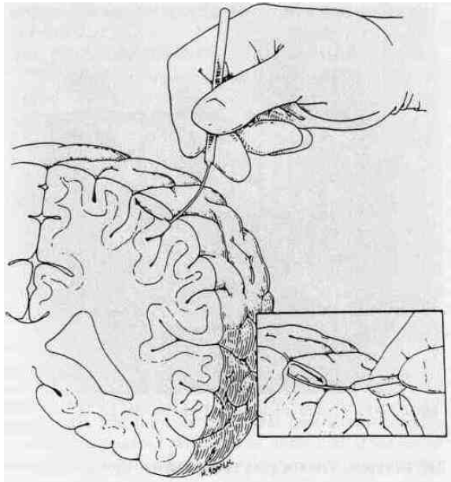

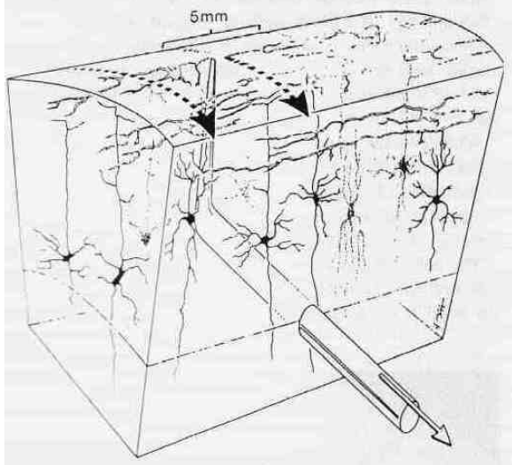

* take care when encountering *gyrus curves* (outer length of curve is much longer than inner length – use staggering cut lengths so that slices converging at center of curve do not all join at common point or come so close together as to severely damage cortex).
* *pial bleeding* at blade insertion point usually is controlled with bipolar cautery or small square of thrombin-soaked Gelfoam; significant subpial hemorrhage should not occur.

Complications

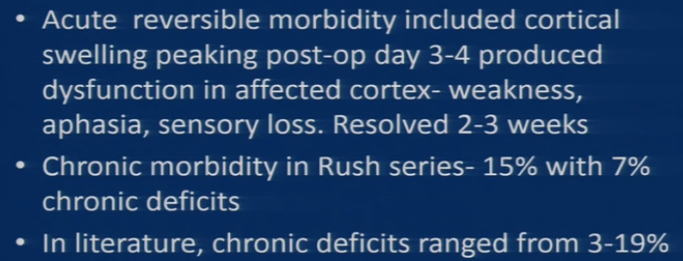

Outcome

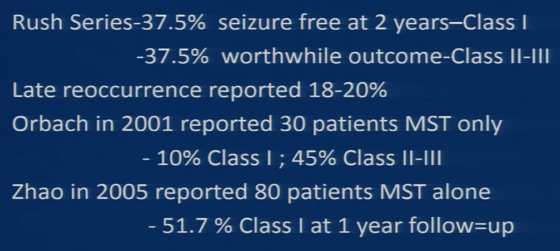

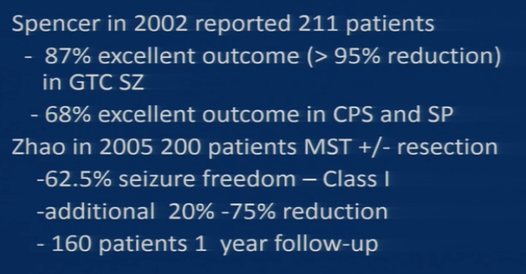

Bibliography for ch. “Epilepsy and Seizures” → follow this [link](http://www.neurosurgeryresident.net/E.%20Epilepsy%20and%20Seizures\E.%20Bibliography.pdf)

[Viktor’s Notes℠ for the Neurosurgery Resident](http://www.neurosurgeryresident.net/)

[Please visit website at www.NeurosurgeryResident.net](http://www.neurosurgeryresident.net)