Hemispherectomy

Last updated: February 8, 2023

Anatomical hemispherectomy 1

Indications 1

Counselling 2

Timing of Surgery 2

Work up 2

Procedure 2

Positioning 2

Incision 3

Functional hemispherectomy 3

Indication 4

Outcomes 4

Technique 4

hemispherectomy, to functional hemispherectomy, to hemispherotomy, which is the latest development

in disconnective surgeries and represents a less invasive microsurgical procedure to disconnect the cortex of the affected hemisphere.

Anatomical hemispherectomy

- entire hemisphere, excluding *basal ganglia*\*, anatomically removed from cranium → potentially lethal **hydrocephalus** and progressive **superficial cerebral hemosiderosis**.

*so more accurate term is *hemicorticectomy*

**superficial cerebral hemosiderosis**

* unique complication to anatomic hemispherectomy - occurs in 16-25% cases.
* gradual but devastating neurologic deterioration beginning years after surgical procedure and eventually resulting in death.
* pathology - hemorrhagic subdural membrane within resected cavity, granular ependymitis along ventricular walls (granulomatous membrane indistinguishable from that of chronic subdural hematoma), and superficial hemosiderosis of remaining brain and cranial nerves.
* contralateral foramen of Monro or aqueduct of Sylvius becomes occluded → hydrocephalus leading to herniation and death.
* first introduced by Dandy in 1923 for malignant glioma.

Indications

1. hemimegalencephaly
2. diffuse malformations of cortical development
3. reoperation after other disconnective hemispherectomy techniques have failed (anatomical HE has success rate of 50% after functional HE has failed).

* anatomic removal of the affected tissue is preferred over disconnection to help ensure seizure activity ceases completely.
* ideal candidate has a contralateral hemiparesis and hemianopsia without fine finger movements.

Counselling

* parents need to be counseled about the presence of a contralateral hemianopsia postoperatively - will preclude driving later in life.
* although not an absolute contraindication, the evidence of independent bilateral hemispheric ictal patterns may influence postoperative seizure outcome and parents should be counseled appropriately.

Timing of Surgery

* earlier intervention maximizes chances for neurodevelopment.
* risks (blood loss, hypothermia) are higher in younger patients.
* body weight of 10 kg is acceptable to undergo the procedure.
  + all patients and families are asked to donate red blood cells and plasma before operation.
* for the patient with catastrophic hemispheric epilepsy, surgery is performed earlier with informed consent on the risks of excessive blood loss and mortality.

Work up

* **WADA test** may be of use in older patients who may not experience language transfer after dominant hemispherectomy.

Procedure

* preop steroids.
* electrocorticography and cortical stimulation are not routinely used.
* two reports from German group of preoperative embolization to minimize blood loss.

Positioning

* head is positioned with a 90 degree lateral turn with ipsilateral shoulder support.
* head is elevated above the level of the heart to assist with venous return and reduce risk of bleeding.
* vertex is slightly down to allow access to the mesial temporal lobe and interhemispheric fissure.

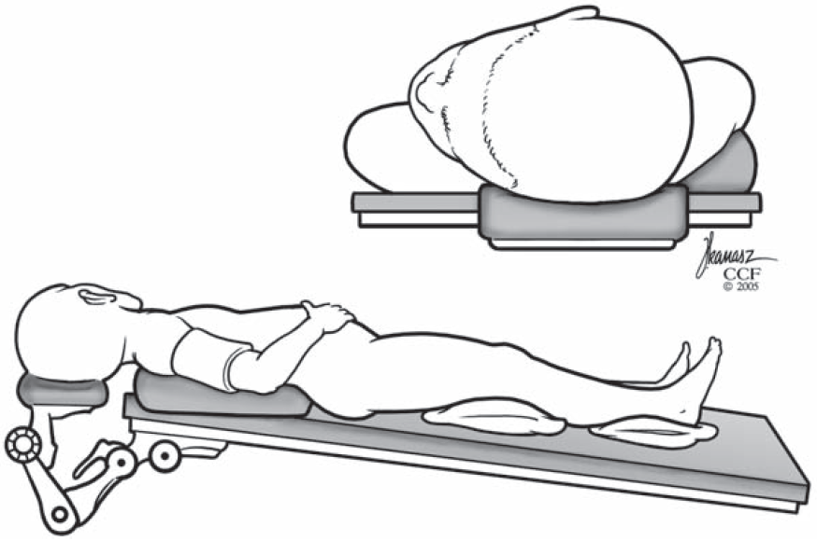

Source of picture: Starr, Barbaro, Larson “Neurosurgical Operative Atlas - Functional Neurosurgery” 2nd ed (2009); Publisher: Thieme (1899); ASIN: B01FJ0ZZN2 [>>](https://www.amazon.com/Functional-Neurosurgery-Neurosurgical-Operative-2008-11-11/dp/B01FJ0ZZN2)

Incision

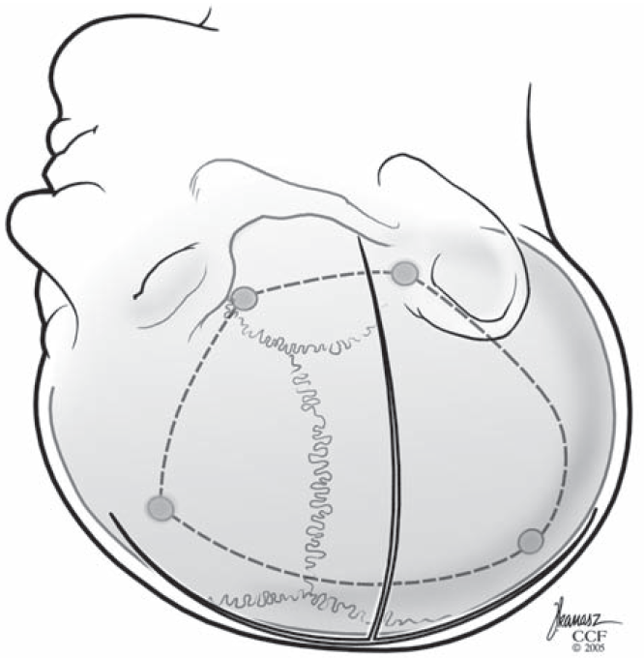

Source of picture: Starr, Barbaro, Larson “Neurosurgical Operative Atlas - Functional Neurosurgery” 2nd ed (2009); Publisher: Thieme (1899); ASIN: B01FJ0ZZN2 [>>](https://www.amazon.com/Functional-Neurosurgery-Neurosurgical-Operative-2008-11-11/dp/B01FJ0ZZN2)

Functional hemispherectomy

- combination of ablation and disconnection:

1. removal of *sensorimotor cortex* and *temporal lobe*.
2. *frontal lobe* and *parieto-occipital lobes* are left intact but are disconnected from cortical and subcortical structures (interhemispheric commissures are divided).

Indication

- severely incapacitating unilateral seizures (when foci cannot be iso­lated) associated with permanent hemiplegia (with useless hand), hemisensory loss, hemianopia, hemiatrophy; i.e. intractable partial and secondarily generalized seizures when entire hemisphere is considered epileptogenic with little or no remaining functional cortex.

* ***special indications*** - infantile hemiplegia syndromes, Rasmussen's encephalitis, Sturge-Weber syndrome, hemimegalencephaly, large hemispheric infarctions.

Outcomes

* results in seizure control are comparable to anatomic hemispherectomy.
* function also improves (seizures may have caused functional impairment).
* 84% seizure freedom (Engel IA) at 6 months, 76% at 2 years, and 76% at 5 years and beyond.

Robert A. McGovern et al. Hemispherectomy in adults and adolescents: Seizure and functional outcomes in 47 patients. Epilepsia Nov 2019

* + postoperative seizures and contralateral interictal spikes at 6‐month follow‐up EEG were associated with seizure recurrence.
  + patients who could walk unaided preoperatively and had no cerebral peduncle atrophy on MRI were more likely to experience worsening of motor function postoperatively.

Technique

<http://www.neurosurgicalatlas.com/grand-rounds/hemispherotomy-techniques-pearls-and-pitfalls>

Schematic view of functional hemispherectomy:

**A**. Shaded area - cortical resection in central region, cross-hatched area - temporal lobe resection.

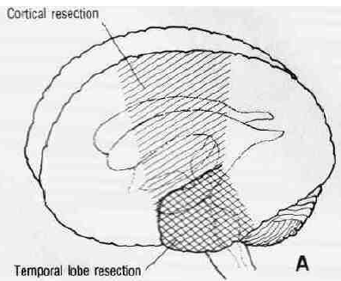

[Source of picture: Marshall B. Allen, Ross H. Miller “Essentials of Neurosurgery: a guide to clinical practice”, 1995; McGraw-Hill, Inc.; ISBN-13: 978-0070011168 >>](http://www.amazon.com/gp/product/0070011168)

**B**.Incisions in corpus callosum and deep projection fibers in white matter disconnecting remaining frontal and occipital lobes.

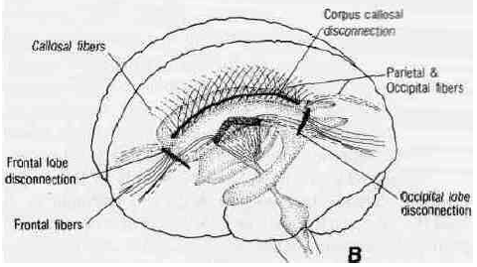

[Source of picture: Marshall B. Allen, Ross H. Miller “Essentials of Neurosurgery: a guide to clinical practice”, 1995; McGraw-Hill, Inc.; ISBN-13: 978-0070011168 >>](http://www.amazon.com/gp/product/0070011168)

* resection of central cortex is followed by temporal lobectomy.
* blood supply to basal ganglia and frontal and occipital lobes is preserved.
* after sectioning corpus callosum, projection fibers to frontal and occipital lobes are divided, isolating these struc­tures but leaving them in place.
* degree of resection or isolation may be modified to adjust to presenting pathological and electrocorticographic changes and function to be preserved.

MRI following functional hemispherectomy - note ablated area and disconnection incisions:



[Source of picture: Marshall B. Allen, Ross H. Miller “Essentials of Neurosurgery: a guide to clinical practice”, 1995; McGraw-Hill, Inc.; ISBN-13: 978-0070011168 >>](http://www.amazon.com/gp/product/0070011168)

Bibliography for ch. “Epilepsy and Seizures” → follow this [link](http://www.neurosurgeryresident.net/E.%20Epilepsy%20and%20Seizures\E.%20Bibliography.pdf)

[Viktor’s Notes℠ for the Neurosurgery Resident](http://www.neurosurgeryresident.net/)

[Please visit website at www.NeurosurgeryResident.net](http://www.neurosurgeryresident.net)