Corpus Callosotomy

Last updated: September 9, 2021

History 1

Extent of procedure 1

Indications 2

Preoperative tests 2

Procedure 2

Anesthesia 2

Position 2

Incision & dissection 3

Callosotomy 3

End of procedure 5

Postoperative care 5

Complications 6

Outcomes 7

Modifications 7

Endoscopic-Assisted Corpus Callosotomy combined with Anterior, Hippocampal, and Posterior Commissurotomy 7

LITT callosotomy 7

**Anatomy, physiology of corpus callosum** – see [p. A143 >>](http://www.neurosurgeryresident.net/A.%2520Neuroscience%2520Basics\A143.%2520Cerebrum%2520(white%2520matter)\A143.%2520White%2520Matter%2520Tracts%2520(cerebrum).pdf)

Reading

M.S. Park, E. Nakagawa, M.R. Schoenberg, S.R. Benbadis, F.L. Vale. Outcome of corpus callosotomy in adults. Epilepsy Behav, 28 (2) (2013), pp. 181-184

History

* first reported in 1939 (Van Wagenen and Herron), refined by Wilson in 1970s.
* formerly, various additional structures were sectioned - anterior commissure, hippocampal commissure, massa intermedia, unilateral fornix.
* in recent years, only corpus callosum has been sectioned.

Extent of procedure

* extent of sectioning necessary for ***maximum seizure control*** with ***minimum risk of disconnection syndrome*** (mutism, left-sided apraxia resembling hemiparesis, bilateral frontal lobe reflexes) is not known.
* best seizure results come from complete callosal section.

**80-90% section** sparing *splenium* seems to be optimal.

* advisable to perform in two stages (anterior-posterior) - avoids acute prolonged apathy and confusion seen after complete division in single stage

1. First stage resects **anterior 2/3** of corpus callosum.
2. If necessary, **complete** callosotomy is performed at second stage (↑risk of disconnection syndrome)

Indications

* rarely performed today (replaced by **vagus nerve stimulation**; in the past, Corpus Callosotomy was the only applicable surgery for **generalized seizures**).
* no clearly defined indications - medically refractory primarily and secondarily generalized seizures (esp. Lennox-Gastaut syndrome*).

*treatment of choice for Lennox-Gastaut syndrome is vagal nerve stimulator

* **atonic seizures (drop attacks)**\* are helped most significantly, but having atonic seizures does not guarantee benefit from surgery (seizures still occur as partial seizures, but they do not result in falls). *frequent facial and neck injuries due to fall
* **complex partial seizures** can be reduced in ≈ 50% patients, but exacerbated in ≈ 25%.
* *mentally handicapped patients* fare less favorably.
* aim is to reduce seizure frequency (vs. resective surgery – to achieve seizure-free outcome); additional goals of social or vocational rehabilitation are not realistic expectations.

N.B. callosotomy disrupts EEG bilateral synchrony but does not eliminate epileptiform discharges!

Preoperative tests

1. **tests for interhemispheric transfer** (incl. cross-retrieval and naming of objects, cross-replication of hand postures, cross-localization of fingertips); routine extensive neuropsychological testing is not required.
2. **Wada testing** - if ***mixed cerebral dominance*** for handedness and language exists (e.g. right-handed person with right-hemisphere language dominance) - risk for *postcallosotomy language impairments*.
3. selec­tive **visual field testing**.
4. coronal **MRI** – may find *singular (s. simian) pericallosal artery*.

Procedure

* now can be done with laser ablation.

Anesthesia

* most dangerous complication is **air embolism** (from tear in superior sagittal sinus).
* **bleeding** from sagittal sinus can be extensive, with significant blood volume loss accumulating rapidly (one policy is not to begin surgery without transfusable blood in operating room for pediatric cases).
* patients undergoing callosotomy with narcotic anesthesia often are slow to arouse immediately after surgery and therefore are difficult to evaluate neurologically (thus, some have abandoned narcotic anesthesia in favor of **inhalation agents**).
* ***lumbar drain*** can be placed - to allow CSF drainage for improved exposure until callosum is sectioned.

Position

1. **supine position** (favored by most surgeons) - necessitates frontal lobe retraction.
2. **lateral decubitus position** with side for craniotomy dependent ("hanging hemisphere" approach) - to allow gravity to pull dependent hemisphere gently away from falx; it may be necessary to support superior hemisphere by retractors when falx does not extend far inferiorly be­tween hemispheres.

* Mayfield frame, neck secured in neutral position.
* operating table is tilted at head up incline of 15°.

Incision & dissection

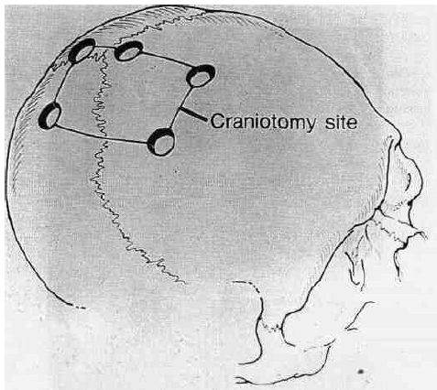

* **rectilinear vertex scalp incision** is centered over junction of coronal and sagittal sutures.
* in intact patients with dominant left hemisphere, approach is from right, but if there is evidence of damage to left hemi­sphere or if cortical vein position interferes with approach from right, approach from left is preferred.
* 4-hole **bone flap** is elevated.
* alternative – **bifrontal craniotomy**.
* from this point, ***operating microscope*** is used; to provide superior stability, may operate while seated, using sterile draped Mayo stand for elbow support.
* **dura** over dependent hemisphere is opened to edge of sagittal sinus. The dural flap is pulled tight with retention sutures to provide maximum exposure of interhemispheric fissure.
* problem where falx ends – sometimes cingulate gyri are adherent – dissect meticulously (esp. vessels) – ***lysis of midline adhesions*** between arachnoid and dura is performed using bipolar cautery.
* attempt to preserve *bridging veins*, but 1 or 2 veins (anterior to coronal suture) can be sacrificed, if necessary.
* moist cottonoid strips are placed over medial frontal cortex of dependent frontal lobe, and any additional adhesions between cortex and falx are cut with bipolar cautery.
* dissection is carried down to corpus callosum, which is identified only after clear visualization of both *pericallosal arteries* (without this verification, inexperienced surgeon may mistake cingulate gyrus for callosum).

Callosotomy

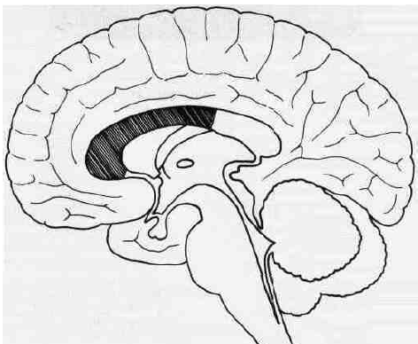

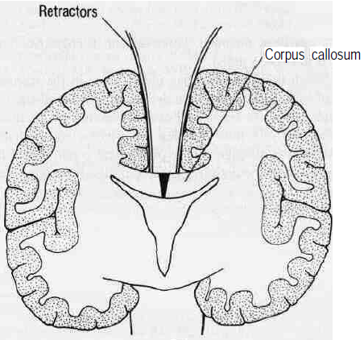

* after both *pericallosal arteries* are separated and protected and callosum has been exposed (white structure), callosum is opened along midline of body by semisharp dissector or by suction.
* incision is carried deep until cavum septum pellucidum is entered, leaving ventricular ependyma intact.
* in rare instances, one major pericallosal artery supplies both hemispheres and makes dissection more difficult because artery must be manipulated from side to side without damaging branches to either hemisphere.
* **bipolar cautery & suction** are used to cut callosum.
* care is taken to stay within cavum septum pellucidum and avoid entry into ventricle (→ chemical meningitis that might be fatal)
* entire rostrum, genu, and body are divided, and dissection is carried posteriorly until ***only splenium remains intact***; MRI-compatible clip may be applied at posterior extent of section for reference.
* no need to section anterior commissure.
* some advocate sectioning CC with intraoperative EEG until typical bisynchronous discharges become asynchronous.
* if second stage is required, craniotomy is performed using more posterior bone flap, and remain­ing corpus callosum is sectioned; extent of section may be recorded by MRI after each stage.

End of procedure

* lumbar drain is removed.
* wound is irrigated generously to replace most of drained CSF.
* dura is closed, dural tack-up sutures secured, and craniotomy closed in layers.

Postoperative care

* patient needs to be watched particularly closely for first 24 hours - neurologic parameters may fluctuate and be complicated by disconnection syndrome.
* patient may not verbalize readily or respond quickly and may have unexplained pupillary inequality (CT scan can rule out clot or tension pneumocephalus).
* by POD#2, normal baseline neurological status should begin to return.
* patient is maintained on same anticonvulsant regimen as before surgery (seizures may increase transiently during postoperative first week).
* MRI - evaluate extent of sectioning:

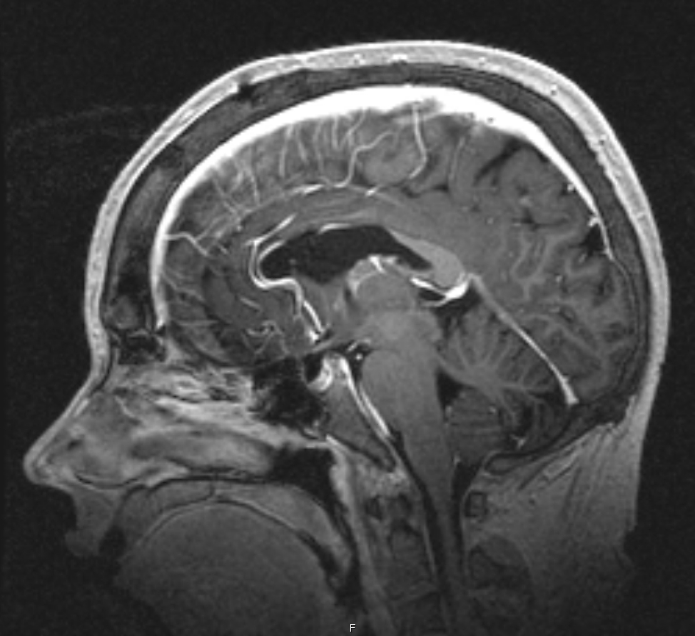

[Source of picture: Viktoras Palys, MD >>](mailto:vpalys@uams.edu)

Complications

* 1. **air embolism**, **excessive bleeding** from superior sagittal sinus
  2. **frontal lobe edema**
  3. **hydrocephalus** and **aseptic meningitis** (up to 50% in early series) - partly due to opening ependyma into ventricles; can be minimized by entering only cavum septum pellucidum.
  4. **venous infarction** (from sacrificing major bridging veins).
  5. transient left-sided **hemiparesis** (lateral decubitus positioning may eliminate much of this problem).
  6. temporary **bladder incontinence** (damage to cingulate gyrus).
  7. **disconnection phe­nomena (split brain)**: lethargy, transient mutism, apathy, confusion, left tactile anomia, ideomotor apraxia of nondominant hand, impaired spatial synthesis of right hand resulting in difficulty copying complex figures, incontinence.
     + may be observed for 3-4 days.
     + patients usually adapt after 2-3 months, with final function normal for most daily activities (deficits may show up on neuropsychological testing); long-term sequelae with anterior corpus callosotomy are extremely rare but reported.
     + in past, when complete callosotomy was done in single stage, disconnection phenomena were prolonged.
     + some experts state, even in complete callosotomies, syndrome may be mild in some patients.
     + *intermanual conflict* *(“alien hand” syndrome)* following complete corpus callosotomy may be incapacitating and prolonged
     + *persistent se­vere aphasia* have been reported with partial and total corpus callosotomies in right-handed patients with language func­tion located in right hemisphere ("crossed dominance") - Wada test is recommended in all left-handed patients.
  8. **increase in aggressive outbursts** in some children with mental handicaps (some patients are more alert and more aware of their surroundings after surgery and, hence, may be frustrated more easily).

Outcomes

* ***bilateral synchronous discharges*** – abolished in 50% patients after anterior callosotomy.
* anterior 2/3 CC gives 58% seizure freedom (adding splenium – gives additional 10%); other data shows only 2-5% seizure freedom.
* CC is effective for both drop seizures and other generalizing epilepsy types;

Drop seizures – 60-100% responder rate (> 50% seizure reduction)

GTC – 21-67% responder rate (> 50% seizure reduction)

* earlier age at surgery - lower risk and better outcome (younger age at surgery correlates with better seizure outcomes).
* corpus callosum also has inhibitory tracts – partial seizures may worsen postop.

Modifications

Endoscopic-Assisted Corpus Callosotomy combined with Anterior, Hippocampal, and Posterior Commissurotomy

* through a mini craniotomy.

Chandra, Sarat P. Endoscopic-Assisted (Through a Mini Craniotomy) Corpus Callosotomy Combined With Anterior, Hippocampal, and Posterior Commissurotomy in Lennox-Gastaut Syndrome: A Pilot Study to Establish Its Safety and Efficacy. Neurosurgery: [May 2016 - Volume 78 - Issue 5 - p 743–751](http://journals.lww.com/neurosurgery/toc/2016/05000)

Results in 16 patients with Lennox-Gastaut syndrome (drop attacks) with moderate to severe mental retardation

Chandra, P. Sarat MCh*; Kurwale, Nilesh MCh*; Garg, Ajay MD‡; Dwivedi, Rekha MPhil*; Malviya, Shri Vidya MPhil, PhD*; Tripathi, Manjari DM “Endoscopy-Assisted Interhemispheric Transcallosal Hemispherotomy: Preliminary Description of a Novel Technique” Neurosurgery April 2015 - Volume 76 - Issue 4 - p 485–495

LITT callosotomy

* usually need 3 laser trajectories (consider treating in stages because brain shifts).
* if CC is not very curved, all LITT trajectories could be done from one posterior entry bur hole (using robot)
* do on one (nondominant) side and ablate full thickness of CC.
* given that reoperation and dissection of a scarred interhemispheric fissure is technically challenging and associated with a higher risk of surgical complications, LITT is especially useful in failed anterior 2/3 CC.

2 laser fiber trajectory technique to an anterior laser corpus callosotomy. **A**, Frontal entry targeting the rostrum and genu. **B**, Parietal entry targeting the body and remaining genu:

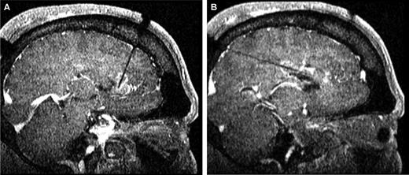

Bibliography for ch. “Epilepsy and Seizures” → follow this [link](http://www.neurosurgeryresident.net/E.%20Epilepsy%20and%20Seizures\E.%20Bibliography.pdf)

[Viktor’s Notes℠ for the Neurosurgery Resident](http://www.neurosurgeryresident.net/)

[Please visit website at www.NeurosurgeryResident.net](http://www.neurosurgeryresident.net)