Status Epilepticus (SE)

Last updated: February 8, 2023

Definitions 1

Seizure cluster (s. acute repetitive seizures crescendo seizures, seizure flurries) 1

Status Epilepticus (SE) 1

Refractory SE 2

Super-refractory SE 2

Epidemiology 3

Etiology 3

Adults 3

Children 3

Pathology 3

Classification & Clinical Features 4

Differential Diagnosis 5

Management 6

First Aid 6

Treatment for convulsive SE 6

1st line medications 8

2nd line medications 9

Treatment for nonconvulsive SE 14

Management following status epilepticus 15

Prognosis 15

Special types 16

Febrile status epilepticus 16

New-onset refractory status epilepticus (NORSE), Febrile infection–related epilepsy syndrome (FIRES) 17

Pyridoxine-dependent, pyridoxine-responsive epilepsies 18

Definitions

Seizure cluster (s. acute repetitive seizures crescendo seizures, seizure flurries)

– acute episode of consecutive seizures that occur within a short period of time with a patient regaining consciousness during the interictal period.

* clusters are distinct from a person’s typical seizure pattern.
* when left untreated, can progress to status epilepticus.

Status Epilepticus (SE)

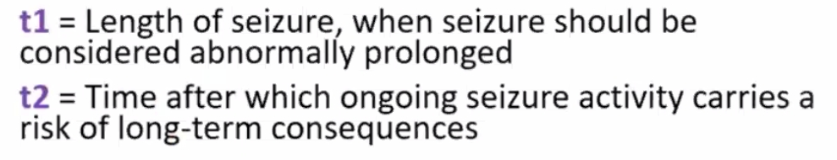

t1 – time when seizure will likely be prolonged (time to initiate treatment)

t2 – time when seizures likely will leave long-term consequences (i.e. brief seizures probably are not harmful)

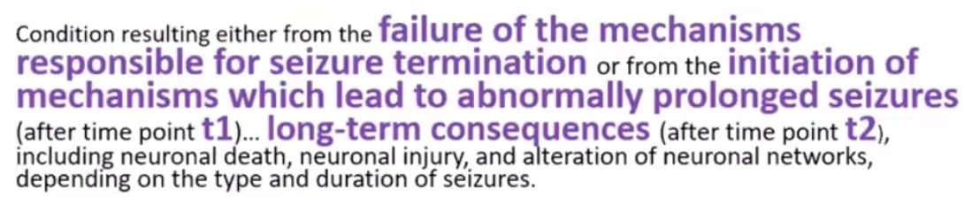

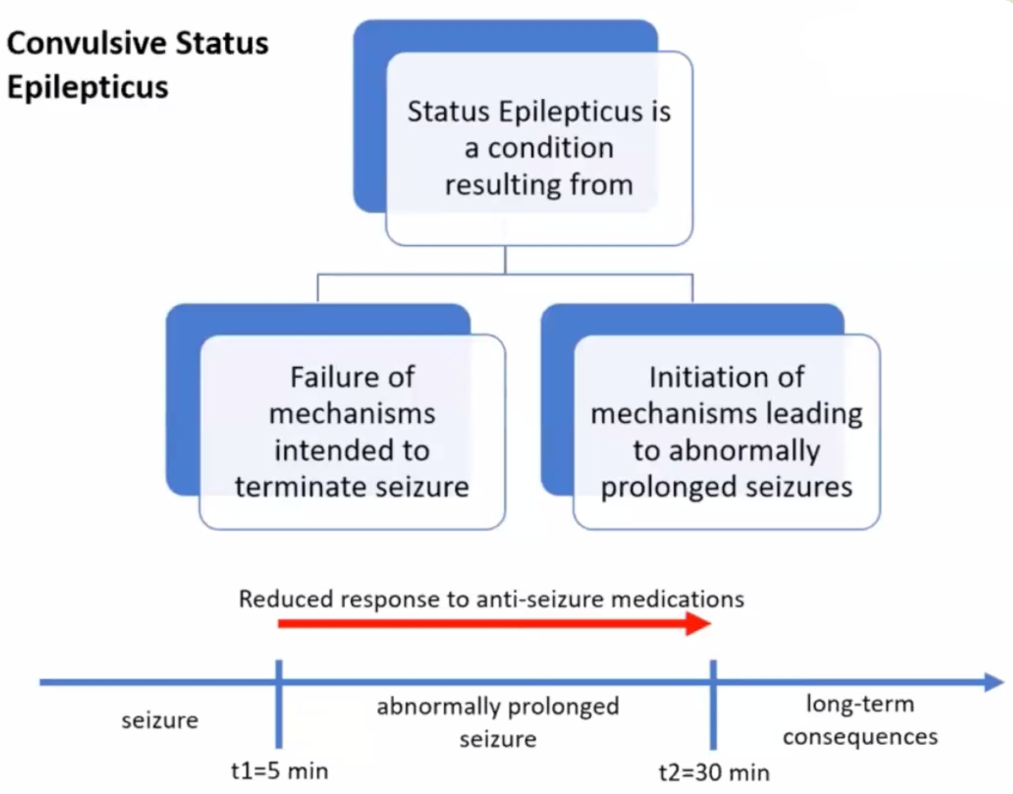

SE is failure of inhibitory mechanisms (thus, not every seizure proceeds to status); clustering - partial failure of inhibitory mechanisms.

**2015 ILAE task force definition** (t1 and t2 are different for different seizure types):

1. seizure lasting **> 5 min** for generalized tonic-clonic seizures (t2 = 30 mins)
2. seizure lasting **> 10 min** for focal seizures (t2 = 30-60 mins)
3. seizure lasting **> 10-15 min** for absence seizures (t2 unknown)

Other definitions:

1. persistent seizure activity after sequential administration of appropriate **first and second-line AEDs**
2. **continuous** seizure activity (clinical or electrical) ≥ 30 min.
3. **repetitive** seizures with incomplete neurological recovery interictally for period ≥ 30 min.

Refractory SE

(present in up to 23-43% patients) – if seizures continue beyond t2 despite two AEDs (1st and 2nd tier medications) after 30 minutes (for generalized seizures) or 60 minutes (for focal seizures) - mortality 17-39%.

Super-refractory SE

– if SE continues or recurs 24 hours after onset of anesthetic therapy or at withdrawal.

Epidemiology

* incidence - 15-20 cases per 100,000 people.
* most cases (70%) occur in young children (among children, 73% are < 5 yrs old)
* next most affected group is patients > 60 yrs age.

Etiology

1. **Acute CNS insults** (50%) - anoxia, head injury, stroke, neoplasm, infection, ethanol withdrawal or intoxication (!!!).
2. **Therapy related** (20%) - medication adjustments, ***noncompliance*** (most common cause in pre-known epileptic patients! esp. with abrupt phenobarbital withdrawal), intercurrent illness (preventing PO intake of meds), drug-drug interactions (lowering effectiveness of AEDs)
3. **Undetermined cause** (30%); may be as first manifestation of idiopathic epilepsy.

* in > 50% of cases, SE is **patient's first seizure** (i.e. > 50% SE patients do not have history of epilepsy); 1 out of 6 patients presenting with first time seizure will present in SE.
* 5-15% epileptic patients have had one or more SE episodes at some time.

Adults

* most common cause - subtherapeutic AED levels in patient with known seizure disorder.
* cerebrovascular disease predominates (25%) in older adults
* structural lesion is more likely than in pediatric subgroup.

Children

* in children < 1 yr age, 28% are secondary to CNS infection, 30% due to electrolyte disorders, 19% associated with fever.

***Fever & infection*** are most common precipitants in children!

Pathology

* in animals, neurons begin to die *after 20-60 minutes of continuous discharging* (precise time period in humans is unknown but irreversible changes begin to appear in neurons after as little as 20 minutes of convulsive activity; cell death is very common after 60 mins)
  + mean duration of SE in patients without neurologic sequelae is 1.5 hrs.
* significant increases in cerebral blood flow and metabolic rate during SE.
* neuron death may result from:

1. metabolic ***exhaustion***
2. damage by ***excitatory neurotransmitters***

* most vulnerable areas - hippocampus, amygdala, cerebellum, middle cortical areas, thalamus.
* acute macroscopic changes - venous congestion, small petechial hemorrhages, edema.
* microscopic changes: ischemic cellular changes → microglial proliferation, neuronophagia → cell loss → increased numbers of reactive astrocytes.

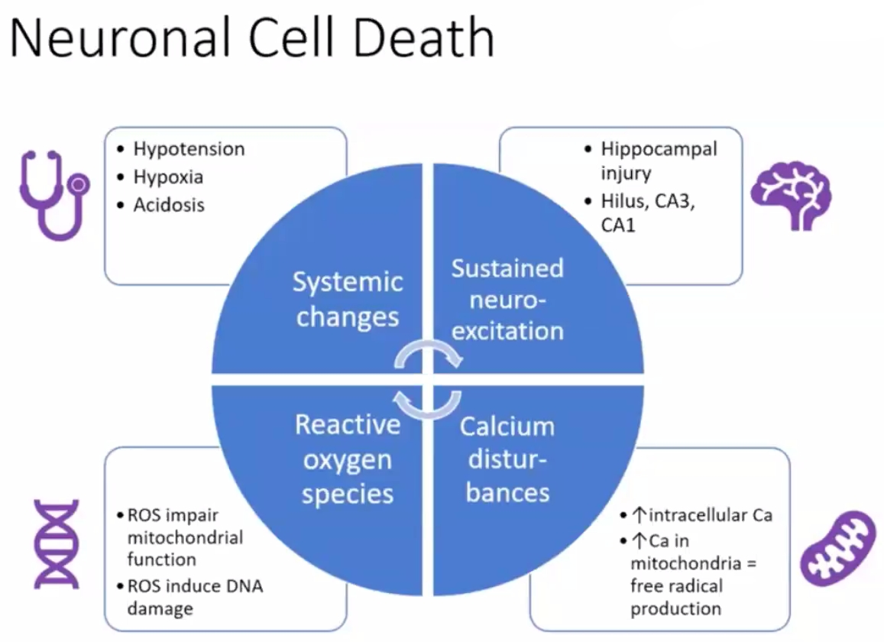

Classification & Clinical Features

1. **generalized** or **partial**
2. **convulsive** or **nonconvulsive**.

**Generalized convulsive SE (GCSE)** - convulsive activity accompanied by coma and epileptiform activity on EEG (EEG is not required for diagnosis):

*Most frequent (75%) and most dangerous type of SE!*

* 1. **tonic-clonic**
  2. **tonic**
  3. **clonic**
  4. **myoclonic**

**Nonconvulsive SE** (clouding* of consciousness ± minor motor manifestations; i.e. abrupt-onset sustained confusional-delirious state):

*not complete loss (so sometimes called "twilight" form of SE)

1. **absence** **SE** (75% patients < 20 yrs; most other – older adults) - usually presents as one continuous episode (twilight state).
2. **complex partial** **SE** - usually recurring cycles of 2 distinctly separate phases (ictal and interictal).

N.B. patients can appear totally functional - clinical picture may be so subtle that only recognizable to friends and family!

* if patient is comatose, it most likely represents “burned-out” GCSE (i.e. subtle SE).
* **EEG is required** for diagnosis (and to distinguish two types):

absence SE – continuous 1-2.5 Hz generalized spike-wave activity ("spike-wave stupor");

complex partial SE - ictal activity is localized (usually to frontal or temporal lobes).

**Simple partial SE** – rare; diagnosis clinical (EEG frequently negative).

* + clonic simple partial SE is called ***epilepsia partialis continua (EPC)***. [see p. E9 >>](http://www.neurosurgeryresident.net/E.%20Epilepsy%20and%20Seizures\E9.%20Epileptic%20Syndromes.pdf)

GCSE manifestations change over time - paradoxical evolution of apparent clinical improvement (inexperienced clinician may stop treatment because of apparent improvement):

* SE begins with series of generalized tonic, clonic, or tonic-clonic seizures (**overt SE**);
  + each seizure is discreet; motor activity stops abruptly, coincident with end of electrographic seizure.
  + each convulsion is followed by gradual recovery, and then next seizure occurs.
* if SE is not treated, discrete convulsions give way to increasingly subtle clinical manifestations (**subtle SE**); e.g. only nystagmoid jerks of eyes or shoulder twitching may be seen.
  + occasionally, subtle SE occurs without prior convulsive activity (e.g. in severe diffuse cerebral dysfunction).
* eventually, coma without motor activity is all that remains, although electrographic seizures persist (**electrical SE**).

N.B. status epilepticus should be suspected in any unexplained coma (e.g. patient stops having overt seizures, yet remains comatose)

Treatment should be continued until ***electrographic seizure activity***\* has resolved completely!

*CNS injury can occur even when patient is paralyzed with neuromuscular blockade but continues to have electrographic seizures.

GCSE produces **systemic effects**:

***Permanent brain damage*** is caused more by *ongoing seizure activity* than by *systemic factors*!

1. **hypoxia**, respiratory and metabolic **acidosis**

* convulsive SE affects mechanical aspects of breathing (respiratory fatigue) + can cause neurogenic pulmonary edema + aspiration.
* medications used for treating SE (esp. benzodiazepines and barbiturates) inhibit respiratory drive.

1. cerebral dysautoregulation, **BP instability** (↑ then ↓)
2. **hyperpyrexia** up to 42°C (motor activity + central sympathetic drive)
3. acute hypercatecholaminemia may trigger fatal cardiac **arrhythmias**.
4. hyperazotemia; hypokalemia; hyponatremia; hyperglycemia → hypoglycemia.
5. **rhabdomyolysis** → myoglobinuria, acute tubular necrosis, renal failure.
6. ↑↑↑ of plasma prolactin, glucagon, growth hormone, ACTH.
7. **leukocytosis** (bands should not be seen in absence of infection); modest **CSF pleocytosis**.

Differential Diagnosis

SE diagnosis depends on demonstrating ictal patterns in EEG!

Neuroimaging has no impact on immediate management until seizures are controlled.

MRI-DWI shows diffusion restriction (up to 3 days after status)

1. **Nonepileptic phenomena** (tremor, myoclonus, eye and oral-buccal movements that follow anoxia, brain stem or bilateral cerebral ischemia, drug overdose, severe metabolic disturbances) - difficult to differentiate clinically from nonconvulsive SE.
2. Prolonged **psychogenic seizures**.

Management

First Aid

Acute life-threatening emergency that demands prompt diagnosis and treatment if severe neurological sequelae (pathologic brain changes) and death are to be minimized!

N.B. ***SE duration*** *is major determinant of morbidity and mortality*!

“Time is brain” - the sooner treatment is initiated, the better the chances of success, and the lower the risk for adverse consequences!

Nasal midazolam (Nayzilam®) - nasal spray CIV, FDA approved for the acute treatment of **seizure clusters** in patients ≥ 12 years. [see p. E3 >>](http://www.neurosurgeryresident.net/E.%20Epilepsy%20and%20Seizures\E3.%20Antiepileptic%20Drugs.pdf#Nayzilam)

* **seizure activity ≥ 5-10 minutes** - treat as status, because most seizures must terminate spontaneously within 1-2 minutes.

If seizure lasts **> 2 minutes**, place *intravenous line* and *draw blood* for tests. If seizure continues **beyond 5 minutes**, begin treatment as status epilepticus with *benzodiazepine*

* ***impending status epilepticus*** - 3 or more TCS within 24-hour period (esp. if this represents increase from typical frequency); H: home treatment with one dose rectal diazepam gel (Diastat®) 10-20 mg (0.05-0.1 mg/kg) should be considered before transfer to ED.

N.B. infusing buccal midazolam into mouth (between gums and cheek) is twice as effective as rectal diazepam!

If seizures continue, EMS can give IV/IM* fosphenytoin

*gets absorbed in 5 mins, therapeutic level in 10 minutes

* admit to ICU, set a clock in motion.
* relapsing seizures in patient with *known seizure disorder* and *subtherapeutic AED* *levels* usually responds to bolus of maintenance AEDs, however, SE still should be treated by standard protocol.

N.B. *use of neuromuscular blockers is inappropriate* (unless needed for intubation – use short acting agent) because they do not stop seizure activity in brain (which is cause of brain damage!).

Treatment for convulsive SE

**STEP 1** (0-5 minutes of seizure) – **ABC** + **Coma** [see p. S30 >>](http://www.neurosurgeryresident.net/S.%20Symptoms,%20Signs,%20Syndromes\S30-34.%20Alterations%20of%20Consciousness,%20Coma,%20Vegetative%20State,%20Brain%20Death\S30.%20Alterations%20in%20Level%20of%20Consciousness,%20Coma.pdf)

* 1. ***ABC*** - secure oral airway (e.g. tongue may cause obstruction in younger patient - place nasopharyngeal airway), prevent aspiration (turn head to side, suction secretions), administer 100% O2 (via properly fitting face mask); intubate if respirations compromised or if seizure persists > 30 min.
  2. ***Monitor*** - ECG, SaO2, vital signs.
  3. ***Blood tests*** - bedside (fingerstick) glucose test; AEDs levels (if indicated), CBC, chemistries (electrolytes, Ca2+, Mg2+, BUN, creatinine, LFT), toxicological screens.
  4. **Establish intravenous line** with normal saline.
  5. Thiamine 50-100 mg IV → dextrose 50% 50 ml IV (D25 2 ml/kg in children).
  6. Search for probable cause of SE (tests should not impede rapid and aggressive treatment!):

1. obtain ***history***
2. perform ***examination***
3. some authors feel that ***EEG monitoring*** should be routine part of treatment; others use EEG only selectively (e.g. when GCSE diagnosis in doubt, assessing treatment adequacy).

In general, EEG has no role in management of GCSE!

1. ***neuroimaging*** should be done in all patients (except children with febrile SE); CT is sufficient to exclude acute brain lesion; MRI should be obtained later if CT was normal.
2. ***lumbar puncture*** is performed in any febrile patient (even if signs of meningitis are not present); if ICP↑ or mass lesion are suspected, antibiotics should be given immediately and CT scan obtained first.

WBC pleocytosis (up to 80) can occur following SE (**benign postictal pleocytosis**), but these patients should be treated with antibiotics until infection is ruled out by negative cultures!

* ***acidosis***should not be treated (acidosis does not correlate with degree of neuronal injury + acidosis is anticonvulsant).
* ***hyperthermia***should be treated aggressively (correlates with poor neurological outcome) - fans and antipyretics.

**STEP 2** (5-20 minutes of seizure) – intravenous **anticonvulsants** (terminate 80-97% cases):

* + continuously monitor for respiratory depression, hypotension, arrhythmias.
  + advanced cardiac life support must be ready!

2016 American Epilepsy Society (AES) guidelines:

Seizure > 5 minutes: IV bolus of *rapid-acting* anticonvulsant:

1. lorazepam 0.1 mg/kg (e.g. patient > 40 kg → 4 mg; if seizures continue after 1 minute wait → given additional doses up to max 9 mg) – **preferred agent**!
2. diazepam 0.1 mg/kg (q5min, up to 10 mg)
3. phenobarbital 20 mg/kg (max 1000 mg) - slower rate of administration, so it is a second choice to benzos
4. IM midazolam 10 mg - first choice **if patient has no IV line**

Seizure > 20 minutes (practically, start at the same time as benzos): → loading dose of *long-acting* anticonvulsant (all equally effective at stopping SE):

1. LEV 60 mg/kg (max 4500 mg)
2. VPA 40 mg/kg (max 3000 mg) – platelet risk, esp. in neurosurgery!
3. fosphenytoin 20 mg PE/kg (max 1500 mg – i.e. 75 kg dose) – proconvulsant if overdosed!

If SE does not stop – it is RSE

N.B. **give full dose at once** (do not break down in small doses to check for response)! – “time is brain and SE is not a benign condition”

* + benzos IV in normal person risks respiratory depression; vs. in patient with status - benzos IV decrease the risk of needing intubation.
* in convulsive RSE, clinicians often add IVI of anesthetizing ASMs (“therapeutic coma”) such as MDZ, pentobarbital (PTB), or propofol (PRO) as third-line therapy – risk of serious adverse effects (3-9 fold relative increased risk of death, 4-fold increased incidence of infection, 7-fold relative increased risk of new disability).
* US Veterans Administration trial: in adults with CSE, first ASM worked in 55.5%, second ASM worked in another 7.0%, and the third ASM worked in only 2.3% of patients.
* in children, the second ASM appears less effective than the first, and there are no data about the third ASM.
* some experts advocate **early** **polytherapy** – to target multiple drivers of SE:

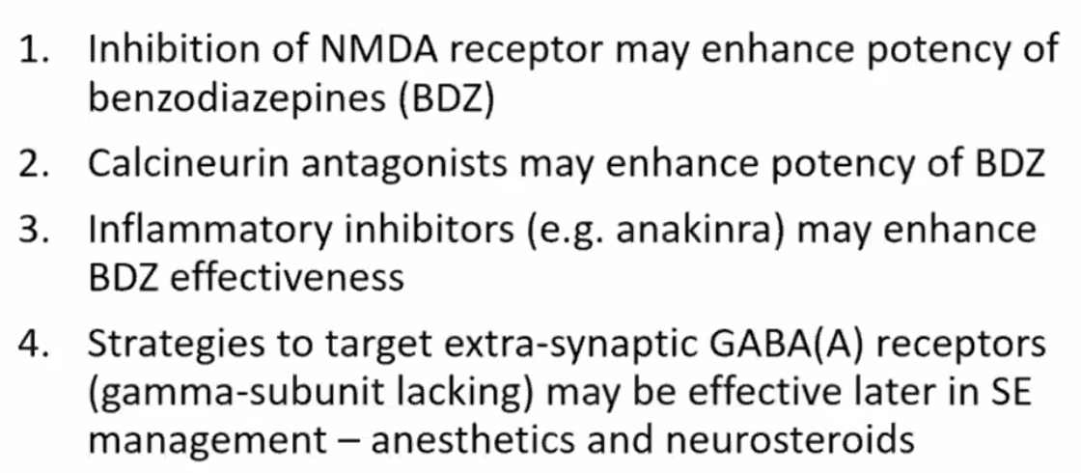

1st line medications

*- rapid-acting* anticonvulsant - benzodiazepine (repeat once after 5 minutes PRN)

1. **lorazepam** – preferred agent (aborts SE in 97% cases, provides coverage for 12 hours)

* 0.1 mg/kg (0.02-0.5 mg/kg in children); in general:

< 40 kg → 2 mg

> 40 kg → 4 mg (or 2+2 mg).

* at < 2 mg/min - less respiratory depression, less fat soluble - slower, but **longer duration of action** – up to 2-3 hours!!!

N.B. even though lorazepam has much shorter T1/2 than diazepam, its effective half-life in brain is longer.

* wait 1 minute for response; if seizures continue → given additional doses up to max 9 mg (adult)

1. **midazolam**

N.B. IM midazolam 10 mg (5 mg for those < 40 kg) is more effective and faster to terminate seizures than IV lorazepam (at least in prehospital setting – RAMPART trial).

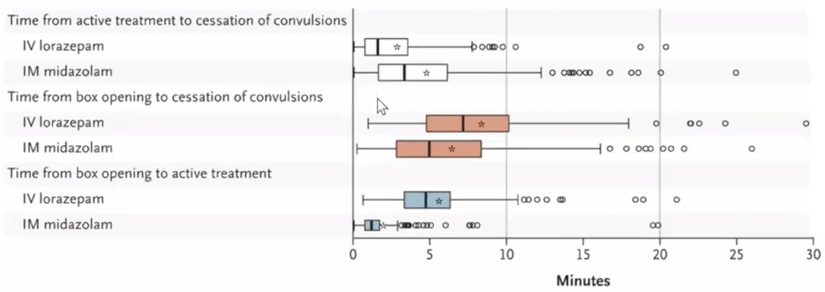

1. **diazepam** 0.1-0.2 mg/kg (0.1-1.0 mg/kg in children) at 1-5 mg/min up to 10 mg; repeat once or twice q5-30min if seizures persist (aborts SE in 68% cases)

* diazepam (high lipid solubility and rapid CNS entry) frequently abolishes seizure activity within minutes, only for seizures to recur within 30 minutes (as drug redistributes to other fatty tissues).

N.B. diazepam enters CNS slightly faster than lorazepam but affords only 30 minute protection (vs. 12 hrs by lorazepam).

* if IV access is not obtainable, diazepam is drug of choice - may be given rectally (0.5 mg/kg, maximum 20 mg), endotracheally, intraosseously.

2nd line medications

- immediately next step (to prevent seizure recurrence) – *long-acting* anticonvulsant – equally effective alternatives:

1. **fosphenytoin** 20 mg PE/kg (up to 150 mg PE/min – i.e. can be infused 3 times faster); PE = phenytoin equivalents.

N.B. administering fosphenytoin to patient who is taking PHT may raise level to point at which PHT actually becomes proconvulsant and cause cardiac arrest

* contraindicated in drug-induced seizures.
* if fosphenytoin is unavailable - **phenytoin** 15-20 mg/kg load (up to 50 mg/min or 1 mg/kg/min); if seizures persist → additional 5-10 mg/kg boluses q20min (up to 30 mg/kg total or 30 μg/ml level)

N.B. phenytoin is incompatible with glucose-containing solutions!

* use ***continuous ECG and BP monitoring*** during infusion! (phenytoin is contraindicated in heart block).

1. **levetiracetam** 60 mg/kg (max 4500 mg/dose)
2. **valproate** 30-40 mg/kg (slow onset of action is drawback).

* in hypersensitive to PHT or patients who already are taking PHT but in whom blood level of PHT is not yet known.
* drug of choice for myoclonic status; can add lorazepam or clonazepam to help with acute control.

Other alternatives:

Lacosamide 10 mg/kg

Phenobarbital 20 mg/kg (max 1000 mg/dose) – preferred for refractory febrile seizures in < 6 mos or drug-induced seizures.

N.B. most common cause of treatment failure - appropriate medication administered in ***inadequate dosages*** via ***inappropriate route***!

Established Status Epilepticus Treatment Trial (ESETT)

- multicenter, randomized, double-blind trial

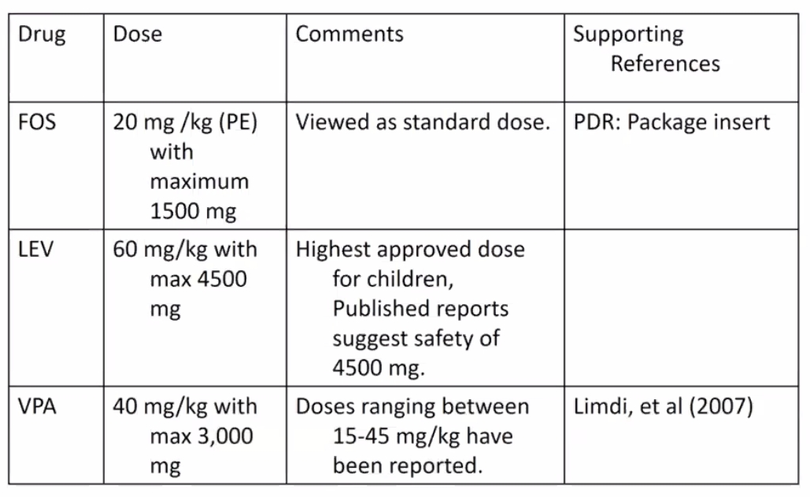

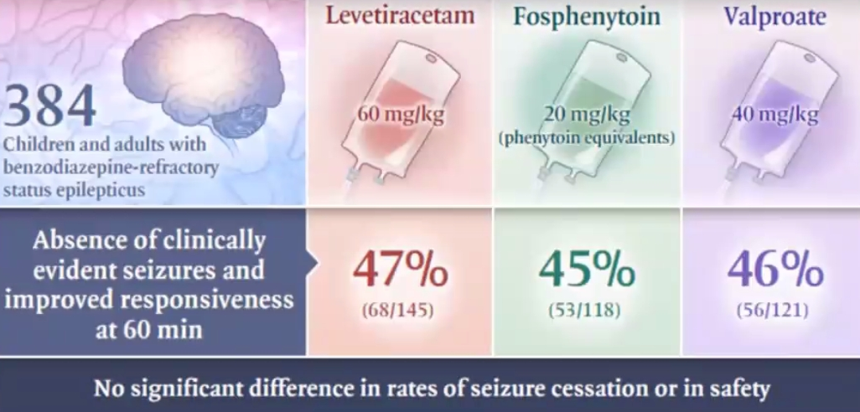

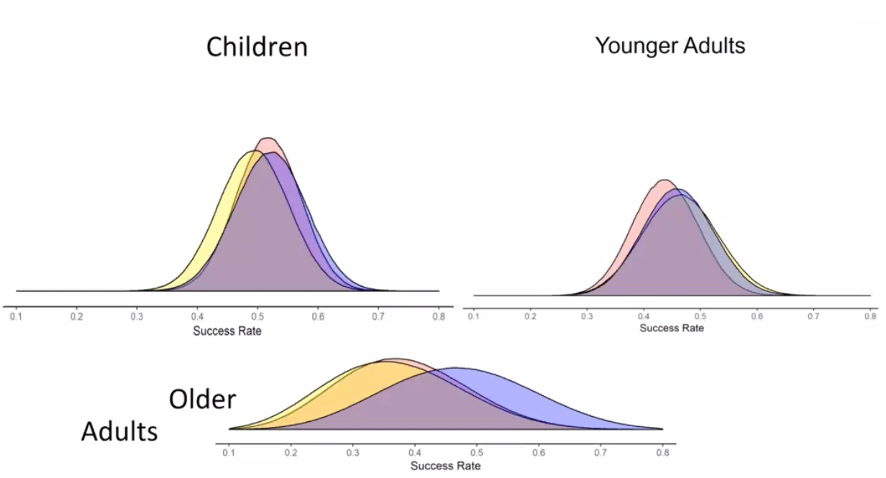

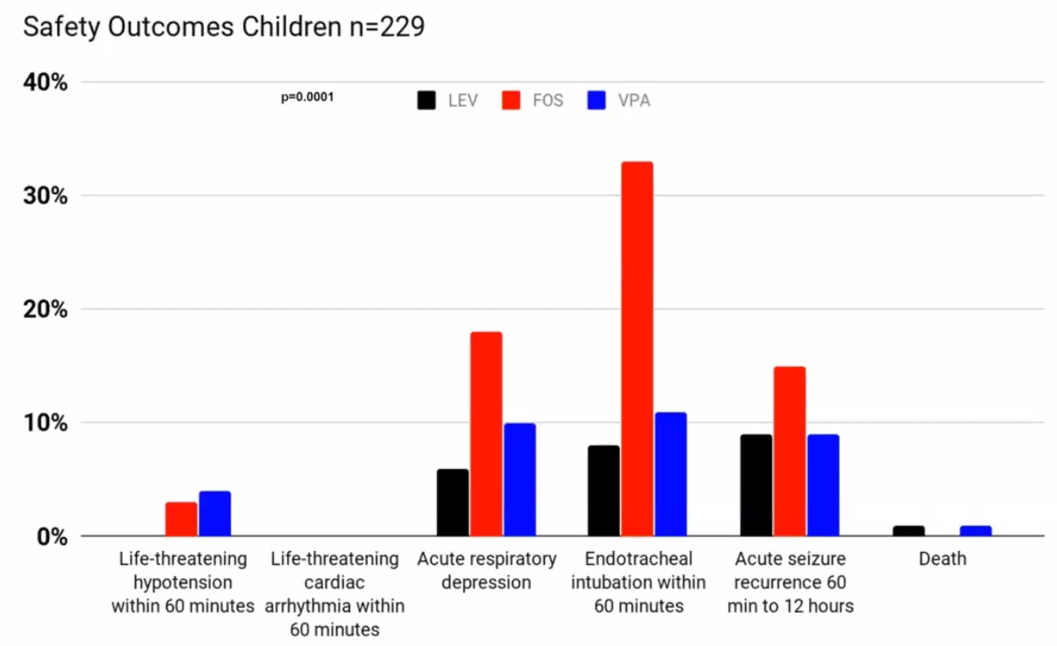

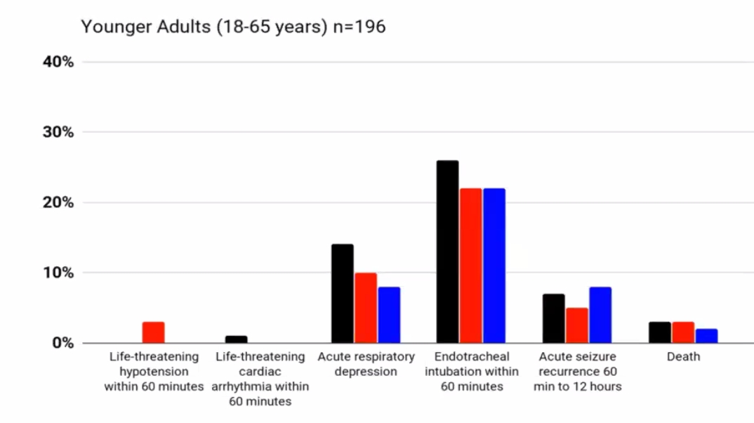

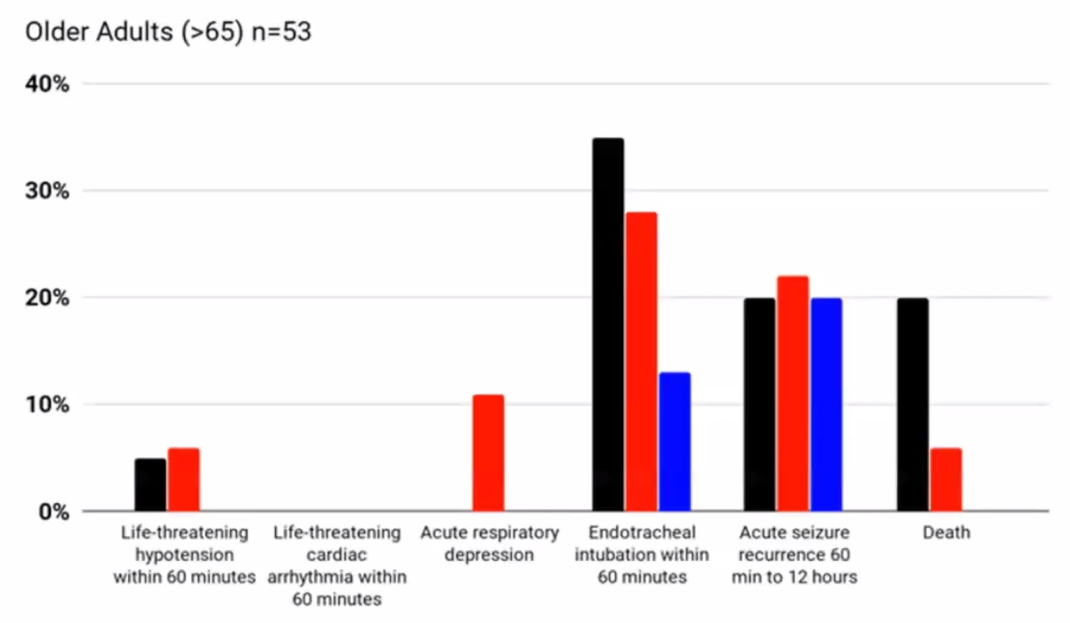

[Convulsive Status Epilepticus Pediatric Trial](https://www.thelancet.com/journals/lancet/article/PIIS0140-6736(19)30722-6/fulltext?rss=yes) (ConSEPT)

* randomly assigned 233 children to receive either levetiracetam or phenytoin.
* clinical cessation of seizure activity - 50% of the levetiracetam group and 60% of the phenytoin group (however, when the drugs were administered sequentially, the rate of seizure cessation rose to approximately 75%).

[Emergency treatment with Levetiracetam or Phenytoin in convulsive Status Epilepticus in children trial (EcLiPSE)](https://www.thelancet.com/journals/lancet/article/PIIS0140-6736(19)30724-X/fulltext)

* randomly assigned close to 300 children experiencing CSE to receive either levetiracetam or phenytoin.
* no statistically significant difference between the two groups was found in either the termination of the episode (CSE was terminated by levetiracetam in 70% of participants, and by phenytoin in 64% of participants) or the median time to seizure cessation, although there was a trend in favor of levetiracetam in both outcomes.

N.B. there is lack of evidence of what to do beyond 2nd line medications

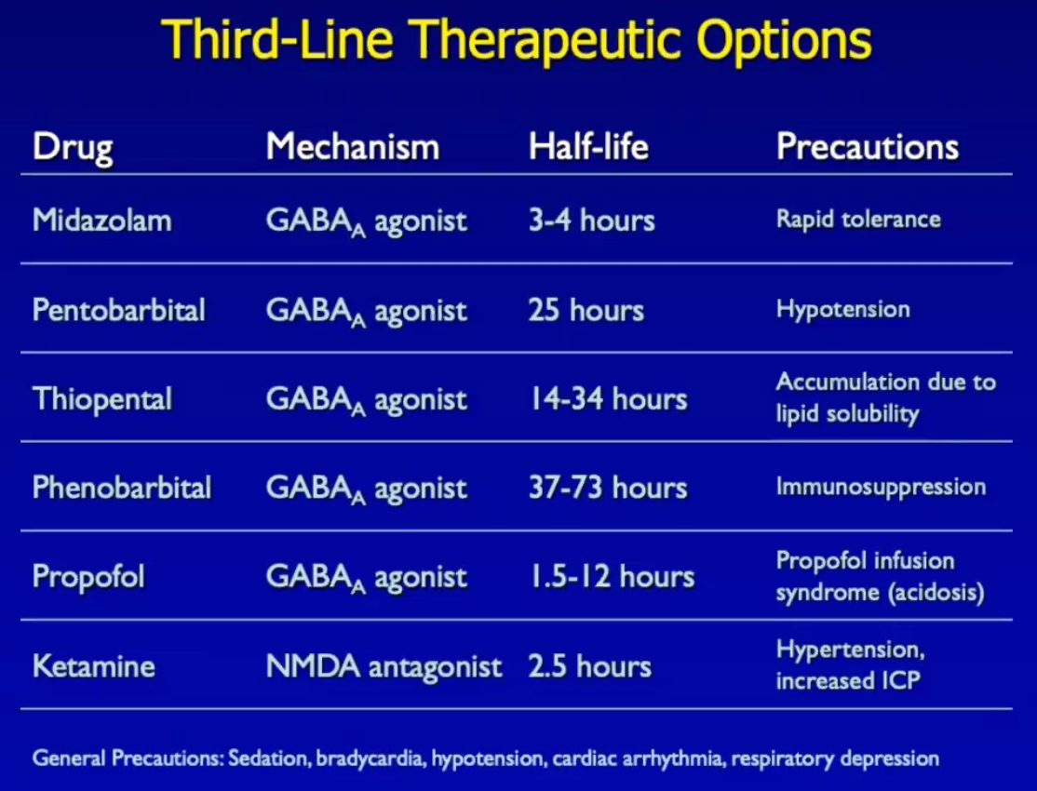

**STEP 3 – pharmacological coma** (administered by anesthesiologist):

1. Elective **intubation** (because benzodiazepine + barbiturate will cause respiratory depression) using rapid sequence technique (because all patients are considered as having full stomach).
2. Place **arterial line** + draw **arterial blood gases**.

**Pentobarbital** 3-15 mg/kg load → 0.5-5 mg/kg/hr maintenance (titrated to *burst-suppression* near-electrocortical silence).

* treatment is continued for 6-48 hours.
* continuously monitor EEG (for recurrence of seizure activity).
* high risk of hypotension - ventilatory assistance and vasopressors are invariably required.
* other drugs used for refractory SE:
  1. propofol (1-2 mg/kg → 2-10 mg/kg/h)
  2. midazolam (0.2 mg/kg → 0.75-45 μg/kg/min)
  3. carbamazepine
  4. oxcarbazepine
  5. lacosamide

40-60% success rate in SE, with low toxicity; TRENdS trial, which compared lacosamide with fosphenytoin in adults with nonconvulsive SE, showed success rates of 63% and 50%, respectively (no significant difference), with similar rates of adverse effects.

* 1. brivaracetam (30% response rate and low toxicity).
  2. perampanel; there’s not yet IV formulation, and the few available data in refractory SE show low effectiveness (5-20%).
  3. stiripentol - moderate efficacy (30-50%) and low toxicity, though no IV formulation is available
  4. topiramate (initial dose of 100 mg/d and high median maintenance dose of 400 mg/d); response rate 27.4%; hyperammonemia was a frequent adverse event (35.8%), mainly in combination with the administration of valproate.

Anne Fechner et al. Treatment of refractory and superrefractory status epilepticus with topiramate: A cohort study of 106 patients and a review of the literature. Epilepsia Nov 2019

* 1. lamotrigine
  2. diazepam drip ≈ 2-3 mg/hr.
  3. paraldehyde 5% (150-200 mg/kg IV slowly for 15-20 min → 20 mg/kg/hr in concentration in glass* bottle); if administered rectally or IM can produce tissue damage and sloughing! *drug is incompatible with plastic
  4. lidocaine (may cause seizures in toxic doses)
  5. ketamine - reserved for super-refractory SE (in 26 studies involving 303 super-refractory patients, ketamine treatment worked in 74%)
  6. magnesium sulfate - may be effective in eclampsia.

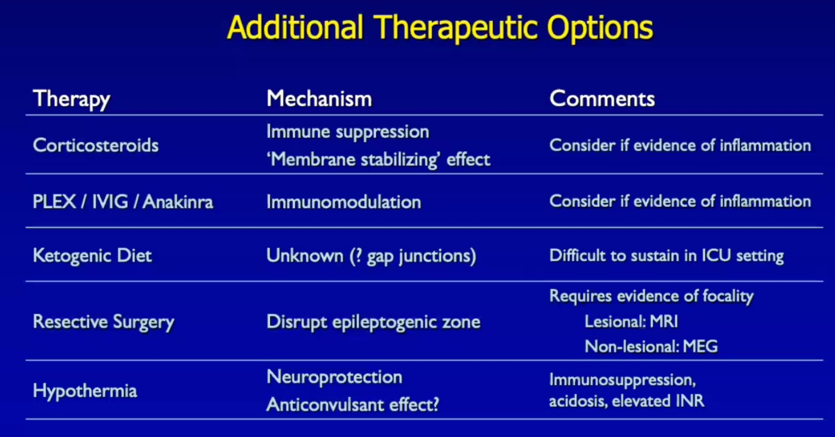

**STEP 4 – general anesthesia** using inhaled anesthetic (halothane < isoflurane).

* novel therapeutic options (no systematic studies): transcranial magnetic stimulation, electroconvulsive therapy (shock therapy).

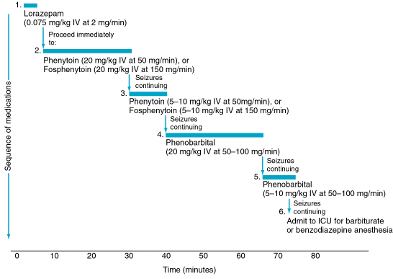

**STEP 5 – emergency surgery** (seizure focus resection, VNS at high stimulation parameters, etc).

* use intraop ECoG to delineate need to resect cortex.

Treatment for nonconvulsive SE

- *may be treated less aggressively* - risk of neurological sequelae is significantly lower!

* good guideline is not to worsen patient's level of consciousness by pharmacologic means.

**Absence SE**: low doses of benzodiazepine → dramatic improvement in mental state → valproate IV or rectally (20-25 mg/kg in 50-mL solution over 10 minutes; repeat after 3 hours, then q6h) or oral ethosuximide.

* no deaths or long-term morbidity have been reported!
* differentiation from other causes is important - many mimics of absence SE can lead to irreversible neuronal damage if not aggressively treated!

**Complex partial SE** – treatment as for GCSE:

1. intravenous benzodiazepines.
2. fosphenytoin (IM or IV)
3. **oral** anticonvulsants
   * negative outcomes can occur!

**Simple partial SE** – treatment less aggressive as for GCSE (e.g. if first-line drugs are ineffective, clinician may elect not to use general anesthetic agent to stop simple partial SE).

Management following status epilepticus

* ***idiopathic status epilepticus in previously healthy patient*** → maintain **AED therapy for 3 months** → discontinue if remains asymptomatic.
* ***other cases*** – as general principles require. [see p. E5 >>](http://www.neurosurgeryresident.net/E.%20Epilepsy%20and%20Seizures\E5.%20Epilepsy%20-%20Treatment%20Principles.pdf)

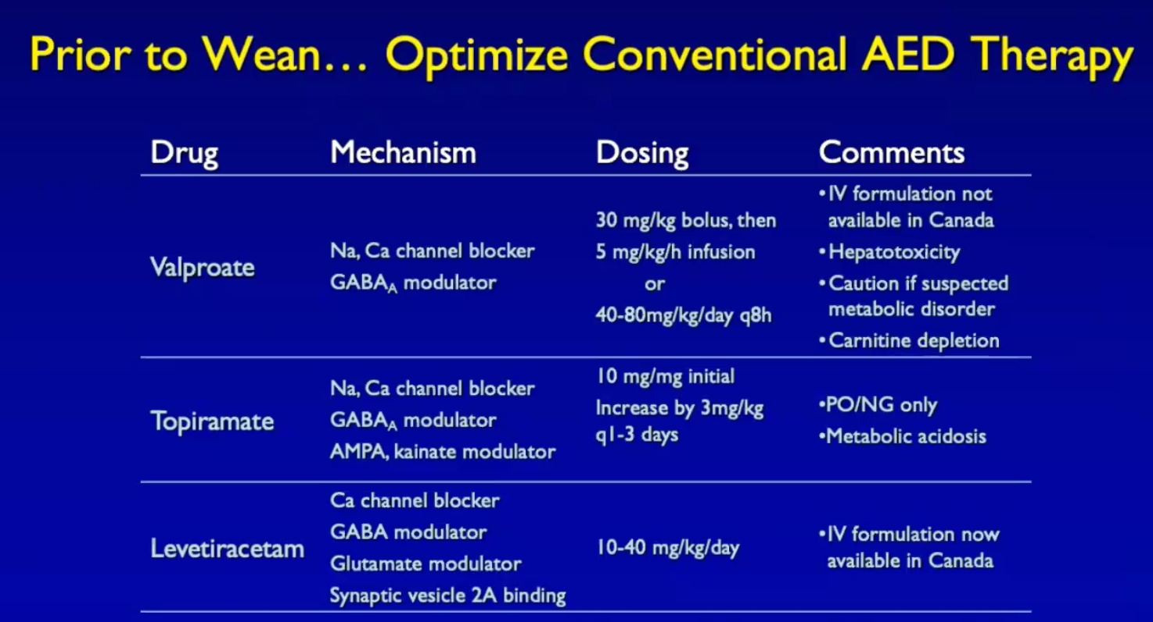

Prognosis

Morbidity & mortality depend on:

1. **intervention speed** (duration > 1 hour carries poor prognosis)
2. **age** (outcome is better in children)
3. **etiology** (outcome is better with pre-existing idiopathic epilepsy, drug-induced SE).

**Mortality** (within 30 days): 20% (1-65%); 38% for refractory SE

* 27% for overt GCSE vs. 65% for *subtle GCSE*
* 4-6% in children, 13% in young adults, 38% in elderly, > 50% in *those > 80 years*.

1% of patients die during episode itself.

Morbidity and mortality is due to:

1. CNS injury from repetitive electric discharges
2. Systemic stress from seizure (cardiac, respiratory, renal, metabolic)
3. CNS injury by acute etiological insult

StEp Audit (2015):

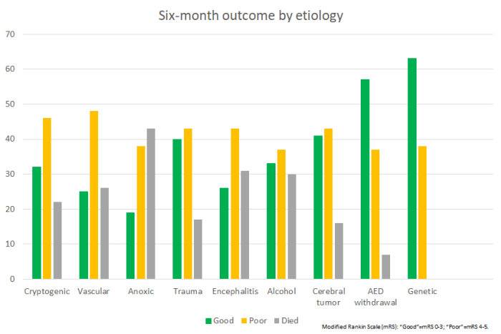

Special types

Febrile status epilepticus

* often child’s first seizure.
* rarely stops spontaneously.
* most common life-threatening emergency in childhood.

MRI changes after febrile SE (predict development of hippocampal sclerosis):

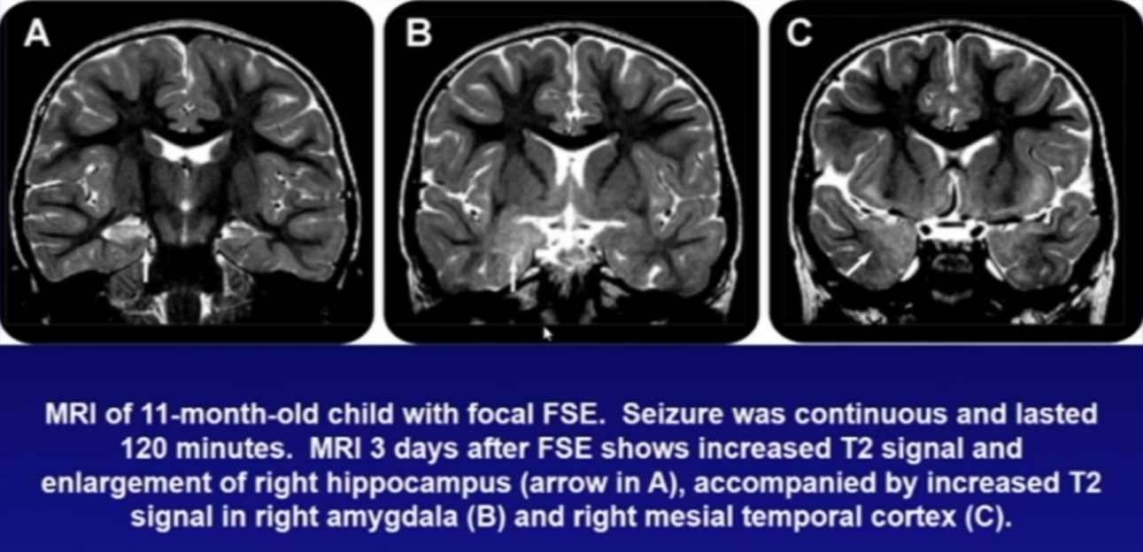

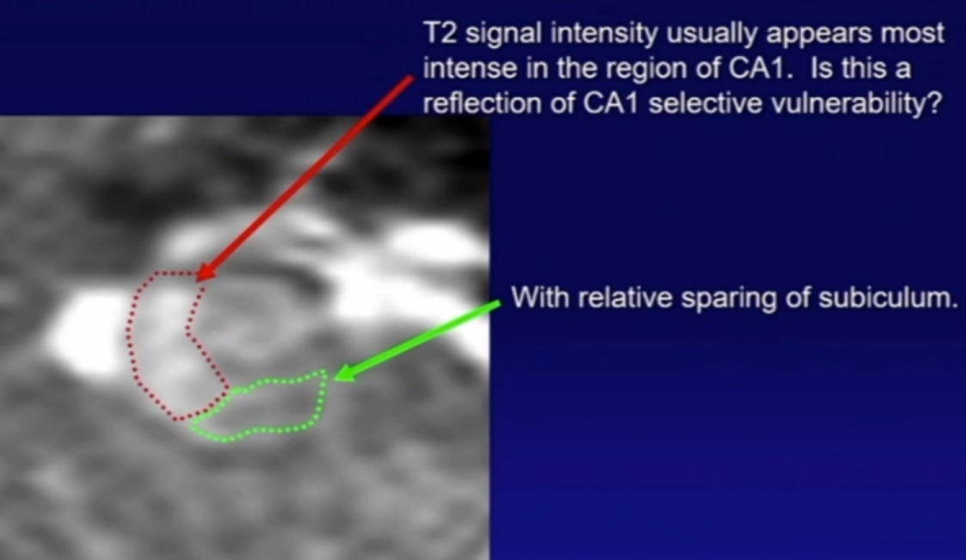

New-onset refractory status epilepticus (NORSE), Febrile infection–related epilepsy syndrome (FIRES)

- a clinical presentation, not a specific diagnosis:

NORSE - rare devastating condition characterized by de novo onset of refractory status epilepticus without identifiable acute or active structural, toxic, or metabolic cause.

FIRES – subcategory of NORSE, i.e. NORSE preceded by a febrile infection (i.e. prior febrile illness starting between 2 weeks and 24 hours before onset of RSE (with or without fever at onset of status epilepticus)

* pathophysiology is largely unknown (autoimmune encephalitis in only half of cases); high levels of cytokines (IL-6 and TNFα), in the serum and CSF.
* one study identified an association between FIRES and polymorphisms in the IL-1 receptor antagonist gene.
* diagnosis - early testing for autoimmune antibodies is of great importance! MRI with contrast – for all patients within 48 hours!
* treatment - immune therapies:
* steroids, intravenous immunoglobulins, and plasma exchange:
  + although often ineffective in cryptogenic NORSE/FIRES, steroids (methylprednisolone 20-30 mg/kg per day [max 1 g] for 3-5 days) should be initiated pending autoantibody panel report as soon as the most common viral, bacterial and fungal infections have been ruled out.
  + IVIG can be given as an alternative to steroids as first line immunological treatment.
  + IVIG and steroids can be administered simultaneously.
* **ketogenic diet** (anti-inflammatory effects) - more efficacious.
* CBD is not first line treatment.
* in non-infectious NORSE/FIRES with inadequate response to first line immune treatment, second line immunological treatment should be started within 7 days of seizure onset

1. rituximab – first choice in adults, also first choice if pathogenic antibodies identified
2. tocilizumab (IL-6 antagonist) – first choice in children, also first choice in cryptogenic cases.
3. anakinra (IL-1 receptor antagonist).

* for focal-onset seizures from unilateral or bilateral temporal regions, an evaluation for epilepsy surgery should be considered;

Pyridoxine-dependent, pyridoxine-responsive epilepsies

- should be considered in children (birth - 3 yo) with refractory seizures and no imaging lesion or other acquired cause of seizures.

Bibliography for ch. “Epilepsy and Seizures” → follow this [link](http://www.neurosurgeryresident.net/E.%20Epilepsy%20and%20Seizures\E.%20Bibliography.pdf)

[Viktor’s Notes℠ for the Neurosurgery Resident](http://www.neurosurgeryresident.net/)

[Please visit website at www.NeurosurgeryResident.net](http://www.neurosurgeryresident.net)