Hair Cell Function
Last updated: May 11, 2019
Hair cell structure:
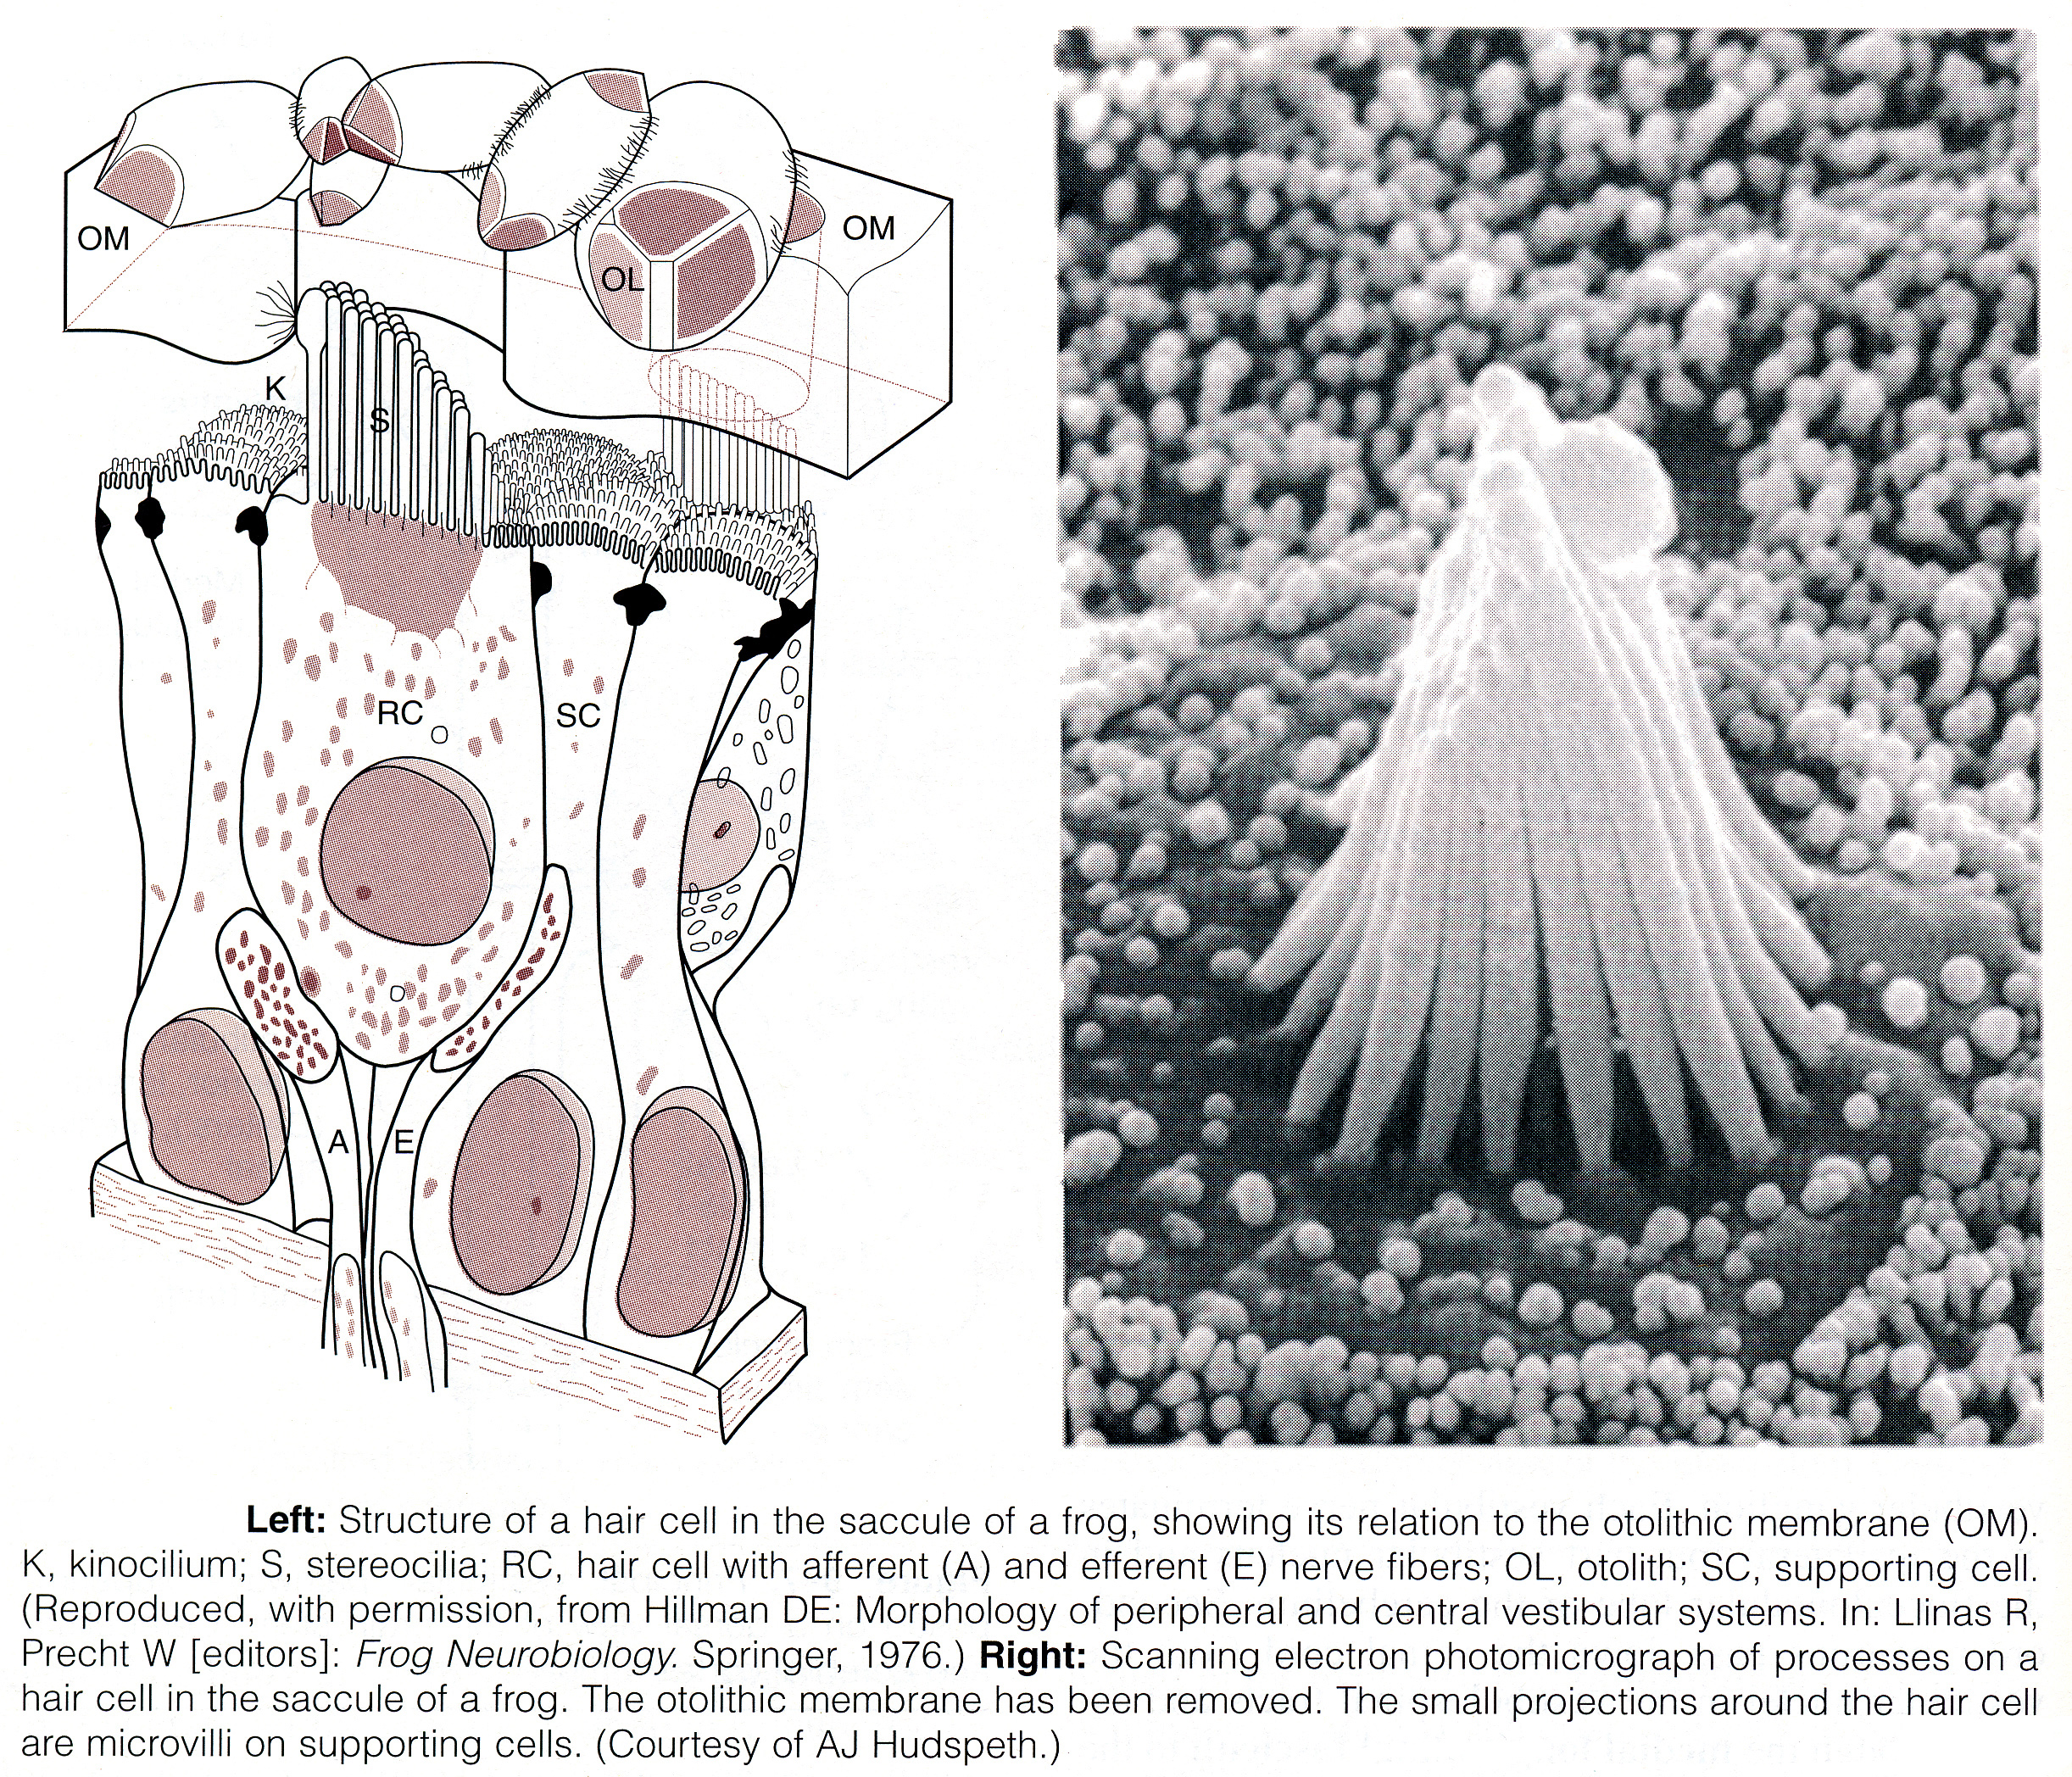
Source of picture: William F. Ganong “LANGE Review of Medical Physiology”, 21st ed. (2003); Publisher: McGraw-Hill / Appleton & Lange; ISBN-10: 0071402365; ISBN-13: 978-0071402361 >>

Corti organ structure:
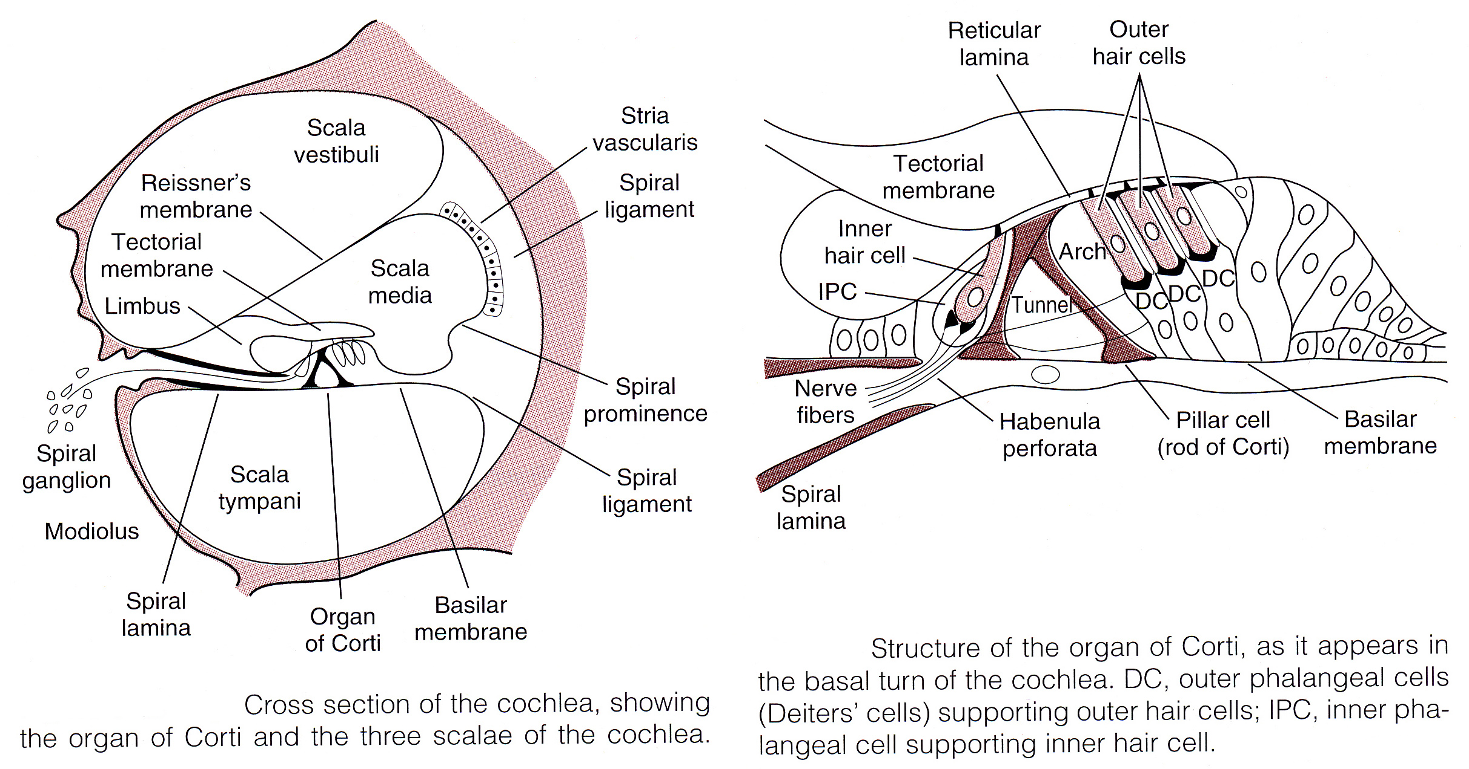
Source of picture: William F. Ganong “LANGE Review of Medical Physiology”, 21st ed. (2003); Publisher: McGraw-Hill / Appleton & Lange; ISBN-10: 0071402365; ISBN-13: 978-0071402361 >>

Hair cell’s membrane potential is -60 mV; hair processes generate changes in membrane potential proportionate to displacement direction:
- when stereocilia are pushed toward kinocilium, membrane potential is decreased to -50 mV.
- when bundle of processes is pushed away from kinocilium, cell is hyperpolarized.
- displacing processes in direction perpendicular to this axis provides no change in potential.

- processes of hair cells project into endolymph whereas bases are bathed in perilymph.  - perilymph is formed mainly from plasma - resembles extracellular fluid.  - endolymph is formed by stria vascularis and has high K⁺ concentration and low Na⁺ concentration; in addition, stria vascularis has unique electrogenic K⁺ pump → endolymph of scala media is electrically positive by +85 mV relative to perilymph of scala vestibuli & scala tympani. | 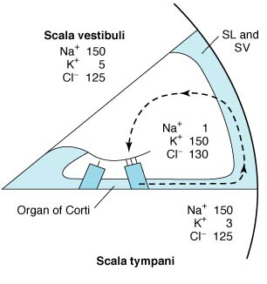  SL, spiral ligament. SV, stria vascularis.  dashed arrow indicates path by which K⁺ recycles: hair cells → supporting cells → spiral ligament → secreted back into endolymph by stria vascularis.
Very fine processes called tip links tie tip of each stereocilium to side of its higher neighbor.  - at junction, higher stereocilium has mechanically sensitive cation channels (α-subunit of epithelial sodium channel may be involved);  - tension on each of channels is adjusted by "adaptation motor" made up of myosin in higher stereocilium;  - when shorter stereocilia are pushed toward higher, open time of channels increases; stereocilia displacement in opposite direction reduces channel open time.  - channels are relatively nonspecific cation channels, but since they are bathed in endolymph (high K⁺ concentration + strongly positive relative to cell inside → electrochemical gradient*), K⁺ enters hair cell when they are open → hair cell depolarization → Ca²⁺ enters cell → excitatory synaptic transmitter (probably glutamate) release → afferent neuron depolarization. | 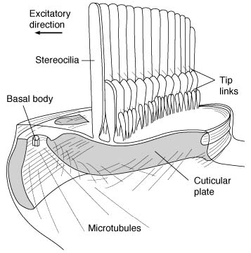  Arrow indicates direction in which pushing cilia increases ion influx into hairs.
- K⁺ that enters hair cells is recycled back to endolymph.
* in general, there is no K⁺ concentration gradient between endolymph and hair cell interior, but at least it does not impede K⁺ movement into cell.

Bibliography for ch. “Otology” → follow this link >>

Viktor’s Notes℠ for the Neurosurgery Resident
Please visit website at www.NeurosurgeryResident.net

