Auditory Pathways
Last updated: May 11, 2019

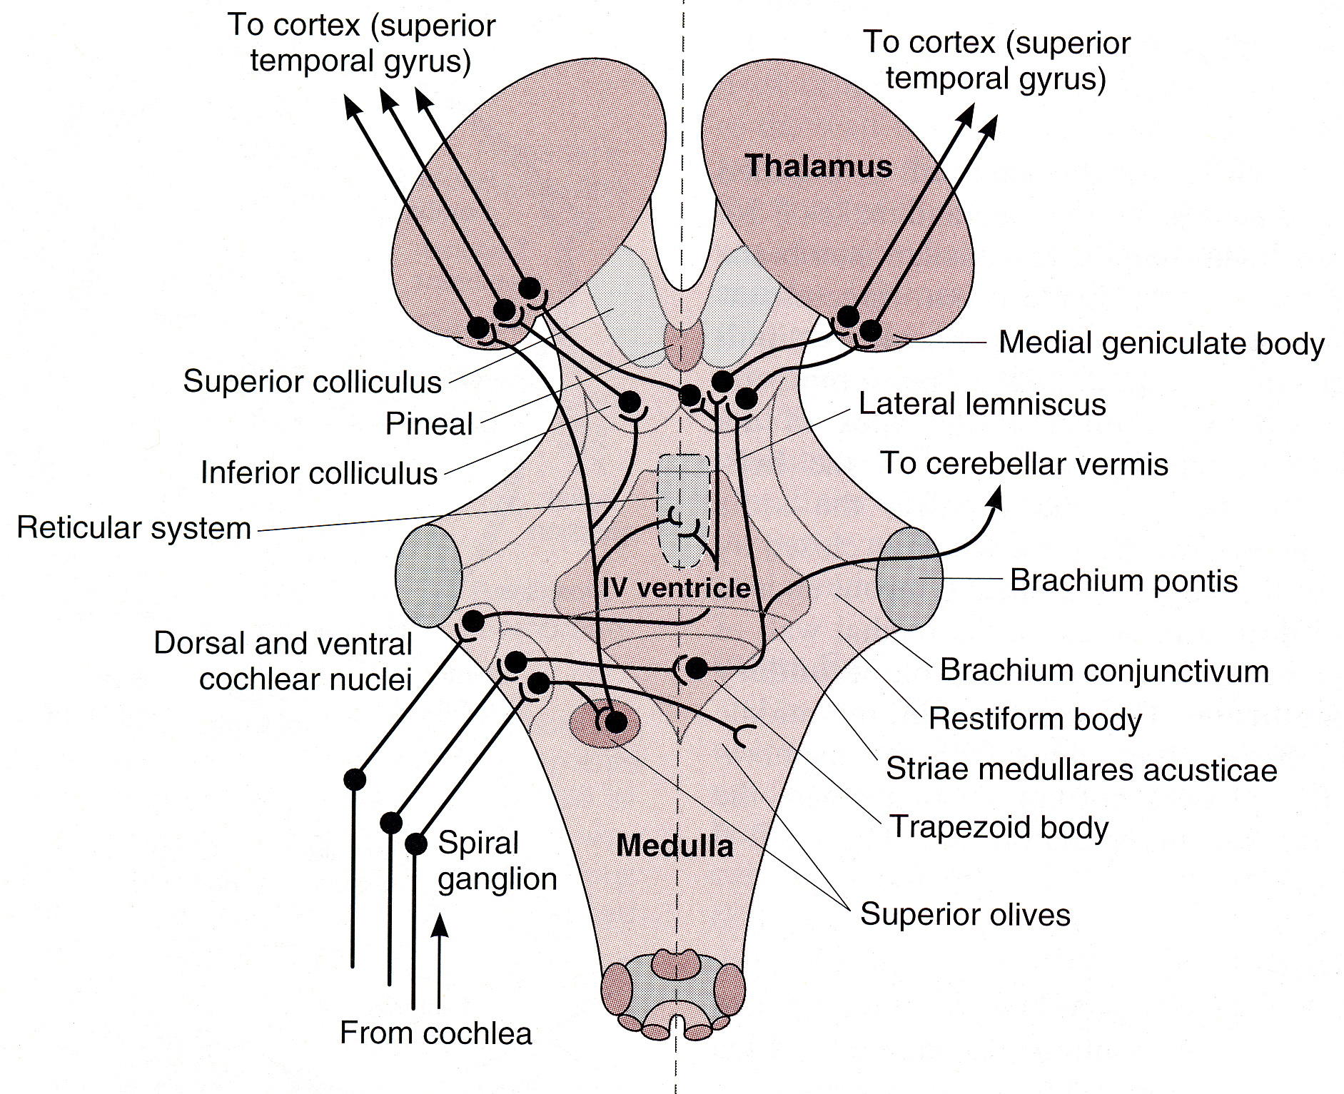
Source of picture: William F. Ganong “LANGE Review of Medical Physiology”, 21st ed. (2003); Publisher: McGraw-Hill / Appleton & Lange; ISBN-10: 0071402365; ISBN-13: 978-0071402361 >>

- Organ of Corti - outer hair cells in organum spirale (cochlea)
- Spiral (s. cochlear) ganglion in modiolus; cells use glutamate (+) and aspartate (+)
- Cochlear part of CN8
  - blood supply – labyrinthine artery
- Cochlear Nuclei (anterior, posterior)
  - blood supply – AICA
  - have input from hypothalamus (histamine-containing fibers), locus ceruleus (noradrenergic projections), olive (olivocochlear projection uses enkephalin)
- Trapezoid body – crossing fibbers (acoustic striae); has also nuclei
- Superior olive; cells use cholecystokinin
  - blood supply – BA (long circumferential branches)
  - stapedius reflex!!!, spatial sound localization!!!
  - olivocochlear fibers – modulate sensitivity of hair cells
- Lateral lemniscus; has nuclei that contain dynorphin
  - blood supply – BA (long circumferential branches)
- Inferior colliculus; major feedback to lower nuclei
  - blood supply – BA&SCA (long circumferential branches)
  - has input from locus ceruleus (noradrenergic projections)
- Medial geniculate body - thalamic relay station; directs auditory attention
  - blood supply – PCA (thalamogeniculate branches)
- Temporal auditory cortex:
- primary auditory cortex (41-42)
- secondary auditory cortex (22)

Three categories of deafness:
Conductive hearing loss – external ear, middle ear (otitis media, otosclerosis).
- Weber lateralizes to affected side
- Rinne is negative (abnormal)
Sensorineural hearing loss – cochlea, cochlear part of CN8.
- Weber lateralizes to normal side
- Rinne is positive in mild cases (in severe cases, 512 Hz tunning fork is not heard at either position)
- tinnitus
Central deafness – cochlear nuclei, central connections, auditory cortex
- system (central to dorsal and ventral cochlear nuclei) is bilateral and multisynaptic – synapse and crossing (or re-crossing) occurs at several levels – central lesions rarely result in unilateral or bilateral hearing losses that can be detected
exception - damage to trapezoid body
- cochlear nuclei-primary auditory cortex: diminished auditory acuity, decreased ability to hear certain tones, difficulty in precise space localization.
- secondary auditory cortex: difficulty in understanding / interpreting sounds (auditory agnosia).

Bibliography for ch. “Otology” → follow this link >>

Viktor’s Notes℠ for the Neurosurgery Resident
Please visit website at www.NeurosurgeryResident.net

