External Ear Disorders

Last updated: May 11, 2019

Obstructions 1

Cerumen (earwax) impaction 1

Treatment 1

Foreign body 1

External Otitis 2

Clinical Features 2

Treatment 2

Prevention 2

Perichondritis 2

Treatment 2

Malignant External Otitis 3

Clinical features 3

Diagnosis 3

Treatment 3

Trauma 3

Subperichondrial hematoma 3

Lacerations 3

Fractures 4

Tumors 4

Obstructions

Cerumen (earwax) impaction

- cerumen accumulation that causes symptoms and / or prevents ear examination.

N.B. definition of cerumen impaction *does not require complete obstruction*!

**Cerumen (earwax)** - naturally occurring substance that cleans, protects, and lubricates external auditory canal and is expelled by self-cleaning mechanism.

* affects in USA - 10% children, 5% healthy adults, 57% older persons in nursing homes, 36% those with mental disabilities.
* symptoms – itching, otalgia, odor, discharge, tinnitus, fullness, cough, temporary **conductive hearing loss**.

N.B. patients must not remove earwax (using cotton-tipped swabs or oral jet irrigators).

* evaluate patients with ***hearing aids*** for cerumen impaction q 6-12 months (cerumen can cause feedback, reduced sound intensity, or damage to hearing aid).
* complication – infection.

Treatment

- removal by:

* + 1. **irrigation** (*contraindicated in positive otologic history*, esp. otorrhea or TM perforation – water may exacerbate chronic otitis media!); *direction of jet* must be backward & upward; pressurized irrigation entails risk of trauma!
    2. **specialty instruments** (blunt curette, loop, hook, probe, forceps, suction) **-** preferred for narrow / distorted ear canals*, TM perforation or tube, immune deficiency, diabetes mellitus.

*binocular microscope with microinstrumentation may be needed

* + 1. ear candling - ineffective and potentially dangerous.



[Source of picture: Rudolf Probst, Gerhard Grevers, Heinrich Iro “Basic Otorhinolaryngology” (2006); Georg Thieme Verlag; ISBN-13: 978-1588903372 >>](http://www.amazon.com/gp/product/1588903370)

* ***ceruminolytics (cerumen solvents)*** are most effective when instilled 15-30 minutes before treatment; long term use (e.g. olive oil drops daily for 4 days, followed by irrigation) is not recommended (frequently causes maceration and allergic reactions).
  + - * no specific ceruminolytic agent has been found to be superior in clinical trials.
* complications of treatment (0.1%) - ear canal laceration, infection, hearing loss, otitis externa, pain, syncope, dizziness.

Foreign body

* children, mental handicaps.
* if present for long time, may cause discharge.
* best removed by raking it out with **blunt hook** or **suction tip**.
  + - *forceps* tend to push smooth objects deeper into canal!



[Source of picture: Rudolf Probst, Gerhard Grevers, Heinrich Iro “Basic Otorhinolaryngology” (2006); Georg Thieme Verlag; ISBN-13: 978-1588903372 >>](http://www.amazon.com/gp/product/1588903370)

* foreign body lying *medial to isthmus* is difficult to remove without injuring tympanic membrane and ossicular chain!
* metal and glass beads can sometimes be removed by irrigation; hygroscopic foreign body (e.g. bean) swells when water is added to it, complicating its removal.
* use general anesthetic:

1. when child is uncooperative
2. when mechanical problem makes removal difficult.

* **insects** are most annoying while alive (may cause pain) - filling canal with ***mineral oil*** (or ***lidocaine solution***) kills insect (immediate relief), and facilitates its removal with forceps.
* after removal, **antibiotic + steroid** drops prevent infection and reduce inflammation.

External Otitis

*- infectious dermatitis of ear canal*

1. localized (**furuncle**); usually due to *S. aureus*
2. diffuse, affecting entire canal (**diffuse external otitis**).

* predisposing causes are swimming (so called ***swimmer's ear***), forceful cleaning of ear, trauma.
* dermatologic persons (allergies, psoriasis, eczema, seborrheic dermatitis) are particularly prone.
* normally, ear canal cleanses itself by moving desquamated epithelium, as on conveyor belt, from tympanic membrane outward;

cotton applicators interrupt self-cleansing mechanism; debris and cerumen trap water allowed into canal → skin maceration sets stage for invasion of pathogenic bacteria.





[Source of picture: Rudolf Probst, Gerhard Grevers, Heinrich Iro “Basic Otorhinolaryngology” (2006); Georg Thieme Verlag; ISBN-13: 978-1588903372 >>](http://www.amazon.com/gp/product/1588903370)

Clinical Features

* itching, **pain** (worse on jaw movement), foul-smelling **discharge**.
* hearing loss (if canal becomes swollen or filled with purulent debris).
* **tenderness** on traction of **pinna** and on pressure over **tragus** (vs. in otitis media).
* **otoscopy** - skin of ear canal is red, swollen, littered with moist, purulent debris.



[Source of picture: Rudolf Probst, Gerhard Grevers, Heinrich Iro “Basic Otorhinolaryngology” (2006); Georg Thieme Verlag; ISBN-13: 978-1588903372 >>](http://www.amazon.com/gp/product/1588903370)

Treatment

**Diffuse external otitis**:

1. infected debris is gently and thoroughly removed from canal with suction or dry cotton wipes.
2. topical 2% **acetic acid**
3. topical **antibiotics** (neomycin + polymyxin B) + **corticosteroids** (1% hydrocortisone)
4. analgesic (up to narcotic!)
5. spreading cellulitis → ***systemic antibiotics***.

**Furuncles** - allow to drain spontaneously (incision may lead to spreading perichondritis of pinna!!!).

* + ***oral antistaphylococcal antibiotics*** (topical antibiotics are ineffective!).
  + analgesics.
  + dry heat.

Prevention

- irrigating ears with 1:1 mixture of rubbing **alcohol** (helps remove water) and **vinegar** immediately after swimming.

Perichondritis

*- infection of perichondrium of pinna*

* etiology - trauma, insect bites, incision of superficial infections of pinna; usually Gr- rod.

N.B. external ear is most common (88%) site of **relapsing polychondritis** (systemic autoimmune disease).

* cartilage blood supply is provided by perichondrium.
* pus accumulates between cartilage and perichondrium → avascular necrosis → deformed pinna.
* clinical course indolent, long-lasting, destructive.

Treatment

* wide **incision** and suction **drainage** (to approximate blood supply to cartilage).
* ***systemic antibiotics***.

Malignant External Otitis

*-* ***Pseudomonas*** *(95%) osteomyelitis of ear canal and temporal bone.*

Clinical features

1. 90% - **elderly** (> 60 yrs) **diabetics**.
2. young **immunosuppressed** (e.g. AIDS) patients.

* 50% cases have been reported to be preceded by *traumatic aural irrigation*!
* begins as external otitis that progresses into skull base osteomyelitis.
  1. persistent severe deep-seated **earache**
  2. foul-smelling purulent **otorrhea**
  3. **marked tenderness** in soft tissue between mandible ramus and mastoid tip.
  4. ± **conductive hearing loss**
  5. **CN7 (± other nerves) paralysis** in severe cases.

*Pain is out of proportion to physical examination findings!!!*

* fever is uncommon
* osteomyelitis spreads along skull base and ***may cross midline***!
* malignant (without a/b) - aggressive clinical behavior (→ purulent meningitis), poor treatment outcome (poorer in AIDS than in diabetes), high mortality (40-50%; < 10% with appropriate antibiotics).
* 9-27% can recur (as long as one year after treatment is completed).

Diagnosis

* **otoscopy**:
  + **granulation tissue** in ear canal (granulation tissue ***at floor of osseocartilaginous junction*** is virtually pathognomonic).
  + may reveal **exposed bone**.
  + tympanic membrane is usually intact.
* imaging:

1. fine-cut **CT** of skull base and temporal bone (30-50% of bone destruction is required to detect osteomyelitis by CT!).
2. **gadolinium-enhanced** **MRI** provides poor bone resolution.
3. **radioscans** (very sensitive but not specific; application of SPECT improves poor spatial resolution) - Technetium Tc 99 methylene diphosphonate, Gallium citrate Ga 67, Indium In 111–labeled leukocyte.

* **biopsy** of ear canal (to differentiate from malignant neoplasm + to identify causative organism).
* **ESR**↑↑↑ can be used to support clinical diagnosis since acute external otitis or ear canal malignancy do not cause elevation!

**A:** Coronal CT, left temporal bone - inflammatory mass (*arrows*) has destroyed ossicles and walls of external canal.

**B:** Axial CT, right temporal bone - destruction of anterior and posterior canal walls (*arrows*).

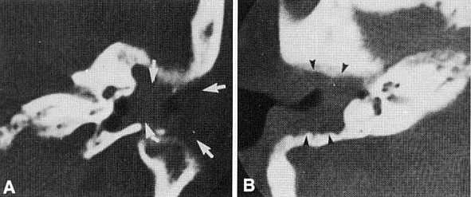

Treatment

* **diabetes control**
* antipseudomonal IV antibiotic therapy (6-12 weeks):
  1. fluoroquinolone
  2. 3rd generationcephalosporin
  3. semisynthetic penicillin + aminoglycoside.
* aural toilet, hyperbaric oxygen therapy.
* *response* should be evaluated with **Ga-67 scan** q4-6 weeks during treatment;
  + - CT / MRI cannot determine osteomyelitis resolution!;
    - antibiotics are continued for 1 week after Ga-67 scan becomes normal.
* ***surgery*** is usually not helpful or necessary (reserved for granulation tissue and bony sequestra).

Trauma

Anesthesia - raise wheal with lidocaine (without epinephrine!!!) about entire base of ear - anesthetizes all but external canal and concha (require direct infiltration).

Subperichondrial hematoma

* blunt trauma to pinna.
* pinna becomes shapeless, reddish purple mass.
* *avascular cartilage necrosis* may occur.
* "*cauliflower ear*" (wrestlers, boxers) results from ***organized, calcified hematoma***.
* treatment – promptly **evacuate** clot through incision (or aspirate with 18 G needle) + **approximate** skin and perichondrium to cartilage with suction drainage or pressure bandage for 5-7 days (to keep cartilage close to its blood supply).
  + often reaspiration is necessary.



Lacerations

- managed surgically:

* skin margins are sutured (sutures should not extend into cartilage!).
  + use absorbable sutures on medial surface (to avoid having to bend ear back to remove those sutures).
* *if cartilage is involved*, minimal debridement and approximation of cartilage and perichondrial layer with fine absorbable suture should precede skin closure.
  + if there is skin loss, small amount of cartilage may be removed to allow skin coverage.
  + if skin loss is significant, remaining cartilage is removed and saved in subcutaneous pocket for later use.
* *all significant ear injuries should be splinted* following repair: wet (benzoin-impregnated) cotton balls are packed about ear to give support; ear and head are then wrapped with circumferential protective dressing.

N.B. ear should not be bandaged against skull without padded splinting (→ severe pain, cartilage necrosis).

* **staphylocidal antibiotic**! (relative avascularity of cartilage - risk of smoldering chondritis).
* **external canal** lacerations - managed by *microscopically* placing any skin flaps in their normal position, *packing* ear canal, administering *topical antibiotic* drops.

Fractures

* forceful ***blows to mandible*** may be transmitted to anterior wall of ear canal.
* displaced fragments (may cause canal stenosis) must be **reduced / removed**.

Tumors

**Sebaceous cysts, osteomas, exostoses, keloids** may occlude ear canal:

1. retention of cerumen → conductive hearing loss.
2. retention of water → external otitis.

* excision is treatment of choice.



[Source of picture: Rudolf Probst, Gerhard Grevers, Heinrich Iro “Basic Otorhinolaryngology” (2006); Georg Thieme Verlag; ISBN-13: 978-1588903372 >>](http://www.amazon.com/gp/product/1588903370)

**Ceruminomas** arise in outer third of ear canal.

* appear benign histologically, but *behave in malignant manner - should be excised widely.*

**Basal cell, squamous cell carcinomas** on ***pinna*** after regular sun / radiation exposure; in ***ear canal*** after persistent inflammation in chronic otitis media.

* early lesions - cautery and curettage or radiation therapy.
* advanced lesions:

***pinna*** → **V-shaped excision**.

***ear canal*** → resection:

tumor 5 mm lateral to eardrum → **external canal excision**;

tumor impinges on eardrum without middle ear invasion → **lateral temporal bone resection**;

tumor invades middle ear → **total en bloc temporal bone resection**.

* ***cartilage invasion*** makes radiation therapy less effective and surgery preferred treatment.



[Source of picture: Rudolf Probst, Gerhard Grevers, Heinrich Iro “Basic Otorhinolaryngology” (2006); Georg Thieme Verlag; ISBN-13: 978-1588903372 >>](http://www.amazon.com/gp/product/1588903370)

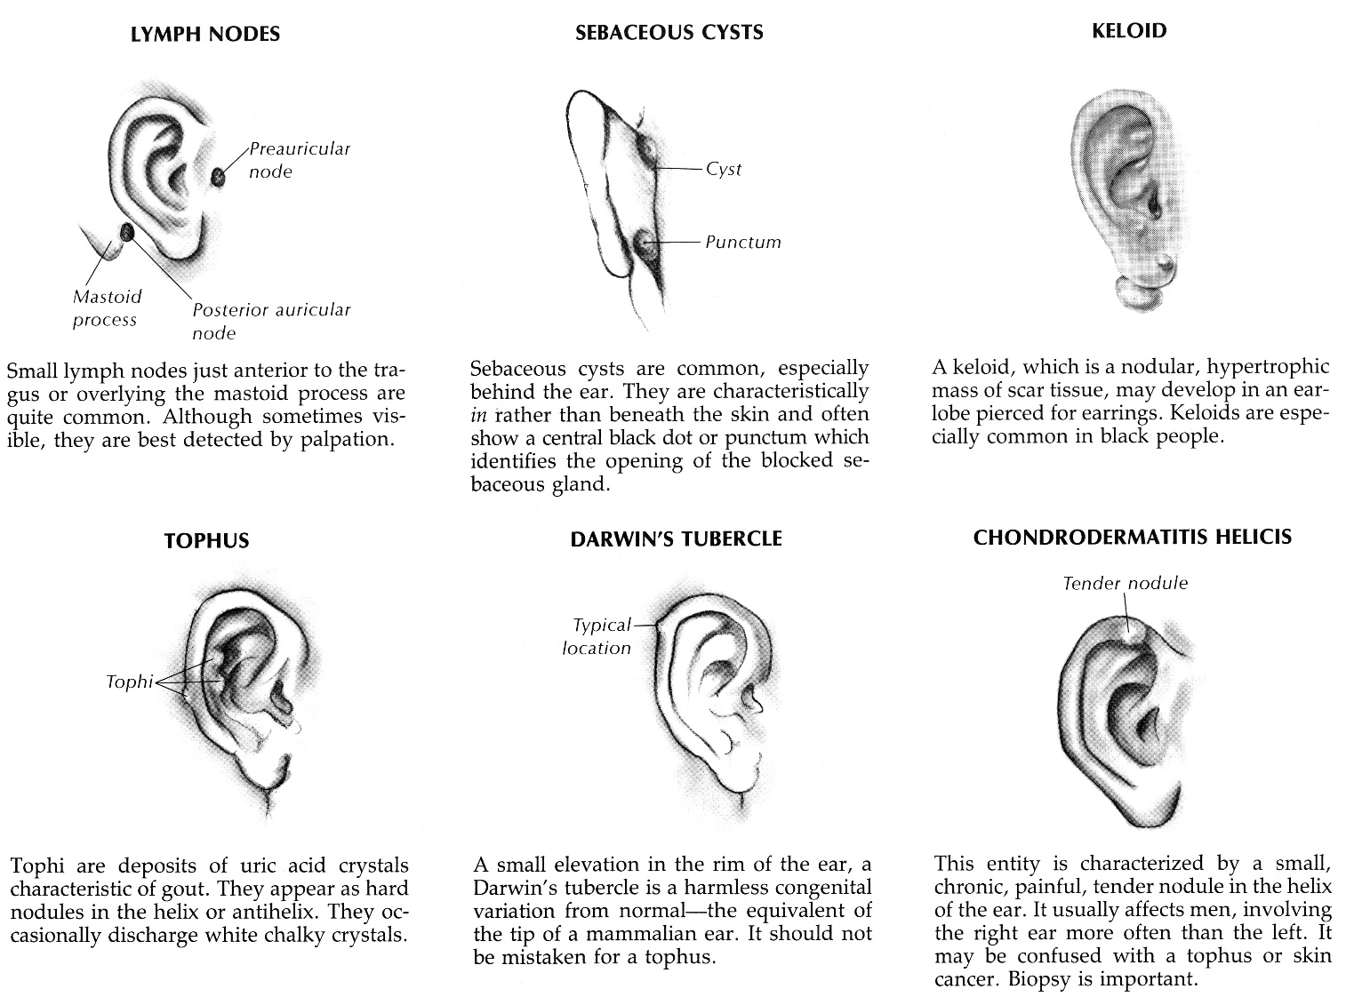

[Source of picture: Barbara Bates “A Guide to Physical Examination”, 3rd ed. (1983); J.B. Lippincott Company; ISBN-13: 978-0397543991 >>](http://www.amazon.com/gp/product/1605478032)

Bibliography for ch. “Otology” → follow this [link >>](http://www.neurosurgeryresident.net/Ear.%20Otology\Ear.%20Bibliography.pdf)

[Viktor’s Notes℠ for the Neurosurgery Resident](http://www.neurosurgeryresident.net/)

[Please visit website at www.NeurosurgeryResident.net](http://www.neurosurgeryresident.net)