Eye Optics
Last updated: May 9, 2019
Refractive Power 1
Accommodation 1
Visual Acuity 2
Critical Fusion Frequency (CFF) 2
Visual Fields & Binocular Vision 2

- light rays are bent (refracted) when they pass from one medium into medium of different density (except when they strike perpendicular to interface).

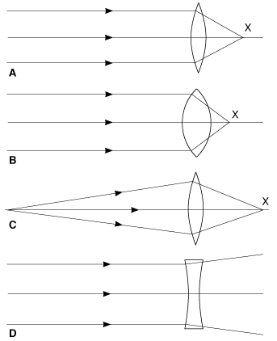 | - parallel light rays striking biconvex lens are refracted to point (focal point) behind lens; biconcave lenses cause light rays to diverge.  - focal point is on line passing through centers of lens curvature (principal axis).  - distance between lens and focal point is focal distance.  - for practical purposes, rays from object > 6 m away are parallel (rays from object closer than 6 m are diverging → brought to focus farther back than principal focus).  A: Biconvex lens.  B: Biconvex lens of greater strength than A.  C: Same lens as A, showing effect on light rays from near point.  D: Biconcave lens.  X is focal point

Refractive Power
- greater lens curvature, greater its refractive power.
- refractive power (P) is measured in diopters (reciprocal of focal distance in meters);
P = 1 / focal distance
e.g. lens with principal focal distance of 0.25 m has refractive power of 4 diopters (i.e.1/0.25).
- human eye has refractive power ≈ 60 diopters at rest; light is refracted at:
  - anterior cornea surface > 40 D
  - anterior and posterior lens surfaces ≈ 20 D.

- if light rays are parallel when they enter lens, they will converge at focal plane.

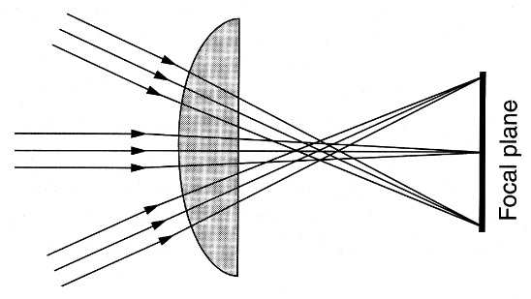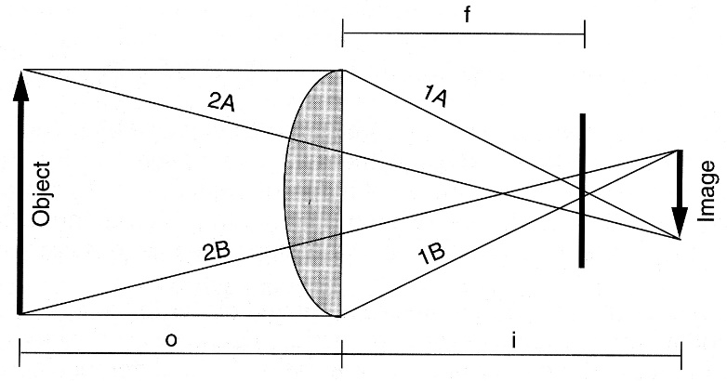

- if light rays are diverging when they enter lens, image will be formed behind focal plane; relationship between object distance (o), focal distance (f), and image distance (i) is given by lens formula:
P = P | 1 | + | 1 | = | 1
 | o |  | i |  | f

"Reduced" (s. "schematic") eye - drawing eye diagrammatically as if all refraction occurs at anterior cornea surface; nodal point (optical eye center - light rays pass without refraction) coincides with junction of middle and posterior third of lens.
- if object height (AB) and distance (Bn) are known, size of retinal image can be calculated, because AnB and anb are similar triangles.  - angle AnB is visual angle subtended by object AB.  N.B. retinal image is inverted. | 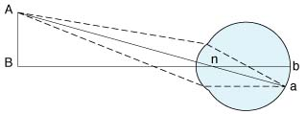

Accommodation
- when ciliary muscle is relaxed, parallel light rays are brought to focus on retina; rays from objects closer than 6 m are brought to focus behind retina → objects appear blurred.
- in mammals, problem is solved by increasing lens curvature - called accommodation.
- at rest, lens is held under tension by lens ligaments (pulled into flattened shape).
- when ciliary muscle contracts, it relaxes lens ligaments → lens springs into more convex shape.
- in young individuals, change in lens shape may add as many as 12 diopters (up to 72 D total)!
- relaxation of lens ligaments is produced by contraction of:
  - circular ciliary muscle fibers (sphincter-like action)
  - longitudinal ciliary muscle fibers (that attach anteriorly, near corneoscleral junction - pull whole ciliary body forward and inward - brings edges of ciliary body closer together).
- accommodation affects principally anterior lens surface; posterior lens surface is changed very little.  - accommodation is active process (can be tiring) - ciliary muscle is one of the most used body muscles!  - accommodation goes together with convergence and miosis* (near reaction). | 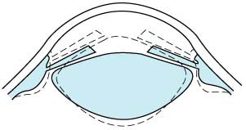
*Role of pupilloconstriction during accommodation – reducing chromatic and spherical aberrations.
chromatic aberration - difference in focus (or magnification) of image arising because of difference in refraction of different wavelengths composing white light.
spherical aberration - monochromatic aberration when paraxial and peripheral rays focus along axis at different points.

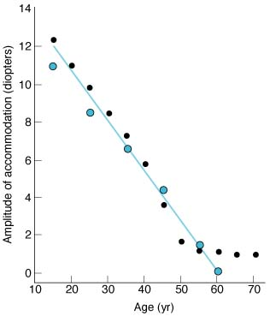  Decline in accommodation amplitude with advancing age (different symbols identify data from different studies). | - degree to which lens curvature can be increased is limited; near point (s. punctum proximum) - nearest point at which object can still be brought into clear focus by accommodation.  - near point recedes throughout life (due to increasing lens hardness):  8,3 cm - at age 10 (due to 12 D maximal accommodation);  83 cm - at age 60;  at age 40-45, accommodation loss is sufficient to make reading and close work difficult (presbyopia).

far point – distance from which object is clearly seen without accommodation; norma – 6 m.

Visual Acuity
- degree to which object details and contours are perceived.
- complex phenomenon - influenced by large variety of factors:
optical factors (e.g. state of image-forming mechanisms of eye);
retinal factors (e.g. state of cones);
stimulus factors (e.g. illumination, brightness of stimulus, contrast between stimulus and background, length of time subject is exposed to stimulus).

Clinically, visual acuity is defined in terms of minimum separable (shortest distance by which two lines can be separated and still be perceived as two lines) - determined with Snellen letter charts.
Minimum separable in normal individual is visual angle of 1 minute! see p. D1eye >>

Critical Fusion Frequency (CFF)
- rate at which stimuli can be presented and still be perceived as separate stimuli.
- stimuli presented at higher rate than CFF are perceived as continuous stimuli (e.g. motion pictures; movies begin to flicker when projector slows down).

Visual Fields & Binocular Vision
- theoretically, visual field of each eye should be circular, but actually it is cut off medially by nose and superiorly by orbit roof.
- central visual fields are mapped with tangent screen (black felt screen across which white target is moved).
- peripheral portions of visual fields are mapped with perimeter (process is called perimetry).  - central parts of visual fields of two eyes coincide (binocular vision).  - impulses set up in two retinas by light rays from object are fused at cortical level into single image (fusion).  - retinal points on which image must fall if it is to be seen binocularly as single object are called corresponding points.  - depth perception:  - binocular vision  - monocular components - relative sizes of objects, their shadows, movement relative to one another (movement parallax). | 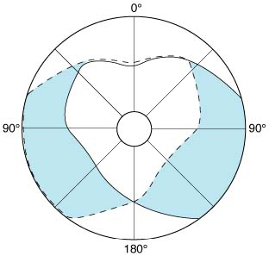  dashed line encloses visual field of left eye; solid line, that of right eye.  common area (heart-shaped clear zone in center) is viewed with binocular vision; colored areas are viewed with monocular vision.

Bibliography for ch. “Ophthalmology” → follow this link >>

Viktor’s Notes℠ for the Neurosurgery Resident
Please visit website at www.NeurosurgeryResident.net

