Optic Nerve and Visual Pathways Disorders
Last updated: May 9, 2019
Anterior chiasmal syndrome 2
Diagnosis 3
General Management 3
Clinical Syndromes 3
Optic Nerve 3
Papilledema (Choked Disk) 3
Clinical features 3
Pseudopapilledema 6
Etiology 6
Clinical Features and Examination 6
Treatment 7
Papillitis (Optic Neuritis) 7
Etiology 8
Symptoms & signs 8
Diagnosis 8
Treatment 9
Retrobulbar Optic Neuritis 9
Optic Nerve Infarction (Anterior Ischemic Optic Neuropathy) 9
Etiology 9
Clinical Features 9
Diagnosis 9
Treatment 11
Compressive Optic Neuropathy 11
Etiology 11
Clinical Features 11
Diagnosis 11
Treatment 11
Toxic / Nutritional Optic Neuropathy (s. Alcohol-Tobacco Amblyopia) 11
Etiology 12
Clinical Features 12
Diagnosis 12
Treatment 12
Optic Atrophy (Optic Nerve Atrophy) 12
Leber hereditary optic atrophy 13
Foster Kennedy syndrome 13
Optic Nerve Hypoplasia 13
Optic Chiasm 13
Optic Tract / Lateral Geniculate Body 14
Optic Radiations 14
Occipital Lobe 14
Higher Cortical Lesions 14
Psychogenic Visual Loss 15
Differential tools to detect nonorganic causes 15
Radiation optic neuropathy → see p. Rx11 >>
Traumatic optic neuropathy → see p. Eye86 >>
Optic pathway glioma → see p. Onc10 >>

Types of afferent visual pathways lesions:
- retinal → see p. Eye63 >>
- retrobulbar (anterior to and including chiasm) - acuity loss, color deficits, visual field defects (usually central or cecocentral scotomas), afferent pupillary defect
N.B. unilateral optic nerve lesions cause afferent pupillary defect even with apparently normal vision, whereas with macular lesions this is late finding!
Unilateral temporary vision loss while looking to the side – optic nerve draped over orbital tumor!
- retrochiasmal (optic tract ÷ primary visual cortex) - visual field defects (without acuity abnormalities*).
* bilateral retrochiasmal lesions can affect visual acuity (but acuities should be symmetrical)
- visual association cortex - deficits in object recognition, color perception, visual inattention, etc.
patients with higher cortical disorders often have nonspecific complaints (e.g. "trouble seeing", "difficulty focusing").

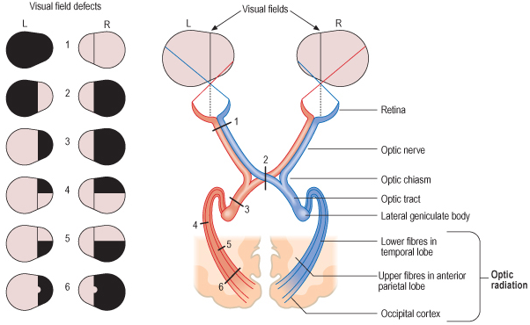

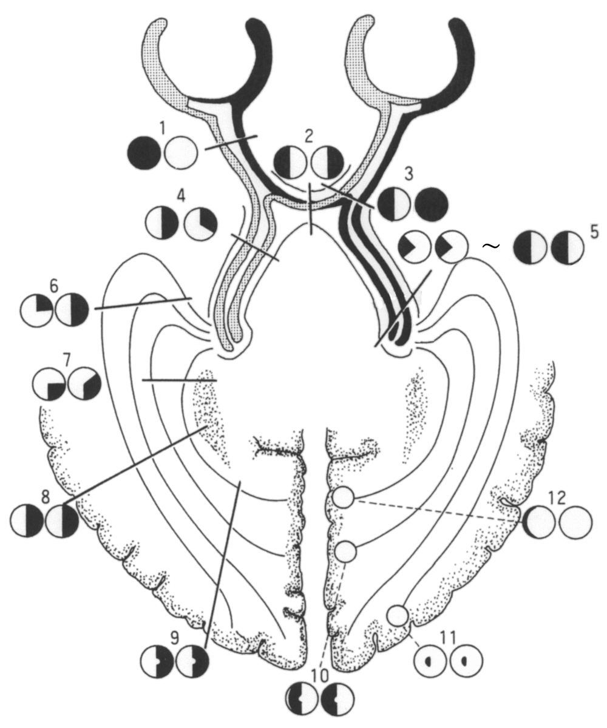

Field defects respecting:
vertical midline - chiasmal or retrochiasmal pathology;
horizontal midline - ocular disease (nerve fiber layer involvement or branch retinal vessel occlusion), occipital stroke above or below calcarine fissure.

negative & positive phenomena see p. Eye59 >>
N.B. features & complexity of positive phenomena does not help to specify localization!

Anterior chiasmal syndrome
(lesion at junction of optic nerve and chiasm) - affects optic nerve fibers and contralateral inferonasal fibers (Wilbrand's knee) → ipsilateral optic neuropathy (central scotoma) + contralateral superotemporal field defect (junctional scotoma)

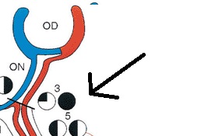

Classical teaching: once crossed, inferonasal fibers briefly loop back (Wilbrand’s knee) into contralateral optic nerve sheath, before returning to chiasm.
- Wilbrand’s knee is artifact: optic nerve axons from one eye can only be selectively studied after enucleation of contralateral eye and thus degeneration of the axons on one side - after several years, occurring optic nerve atrophy results in artifactual looping of axons into atrophic nerve.

Central scotoma: Junctional scotoma:
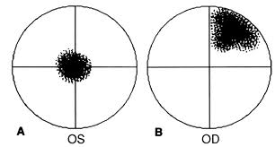
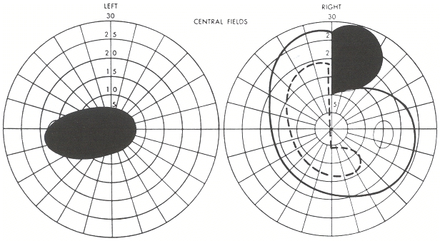

Normal blind spot is 1/3 above and 2/3 below horizontal midline.

Diagnosis
Optic Nerve & Visual Pathways Examination – see p. D1eye >> , p. Eye60 >>
ESR is especially important in visual loss in elderly - to rule out giant cell arteritis!

All visual pathway disorders require neuroimaging
- major exceptions: typical optic neuritis, classic anterior ischemic optic neuropathy, transient visual loss in migraine (if historical features are characteristic and neurological examination is normal).
- MRI ± gadolinium is preferred technique;
intraorbital process → MRI with gadolinium and fat suppression.
vascular disturbances → MRI-angiography, Doppler (→ formal angiography).
  - within orbit, nerve is ≈ 5 mm in diameter and is surrounded by fat.
- CT is helpful in fractures, bony erosion, calcification (e.g. meningiomas, craniopharyngiomas).
- PET or SPECT – demonstrate hypoperfusion in visual association cortex (e.g. in visual agnosias, achromatopsia, deficits in motion perception).
- Fluorescein angiography highlights choroidal & retinal vasculature - detects vascular occlusion, abnormal retinal pigmentation or hemorrhages, disturbances of retinal pigmented epithelium.
[truly swollen discs leak fluorescein, whereas, discs with pseudopapilledema do not]

Electrophysiology
electroretinogram (ERG) - measures rod & cone function; see p. Eye36 >>
- helps to distinguish retinal degenerations and dystrophies.

visual evoked potentials (VEP) - cortical activity in response to visual stimuli. see p. Eye60 >>

General Management
poor visual acuity - low vision aids: magnifiers, closed circuit televisions (enlarge written material without distortion that lenses do).

Dense homonymous hemianopia – base-out prism therapy (30-45 diopter base-out Fresnel press-on prism is placed on temporal half of eyeglass ipsilateral to hemianopia - projects images in blind half of vision into good half;
- patients use prism to notice novel objects in blind field; they then turn their head in that direction to use good field to see objects more clearly;
- use only in individuals who have normal mentation (otherwise method is confusing).

Visual occupational therapy & rehabilitation are relatively unhelpful.

Clinical Syndromes
Retinal disorders - see p. Eye63 >>

Optic Nerve
Clinical features of optic nerve dysfunction:
- blurred vision (visual acuity↓)
- decreased color perception
Color vision is impaired (dyschromatopsia) out of proportion to acuity loss! esp. red desaturation
N.B. color vision deficit is more sensitive indicator of optic nerve injury than loss of visual acuity!
- darkening (brightness↓) of vision
- decreased direct pupillary light reflex, i.e. relative afferent pupillary defect (Marcus Gunn pupil) – best shown with swinging-flashlight test – it seems that abnormal pupil dilates when light shines at it.
N.B. in afferent defects (i.e. optic nerve), both pupils are equal in size at all times! -because of hemidecussation of all afferent light input to midbrain → equal efferent stimulation through both CNIII (i.e. intact consensual light reflex)
- scotomas - central / cecocentral, or altitudinal (because arcuate or nerve-fiber-bundle abnormalities respect nasal horizontal line, corresponding to separation of upper and lower nerve-fiber bundles by horizontal raphe in temporal portion of retina).

- pain on eye movement is important symptom of optic neuritis!
- Pulfrich phenomenon - stereo-illusion caused by delayed conduction in one optic nerve, making it difficult to localize moving objects (e.g. objects moving in straight line may appear to have curved trajectory).
- Uhthoff phenomenon is possible (vision loss exacerbation by heat or exercise).

Etiologies:
bilateral abnormalities - hereditary, toxic, nutritional, demyelinating disorder;
unilateral abnormalities - ischemic, inflammatory, compressive disorder.

Papilledema (Choked Disk)
- optic nerve head swelling due to increased ICP (finding papilledema requires urgent further evaluation / intervention!)
N.B. term should not be used to describe optic disc swelling with underlying infectious, infiltrative, inflammatory etiologies!
- mechanism – subarachnoid space extends along n. opticus; pressure↑ in subarachnoid space:
axoplasmic flow stasis → intra-axonal edema;
v. centralis retinae compression → fluid leak into optic papilla.
- papilledema takes 6-24 hours to develop.
- following lowering of ICP, well-developed papilledema takes 6-10 weeks to regress.
- fails to develop in many patients (esp. elderly > 55 yrs, children < 3 yrs).
N.B. papilledema does not develop up to age 3 years (because open sutures & fontanelles accommodate ICP↑).

Clinical features
- almost always bilateral; unilateral papilledema - Foster Kennedy syndrome. see below
- vision is well preserved initially!!!
  - blind spot is enlarged!
  - some experience transient visual obscurations (graying-out of vision when rising from lying position, or transient flickering as if rapidly toggling light switch).
  - if ICP is not reduced, secondary optic atrophy and blindness occur.
ophthalmoscopy:
- elevated & widened, swollen, hyperemic optic papilla (no physiologic cup) with blurred margins.
- degree of disk elevation is determined by comparing highest plus lens needed to bring most elevated disk portion into sharp focus with lens needed to clearly see unaffected portion of retina.
- usual additional findings:
  - engorged tortuous nonpulsating retinal veins (venous stasis)
N.B. retinal venous pulsations, when present, imply that CSF pressure is normal, but their absence is not helpful diagnostically.
  - constricted arterioles
  - flame-shaped retinal hemorrhages around disk (but not into retinal periphery)
  - coarsening and opacification of nerve fiber layer.
- normal arterioles + normal BP help differentiate brain tumor from arterial hypertension.
- stereo color photographs are useful to document changes.

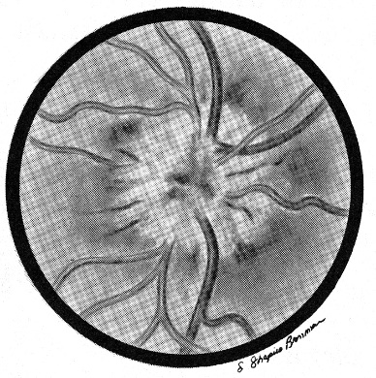

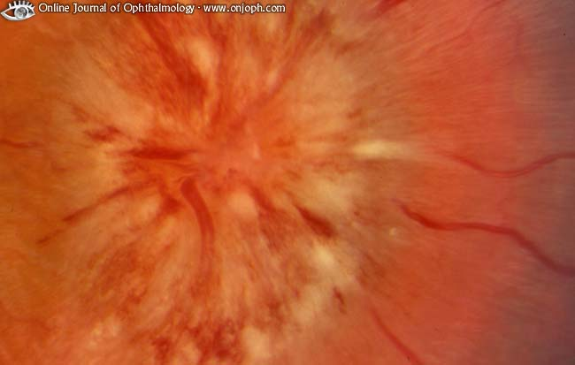
Source of picture: “Online Journal of Ophthalmology” >>

Glioblastoma - swelling of right optic disc appears chronic: only single hemorrhage, dilation of retinal veins minimal; chorioretinal striae present temporally:
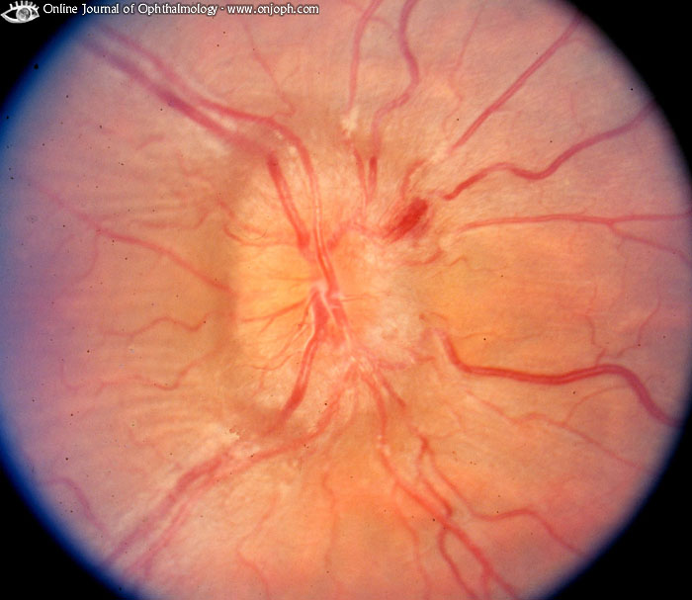
Source of picture: “Online Journal of Ophthalmology” >>

MRI with fat suppression and gadolinium: elevation and enhancement of both optic nerve heads; each optic nerve sheath is dilated by excess subarachnoid fluid:
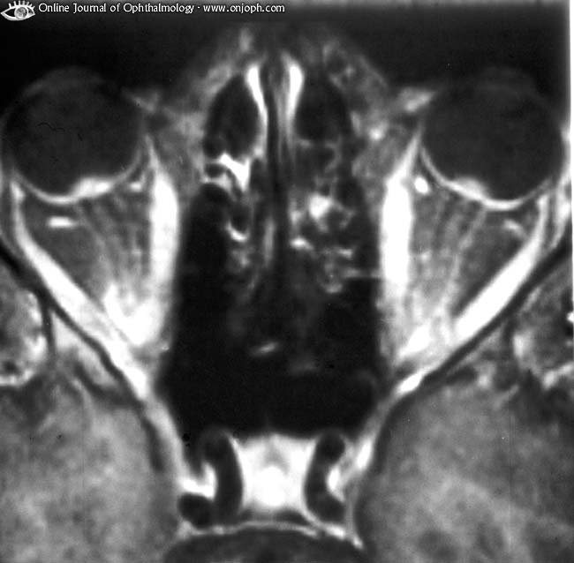
Source of picture: “Online Journal of Ophthalmology” >>

Disc nearly 30° in diameter; innumerable hemorrhages and cotton wool spots; incomplete nasal exudative macular star is present:
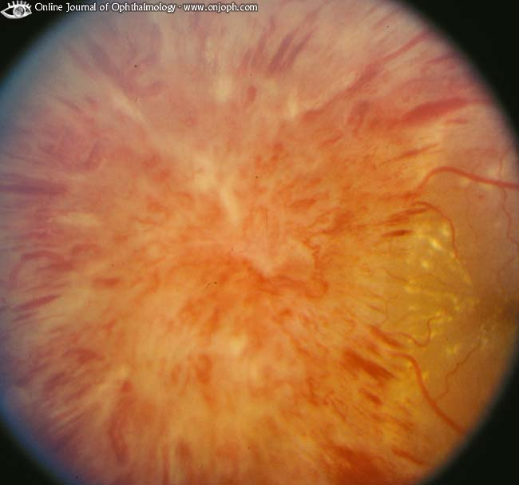
Source of picture: “Online Journal of Ophthalmology” >>

Tissue in front of lamina cribrosa more voluminous due to swelling of nerve fibers and vascular congestion; tissue bulges towards vitreous cavity and pushes retina sideways:
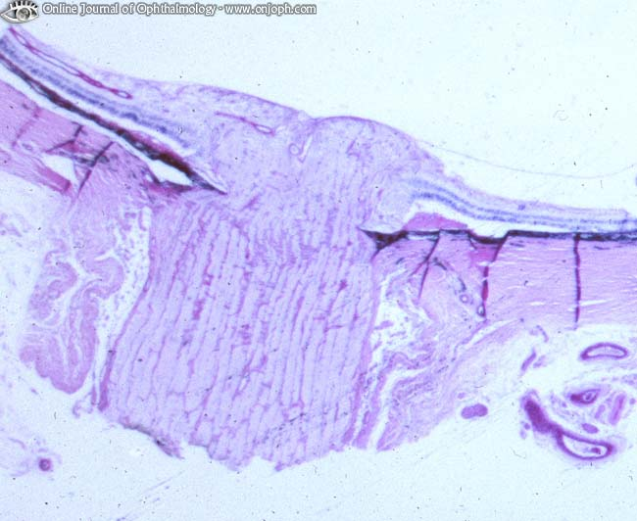
Source of picture: “Online Journal of Ophthalmology” >>

Pseudotumor cerebri - left optic disc with moderate chronic papilledema; Paton lines (arc-shaped retinal wrinkles concentric with disc margin) are seen along temporal side of inferior pole of disc:
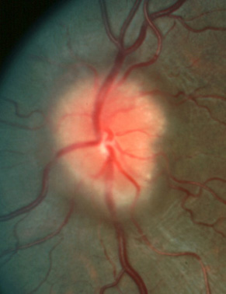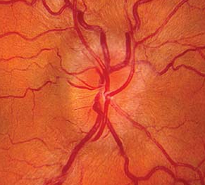

Pseudopapilledema
- optic disc swelling that simulates papilledema but is secondary to benign process.

Etiology
- cases often represent morphologic variant of normal!
- optic nerve enters eye at extremely oblique angle → tilted disc (prominently elevated nasal aspect with sunken temporal aspect).
- hyperopic eye → optic cup smaller than usual → crowding of axons (become elevated as they leave eye).
- partially myelinated nerve fiber layer (normally is translucent).
- buried disc drusen - small conglomerates of hyaline bodies (mucopolysaccharides & proteinaceous material derived from degenerated retinal pigment cells) within nerve substance → elevated disc; vision loss is possible; tend to enlarge and become calcified with advancing age.
.
Clinical Features and Examination
- most patients lack visual symptoms (vs. in papilledema), except in optic disk drusen - transient visual obscurations (rarely permanent visual loss).
- may be unilateral or bilateral (vs. papilledema – bilateral).
- extensive workup is usually unnecessary, ophthalmoscopy is enough:
  - disc is yellow, venous congestion is not present, spontaneous venous pulsations are often present;
  - peripapillary vessels are clearly seen (except in myelinated nerve fibers).
N.B. edema of nerve fiber layer that blurs disc margins and peripapillary vasculature is hallmark of true papilledema!!!
- B-scan ultrasonography detects buried disc drusen (calcified drusen have high reflectivity on ultrasound); drusen may autofluoresce on fluorescein angiography (buried disc drusen do not autofluoresce).

Drusen of optic nerve head:
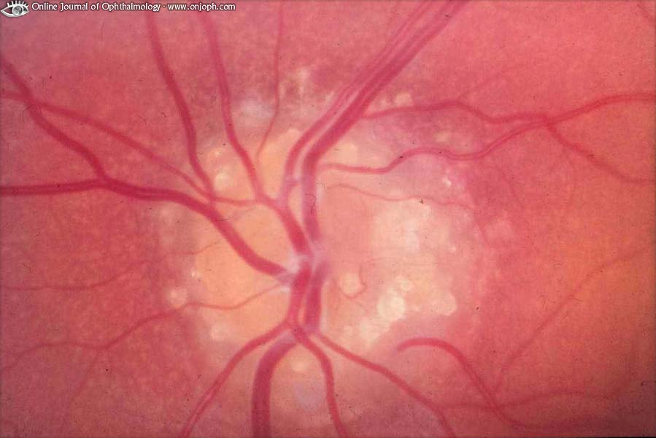
Source of picture: “Online Journal of Ophthalmology” >>

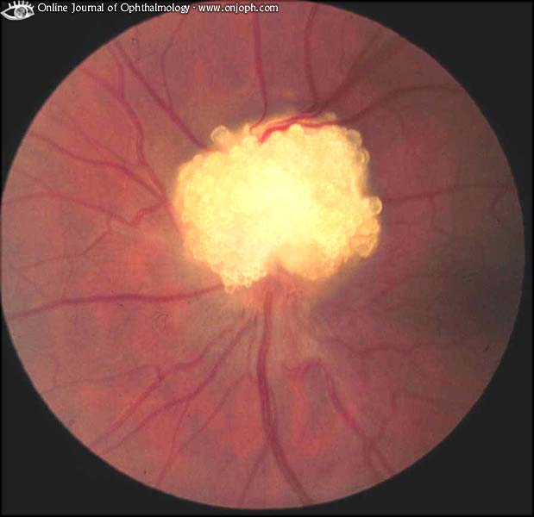
Source of picture: “Online Journal of Ophthalmology” >>

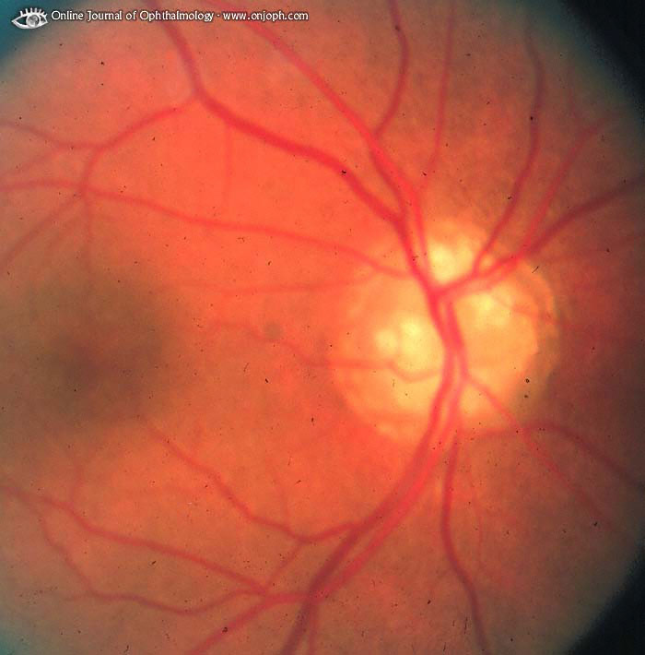
Source of picture: “Online Journal of Ophthalmology” >>

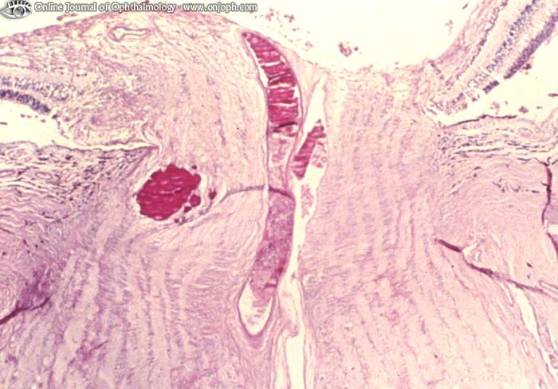
Source of picture: “Online Journal of Ophthalmology” >>

Treatment
- no treatment is needed.
- some patients with disc drusen present with progressive visual loss; unfortunately, no successful therapy is available.

Papillitis (Optic Neuritis)
- inflammation / infarction of optic nerve portion visible ophthalmoscopically.
- females comprise 60-75% cases.
- usually unilateral.
- bilateral cases:
- simultaneous – if occur within 3 weeks of each other
- sequential - if separated by > 3 weeks.

Etiology
  - demyelinating conditions, i.e. autoimmune reactions, resulting in demyelinating inflammation (multiple sclerosis, viral/postviral/postimmunization*) - young adult patients.
N.B. 13-85% patients with optic neuritis ultimately develop MS! see p. Dem5 >>
  - meningitis (e.g. syphilis, Lyme disease, tbc), adjacent inflammation of paranasal sinuses or orbit.
  - tumorous metastasis to optic nerve head.
  - collagenoses (e.g. SLE), sarcoidosis
  - idiopathic (in many cases it is forme fruste of MS)

*most common cause in children
Symptoms & signs
- major symptom - acute vision loss: small (para)central scotoma* → progression (up to complete blindness) maximal within 1-7 days → spontaneous gradual resolution (in weeks; in general, visual improvement begins in < 1 month after onset).
*almost any type of visual field defect is possible
- direct pupillary light reflex↓
relative (i.e. more pronounced in one eye) afferent pupillary defect is detectable in all unilateral cases; if not present, pre-existing optic neuropathy in the fellow eye should be suspected (e.g. subclinical demyelination in MS).
- pain on moving eye; in children headache is common.

Diagnosis
- Ophthalmoscopy:
  - disc edema, hyperemia (more noticeable changes in advanced cases); vs. in retrobulbar neuritis!
  - engorged pulsating veins - indicate that CSF pressure is less than venous pressure and probably normal (important difference form papilledema!!!).
  - disc edema is diffuse (segmental changes, arterial attenuation, splinter hemorrhages suggest other diagnoses!).
  - retina around papilla edematous.
  - few exudates and hemorrhages may be present near / on papilla.
  - no more than minimal vitreous cellular reaction.

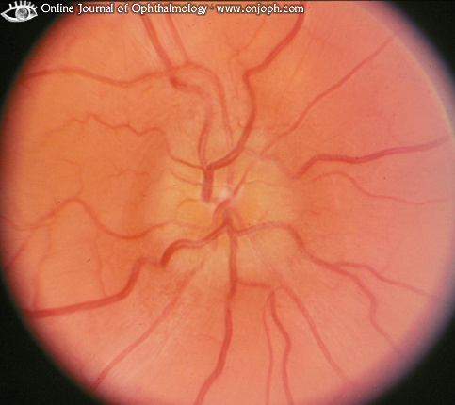
Source of picture: “Online Journal of Ophthalmology” >>

- MRI (with fat saturation techniques to help visualize gadolinium enhancement) – imaging technique of choice:
- may detect occult MS; because there is no effective method to prevent / delay MS, role of routine MRI in typical cases is debatable (MRI is warranted in atypical cases).
- helps exclude compressive causes.
- VEP (visually-evoked potentials) - loss of P100 response in acute phase; P100 recovers with time, but markedly prolonged P100 latency persists indefinitely.
- VEP may be diagnostic, even when MRI is normal!
- VEP may be abnormal without past history of optic neuritis (evidence of subclinical optic neuritis) - VEP is often performed in suspected diagnosis of MS.

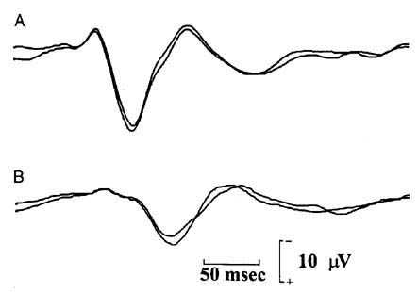 | A - normal subject;  B - patient with past history of optic neuritis (P100 response is prolonged to 146 msec).

- ESR↑ in cranial giant cell arteritis (→ temporal artery biopsy).

Treatment
- no treatment (esp. first episode of typical optic neuritis with only mild pain)
- intravenous* corticosteroids (methylprednisolone 1 g/d for 3 days; followed by oral prednisone taper for 11 days) - speed visual recovery but provide no lasting benefit to vision; also reduced rate of new neurologic events consistent with MS, but this beneficial effect also abates after 2 years.
*do not use oral prednisone alone - increases rate of recurrences!
- corticosteroids must be guided by neurologist / ophthalmologist because of complex relationship between dose and improvement (e.g. dependence on oral corticosteroids alone can lead to ↑recurrences).
- if brain lesions on MRI indicate high risk of developing clinically definite MS, consider immunomodulators (interferon β-1a, interferon β-1b, glatiramer acetate).

Prognosis (depends on etiology, early treatment):
- restored vision but not return to full normal! (frequent residual deficits in color vision, contrast sensitivity, light brightness sense, stereopsis; Uhthoff symptom*; visually evoked potential latency almost always remains prolonged).
- postneuritic optic atrophy with varying degrees of vision loss.
*warn patients about Uhthoff symptom so that they do not think they are having recurrence.
- 20% cases recur (with each episode, chances for visual recovery decrease - permanent total blindness may result).
- 75% female and 35% male patients ultimately develop MS! - attempt to diagnose MS following optic neuritis.

Retrobulbar Optic Neuritis
- inflammation of orbital portion of optic nerve.
Makes ≈ 2/3 of all optic neuritis cases (but only 35% in children).
Etiology, clinical features, treatment, prognosis ≈ papillitis.
- most cases are due to MS!!!; idiopathic cases are more common than with papillitis.
- ophthalmoscopy - fundus appears normal (vs. in papillitis). No disc swelling!!!
“Patient sees nothing, and doctor sees nothing”;
in recurrent cases optic atrophy may be visible.

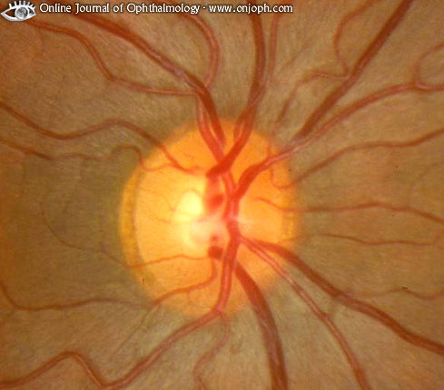
Source of picture: “Online Journal of Ophthalmology” >>

Adult Optic Neuritis | Pediatric Optic Neuritis
Unilateral | Bilateral
Retrobulbar optic neuritis | Papillitis
Pain on eye movements | Headache
Most often idiopathic | Most often postinfectious / postimmunization
High probability of MS | Low probability of MS

Optic Nerve Infarction (Anterior Ischemic Optic Neuropathy)
Etiology
– ischemic disorders, affecting posterior globe circulation* (principally short posterior ciliary arteries supplying optic nerve at its exit from eye):
- arteritic - temporal arteritis (in ≤ 50% cases visual loss is bilateral!) and other vasculitides.
- nonarteritic - painless** idiopathic (atherosclerosis is assumed to be in basis); structural susceptibility is suggested - crowded discs, with small, if any, physiologic cup; fellow eye is similarly affected after months or years.
*more posterior ischemia (posterior ischemic optic neuropathy) results in similar condition, without visible disc swelling.
**major difference from optic neuritis
Clinical Features
- patients usually older than 50 (most common acute optic neuropathy in older age groups!) – another difference from optic neuritis.
- visual defect – altitudinal (occasionally centrocecal), sudden in onset, and stable (occasionally progressive during initial weeks) with little recovery.

Diagnosis
ophthalmoscopy: pallid (chalky white) disc swelling (no hyperemia!!!) with adjacent superficial hemorrhages (A) → swelling resolves in 4-6 weeks → optic atrophy with arteriolar narrowing on disc (B):
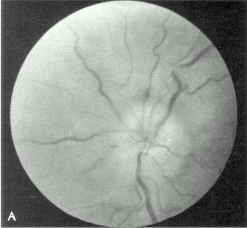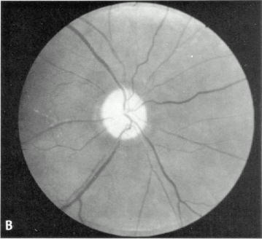

Classic appearance of arteritic AION - pallid disc swelling, absent hemorrhage, minimal opacification of nerve fiber layer (preserved visibility of retinal vessels near disc margin), focal areas of choroidal ischemia (temporal and superior to disc):
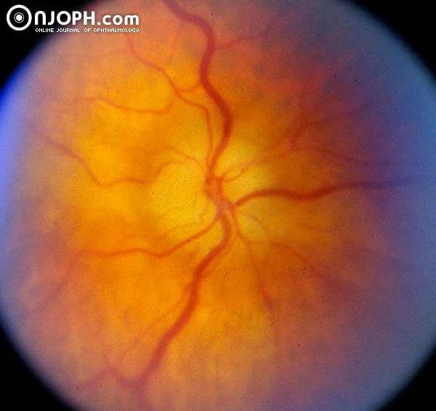
Source of picture: “Online Journal of Ophthalmology” >>
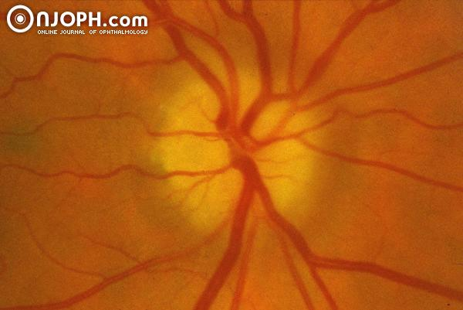
Source of picture: “Online Journal of Ophthalmology” >>

Features of nonarteritic variant:
sectorial disc edema (especially of superior disc), small cup disc ratio, more pronounced hemorrhages:
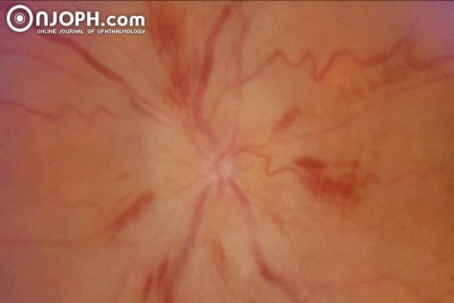
Source of picture: “Online Journal of Ophthalmology” >>

segmental disc edema and hemorrhage:
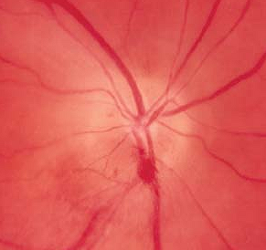

fluorescein angiography distinguishes arteritic form (markedly prolonged choroidal filling time) from nonarteritic.

ESR > 40 mm/h → temporal artery biopsy – for temporal arteritis.

Treatment
- temporal arteritis → early corticosteroids (other eye is at risk until treatment is started!).
- steroids have no place in nonarteritic form.
- optic nerve fenestration was advocated until completion of Ischemic Optic Neuropathy Decompression Trial (IONDT) - this study conclusively showed no effect of surgery.
- use aspirin to prevent other eye involvement.
- visual loss is stable - little can be performed to treat it (very frustrating disease)!

Compressive Optic Neuropathy
- optic nerve is most vulnerable to compression where it is adjacent to / surrounded by bone and is relatively immobile.
- ischemia → disruption of axonal transport.

Etiology
- thyroid ophthalmopathy - most cases!
- malignancies - optic nerve gliomas (esp. children), optic nerve sheath meningiomas, solid orbital tumors
- inflammatory / infiltrative processes, sarcoidosis
- cavernous hemangiomas
- trauma

Causative lesions are quite rare, but when they occur blindness is not uncommon!

Clinical Features
- slowly progressive* visual loss (rarely, sudden visual loss – e.g. pituitary apoplexy, bleeding optic nerve glioma; in optic neuritis visual loss continues < 2 weeks):
- visual acuity↓
- visual field defects (most common - central scotoma, enlarged blind spot, constriction; but nearly all types of visual field abnormalities can occur!).
- dyschromatopsia
* delay in diagnosis (patients incidentally discover their visual loss when one eye becomes blind!)
- relative afferent pupillary defect.
- axial proptosis is not uncommon (per se may cause hyperopic shift).

Diagnosis
Ophthalmoscopy:
- disc appears normal or pale; disc may be swelled.
Unilateral optic disc swelling must be investigated promptly with CT / MRI!
- in chronic cases – optic atrophy.
Incidentally discovered optic atrophy must be examined to exclude compression!
- optociliary shunt veins (optochoroidal collaterals) – classic sign of optic nerve sheath meningioma.
Imaging:
- plain x-ray studies (play little role) - asymmetric enlargement of optic foramen, hyperostosis of optic nerve canal.
- CT better illustrates bony detail
- MRI better delineates soft tissue lesions.
- optic nerve sheath meningiomas - "tram tracking" on axial views, "target sign" on coronal views.
- optic nerve glioma – kinking on sagittal views, fusiform nerve enlargement on axial views, diffuse enhancement on coronal views.
- thyroid ophthalmopathy - characteristic pattern of extraocular muscles enlargement.

Treatment
- prescribe polycarbonate safety glasses to protect vision in remaining eye.
- corticosteroids are useful (esp. in inflammation, thyroid ophthalmopathy*, lymphoma, sarcoid); vision improves only to deteriorate again when steroids are withdrawn!
N.B. compressive lesions must be in differential diagnosis of all corticosteroid responsive optic neuropathies!
- orbital tumors → orbital surgical decompression.
*definitive procedure for thyroid ophthalmopathy is orbital decompression!
- practical approach if imaging strongly indicates meningioma - follow with serial visual acuity measurements and field testing - if visual loss progresses → radiation; if growth continues → surgery (but it often results in further vision loss).
Optic canal decompression is extremely risky - not uncommonly results in loss of any remaining vision!
Adequately inform patient that vision may deteriorate despite surgery or radiation!

Toxic / Nutritional Optic Neuropathy (s. Alcohol-Tobacco Amblyopia)
- reduction in visual acuity due to toxins or vitamin deficit.
- most damaged is papillomacular bundle of optic nerve (possible mechanism – damage to ganglion cells in macular retina; others think that ganglion cell loss is secondary).
- bilateral.

Etiology
- most often in patients who use alcohol / tobacco excessively – alcoholic malnutrition [e.g. vit. B₁₂, B₁, folic acid] + toxins in tobacco* [e.g. cyanides]. *role of tobacco is questionable
- also other chemicals (e.g. lead, methanol, ethambutol, isoniazid, chloramphenicol, amiodarone, digitalis), pernicious anemia (vit. B₁₂ deficiency).

Clinical Features
- subacutely enlarging bilateral centrocecal scotomas (involving both fixation and blind spot); may become absolute → blindness.
- dyschromatopsia – constant feature!
- peripheral visual fields normal!
- no pain!
- other syndromes of nutritional deficiency (predominantly sensory polyneuropathy).

Diagnosis
- ophthalmoscopy – no abnormalities (temporal disk pallor may develop later).
- although imaging studies yield normal results, they almost always are indicated (esp. MRI), unless one is absolutely certain of diagnosis.

Treatment
- cause removal (e.g. absolute withdrawal of alcohol / tobacco, chelation therapy in lead poisoning).
- B vitamins + well-balanced high in protein diet.
- substantial recovery is possible.

Optic Atrophy (Optic Nerve Atrophy)
- sign of chronic optic nerve disease (search for cause!)
- seen at least to some degree in all chronic optic neuropathies (when duration ≥ 4 weeks).
- visual loss is roughly proportional to degree of nerve atrophy (little vision loss ÷ total blindness).
- dramatic vision return can accompany treatment (e.g. relief of pressure caused by tumor).

Ophthalmoscopy - death of optic nerve fibers leads to loss of tiny disc vessels:
primary optic atrophy (pathology distant from papilla – atrophy is retrograde) - disk is white* with sharp edges; lamina cribrosa clearly visible in physiologic cup; normal retina.
secondary optic atrophy (pathology at retina - atrophy is antegrade) - disk is dirty-white* with irregular, indistinct margins, covered by glial tissue that conceals lamina cribrosa.
*disappeared axons and accompanying capillaries (white sclera is visible)
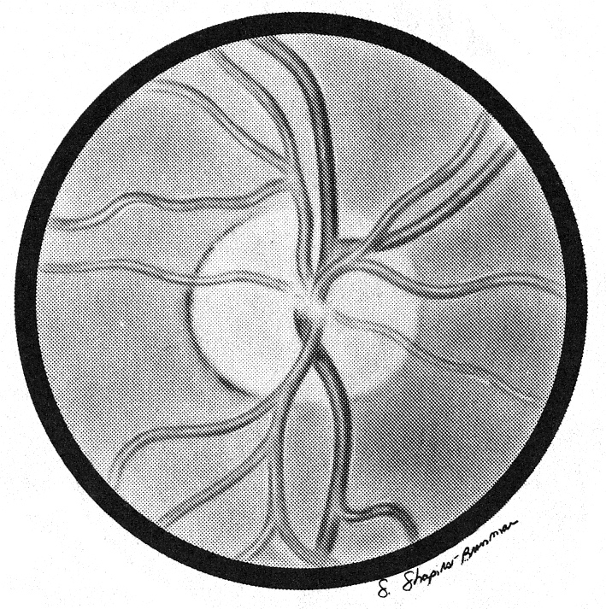

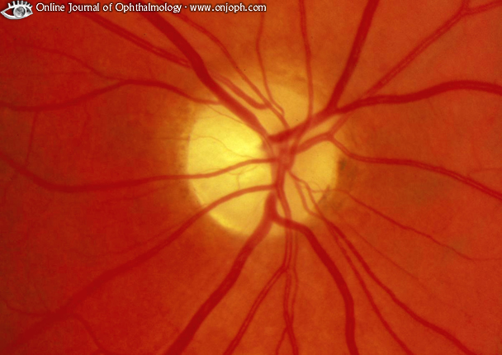
Source of picture: “Online Journal of Ophthalmology” >>

- in macular degeneration (papillomacular bundle disappearance) – disk becomes white on its lateral side.

Pseudotumor cerebri - optic disc with postpapilledema optic atrophy; diffuse disc pallor and absence of small arterial vessels on surface, with very little disc elevation; disc margin at upper and lower poles and nasally obscured by residual edema in nerve fiber layer and gliosis that often persists even after all edema has resolved:
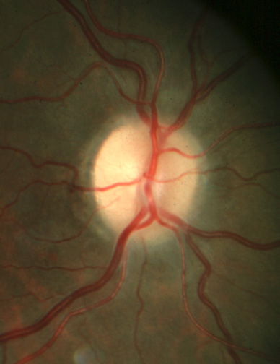

Leber hereditary optic atrophy
- hereditary degeneration of optic nerve & papillomacular bundle → rapid bilateral painless loss of central vision (progressive for several weeks, but not to blindness) → permanent cecocentral scotoma (i.e. ≈ bilateral sequential optic neuritis with little recovery*).
*recovery from blindness is possible (depends on mutation involved).
- point mutation in mitochondrial DNA with much genetic heterogeneity (at least 8 different genes) – maternal inheritance.
- onset in adolescence or early adulthood, but may be after 60 yrs.
- males >> females for unclear reasons (linkage to X-chromosome locus is not proven; sex differences explained more by sex-related physiological differences).
- rarely, additional neurological features - signs suggestive of multiple sclerosis, multisystem atrophy, bilateral striatal necrosis, MELAS.
- ophthalmoscopy – papillary edema* with peripapillary telangiectasias** → optic atrophy.
* due to impaired axonal transport, not due to abnormal vascular permeability.
** may long antedate visual loss.
- diagnosis – mtDNA mutation detection;
- failure to demonstrate mutation does not exclude diagnosis in familial cases with maternal inheritance.
- in sporadic cases, there is no way to distinguish Leber from other optic neuritides except by demonstrating mtDNA mutation.
N.B. there are no ragged-red fibers (vs. many other mitochondrial diseases)!!!
- avoid tobacco and alcohol abuse in family members at risk.

Foster Kennedy syndrome
- combination of optic disc atrophy and contralateral papilledema.
- culprit lesion is subfrontal tumor (typically orbital or skull base meningioma) - compresses ipsilateral optic nerve (causing disc atrophy).
- when lesion is large enough to cause elevated ICP, papilledema results in contralateral eye (ipsilateral optic nerve cannot swell because it is atrophic).

Pseudo-Foster Kennedy syndrome - nontumor causes; e.g. consecutive anterior ischemic optic neuropathy (new ischemic disc swelling in one eye accompanied by longstanding disc atrophy resulting from previous event in other eye).
- differentiated from tumor by finding altitudinal visual loss in eye with papilledema.

Optic Nerve Hypoplasia
- abnormally small optic nerve heads surrounded by mottled yellowish peripapillary halo, bordered by ring of hyperpigmentation or hypopigmentation (“double ring” sign).
- exclude CNS midline defects (e.g. abnormal hypothalamic-pituitary axis).

Optic Chiasm
- bitemporal field defects that respect vertical meridian (patients are often without visual complaints!)
- any visual loss accompanied by endocrinopathy.
- most commonly caused by sellar / suprasellar compressive masses:
pediatric population - chiasmal-hypothalamic gliomas, craniopharyngiomas.
middle-age to elderly-age patients - pituitary adenomas, internal carotid aneurysms, craniopharyngiomas, meningiomas.
- visual loss - insidious (rapid onset suggests pituitary apoplexy) bitemporal hemianopia.
N.B. "tunnel vision" is also classic visual field defect in malingering or psychogenic cases!
- exact visual loss pattern depends both on chiasm position (prefixed, postfixed) and process nature and location:
prefixed chiasms or more posteriorly situated lesions → optic tract syndromes, central hemianopic scotomas.
postfixed chiasms or more anteriorly situated lesions → optic neuropathy, junctional scotoma (involvement of ipsilateral optic nerve and Wilbrand knee).
- asymmetrical lesions may produce ipsilateral afferent pupillary defect.
- chronic processes may lead to optic atrophy.
- medical / surgical decompression may provide partial or complete visual recovery.

Optic Tract / Lateral Geniculate Body
- complete lesions → dense contralateral homonymous hemianopias;
awareness of defect is varying - patient may be aware only of bumping into things on that side or of trouble reading (difficulty seeing next word with right hemianopia, or difficulty finding next line with left hemianopia).
partial lesions → incongruous homonymous hemianopias.
further posterior lesion is, more congruous is defect (because fibers from corresponding retinal loci in two eyes converge on same occipital locus).
- causes (of optic tract compression) - sellar & parasellar masses (esp. craniopharyngiomas and aneurysms), demyelination, ischemia.
- visual acuity is normal in isolated tract lesions.
- Wernicke sign - hemianopic pupillary reactivity - loss of pupillary constriction when light is directed to blind side of retina; pupillary constriction is maintained when light stimulates normal side.
N.B. sign cannot be seen with bright light - because of intraocular scatter onto seeing half of retina!
- with optic tract lesions (anterior to geniculate synapse) bilateral optic atrophy develops:
ipsilateral temporal pallor
contralateral “bow-tie" optic atrophy - nasal disc pallor due to loss of nasal fibers; mild temporal pallor is more evident due to loss of nasal half of papillomacular bundle; imaginary vertical line through macula corresponds to vertical line that separates nasal and temporal halves of visual field; relatively pink appearance above and below where fibers from temporal retina reach disc.
- clinically difficult to distinguish between lateral geniculate and tract syndromes, but two exceptions owe to geniculate's dual vascular supply:
anterior choroidal artery infarction → upper / lower homonymous sectoranopias.
lateral choroidal artery infarction → congruous homonymous horizontal wedge-shaped sectoranopia.

Optic Radiations
- complete interruption → dense homonymous hemianopia.
- lesion of Meyer's loop → congruous or incongruous contralateral homonymous hemianopia denser superiorly (“pie-in-the-sky” defect).
- lesions of parietal lobe → defects more prominent inferiorly.
- visual acuity is spared in unilateral lesions.
- pupillary responses are normal, no optic atrophy develops.

Occipital Lobe
Unilateral lesion → congruous contralateral homonymous hemianopia respecting vertical meridian.
N.B. patients frequently mistake homonymous visual loss as monocular deficit!
Bilateral lesions → cortical blindness (intact pupillary light responses!);
patients may confabulate visual perceptions or deny their blindness (Anton syndrome).
Lesions of upper / lower calcarine banks → quadrantanopias.
Unilateral occipital lobe tip lesion → homonymous hemianopic central scotomas.

N.B. lesions of upper or lower calcarine banks produce quadrantic defects (altitudinal hemianopias) respecting horizontal meridian, whereas lesions within temporal / parietal lobes cause field defects, which tend not to respect horizontal meridian.

- acuity is preserved with unilateral occipital lobe damage.
- optokinetic response is normal; if cause is occipital lobe mass with edema extending into parietal lobe → abnormal optokinetic response when targets are drawn ipsilaterally to lesion (Cogan's rule).
- unusual features:
- unconscious vision in blind hemifield (blindsight).
- recovery of motion perception (Riddoch phenomenon).
"second" visual pathway (more primitive, retinal-tectal-pulvinar subcortical, extrastriate) has been proposed as possible explanation.

PCA infarction (causes 90% cases) → hemianopia with macular sparing (rather than macular splitting) - specific to occipital lobe-related hemianopias - proposed mechanisms:
  - dual vascular supply of occipital poles
  - bilateral representation of maculae
  - test artifact due to poor central fixation by patient.

Migrainous phenomena can involve occipital lobes - transient hemianopic phenomena (e.g. scintillations, phosphenes).

Higher Cortical Lesions
- if striate cortex is involved → visual field defects, but visual complaints cannot be explained by field loss alone.

Inferior occipital lobe dysfunction, involving lingual & fusiform gyri → contralateral homonymous upper quadrantanopia + abnormal color vision in contralateral hemifield (cerebral hemiachromatopsia).

Left-sided lesions with splenium of corpus callosum involvement (or adjacent periventricular white matter) → alexia without agraphia (s. pure alexia, "word blindness").

Bilateral medial occipitotemporal lesions disrupting inferior longitudinal fasciculus → visual agnosia;
lateral occipitotemporal lesions → defective motion perception.

Large right parietal lesions → hemineglect ± hemianopia.
- neglect severity ranges: complete inattention to all stimuli in left hemifield ÷ subtle visual neglect of objects to left only when stimuli are presented simultaneously on both sides of midline (double simultaneous stimulation).
- experimental treatment - vestibular stimulation (e.g. by cold water).

Bilateral occipitoparietal (superior occipitotemporal) lesions (visual association area important for visual attention and foveal refixation) → Balint syndrome: see p. Eye64 >> , p. A156 (2) >>
  - optic ataxia (defect in reaching under visual guidance – i.e. defective smooth pursuit in all directions)
  - simultanagnosia (inability to recognize whole picture despite ability to perceive its parts) + inability to avoid objects seen in one's path.
  - oculomotor apraxia / ocular ataxia (defect in voluntary eye movements - inability to direct eyes to precise point in visual field); in general, intentional saccades are relatively preserved.
- lesions commonly involve upper banks of occipital cortex → inferior altitudinal field defects.
- usual cause - watershed infarctions (in border zone between MCA and PCA territories bilaterally); less commonly - embolic occlusion of top of basilar artery.

Psychogenic Visual Loss
- subconscious (hysteria, s. conversion)
- deliberate and willful (malingering).

- when questioned, patients often repeat, "I don't know".
- most commonly:
- complete loss of vision (malingering - often unilateral; hysteria (conversion) - bilateral)
- visual field defects such as constricted fields ("tunnel vision" is classic nonphysiologic visual field defect!)
- monocular diplopia.

Differential tools to detect nonorganic causes
“Binocular blindness”
- Threat reflex - approaching examiner's hand* (or bright light) directed into “blind” eye causes blink response. *be careful not to elicit corneal reflex by gust of air!
- Present optokinetic nystagmus!
- Holding mirror in front of patient and gradually moving it - vision must be present if eyes fixate on mirror and track.
- Normal direct and consensual light response (but also present in cortical blindness).
- Can read only top line on Snellen chart regardless of its distance!!!

True organic bilateral visual loss:
- patient attempts protection from environment (wide-based gait with hands held for protection) and do not purposely run into doors, examiners, or other people.
- because of auditory tracking, blind person can look at face of someone who is talking.
- blind patients look at parts of their own body, such as hand.

“Monocular blindness”
- Threat reflex – see above
- Normal direct pupillary light reflex.
N.B. malingering patients may instill mydriatic drops in their eyes! (H: pupils will not constrict with pilocarpine)
- EEG - light shone into normal eye causes dampening of posterior dominant α rhythm.
- Psychogalvanic skin reflex - electrode placed on skin to measure sympathetic response when bright light is shone into eye; normal response produces deflection; no response is expected from blind eye.
- VEPs may also be helpful (but abnormal responses can be intentionally generated).
- Tests that require binocularity (unbeknownst to patient!):
- Titmus test - perception of nine of nine stereo dots requires 20/20 vision in both eyes.
- Worth four-dot test - patient views red and green lights through red glass over right eye and green one over left (it is impossible for individual with one blind eye to see red and green dots simultaneously).
- prism is placed over “blind” eye while patient reads Snellen chart:
  - reading continues uninterrupted if eye is blind;
  - if eye is normal, patient pauses while refixating.
- fog good eye secretively (with +10.00 diopter lens), then ask to read Snellen chart with both eyes - any line read correctly must have been seen by “blind” eye.

“Poor vision”
- Schmidt-Rimpler test (tests proprioception more so than vision!):
  - ask patient hold up his / her hand while instruct to look at it – “functional” patient looks everywhere but directly at hand
  - ask patient to touch two index fingertips together – “functional” patient performs improperly.
- Fixation of patient's eyes on his or her reflected image during "swinging mirror" test.
- Lack of normal linear improvement of Snellen visual acuity with decreasing distance or increasing letter size (e.g. if patient correctly identifies 20/100 letter at 20 feet, he should equally identify 20/50 letter at 10 feet).
- Normal color vision & stereoacuity despite severely affected Snellen acuity.
- Optokinetic nystagmus using optokinetic nystagmus (OKN) strip.
N.B. optokinetic nystagmus is preserved in hysterical blindness!

“Monocular diplopia” (although may have rare identifiable causes - dislocation of natural or artificial lens, buckling of retina, some occipital lobe lesions) is considered nonphysiologic, esp. when do not resolve with pinhole.

“Monocular hemianopia” if present while testing “involved” eye, absent while testing unaffected eye, then present again when testing under binocular conditions is nonphysiologic.

“Tunnel” vision - tangent screen testing - lack of physiological expansion of patient's perceived visual fields when target size and distance from screen are doubled (i.e. tunnel size remains same at all focal lengths).

Bibliography for ch. “Ophthalmology” → follow this link >>

Viktor’s Notes℠ for the Neurosurgery Resident
Please visit website at www.NeurosurgeryResident.net

