Retinal Disorders
Last updated: May 9, 2019
Central Retinal Artery Occlusion (CRAO) 1
Pathophysiology & Ophthalmoscopy 1
Etiology 2
Clinical Features 2
Diagnosis 2
Treatment 2
Branch Retinal Artery Occlusion 3
Central Retinal Vein Occlusion (CRVO) 3
Pathophysiology & Etiology 3
Clinical Features 3
Diagnosis 3
Treatment 3
Complications 4
Classification 4
Retinal Detachment 4
Etiology & Pathophysiology 4
Clinical Features 4
Diagnosis 4
Treatment 5
Retinitis Pigmentosa 6
Clinical Features 6
Diagnosis 6
Treatment 7
Age-Related Macular Degeneration (ARMD) s. Senile Macular Degeneration 7
Pathophysiology 7
Clinical Features 7
Diagnosis 7
Treatment 9
Prevention 9
Retinopathy Of Prematurity (ROP), s. Retrolental Fibroplasia 9
Pathophysiology & Etiology 9
Prognosis 9
Neuroretinitis (s. Papilloretinitis) 9
Retinoblastoma 10
Diagnosis 10
Screening 11
Treatment 12
Follow-up, Prognosis 12
Color Blindness 12
Etiology 12
Giant cell arteritis – see p. 1182 (1) >>

- retina-related visual loss is painless and almost always associated with abnormality on funduscopic examination (esp. in acute setting).
- macular lesions cause afferent pupillary defect only very late in course (vs. optic nerve lesions - afferent pupillary defect even with apparently normal vision).
- retinal ischemia / hemorrhages provoke neovascularization (proliferation of new vessels lacking proper support → rupture, etc).

Central Retinal Artery Occlusion (CRAO)
Pathophysiology & Ophthalmoscopy
- loss of blood supply to inner layer of retina.
- ophthalmic artery (first branch of internal carotid artery) enters orbit through optic canal (underneath optic nerve).
- central retinal artery (first intraorbital branch of ophthalmic artery) enters optic nerve 8-15 mm behind globe – direct supply to retina.
- short posterior ciliary arteries (branch more distally from ophthalmic artery) supply choroid; anatomical variant (≈ 14%) - cilioretinal artery (branch from short posterior ciliary artery) - additional supply to macula from choroidal circulation.
  - 25% eyes with CRAO have cilioretinal artery!
  - if cilioretinal artery supplies fovea, visual acuity (central vision) in 80% returns to 20/50 (or better) over 2-week period.
fovea is the only part with 20/20 vision!

Acute stage - inner retinal layer edema, ganglion cell nuclei pyknosis.
pale, opaque fundus with red fovea
- ischemic necrosis - retina becomes opacified (yellow-white “ground glass” retina); opacity most dense in posterior pole (more thick nerve fiber layer and ganglion cells); opacification takes 15 minutes ÷ several hours to become evident.
irreversible cell injury occurs after 90-100 minutes of total CRAO
- foveola assumes cherry-red spot (pigment of intact retinal epithelium & choroid seen through thin macula ± foveolar retina may also be nourished by choriocapillaris).
- arteries are attenuated and may even appear bloodless.
- boxcar appearance of blood column (blood column segmentation) can be seen in both arteries and veins (sign of severe obstruction).
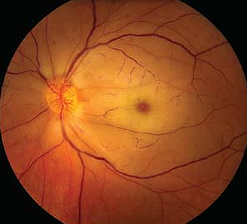

- emboli at retinal vascular bifurcations (can be seen in ≈ 20%):
yellow (Hollenhorst plaque) – cholesterol plaque – most common emboli!
white – calcium, talc (from intravenous drug abuse).
fluffy – platelet fibrin
red – sickle cells, thromboembolism

Branch retinal artery occlusion with Hollenhorst plaque:
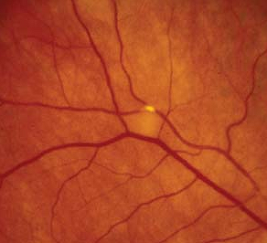

Chronic stage - homogenous scar replacing inner retinal layer (i.e. retinal opacification resolves in 4-6 weeks), optic nerve pallor may be the only sign left.
- retinal pigment epithelium is unaffected (pigmentary changes are absent).

Etiology
Comorbid diseases:
- systemic hypertension (≈ 67%)
- diabetes mellitus
- cardiac valvular disease (≈ 25%), cardiac anomalies (such as patent foramen ovale)
- atrial fibrillation, endocarditis
- hypercoagulable states (sickle cell anemia, antiphospholipid antibodies, polycythemia) - more common in patients < 30 years.
- atherosclerotic disease is leading cause in patients 40-60 years.

1. Embolism
- associated with poorer visual acuity, correlates with higher morbidity and mortality (56% mortality rate over 9 years, vs. 27% in patients without arterial emboli).
- emboli from heart - most common cause in patients < 40 years.

2. Thrombosis
- temporal arteritis (patients > 65 years)!!!
- rare causes:
- Behçet disease
- syphilis
- increased intraocular pressure:
  - glaucoma
  - prolonged direct pressure to globe in unconscious patients (e.g. drug-induced stupor, improper positioning during surgery).

3. Vasospasm (e.g. migraine).

Clinical Features
- sudden, severe, persistent, painless vision loss.
- vision loss is sudden (in seconds of occlusion), in range of counting fingers ÷ light perception; if visual acuity is even worse - consider ophthalmic artery occlusion.
- 1-2% bilateral.
- afferent pupillary defect (Marcus Gunn pupil) may precede funduscopic retinal changes by 1 hour.
- mean age - early 60s.
- some patients reveal preceding episodes of amaurosis fugax (transient ischemic blindness).

Diagnosis
- perform systemic examination for temporal arteritis (ESR is absolutely necessary test!!!)
- in case of emboli, listen for carotid bruits & cardiac arrhythmias.
- laboratory studies are helpful in determining etiology: CBC, ESR, coagulation studies, etc.

Fluorescein angiogram
- delay in retinal arterial filling.
- normal choroidal filling (normally begins 1-2 seconds before retinal filling and completely filled within 5 seconds); significant delay (> 5 sec) in choroidal filling - consider ophthalmic artery occlusion / carotid artery obstruction.
- arteriovenous transit time↑ (< 11 seconds is normal).
- arterial narrowing with normal fluorescein transit after recanalization.

Electroretinogram - diminished b-wave (Muller and/or bipolar cell ischemia).

Treatment
- must be very urgent!!!
Mainstay of therapy – reducing intraocular pressure - allows greater perfusion (pushing emboli further down).
  - controversy exists regarding optimal window of treatment, but treatment may help up to 24 hours.

Procedures
      - Intermittent digital massage over closed eyelids
- forces humor into canals of Schlemm, can dislodge embolus further down arterial circulation.
- direct eye pressure for 5-30 seconds, then release; repeat several times.

- Anterior chamber paracentesis
- local anesthesia; 30-gauge needle on tuberculin syringe.
- enter at limbus with bevel up (do not damage lens!).
- withdraw fluid until the anterior chamber shallows slightly (0.1-0.2 cc).
- postprocedure topical antibiotic.

- Intra-arterial fibrinolysis (controversial)

Conservative Measures
- Immediate lowering of intraocular pressure (as in glaucoma)
  - acetazolamide 500 mg (IV or PO) once.
  - topical medications (e.g. dorzolamide, apraclonidine, dipivefrin, timolol).
  - if no drug lowers IOP → mannitol rapidly IV after test dose.

- Increasing oxygenation
- 100% O₂ inhalation at 2 atm. (some studies show 40% improvement of visual acuity).
- hyperbaric oxygen therapy (beneficial if begun within 2-12 hours → increased visual recovery).
- carbogen therapy (5% CO₂, 95% O₂): CO₂ dilates retinal arterioles, O₂ increases oxygen delivery to ischemic tissues - perform for 10 min every 2 hours for 48 hours.

- some also advocate aspirin in acute phase.
- if temporal arteritis is suspected / confirmed → corticosteroids.

Further Care
- ischemic damage produces angiogenesis factors → abnormal vascularization - repeat examination in 1-4 weeks - checking for neovascularization of iris (20%; detected best on undilated iris) or optic disc (2-3%) – if it occurs → panretinal photocoagulation.
- patients must understand that prognosis for visual recovery is poor and that visual changes are result of systemic process that needs treatment.

Branch Retinal Artery Occlusion
- often caused by embolus (original or dislodged during CRAO treatment).
- fundus abnormalities are limited to that sector of retina → permanent subtotal visual field loss (unless occlusion is relieved).
- treatment is the same as for CRAO.

Roth spots – hemorrhagic retinal infarcts (emboli from infective endocarditis) – white spots surrounded by hemorrhage.

Central Retinal Vein Occlusion (CRVO)
Pathophysiology & Etiology
- blockage of central retinal vein → blood stagnation and ischemia of inner retinal layers.
- central retinal artery and vein share common adventitial sheath (as they pass through narrow opening in lamina cribrosa) - vessels are in tight compartment with limited space for displacement - predisposes thrombus formation in central retinal vein.

- Vein compression:
  - most common CRVO cause - central retinal artery atherosclerosis (in diabetes mellitus, hypertension) transforms artery into rigid structure that impinges upon pliable central retinal vein → thrombus formation.
  - structural changes in lamina cribrosa (e.g. glaucomatous cupping).
  - inflammatory optic nerve swelling
  - orbital disorders.

- Hemodynamic disturbances (hyperdynamic or sluggish circulation).

- Vessel wall changes (e.g. vasculitis).

- Changes in blood (hyperviscosity, ↓thrombolytic factors, ↑clotting factors).

- Idiopathic (resembling retinal phlebitis) - in young persons.

- clot dissolution, formation of optociliary shunt vessels may restore circulation.

Clinical Features
- monocular painless subacute variable visual loss.
- less abrupt than in arterial obstruction (evolves over hours); patients can present with transient vision obscurations initially, later progressing to constant visual loss.
- vision is more preserved (than in CRAO) and pupillary light reflex is ≈ normal.
- usually in elderly patients (> 90% are > 50 yrs).

Diagnosis
- no laboratory studies are indicated routinely.
- ophthalmoscopy:
  - dilated tortuous retinal veins
  - congested edematous fundus (incl. macular edema and optic disc edema).
  - numerous retinal hemorrhages (superficial, dot and blot, and/or deep) along veins, extending all over fundus ("blood and thunder" or “stormy sunset” appearance)
  - cotton wool spots (concentrated around posterior pole)

Central retinal vein occlusion: Branch retinal vein occlusion:
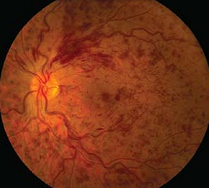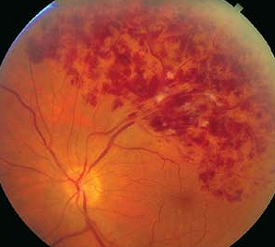

- fluorescein angiography - most useful test for CRVO classification – detects areas of retinal capillary nonperfusion (hypofluorescence), posterior segment neovascularization, and macular edema (as leakage from perifoveal capillaries).
N.B. in acute stages, hemorrhages can block fluorescence (false-positive hypofluorescence) - fluorescein angiography is not useful in acute stages!
- electroretinography - amplitude of b wave↓ (b-to-a ratio < 1).

Treatment
- no generally accepted medical therapy!!!
- different authors advocate – aspirin, systemic anticoagulation, local anticoagulation (intravitreal alteplase), fibrinolytic agents, systemic corticosteroids, NSAIDs, isovolumic hemodilution, plasmapheresis, intravitreal injection of triamcinolone, intravitreal injection of bevacizumab (effective not only in resolving the edema but also in corresponding improvement in vision!).

FDA has approved ranibizumab (Lucentis®) injection - for macular edema following retinal vein occlusion.

Complications
- neovascularization can occur weeks to months after occlusion:
- iris (rubeosis iridis) → secondary (neovascular) glaucoma.
- retina, optic disc* → preretinal, vitreous hemorrhages.
*differentiate from optociliary shunt vessels (compensatory blood vessels on disc, directing blood from retinal circulation to choroidal circulation).
- neovascularization is treated with panretinal photocoagulation; prophylactic panretinal photocoagulation is not recommended.
- if ocular media is hazy for laser to be applied, transscleral cryoablation of peripheral fundus is performed.
- macular edema (common cause of decreased vision after CRVO);
- no effective treatment (grid pattern argon laser macular photocoagulation is not effective!)
- may resolve or develop permanent degenerative changes.

Classification
- it may be difficult to classify on initial presentation (since CRVO may change with time).

Nonischemic CRVO - milder form.
  - presents with good vision, few retinal hemorrhages and cotton-wool spots, no relative afferent pupillary defect, good retina perfusion.
  - macular edema is more common!
  - 10% resolve fully (with good visual outcome); 30% progress to ischemic type.

Ischemic CRVO - severe form.
  - presents with severe visual loss, extensive retinal hemorrhages and cotton-wool spots, relative afferent pupillary defect, poor perfusion to retina, severe electroretinographic changes.
  - in > 90% patients, final visual acuity is 20/200 or worse.
  - may end up with neovascular glaucoma (> 60% patients) → painful blind eye.

Retinal Detachment
- neural retina separation from retinal pigment epithelium.

Etiology & Pathophysiology
N.B. in every case, eventual fluid accumulation leads to neurosensory retina separation.
Myopic eyes, in general, are more prone to retinal detachments!

Rhegmatogenous detachment [G. rhegma, breakage] - produced by retinal tear - most common type of retinal detachment!
Causes of retinal tears:
- vitreoretinal traction (most common cause) - as vitreous becomes more syneretic with age, posterior vitreous detachment occurs; only if strong vitreoretinal adhesions are present → retinal tear.
- retinal necrosis (e.g. CMV retinitis in AIDS) → retinal tear.
- cataract surgery (intact posterior capsule delays posterior vitreous detachment)
N.B. it is imperative that general ophthalmologist examines peripheral retina prior to referral to cataract surgeon!
- ocular trauma

Traction detachment - produced by vitreoretinal traction - second most common type of retinal detachment!
  - proliferative vitreoretinopathy after penetrating ocular trauma, retinal reattachment surgery (see below).
  - progressive retinal ischemia (e.g. proliferative diabetic retinopathy!!!, retinopathy of prematurity!!!, sickling hemoglobinopathies, retinal venous obstructions) → neovascularization (vitreous serves as scaffold where strong vitreoretinal adhesions develop; with time, vitreous starts pulling away).

Exudative detachment - produced by fluid transudation into subretinal space.
- under normal conditions, water flows from vitreous cavity to choroid (relative hyperosmolarity of choroid with respect to vitreous + retinal pigment epithelium pumps); pathophysiology:
- fluid inflow↑ (e.g. abnormal leaky blood vessels, broken blood-retinal barrier).
- fluid outflow↓ (e.g. abnormally thick sclera in nanophthalmos, damage to retinal pigment epithelium).
Etiological causes:
uveitis [esp. Vogt-Koyanagi-Harada syndrome], scleritis, choroidal tumors, chronic renal failure, preeclampsia-eclampsia, Coats disease, central serous chorioretinopathy, sympathetic ophthalmia, rheumatoid arthritis, Wegener granulomatosis, exudative age-related macular degeneration, etc.

Clinical Features
- subacute monocular visual loss evolving over hours.
- painless.
- may be preceded by shower of "sparks" (photopsia) (due to mechanical vitreoretinal traction on retina) / shower of floaters (vitreous opacities).
- only after retina actually separates from pigment epithelium does “black curtain” of visual loss move across visual field.
- if macula is involved, central visual acuity fails drastically.

Diagnosis
ophthalmoscopy:
retina is slightly opaque (secondary to intraretinal edema);
in tears - retinal irregularities (corrugated retina);
    - indirect ophthalmoscopy (incl. scleral depression) is necessary for detecting peripheral breaks and detachment.
    - 60% tears are in upper temporal quadrant.
    - cell and flare in anterior chamber.
    - pigment in anterior vitreous (tobacco dusting or Shaffer sign).
in exudative forms - bullous (convex) retinal elevation with shifting subretinal fluid (fluid accumulates in its most dependent position) that undulates freely with eye movements.
in traction forms – retina has concave configuration, retinal mobility is severely reduced (shifting fluid is absent).
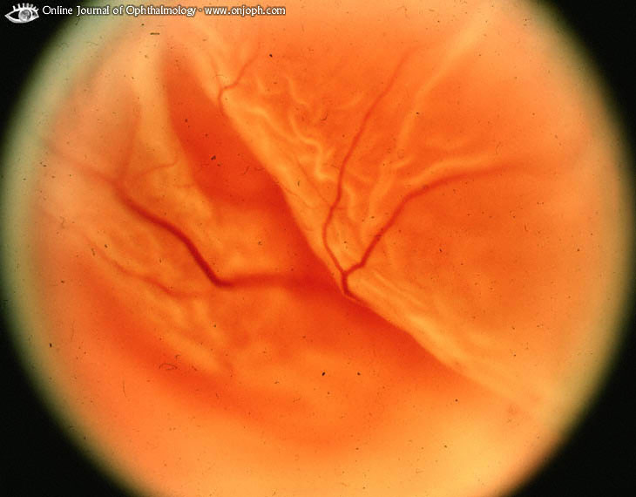
Source of picture: “Online Journal of Ophthalmology” >>

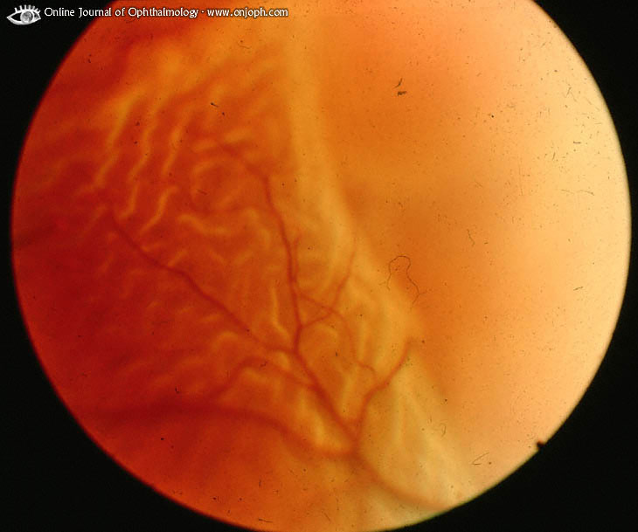
Source of picture: “Online Journal of Ophthalmology” >>

B-scan ultrasonography - performed if vitreous hemorrhage obscures retina.
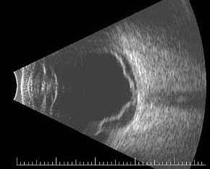

electroretinogram is indicated if ultrasound cannot differentiate retinal detachment from partially detached thickened posterior hyaloid (if good response from ERG is obtained, retina probably is attached).

Treatment
N.B. if not treated promptly detachments can expand to involve entire retina.
Rhegmatogenous detachment → sealing all retinal breaks:
- Closure of breaks occurs when break edges are brought into contact with underlying pigment epithelium:
- by bringing eye wall closer to detached retina (scleral buckle, ± fluid drainage from subretinal space).
- by pushing detached retina toward eye wall (pneumatic retinopexy - intraocular tamponade with gas bubble).
- by pars plana vitrectomy (used by number of surgeons for primary uncomplicated retinal detachments); ideal candidates are those with pseudophakia, aphakia, or phakic eyes with posterior breaks.
- Sealing of breaks is accomplished by creating strong chorioretinal adhesion around breaks - by laser / diathermy / cryotherapy.

- > 90% detachments can be reattached surgically.
- retinal breaks without detachment:
anterior → transconjunctival cryopexy;
posterior → photocoagulation.
- of eyes that are successfully reattached after macula detachment, 50% obtain final visual acuity of 20/50 or better (outer segments of photoreceptors regenerate).

Traction detachments → surgery to relieve vitreoretinal traction:
  - scleral buckling techniques
  - vitrectomy.

Exudative detachments:
inflammatory conditions → systemic corticosteroids;
choroidal tumors → enucleation / radiation / chemotherapy;
choroidal hemangiomas may respond to photocoagulation / or plaque brachytherapy
- surgical treatment of detachment per se varies according to etiology.

After any vitreoretinal surgery:
- topical antibiotic
- topical corticosteroid (e.g. prednisolone acetate)
- topical cycloplegic (e.g. atropine 1%)
- monitor intraocular pressure

Warn patients about potential detachment risk to fellow eye - in phakic eyes 10-15%, in aphakic / pseudophakic eyes 25-40%.
Instruct to seek attention immediately if experiencing floaters and/or photopsias!

Most common cause of failure in retinal detachment surgery - proliferative vitreoretinopathy - it is reparative process initiated by retinal breaks (full- or partial-thickness), retinopexy, other types of retinal damage - surrounding glial or retinal pigment epithelial cells to migrate to both surfaces of retina → hypocellular keloid-like process (periretinal proliferation, vitreous contraction) → traction retinal detachment; if not treated successfully → blindness.

Retinitis Pigmentosa
- phenotypic description of several related, yet distinct, dystrophies of photoreceptors & pigment epithelium,
i.e. loss of viable photoreceptors + pigmentary changes in retinal pigment epithelium (primary or secondary to photoreceptor loss).
- hereditary pattern; to date, > 70 different genetic defects have been identified (most cases autosomal recessive, but may also be autosomal dominant or, infrequently, X-linked).
- may occur as:
- isolated form (primary RP).
- association with systemic syndromes (e.g. Usher, Alport, Alström, Jansky-Bielschowsky, Vogt-Spielmeyer-Batten, Zellweger, Refsum, Kearns-Sayre, Bassen-Kornzweig, Laurence-Moon-Biedl).

Clinical Features
- slowly progressive, painless, symmetric bilateral vision loss.
- occurs anywhere from infancy to mid 50s; visual degeneration occurs over 30-40 years.
Depending which photoreceptors predominantly are affected:
- cone-rod dystrophies or pure-cone dystrophies - day vision problems: visual acuity loss, color discrimination loss.
- rod-cone dystrophies:
- defective night vision (nyctalopia); may become symptomatic in early childhood.
- midperipheral ring scotoma (tunnel vision); widens gradually → central vision eventually is reduced.

Diagnosis
Depending on stage and type of disorder, visual acuity ranges from normal (20/20) to no light perception.
- genetic subtyping + examine family members to establish hereditary mode.

ophthalmoscopy:
- triad of optic atrophy, attenuated retinal vessels and pigmentary changes.
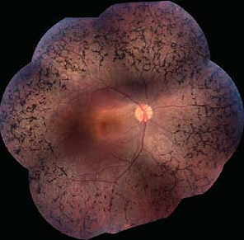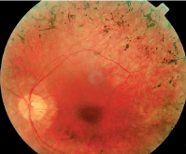

cone-rod dystrophies - bull's eye maculopathy.
rod-cone dystrophies - dark pigmentation (“bone-spicule” configuration) in equatorial retina.
- narrowed retinal arteries, waxy disk pallor:
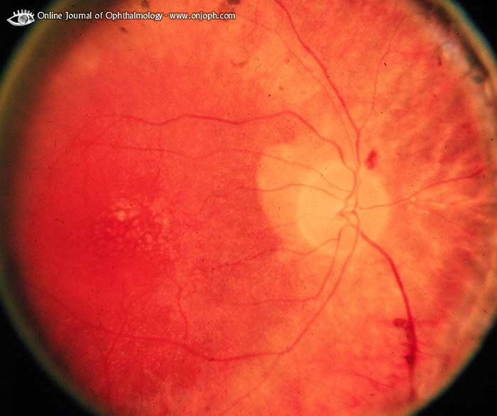
Source of picture: “Online Journal of Ophthalmology” >>

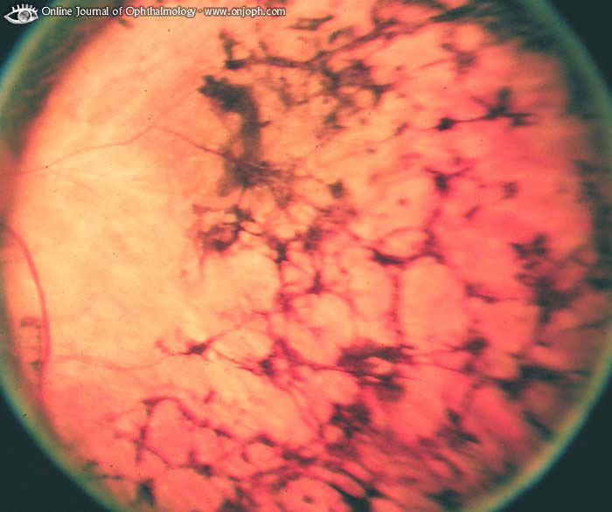
Source of picture: “Online Journal of Ophthalmology” >>

electroretinography (incl. after dark adaptation) - most critical diagnostic test - provides objective measure of rod and cone function.

Treatment
No treatment is effective!

Suggested medical therapies:
- Vitamin A/beta-carotene very high daily doses
- High doses of vitamin E.
- 1000 mg/d ascorbic acid.
- Acetazolamide (for small percentage of patients with cystoid macular edema).
- Diltiazem
- Lutein
- Bilberry.

Experimental methods:
- fetal neural retina transplantation.
- retinal prosthesis (phototransducing chip)
- intravitreal / subretinal gene therapy

Age-Related Macular Degeneration (ARMD)
s. Senile Macular Degeneration
- collection of inherited diseases (multifactorial) that share common features - age predilection, frequently positive family history.
- no predisposing systemic risk factor is known! (association appears to exist with smoking).
- leading cause of visual loss in elderly!
- much more common in whites.

Pathophysiology
Retinal pigment epithelium degeneration / atrophy in macular region
Macular region: enlarging / coalescing drusen* → overlying retinal pigment epithelium degeneration / atrophy → loss of overlying photoreceptors (”DRY” form).
*yellow-gray extracellular material in Bruch membrane, composed of various substances.
- damaged retinal pigment epithelium may also disturb underlying choroidal perfusion → choroidal neovascularization (conversion to ”WET” form).

Traditional theory - senescence of retinal pigment epithelium - accumulates metabolic debris as remnants of incomplete degradation from phagocytosed rod and cone membranes; progressive engorgement of these pigment cells leads to drusen formation.

Clinical Features
- slow or sudden, painless loss of central visual acuity (e.g. difficulty with reading and making out faces) + difficulty with night vision and with changing light conditions.
- manifests after age 50 years (according to international classification system, ARMD cannot be diagnosed in patients < 50 years).
- variability of vision from day-to-day is common.
- new onset metamorphopsia (self-tested with Amsler grid) may indicate onset of choroidal neovascularization.
N.B. biggest treatable risk of visual loss in dry AMD is development of neovascularization – so, new onset metamorphopsia is indication for fluorescein angiography!!!
- although often legally blind (< 20/200 vision), patients have good peripheral and color vision.
N.B. patients don’t lose all sight!

Diagnosis
Funduscopy - pathology in macular region:

Atrophic (dry) form (more common form) – only pigmentary disturbance (no elevated macular scar, no hemorrhage, no exudation); retinal pigment epithelium atrophic with easier visualization of underlying choroidal plexus.
- peripheral retina often has drusen, as well as retinal pigment epithelium mottling and atrophy.
Dry ARMD with fine drusen: Dry ARMD with soft drusen:
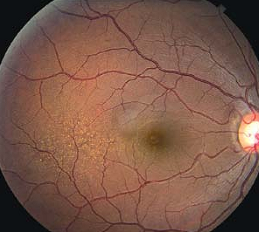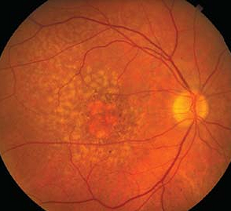

Exudative (wet) form (more rapidly progressing visual loss) - subretinal choroidal neovascularization network → subretinal fluid, intraretinal hemorrhage, pigment epithelial detachment, hyperpigmentation → eventually this complex contracts → distinct elevated scar at posterior pole.
- often bilateral (but not necessarily symmetrical).  - contralateral eye always shows some pigmentary disturbance and macular drusen. | 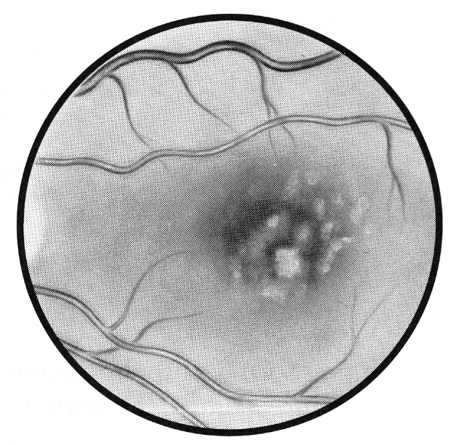

Fluorescein angiography - neovascular membrane beneath retina (late leakage of fluorescein).

In area of slight depigmentation (previous retinal pigment epithelium detachment) is darkly pigmented spot surrounded by slim ring of subretinal blood:
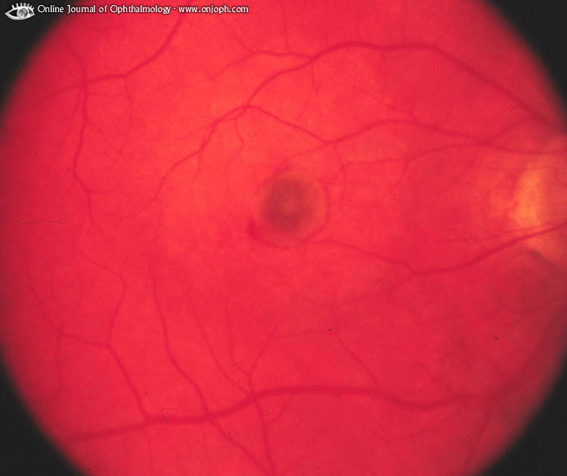
Source of picture: “Online Journal of Ophthalmology” >>

In mid-angiogram neovascularization becomes prominent; ring of surrounding blood blocks fluorescence:
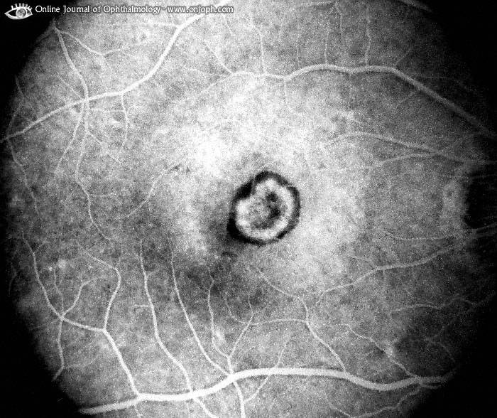
Source of picture: “Online Journal of Ophthalmology” >>

Exudative ARMD:  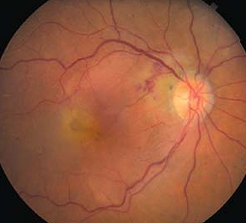 | IVFA of exudative ARMD:  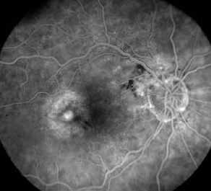

Treatment
- low-vision devices & service counseling.

Dry ARMD - no proven treatments available; daily Amsler grid self-evaluation is necessary (to detect conversion to wet ARMD).
- high-dose combination of vitamin C (500 mg), vitamin E (400 IU), beta-carotene (15 mg), zinc (80 mg) and cupric oxide (5 mg) reduces progression to advanced ARMD by 25% over 5 years, and reduces risk of vision loss by 19% by 5 years.

Wet ARMD:
A. Neovascular network outside fovea* → laser photocoagulation (best-studied and standard treatment!!!);
* if neovascular network is located subfoveally, laser treatment causes blinding central scotoma!
B. Subfoveal neovascularization:
- Selective vascular endothelial growth factor (VEGF) antagonists (injected intravitreally) – FDA approved:
- Pegaptanib (Macugen®) - injected intravitreally q 6 weeks.
- Ranibizumab (Lucentis®) - injected intravitreally q 1-3 month; unlike other treatments can improve visual acuity!
- Bevacizumab (Avastin®); not yet FDA approved.
- aflibercept (Eylea®)

- Photodynamic Therapy (PDT) (FDA approved): IV photosensitizing dye [verteporfin (Visudyne®)] → nondestructive (cold) laser to activate dye within choroidal neovascularization; performed q 3 months for 1-2 years.

ARMD treatment algorithm:
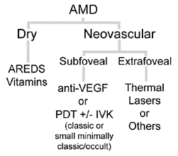

Implantable Miniature Telescope (IMT) - FDA approved to improve vision in some patients with end-stage age-related macular degeneration (AMD).

Prevention
- daily multivitamins (esp. vit. E and zinc) and lutein.
- stop smoking.

Retinopathy Of Prematurity (ROP), s. Retrolental Fibroplasia
- bilateral abnormal retinal vascularization in premature infants.

Pathophysiology & Etiology
- inner retinal blood vessels start growing about midpregnancy and have fully vascularized retina by full term; in premature birth their growth is incomplete.
- ROP results if these vessels continue growth in abnormal pattern;
- abnormal tissue ridge forms between vascularized central retina and nonvascularized peripheral retina;
- new vessels may invade vitreous →→→ retinal traction detachment;
- sometimes entire eye vasculature becomes engorged ("plus" disease).
- increased ROP risk correlates with:
  - proportion of retina that remains avascular at birth – this correlates with low birth weight (> 80% infants weighing < 1 kg at birth develop ROP).
  - excessive (esp. prolonged) O₂ administration; hyperoxia induces vasospasm → endothelial damage → ischemia → reactive proliferative neovascularization → retinal traction → retinal traction detachment.

Prognosis
    - abnormal vessel growth often subsides spontaneously → normal vision.
    - 4% progress to retinal detachments and vision loss within 2-12 mo.
    - healed ROP may leave cicatricial scars (dragged retina or retinal folds) - risk for retinal detachments later in life (should be followed at least annually for life!!!).

Prevention after preterm birth (any baby < 31 week or < 1500 g):
- use O₂ only in amounts sufficient to avoid hypoxia.
N.B. threshold safe level or duration of elevated Pa_{O2} is not known!
- vitamin E (antioxidant) + restriction of light exposure (pro-oxidant).
- retinal vascularization must be closely followed (ophthalmoscopy) at 1-2-wk intervals (started at 4-6 weeks old) until vessels have matured sufficiently (usually 36 postmenopausal weeks).

Treatment for severe ROP only:
cryotherapy / laser photocoagulation to ablate peripheral avascular retina → ↓incidence of retinal fold or detachment.
- if retinal detachments occur, scleral buckling surgery or vitrectomy & lentectomy may be considered as late rescue with low benefit.

Neuroretinitis (s. Papilloretinitis)
– inflammation of optic nerve head + posterior pole of retina (with cells in nearby vitreous) producing macular star (lipid exudate in macula).
- visual loss is due to optic nerve dysfunction and / or macular dysfunction.

Examples:
- Leber's idiopathic stellate neuroretinitis - unilateral neuroretinitis with spontaneous regression in a few months.
- Cat-scratch disease (caused by Bartonella henselae).

Syphilis
- Post-viral inflammatory reaction in optic nerve

Very mild optic disc swelling with delicate macular star:
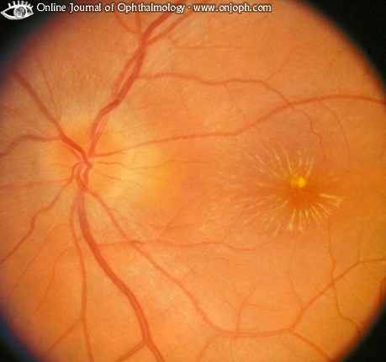
Source of picture: “Online Journal of Ophthalmology” >>

Disc swelling confined to superior disc pole. Numerous white spots distinct from exudates in deep retina around optic disc:
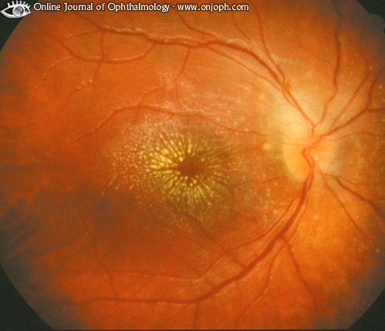
Source of picture: “Online Journal of Ophthalmology” >>

Retinoblastoma
- malignant tumor from immature retina.
- occurs in 1/18,000 to 1/30,000 live births.
- most common primary ocular malignancy of childhood!
- represents 2% of childhood malignancies.
- tumor arises from multipotential precursors of photoreceptor (retinoblasts).

60-70% nonheritable.
30-40% inheritable:
- 5-10% have positive family history of retinoblastoma.
- 20-30% have bilateral disease (others have unilateral multicentric disease); some patients with bilateral retinoblastoma have similar tumor (pineoblastoma) of pineal region (trilateral retinoblastoma).
- also increased risk for osteosarcoma from osteoblasts!
“Two hits” hypothesis see p. 3785-3786 >>
- constitutive genetic abnormality (i.e. genomic mutation - present in all body cells) inherited in autosomal dominant fashion; it is deletion / mutation of retinoblastoma gene (tumor suppressor gene located in 13q14).
- somatic mutation in allelic 13q14 results in tumor.

- extraocular extension:
    - through sclera
    - along optic nerve
- distant metastases are rare.

Diagnosis
- 90% are diagnosed before age 5 yrs - usually when investigating presenting symptoms - white pupil reflex (leukokoria, s. cat's-eye pupil), strabismus.

indirect ophthalmoscopy (with pupils widely dilated, child under general anesthesia) - gray-white elevations in retina;
  - endophytic growth - tumor seeds visible in vitreous; tumor has either no surface vessels or small irregular vessels.
  - exophytic (subretinal) growth - subretinal fluid accumulation and retinal detachment; overlying retinal vessels are increased in caliber and tortuosity.
  - diffuse infiltrating growth (only 1.5% cases) - flat infiltration without discrete tumor mass; grows slowly; may present as pseudouveitis.

Choroidal melanoma:
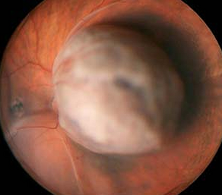

CT, MRI, ultrasonography, X-ray - calcification (in almost all tumors).

Ratio of aqueous humor LDH / serum LDH > 1.0.

Histology:
- classic findings are Flexner-Wintersteiner rosettes and less commonly fleurettes.
- Homer-Wright rosette can also be encountered, but they are seen in other neuroblastic tumors.

Screening
- for immediate family members - genetic studies (for detecting asymptomatic carriers);
- if risk of retinoblastoma cannot be ruled out by genetic studies → regular ophthalmologic examination under anesthesia:
q 3-4 months until age 3-4 years; q 6 months until age 5-6 years and then annually (at age 8 years, most patients tolerate dilated fundus examination in office without anesthesia).

Trilateral retinoblastoma = bilateral retinoblastoma + ectopic intracranial retinoblastoma (usually pineal gland or parasellar region).
- screen those with hereditary (bilateral or multifocal) disease - gadolinium-enhanced MRI or CT with contrast every 6 months up to age 5 years.

Quadrilateral retinoblastoma = bilateral retinoblastoma + tumors in pineal gland and suprasellar regions.

Trilateral retinoblastoma = bilateral retinoblastoma + thalamic retinoblastoma (heterogeneously enhancing) – FLAIR, T1 with contrast:
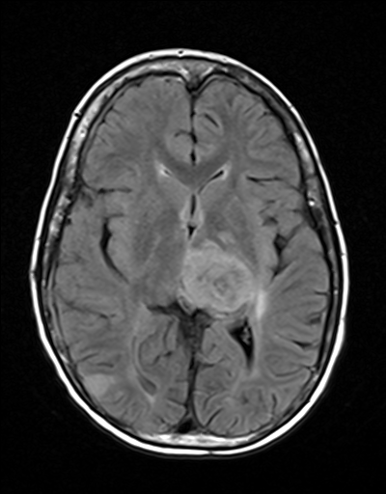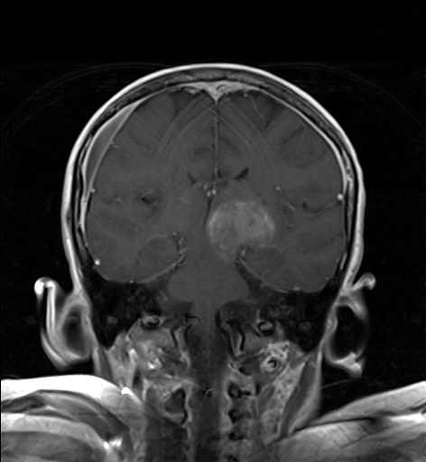
Source of picture: Viktoras Palys, MD >>

Treatment
enucleation with removal of as much of optic nerve as possible (> 90% intraocular tumors can be cured!).
bilateral disease - vision usually can be preserved with:
- unilateral enucleation + contralateral photocoagulation / cryotherapy / radiation*.
- bilateral coagulation
*radiotherapy has high incidence of local control, but results in bone growth cessation (→ significant midface hypoplasia), increases risk of second cancers 6-fold; so neoadjuvant chemotherapy (chemoreduction) has superseded radiotherapy.
Significant local spread → exenteration.
Metastases → systemic chemotherapy (carboplatin + etoposide + vincristine ± cyclosporine).
N.B. combination of high-dose chemotherapy + radiation therapy + transplantation of blood-producing stem cells can cure even metastatic retinoblastoma!!! (except in CNS)

Follow-up, Prognosis
- ophthalmologic reexamination at 2-4-mo intervals.
- studies of CSF & bone marrow for malignant cells - diagnosis of distant spread.
N.B. primary mode of retinoblastoma spread is hematogenous to bone marrow and back through optic nerve into CSF.
- overall survival rate presently is > 85%.
- death occurs secondary to intracranial extension
- 70% (i.e. inheritable cases with genomic mutation) develop second nonocular malignancy within 30 yrs of diagnosis.

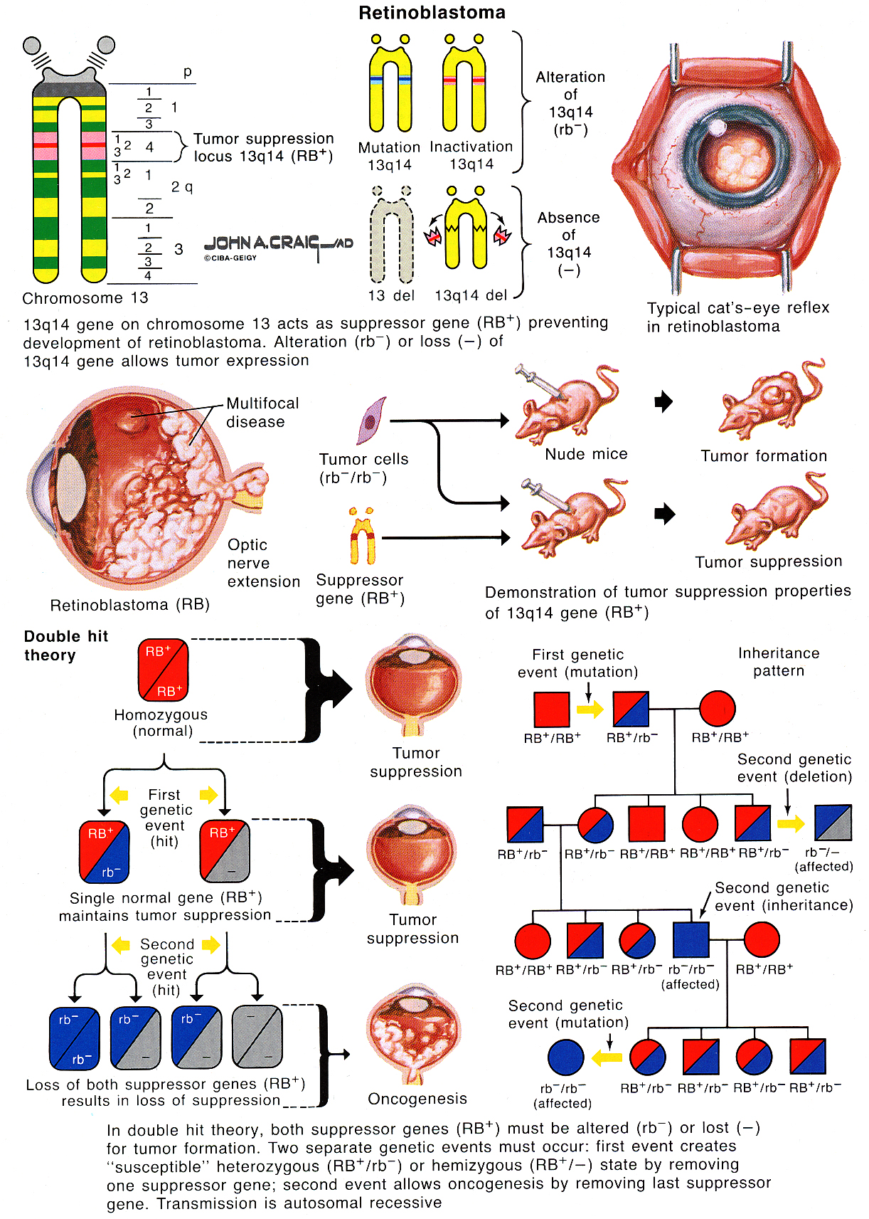

Color Blindness
suffix "-anomaly" = color weakness.
suffix "-anopia" = color blindness.

prefixes "prot-", "deuter-", "trit-" = defects of red, green, blue cone systems.

Trichromats (have all three cone systems, but one may be weak) - norma, protanomaly, deuteranomaly, tritanomaly.
Dichromats (only two cone systems) - protanopia, deuteranopia, tritanopia.
Monochromats (only one cone system).

Etiology
- Inherited (most frequently - 8% white males, 0.4% white females):
- tritanomaly / tritanopia are rare (more commonly acquired) and show no sexual selectivity.
- genes for green-sensitive and red-sensitive cone pigments are located near each other in head-to-tail tandem on Xq:
- prone to unequal crossing over → hybrid pigments with shifted spectral sensitivity (≈ 6% males are anomalous trichromats).
- 2% males are dichromats (protanopia or deuteranopia).
- these abnormalities are inherited in recessive X-linked pattern (females show defect only when both X chromosomes contain abnormal gene; color blindness skips generations and appears in males of every second generation; Turner syndrome patients have ♂ incidence; Klinefelter syndrome patients have ♀ incidence).
- Lesions of V8 (achromatopsia).
- Macular / optic nerve diseases.
- Sildenafil (inhibits retinal form of phosphodiesterase) - transient blue-green color weakness.

Bibliography for ch. “Ophthalmology” → follow this link >>

Viktor’s Notes℠ for the Neurosurgery Resident
Please visit website at www.NeurosurgeryResident.net

