Eyelid Disorders
Last updated: May 9, 2019
Lid Edema 1
Etiology 1
Treatment 1
Blepharitis 1
Etiology 1
Clinical Features 1
Treatment 2
Hordeolum 2
Clinical Features 2
Treatment 2
Chalazion (Meibomian Cyst) 2
Clinical Features 2
Treatment 3
Entropion And Ectropion 3
Treatment 3
Treatment 4
Tumors 4
Lid Retraction, Lagophthalmos 4
(Blepharo)Ptosis 4
Blepharospasm → see p. Mov21 >>
Eyelid reconstruction → see p. 2215 >>

- normal upper eyelid margin is located 1-1.5 mm below superior limbus.
- eyelid position is quantified by margin-reflex distance (MRD) - MRD₁ for upper lid, MRD₂ for lower lid. see p. D1eye >>

Lid Edema
Etiology
- Allergies:
  - acute type (seasonal allergic lid edema) - hypersensitivity to airborne pollens or direct hand-to-eyelid application of pollens.
  - chronic type - contact sensitivity to topical drugs (e.g. atropine, neomycin), cosmetics, metals (e.g. nickel); perennial allergic lid edema - hypersensitivity to molds or to animal or dust mite dander.
- Trichinosis - chronic bilateral lid edema (resembles allergic type); fever and other systemic symptoms may not be present initially; eosinophilia > 10% is characteristic.
- Hereditary angioedema - acute lid edema.

Treatment
For allergic lid edema:
- removal of offending cause.
- cold compresses over closed lids may speed resolution.
- corticosteroid ointments (for not more than 7 days) if swelling persists > 24 h.

Blepharitis
- inflammation of lid margins.
Etiology
Ulcerative blepharitis - acute bacterial infection (usually staphylococcal).
Seborrheic blepharitis - chronic blepharitis; associated with seborrheic dermatitis (Pityrosporum ovale).
Meibomian gland dysfunction (meibomitis) - chronic blepharitis caused by abnormal meibomian gland secretions; often associated with acne rosacea.

Clinical Features
- on lid margins: itching, burning, redness (red-rimmed eyelids), thickening, scales & crusts clinging to lashes.
- lid edema
- conjunctival irritation (lacrimation, photophobia).

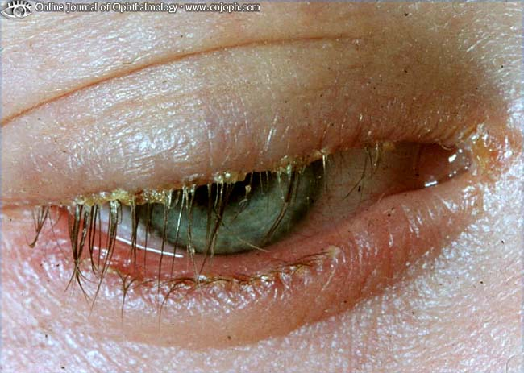
Source of picture: “Online Journal of Ophthalmology” >>

- ulcerative blepharitis: small pustules in lash follicles → break down → shallow marginal ulcers with dry adherent crusts (leave bleeding surface when removed; during sleep, lids become glued together by dried secretions); may result in loss of eyelashes and eyelid scarring.
- seborrheic blepharitis: greasy, easily removable scales on lid margins; secondary bacterial colonization occurs on scales.
- meibomian gland dysfunction: meibomian gland orifice inspissated (plugged) with hard waxy plug.

Patients with seborrheic blepharitis and meibomian gland dysfunction often have:
  - secondary keratitis sicca.
  - history of repeated styes and chalazia.
  - exacerbations that are uncomfortable & unsightly but do not result in central corneal scarring or visual loss.

Treatment
Ulcerative blepharitis - antibiotic ointment (e.g. bacitracin/polymyxin B or gentamicin or sulfacetamide for 7-10 d).
Seborrheic blepharitis - eyelid hygiene (scrubbing lid margin daily with cotton swab dipped in dilute baby shampoo); occasionally, antibiotic ointment is indicated.
Meibomian gland dysfunction - normalizing meibomian gland secretions:
- doxycycline tapered over 3-4 mo.
- warm compresses (melt waxy plugs and allow trapped secretions to flow out).

Hordeolum
- acute localized pyogenic infection of eyelid gland:
- ciliary (Moll) gland (external hordeolum, stye) - modified apocrine sudoriferous glands that open into follicles of eyelashes.
- Zeis gland (external hordeolum, stye) - sebaceous glands that open into follicles of eyelashes.
- tarsal (meibomian) gland (internal hordeolum, meibomian stye, acute chalazion) - sebaceous glands embedded in tarsal plate, discharging at lid edge near posterior border.
- usually staphylococcal.
- polymorphonuclear leucocytes and necrosis with pustule formation.
- often secondary to blepharitis.
- recurrence is common.

Clinical Features
External hordeolum – superficial, at eyelash base: begins with pain, redness, tenderness, foreign-body sensation → small, round, tender area of induration → small yellowish spot in center of induration (pointing) → abscess soon ruptures with pus discharge and pain relief.

Internal hordeolum (very rare) – deeper, more severe.
- conjunctival lid side shows small yellow elevation (site of affected gland).
- abscess points on conjunctival lid side (sometimes points through skin); spontaneous rupture is rare!!!
- recurrence is common.
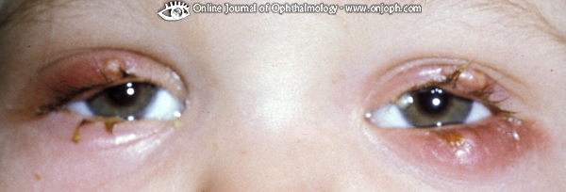
Source of picture: “Online Journal of Ophthalmology” >>

Treatment
- suppuration may be aborted in early stages by systemic antibiotics (e.g. dicloxacillin or erythromycin); however, because of minor nature and short natural history, antibiotics are not indicated.
Topical antibiotics are ineffective!
- pointing is hastened by hot compresses (applied for 10 min qid).
- hordeolum will rupture on its own; however, to speed resolution, hordeolum can be incised (as soon as pointing occurs) and its contents expressed.
Incision direction:
in conjunctiva – vertical
in skin – horizontal.

Chalazion (Meibomian Cyst)
- chronic granulomatous inflammation (lipogranuloma) of meibomian gland.
- due to duct occlusion (often after internal hordeolum) - lipid breakdown products, possibly from bacterial enzymes, leak into surrounding tissue and incite granulomatous chronic inflammation (with lymphocytes and lipid-laden macrophages [Touton-type giant cells]).
- contrary to popular opinion, research has not shown that eyelid cosmetic products either cause or aggravate condition.
- hormonal influences on sebaceous secretion and viscosity (androgenic hormones increase sebum viscosity) may explain clustering at puberty and during pregnancy.

Clinical Features
- onset - indistinguishable from stye; more common on upper lid.
- after few days → painless, slowly growing round mass in lid; seen subconjunctivally as red-gray mass; overlying skin can be moved loosely.
- large lesions have been reported to cause astigmatism or hyperopia resulting from central corneal flattening.
- acute inflammatory exacerbation (internal hordeolum) can result in anterior rupture (beneath skin) or posteriorly (through conjunctiva); it never points to lid margin (unlike sty).
- sebaceous dysfunction and obstruction elsewhere (e.g. comedones, oily face) are the only associated features.
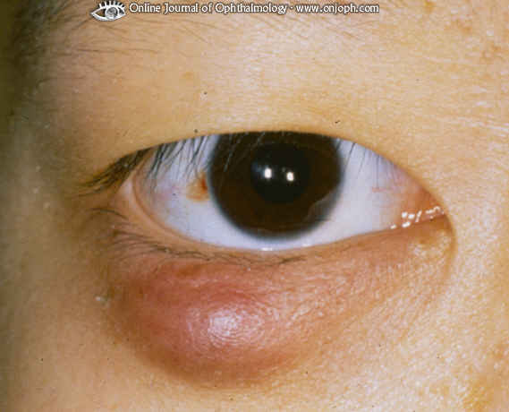
Source of picture: “Online Journal of Ophthalmology” >>

Treatment
- most disappear after few months (hot* compresses for 10-15 min qid may hasten resolution);
*as hot as can be tolerated – melting lipid secretions.
- early in condition, blocked glandular orifices may be opened by vigorous lid massage between 2 cotton wool buds at slit lamp (local anesthesia may be beneficial);
self-administered technique is also available - called "4 fingers times 10 massage"
(at conclusion of bath / shower, patient warms hands under hot water; using 1 drop of baby shampoo, patient works up lather, and then places index finger over closed lids at lid margin and vigorously massages lid back and forth 10 times; then repeats procedure with middle, ring, and little fingers).
- if there is no resolution after 6 wk:
  - incision & curettage; after procedure, cauterization with phenol or trichloroacetic acid may prevent recurrence of small chalazia.
  - intrachalazion corticosteroid (e.g. triamcinolone diacetate).
- if associated with acne rosacea, 6 month course of low dose tetracyclines may help sebaceous glands to produce shorter-chain fatty acids that are less likely to block gland orifices.
N.B. recurrent chalazia, especially if recur despite previous successful drainage in the same location, must be considered sebaceous cell carcinoma!

Entropion And Ectropion
Both conditions, if persistent and bothersome, are best treated surgically!
Ectropion - eyelid eversion
- results from:
  - tissue relaxation with aging (lid-laxity ectropion)
  - scar (cicatricial ectropion)
  - CN7 palsy (paralytic ectropion)
  - ichthyosis (congenital ectropion).
- usually involves lower lid.
- poor tear drainage through nasolacrimal system → epiphora.
- conjunctival / corneal exposure → redness, irritation, keratinization of palpebral conjunctiva, corneal ulceration.

cicatricial ectropion:
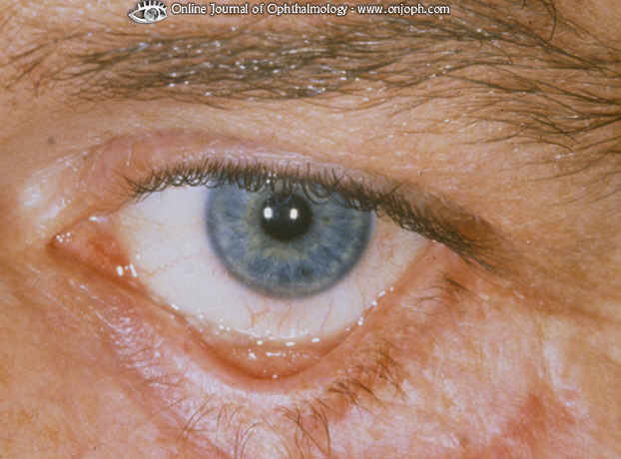
Source of picture: “Online Journal of Ophthalmology” >>

congenital ectropion (in ichthyosis):
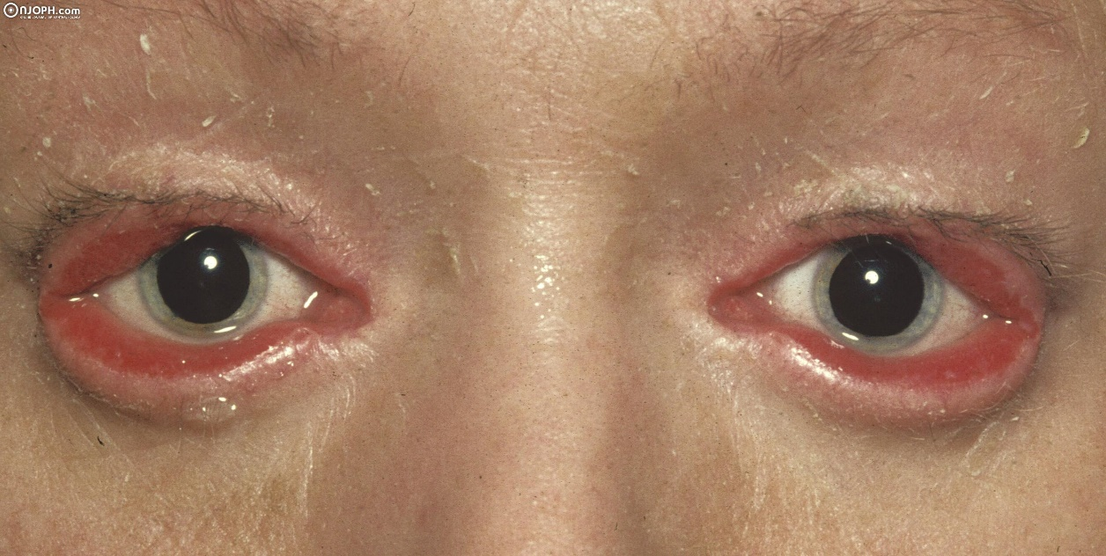
Source of picture: “Online Journal of Ophthalmology” >>

Treatment
- lubrication, moisture shields.
- cicatricial ectropion - digital massage to stretch scar, steroid injection into scar.
- paralytic ectropion - taping lateral canthal skin supertemporally provides temporary relief; external paste-on upper lid weights.

Entropion - eyelid inversion
- Acute spastic entropion - orbicularis oculi spasm due to ocular irritation.
- Involutional entropion - horizontal laxity of medial and/or lateral canthal tendons, involution of orbital fat (involutional enophthalmos with unstable eyelid position).
- Cicatricial entropion - scar tissue of conjunctiva; digital eversion of eyelid margin is difficult!
- Congenital entropion (very rare) - dysgenesis of lower eyelid retractors, structural defects in tarsal plate also (tarsal kink syndrome.

- causes irritation (lashes rub against globe) → corneal ulceration and scarring.
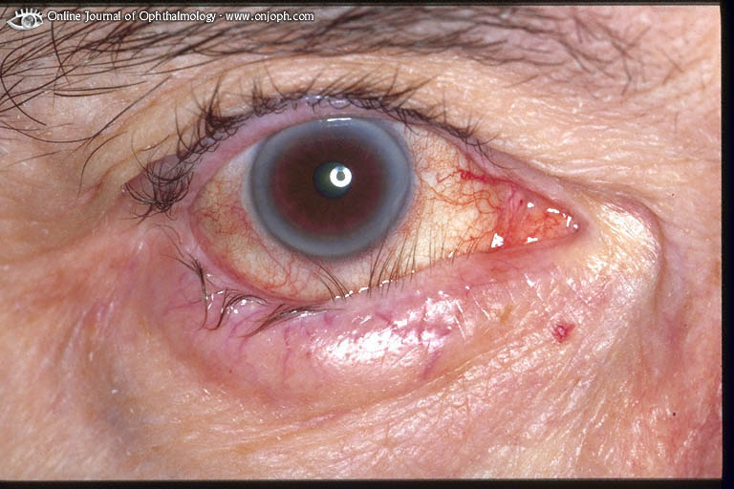
Source of picture: “Online Journal of Ophthalmology” >>

Treatment
- ocular lubrication (tear preparations).
- spastic entropion - eyelid hygiene, antibiotics, corticosteroids, botulinum toxin.

Tumors
Xanthelasma - common, benign subcutaneous deposit, with yellow-white, flat plaques of lipid material; associated with hypercholesterolemia; do not need be removed (except for cosmetic reasons).

Basal cell carcinoma frequently occurs at lid margins, at inner canthus, and on upper cheek.

- other malignant tumors are less common; tumors simulating chronic blepharitis or chronic chalazion should be biopsied rather than treated for a long time.

Lid Retraction, Lagophthalmos
Whenever lid retraction is suspected, exclude contralateral ptosis!
- etiology:
- thyroid-associated ophthalmopathy see p. 2744 >>
- Parinaud (dorsal midbrain) syndrome see p. Eye64 >>
- prior lid surgery / trauma.
- differentiate from CN7 palsy.

lagophthalmos - condition in which complete closure of eyelids over eyeball is difficult or impossible.
- etiology: exophthalmos, mechanical obstacles, CN7 palsy.
- lubricate eyes with liquid paraffin ointment.
- corneal ulceration may develop; H: temporary tarsorrhaphy.

(Blepharo)Ptosis
Etiology:
- weakening of levator aponeurosis due to age / trauma.
- hypotropia (causes pseudoptosis).
- Horner syndrome – both MRD₁ & MRD₂ ↓
- CN3 palsy – MRD₁↓ with unchanged MRD₂
- myasthenia gravis; ptosis is transient;
curtain sign (not specific for myasthenia gravis) - elevation of one lid causes contralateral lid to droop (explained by Hering law);
Cogan lid twitch - patient is asked to quickly look upward from downward position → lid overelevates and then droops.

Bibliography for ch. “Ophthalmology” → follow this link >>

Viktor’s Notes℠ for the Neurosurgery Resident
Please visit website at www.NeurosurgeryResident.net

