Uveitis
Last updated: May 9, 2019
Classification 1
Etiologic categories 2
Treatment 2
Complications 2
Common Uveitic Syndromes 2
Masquerade Syndromes 3

Uveitis - heterogenous ocular diseases - inflammation of any component of uveal tract (iris, ciliary body, choroid).

Classification
Anterior uveitis (most common uveitis) - localized to anterior segment - iritis and iridocyclitis.
iritis - white cells confined solely to anterior chamber.
iridocyclitis - cellular activity also involves retrolental vitreous.
- etiology (most do not have underlying systemic disease):
  - idiopathic postviral syndrome (most commonly 38-60%)
  - HLA-B27 syndromes, many arthritic syndromes (≈ 17%)
  - trauma (5.7%)
  - herpes simplex, herpes zoster disease (1.9-12.4%)
  - iatrogenic (postoperative).
- tends to be most symptomatic:
- pain
- photophobia!!!
- miosis (vs. in glaucoma – mydriasis); pain increases as eyes converge and accommodate (positive Talbot test).
- perilimbal injection (ciliary flush) of scleral / episcleral vessels; conjunctival injection
- vision may be normal / slightly decreased
N.B. in some cases eye is normal-looking!
- slit-lamp:
    - cells & flare (i.e. WBCs & protein) in aqueous humor;
    - keratic precipitates (clumps of WBCs and proteinaceous material adherent to corneal endothelium);
    - if enough white cells deposit on chamber bottom, hypopyon results;
    - inflammatory nodules on iris suggest granulomatous uveitis;
    - in chronic cases anterior / posterior synechiae may form.

Mixed injection, heavy flare in aqueous and reactive miosis (induces circular posterior synechiae):
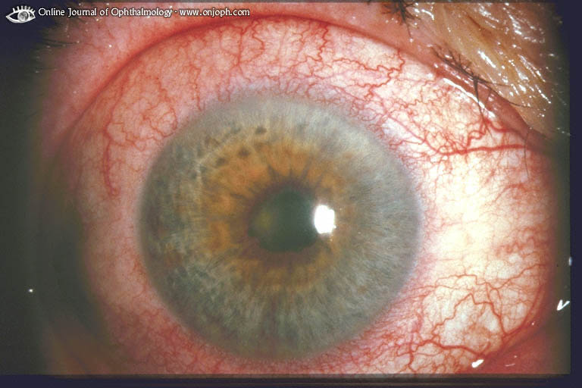
Source of picture: “Online Journal of Ophthalmology” >>

Acute iritis - irregular pupil and circumciliary injection:
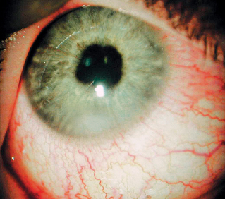

Intermediate uveitis (s. peripheral uveitis) - centered immediately behind iris and lens in region of ciliary body and pars plana - cyclitis and pars planitis.
- etiology:
  - idiopathic (i.e. pars planitis) (≈ 69%)
  - major granulomatous diseases - sarcoidosis (22%), tuberculosis, Lyme disease, lues.
  - multiple sclerosis (8%)
N.B. focus on excluding sarcoidosis and multiple sclerosis!
- classically painless - presents with floaters (cells in vitreous humor), blurred vision (due to cystoid macular edema – fluid leakage from retinal vessels in perifoveal macular area).
- indirect ophthalmoscopy - cells in vitreous humor, cellular aggregates & condensations over pars plana (most frequently inferior - classic “snowbank” appearance); posterior synechiae may form.

Posterior uveitis - choroiditis ± retinitis (chorioretinitis, retinal vasculitis), optic neuritis.
- etiology:
  - infections - toxoplasmic, herpetic infection, histoplasmosis
  - major granulomatous diseases (tuberculosis, sarcoidosis, Lyme disease, lues).
  - birdshot chorioretinitis
- ≈ intermediate uveitis - floaters and blurred vision.
- indirect ophthalmoscopy - cells in vitreous humor, yellow-white lesions in retina and/or underlying choroid, exudative retinal detachments, retinal vasculitis, optic nerve edema.  - healing leaves asymptomatic (unless macula is affected) chorioretinal scar – white patch with pigmentation around: | 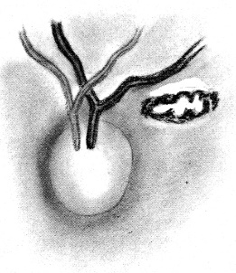

Diffuse uveitis (s. panuveitis, endophthalmitis) – involves all parts of eye.
- etiology:
- overwhelming infections (e.g. infantile toxocariasis, postoperative bacterial endophthalmitis, severe toxoplasmosis).
- dissemination of granulomatous uveitides.

Etiologic categories
- Inflammatory (primary autoimmune)
- Infectious
- Infiltrative (invasive neoplastic processes)
- Injurious
- Iatrogenic (surgery, inadvertent trauma, medication)
- Inherited (metabolic / dystrophic disease)
- Ischemic
- Idiopathic (when all diagnostic means fail to reveal specific etiology)
Uveitis can present with most challenging diagnostic dilemmas in all of ophthalmology!
No standard laboratory evaluation exists for uveitis, except in screening for syphilis and sarcoidosis*, both of which can present in myriad of ways.
*order VDRL & FTA-ABS and ACE level & chest x-ray for all patients!

Treatment
- cycloplegics (e.g. cyclopentolate, atropine) - to decrease photophobia & pain (caused by ciliary spasm), to break up / prevent formation of posterior synechiae.
- topical or systemic corticosteroids;
  - when more posterior effect is necessary or when compliance is issue, periocular deposit of long-lasting corticosteroids can be used (transseptal or sub-Tenon approach)
N.B. initially treat with topical steroid for 2-3 weeks - to ensure that patient is not steroid responder!
  - if unresponsive to steroids / complications associated with usual therapy → immunosuppressants can be used.
- gevokizumab (Xoma) – FDA approved for noninfectious intermediate uveitis, posterior uveitis, or panuveitis, or chronic noninfectious anterior uveitis
  - monoclonal antibody that binds strongly to interleukin 1β (IL-1β).

- many cases of mild, first episode unilateral uveitis are associated with either trauma or idiopathic viral or sinus infection - present little risk of complications - best served by symptomatic treatment, observation, and no initial diagnostic testing.
- posterior and intermediate uveitis may be associated with visually disabling vitreous opacification that is unresponsive to medical therapy → vitrectomy.

Complications
May produce profound and irreversible vision loss!
- Cataract
- Glaucoma
- Retinal detachment
- Neovascularization of retina, optic nerve, iris
- Cystoid macular edema (most common cause of decreased vision from uveitis).

Common Uveitic Syndromes
Ankylosing spondylitis - common cause of unilateral anterior uveitis.

Reiter's syndrome - triad of conjunctivitis/uveitis, arthritis, urethritis.

Juvenile rheumatoid arthritis (particularly pauciarticular variety) - chronic bilateral iridocyclitis without pain, photophobia, conjunctival injection (“white iritis”).

Behçet syndrome (rare in USA; common cause of uveitis in Middle and Far East) - severe anterior uveitis with hypopyon, retinal vasculitis, optic nerve inflammation.
- clinical course is severe, with multiple recurrences.
- associated systemic manifestations - oral or genital aphthous ulcers; dermatitis (incl. erythema nodosum); thrombophlebitis; epididymitis. see p. 1170 >>
- most patients eventually require immunosuppressive drugs (cyclosporine, chlorambucil).

Toxoplasmosis - posterior lesions (retinitis) + anterior segment involvement.

Cytomegalovirus - posterior lesions (most common cause of retinitis in immunocompromised patients).

Herpes zoster, herpes simplex - anterior uveitis ± dermatitis, keratitis, scleritis.
- rarely, rapidly progressing acute retinal necrosis, with dense vitreitis.

Toxocariasis (one of most common causes of retinitis in childhood); classic forms of uveitis:
  - posterior granuloma near or involving optic nerve or macula;
  - peripheral granuloma involving pars plana (intermediate uveitis);
  - severe and diffuse endophthalmitis.
N.B. will worsen if given antihelmintic drugs - patient will fare better with only anti-inflammatory treatment!

Birdshot chorioretinopathy - idiopathic chronic bilateral, intermediate & posterior uveitis (moderate ÷ severe vitreitis and multiple areas of choroiditis in distinctive radial or streak-like pattern).
    - patients are in 5th to 7th decades of life.
    - very strong association with HLA-A29.

Ocular histoplasmosis (endemic to Mississippi-Ohio-Missouri River valleys) - multifocal choroiditis (occasionally with macular hemorrhage from choroidal neovascularization).

Syphilis may cause any uveitis at any stage of disease.

Ocular sarcoidosis - uveitis (anterior / intermediate / posterior) occurs in 10% patients with systemic sarcoidosis.
N.B. classically manifests as anterior granulomatous uveitis!

Vogt-Koyanagi-Harada syndrome (uveoencephalitis):
  - diffuse uveitis, commonly with exudative detachment of retina.
  - neurologic symptoms (occur early) - tinnitus, dysacusis, vertigo, headache, meningismus.
  - cutaneous findings (occur later) - patchy vitiligo, poliosis, alopecia.
- always affects more heavily pigmented persons.
- autoimmune reaction against choroidal melanocytes (moderately strong association with HLA-DR4).
- severe / prolonged attacks require immunosuppressants (e.g. cyclophosphamide, chlorambucil).

Sympathetic ophthalmia - bilateral granulomatous uveitis after penetrating trauma (0.5%) / surgery (< 0.1%) to one eye.
- autoimmune reaction against choroidal melanocytes (as in Vogt-Koyanagi-Harada syndrome).
- uveitis appears within 2-12 wk after injury.
- typically - floaters & decreased vision in sympathizing, noninjured eye.
- inflammation may be anterior / intermediate / posterior (choroiditis with overlying exudative retinal detachment is common).
- treatment - long-term corticosteroids + immunosuppressive drugs.
- prophylaxis - enucleation of severely injured, blind eye within 2 wk of vision loss!

Multiple yellowish ill defined lesions in choroid:
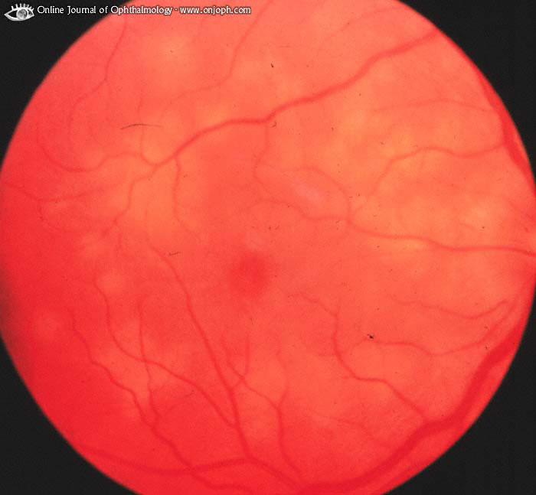
Source of picture: “Online Journal of Ophthalmology” >>

Endophthalmitis - acute, severe, diffuse uveitis.
- results from intraocular infection (vast majority after trauma or intraocular surgery).
- vitreous acts as superb medium for bacteria growth (in past, animal vitreous was used as culture medium!).
- severe pain and decreased vision, signs of intraocular inflammation (red eye, anterior chamber cells and flare, vitreitis, etc).
- medical emergency - infection may quickly involve orbit and CNS.
- treatment:
- broad-spectrum intraocular and systemic antibiotics (e.g. vancomycin, ceftazidime); ultimate treatment should be based on cultures taken on aqueous and vitreous fluid;
- mydriatics;
- intraocular corticosteroids are used in selected cases.
- sometimes pars plana vitrectomy is indicated.
N.B. visual prognosis is often poor, even with early and appropriate treatment!

Endophthalmitis (after cataract extraction); mixed injection, corneal endothelial decompensation, Descemet's creases, flare in anterior chamber, necrosis of iris root (indicates intraoperative mechanical damage):
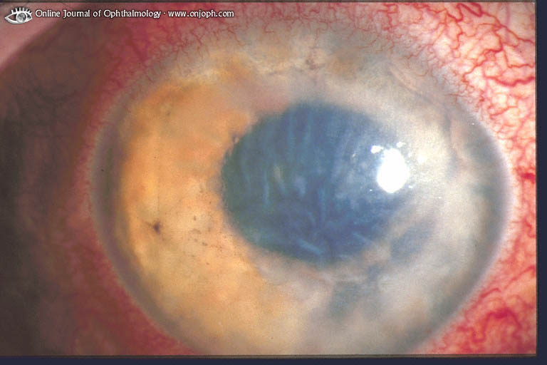
Source of picture: “Online Journal of Ophthalmology” >>

Masquerade Syndromes
- conditions that mimic uveitis:
- Intraocular malignancy (primary / metastatic) in very young / elderly may be accompanied by significant intraocular inflammation (e.g. intraocular lymphoma).
- Retinitis pigmentosa
- Reactions to drugs (e.g. systemic sulfonamides, pamidronate, rifabutin).

Vitreous opacities caused by metastasis of bronchial carcinoma. Vitreous biopsy reveals tumor cells
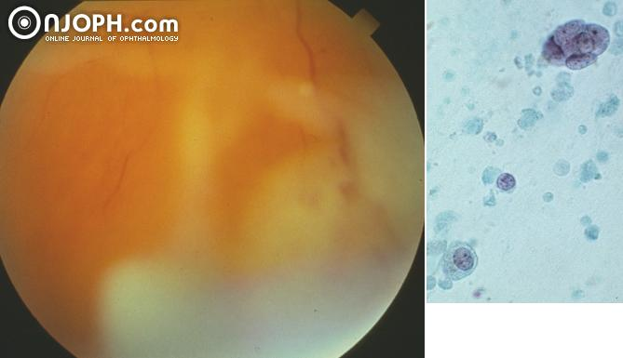
Source of picture: “Online Journal of Ophthalmology” >>

Bibliography for ch. “Ophthalmology” → follow this link >>

Viktor’s Notes℠ for the Neurosurgery Resident
Please visit website at www.NeurosurgeryResident.net

