Conjunctival and Scleral Disorders
Last updated: May 9, 2019
Acute Conjunctivitis 2
Etiology 2
Clinical Features 2
VIRAL CONJUNCTIVITIS 2
Diagnosis 2
Treatment 2
BACTERIAL CONJUNCTIVITIS 3
Diagnosis 3
Treatment 3
Ophthalmia Neonatorum (s. blennorrhea neonatorum, neonatal conjunctivitis, infantile purulent conjunctivitis) 3
Etiology 3
Diagnosis 3
Treatment 3
Chronic Conjunctivitis 3
Episcleritis 4
Scleritis 5
Clinical Features 5
Treatment 6
Ocular Cicatricial Pemphigoid → see p. 2991 >>

Eye Hyperemia
Diffuse conjunctival hyperemia (mainly posterior conjunctival blood vessels) – movable bright red irregular vessels, fading toward cornea, both bulbar and tarsal conjunctivae; vessels constrict with topical vasoconstrictors – conjunctivitis:
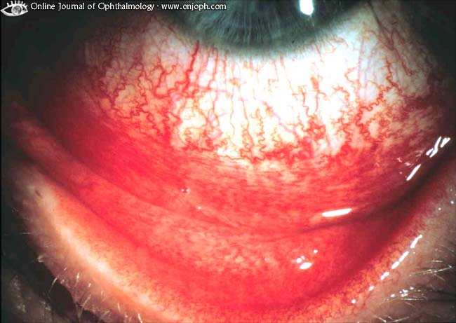
Source of picture: “Online Journal of Ophthalmology” >>

Circumcorneal (perilimbal) deep hyperemia (branches of anterior ciliary artery) – nonmovable, dilated, fine, straight, deep vessels that regularly radiate 1-3 mm out from limbus – iritis, acute glaucoma, keratitis.
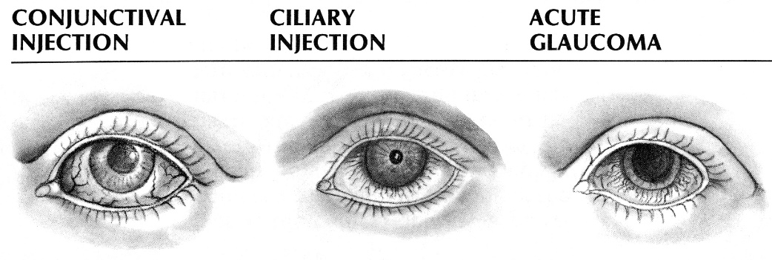

Large patch of deep hyperemia (involving 20-100% of bulbar surface without hyperemia of tarsal surface) – episcleritis, scleritis.

Subconjunctival hemorrhages
- gross blood extravasation beneath conjunctiva.
- appears as nonmovable homogenous red patch (vessels are not visible).
- may occur after minor trauma / straining / sneezing / coughing; rarely, spontaneously.
- no pathologic significance!!! (if recurs – consider bleeding diathesis)
- absorbed spontaneously (usually within 2 wk).
- reassurance is adequate therapy (topical corticosteroids, antibiotics, vasoconstrictors, compresses do not speed reabsorption).

Conjunctival edema
Bulbar conjunctiva - translucent, bluish, thickened conjunctiva.
chemosis - gross edema with conjunctiva ballooning & prolapse.
Tarsal conjunctiva - fine, minute projections (papillae), giving conjunctiva velvety appearance.

Hyperplasia of lymphoid follicles (most commonly in inferior tarsal conjunctiva) - small bumps with pale centers.

Benign neoplasms of conjunctiva
pinguecula - raised yellowish white mass (connective tissue accumulation) on bulbar conjunctiva, adjacent to cornea (at 3- and/or 9-o'clock position); unsightly but does not grow onto cornea (need not be removed); may become inflamed (responds to topical steroids). | 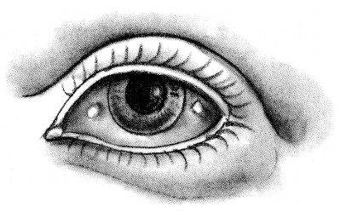
pterygium - fleshy triangular bulbar conjunctiva growth onto cornea (at 3- and/or 9-o'clock position) - may spread across and distort cornea → astigmatism, change in refractive power (H: removal). | 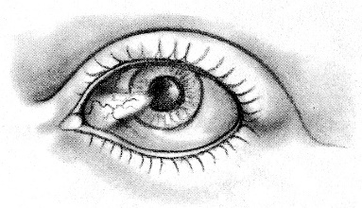

Acute Conjunctivitis
Etiology
- Viruses
- Bacteria
- Allergy – seasonal allergic conjunctivitis see p. 1665 (1-2) >>
- Irritation (wind, dust, smoke, air pollution, intense UV, reflection from snow, eyelid pathology), foreign bodies.

Clinical Features
 | Acute Conjunctivitis
 | Viral | Bacterial | Allergic
Discharge (cells) | clear, watery  (mononuclear cells) | purulent (polymorphonuclear cells) | clear, mucoid, ropy (eosinophils)
Lid swelling | + | ++ | +++
Preauricular node swelling | + | +/– | –
Itching | – | – | +++

- ocular irritation (photophobia, foreign-body sensation), diffuse hyperemia & edema (bulbar + tarsal).
- discharge; eyelids are stuck together on awakening.
- cornea*, iris, pupils, vision intact.
*focal corneal inflammation is possible → residual corneal scarring (0.5-1.0 mm) may be visible by slit lamp for up to 2 yr. (may result in decreased vision and significant glare).
N.B. always perform corneal fluorescein staining!

VIRAL CONJUNCTIVITIS
Adenoviruses
- pharyngoconjunctival fever (serotypes Ad 3, 4, 7)
- epidemic keratoconjunctivitis (serotypes Ad 8, 19, 37, 5):
injection, follicles and edema of conjunctiva. subepithelial infiltrates of cornea:
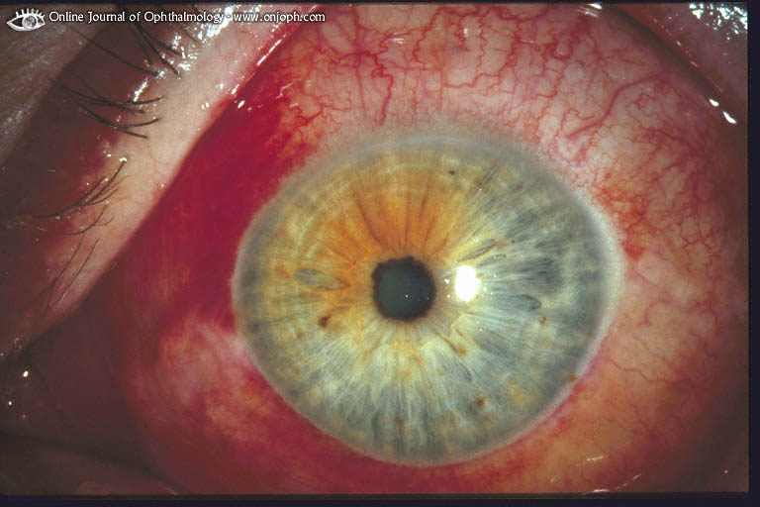
Source of picture: “Online Journal of Ophthalmology” >>

pseudo-membrane of fibrin & pus (can easily be peeled off without epithelial defect or bleeding):
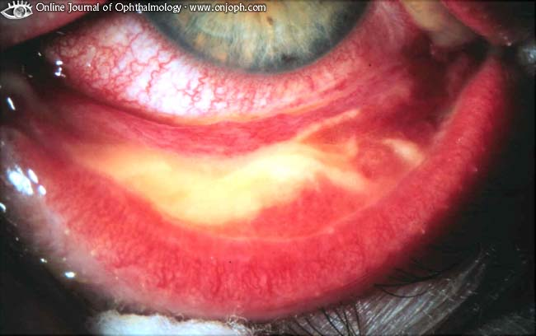
Source of picture: “Online Journal of Ophthalmology” >>

Enterovirus type 70 - outbreaks of acute hemorrhagic conjunctivitis.
Herpesviruses
Coxsackieviruses

May be unilateral!

Diagnosis
- although cultures can be taken, special tissue culture facilities are necessary;
secondary bacterial infection is very rare (if suspected → stained eye smears, cultures).

Treatment
- no treatment is needed or available!
- self-limiting, lasting 1-3 wk in severe cases.
- highly contagious!!! - wash hands thoroughly, avoid touching noninfected eye after touching infected eye or nasal secretions, avoid sharing towels or pillows.
- eyes should be kept free of discharge and should not be patched.
- severe conjunctivitis associated with pseudomembranes, vision-limiting corneal inflammation / scarring → topical corticosteroids (N.B. can exacerbate ocular herpes simplex virus infections!!!).

BACTERIAL CONJUNCTIVITIS
Neisseria gonorrhoeae - gonococcal conjunctivitis see p. 229 (9) >>
Chlamydia trachomatis (type D-K) - inclusion conjunctivitis see p. 244 (4) >>
Staphylococcus aureus
Streptococcus pneumoniae
Haemophilus influenzae.

Diagnosis
- discharge should be cultured, smears should be stained with Gram stain (to identify bacteria) and with Giemsa stain (to determine leukocytic response).

Treatment
- bacteria are contagious - spread by hand-to-eye and fomite inoculation.
- lasts up to 3 wk without treatment and 1-2 days with topical treatment (qid for 7-10 days):
    - sulfacetamide sodium 10%
    - trimethoprim / polymyxin B
    - gatifloxacin (Zymaxid®) 0.5% - FDA approved
    - besifloxacin (Besivance®) 0.6% ophthalmic suspension - FDA approved
N.B. poor clinical response after 2-3 days - insensitive bacterium, virus, or allergy.

Ophthalmia Neonatorum (s. blennorrhea neonatorum, neonatal conjunctivitis, infantile purulent conjunctivitis)
- bacterial conjunctivitis within first 10 days of life.

Etiology
- in decreasing order:
- Chemical injury - secondary to instillation of silver nitrate drops (for ocular prophylaxis); appears within 6-8 h after instillation, disappears spontaneously within 1-3 d.
- Bacterial infection (acquired during parturition):
- Chlamydia trachomatis type D-K (2-4% live births – no prophylaxis is currently used); account for 30-50% of conjunctivitis in infants < 4 wk; occurs 5-14 days after birth
- Haemophilus influenzae
- Neisseria gonorrhoeae (gonorrheal ophthalmia); appears 2-5 days after birth (or earlier with premature rupture of membranes) see p. 229 (9) >>
Isolation of other bacteria (e.g. S. aureus, Str. pneumoniae) usually represents colonization rather than infection.
- Viral infection - herpes simplex virus types 1 and 2 - herpetic keratoconjunctivitis.
see p. 256 (5) >>

- etiology is difficult to distinguish on clinical grounds alone.

Diagnosis
Chlamydial ophthalmia - conjunctival tissue culture, direct monoclonal antibody tests and ELISA; on smear - mononuclear reaction with no m/o.
Gonorrheal ophthalmia - culture and Gram stain of conjunctival specimen.
Herpetic keratoconjunctivitis - immunofluorescence in conjunctival cultures (N.B. diagnosis is crucial - disease may disseminate to CNS and other organs!!!).

Treatment
Chlamydial ophthalmia – systemic erythromycin ethylsuccinate (50 mg/kg/day po q6-8h 2 wk).
Gonorrheal ophthalmia – systemic ceftriaxone (25-50 mg/kg IM) + frequent saline irrigations (topical a/b are not needed).
Other bacteria - topical polymyxin + bacitracin, erythromycin, tetracycline.
Herpetic keratoconjunctivitis - systemic acyclovir (30 mg/kg/day q8h 2-3 wk) + topical trifluridine OR vidarabine while awake + idoxuridine ointment at bedtime.

N.B. ointments containing corticosteroids may seriously exacerbate eye infections due to Chlamydia trachomatis or herpes simplex virus!

Chronic Conjunctivitis
- exacerbations and remissions that occur over months or years.
- causes - similar to acute conjunctivitis;
Chlamydia trachomatis (types A-C) - trachoma see p. 244 (3) >>
allergy: giant papillary conjunctivitis see p. Eye72 >>
vernal keratoconjunctivitis, perennial allergic conjunctivitis see p. 1665 (1-2) >>
- symptoms ≈ acute conjunctivitis but less severe (may be without discharge).

Trachoma; follicle formation of conjunctiva that looks like sago grains:
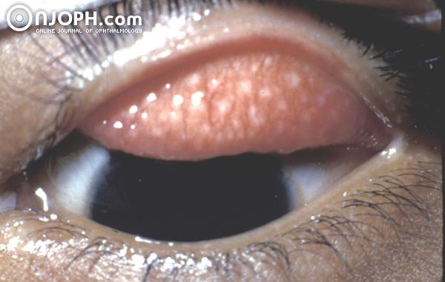
Source of picture: “Online Journal of Ophthalmology” >>

Trachoma; conjunctival cicatrization with shrinkage (esp. conjunctival side of upper lid), entropion and trichiasis; thickened epithelium near limbus; cornea opacified due to xerosis, formation of pannus and trichiasis:
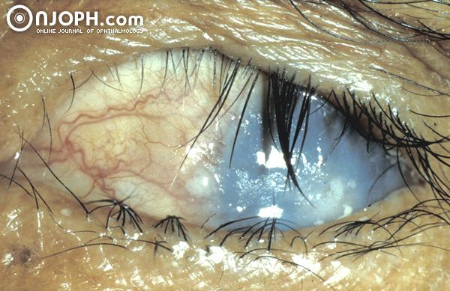
Source of picture: “Online Journal of Ophthalmology” >>

Vernal Conjunctivitis
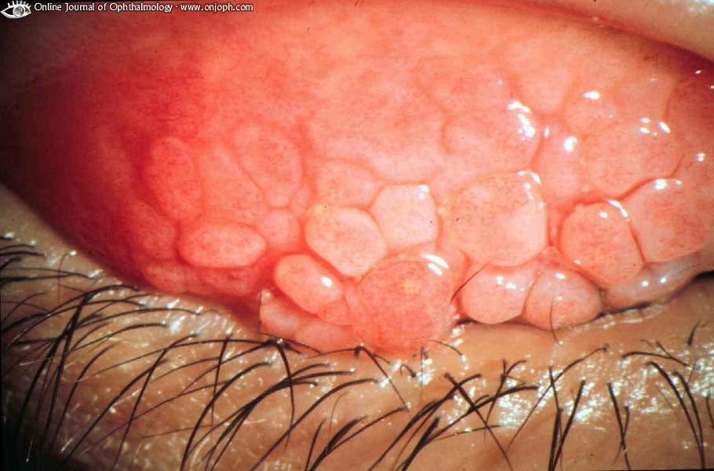
Source of picture: “Online Journal of Ophthalmology” >>

Follicular conjunctivitis - upper lid has been everted showing giant papillae:
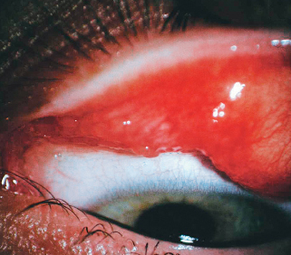

- therapy depends on cause.
- irritating factors must be eliminated.
- overtreatment may produce drug sensitivity!

Episcleritis
- occurs in young adults; tends to recur.
- cause can be any inflammatory systemic condition (e.g. RA, Sjögren syndrome, coccidioidomycosis, syphilis, zoster, tuberculosis); most often etiology cannot be determined.
- tenderness, irritation, mild photophobia, some lacrimation.
localized conjunctival hyperemia - bright red patch just under bulbar conjunctiva (simple episcleritis) or hyperemic, edematous, raised nodule (nodular episcleritis).

N.B. palpebral conjunctiva is normal!

- self-limited - treatment options:
    - no treatment
    - topical vasoconstrictors (e.g. tetrahydrozoline HCl) + topical corticosteroid OR oral NSAID.

Diffuse episcleritis in Epidemic Keratoconjunctivitis (hyperemic conjunctival and episcleral vessels):
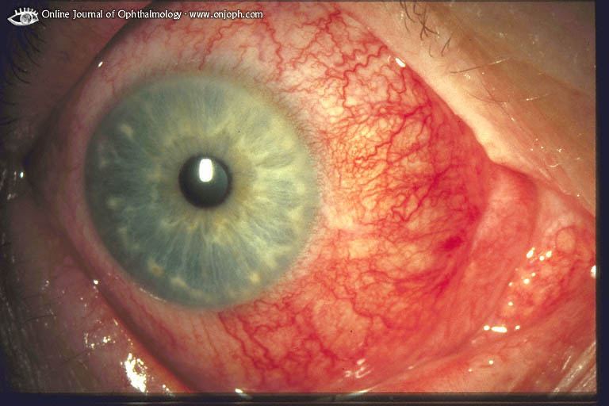
Source of picture: “Online Journal of Ophthalmology” >>

Scleritis
- severe, destructive, vision-threatening* inflammation of deep episclera and sclera.
*14% lose significant visual acuity within 1 yr!
Clinical Features
- most common in 4-6th decades.
- extreme deep pain - interferes with sleep and appetite!
- tenderness, photophobia, lacrimation.
- bulbar hyperemia:
- deep beneath conjunctiva, more bluish than in episcleritis!
- surrounding and overlying bulbar conjunctiva is hyperemic (palpebral conjunctiva is normal!)
- sectoral or widespread (diffuse scleritis);
- may contain hyperemic, edematous, raised nodule (nodular scleritis);
- may contain avascular area (necrotizing scleritis) → globe perforation and eye loss may ensue.
- associated connective tissue disease (RA, gout) in 20% (in 50% with necrotizing scleritis).
N.B. necrotizing scleritis in association with RA → 50% mortality in 10 yr (mostly from MI)!

necrotizing scleritis with severe RA; superficial and deep injection:
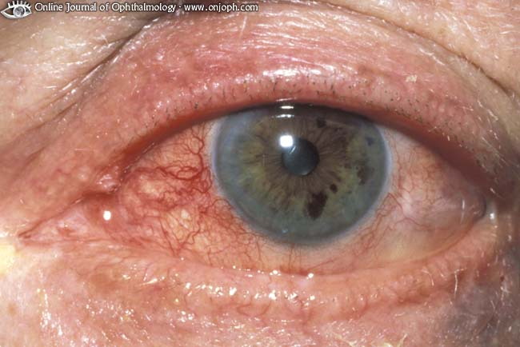
Source of picture: “Online Journal of Ophthalmology” >>

nodular scleritis - elevated, hyperemic, painful:
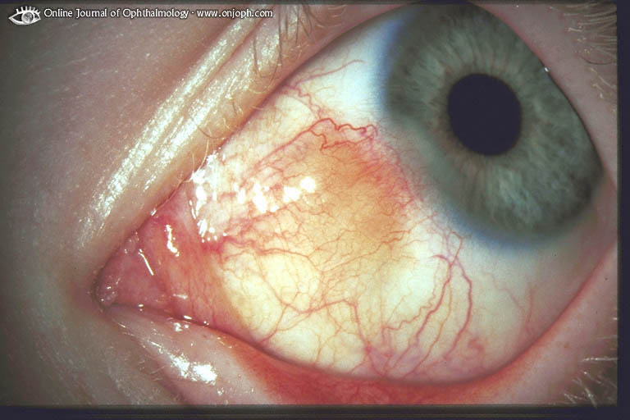
Source of picture: “Online Journal of Ophthalmology” >>

scleritis and scleromalacia in RA:
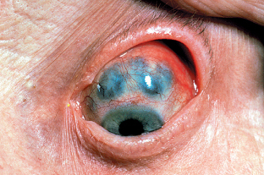

necrotizing scleritis - areas of pallor within diffuse areas of redness indicating ischaemia:
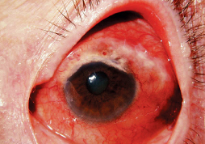

posterior scleritis - posterior fundus shows choroidal folds caused by thickened sclera which pushes choroids inward:
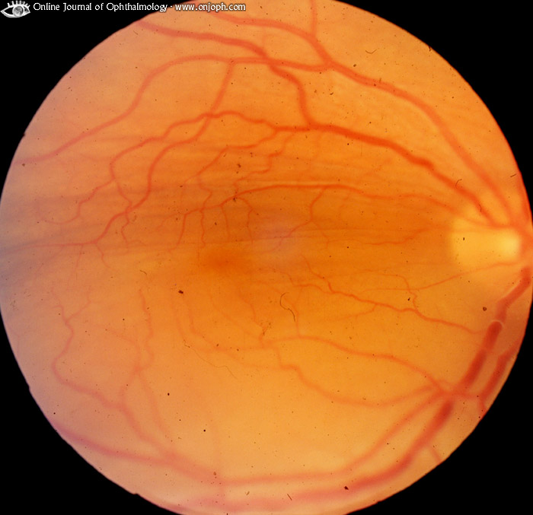
Source of picture: “Online Journal of Ophthalmology” >>

Treatment
- systemic corticosteroid.
- if unresponsive or necrotizing scleritis + RA → systemic immunosuppression (e.g. cyclophosphamide, azathioprine).

Bibliography for ch. “Ophthalmology” → follow this link >>

Viktor’s Notes℠ for the Neurosurgery Resident
Please visit website at www.NeurosurgeryResident.net

