Orbital Disorders
Last updated: May 9, 2019
(Peri)Orbital Cellulitis 1
Symptoms & Signs 1
Diagnosis 2
Treatment 2
Exophthalmos (Proptosis) 2
Etiology 2
Diagnosis 2
Treatment 2

(Peri)Orbital Cellulitis
orbital cellulitis - infection of orbital tissues (posterior to orbital septum)
periorbital (s. preseptal) cellulitis - infection of periorbital skin and eyelid (anterior to orbital septum).
Sources of infection:
- extension from paranasal sinuses (ethmoid sinusitis – 90% cases!!!), teeth
- introduced via orbital trauma / surgery (most commonly - S. aureus and S. pyogenes).
- hematogenous spread from bacteremia (most commonly - Haemophilus influenzae type b, Streptococcus pneumoniae).

Symptoms & Signs
- primarily children (periorbital cellulitis < 5 yr of age, orbital cellulitis > 5 yr).
- > 90% unilateral.
- extreme orbital pain, exophthalmos (with painful resistance to globe retropulsion)*, painful ophthalmoplegia*, eyelid-conjunctival redness & swelling, decreased visual acuity*, nasal discharge.
*absent in periorbital cellulitis

Peri-orbital cellulitis caused by Pseudomonas aeruginosa (in acute myelogenous leukemia):
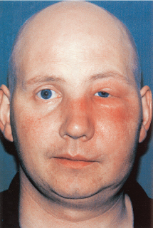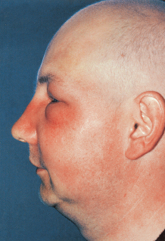

Acute infection of orbital tissue (esp. preseptal):
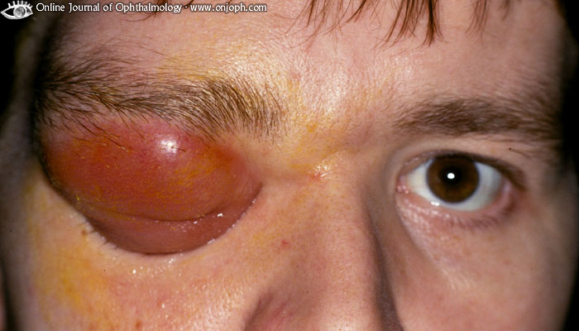
Source of picture: “Online Journal of Ophthalmology” >>

Mucormycosis of orbit (uncontrolled diabetes mellitus, especially with ketoacidosis); potentially fatal fungal infection that involves nose, sinuses and orbit → proptosis, ophthalmoplegia, visual loss:
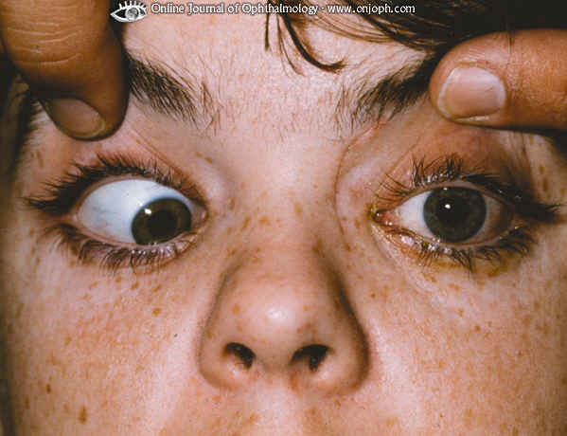
Source of picture: “Online Journal of Ophthalmology” >>

- fever & malaise, progressing rapidly to prostration!
- complications:
- vision loss (from optic neuritis, increased intraocular pressure, ischemia)
- thrombophlebitis of orbital veins → cavernous sinus thrombosis (dilation of episcleral vessels is first sign!)
- panophthalmitis
- infection spread to meninges / brain.
N.B. orbital veins (drain from middle third of face, including paranasal sinuses) have no valves - allow infection passage both anterograde and retrograde!

Diagnosis
X-ray of sinuses, CT of orbit
Blood cultures (positive only in 33%)
Needle aspiration of orbit is contraindicated!
Indications for CSF culture:
- infant < 1 yr with no external focus of infection
- suspected spread to CNS

Treatment
- antibiotics i/v ASAP (e.g. cefuroxime, cephalexin, cefazolin, nafcillin).
in preantibiotic era mortality rate was 17% (20% of survivors were blind in affected eye!)
- if secondary to sinusitis – add nasal decongestants.
- if infection does not respond to antibiotics in 48-72 h or if suppuration is suspected → incision & drainage.

Exophthalmos (Proptosis)
- eyeball protrusion.
Etiology
- Orbital inflammation, edema, infiltration (e.g. hyperthyroidism), tumors, injuries, hemorrhage, orbital pseudotumor (non-neoplastic cellular infiltration and proliferation, e.g. Wegener's granulomatosis), shallow orbits.
- Cavernous sinus thrombosis, carotic-cavernous fistula (pulsating exophthalmos with orbital bruit).
- Eyeball enlargement (e.g. congenital glaucoma, unilateral high myopia).

- causes of pseudoproptosis - lid retraction, unilateral high myopia, facial asymmetry, contralateral enophthalmos.

If orbital pressure is eccentric → eyeball deviation, diplopia.
Globe exposure can lead to corneal drying, infection (exposure keratitis), ulceration!!!

Diagnosis
Hertel exophthalmometer - formal measurement of position of anterior corneal surface in relation to lateral orbit wall.
- if proptosis is > 2 millimeters - space-occupying orbit lesion must be suspected.

Etiological diagnosis: CT / MRI of orbit, thyroid studies.

Treatment
Etiology determines therapy.
- cornea should be protected from exposure.
- surgical orbital decompression.

Bibliography for ch. “Ophthalmology” → follow this link >>

Viktor’s Notes℠ for the Neurosurgery Resident
Please visit website at www.NeurosurgeryResident.net

