Infections of Nervous System
Last updated: April 17, 2019
Pathogenesis 1
Classification 1
Viruses 1
Fungi 2
Predisposing Factors 2
Diagnosis 2
Treatment 2
Antibiotics 2
Antivirals 3
Antifungals 3
Candida 3
Postoperative Infection – see p. Op120 >>

Pathogenesis
- CNS is normally sterile.
- parenchyma, coverings, and blood vessels of nervous system may be invaded by virtually any pathogenic microorganism.

Principal routes of entry:
  - hematogenous spread (bacteria, viruses) via septicemia, septic emboli - most common!
- ordinarily through arterial circulation, but retrograde venous spread can occur (e.g. via anastomotic connections between veins of face and cerebral circulation).
- most common sources: pneumonia, bronchiectases, bacterial endocarditis.
  - direct implantation (bacteria) - invariably traumatic (rarely – iatrogenic*); associated with congenital malformations (e.g. meningomyelocele).
*esp. LP, ventriculo-peritoneal shunts
  - local extension (bacteria) from established infection – paranasal sinus (most often frontal), middle air, tooth, surgical site in cranium or spine (osteomyelitis → bone erosion → propagation into CNS).
  - retrograde transport through PNS (certain viruses - rabies, herpes simplex, poliovirus).

Infection becomes rapidly disseminated once organisms reach CSF.
- CSF is area of impaired host defense - lack of sufficient numbers of complement components and immunoglobulins for opsonization, contains no phagocytic cells; fluid medium impairs phagocytosis.

Damage to nervous tissue:
    - direct invasion by infectious agent
    - microbial toxins
    - destructive inflammatory / immune-mediated response - recently recognized as very important (even in bacterial meningitis).

Inflammatory reaction in confined intracranial space can cause ICP↑

Classification
- according to major site of involvement:
N.B. process frequently involves more than one of these structures (e.g. meningoencephalitis, encephalomyelitis)

- Osteomyelitis – inflammation of bones.
- Meningitis – inflammation of meninges.
- Encephalitis – viral invasion of brain parenchyma; often diffuse.
- Cerebritis – focal bacterial invasion of brain parenchyma; no capsule or pus.
- Myelitis – inflammation of spinal cord parenchyma; no capsule or pus.
- Abscess – focal, encapsulated, pus-containing cavity in brain parenchyma (rarely, in spinal cord parenchyma).
- Empyema – abscess in enclosed or potential space:
  - subdural
  - extradural
- Granuloma – focal, more or less encapsulated, chronic inflammatory lesion without pus (e.g. sarcoidosis, syphilis, tuberculosis, fungi, larvae of intestinal parasites).

Infections of spine:
- vertebral osteomyelitis/discitis
- epidural abscess
- subdural abscess*
- meningitis
- spinal cord abscess*
*exceedingly rare.

Viruses
Neuroinvasive - virus has ability to enter nervous system.
Neurotropic - virus infects nervous cells.
Neurovirulent - virus causes clinically recognizable neurologic symptoms.

Acute viral infections:
- viral (aseptic) meningitis
- encephalitis
- myelitis

Delayed complications of acute infection - postinfectious polyneuritis, acute disseminated encephalomyelitis (ADEM), acute cerebellar ataxia.

Latent infections with recurrences from time to time: herpesviruses (HSV, VZV).

Slowly progressive disorders (slow viral infections):
- conventional viruses:
  - subacute sclerosing panencephalitis (SSPE) (measles virus)
  - progressive rubella panencephalitis (PRP) (rubella virus)
  - progressive multifocal leukoencephalopathy (PML) (JC virus)
  - human T-lymphotrophic virus (HTLV)-associated myelopathy (HAM) / tropical spastic paraparesis (TSP) (HTLV-I)
  - acquired immunodeficiency syndrome (AIDS) (HIV)
- unconventional transmissible spongiform encephalopathy agents (prions).

Fungi
– opportunistic organisms – infect only immunosuppressed individuals.
(except few pathogenic fungi – Histoplasma*, Blastomyces*, Coccidioides*, Paracoccidioides** – may infect normal hosts).
*endemic to some areas of North America
**endemic to some areas of Central-South America
- most fungi invade brain by hematogenous dissemination (but direct extension by Mucor).
- lungs / skin / hair are usual primary sites.

Cryptococcosis* is most common mycotic CNS infection!
*may be primary infection and occur in normal individuals!
- meningitis
- intraparenchymal abscess / granuloma
- vasculitis → thrombosis → infarction (often strikingly hemorrhagic) - Mucor, Aspergillus

Predisposing Factors
- Recent infection that may progress to meningitis (e.g. upper respiratory infection, pneumonia, otitis media leading to pneumococcal meningitis; mumps, chickenpox).
- Exposure to others with infectious illness (e.g. meningococcus or Haemophilus influenzae).
- Recent travel (e.g. mosquitoes → arbovirus encephalitis; Central America → cysticercosis).
- Occupation (e.g. painter exposed to Cryptococcus in pigeon droppings)
- Underlying disease:
- lymphoma, leukemia, other malignancy
- renal failure
- AIDS and other immunodeficiency states
- alcoholism
- diabetes
- Drugs (chemotherapy, immunosuppressant, steroids)
- Recent head injury (precedes 10% of pneumococcal meningitis), penetrating skull trauma.
- Recent neurosurgical procedure. see p. Op120 >>
- Recent insect bite (e.g. Lyme disease, rickettsial infection).
- History of positive PPD.

Diagnosis
- CT / MRI is indicated in any patient with syndrome compatible with CNS infection!
- CSF is indicated in any patient (after exclusion of intracranial mass).
- brain biopsy (→ immunostaining techniques, electron microscopy, injection into susceptible animals and tissue culture cell lines) is still standard of diagnosis in some specific CNS infections.
- CBC with differential is nonspecific adjunct in diagnostic evaluation.
CBC may be normal in elderly or immunosuppressed patients!
- 2-3 blood cultures should be obtained from all patients (even when antimicrobial therapy has already been administered).
- in suspected any viral CNS infection, draw serum specimen acutely and save to compare with convalescent sera (3-5 weeks after onset of illness) – ≥ 4-fold rise in IgG titers?
- search of infection source – chest X-ray (!), echocardiography, cultures of other body fluids, bone scans.
- serum electrolytes, glucose*, urea nitrogen, creatinine.
*for interpretation of CSF glucose level.

Treatment
With exception of viral meningitis, all but most chronic CNS infections require initial inpatient evaluation and treatment:
- Bed rest
- Analgesics
- IV antimicrobials
- Fluid balance

Antibiotics
Drug IV | Neonates  (0-7 days → 8-28 days) | Children | Adults
penicillin G | 100,000-150,000 U/kg/d (divided every 12 hr) → 150,000-200,000 U/kg/d (divided every 6-8 hr) | 250,000-400,000 U/kg/d (divided every 4 hr) | 20-24 million U/d* (divided every 4 hr)
ampicillin | 50-75 mg/kg q12h →  50-100 mg/kg q6-8h | 50-100 mg/kg q6h | 2 g q4h
methicillin |  | 50 mg/kg q6h
oxacillin | 50-75 mg/kg q12h →  50 mg/kg q6-8h | 33 mg/kg q4h or 50 mg/kg q6h | 2 g q4h
nafcillin |  | 33 mg/kg q4h | 1.5-2 g q4h
ticarcillin | 75-100 mg/kg q12h | 75 mg/kg q6h | 3 g q4h
gentamicin | 2.5 mg/kg q12h → q8h | 2.5 mg/kg q8h | 1.66 mg/kg q8h
amikacin | 7,5-10 mg/kg q12h → q8h | 10 mg/kg q8-12h | 7.5 mg/kg q12h
cefotaxime | 50 mg/kg q12h →  50 mg/kg q6-8h | 50 mg/kg q6h | 1.5-2 g q4h
ceftriaxone | - (displaces bilirubin from albumin-binding sites) | 40-50 mg/kg q12h | 2-3 g q12h
ceftazidime | 30 mg/kg q12h → q8h | 40-50 mg/kg q8h | 2 g q8h
vancomycin ^{R} | 15 mg/kg q12h → q8h | 10 mg/kg q6h | Load 25-30 mg/kg  (max. 3000 mg)  ↓  500-750 mg q6h  (check trough level after 3rd dose)
chloramphenicol | 25 mg/kg q24h → q12h | 20-25 mg/kg q6h | 1 g q6h
metronidazole |  | 7.5 mg/kg q8h | 500 mg q6h
SMX/TMP |  |  | 15-20 mg/kg/d divided equally as q6h or q8h doses
oral rifampin |  | > 1 yr.: 10 mg/kg q12h  < 1 yr.: 5 mg/kg ql2h | 600 mg q12h
*may produce convulsions if large concentrations are introduced into CSF
^{R} dose adjustment necessary for Creatinine Clearance < 60 mL/min

N.B. only 3rd generation cephalosporins are used; cefuroxime enters CSF, but frequent treatment failures!

Antibiotic | Ratio CSF to serum
penicillin G | 2-5%
ampicillin | 15-20%
cefotaxime | 27-63%
nafcillin | 10-15%
vancomycin | 10-15%

Antivirals
- ganciclovir 5 mg/kg q12h IVI over 1 h for minimum 14-21 days → 6 mg/kg/d for indefinite period.
- foscarnet 40-60 mg/kg q8h (or 100 mg/kg q12h) IVI over 1 h for 14-21 days → maintenance 60-120 mg/kg/d IV for indefinite period.
- acyclovir
  - 10 mg/kg (or 500 mg/m²) IVI q8h over 60 min (to minimize risk of renal dysfunction).
- dilute to concentration ≤ 7 mg/mL (e.g. 70-kg person - 700 mg is diluted in 100 mL).
- extravasation → local inflammation and phlebitis.
- excellent CSF penetration.
- acyclovir-resistant strains are problem only in AIDS patients.
  - 800 mg orally ×5/d.
- valacyclovir 1.0 g orally ×3/d.
- famciclovir 500-750 mg orally ×3/d.

Antifungals
Candida
From 2016 guidelines:
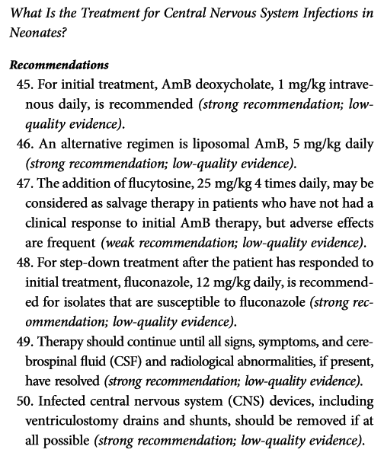

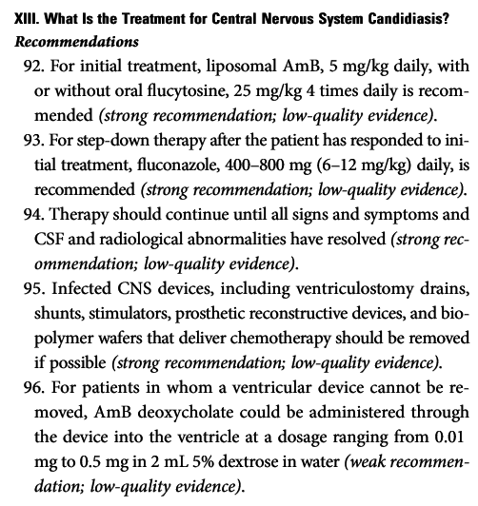

Related:
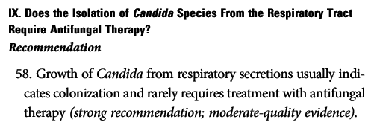

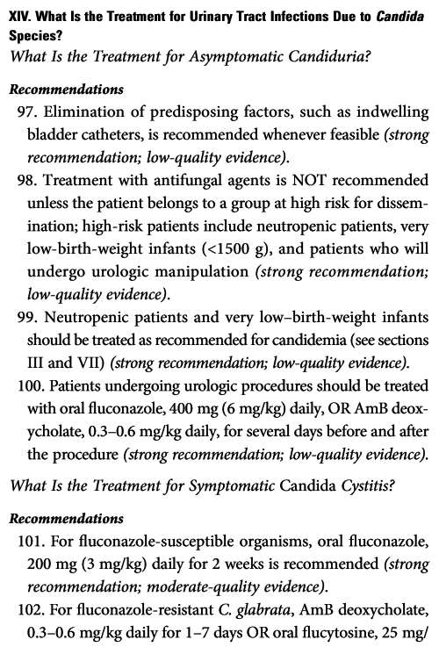
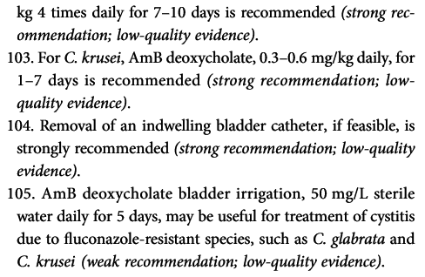

Bibliography for ch. “Infections of Nervous System” → follow this link >>

Viktor’s Notes℠ for the Neurosurgery Resident
Please visit website at www.NeurosurgeryResident.net

