Parkinsonism-Plus Syndromes
Last updated: April 17, 2019
Parkinsonism-Plus Syndromes 1
Progressive Supranuclear Palsy (PSP, s. Steele-Richardson-Olszewski syndrome) 1
Corticobasal Ganglionic Degeneration (CBGD) 3
Multiple System Atrophy (MSA) 3
Lytico-Bodig disease (Parkinsonism-Dementia-ALS complex of Guam) 5
Heredodegenerative Parkinsonism 5
Hallervorden-Spatz Disease 5
Familial Basal Ganglia Calcifications 5
Wilson Disease (Hepatolenticular Degeneration) 5

Parkinsonism-Plus Syndromes
Parkinsonism-Plus Syndromes (Multiple System Degenerations) - primary neurodegenerative conditions:
- parkinsonism is one of major clinical features (10-15% of all parkinsonism cases) but usually no tremor.
- additional features not typical of Parkinson's disease.
- poorer response to antiparkinsonian therapy (destroyed postsynaptic D receptors).
- overall worse prognosis – most patients are dead at 5 years after diagnosis.

Progressive Supranuclear Palsy (PSP, s. Steele-Richardson-Olszewski syndrome)
- most common parkinsonism-plus syndrome (1% of PD patients).
- age-adjusted prevalence - 1.38 per 100,000 population.
- rare familial clusters have been reported (association with particular tau genetic factor – PSP is taupathy).

Pathophysiology, Pathology
- idiopathic with no known precipitant or strong genetic component.
- pathology is reminiscent of encephalitis lethargica, although no infectious agent was identified.
- microscopy - neuronal loss & gliosis, neurofibrillary tangles (argyrophilic; different from Alzheimer disease - composed of 15-nm straight helical filaments) and neuropil threads.
- sites of maximum involvement (far more diffuse process than Parkinson's disease) – midbrain (SN, superior colliculus, pretectal area), subthalamic nucleus, globus pallidus, substantia innominata (basal nucleus of Meynert).
- mild diffuse cerebral atrophy also may be present.
- affected neurotransmitter systems - dopaminergic, cholinergic, adrenergic.

Bielschowsky silver stain - globose tangle (arrow) in neuron of brainstem:
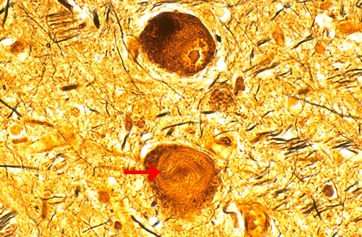
Source of pictures: “WebPath - The Internet Pathology Laboratory for Medical Education” (by Edward C. Klatt, MD) >>

Clinical Features
- onset – after 50 yrs. (in general, ≈ 10 years later than Parkinson disease).

- Parkinsonism
  - profound postural instability → early frequent falls (within first year of clinical disease)
  - axial rigidity > limb rigidity; retrocollis - erect posture with tonic neck hyperextension (intense rigidity of posterior cervical muscles); posture is extended (vs. PD – flexed).
  - tremor almost never occurs.

- Supranuclear vertical gaze paresis (usually appears within 1-2 years of symptom onset)
- difficulty with tasks requiring volitional downgaze (reading, eating, descending stairs).
- loss of vertical opticokinetic nystagmus on downward movement of target.
- later, upward and then lateral conjugate gaze also become impaired.
- paresis may be overcome by passive head movement, i.e. via oculocephalic reflexes (intact reflex downgaze! - hence designation “supranuclear”).

- Subcortical dementia
- severe bradyphrenia, impaired verbal fluency, difficulty with sequential actions or with shifting from one task to another.
- bilateral frontal lobe dysfunction - severe palilalia, emotional incontinence, etc.

- Pseudobulbar palsy (dysphagia, dysarthria, emotional incontinence).

- Disturbances of eyelid motility – blepharospasm, apraxia of eyelid opening or closing (→ exposure keratitis), lid retraction + sustained frontalis contraction (appearance of surprise).

Diagnosis
MRI - to rule out multi-infarct state or hydrocephalus.
atrophy of pons & midbrain may be noted (AP diameter of midbrain < 15 mm):

Midbrain to pons area ratio is measured on midline sagittal images:
- pontomesencephalic junction is defined by a line between the superior pontine notch and the inferior border of the quadrigeminal plate;
- pontomedullary junction is defined by a line parallel to the first line, at the level of the inferior pontine notch.
- normal value is ≈ 0.24 (in PSP, it is significantly reduced to 0.12)
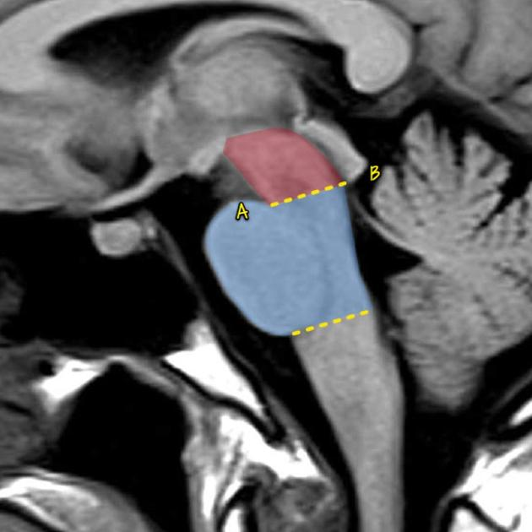

- hummingbird sign (s. penguin sign):
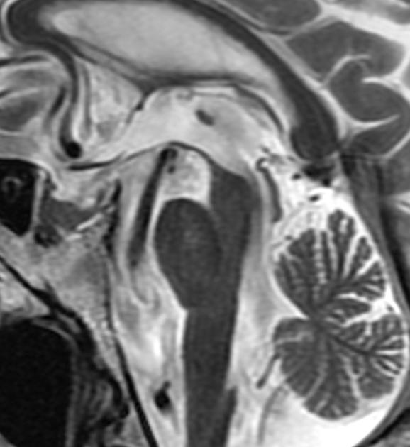
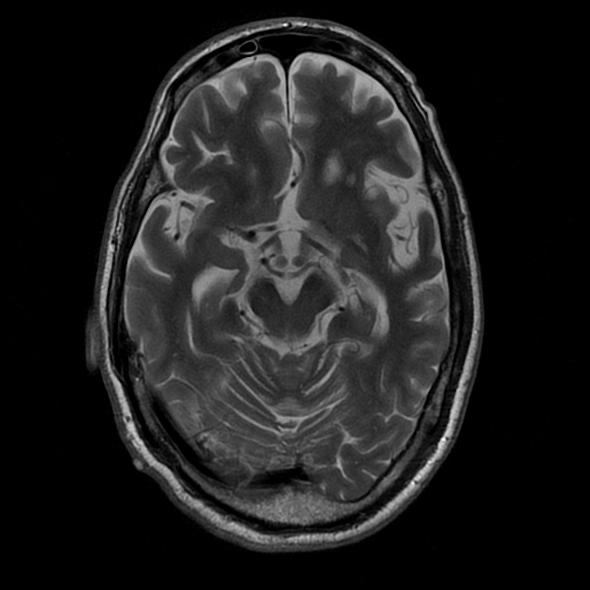

- mickey mouse appearance:
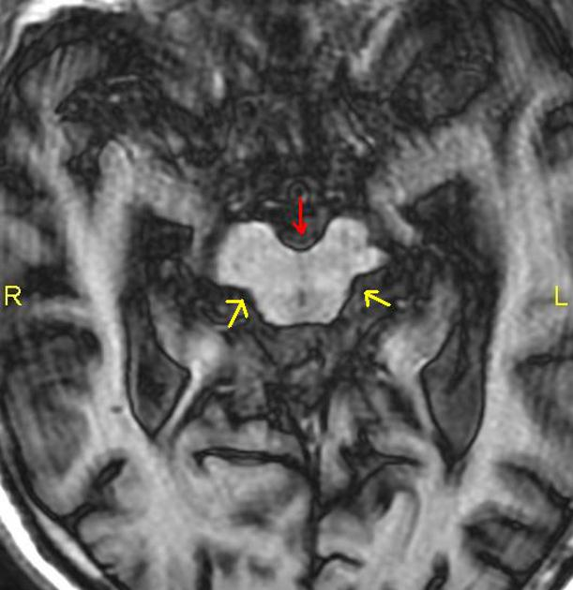

SPECT, PET - frontal and basal ganglia hypometabolism, decreased striatal D₂ dopamine receptors.

EEG - some slowing and disorganization without localizing features.

Treatment
Pharmacological therapies remain disappointing!
- levodopa effective in 1/3 cases, but benefit rarely persists beyond 1-2 years.
- D agonists rarely provide additional benefit.
N.B. if dopaminergic drugs improve bradykinesia but have no impact on poor balance → medicated patient falls more frequently → greater disability.
- anticholinergic drugs - for emotional incontinence, drooling.
- idazoxan (noradrenergic drug) - modest improvement in small number of patients, but sympathomimetic and other side effects are limiting.
- electroconvulsive therapy, adrenal implantation, pallidotomy - no benefit.

Prognosis
Median interval from onset of initial symptom:
to onset of gait difficulty - 0.3 years;
to need for gait assistance - 3.1 years;
to confinement to bed / wheelchair - 8.2 years;
to death - 9.7 years (falls and aspirations).

Corticobasal Ganglionic Degeneration (CBGD)
- no familial predisposition, no environmental factors increase risk.
- prevalence ≈ 1% of PD.

Pathology
- diffuse cytoskeletal process characterized by accumulation of pathologic tau proteins.
- asymmetrical, focal frontoparietal cortical atrophy with "ballooned" achromatic neurons (immunostain positively to neurofilaments).
- depigmentation of substantia nigra (without Lewy bodies).

Clinical Features
- progressive perceptual-motor syndrome:
- onset - after age 60.
- progresses steadily, ambulation becomes impaired in all individuals at some point.
- death within 7-10 years of diagnosis (dysphagia → aspiration).

- Focal or asymmetrical parkinsonism.
H: levodopa or D agonists - modest success.
- Marked dystonia (usually predominantly in one upper extremity).
H: botulinum toxin.
- Dysfunction of frontoparietal cortex:
- most characteristic symptom - limb apraxia (progressive, untreatable, markedly disabling!) - involved extremity can become so dysfunctional that it moves completely by itself (“alien limb”) – myoclonic jerks, levitation, etc.
- psychomotor slowing, visuoperceptual disturbances.
- cortical sensory loss.
- cognitive decline occurs late and only in some cases.

Diagnosis
CT / MRI - asymmetrical predominantly parietal cortical atrophy.
SPECT - asymmetrical cortical (and subcortical) hypoperfusion.

Multiple System Atrophy (MSA)
Do not confuse with combined systems degeneration (due to vit. B12 deficiency)!
Neurodegenerative syndromes with:
- cytoplasmic fibrillary inclusions in oligodendrocytes (distinctively different from other neurodegenerative syndromes):
- composed of altered 20-40 nm microtubules.
- can occur in absence of neuronal loss, suggesting that they may represent primary pathologic event!
- unknown pathogenic mechanisms.
- no evidence for genetic factors.

Clinical Features
      - parkinsonism - poorly responsive to levodopa!
      - combination of varying degrees of autonomic / cerebellar / pyramidal dysfunction.
    - mean survival ≈ 8.0 years.

MSA encompasses three syndromes (in past were considered clinically distinct):
- striatonigral degeneration (SND) - prominent anterocollis and pyramidal dysfunction.
- olivopontocerebellar atrophy (OPCA) - prominent cerebellar features.
- Shy-Drager syndrome (SDS) - dysautonomia far outweighs other signs.

Diagnosis
  - T2 weighted MRI - marked striatum (putamen) hypointensity + linear hyperintensity lateral to putamen (iron deposition).
  - PET - decreased striatal D₂ receptors.
  - external urethral & rectal sphincter EMG is abnormal (large motor units) in almost all patients!
Onufrowicz nucleus (external urethral sphincter innervation) is strikingly preserved in LMN diseases but is lost along with autonomic pre-ganglionic cells in MSA (esp. Shy-Drager syndrome)!

Striatonigral Degeneration (SND), s. MSA-Parkinson (MSA-P)
- pathology – macroscopic atrophy with neuronal loss & marked gliosis in corpus striatum (putamen-globus pallidus-caudate), substantia nigra, subthalamic nuclei → presynaptic & postsynaptic parkinsonism.
Lewy bodies are not seen!
- seemingly classic Parkinson's disease with little / no response to dopaminergic medication!
  - tremor usually absent.
  - cognitive function preserved.

Machado-Joseph Disease (Spinocerebellar Ataxia type 3)
- autosomal dominant form of SND. see p. Mov50 >>

Olivopontocerebellar Atrophy (OPCA), s. MSA-cerebellar (MSA-C)
- group of genetically distinct diseases; some cases are nonfamilial.
- pathology – atrophy with neuron loss in cerebellar cortex, basis pontis, inferior olivary nuclei; neuronal loss in striatum and substantia nigra also occurs.
- neurochemistry - aspartate and glutamate contents in inferior olive and Purkinje cell layer of cerebellum are significantly decreased.
- clinical features – parkinsonism + cerebellar syndrome (ataxia, tremor, involuntary movement, dysarthria).
- up to 60% cases have cognitive impairment.
- five clinical types (four with dominant, one with recessive inheritance) - each characterized by additional findings (e.g. sensory loss, retinal degeneration, cranial nerve palsies).
N.B. extreme clinical variation - even within affected pedigree, no two cases are exactly alike!

- MRI - marked atrophy of ventral pons and of “pontine nuclei” and their axons.  A. Sagittal T1-MRI  B. Axial T2-MRI (signal change as well as atrophy give rise to “hot-cross bun” appearance, darker areas representing preserved corticospinal and lemniscal pathways). | 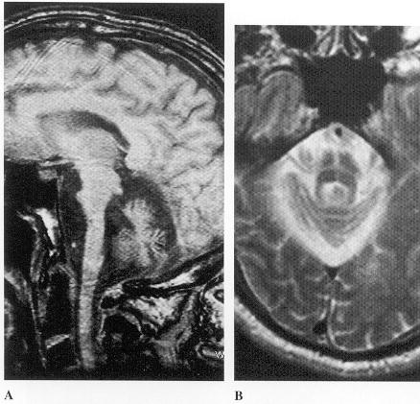
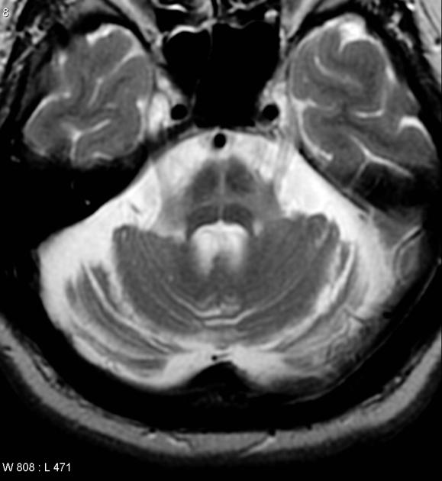

- some respond to levodopa if striatum is not severely degenerated.

Shy-Drager Syndrome
Diffuse degenerative changes in central (preganglionic) autonomic neurons, extrapyramidal system, cerebellum, pyramidal tracts, and anterior horn cells.

Parkinsonism (usually without tremor).
Diffuse autonomic dysfunction - lost preganglionic sympathetic neurons in spinal intermediolateral column → sympathetic dysfunction (also cholinergic cells in intermediolateral columns and postganglionic degeneration occurs):
- orthostatic hypotension is major disabling feature; see p. 1349-1351 >>
- hypotension is sometimes described by patient as “weakness”, blurring of vision (that starts peripherally and encroaches on central vision just before fainting).
N.B. no pallor, nausea, increased sweating, or yawning before syncope (vs. before vagotonic vasovagal syncope).
- accentuated in early morning (due to overnight natriuresis), postprandially, after exercise.
- diagnosis – BP is checked after 3 minutes in recumbent posture and again after 3 minutes of standing - pulse rate does not rise to compensate for BP fall!!! (vs. hypovolemic orthostasis - significant compensatory tachycardia).
- because postganglionic sympathetic neuron is intact, plasma [NE] is normal when supine, but fails to rise when patient stands.
- normal (or hypersensitive) responses to IV norepinephrine and tyramine.
see p. Veg1 >>
- impotence – first symptom in males!
- anhidrosis with thermoregulatory disturbances
- Horner's syndrome, alternating anisocoria, external ophthalmoplegia, iris atrophy
- poor lacrimation and salivation
- constipation, rectal incontinence
- disturbances in bladder emptying.
- respiratory disturbance - involuntary gasping, cluster breathing, laryngeal stridor, obstructive sleep apnea.

  - some families with autosomal dominant inheritance (association with HLA Aw32, but no gene identified).
  - age at onset – 37-75 years (mean of 55 years).
  - course insidious, but progressive.
  - late in course – emotional lability, difficulty swallowing (prone to aspiration), respiratory dysfunction (stridor at night, periods of apnea), depression (but mental deterioration, if present, is usually mild).
  - patients became bedridden and debilitated before they die (≈ 8 years after onset).

Treatment
Orthostatic hypotension - Na & volume repletion, constrictive garments to lower body (including abdomen), fludrocortisone, ephedrine, indomethacin (inhibits vasodilator prostaglandin synthesis), midodrine. see p. 1349-1351 >>
- if this causes supine hypertension → sleep at incline (instead of in recumbent position); this will also decrease morning hypotension.
- levodopa can exaggerate orthostatic hypotension!

Urinary frequency / incontinence (detrusor hyperreflexia) - peripherally acting anticholinergics (oxybutynin, propantheline).

Lytico-Bodig disease (Parkinsonism-Dementia-ALS complex of Guam)
parkinsonism + dementia + motor neuron disease
- depigmentation, basophilic inclusion bodies, neurofibrillary tangles in degenerating neurons (incl. substantia nigra, anterior horn cells).
Lewy bodies and senile plaques are absent!
- occurs among Camorra natives on Guam in Western Pacific (locally known as Lytico-Bodig disease).
- incidence has declined gradually since 1950s.
- probable environmental exposure during adolescence or adulthood.
e.g. neurotoxin (excitatory amino acid) found in seed of plant Cycas circinalis - natives on Guam used this seed to make flour in World War II – this hypothesis recently was strongly questioned!!!
- death occurs within 10 years of diagnosis.

Heredodegenerative Parkinsonism
Hallervorden-Spatz Disease
s. "neurodegeneration with brain iron accumulation type 1"
- autosomal recessive inheritance.

Pathology
- heavy iron deposition (extra- and intracellularly) in globus pallidus and substantia nigra (pars reticulata); at autopsy - asymmetrical rust-brown pigmentation.
cysteine (increased in globus pallidus) chelates iron → generation of free radicals.
- neuronal degeneration in basal ganglia, corticospinal tract, cerebellum.
- "mulberry" concretions typically present in extracellular space.
- numerous large spheroid bodies (degenerating myelinated axons).

Clinical Features
- childhood- or adult-onset: parkinsonism, progressive dementia, spasticity, variously combined with dystonia, choreoathetosis, ataxia, seizures, amyotrophy, retinitis pigmentosa.
- mean disease duration - 11 years (45% die before age of 20 years).

Diagnosis
- MRI-T2 - "eye of tiger" - hypointensity in globus pallidus (internal segment) and substantia nigra (pars reticulata) surrounded by circumscribed region of hyperintensity.

Chelation therapy (to remove excess iron) is not useful.

Familial Basal Ganglia Calcifications
- calcium accumulation in basal ganglia:
- hypoparathyroidism
- Fahr disease (familial disorder) - progressive calcific deposition in blood vessel walls of basal ganglia.
- parkinsonism, dementia, chorea, palilalia.
- brain imaging may detect basal ganglia calcification in clinically unaffected relatives.

Wilson Disease (Hepatolenticular Degeneration)
see p. 2774 (2-4) >>
Neurologic manifestations rarely appear before 10 yr of age (most commonly in early twenties) - signs of progressive basal ganglia destruction:
I. Motor disorders
- progressive dystonia - initial sign.
- postural tremors of extremities - unilaterally at first, eventually coarse, generalized, incapacitating ("wing-beating" tremor).
- parkinsonism with drooling
- "fixed sardonic smile" (retraction of upper lip), dysarthria, dysphonia, contractures, choreoathetosis.

II. Behavioral, psychiatric & mental abnormalities  Sensory disturbances never occur!  MRI-T2: increased density of caudate (small arrow) and putamen (large arrow).  "face of panda" in midbrain = hypodensity of superior colliculi + hyperdensity in medial substantia nigra and tegmentum.  If untreated - bedridden and demented patient dies in coma within few years from onset of disease. | 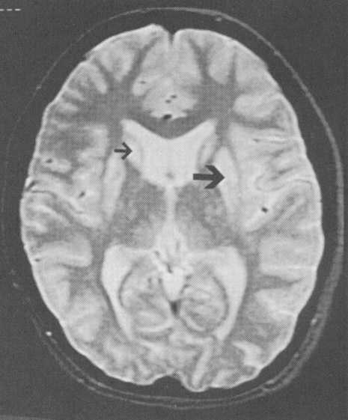

Bibliography for ch. “Movement disorders, Ataxias” → follow this link >>

Viktor’s Notes℠ for the Neurosurgery Resident
Please visit website at www.NeurosurgeryResident.net

