Gait Disorders, Falls, Immobility
Last updated: April 17, 2019
Gait Disorders 1
Clinical Features 1
CLINICO-ANATOMICAL syndromes 1
CLINICO-PHYSIOLOGICAL syndromes 1
Dyssynergy Syndromes 1
Frontal gait 2
Sensory Gait Syndromes 2
Sensory ataxia 2
Vestibular ataxia 2
Visual ataxia 2
Multisensory disequilibrium 2
Perception / Orientation Syndromes 2
Motor Force Disorders 3
Force Scaling Disorders 3
Parkinsonian gait 3
Choreic gaits 3
Dystonic gaits 3
Cerebellar ataxia 3
Corticospinal gaits 4
Impaired Adaptation and Strategies 4
Psychogenic gait disorders 5
General Management 5
Falls 6
Etiology 6
Management 6
Complications 6
Immobility 7
Etiology 7
Consequences 7
Prevention 7

Gait Disorders
Walking is product of three interrelated functions:
- Locomotion (locomotor synergies) - stereotyped patterns of muscle activation of limbs and trunk that produce repetitive stepping (incl. initiate and arrest stepping, alter stepping for turns, different speeds, and different support surfaces); centers present in spinal cord (central pattern generators) – are switched on by brain stem input via reticulospinal tract.
- Balance (equilibrium synergies) - postural responses that enable to arise and remain erect (during standing and locomotion) - body sway is kept within limits of base of support provided by feet; centers present in brain stem.
  - anticipatory postural responses - precede voluntary movements - to offset disturbances in balance that would result from voluntary movement.
  - reactive postural responses (feedback responses) - protect against unexpected external perturbations; triggered by sensory cues.
- Adaptation - adjustment of locomotor and balance synergies to constraints produced by environment, body, and ongoing voluntary activities; function of frontal lobes, basal ganglia, cerebellum
- frontal motor areas are involved in precise skilled locomotion (such as walking on uneven surfaces, avoiding obstacles on ground, and dancing).

Secure gait depends on:
  - proprioceptive, vestibular, visual information;
  - ability to integrate information;
  - ability to produce force (through bones, joints, muscles);
  - ability to modulate force for optimum performance;
  - ability to select & adapt locomotor and balance synergies (to environmental requirements and individual's capabilities).

Clinical Features
- patients complain of:
- slow / unsteady walking
- freezing on turns
- bumps and falls
- widened base during walking indicates sensory / cerebellar / frontal lobe dysfunction.
- freeze during turning (turn hesitation) is very typical of parkinsonism and frontal lobe gaits.

CLINICO-ANATOMICAL syndromes
Anatomic Location | Gait Abnormality
Cerebral cortex | freezing, disequilibrium, visual field defects, visual hemineglect
Brain stem | astasia, disequilibrium
Basal ganglia | freezing, astasia, hypokinetic / hyperkinetic gait
Cerebellum | ataxia
Vestibular system | ataxia
Spinal cord | spastic gait, sensory ataxia
Peripheral nerve | foot drop, sensory ataxia
Muscle / neuromuscular junction | waddle

CLINICO-PHYSIOLOGICAL syndromes
(1) locomotor and balance dyssynergias
(2) primary sensory function
(3) perception / orientation
(4) force production
(5) force scaling
(6) adaptation / cognition / attention.

Dyssynergy Syndromes
Freezing (difficulty in initiating / maintaining locomotion).
- interruption of voluntary access to brain stem locomotor regions or spinal central pattern generators.
- feet seem to stick to floor, and patient may be at loss as to how to start walking (gait ignition failure, s. start hesitation); hesitation of several seconds ensues before patient can begin to walk.
- gait begins with small steps that increase in length, sometimes to normal length (slipping clutch gait).
- turns are accomplished with slow, small steps and sometimes freezing (turn hesitation).
- any distraction that interrupts patient's concentration on walking may precipitate freezing.
- freezing may be overcome by tricks that convert walking from automatic act to cortically directed process; e.g. patients may initiate gait by focusing on stepping on particular spot on floor, pretending to kick something, or stepping over object; then more automatic stepping can function, but always under constant surveillance of cortex (distraction in these patients brings locomotion to halt).
- etiology:
- Parkinson's disease
- frontal cortex and deep white matter lesions - marked start freezing (gait ignition failure), but once under way they have almost / completely normal stride, with preserved arm swing; there may be exaggerated side-to-side sway of trunk in attempt to raise feet off floor.

Frontal disequilibrium (Bruns ataxia, s. frontal ataxia)
- lesions of frontal lobes / deep white matter - loss of access to balance synergies, inappropriate selection of synergies, or release of inappropriate brain stem synergies → profound balance disturbance (may preclude rising and standing):
  - patients do not bring their feet under themselves as they try to rise;
  - cannot stand because they do not bring their weight over their feet (many hyperextend trunk and push backward);
  - bizarre stepping with crossing of legs and no coordination between trunk and legs.
- sometimes termed gait apraxia - inappropriate term (frontal gait is limited by balance, not by locomotor difficulties).

Frontal gait
= frontal disequilibrium + frontal freezing (i.e. isolated gait ignition failure).
- often seen with multi-infarct dementia or normal pressure hydrocephalus.

Sensory Gait Syndromes
- inadequate information (reduced sensory input)
- mismatch between sensory information.
- sensory systems that aid to balance & locomotion - somatosensory, vestibular, visual.
Generally, one sensory system is adequate for normal balance and gait!

Sensory ataxia
- proprioceptive sensory loss in lower extremities.
- etiology - large myelinated peripheral nerves / dorsal roots / posterior columns.  - present Romberg sign (e.g. walking in dark room, closing eyes to wash face, walking backward, making sudden turns).  - increased sway when standing.  - gait:  - unsteady and wide-based (feet wide apart).  - irregular steps; throws feet forward and outward (too high, too far) and brings them down, first on heel and then on toes (double tapping sound).  - eyes focused on feet and ground immediately in front of them (diverting eyes away from feet may cause patient to fall).  - delayed reactive postural responses (induced by pull test).  - cane may aid in walking - proprioceptive cues from hands. | 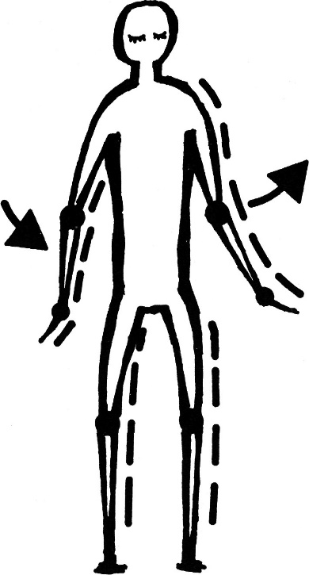
Vestibular ataxia
- vestibular dysfunction.
- severity depends on lesion development speed:
- in longstanding complete vestibular loss, patient may appear completely normal under most circumstances; deficits emerge only when vision + proprioceptive clues are reduced).
- sudden vertigo may be associated with inability even to stand.
N.B. vestibular function that is present but distorted causes more difficulty than absent vestibular function!
- coordination of individual limb movements is not impaired.
- patient sways in direction of affected labyrinth.
- patients are very dependent on visual information (present Romberg sign), but their deficient vestibular-ocular reflexes make it difficult to differentiate between self and environmental movement!
patients generally describe unsteadiness but not vertigo!
- gait:
- erroneous perceived self-motion → staggered steps trying to correct for imagined change in body position.
- patient tries to minimize head movements (stiff “en block” appearance); asking patient to rotate head from side to side while walking causes gait to become ataxic.

Visual ataxia
- visual deficits:
    - disturbances in visual acuity / visual fields
    - abnormalities of eye movements (e.g. diplopia, limitation of downward gaze)
- increased body sway and falls.

Multisensory disequilibrium
- deficits in multiple sensory systems.
- no single deficit is sufficient to cause problem, but sum causes difficulties.

Perception / Orientation Syndromes
- abnormalities in higher sensory processing - distortion of spatial maps* - inability to integrate and interpret proprioceptive, vestibular, and visual information → abnormalities of orientation.
*exist in parietal cortex, frontal eye fields, ventral premotor cortex, putamen, superior colliculus.

Thalamic, midbrain, putaminal astasia – inability to judge verticality - cannot stand without drifting and falling (despite adequate strength, primary sensation, and coordination).

Cortical neglect - lesions in posterior parietal cortex → spatial disorientation.

Motor Force Disorders
Articular bone / connective tissue disorders of trunk & lower extremities → mechanical restraints or pain.
N.B. extent to which person can adapt ambulation to presence of bony deformities and artificial limbs is remarkable if CNS is undamaged - compensated gait may be bizarre but provides mobility.
- antalgic (arthritic) gait - slow and careful gait with movement of some joints (particularly hips and knees) restricted to reduce pain.

Muscular disorders of trunk and pelvic girdle.
- waddling (ducklike) gait - weakness of gluteal muscles (myopathy) fails to fix pelvis on one side when other leg is being advanced.
- weakness of lumbar paraspinal and abdominal muscles → patients stand with lumbar hyperlordosis and protuberant abdomen.
- shoulders slope forward + winging of scapulae.

Peripheral motor neuropathies typically affect distal muscles.  - steppage gait - foot drop secondary to peroneal palsy - patient looks as if walking up stairs:  - either drags feet or lifts them high (so that toe will not catch on support surface), with knees flexed, and brings them down with slap onto floor.  - toe does not clear minor obstacles on ground → frequent trips.  - unable to walk on heels.  - foot may also be inverted because of unopposed action of posterior tibial muscle.  - differentiate from foot dystonia (produces posture of foot flexion and inversion), but ability to dorsiflex foot is normal. | 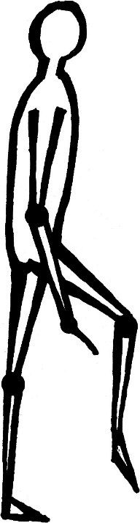
Force Scaling Disorders
- disrupt execution of balance and gait synergies (synergies are too big or too small or distorted by involuntary movements).

Parkinsonian gait
- flexed (stooped, simian) posture:  - head, neck, trunk bent forward, kyphotic back;  - arms: flexed at elbows and wrists; ulnar hand deviation; flexion of MP joints + extension of IP joints (striatal hand); reduced swing.  - hips and knees slightly flexed; feet inversion; big toes may be dorsiflexed (striatal toe).  - no response to push or pull (pro-, latero-, retropulsion) - falls like log! (EMG shows that protective postural response is hypometric and generates insufficient force).  - steps short and shuffling (marche petits pas), feet scrape floor; base narrow!  if base is wide - consider other syndromes (e.g. multi-infarct gait disorders, spinocerebellar atrophies, multiple system atrophy).  freezing: see above  - feet seem as if "glued to ground" (start hesitation).  - patient turns around stiffly ("all in one piece" en block turn) with small shuffling steps (turn hesitation). | 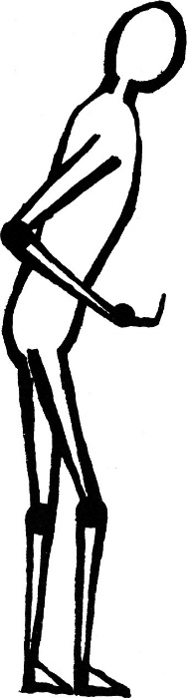
    - walking slows or may stop completely when patient:
      - passes through narrow space (such as doorway);
      - approaches destination (target hesitation);
      - is fearful about inability to deal with perceived barriers (revolving doors, elevator doors that may close, heavily trafficked streets);
      - is distracted
    - freezing is overcome by having patient step over objects (freezing is much less frequent when patient is going up steps than when walking on level ground).
because trunk may be leaning forward in anticipation of moving forward, freezing may cause falls forward onto knees or outstretched arms.

festinating gait - building up speed, even to point of running; cannot stop until coming to barrier, such as wall (mechanism is loss of postural reflexes + flexed posture, which brings center of gravity in front of feet).

Choreic gaits
- normal locomotor and balance synergies distorted by involuntary movements.
- stuttering / dancing gait (“puppet on string”):
  - trajectory of leg varies from step to step - hesitations in some steps, variable length of steps;
  - position of foot (when it makes contact with ground) varies from step to step - patient may rise on toes for one step and then land on side of foot or heel next.
  - choreic movements may flex and extend trunk.

Dystonic gaits
- action dystonia - dystonic spasms may affect leg when person walks forward but not backward.
- dystonic posturing of arms is often brought out by asking patient to walk on toes or heels.
- childhood-onset dystonia often begins in leg → abnormalities of walking or running (described as “limp” by parents).

Cerebellar ataxia
- pathophysiology - appropriate synergy, but inappropriately scaled (i.e. cerebellum modifies execution of synergies that are generated elsewhere in nervous system).  - gait is staggering, unsteady, wide-based (separation of legs), irregular small steps.  - legs are lifted too high and brought down with undue force.  - decomposition of truncal and leg movements (legs preceding while trunk remains behind).  - tremor of trunk (titubation), and lurching from side to side (“drunken sailor”).  - arms do not swing synchronously with movement of opposite leg.  - unsteadiness is most prominent on arising quickly from sitting position, turning quickly, or stopping suddenly while walking.  - tendency to deviate & fall to unilateral hemispheric lesion side.  - cannot stand steadily with feet together, whether eyes are open or closed (absent Romberg sign).  - hypermetric anticipatory and reactive postural responses. | 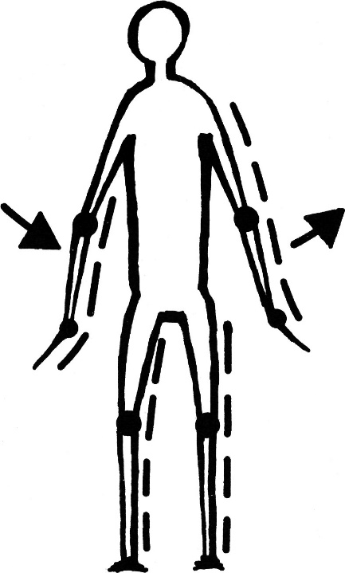

Cerebellar gait ataxia is often described as three distinct syndromes: see p. Mov5 >>
- lesions of vestibulocerebellum ≈ vestibular ataxia.
- lesions of spinocerebellum
- lesions of cerebrocerebellum - ataxia of limbs and consequently ataxic gait.
N.B. syndromes are not reliable indicators of anatomical location of cerebellar pathology - in clinical practice, cerebellar ataxic gait with no other cerebellar signs is attributed to midline cerebellar dysfunction; cerebellar ataxic gait with limb ataxia is attributed to lateral cerebellar lobes.

Corticospinal gaits  - patterns (of automatic postural responses, anticipatory responses, gait) are basically preserved.  - abnormalities - less force (scaling deficit), delays in distal muscle activation, co-contraction.  N.B. if there is adequate strength, spasticity rarely prohibits ambulation.  Spastic Hemiparesis - unilateral UMN disease.  - arm is held immobile (decreased swing) and close to side (with elbow, wrist, and interphalangeal joints flexed).  - leg is extended with foot plantar flexion; most of forward leg movement comes from hip.  - patient either drags his foot (often scraping his toe) or leg moves as rigid pillar in semicircle (circumduction) to prevent catching toe.  - upper body often rocks slightly to opposite side during circumduction.  - toe often scrapes along floor and may catch on small irregularities, causing falls (toes of shoes are scuffed and worn out of proportion to remainder of sole of shoe).  - leg may even cross midline at end of swing phase (because of increased tone in thigh adductors). |  | 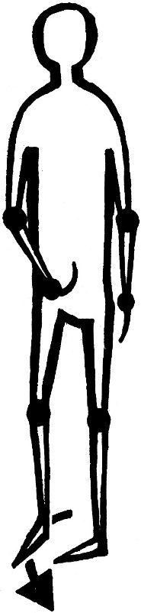
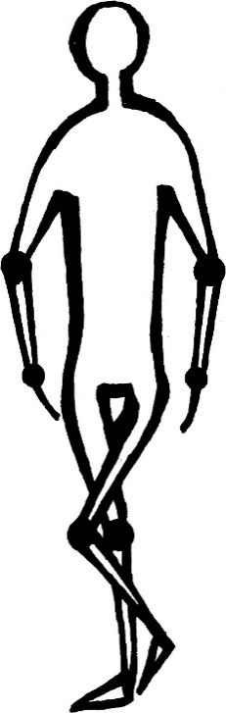 | Scissors Gait (bilateral spastic paresis of legs) - patient looks as if walking through water (evidence of considerable effort):  - gait is slow, stiff, steps are short.  - each leg is advanced slowly and thighs cross forward on each other at each step.  - as legs circumduct at hips, toes scrape floor.

Impaired Adaptation and Strategies  Cautious Gait (often inappropriately referred to as senile gait) - it is not pathological gait but is more conservative gait pattern (proper response to perceived postural insecurity in anterior-posterior direction); e.g. normal person on icy surface.  - steps slow, short, wide-based, uncertain, and even shuffling; legs flexed at hips and knees (stooped posture).  - en bloc turns; often retro-pulsion.  - multifactorial etiology: bihemispheric, cerebellar, vestibular, spinal cord disease; impaired proprioception; muscle weakness. | 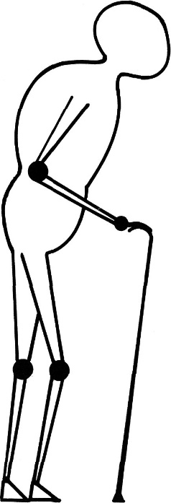
Dementia is not associated with particular gait pattern.
- dementia is strong risk factor for falls!
- poor insight - patient attempts do things that are not reasonable for his physical capabilities and environmental situation.
- demented patients may have normal balance synergies but cannot use them effectively because of their impaired attention and insight and inability to profit from experience.
N.B. some nondemented patients with severely compromised balance and gait synergies never fall because of their insight and carefulness!

Apraxia - patient appears to be stuck in place.

Post-fall syndrome - sudden inability to walk after fall.
- no evidence of neurological or orthopedic abnormality.
- with support, patients can learn to walk normally.
- etiology - excessive fear (perceived insecurity of balance that does not match person's physical capacity).

Psychogenic gait disorders
Hysterical gait - suggesting features:
- variability in gait from time to time (particularly with suggestion or distraction);
- excessive slowness and hesitation in walking;
- tandem walking - much arm waving and swing foot wavering combined with prolonged periods of balancing on stance foot;
- bizarre gait patterns with no explanatory neurological findings;
- astasia-abasia (severe difficulty maintaining standing balance with no comparable difficulty when sitting or lying in bed).
- in hysterical hemiplegia, patients drag affected leg along ground behind body and do not circumduct leg or use it to support weight (as in organic hemiplegia).
- may fall, but only when nearby physician or family member can catch them or when soft objects are available to cushion fall.

Neurological disorders that are sometimes improperly labeled as psychogenic:
- dystonia - strange postures present only during certain specific tasks (e.g. during walking but not running).
- thalamic astasia - striking disequilibrium with lack of other neurological signs.
- frontal gait - balance and gait dysfunction without other neurological signs in presence of personality changes.

General Management
- vitamin B₁₂ is indicated for patients with no obvious cause of gait / balance difficulties.

First management goal is patient safety:
  - padded clothing, knee pads, and elbow guards.
  - occupational therapist can evaluate home for safety (may suggest use of parallel grab bars, new lighting, floor coverings, different furniture arrangement, and so forth to prevent falls).
  - stabilizing ambulation aids (e.g. walkers, canes, crutches) - help with weight bearing, balance, or both; choose one that provides best combination of stability and freedom for patient.
N.B. some patients with freezing may find such aids of more hazard than benefit.

Ambulation Aids:
Characteristic | Walker | Crutches | Canes
Stability | Very good | Good | Least stable
Walking speed | Slowest | Slow | Can be fast
Use on steps | None | Training needed | Easy
Strength of arms required for use | Normal | Moderate strength | Normal
Number of hands required for use | 2 | Usually 2 | Usually 1
Possibility of carrying objects | With attached basket | None | Possible
Cost | Most expensive | Inexpensive | Least expensive

Correct cane height: patient's elbow should be bent at < 45° when maximum force is applied:

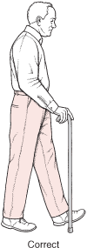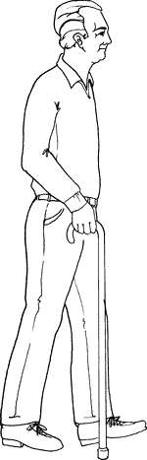

Fitting crutches:  - patient wears type of shoes usually worn, stands erect, and looks straight ahead with shoulders relaxed.  - end of each crutch is placed 5 cm from side of shoe and about 15 cm in front of toe; top of crutch should be 2-3 finger widths (5 cm) below axilla.  - adjust hand grip so that elbow bends 20-30°. | 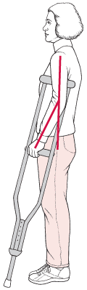

Wheelchairs provide mobility to patients who cannot walk.
- some models are self-propelled and provide stability over uneven ground and up and down curbs.
- if patients have little or no arm function, motorized wheelchair is prescribed (e.g. wheelchairs for quadriplegics have chin or mouth (sip and puff) controls and built-in ventilators).

Physical therapy programs (ambulation exercises) for strengthening and improved balance.
    - if individual muscles are weak or spastic, orthotic may be used; orthoses designed to fit into shoes shift patient's weight to different parts of foot to compensate for lost function, prevent deformity or injury, help bear weight, or relieve pain, as well as provide support.
    - assistive belt helps therapist prevent falls
    - anyone assisting patients should know how to properly support them (if patient is wearing waist belt, left hand is used to grasp it in back):
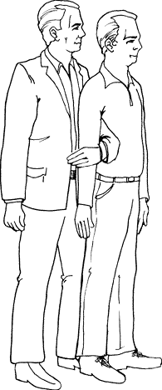

Falls
- major age-related syndrome involving neural, musculoskeletal, and cardiovascular systems.
- most falls occur in home (rate is higher in long-term care facilities).

Etiology
Falls in older people are rarely due to single cause! Propensity to falls is generated by cumulative handicaps of multiple factors!
Most falls in older adults are due to combination of several factors:
Internal causes - sensory impairment (poor eyesight, hearing loss, balance disturbances); neurodisorders (impaired proprioception, TIAs, drop attacks); cognitive impairment (poor judgment or apraxia); cardiovascular (syncope, postprandial hypotension, peripheral edema*), respiratory, and metabolic diseases; musculoskeletal conditions (lower limb weakness, poor grip strength, osteoporosis, RA, osteoarthritis, foot disorders).
*burdens impaired leg strength and gait with additional 2-5 kg
External causes (drugs):
benzodiazepines – affect vestibular system;
phenytoin – affects cerebellum;
neuroleptics – affect basal ganglia;
sedative-hypnotics – affect attention and judgment;
diuretics, α-blockers, etc - produce orthostatic hypotension (most prominent after meals).

Environmental problems increase risk of falls:
inside home - stairs (coming down is more hazardous than climbing up, as first and last steps often have no railing or unusable one); loose objects (furniture, cords, and rugs); poor lighting (particularly in areas with dark and light variability); poorly fitting shoes; surfaces with glare or patterning; lack of bathroom safety equipment.
outdoor - uneven pavements, surfaces slippery from ice, water, fallen leaves.

Management
- tests are needed only if history / physical examination do not reveal cause of falling or if they point to particular abnormality that requires laboratory evaluation.
- causative relationship is multiplicative rather than additive - even minor improvement in number of these factors will reduce risk substantially.
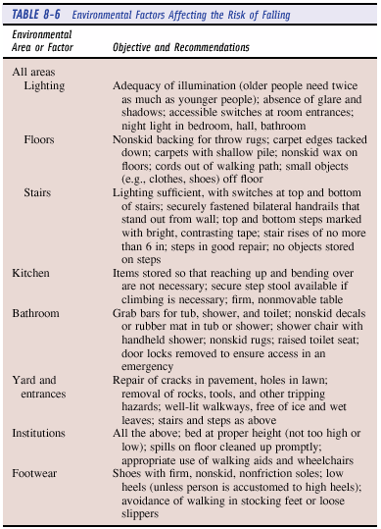
- ensure availability of phones at floor level, portable phone, or lightweight radio call system.
- recurrent falls → regular exercise, gait & balance training (after risk factors for falling are fully addressed).
N.B. first fall leads to loss of mobility and loss of confidence, making next fall more likely!
- protective hip pads.
- treat osteoporosis!
- list of medications should be reviewed periodically!

Complications
- 1 out of 4 people who fall suffers serious injury:
- fractures (5% falls); hip fractures (1% falls)
- serious soft tissue damage (5% falls), rhabdomyolysis
- subdural hematoma
- dehydration, electrolyte imbalance, pressure sores, hypothermia
- falls are 6th leading cause of death after age 65 yrs (fatality rates increase with age) and contributing factor in 40% admissions to nursing homes.
- resultant hip problems and fear of falls are major causes of loss of independence.

Immobility
Etiology
- Weakness
- Stiffness
- Pain
- Imbalance (→ fear of falling):
  - general debility
  - neurologic causes (stroke; loss of postural reflexes; peripheral neuropathy due to diabetes mellitus, alcohol, or malnutrition; vestibulocerebellar abnormalities)
  - orthostatic (e.g. following prolonged bed rest) or postprandial hypotension
  - drugs (diuretics, antihypertensives, neuroleptics, antidepressants)
- Psychological problems (severe anxiety, depression)

Consequences
- Thrombophlebitis and pulmonary embolus
- Cardiovascular deconditioning (occurs within days) - fluid shifts, fluid loss, decreased cardiac output, decreased peak oxygen uptake, and increased resting heart rate → postural hypotension → falls.
- Changes in skeletal muscle: intracellular ATP & glycogen↓, protein degradation↑ (→ contractile velocity and strength↓, atrophy, weakness, shortening).
- Pressure sores

N.B. these changes usually take weeks ÷ months to reverse!

Prevention
Most important step is preventive - to avoid bedrest whenever possible.
- patients should be positioned as close to upright position as possible several times daily.
- range-of-motion exercises, isometric and isotonic exercises.
- patients should assist their own positioning, transferring, and self-care.
- pressure sore prophylaxis. see p. 2217 >>
- ambulation ASAP.

Bibliography for ch. “Movement disorders, Ataxias” → follow this link >>

Viktor’s Notes℠ for the Neurosurgery Resident
Please visit website at www.NeurosurgeryResident.net

