Myasthenia Gravis
Last updated: April 19, 2019
CLASSIFICATION of Neuromuscular Transmission Disorders 1
Pathogenesis & Pathophysiology 1
Epidemiology 2
Clinical Features 2
Myasthenic Crisis 3
Transient neonatal MG 3
Diagnosis 3
Differential Diagnosis 5
Treatment 5
Symptomatic Treatment 5
Pathogenetic Treatment 5
Myasthenic Crisis 5
Pregnancy 5
Prognosis 6

- neuromuscular transmission disorders cause abnormal weakness and fatigability.

CLASSIFICATION of Neuromuscular Transmission Disorders
I. Autoimmune
- myasthenia gravis
- Lambert-Eaton myasthenic syndrome (LEMS) see p. Mus2 >>

II. Congenital see p. Mus2 >>
- Pre-synaptic defects
  - ACh resynthesis / packaging defect
  - paucity of synaptic vesicles and reduced quantal release
- Synaptic defect
congenital end-plate AChE deficiency
- Post-synaptic defects: increased response to ACh
slow-channel syndromes
- Post-synaptic defects: decreased response to ACh
- low-affinity fast channel syndromes
- mode-switching kinetics of ACh receptors
- ACh receptor deficiency without kinetic abnormality
- Partially characterized syndromes
- congenital myasthenic syndrome resembling LEMS
- familial limb-girdle myasthenia
- benign congenital myasthenic syndrome with facial malformations

III. Toxic
  - Drug-induced:
- D-penicillamine (!!!) – induces anti-AChR antibody production → clinical manifestations similar to typical MG; antibodies disappear when drug is discontinued.
- curare
- aminoglycosides (esp. neomycin) - decrease both presynaptic ACh release (antagonism to Ca²⁺) and sensitivity of postsynaptic membrane to Acch (curare-like effect);
H: calcium infusion, cholinesterase inhibitors, aminopyridines
Aminoglycosides are relatively contraindicated in both presynaptic and postsynaptic disorders of neuromuscular transmission!
- polypeptide antibiotics (colistin, polymyxin B)
- antiarrhythmics (quinidine, procainamide)
- Ca-channel blockers
  - Organophosphate intoxication see p. A35 >>
  - Venoms & toxins:
- botulism see p. 227 (5-7) >>
- coral snake, scorpion, black widow spider see p. 2780 >>
- tick paralysis see p. 2780 >>

Myasthenia Gravis
Pathogenesis & Pathophysiology
Autoimmune acetylcholine receptor damage → postsynaptic destruction of neuromuscular junction (decreased numbers of muscle ACh receptors) → small end-plate potentials which may fail to trigger muscle action potentials.
Curare also blocks muscle ACh receptors!
- Sensitized T cells (thymus is unequivocally involved in pathogenesis!!!)
  - muscle-like (myoid) cells within thymus, which bear ACh receptors on their surface, may serve as source of autoantigen → trigger autoimmune reaction within thymus.
- Anti-acetylcholine receptor antibodies (anti-AChR) - key to ACh receptor damage!; antibodies react with multiple determinants on AChR:
  - destruction of receptors (complement-mediated lysis of junctional folds at motor end-plate).
  - acceleration of normal degradative processes (e.g. cross-linking of receptors by Ab → endocytosis, lysosomal hydrolysis).
  - small percentage of anti-AChR interfere directly with binding of ACh - functional blockade of receptors (explains response to acetylcholinesterase inhibitors)

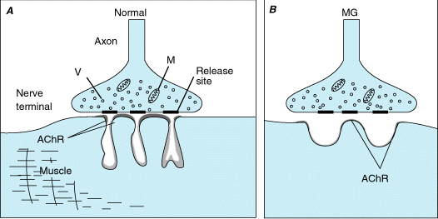

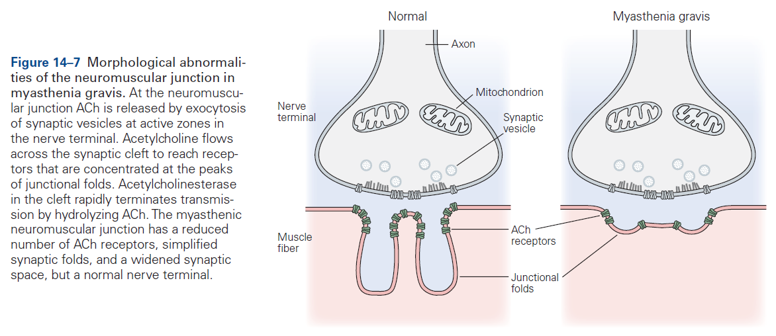

N.B. in MG, the presynaptic vesicles contain normal amounts of ACh and the process of transmitter release is intact!

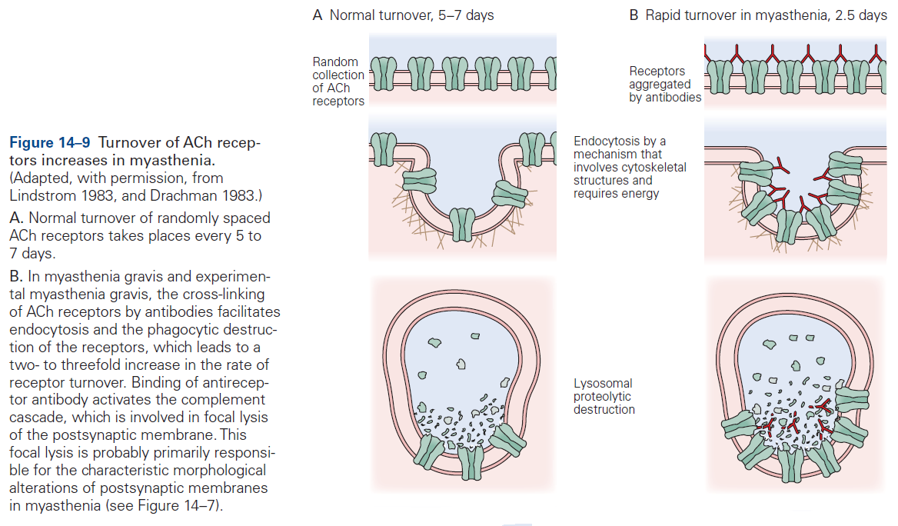

Histology
  - decreased numbers of acetylcholine receptors
  - simplification (flattening) of postsynaptic clefts
  - widening of synaptic space
  - immune deposits at end plate (C3 localization is most convenient way to confirm suspected diagnosis).
  - normal presynaptic nerve terminal - ACh is released normally!
  - thymic abnormalities:
    - lymphoid hyperplasia (65-70%); in normal individuals, germinal centers are sparse in thymus.
    - neoplasms (10-15%) - usually locally invasive epithelial cell tumors (lymphoepithelial thymomas* or rarely carcinomas); tend to occur in older patients.
*contain T-cells, but neoplastic elements are epithelial cells
  - lymphorrhages in muscle (≈ 50%) - focal clusters of lymphocytes near small necrotic foci without perivascular predilection.
  - in severe cases - disuse changes with type 2 muscle fiber atrophy.

Epidemiology
      - onset – any age.
      - bimodal peak of incidence:
        - younger women (2-3rd decades)
        - older men (5-6th decades)
      - prevalence – 3-4 in 100,000
before age 40, disease is 3 times more common in women;
at older ages, both sexes are affected equally;
overall, ratio females : males = 3 : 2.
      - partial genetic predisposition (case reports of families with various autoimmune conditions, incl. MG); disproportionate frequency of HLA haplotypes B8, DR3.

Clinical Features
- fatigability and weakness of skeletal muscles that fluctuates (like in no other disease of nerves and muscles)

N.B. patients never complain of fatigue - myasthenic symptoms are always due to weakness not to rapid tiring!

N.B. patients who complain of fatigue (if not anemic or oncologic) almost always have emotional problems (usually depression).

      - in 10% MG is associated with another autoimmune disease.

Distribution
- 40% cases begin with ocular muscles with various combinations (diplopia + ptosis); often asymmetric; pupils are normal.
- oropharyngeal weakness - dysphagia and dysarthria; nasal regurgitations, aspirations; vocal cords are only exceptionally affected
ocular and oropharyngeal weakness occurs in virtually all patients (“expressionless facies with drooping eyelids and snarling smile”) - diagnosis is doubtful if there are no cranial symptoms!

patient is attempting to open eyelids (note raised forehead brow lines reflecting effort):
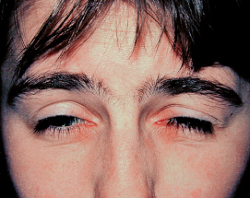

- limb & postural muscles are generally less affected; limbs (upper > lower; proximal > distal; may be asymmetric) are never affected alone!
- weakness becomes generalized in majority (15% remain confined to ocular muscles); examination of neck flexors is most sensitive in demonstrating generalized disease (holding head up from surface of examining table while lying supine - gravity cannot be overcome for more than few seconds).
Deep tendon reflexes remain normal (even in weak muscles)!
- muscular atrophy (of variable degree) is found in only 10% cases - usually only in severely dysphagic patients with malnutrition; fasciculations do not occur!

Fluctuating Nature
- weakness varies in course of single day (sometimes within minutes), and from day to day (or over longer periods); constant weakness may occur.
- major prolonged variations are termed remissions / exacerbations.
- during physical stress (esp. respiratory infection, surgery) precipitous worsening may occur!
- symptoms are exacerbated by heat and improved by cold (e.g. ptosis may improve after cooling of eyelid with ice pack).

disease severity:
grade I - ocular disease only;
grade II - generalized weakness of mild (IIa) or moderate (IIb) intensity;
grade III - severe generalized disease;
grade IV - myasthenic "crisis".

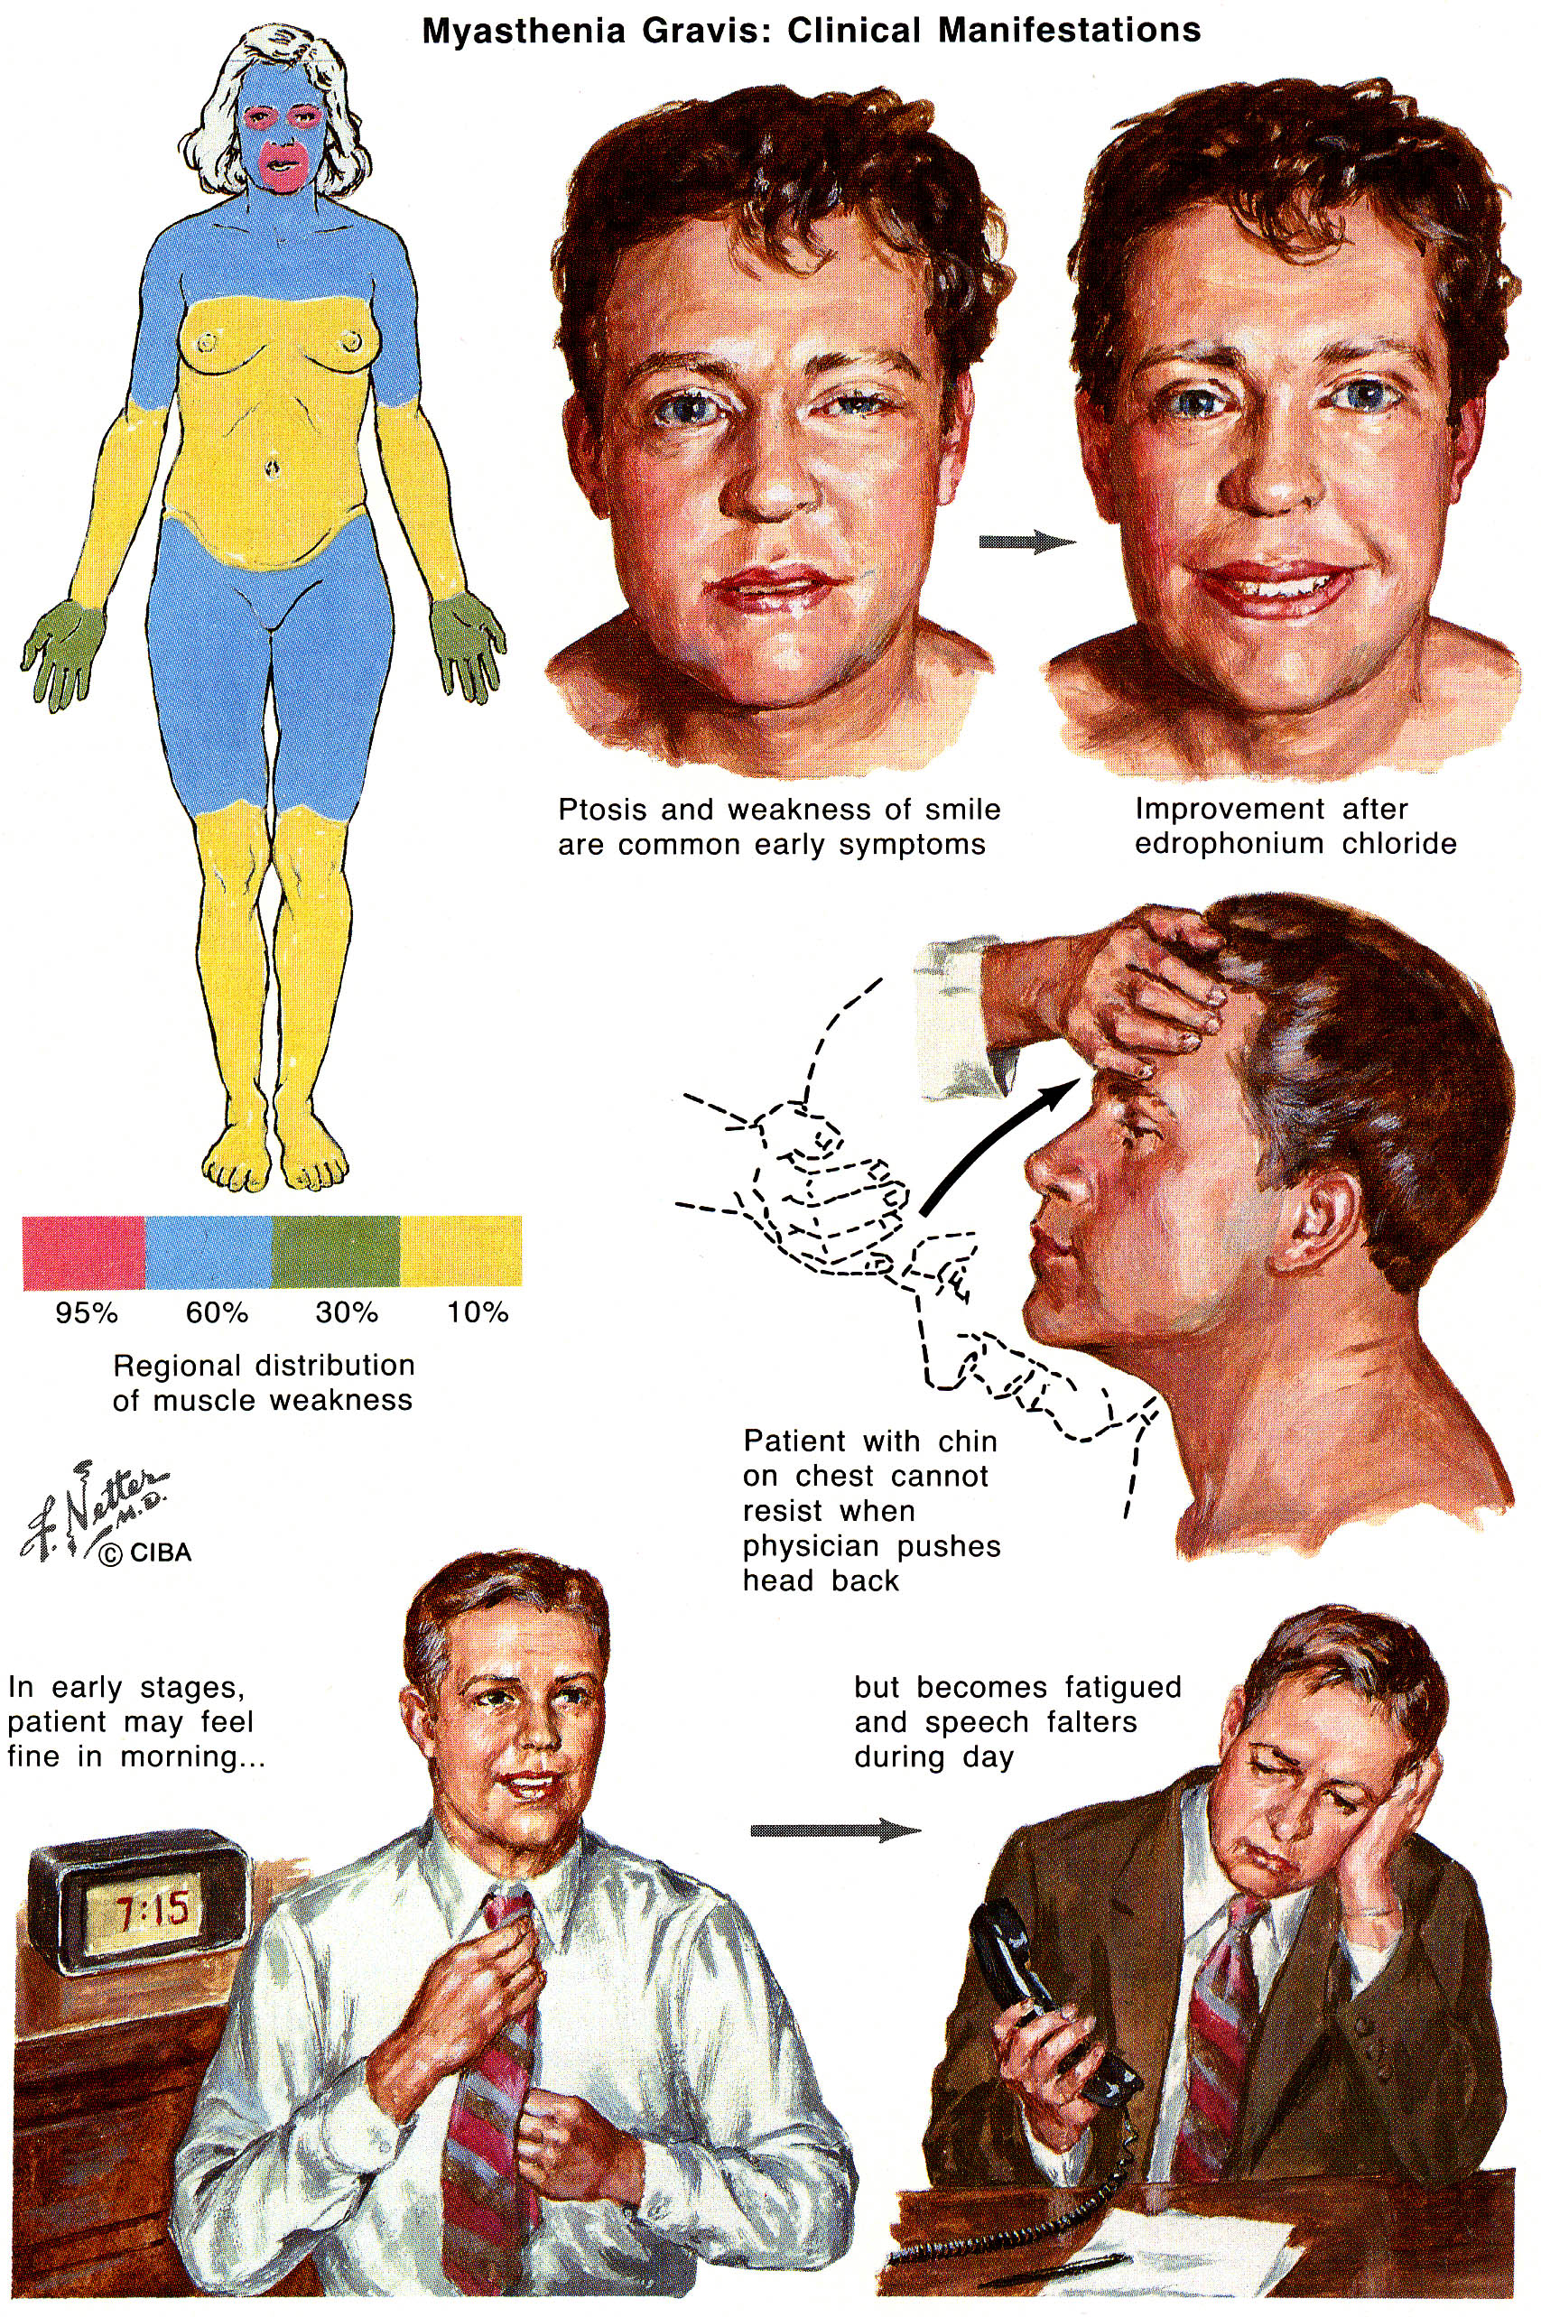

Myasthenic Crisis
- respiratory failure needing assisted ventilation.
- occurs in 10% patients.
- mechanisms:
  - respiratory muscle weakness
  - oropharyngeal weakness → aspiration
Failure of respiratory muscles can be life threatening!

Transient neonatal MG
- myasthenic syndrome from passive transfer of maternal AChR-ab (occurs to ≈ 12% myasthenic mothers).
- impaired sucking, weak cry, limp limbs, and sometimes respiratory insufficiency (may require ventilatory assistance, exchange transfusion).
- symptoms begin in first 48 hours and resolve in 2 weeks.

Diagnosis
Curare test is no longer used (patients are abnormally sensitive to curare).
N.B. curariform medications are only drugs absolutely contraindicated in MG!

Quantifiable timed endurance tasks:
- maintaining upward gaze
- holding forward outstretched arms in abduction
- vital capacities
- squats
- reading standard passage (measure time it takes for speech to become mushy and dysarthric)
- ergogram (repetitive measure of grip strength); N.B. simple grip dynamometry does not aid in evaluation.
“Normal neurologic examination is incompatible with diagnosis of symptomatic myasthenia gravis”

Edrophonium chloride (Tensilon) injection → clinical weakness improvement.
- first fatigue patient with task that includes signs that can be easily clinically assessed (see above).
N.B. muscle that is clearly weak must be identified!
- initial test* dose 2 mg IV** → in 15 seconds additional 3 mg → in another 15 seconds final 5 mg (i.e. maximum of 10 mg).
* monitor heart rate with ECG - to avoid bradycardia and vasodepressor syncope; H: atropine.
** if definite improvement occurs (document with photo!), test is considered positive and is terminated.
- rapid improvement / recovery of fatigued muscles over subsequent 2 minutes is positive test → weakness returns within 5 minutes.
- test may be repeated in 30 minutes if necessary.
- normal subjects have no change in muscle strength; may transiently experience salivation, lacrimation, diaphoresis, fasciculations (perioral, periocular, or lingual).
N.B. false-negative and false-positive tests do occur!
N.B. subjective increase in general strength or relief of fatigue are not positive test!
- edrophonium (cholinesterase inhibitor) - rapid onset (30 s) and short duration (< 5 min) - preferred for ocular and other cranial muscles.
- neostigmine (effect lasts up to 2 hours) - can be used for limb or respiratory muscles, which may require more time for testing.
- placebo may be useful in evaluating limb weakness (placebos are not necessary in cranial muscle weakness because that cannot be simulated); placebo is difficult to “blind” because real cholinesterase inhibitor produces intestinal cramping and muscle fasciculations in eyelids.

Ice Pack test
- simple noninvasive bedside test to evaluate ptosis; lack of side effects.
- ice placed in surgical glove is placed lightly over eyelid.
- cooling of eyelid below 29° C is accomplished within 2 minutes.
- ptosis improves in ≥ 80% patients; test is at least as sensitive as edrophonium test.
- positive ice pack test strongly suggests ocular myasthenia gravis and alleviates any need for Tensilon test.
- in bilateral ptosis, more affected eye should be tested.
- normal individuals show no change in palpebral fissure.

Detection of AChR-ab in serum (commercially available test)
- sensitivity 50-70% (in ocular myasthenia) ÷ 88% (in generalized disease); only 25% in remission.
- specificity > 99.9% (definite diagnosis if positive; negative result does not exclude MG).
- titer does not match severity of symptoms (normal titer does not exclude diagnosis – so sensitivity is < 100%).

Repetitive nerve stimulation → CMAP decrement see p. D22 >>
- test at least 3 nerve-muscle systems (median-thenar; ulnar-hypothenar; accessory-trapezius).
- sensitivity ≈ 75% percent; virtually always present in generalized MG (clinically weak muscles are more likely to demonstrate decremental response).
- for patient comfort, first perform on distal muscle (if negative → proximal muscles).
- single dose of edrophonium may prevent or diminish this decremental reaction.

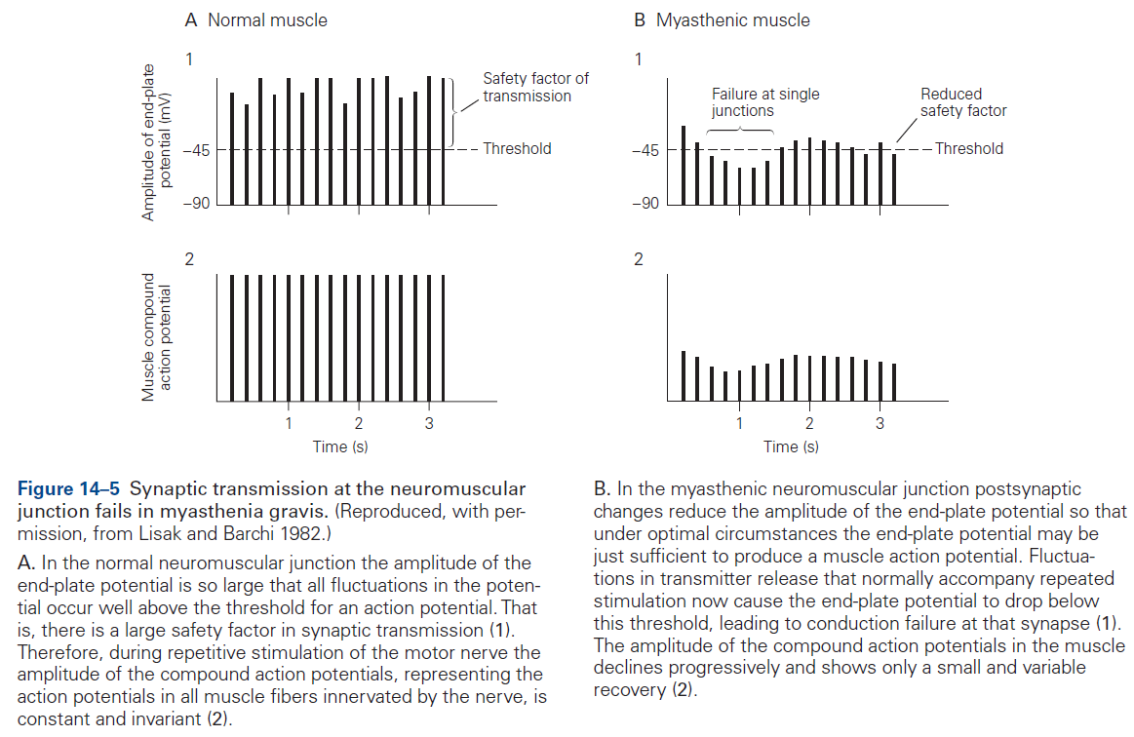

N.B. in normal humans, the amount of ACh released during synaptic transmission can be reduced to as little as 25% of normal before it fails to initiate an action potential.

Single fiber EMG - progressively fewer fibers respond to arrival of nerve impulse → increased "jitter", blockings see p. D20 >>
- sensitivity – 80% (in ocular MG) ÷ 100% (in moderate generalized MG).
most sensitive test for MG!!!
- in 9% cases, this is only abnormal test.

AChR-ab + repetitive stimulation + single fiber EMG identifies all MG cases.

Microelectrode study - ↓amplitude of miniature end-plate potentials (to ≈ 20% of normal).

Standard EMG is normal (occasionally shows myopathic pattern, and never denervation).

Pulmonary function tests (for respiratory muscle weakness); include inspiratory & expiratory pressures - may be abnormal before overt symptoms.

Search for Associated Conditions – tests indicated in all patients:
- Chest CT / MRI - to screen for thymoma / thymic hyperplasia.
  - thymoma is found in 15% of MG cases.
  - detectable thymic tissue in patient > 40 yrs. - suspicion of thymoma.
- Thyroid function tests (hyperthyroidism occurs in 3-8% MG patients!)
- Blood tests for rheumatoid factor & antinuclear antibodies – for associated other autoimmune disorders.
- Head MRI – for ocular myasthenia

Differential Diagnosis
- other disorders of neuromuscular transmission (congenital myasthenic syndromes, botulism, Lambert-Eaton myasthenic syndrome)
- neurogenic weakness (e.g. cranial nerve abnormalities)
- chronic progressive external ophthalmoplegia
- drug-induced myasthenia, organophosphate intoxication
- hyperthyroidism, Graves' disease – occurs in 3-8% MG patients
- psychogenic weakness / fatigue (neurasthenia)

Treatment
Lifelong immunomodulating therapy is often required!!!

Symptomatic Treatment
Acetylcholinesterase inhibitors - symptomatic treatment in all clinical forms throughout disease course.
- should be given as soon as diagnosis is made.
- three equally effective drugs - neostigmine**, pyridostigmine*, ambenonium.
*preferred - less severe GI side effects, longer duration of action (3-4 h).
**available for injections (1.0 mg is equivalent to 60 mg pyridostigmine).
- usual starting dose of pyridostigmine is 60 mg q4h orally while patient is awake;
  - difficulty eating – take doses 30 min before meal.
  - difficulty on waking in morning - give prolonged-release 180-mg tablet at bedtime (prolonged tablets should never be used for daytime because of variable absorption).
  - muscarinic symptoms - atropine (0.4-0.6 mg) or propantheline (15 mg) with each dose of pyridostigmine; loperamide for diarrhea.
- cholinergic toxicity (transient weakness + muscarinic effects) can be difficult to distinguish from impending myasthenic crisis (no muscarinic effects + response to edrophonium in 1-mg increments)
H: admission to ICU for transient cessation of cholinesterase inhibition.
N.B. cholinergic drugs do not return function to fully normal (e.g. some diplopia almost always persists)!

Plasma exchange (daily 2 liters), intravenous pooled Ig (400 mg/kg for 5 days; mechanism of action is not known) - effective short-term treatments (e.g. for MG crisis, stabilization prior to thymectomy).

Pathogenetic Treatment
Thymectomy - indicated for:
    - generalized myasthenia
    - thymoma (absolute indication at any age) - possibility of local tumor spread
- not usually recommended for pure ocular* myasthenia.
*thymectomy is so safe that it might be considered for truly disabling ocular myasthenia.
- preoperative plasmapheresis improves care.
- transsternal approach is preferred; transcervical approach (by indirect mediastinoscopy -cosmetically more appealing) → higher risk of residual thymus tissue.
- beneficial effects are delayed for months and occur in 1st year (but may be seen as late as 5 years from surgery) - 85% patients without thymoma show improvement / remission.

Corticosteroids - mainstay of immunotherapy (if patient is still seriously disabled after thymectomy).
- start with 40-60 mg prednisone /d → taper to alternate-day dosing (e.g. 50-100 mg every other day).
with such dosage initial exacerbation of weakness occurs in many - hospitalization is advised!
- equally satisfactory response without exacerbation can be seen with lower starting dosage, but it takes longer time (e.g. with dose 25-40 mg, benefit may be seen in 2 to 3 months).
- 70-80% patients have complete remission.

Cytotoxic therapies – indicated in:
  - patients who do not improve after 6 months of prednisone.
  - patients who are not able to achieve sufficiently low doses of prednisone.
  - significant steroid side effects.
- azathioprine - as adjunct to prednisone (some patients respond well enough to discontinue prednisone); earliest time for improvement onset is 3 months.
- cyclosporine is more effective & more toxic.
- cyclophosphamide is used occasionally for patients refractory to other drugs.

Myasthenic Crisis
- principles of treatment are those of respiratory failure in general.
- cholinergic drug is discontinued* once endotracheal tube has been placed and positive pressure respiration started.
* avoids uncertainties about overdosage (cholinergic crisis) + avoids cholinergic stimulation of pulmonary secretions.
N.B. overmedication of myasthenic crisis can convert it into cholinergic crisis!!!
- plasma exchange / intravenous Ig may shorten crisis duration.
- vigorous infection treatment (myasthenic patient with fever and early infection should be treated like other immunocompromised patients!!!).
- crisis spontaneously subsides in few days or weeks.
- pulmonary intensive care is now so good that crisis is almost never fatal.

Pregnancy
- course of MG may variably change during pregnancy (some women worsen).
- MG has no deleterious effect on uterine smooth muscle.
- frequent emesis may interfere with absorption of any oral medication.
- growing fetus may further restrict diaphragmatic movement.
- MgSO₄ can exacerbate weakness.
- cholinesterase inhibitors can be used (do not provoke uterine contractions).
- significant weakness may be adequately controlled with cholinesterase inhibitors and plasmapheresis.
- avoid immunosuppressive drugs.

Prognosis
- myasthenia is not steadily progressive disease - general nature is established within months after first symptoms:
  - if myasthenia is restricted to ocular muscles for 2-3 years, it will remain restricted;
  - spontaneous remission / progressive deterioration is more likely in first 2-3 years;
  - remissions are rarely complete or permanent.
- before 1958 - 1/3 patients died, 1/3 failed to improve, 1/3 improved spontaneously.
- currently - mortality is zero - most patients lead normal lives.

Bibliography for ch. “Neuromuscular, Muscular Disorders” → follow this link >>

Viktor’s Notes℠ for the Neurosurgery Resident
Please visit website at www.NeurosurgeryResident.net

