Muscular Dystrophies
Last updated: April 19, 2019
Dystrophinopathies – Duchenne, Becker 2
Pathophysiology 2
Genetics 3
Pathology 4
Epidemiology 5
Clinical Features 5
Duchenne muscular dystrophy 5
Becker muscular dystrophy 6
Carriers 7
Diagnosis 7
Molecular diagnosis 7
Cardiac evaluation 8
Treatment 8
Xp21 myopathies 8
Facioscapulohumeral muscular dystrophy (s. Landouzy-Dejerine disease) 8
Clinical Features 8
Diagnosis 9
Treatment 9
Scapuloperoneal syndromes 9
Myotonic dystrophy (s. Steinert disease) 10
Genetics 10
Clinical Features 10
Diagnosis 11
Treatment 12
Myotonic dystrophy type 2 (s. Thornton-Griggs-Moxley disease, proximal myotonic dystrophy) 12
Emery-Dreifuss muscular dystrophy 12
Genetics 12
Clinical Features 12
Diagnosis 12
Treatment 12
Bethlem myopathy 12
Oculopharyngeal muscular dystrophy 12
Genetics 12
Clinical Features 12
Diagnosis 13
Treatment 13
Limb Girdle muscular dystrophies (LGMD) 13
Genetics 13
Clinical Features 13
Diagnosis 13
Severe childhood autosomal recessive muscular dystrophy (SCARMD) 13
Distal muscular dystrophies 14
Congenital muscular dystrophies (CMD) 14

Muscular Dystrophies (term coined by Erb in 1891) – unrelated hereditary, degenerative disorders of dystrophin (dystrophinopathies) or dystrophin-associated proteins.
Muscular dystrophy has five essential characteristics:
- Genetic, i.e. heritable (even if there are no other cases in family).
- It is primary myopathy (as defined by clinical, histologic, and EMG criteria).
- No histologic abnormalities other than degeneration and regeneration of muscle fibers + reaction to those changes (infiltration by fat and connective tissue); no abnormal storage of metabolic products.
- All (!) symptoms are effects of striated muscle weakness (heart and visceral muscles may also be involved).
- Weakness becomes progressively worse (i.e. not static – vs. congenital myopathies, metabolic myopathies).
Two additional characteristics (may be reversed in future):
- We do not understand why muscles are weak, even where affected gene product is known.
All muscular dystrophies might be reclassified eventually as metabolic myopathies once biochemical defects are better defined.
- No effective therapy for any of dystrophies.

Features of three main types of muscular dystrophies:
 | Duchenne | Facioscapulohumeral | Myotonic
Age at onset | Childhood (< 5 yrs.) | Adolescence (rarely  childhood) | Adolescence or later (rarely congenital)
Sex | Male | Either | Either
Pseudohypertrophy | Common | Never | Never
Onset | Pelvic girdle | Shoulder girdle | Distal limbs
Weakness of face | Rare and mild | Always | Common
Rate of progression | Relatively rapid | Slow | Slow (variable)
Contractures and  deformity | Common | Rare | Rare
Cardiac disorder | Usually late | None | Common (conduction)
Inheritance | X-linked recessive | Dominant | Dominant
Expressivity | Full | Variable | Variable
Genetic heterogeneity | Duchenne and Becker  allelic | None | Proximal limb weakness

Genetic features of muscular dystrophies:
DISEASE | INHERITANCE | GENE MUTATION | PROTEIN
X-linked MD
Duchenne/Becker | XR | Xp21 | Dystrophin
Emery-Dreifuss | XR | Xq28 | Emerin
Limb-Girdle MD
LGMD 1A | AD | 5q22-34 | ?
LGMD 1B | AD | 1q11-21 | ?
LGMD 1C | AD | 3p25 | Caveolin-3
LGMD 2A | AR | 15q15 | Calpain-3
LGMD 2B* | AR | 2p12 | Dysferlin
LGMD 2C | AR | 13q12 | γ-Sarcoglycan
LGMD 2D | AR | 17q12 | α-Sarcoglycan
LGMD 2E | AR | 4q12 | β-Sarcoglycan
LGMD 2F | AR | 5q33 | δ-Sarcoglycan
LGMD 2G | AR | 17q11 | ?
LGMD 2H | AR | 9q31 | ?
Congenital MD
With CNS involvement
Fukuyama CMD | AR | 9q31-33 | Fukutin
Walker-Warburg CMD | AR | 9q31-33 | ? Fukutin
Muscle-eye-brain CMD | AR | 1 | ?
Without CNS involvement
Merosin-deficient classic type | AR | 6q2 | Laminin-2 (merosin)
Merosin-positive classic type | AR | ? | ?
Integrin-deficient CMD | AR | 12q13 | Integrin alpha7
Distal MD
Late-adult-onset 1A (Welander) | AD | 2p15 | Dynactin
Late-adult-onset 1B (Markesbery/Udd) | AD | 2p | ?
Early-adult-onset 1A (Nonaka) | AR | 9p1-q1 | ?
Early-adult-onset 1B (Miyoshi)** | AR | 2q12-14 | Dysferlin
Early-adult-onset 1C (Laing) | AD | 14 | ?
Other MD
Facioscapulohumeral | AD | 4q35 | ?
Oculopharyngeal | AD | 14q11 | Poly(A) binding protein 2
Myotonic dystrophy | AD | 19q13 | Myotonin-protein kinase
Myotonic dystrophy-type 2 | AD | 3q | ?
Desmin storage (s. Myofibrillar) myopathy | AD | 11q21-23 | αβ-crystallin
 |  | 2q35 | Desmin
Bethlem myopathy | AD | 21q22 | Collagen VI
*probably same condition as Miyoshi distal MD.
**probably same condition as LGMD 2B.

Dystrophinopathies – Duchenne, Becker
Pathophysiology
Dystrophin
- large (3685 amino acid, 427-kDa) subsarcolemmal cytoskeletal protein with four distinct domains.
- I-beam shape with globular domains at each end and rodlike segment in middle.
- amino-terminal end binds to cytoplasmic actin filaments; carboxy-terminal end binds to complex of proteins and glycoproteins (dystrophin-associated proteins and dystrophin-associated glycoproteins).

Dystrophin influences number distinct functions; different gene transcripts (dystrophin isoforms) exist:
  - Muscle dystrophin - on sarcolemma surface in skeletal, cardiac, smooth muscle fibers.
  - Cortical dystrophin - in hippocampus, amygdala, thalamus, hypothalamus, neocortex.
  - Purkinje cell isoform - in cerebellum.

Subcomplexes of glycoprotein complex (involved with dystrophin in muscle support):
  - dystroglycan subcomplex (α, β-dystroglycans) - functions as connecting axis (dystrophin-axis) between extracellular matrix (laminin) and subsarcolemma cytoskeleton (actin).
  - sarcoglycan subcomplex (α, β, γ, δ-sarcoglycans) - fixed to dystrophin-axis by lateral association; mutations → limb girdle muscular dystrophies.
  - syntrophin subcomplex (α, β₁, β₂-syntrophins) - binds to carboxy-terminal domain of dystrophin.

    - mutations in α2-laminin → congenital muscular dystrophy; merosin is collective name for laminins that share common α2 chain.

Integrins - another group of transmembrane proteins that link extracellular matrix to sarcolemma (i.e. bind merosin to skeletal muscle).
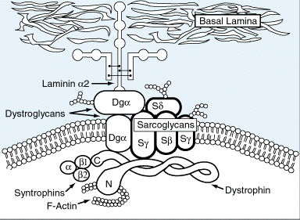

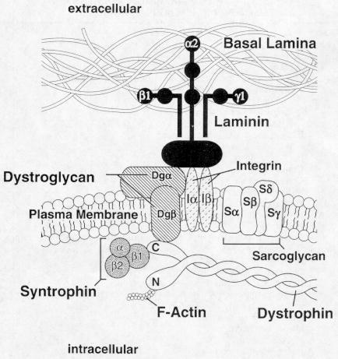
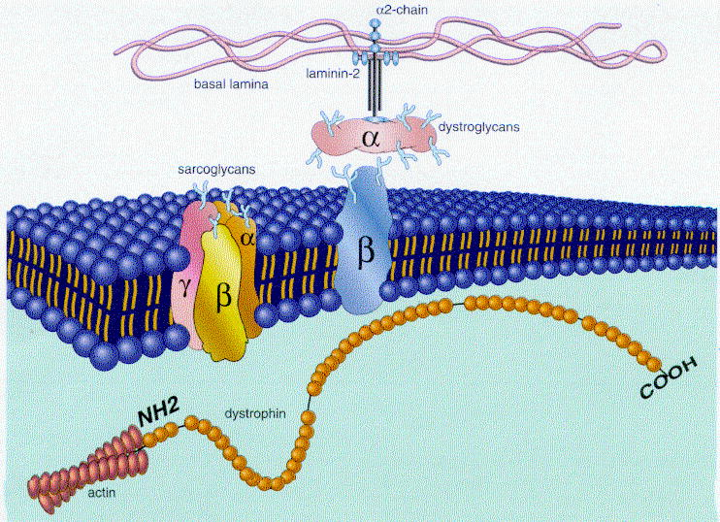

Dystrophin function - support to muscle membrane during contraction.
Dystrophin deficiency weakens sarcolemma → influx of calcium-rich extracellular fluid → activation of intracellular proteases and complement → fiber necrosis;
there is also secondary reduction of other components in dystroglycan subcomplex in muscle membrane (normal dystrophin is required for assembly and integrity of DGC).

Utrophin
- dystrophin homolog.
- confined to neuromuscular junction (vs. dystrophin - found throughout sarcolemma).
- binds to actin and most likely dystroglycan complex - forms utrophin-axis similar to dystrophin-axis.

Genetics
Different mutations in dystrophin gene → X-linked recessive dystrophinopathies:
Duchenne muscular dystrophy (DMD) – absent dystrophin.
Becker muscular dystrophy (BMD) – abnormal dystrophin.
Other milder dystrophinopathies (different sites of mutation in dystrophin gene):
- exercise intolerance associated with myalgias, muscle cramps, or myoglobinuria;
- minimal limb-girdle weakness or quadriceps myopathy;
- asymptomatic elevation of serum CK;
- cardiomyopathy with only mild muscle weakness;
- fatal X-linked cardiomyopathy without muscle weakness.

- dystrophin gene is at Xp21.1 - nearly all patients are males.
- dystrophin gene is one of largest human genes (at least 2.4 megabases and 79 exons) → high mutation rate.
- DMD and BMD are allelic disorders – caused by different mutations in same gene.
- 1/3 DMD cases are new mutations.
- ≈ 20% new DMD cases are caused by gonadal mosaicism.

Large mutations – in 75% DMD and 87% BMD patients.
- ≈ 65% large mutations are deletions (deletion breakpoints are at sites where recombination events occur in healthy individuals).
- large duplications are rare (≈ 5-7%).

Point mutations (not readily detectable!) – in 30% DMD and 15% BMD patients.

Frame-shifting mutations (most DMD patients) → truncated dystrophin molecule (missing carboxy terminus, which does not bind adequately to dystrophin-associated proteins at cell membrane) → near-total loss of dystrophin → severe DMD phenotype.
Non-frame-shifting mutations → dystrophin molecule with preserved carboxy terminus (semifunctional dystrophin) → milder BMD phenotype.
In-frame deletions (relationship between site of deletion and clinical syndrome):
in cysteine-rich and carboxy-terminus domains → DMD phenotype;
in proximal portion of rod domain → very mild DMD phenotype;
in distal region → BMD phenotype.

Rare exceptions from these rules:
- there are out-of-frame deletions that can result in DMD, BMD, or intermediate phenotype;
- there are situations with no correlation between degree of dystrophin deficiency and severity of phenotype.

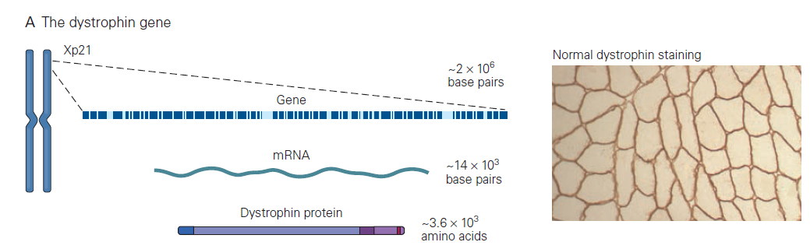
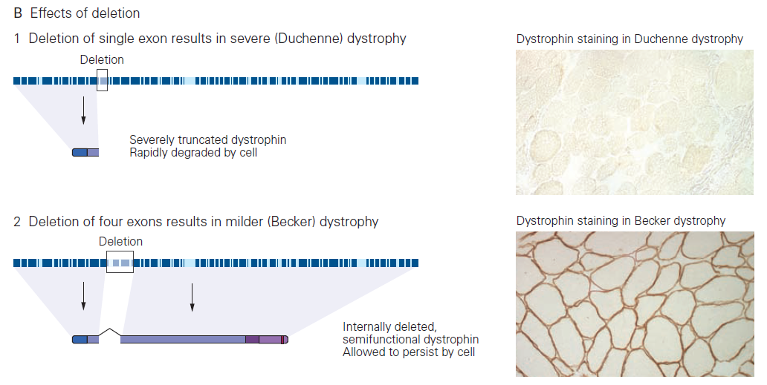

Pathology
- variation in fiber size (diameter) due to presence of both small and giant fibers, sometimes with fiber splitting.
- increased numbers of internalized nuclei (beyond normal 3-5%).
- hypercontracted fibers (enlarged, rounded, hyaline fibers that have lost their normal cross-striations); rare in BMD; result from segmental necrosis at another level, allowing calcium to enter site of sarcolemma breakdown and trigger contraction of whole length of muscle fiber.
- degeneration, necrosis, phagocytosis of muscle fibers.
- regeneration of muscle fibers (blue hue).
- proliferation of endomysial fatty connective tissue (in late stages, muscles become almost totally replaced by fat and connective tissue).

- both type 1 and type 2 fibers are involved.
- more severe phenotype - more necrotic, hypercontracted, and regenerating fibers.
- sarcolemma defects are observed with electron microscopy.

Both atrophic and hypertrophic muscle fibers are seen; some fibers are degenerating (deg). Connective tissue (c) between muscle fibers is increased:
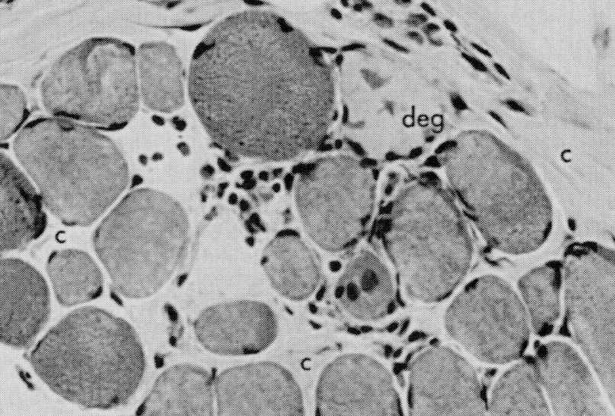
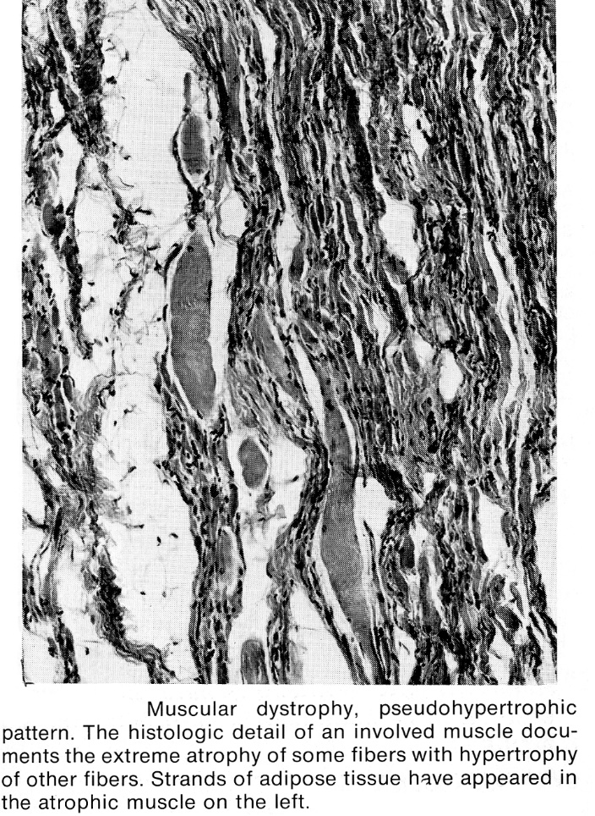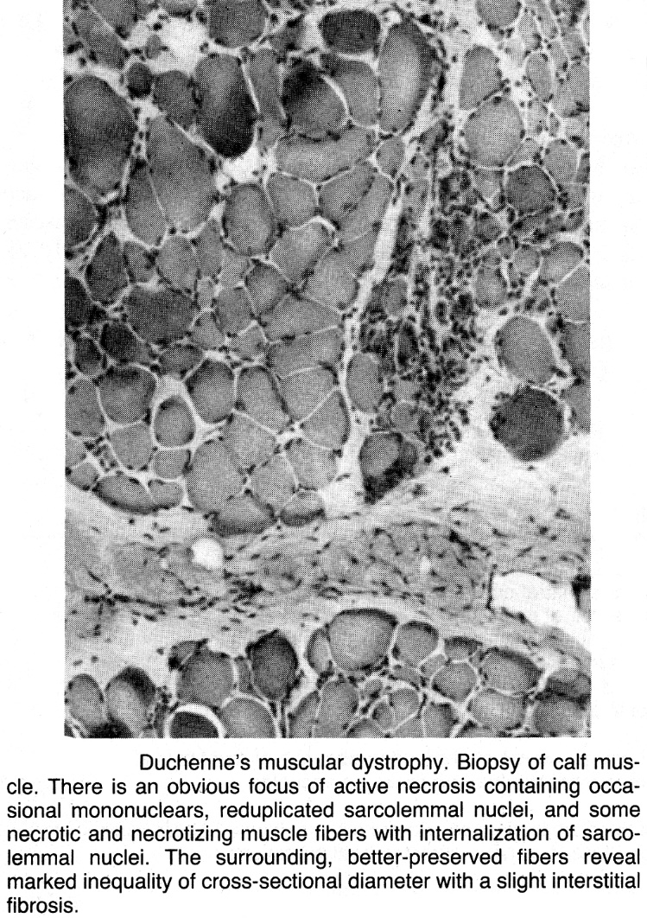

Muscle biopsy in Duchenne muscular dystrophy: several enlarged densely staining hyaline fibres with numerous small necrotic fibres are present throughout; increased quantity of fibrous and adipose connective tissue (top left) - muscular pseudohypertrophy noted clinically:
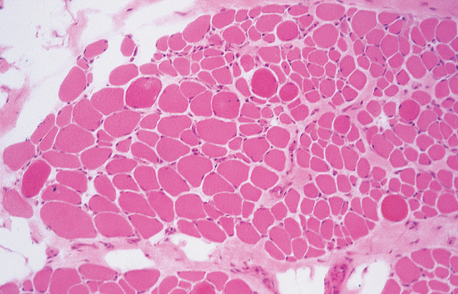

Epidemiology
incidence for DMD - 1 / 3,500 male births (most common neuromuscular disease of childhood!).
- no geographic or ethnic variation.
- for BMD - 1 / 20,000 male births.

prevalence
DMD (prevalence is less than incidence because life span of patients is shortened) – 6.3 / 100,000 or 1 / 18,000 males.
BMD – 2.4 / 100,000

Clinical Features
Duchenne muscular dystrophy

Skeletal muscles
Rapidly progressive proximal muscle weakness with pseudohypertrophy* of calves
* muscle infiltration by fat (but in younger children it is true muscle fiber hypertrophy)
- accurate criteria established by Duchenne 1868:
  - weakness, appearing first in lower extremities
  - wide-based gait and stance, with lordosis
  - subsequent hypertrophy of weakened muscles
  - loss of muscle contractility with electrical stimulation
  - intact sensation / bowel / bladder function
  - progressive, deteriorating course.
- lower extremities > torso > upper extremities (arm weakness is not obvious without careful examination!)
- proximal limbs > distal limbs Pelvic girdle!!!
neck flexors > extensors;
wrist extensors > flexors;
biceps and triceps > deltoid;
quadriceps > hamstrings;
tibialis anterior and peronei > gastrocnemius, soleus, tibialis posterior.
- next most common site of muscular hypertrophy (after calves) is tongue, followed by forearm muscles.
- bulbar & ocular muscles are spared.
- tendon reflexes are gradually lost.
- significant contractures of iliotibial bands, hip flexors, and heel cords develop (in 70% by age 10 yrs) → limited hip flexion, toe-walking.
- myalgias and muscle spasms do not occur.
- reported adverse reactions to succinylcholine and halothane (marked CK elevation, myoglobinuria ÷ cardiac arrest).

Myocardium
- involved in 90% cases.
- stable or only slowly progressive (asymptomatic until late stage).
- pathology - cardiac muscle degeneration and myocardial fibrosis (particularly subendocardial in posterobasal region and adjacent lateral wall of left ventricle).
- extent of cardiac involvement does not correlate with myopathy degree.

Smooth GI muscle
- fatty infiltration of smooth GI muscle → acute gastric dilatation, intestinal pseudo-obstruction.

CNS
- intellectual impairment occurs in all patients (only 20-30% have IQ < 70; average IQ is one standard deviation below normal mean); nonprogressive; affects verbal ability more than performance.
N.B. IQs are lower than those of children with comparably disabling and chronic disorders!
- no consistent neuropathologic abnormalities are found.
- no correlation with changes in dystrophin or affected gene.

Clinical course
- onset < 5 yrs (newborn is asymptomatic!); early motor milestones are met on time.
- earliest problems (usually 2-3 yrs) - developmental delays (esp. in walking and climbing; boys probably never run normally), appearance of enlarged calf muscles.
Poor head control in infancy may be first sign of weakness!
- age 3-6 yrs - waddling and lordotic gait, Gowers' sign see p. D5 >>
- age 5 yrs - muscle weakness is obvious by muscle testing.
- age 6 yrs - enlargement of calf, gluteal, lateral vastus, deltoid, infraspinatus muscles; weakness is readily apparent; frequent falls.
- strength of limb-torso muscles continues to decline steadily from ages 6 though 11 years (tendon reflexes decrease → disappear).
- age 8 years - difficulty in climbing stairs.
- age 10 years - 50% patients have lost proximal (biceps, triceps, knee) reflexes (vs. ankle reflex - remains in 1/3 patients even in end-stage disease!).
- joint contractures commonly appear between 6 and 10 years.
- decreased vital capacity can be detected after age of 10.
- functional impairment - mild until 8 years, then declines more rapidly over next 2-3 years → inability to walk after age 12.
N.B. after ambulation is lost all muscles atrophy!
- second decade - progressive weakness & kyphoscoliosis → decreasing lung capacities and maximal pressures → mechanical ventilation at age ≈ 20 → aspirations, pulmonary infections.
- universally fatal!!!
- mean age of death is 20 +/- 3.9 years.
- respiratory failure (40%), cardiac complications (10-40%) - congestive heart failure and arrhythmias.

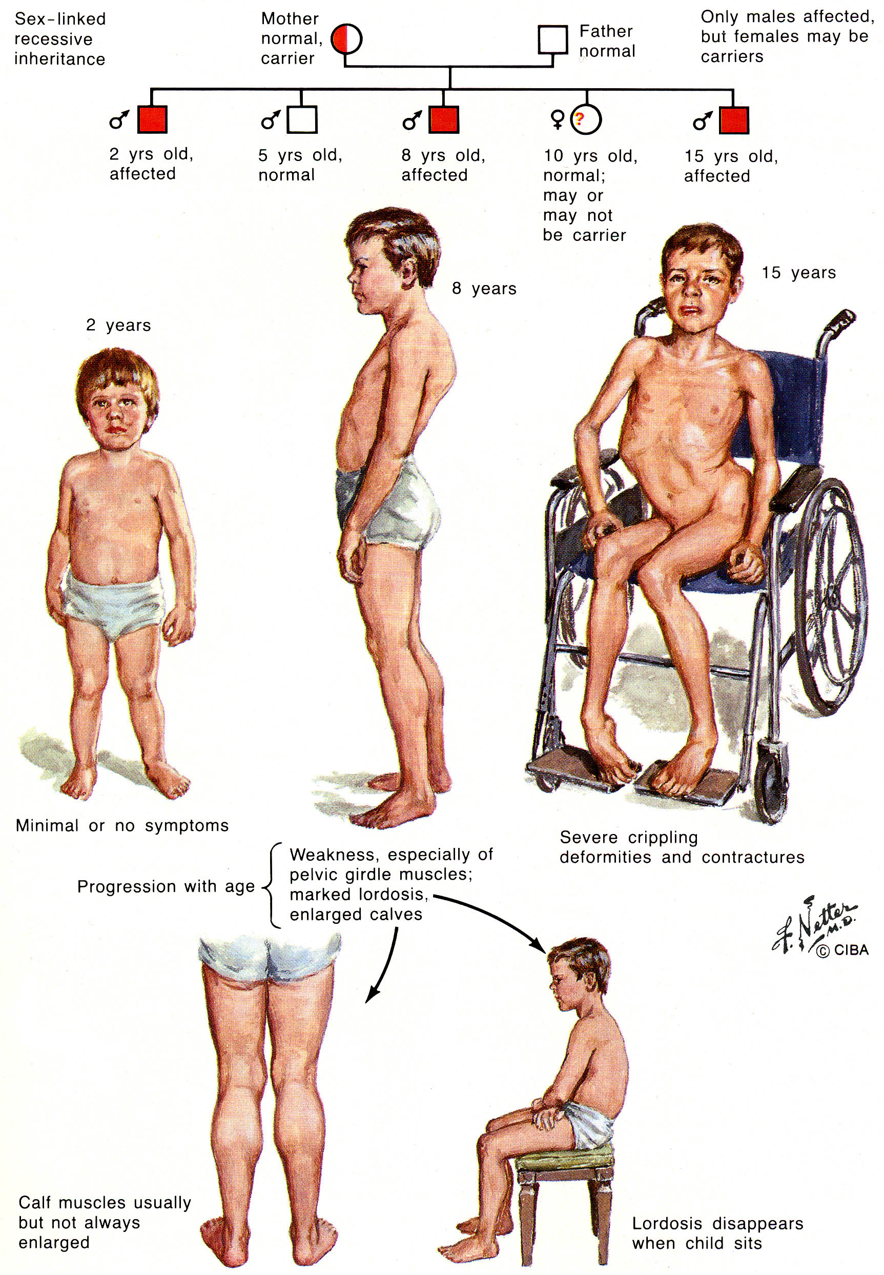

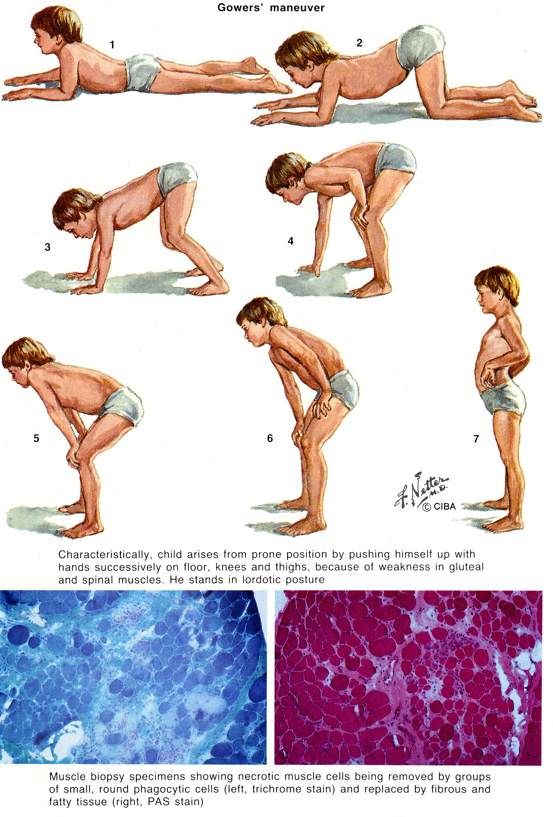

Becker muscular dystrophy
- phenotypes range: myalgias & muscle cramps ÷ phenotype indistinguishable from DMD.
- two main differences from DMD:
- later onset (usually after age 12; ranges 1÷70 years); 90% are affected by age 20.
- slower progression;
    - loss of ambulation 30-40 yrs (i.e. still ambulatory after age 12-15 yrs – main difference from DMD!).
    - age at death 23÷89 years (usually after age 40; average – 42).
- cardiac problems (similar to DMD) are present in 50%.
- mental retardation is rarer than in DMD.
- fertility ranges 10÷79% (correlating positively with phenotype severity).

Carriers
- female carriers are usually asymptomatic.
- rarely may demonstrate moderate limb-girdle weakness, calf hypertrophy, high serum CK levels (manifesting carriers) - explained by Lyon hypothesis.
- full clinical picture of DMD has occurred in several girls with Turner syndrome in whom single X have had Xp21 deletion.

Diagnosis
- CK↑↑↑↑ - 20-100 times normal at birth; peaks during first 3 years → declines exponentially (≈ 20% annually) when there is severe loss of muscle mass; 50-80% female carriers also have CK↑.
Normal serum CK is incompatible with diagnosis!!!
Measure CK in all boys who are not walking by age 18 months!
- Myoglobinemia - roughly correlated with CK.
Ambulatory DMD patients have diurnal fluctuations in myoglobin and CK (increases corresponding to physical activity).
- Other muscle lysosomal enzymes (aldolase, AST) are also increased but are less specific.
- CSF - protein fractions are increased (as in most dystrophies) and upsilon-globulin is decreased.
- Urinary creatinine excretion declines with decreasing functional muscle mass.
- Urinary creatine excretion ≈ twice normal between ages 6 and 11, and it increases with age.
- EMG – myopathy.
- Muscle biopsy (similar changes in BMD and DMD).
N.B. EMG and muscle biopsy are not necessary if diagnosis can be established by molecular studies of WBC!!!

Molecular diagnosis
Neither DMD nor BMD can be diagnosed if no abnormality of gene or gene product is found
Nondystrophin diseases that map to same Xp21 position are called Xp21 myopathies.
Detect dystrophin gene mutation (in DNA of WBCs*):
- PCR amplification using battery of cDNA probes - detects 98% deletions (cause 65% dystrophinopathies); cannot detect duplications!
- Southern blot - detects partial duplications.
*WBC DNA analysis obviates need for muscle biopsy! (muscle DNA is no more specific).

If patient falls into 1/3 of patients in whom deletion cannot be detected → muscle biopsy to demonstrate dystrophin deficiency:
- Immunoblot (immunocytochemical staining of muscle homogenates) with dystrophin antibodies:
- DMD - absent subsarcolemmal dystrophin (in at least 95% DMD patients!!!).
- BMD - discontinuities of subsarcolemmal dystrophin.
N.B. dystrophin should also be evaluated in males with dilated cardiomyopathy (even in absence of muscle weakness), and in girls with symptoms of DMD (some female carriers)!
- Western blot:
DMD – absent dystrophin (quantity < 3% of normal);
BMD – abnormalities of dystrophin (amount↓, abnormal size - ↓ or ↑):
- 80% - small size dystrophin (20-90% of normal).
- 15% - normal size dystrophin but reduced in quantity.
- 5% - abnormally large dystrophin.

Immunoblot:
- Normal term male neonate
- 10-year-old boy with limb-girdle muscular dystrophy
- 6-year-old boy with DMD
- 10-year-old boy with BMD.
  - in A and B (dystrophin is not affected) – sarcolemma of every fiber is strongly stained, including atrophic and hypertrophic fibers.
  - in C - most myofibers express no detectable dystrophin, but few scattered fibers known as "revertant fibers" show near-normal immunoreactivity.
  - in D - abnormal dystrophin molecule is expressed as thin, pale staining of sarcolemma (reactivity varies not only between myofibers but also along circumference of individual fibers).

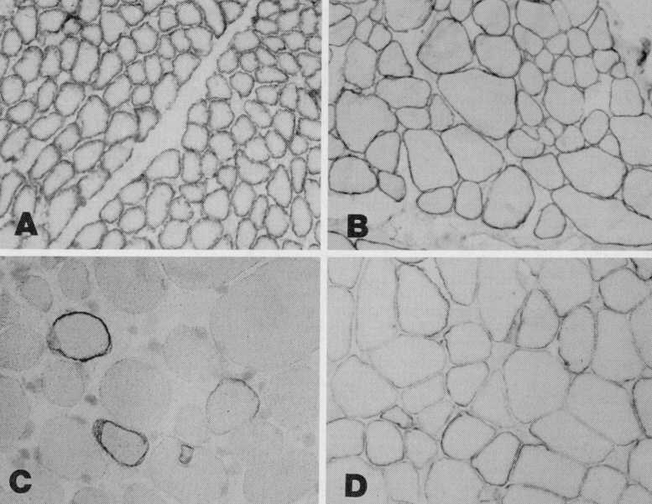

Western blot:
DMD - absent dystrophin;
BMD - altered dystrophin size;
Con – normal control.

Carrier diagnosis (for mothers, sisters and daughters of mothers):
  - PCR amplification (in families with known specific mutation)
  - restriction length polymorphisms (in families without detectable deletions or duplications)
- dystrophin analysis (of muscle biopsy specimens) for carrier detection is not reliable! (mosaic pattern - some fibers contain dystrophin and others show none at all).
- consider prenatal diagnosis for such mothers (risk for recurrence in additional sons is 7%).

Cardiac evaluation
ECG (abnormal in 90% DMD cases):
- persistent or labile sinus tachycardia, rhythm and interatrial conduction defects;
- elevated right precordial R waves and deep left precordial Q waves.
Echocardiography - small internal ventricles, posterobasal ventricular wall hypokinesis, slowed ventricular relaxation, dilatation of ventricular walls.

Treatment
Effective gene therapy remains elusive;
- injecting normal myoblasts into affected muscle did not help (only ≈ 1% of fibers are successfully replaced).
- scientists cannot simply replace defective gene because dystrophin gene is so large it couldn't fit inside disabled virus used to deliver it.
- alternative treatment may be upregulation of related protein utrophin.

Only medication to improve functioning - alternate-day prednisone.
- dosage 0.75-1.5 mg/kg/day - side effects limit practical usage of steroids!
- improvement begins 1 month after beginning treatment and peaks by 3 months; effect lasts up to 3 years.

Much of management remains supportive:
- passive exercises and joint stretching are important in delaying onset of contractures.
- resistance exercises neither hasten physical deterioration, nor maintain strength any better than free exercises.
N.B. physiotherapy contributes little to muscle strengthening because patient usually is already using his entire reserve for daily function - exercise cannot further strengthen involved muscles.
Excessive exercise may actually accelerate process of muscle fiber degeneration!
- maintain ambulation as long as possible (ambulation loss → rapid progress of contractures and scoliosis → restrictive respiratory syndrome).
  - release of hip and ankle contractures by subcutaneous tenotomy while patient is still ambulatory (preserves ambulation for 2 additional years).
  - boys tend to become obese (caloric requirements are less than normal).
- cardiac decompensation often responds well to digoxin (at least in early stages).
- respiratory care:
  - inspiratory resistive exercises (increase respiratory endurance but not vital capacity).
  - routine influenza vaccinations.
  - intermittent ventilatory assistance ameliorates hypoventilation symptoms but does not slow deterioration of respiratory function.
  - assisted ventilation (when vital capacity falls < 10% normal) can prolong survival by 3-4 years.

Xp21 myopathies
- nondystrophin diseases that map to same Xp21 position as dystrophinopathies.
- myopathy may appear when deletion in neighboring gene extends into dystrophin gene - resulting syndrome may be dominated by congenital adrenal insufficiency or glycerol kinase deficiency but there is also myopathy.
- examples:
- syndromes of atypical weakness distribution (distal myopathy, quadriceps myopathy);
- syndromes that lack weakness but manifest other symptoms (recurrent myoglobinuria, X-linked cramps).
- McLeod syndrome – lack of Kell antigen (RBC antigen), acanthocytes, serum CK↑↑↑ (≥ 29 times normal), sometimes limb weakness; dystrophin is normal!

Facioscapulohumeral muscular dystrophy (s. Landouzy-Dejerine disease)
- autosomal dominant:
85% - deletion in 4q35 (protein unknown).
significant correlation between disease severity and size of 4q35 deletion!
15% - still unlinked.
- penetrance - 95% (by time individuals reach their 20s).
- prevalence - 1 in 20,000.

Clinical Features
- significant variability of symptom severity within families (members may be subclinical or even asymptomatic! – 30% of those affected are unaware of involvement - direct examination of relatives of suspected patients is very important).
Affected muscles (no muscle hypertrophy!; no joint contractures; asymmetry is common):
- Facial
  - facial weakness facial weakness is initial manifestation - appears insidiously in orbicularis oculi (wide eyes, failure to bury eyelashes), zygomaticus, orbicularis oris (rounded mouth with slightly everted lips) → expressionless face.
  - patients state that they have never been able to whistle or blow up balloon.
  - spares extraocular, pharyngeal, lingual, and cardiac muscles!
- Scapular stabilizers (serratus anterior, rhomboid, trapezius, latissimus dorsi) → inadequate fixation of scapula:
  - patient first notices asymmetrical weakness in shoulder girdle (although facial weakness may have been present for some time).
  - dramatic scapular winging with arm abduction.
  - patient cannot raise arms to shoulder level! - even though no deltoid weakness is present.
  - considerable disability may result (even though limb weakness may not be detectable).
N.B. deltoids are relatively spared!
- Upper arm (biceps, triceps)
  - marked biceps/triceps atrophy with relative preservation of forearm muscles can produce so-called “Popeye arms”.
- Anterior leg (anterior tibiales and peroneales) → footdrop.

Shoulder girdle has characteristic appearance:
- clavicles seem to sag;
- tips of scapulae project above supraclavicular fossa;
- smallness of pectorals → vertical prominently indented anterior axillary fold (normally diagonal);
- "trapezius hump" due to upward movement of unstable scapula (may be mistaken for muscle hypertrophy).
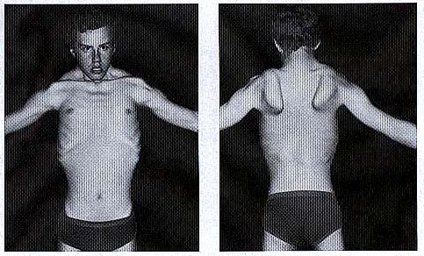

- asymptomatic abnormal AV node / intranodal conduction may occur.
- patients with early onset and relatively rapid progression may have hearing loss (in 4-6 kHz range) and exudative retinitis (Coat's disease) (H: early photocoagulation).

Course is relatively benign!
- onset - from infancy until middle age; usually adolescence (rarely childhood).
- weakness progresses slowly in descending pattern:
facial muscles → shoulder girdle → upper arms → pelvic girdle.
- there may be plateaus (even occasional arrest) of disorder.
- most patients remain ambulatory (only few patients have to use wheelchair due to pelvic girdle weakness).
- lifespan is not significantly decreased!
- cases with early onset have worse prognosis.

Diagnosis
- EMG - myopathic changes.
- Muscle biopsy - changes are mild ÷ moderate: variation in fiber diameter, centrally located nuclei, moth-eaten fibers, often mononuclear inflammatory infiltrates (significance is not known).
Mononuclear cell "inflammation" in muscle biopsy of infants < 2 yrs is usually FSH dystrophy!
- Genetic testing.
- Serum enzyme levels are normal!
- ECG is normal.

Differential diagnosis
- scapuloperoneal spinal muscular atrophy - diagnosis depends entirely on muscle biopsy and EMG.
- inflammatory cells in muscle biopsy simulate polymyositis.
- autosomal dominant scapuloperoneal myopathy - difference depends on difficult determination of whether face is affected.
- mitochondrial myopathy with FSH distribution and cardiomyopathy → muscle biopsy.

Treatment
- steroids - transient benefit if there are inflammatory changes on muscle biopsy; no response to immunosuppressive therapy!
- physical & occupational therapy, orthotics & bracing (e.g. ankle-foot orthoses for footdrop).
- surgical stabilization of scapulae (e.g. wiring scapulae to chest wall).

Scapuloperoneal syndromes
- heterogeneous group of disorders with weakness of shoulder girdle and peroneal muscles:
- neurogenic (scapuloperoneal spinal muscular atrophy)
- myogenic (scapuloperoneal muscular dystrophy)
- neurogenic form is linked to 12q24.1-q24.31, which is region about 20 cM telomeric to location of gene for myopathic form.
- autosomal dominant, autosomal recessive, and sex-linked recessive patterns of inheritance have been reported.
- clinical features of both forms are similar.
- onset - ranges from infancy to adulthood.
- diagnosis - EMG and muscle & nerve biopsies.

Myotonic dystrophy (s. Steinert disease)
incidence - 1 in 8,000 live births (s. 13.5 per 100,000 live births).
prevalence 3-5 per 100,000 population (most common adult muscular dystrophy!!!)
Prevalence is high because disorder is compatible with long life!

Genetics
- autosomal dominant unstable trinucleotide CTG repeat at 19q13.2-3
- gene product (termed myotonin) is uncharacterized; one candidate is protein kinase (DMK) (CTG expansion is in 3' untranslated region of protein kinase gene).
- normal repeat number 5-30; in patients > 50 (up to several thousands).
- gene penetrance 100%.
- repeat size correlates with severity of symptoms.
- CTG repeat number increase in ovum* → anticipation (earlier and more severe symptoms in subsequent generations).
*sperm with greatly expanded triplet repeats do not function well
- DMK protein is localized to postsynaptic side of neuromuscular junction in skeletal muscle and intercalated discs in cardiac muscle.

Clinical Features
Multisystem (pleiotropic) disorder with widely variable clinical picture – two main forms:
- noncongenital form – classic form; onset in adolescence or later.
- congenital form - most extreme example of anticipation; onset in childhood; mother is always affected parent (form occurs in 25% of infants of affected mothers).

- Myotonia (impaired relaxation) – most evident in hands - patients complain of "stiffness" and have difficulty in releasing hand grip, like after handshake.
N.B. abnormal activity arises in muscle not in nerve!
N.B. myotonia is painless!
Myotonia cannot be detected before age 5 yrs!
Noncongenital form - myotonia can be elicited clinically (myotonic maneuvers): see p. D1 >>
- brisk tap on thenar muscle → flexion-opposition of thumb with slow relaxation.
- ask patient to grasp forcefully → slow relaxation.
- press edge of wooden blade against tongue dorsal surface → deep furrow that disappears slowly.
- ask patient to look upward and then rapidly look down → pronounced myotonic eyelid lag; forceful voluntary eye closure → patient unable to open eyelids easily.
Congenital form - myotonia is detectable only by EMG.

- Relatively mild, slowly progressive muscular weakness
Noncongenital form:
- milder weakness in distal extremity (hands = feet); e.g. footdrop.
- one of few neuromuscular disorders in which finger flexor weakness is prominent!
- patients generally do not lose ability to walk.
- marked weakness in face-jaw-neck muscles
- affects cranial muscles in addition to those of face (unlike any of other major dystrophy!) - small temporalis muscles, ptosis; in some cases, impaired eye movements, dysarthria and dysphagia.
- characteristic appearance: long, thin face with sunken cheeks (masseter wasting), ptosis, inverted V-shaped upper lip (“fish mouth” or “tented mouth”), scalloped concave temporalis muscles, “swan neck” (sternocleidomastoid wasting!!!), relatively strong muscles in posterior neck and shoulder girdle; in men, frontal baldness contributes to impression.

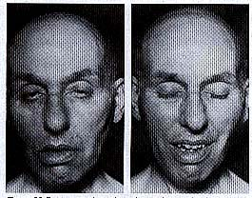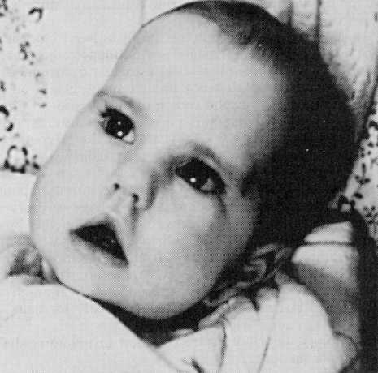

Congenital form - no extremity weakness (?), but generalized hypotonia* with respiratory muscle weakness (present in at least 50% patients) is most common cause of infant death; respiratory weakness may manifest as hypersomnia and cor pulmonale.
*incl. decreased fetal movement and polyhydramnios

N.B. although significant number of patients are mentally impaired, some who are not may be perceived as such because of facial weakness!
Most patients are generally thin, and focal wasting is not prominent.
Weakest muscles often have only minimal myotonia.

- Cardiac conduction defects (90%)
Arrhythmias rather than cardiomyopathy (unlike most other muscular dystrophies)!
- severity of cardiac symptoms does not correlate with severity of other symptoms!
- pacemakers are rarely needed.
- sudden death is well documented!

- Endocrinologic abnormalities
- hyperinsulinism and reduced numbers of insulin receptors are common, but diabetes is not.
- FSH&LH frequently↑; fertility in both sexes reduced to 75% of normal - disease continues to be propagated in family.
  - males - testicular atrophy, Leydig cell hyperplasia, serum testosterone slightly↓.
  - females - no consistent ovarian problems, but high spontaneous abortion rate; incoordination of contractions during labor → prolonged first stage, retained placenta, postpartum hemorrhage.

- Cataracts (sometimes only manifestation of disease) early in disease course*;
- present in virtually every patient.
- characteristic multicolored crystalline subcapsular opacities.
*finding of cataracts on slit lamp examination was most sensitive way of diagnosis before DNA analysis became available.

- GI smooth muscle abnormalities - delayed pharynx relaxation & reduced esophagus motility → aspiration; constipation (pseudo-obstruction or megacolon can be dramatic); anal sphincter abnormalities (encopresis) in children.

- Intellectual function
Noncongenital form – 30% patients mildly impaired.
Congenital form - frequently severely impaired.
- brain may show generalized atrophy.
- well-known behaviors associated with DM - apathy & inertia (with concomitant lower socioeconomic status), hypersomnolence (due to both central and obstructive sleep apneas).

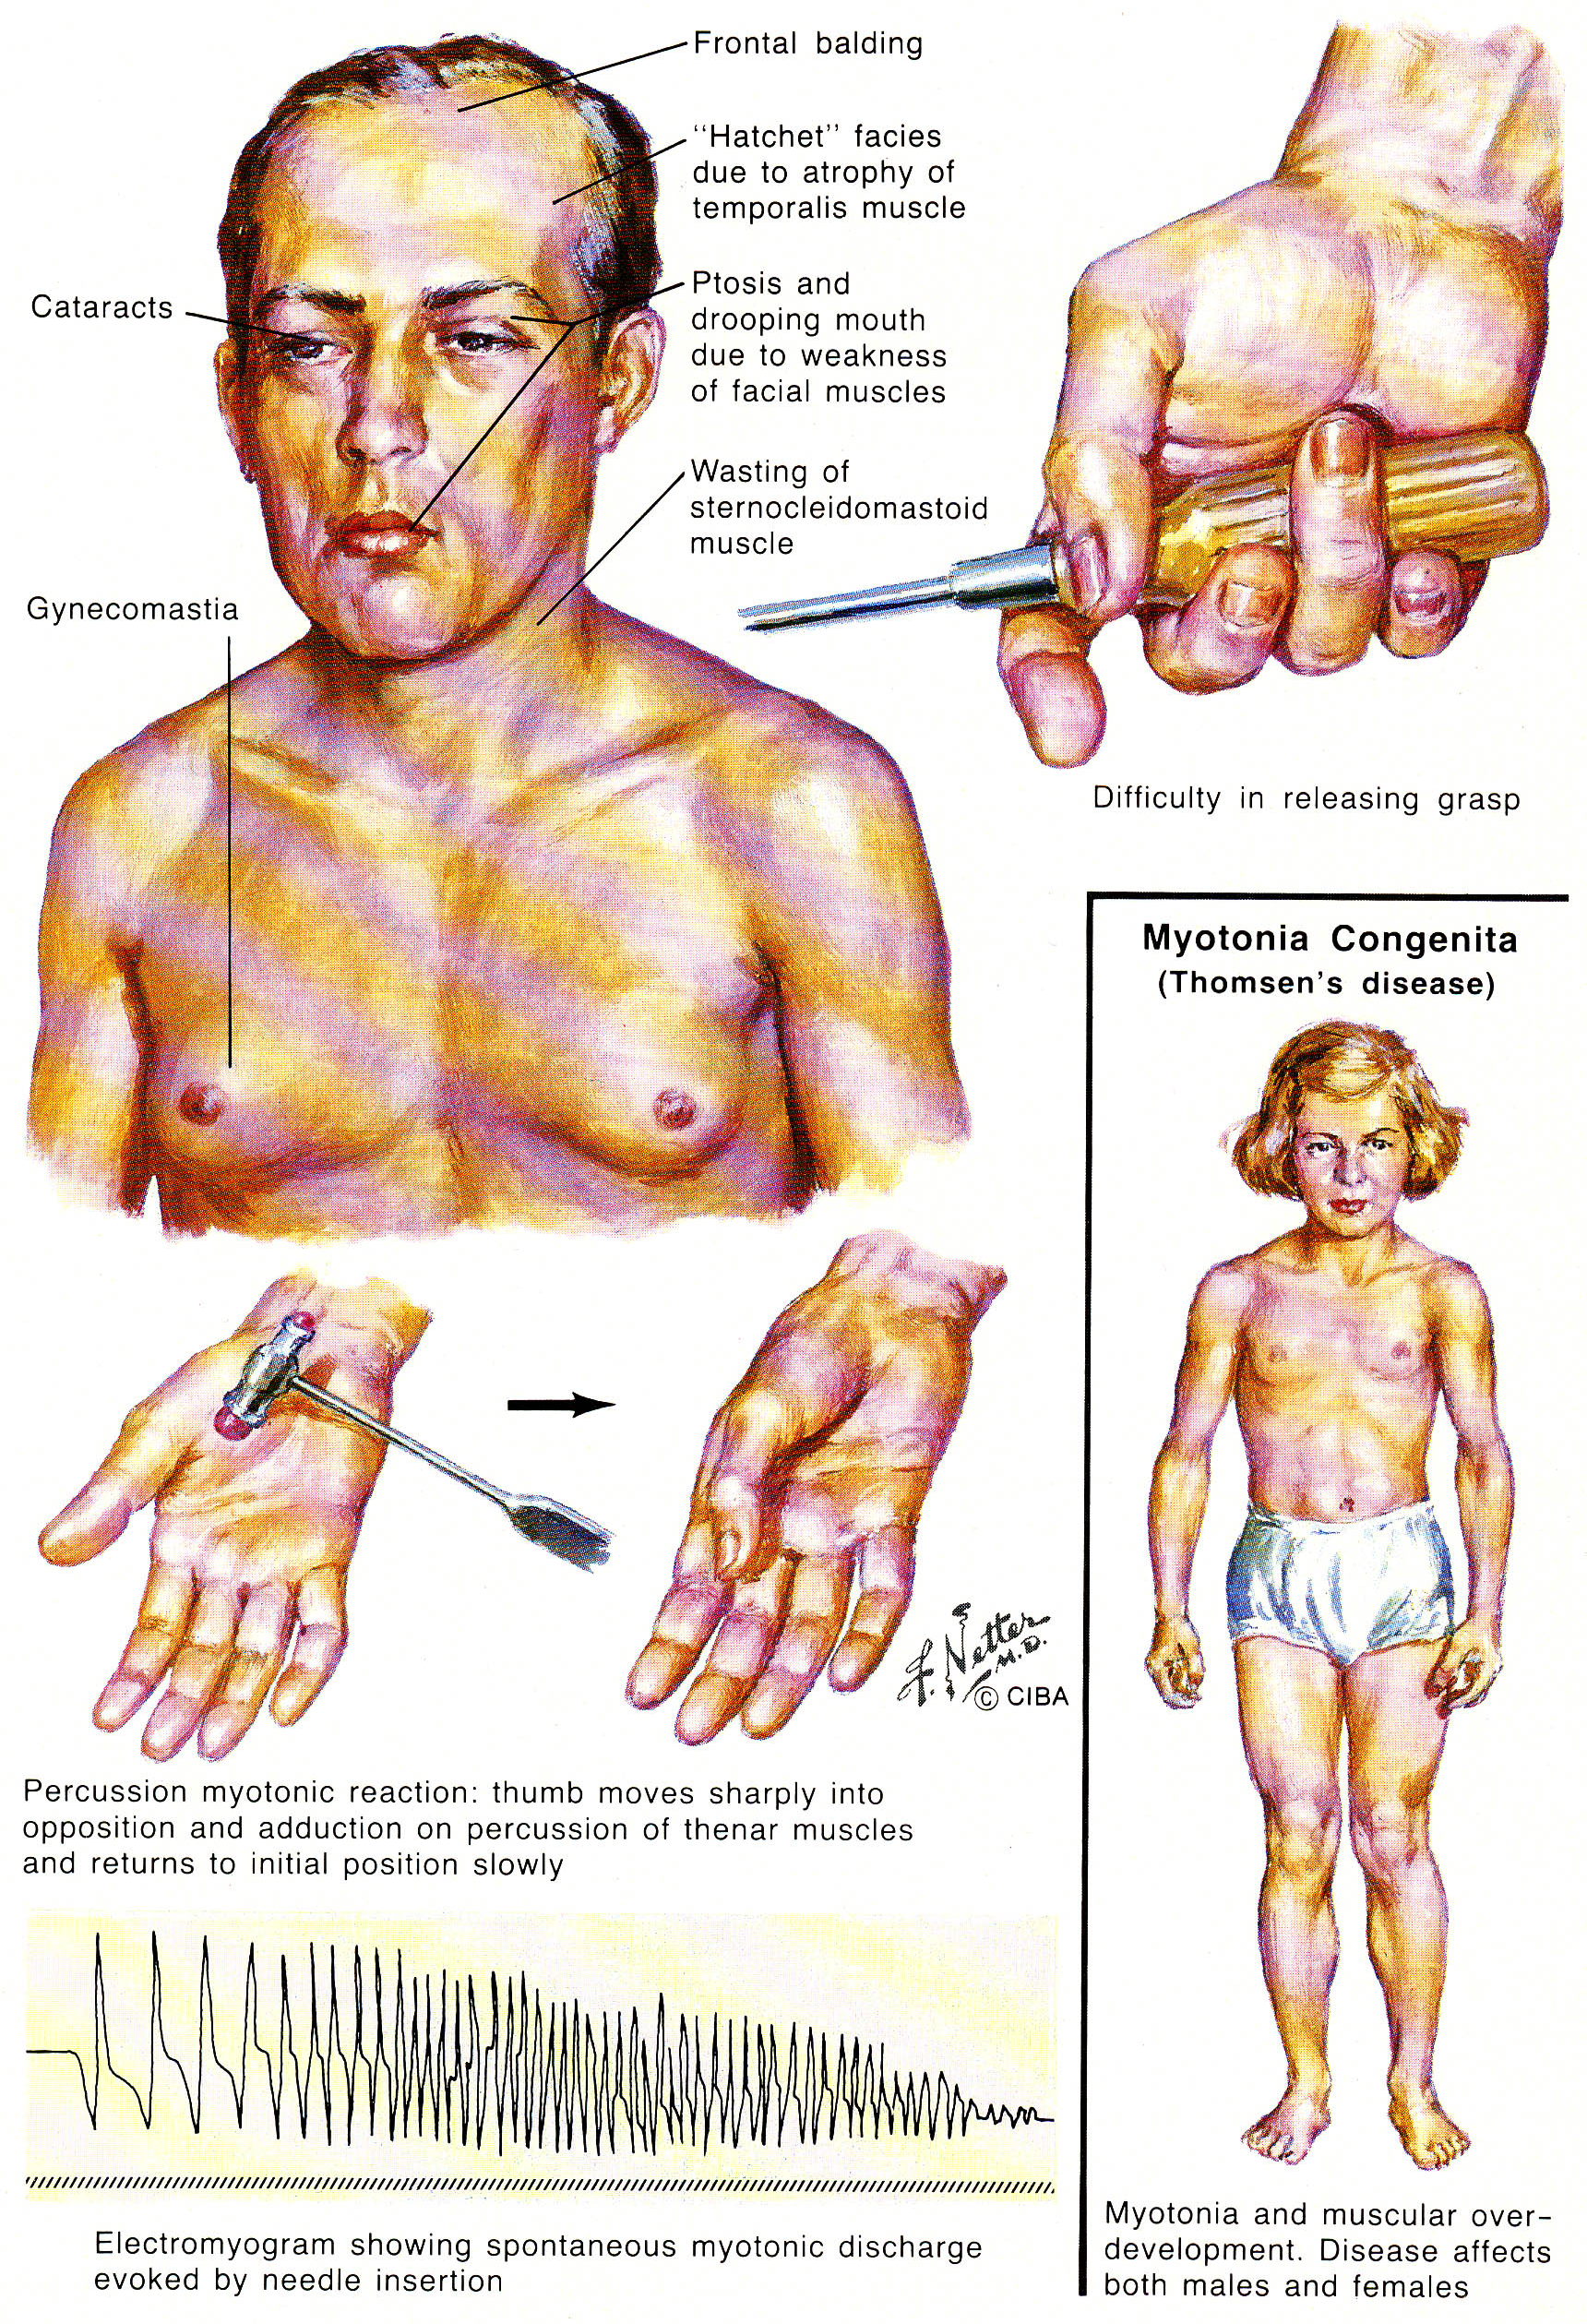

Diagnosis
- serum CK – normal or slightly↑.
- EMG – myopathy with myotonia (EMG always confirms myotonia). see p. D20 >>
- muscle biopsy – mild nonspecific changes:
- increased central nuclei, nuclear chains (internalized nuclei in longitudinal fiber section)
- ringed fibers - subsarcolemmal band of cytoplasm* that is distinct from fiber center.
    - band contains myofibrils that are oriented circumferentially around longitudinally oriented fibrils in rest of fiber;
    - ring fiber may be associated with irregular mass of sarcoplasm (sarcoplasmic mass) extending outward from ring.
- selective atrophy of type I fibers
- increased numbers of fibers in spindles (unlike other muscle dystrophies)
- no fiber necrosis, no fibrosis!
- nerve biopsy - increased arborization at terminal.
- careful slit lamp evaluation for all patients!
- His bundle electrogram; annual ECGs are recommended.
- presymptomatic and prenatal genetic counseling.
- plasma IgG is often low.

Treatment
- phenytoin in usual anticonvulsant dose (100 mg × 3/d) reduces myotonia;
alternative – carbamazepine;
arrhythmogenic alternatives - quinine, procainamide, tocainide, mexiletine.
N.B. myotonia is only rarely bothersome symptom; it is weakness that is disabling!
- anesthesia should be used only when it cannot be avoided:
  - depolarizing relaxants and anticholinesterases may increase myotonia;
  - sedatives (barbiturates, benzodiazepines), opiates may exacerbate ventilatory drive abnormalities → apnea;
  - bracelet that identifies patient as having DM may be helpful!
- pacemakers for conduction defects.
- respiratory problems may be avoided by upright positioning during meals and by spacing meals well ahead of bedtime.
- explain increased risks of pregnancy to affected or carrier mother and fetus, phenomenon of anticipation, and congenital DM.

Myotonic dystrophy type 2 (s. Thornton-Griggs-Moxley disease, proximal myotonic dystrophy)
≈ myotonic dystrophy; differences:
- limb weakness is proximal!
- calf hypertrophy
- result of either another mutation (not CTG expansion) in myotonic dystrophy gene (allelic disorder) or action of gene located on another chromosome, e.g. 3q (locus heterogeneity).
- frequent muscle pain!

Emery-Dreifuss muscular dystrophy
Genetics
- X-linked recessive inheritance - Xq28 (gene STA, protein emerin); several different mutations cause lack of emerin in skeletal and cardiac muscle.
incidence ≈ 1 in 100,000
- more rare autosomal dominant form exists (Hauptmann - Thannhauser muscular dystrophy).

Clinical Features
Variable onset (most commonly 10-20 years):
- early* contractures of elbows, Achilles' tendon, and posterior cervical muscles (rigid spine).
early elbow contractures are important phenotypic key to diagnosis
*before weakness is present!
- slowly progressive weakness and muscle atrophy (generally humeroperoneal).
- most patients remain ambulatory into their third or fourth decade.
- cardiomyopathy - frequently presents as conduction block (potentially lethal); also impairment of impulse generating cells, increased atrial and ventricular heterotopia, functional impairment of myocardium.
N.B. up to 40% patients die suddenly!

Intellectual function is normal.

Diagnosis
- muscle biopsy - nonspecific nonsevere myodystrophic changes (variation in fiber size and fiber necrosis, endomysial and perimysial fibrosis).
- genetic analysis of leukocyte DNA.
- immunohistochemistry - absent emerin.
- serum CK - normal or only moderately↑.

Treatment
- similar to other muscular dystrophies.
- pacemaker insertion (when indicated).

Bethlem myopathy
≈ Emery-Dreifuss dystrophy.
- no cardiac involvement.
- autosomal dominant inheritance (21q22) - mutation of α₁ and α₂ subunits of collagen VI.

Oculopharyngeal muscular dystrophy
Genetics
- autosomal dominant inheritance - increased GCG repeat expansion on 14q11.2-q13 - within poly(A) binding protein 2 gene (PABP2); fundamentally mitochondrial myopathy.
- complete penetrance.
- highest prevalence continues to be in Quebec (result of founder effect).

Clinical Features
Late adult onset (after age 50) – slowly progressive weakness:
- Levator palpebrae → ptosis.
  - eventually all extraocular muscles may become involved (progressive external ophthalmoplegia!); no diplopia!
- Pharyngeal muscles → dysphagia → aspirations, malnutrition.
- Later extremity muscles may become affected (usually in limb-girdle pattern).

Diagnosis
EMG - myopathic changes.
Muscle biopsy - muscular dystrophy (loss of muscle fibers, variation in fiber size, increased numbers of nuclei and internal nuclei, increased fibrous and fatty connective tissue).
- histochemistry - small angulated fibers (react strongly for oxidative enzymes), "rimmed" vacuoles in type I fibers (from extremity rather than extraocular muscles).
- electron microscopy – unique 8.5-nm intranuclear tubular filaments.
Serum CK - normal or slightly↑.

Treatment
- eyelid crutches - to alleviate ptosis.
- feeding tube, cricopharyngeal myotomy, gastrostomy - to prevent early death by malnutrition and starvation.

Limb Girdle muscular dystrophies (LGMD)
- syndromes encompassing several unrelated myopathies.

Genetics
- autosomal inheritance (main difference from dystrophinopathies!):
Type1 – autosomal dominant (more benign clinical course)
Type2 – autosomal recessive (more frequent; clinical course more malignant)

- LGMD are being reclassified on genetic basis.
- LGMD genes are important in structural support system of muscle, particularly of sarcoglycan complex (sarcoglycanopathies)
disturbed sarcolemma-extracellular matrix interaction is molecular basis for muscle fiber necrosis
- prevalence - 1 in 100,000.
- ≈ 1.6% of normal population is heterozygous for LGMD gene.

LGMD Type | Inheritance | Gene Locus | Gene Product | Unusual Symptoms
1A | AD | 5q22-34 | ? | palatal weakness
1B |  | 1q11-21 | ? | cardiac involvement
1C |  | 3p25 | caveolin-3 | similar to 1B
2A | AR | 15q15.1-15.3 | calpain-3 (muscle-specific calcium-activated neutral protease)
2B* |  | 2p12-l3 | dysferlin | some Canadians had distal extremity weakness and wasting (Miyoshi myopathy)
2C** |  | 13q12 | γ-sarcoglycan | cardiac involvement, abdominal, neck flexor and intercostal muscles affected, malignant course
2D |  | 17q12-21.33 | α-sarcoglycan (s. adhalin)
2E |  | 4q12 | β-sarcoglycan | Duchenne-like clinical course
2F |  | 5q33-34 | δ-sarcoglycan
2G |  | 17q11-12 | ?
2H |  | 9q31 | ?
*probably same condition as Miyoshi distal MD
** it is severe childhood autosomal recessive muscular dystrophy (SCARMD)

Clinical Features
symmetrical weakness of proximal lower extremities → weakness in shoulder girdle.
- facial / cranial muscles spared.
- heart uninvolved (except in 1B).
- intellect intact.
- onset - any time from first decade until middle age.
- slow progression → loss of ambulation 10-30 years after onset.

Diagnosis
Serum CK - mildly to moderately elevated.
EMG - nonspecific myopathic changes.
Muscle biopsy - nonspecific myopathic pathology.
LGMD is still diagnosis of exclusion!!!

Severe childhood autosomal recessive muscular dystrophy (SCARMD)
- found primarily in inbred populations in Tunisia and Amish people in United States.
- early onset - age 3-12 yr.
- mimics Duchenne dystrophy in severity but:
- no pseudohypertrophy!
- no cognitive impairment.
- pelvic girdle weakness precedes pectoral girdle weakness.
- contractures form and reflexes are lost.
- abdominal, neck flexor and intercostal muscles affected.
- malignant course - 75% patients are unable to walk by their 30s.
- cardiomegaly and EKG abnormalities.
- diagnosis:
- CK levels may rival those of DMD!!!
- negative sarcolemmal immunostain for adhalin;
deficiency in one of sarcoglycans results in destabilization of entire sarcoglycan complex - immunostaining for each of sarcoglycans is absent (or diminished) regardless of primary sarcoglycan mutation!

Distal muscular dystrophies
- rare heterogeneous disorders with slowly* progressive muscular weakness & atrophy beginning in hands or feet and progressing to proximal limb muscles.
*not life threatening; sometimes plateau.
Serum CK - markedly increased (up to 50 times normal).
EMG - myopathy.
Muscle biopsy - dystrophic changes of variable severity; vacuolated fibers (except in Miyoshi); rimmed vacuoles are frequent.

Age of Onset | Type | Inheritance - Gene (Protein) | Site of Onset
Late adulthood | type 1A (Welander) | AD - 2p15 (dynactin) | Hands; biopsy - vacuolated muscle fibers.
 | Finnish | AD | Legs
 | type 1B (Markesberry- Griggs / Udd) | AD – 2p | Legs
Early adulthood | type 1A (Nonaka) | AR - 9p1-q1 | Anterior compartment of legs
 | type 1B (Miyoshi)* | AR - 2q12-14 (dysferlin) | Posterior compartment of legs, very high serum CK.
 | type 1C (Laing) | AD - 14 | Anterior compartment of legs with facial and sternocleidomastoid weakness
 | Desmin storage (s. myofibrillar) myopathy | AD: 2q35 (desmin) or 11q21-23 (αβ-crystallin) | Distal weakness with respiratory and bulbar involvement
Childhood (5-15 yrs) | Juvenile | AD | Feet → hands
Infancy (< 2 yrs) | Infantile | AR | Hands & feet
*probably same condition as LGMD 2B.

Congenital muscular dystrophies (CMD)
- newborns have severe neuromuscular symptoms (diffuse profound hypotonia*, proximal limb and respiratory weakness). *combined muscle and CNS involvement
- newborns usually have (or develop later) joint contractures (arthrogryposis). H: early stretching exercises.
- cranial nerve musculature is spared (except CN7).
- serum CK↑ (normal ÷ 10 times normal).
- EMG - myopathy.
- muscle biopsy – dystrophic findings (variable fiber size and extensive endomysial fibrosis even at birth; no inflammation or abnormal inclusions).
- neuropathology - neuroblast migratory abnormalities in cerebral cortex, cerebellum, and brain stem.
Autosomal recessive inheritance:
With CNS involvement*
Fukuyama CMD | 9q31-33 | fukutin (secreted protein with unknown function)
Walker-Warburg CMD (cerebral-ocular dysplasia syndrome) | 9q31-33 | fukutin (?)
Muscle-eye-brain CMD (of Santavuori) | 1 | ?

Without CNS involvement**
Merosin-deficient classic type | 6q22-23 | laminin-α2 (merosin)
Merosin-positive classic type | ? | ?
Integrin-deficient CMD | 12q13 | integrin alpha7
* cerebral malformations vary from severe dysplasias (e.g. holoprosencephaly, lissencephaly) to milder conditions (e.g. agenesis of corpus callosum, focal heterotopia of cerebral cortex, cerebellar hypoplasia); progressive course, inanition and death by age 10-12.
** cerebral hypomyelination is usually present on MRI, but course is benign (learning disability is most severe problem; patients may eventually walk independently) - only conditions called “dystrophy” that are not clearly progressive.

Fukuyama CMD
- 2nd most common muscular dystrophy in Japan (following Duchenne); extremely rare outside of Japan.
- congenital brain abnormalities (esp. type II lissencephaly) → seizures and mental retardation.
- severe cardiomyopathy.
- eye involvement is generally less frequent and less severe (than Walker-Warburg or muscle-eye-brain CMD of Santavuori).

Walker-Warburg CMD (cerebral-ocular dysplasia syndrome)
- myopathy and cerebral* abnormalities ≈ Fukuyama.
- ocular malformations (corneal defects, cataracts, CN2 and retinal dysplasia).
* + occipital encephalocele.

Muscle-eye-brain CMD (of Santavuori)
- ≈ Walker-Warburg (but less severe – longer survival - many patients acquire ability to stand and walk).
- prevalent predominantly in Finland.

Bibliography for ch. “Neuromuscular, Muscular Disorders” → follow this link >>

Viktor’s Notes℠ for the Neurosurgery Resident
Please visit website at www.NeurosurgeryResident.net

