Congenital Myopathies
Last updated: April 19, 2019
Nemaline Myopathy 1
Myotubular-Centronuclear Myopathy 1
Central Core Disease 2
Congenital Fiber-Type Disproportion 2
Other Congenital Myopathies 2
Brain Malformations and Muscle Development 2
Amyoplasia 3
Proteus Syndrome (s. Muscular Dysgenesis, Elephant Man's Disease) 3

Congenital Myopathies – rare* congenital** nonprogressive*** primary myopathies, not explained as dystrophic or metabolic abnormalities****.
* incidences < 1 per 100,000.
** in some cases, no symptoms are not present at birth; other cases manifest in utero as reduced fetal movements, and delayed 2nd stage of labor.
*** patients are remarkably active despite their weakness, but some congenital myopathies (e.g. nemaline myopathy, centronuclear myopathy) have progressive weakness with fatal outcome.
**** statement reflects ignorance about etiology.

The commonest presentation - floppy baby with delayed motor milestones, difficulty in keeping up with peers.
- limb-girdle weakness, although distal weakness can occur in some families.  - reduced muscle bulk (no hypertrophy), reduced muscle stretch reflexes.  - muscle weakness can lead to skeletal defects (pectus excavatum, kyphoscoliosis, dislocated hips, pes cavus, etc); marfanoid, slender body habitus; characteristic dolichocephalic head, long thin face, high arched palate; muscles of jaw may be too weak to hold it closed.  - respiratory weakness with CO₂ retention at night causes morning headaches, daytime somnolence. | 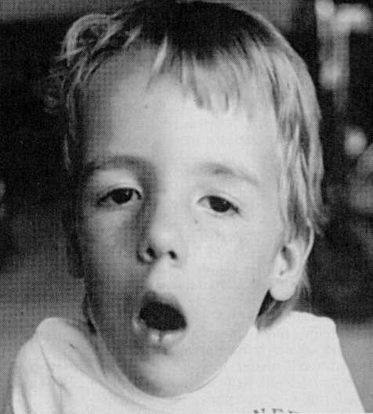

Differential diagnosis, evaluation, and management are similar.
Main diagnostic method - morphological characteristics on muscle biopsy.
CK – normal or only slight increased.
EMG - myopathy

Nemaline Myopathy
rods in muscle biopsy see p. D30 >>

- autosomal dominant - 1q21-23 (α-tropomyosin).
- autosomal recessive - 2q (nebulin is likely candidate gene).

- mild progressive myopathy present from birth; some individuals are more severely affected with early death.

Myotubular-Centronuclear Myopathy
Large central nuclei occupy 25-80% muscle fibers
- more often in type 1 fibers; fibers are small.
- nuclei are in single row in longitudinal section.
- halo around central nuclei shows increased oxidative enzyme activity, and glycogen staining (as in fetal myotubes); cylinder of myofibrils shows normal mature differentiation with ATPase stains.
- immunostains detect vimentin and desmin (normally absent after fetal period).
- original term, myotubular myopathy, was based on morphological resemblance to myotubes.
N.B. morphological similarities to myotubes are only superficial! - centronuclear myopathy is not due to arrest of myotubes!
myotube - muscle fiber formed by myoblast fusion during development; few myofibrils occur at periphery, and central core is occupied by nuclei and sarcoplasm - fiber has tubular appearance.

Cross-section of muscle:
A, normal 14-wk-old fetus.
B, normal full-term neonate.
C, full-term neonate with X-linked recessive myotubular myopathy.
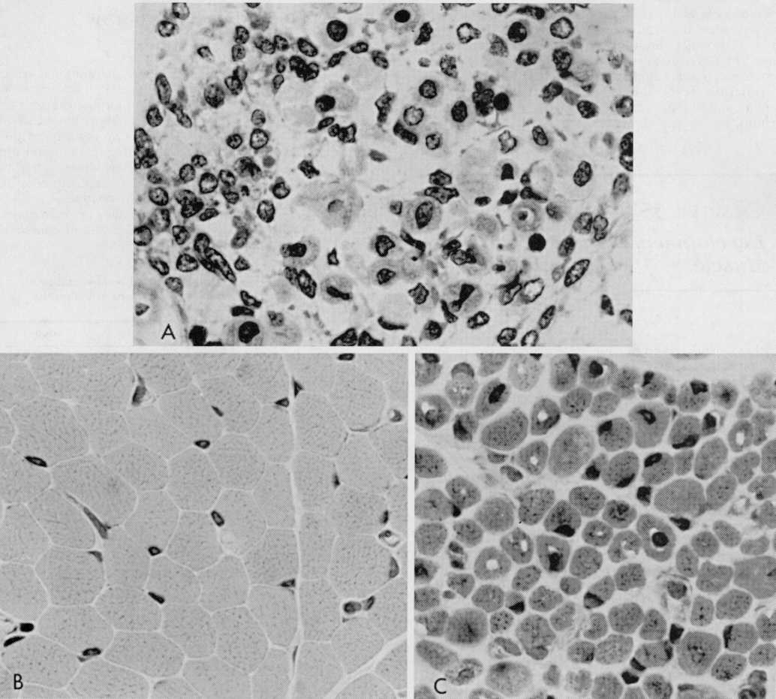

- inheritance patterns:
  - autosomal recessive - late infancy-early childhood form.
  - autosomal dominant - late childhood-adult form.
  - X-linked (Xq28 – myotubularin*) - neonatal form (most common).
* phosphatase important in muscle cell growth and differentiation.
- prominent ptosis & ophthalmoplegia (vs. other congenital myopathies).
- neonatal form has progressive weakness with early fatal outcome;
late forms have mild nonprogressive limb weakness without dysmorphic features.

Central Core Disease
Central / eccentric cores see p. D30 >>
- autosomal dominant point mutations of ryanodine receptor on 19q13.1 (allelic to malignant hyperthermia!).
- consistently associated with malignant hyperthermia! (use dantrolene before anesthesia)

Congenital Fiber-Type Disproportion
increased number of small type I muscle fibers
- type 1 fibers are at least 12% smaller than type 2 fibers (type 2 fibers are of normal / increased size).
- autosomal recessive inheritance with no genetic marker.
- no specific pathophysiological explanation (most poorly understood and characterized congenital myopathy).
association with cerebellar hypoplasia suggests that pathogenesis may be abnormal suprasegmental influence on developing motor unit during stage of histochemical muscle differentiation (at 20-28 wk of gestation).
- not severe, nonprogressive, generalized hypotonia and weakness present at birth.
- atrophy & hypotonia > weakness (child may be stronger than expected during examination).
- mild congenital contractures are often present.

Other Congenital Myopathies
Nonspecific Congenital Myopathy - biopsy shows only minor nonspecific myopathic features.
Cytoplasmic body (s. desmin-related) myopathy - accumulations of desmin.
Multicore/minicore myopathy
Fingerprint body myopathy
Sarcotubular myopathy
Reducing body myopathy
Trilaminar myopathy
Hyaline myopathy with focal lysis of myofibrils
Myofibrillar myopathy

Congenital Muscle Anomalies
Brain Malformations and Muscle Development
Abnormal descending impulses along bulbospinal pathways alter LMN discharge patterns that determine histochemical differentiation of muscle.
Cerebellar hypoplasia - infants are hypotonic and developmentally delayed; muscle biopsy - delayed muscle maturation, fiber-type predominance.

Corticospinal tract does not participate because it is not yet functional during this fetal period - supratentorial lesions are less likely to alter muscle development.

Amyoplasia
- congenital absence of individual muscles; common and often asymmetric.
- most common - palmaris longus muscle - absent in 1/3 normal subjects.
- unilateral absence of sternocleidomastoid muscle → congenital torticollis.
- absence of one pectoralis major muscle - part of Poland anomalad.

Causes
  - defective myogenic regulatory genes → generalized amyoplasia (documented in mice and theoretical in humans - would result in spontaneous fetal loss).
  - defective mesodermal plate (e.g. sacral agenesis) → abnormal somites → failure to form bony vertebrae and muscles (segmental amyoplasia).
  - absence of long bone → aplasia / hypoplasia of associated muscles (e.g. radius absence → aplasia of flexor carpi radialis).
  - undeveloped innervation (e.g. in lower limbs in severe myelomeningocele).

Proteus Syndrome (s. Muscular Dysgenesis, Elephant Man's Disease)
- disturbance of cellular growth, involving ectodermal and mesodermal tissues.
Proteus - Greek god who appeared in different forms
- possible genetic (not mendelian) origin.
- histology - muscular dysgenesis; abnormal zones adjacent to zones of normal muscle formation and do not follow anatomic boundaries (disorder of abnormal paracrine growth factors?).

Variable and changing phenotype:
  - hemihypertrophy - asymmetric overgrowth of extremities - thickening of bones, excessive muscle growth without weakness, grossly enlarged hands (macrodactyly) and feet (large flat feet - “moccasin feet”), bony defects, hypocalcemia
  - hemimegalencephaly (distorted head gigantism), mental deficiency, seizures
  - skin - thickened, hyperpigmented areas, verrucous lesions, hemangiomata and lipomata (subcutaneous and abdominal) (often confused with neurofibromatosis type I)

Bibliography for ch. “Neuromuscular, Muscular Disorders” → follow this link >>

Viktor’s Notes℠ for the Neurosurgery Resident
Please visit website at www.NeurosurgeryResident.net

