Ependymoma
Last updated: April 12, 2019
Genetics 1
Classification 1
Pathology 1
Ependymoma 2
Tanycytic ependymoma 3
Anaplastic ependymoma 3
Myxopapillary ependymoma 4
Anaplastic ependymoma 4
Subependymoma 4
Location 4
Clinical Features 5
Diagnosis 5
Treatment 6
Prognosis 7
Spinal Ependymoma → see p. Onc50 >>
Ependymoblastoma → see p. Onc18 >>

Ependymoma - neoplasm of ependymal cells (lining of ventricles and central canal of spinal cord).
- 2-8% of adult brain tumors; twice more common (8-12%) in children, esp. < 2-3 yrs.
- 50% ependymomas occur in first 2 decades of life (peak 7-16 yrs, mean - 3.7 yrs).

Pediatric 4th ventricle tumor

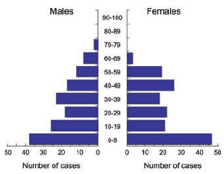

Genetics
- genetic lesions occurring in astrocytomas are not commonly found in ependymomas (i.e. different evolutionary pathways).
- 30% cases have loss of whole 22 chromosome.

RELA fusion-positive ependymoma - recently accepted variant recognized in the 2016 update to the WHO classification
- result of chromothrypsis.
- this variant is responsible for the majority of supratentorial ependymomas in childhood.
- worst prognosis of all molecular subtypes.

Classification
- Subependymoma (WHO grade I) - features of both ependymoma and astrocytoma – tumor attached to ventricular wall
- Ependymoma (WHO grade II); variants (not used today):
True ependymoma is grade II
  - clear cell type with perinuclear halo (resemble oligodendrogliomas) – worst prognostically
  - papillary type with extensive epithelial component
  - tanycytic type
  - true rosette* formation
  - melanotic type* (rare) containing lipofuscin and no melanin pigment.

*only a-c types are recognized in WHO 2016
- Anaplastic ependymoma (WHO grade III)
N.B. distinction between grade II and III is unreliable and prognostically unclear; molecular stratification is the future (see table below)
- Myxopapillary ependymoma (WHO grade I; young adult low-grade tumors in conus medullaris, cauda equina and filum terminale) with papillary arrangement of cells and prominent perivascular-intercellular mucin / myxoid stromal cores

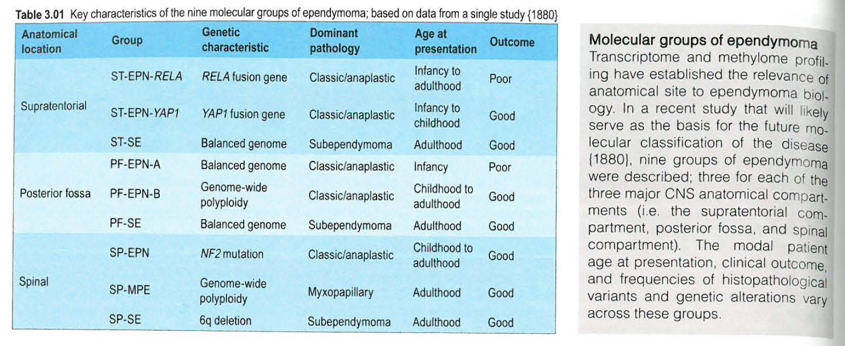

Pathology
- do not proliferate rapidly – slowly growing.
- 100% IDH-1 negative.
- not invasive*, 90% do not metastasize (morbidity by local space-occupying effects); only ≈ 12% spread via CSF (esp. high-grade posterior fossa tumors) – “drop metastases”.
*displaces (rather than infiltrates) brain parenchyma with minimal peritumoral edema.
- moderate cellularity (uniform cells), punctuated by areas of acellular, fibrillary eosinophilic halo surrounding blood vessel (perivascular pseudorosettes).
- ependymal rosettes (diagnostic, but uncommon feature of ependymoma) - ependymal cells radially aligned about central lumen with long, delicate processes (cilia) extending into lumen (gland-like round or elongated structures); cells contain blepharoplasts (basal bodies of cilia near nucleus – identified with special stains).

Ependymoma
Perivascular pseudorosettes:
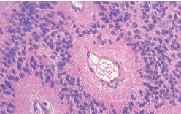
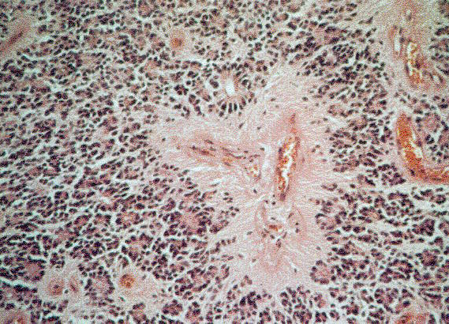
Source of picture: Ramzi S. Cotran “Robbins Pathologic Basis of Disease”, 6th ed. (1999); W. B. Saunders Company; ISBN-13: 978-0721673356 >>

Ependymal rosettes:
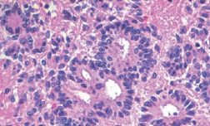

Ependymal canals:
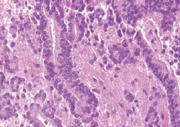
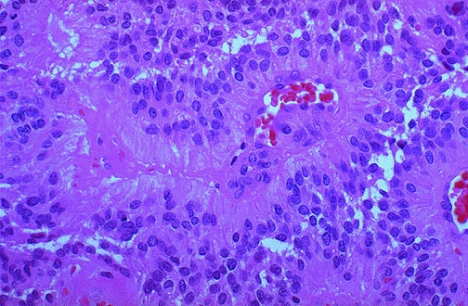
Source of picture: “WebPath - The Internet Pathology Laboratory for Medical Education” (by Edward C. Klatt, MD) >>

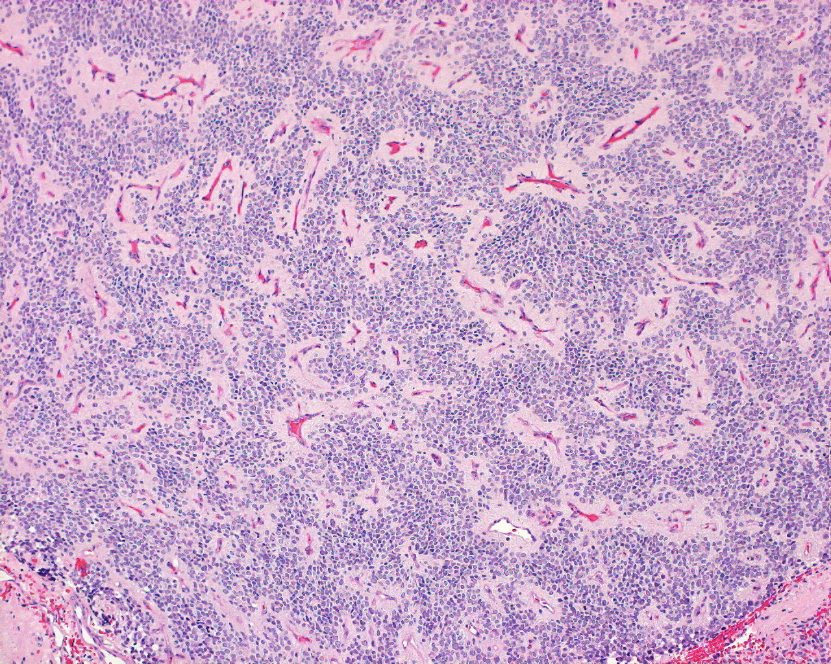

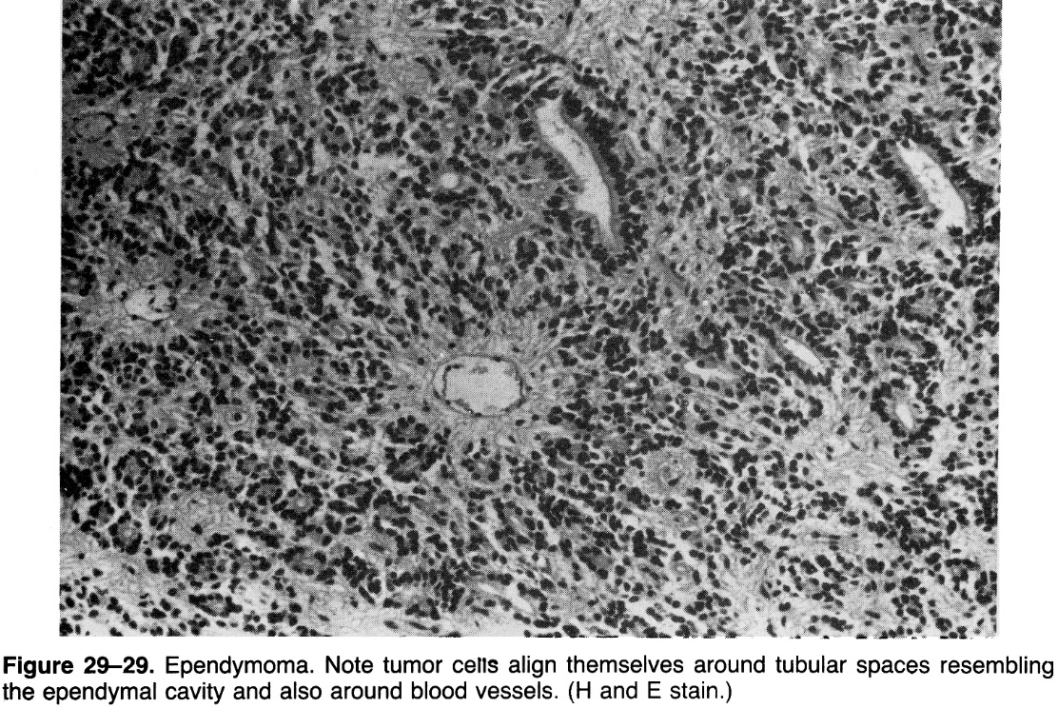

Ultrastructural features of ependymal differentiation: intercellular microlumen (ML) containing microvilli and cillia, bordered by elongate intercellular junction:
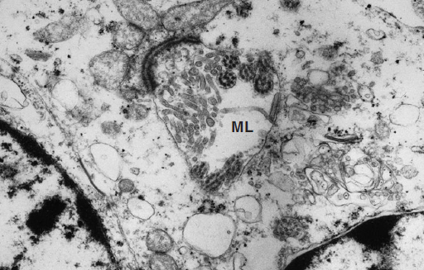
Source of picture: “WHO Classification of Tumours of the Central Nervous System” 4th ed (2007), ISBN-10: 9283224302, ISBN-13: 978-9283224303 >>

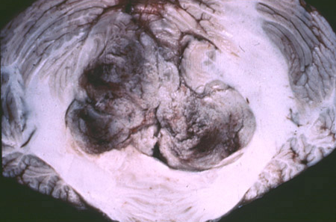

Tanycytic ependymoma
– does not form rosettes.
Tanycytes [Greek. tanus – elongated] are special ependymal cells found in the third ventricle and on the floor of the fourth ventricle and have processes extending deep into the hypothalamus. It is possible that their function is to transfer chemical signals from CSF to CNS.

Anaplastic ependymoma
A Poorly differentiated tumor cells with brisk mitotic activity.
B Large foci of necrosis.
C High MIB-1 labelling index.
D Strong GFAP expression in an anaplastic ependymoma invading adjacent brain structures.
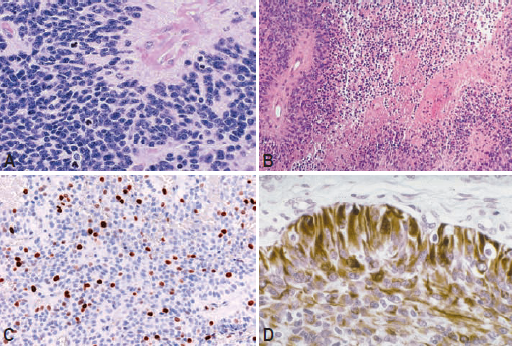
Source of picture: “WHO Classification of Tumours of the Central Nervous System” 4th ed (2007), ISBN-10: 9283224302, ISBN-13: 978-9283224303 >>

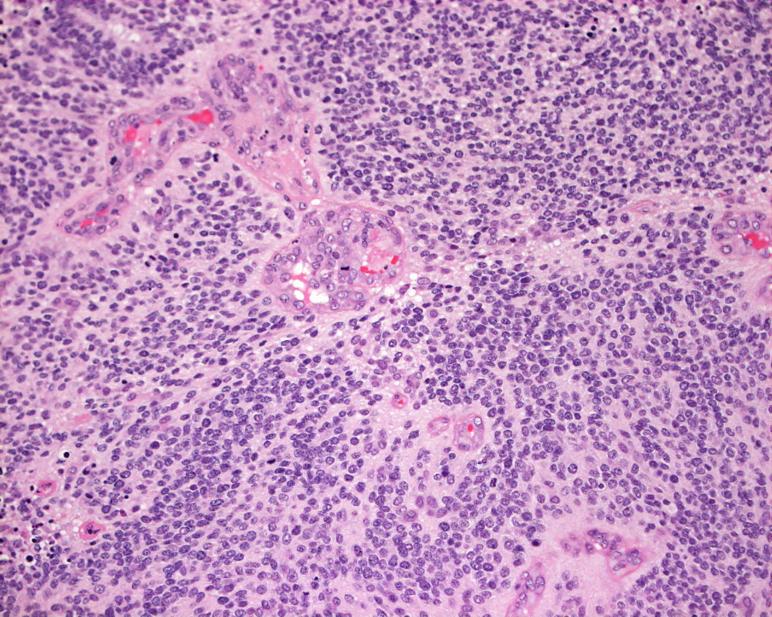

Myxopapillary ependymoma
- spinal ependymoma in conus medullaris. see p. Onc50 >>

Anaplastic ependymoma
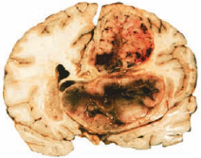

Subependymoma
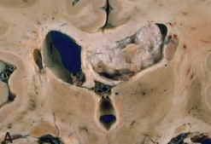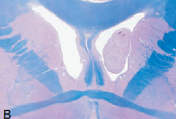
Source of picture: “WHO Classification of Tumours of the Central Nervous System” 4th ed (2007), ISBN-10: 9283224302, ISBN-13: 978-9283224303 >>

Location
- intracranial (90%)
  - 2/3 are located in posterior fossa (> 90% in 4th ventricle with tendency to spread along outlets to cerebellopontine angle and into cervical spinal canal)!
  - 1/3 are supratentorial (esp. in adults).
  - usually intraventricular, although extraventricular rests* of ependymal cells may give rise to hemispheric tumors (esp. near atrium of lateral ventricle).
*where primitive fetal ventricular walls have fused
- intraspinal (often benign histology); most patients are > 12 yrs. see p. Onc50 >>
  - ependymomas are most frequent (56-70%) intramedullary tumors.
  - benign myxopapillary type occurs in filum terminale

- unusual ectopic sites - mediastinum, ovary, broad ligament.

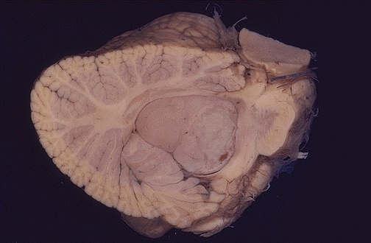
Source of picture: “WebPath - The Internet Pathology Laboratory for Medical Education” (by Edward C. Klatt, MD) >>

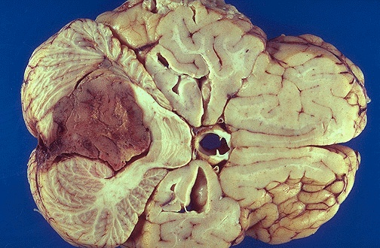
Source of picture: “WebPath - The Internet Pathology Laboratory for Medical Education” (by Edward C. Klatt, MD) >>

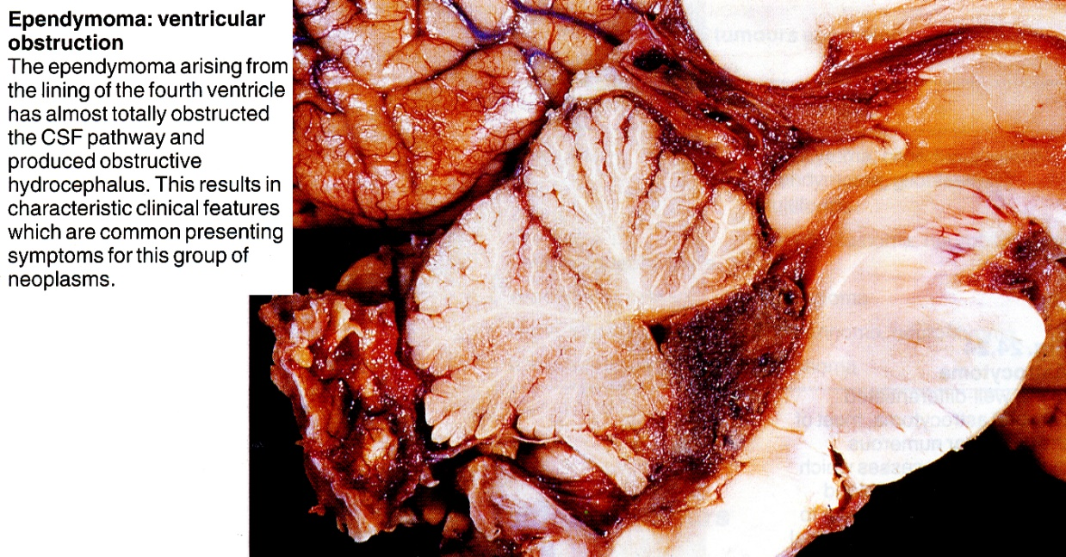
Source of picture: James C.E. Underwood “General and Systematic Pathology” (1992); Churchill Livingstone; ISBN-13: 978-0443037122 >>

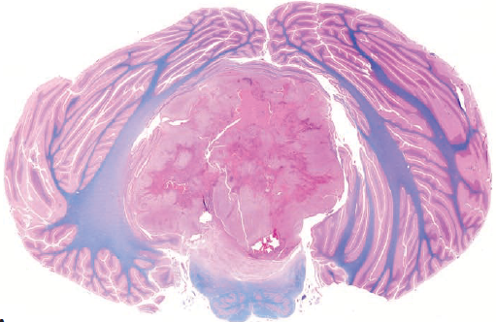
Source of picture: “WHO Classification of Tumours of the Central Nervous System” 4th ed (2007), ISBN-10: 9283224302, ISBN-13: 978-9283224303 >>

Clinical Features
- insidious and progressive:
Nausea & vomiting is most common (80%) presenting symptom!
Supratentorial tumors - mass effect, focal neurological signs, occasional ventricular obstruction.
Posterior fossa tumors - obstructive hydrocephalus ± brain stem compression.

Diagnosis
MRI (diagnostic tool of choice) - discrete, heterogeneous mass with variable enhancement, adjacent to ventricular system.
- hydrocephalus in almost all patients.
- calcification, necrosis, cystic change are frequent.
- hemorrhage is rare.
- spinal MRI is necessary!!!!!!

CT without contrast:  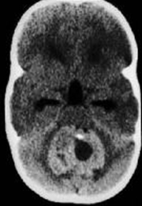 | CT with contrast:  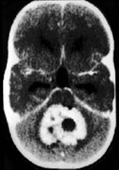

MRI (ependymoma of 4th ventricle, compressing cerebellum and brain stem):
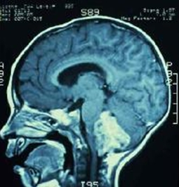

Contrast T1- and T2-MRI - heterogeneously enhancing mass (arrow) fills lower half of 4th ventricle and extends through foramina of Luschka (arrowhead) and Magendie to lie posterior to medulla oblongata and upper cervical spinal cord, which are compressed from behind; obstructive hydrocephalus:
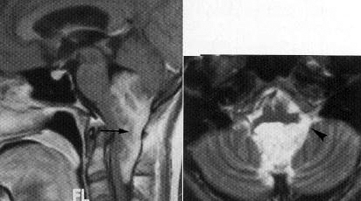

T1-MRI without contrast - large neoplasm encasing basilar artery and extending along premedullary cistern into upper cervical subarachnoid space:
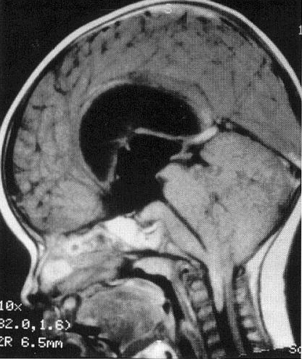

Gadolinium-enhanced MRI:
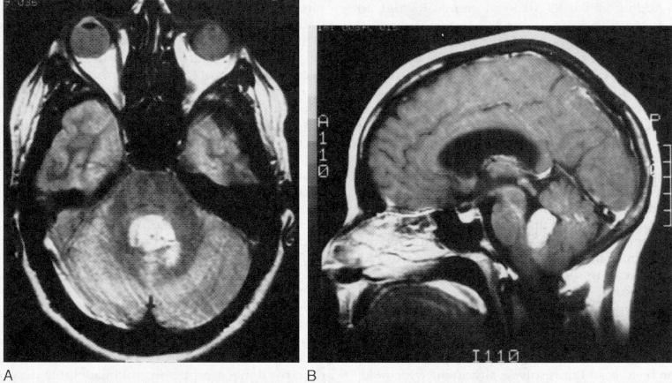

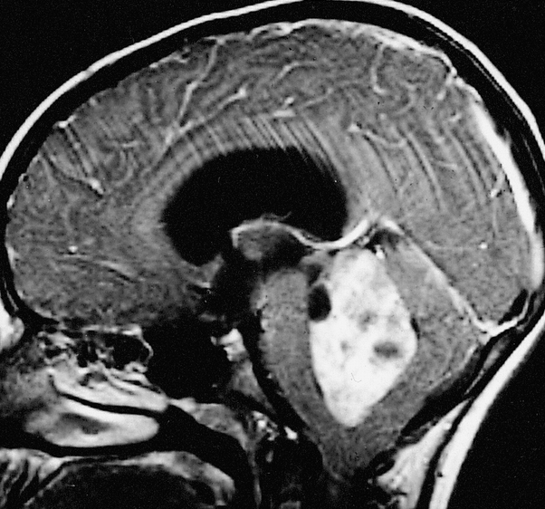

Myxopapillary ependymoma:
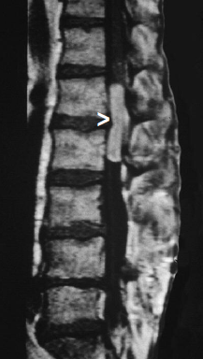
Source of picture: “WHO Classification of Tumours of the Central Nervous System” 4th ed (2007), ISBN-10: 9283224302, ISBN-13: 978-9283224303 >>

CSF cytology (deferred for 2 weeks postoperatively*) - for microscopic leptomeningeal dissemination.
*to avoid herniation, to avoid identifying tumor cells that may have been disseminated as result of surgery.

Treatment
Ventriculostomy is not required preoperatively (patients are usually stable).
N.B. it should be avoided (risk of upward herniation or hemorrhage within tumor)

Surgery - most effective therapy
- unexpected residual lesion → second-look surgery (vs. residual medulloblastoma – treat with chemoradio).
- permanent ventriculoperitoneal shunt is rarely required.
- postoperative MRI for residual disease (within 72 hours of surgery - to avoid confusion with postsurgical inflammation).

Standard postoperative local (1-2 cm margin, 50-55 Gy) radiotherapy substantially improves survival (modern trend – even for kids < 3 yo; adults with GTR may be observed postop).
- aggressive anaplastic features or residual tumor → whole-brain radiation.
- documented leptomeningeal dissemination → craniospinal axis radiation.

N.B. most relapses are local! - inability to eradicate primary tumor remains single most important factor leading to treatment failure!

Chemotherapy - at present, no definitive conclusions.
- recommended for children < 3 yrs with residual tumor until they are old enough to receive radiation.
- cisplatin most effective (30% response rate).
- etoposide in recurrence - response rates as high as 83%.

Prognosis
Progression-free 5-yr survival (overall - 55%):
Gross total resection (up to 85% patients) – 70-80%.
Incomplete resection – 30-35%.

Extent of tumor resection is most important prognostic factor!

- age is second most important prognostic factor - younger patient, worse prognosis! (5-yr survival: infants - 25%, children 1-4 years - 46%, children ≥ 5 yrs - > 70%).
- prognosis is worse than medulloblastoma (later - exquisite sensitivity to adjuvant therapy).
- histology and tumor location* are not significant prognostic indicators!
*exception: spinal tumors have better prognosis

Bibliography for ch. “Neuro-Oncology” → follow this link >>

Viktor’s Notes℠ for the Neurosurgery Resident
Please visit website at www.NeurosurgeryResident.net

