Primitive Neuroectodermal Tumors (PNET)
Last updated: April 12, 2020
ICD-O codes 1
EpidemiologY 1
Location 1
Etiology 1
Genetics 2
Origin 2
Pathology 2
Spread 4
Staging 4
Clinical Features 5
Diagnosis 5
PNT 5
Medulloblastoma 5
Differential 7
Treatment 7
Surgery 7
Radiotherapy 8
Chemotherapy 8
Prognosis 8

Ependymoblastoma – embryonal tumor (form of PNET) not related to ependymoma – small blue cells form multilayer rosettes.

PNETs - very malignant embryonal tumors showing divergent differentiation (of variable degree) along neuronal, glial, or rarely mesenchymal, retinal, or melanocytic lines; some cells may manifest evidence of dual or even triple differentiation.
Term “PNET” was eliminated in WHO 2016 classification
- male-to-female ratio = 1.5-2.0 : 1
- 75% in children < 15 years (50% in first decade; peak – 5 yrs); second smaller peak in young adults (21-40 yrs).
- ≈ 40% of all posterior fossa tumors.

Medulloblastoma (WHO grade IV) - malignant, invasive embryonal tumor of cerebellum with preferential manifestation in children, predominantly neuronal differentiation, and inherent tendency to metastasize via CSF pathways.

ICD-O codes
Medulloblastoma 9470/3
Desmoplastic/nodular medulloblastoma 9471/3
Medulloblastoma with extensive nodularity 9471/3
Anaplastic medulloblastoma 9474/3
Large cell medulloblastoma 9474/3

EpidemiologY
Medulloblastoma
- annual incidence 0.5 per 100 000 children < 15 years
- more frequent whites.
- 65% of patients are male.
- peak age at presentation is 7 years.
- 70% occur in individuals < 16
- in adulthood, 80% arise in 21–40 years age group
- rarely occurs beyond 5th decade

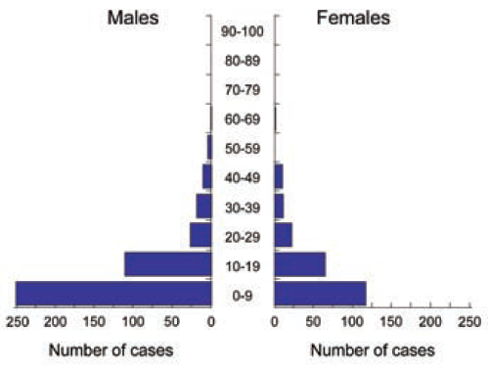
Source of picture: “WHO Classification of Tumours of the Central Nervous System” 4th ed (2007), ISBN-10: 9283224302, ISBN-13: 978-9283224303 >>

Location
supratentorial (4%) - primitive neuroectodermal tumor; 90% in cerebral hemispheres.

infratentorial (96%) - medulloblastoma – prototypic PNT; most common (20-30%) childhood brain tumor!!!; only 1% of adult brain tumors.
- 75% in vermis and project into fourth ventricle
- 25% in lateral cerebellum - percentage increases with age of patient (most tumors located in hemispheres are of desmoplastic/nodular subtype, e.g. desmoplastic medulloblastoma of adults)
N.B. if in brainstem or supratentorial – it is PNET (not medulloblastoma)

Etiology
Medulloblastoma
- role of polyomavirus remains unclear (some studies have demonstrated high frequency of detection of JC virus)
- increased risk in preterm children (standardized incidence ratio 3.1)
- protective function of folate substitution in maternal diet was claimed in earlier study, but was not confirmed in more recent study.

Genetics
- almost all PNETs are abnormal karyotypically
- medulloblastomas and PNTs are different genetically!
- loss of 17p13.3* is most frequent abnormality (30-40% medulloblastomas), accompanied by 17qi (isochromosome on long arm of chromosome 17).
*does not involve p53!
- associated hereditary syndromes:
  - Gorlin syndrome (nevoid basal cell carcinoma syndrome) see p. Onc1 >>
  - Turcot syndrome
  - Li-Fraumeni syndrome
  - blue rubber-bleb nevus syndrome
  - Rubinstein-Taybi syndrome

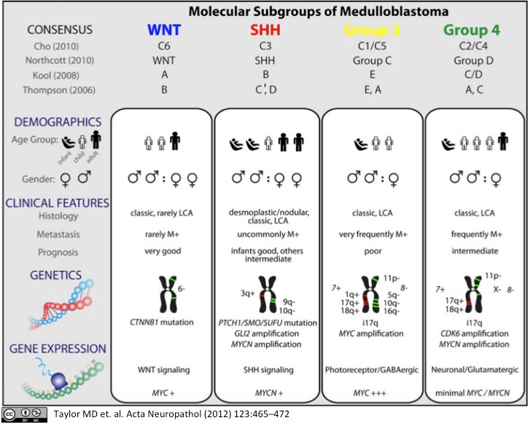

Wingless (WNT) and sonic hedgehog (SHH) exhibit very specific alterations in the respective signaling pathways.
Group 3 and 4 medulloblastomas are not characterized by specific oncogenic drivers

MYC-amplified group 3 - the worst prognosis.
SHH and group 4 - an intermediate prognosis.
WNT is prognostically most favorable.

Origin
- germinal neuroepithelium during embryogenesis:
- common origin from primitive neuroectodermal cells (“unified concept of PNET”)
- different origins from cells already committed to differentiation
- hypotheses of medulloblastoma origin (falsely was thought to arise from medulloblast cells, which do not exist):
- cells of external granular layer of cerebellum.
- posterior medullary velum, from which undifferentiated cells migrate to external granular layer.

Pathology
- tumors are usually solid, soft, and friable; may include central necrosis or cystic changes.
- with H&E staining, it appears as blue tumor.
- primitive small “blue” cells grow in sheets / cords (“Indian file” of blue cells) of dense cellularity with very increased mitotic index* and increased nuclear-cytoplasmic ratio (i.e. minimal perceptible cytoplasm).
*e.g. bromodeoxyuridine 30-minute labeling index ≈ 14% (vs. only 1-10% in gliomas).
- at edges of main tumor mass, tumor cells form linear chains infiltrating through cerebellar cortex to aggregate beneath pia, penetrate pia, and seed into subarachnoid space.
- extension into subarachnoid space may elicit prominent desmoplastic response.
- Homer-Wright rosettes - pseudorosettes - circular arrangement of tumor cells around area of fibrillarity (tangled eosinophilic cytoplasmic [neuritic] processes; no lumen or vessel);
- evidence of neuroblastic differentiation
- found in medulloblastoma (20% cases), PNET, neuroblastoma (15-50%)
- immunohistochemical markers can confirm differentiation toward astrocytic or neuronal lineage (although neuronal and glial markers may be expressed, tumor is often largely undifferentiated).

Irregular posterior fossa mass near midline of cerebellum and extending into 4th ventricle above brainstem:
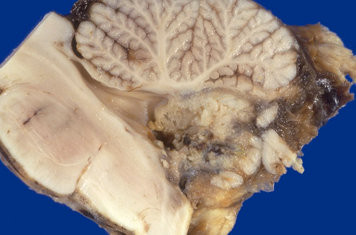
Source of picture: “WebPath - The Internet Pathology Laboratory for Medical Education” (by Edward C. Klatt, MD) >>

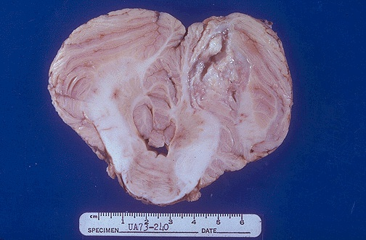
Source of picture: “WebPath - The Internet Pathology Laboratory for Medical Education” (by Edward C. Klatt, MD) >>

Medulloblastoma of cerebellar vermis compressing brain stem.
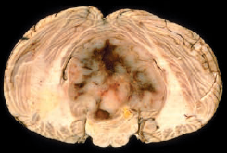
Source of picture: “WHO Classification of Tumours of the Central Nervous System” 4th ed (2007), ISBN-10: 9283224302, ISBN-13: 978-9283224303 >>

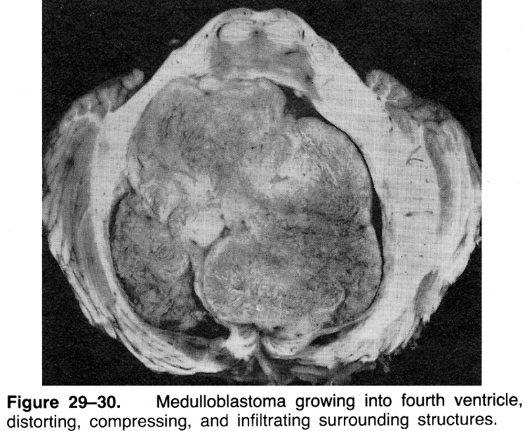

Abundance of Homer-Wright rosettes (round formations of tumor cells surrounding fibrillar zone without lumen or vessel):
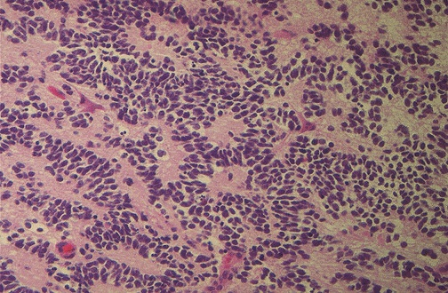
Source of picture: “WebPath - The Internet Pathology Laboratory for Medical Education” (by Edward C. Klatt, MD) >>

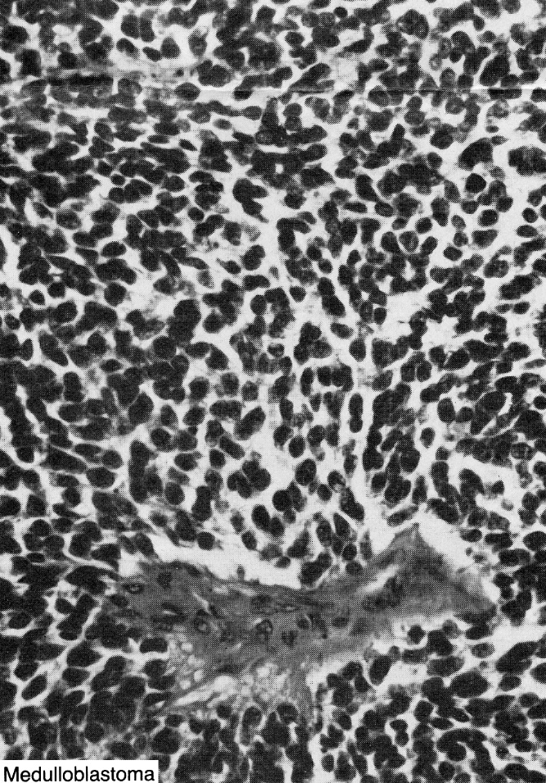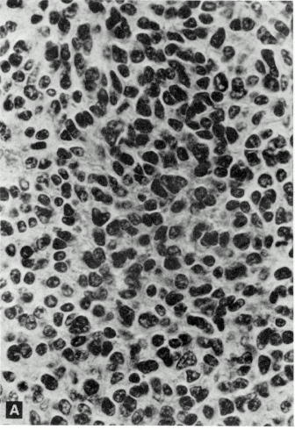

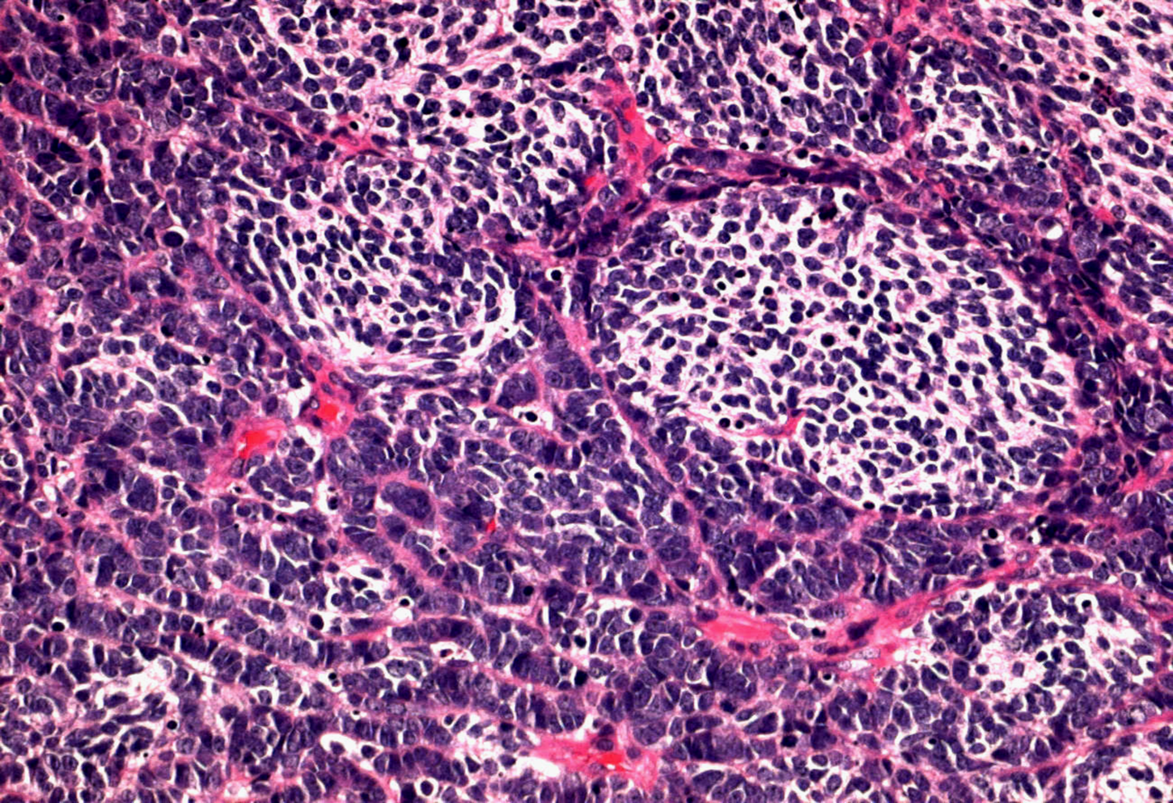
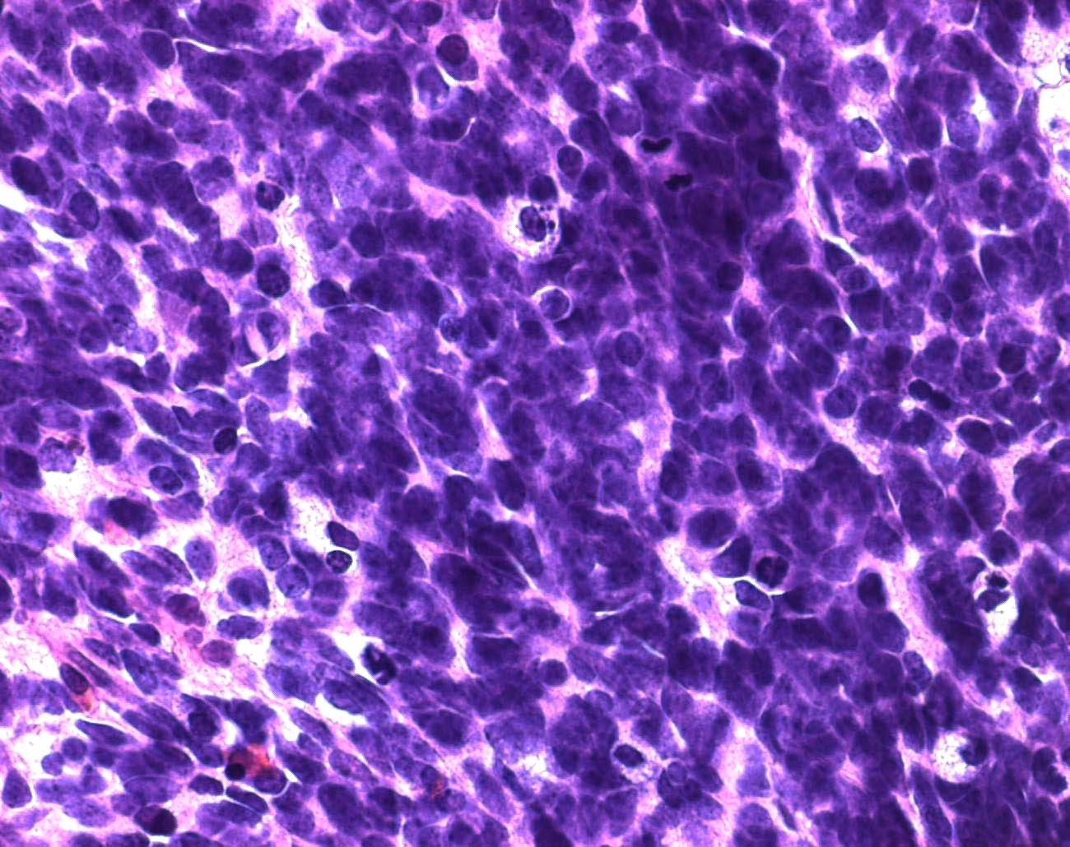
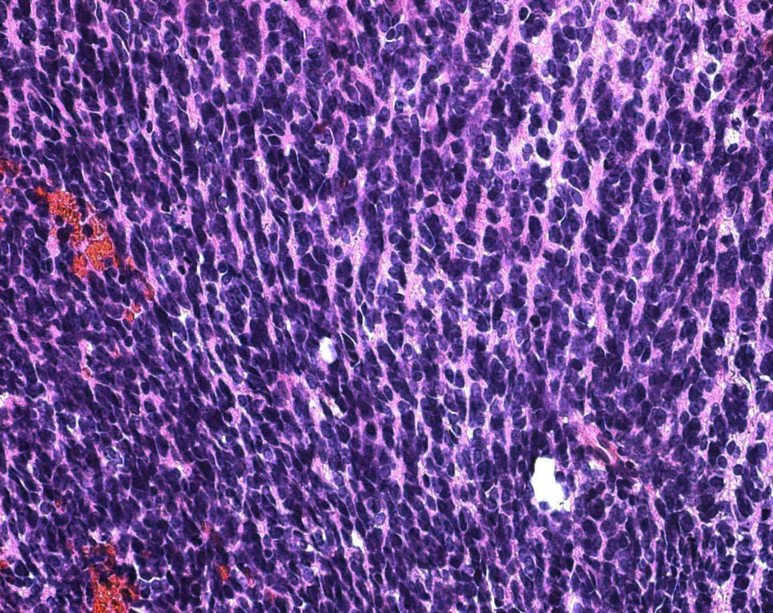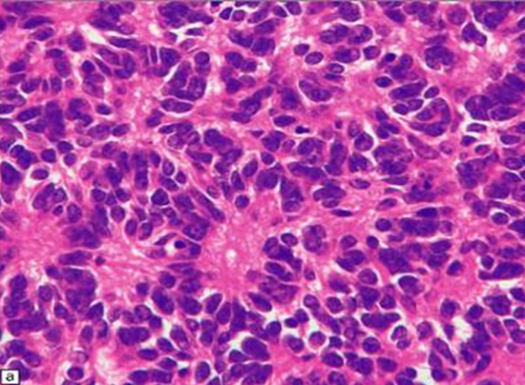

Unusual variants of medulloblastomas:
  - desmoplastic - seen in adults, in cerebellar hemisphere; abundant stromal component with dense reticulin network; cells assemble along reticulin fibers in biphasic pattern (with areas of high and low cellularity); favorable clinical outcome!
  - melanocytic - characteristic small, undifferentiated cells containing melanin.
  - medullomyoblastoma - striated and smooth muscle cells are hallmark (if also contains elements of ectodermal, mesodermal, and endodermal differentiation, tumor must be considered teratoma); clinical outcome similar to ordinary medulloblastoma.
  - large-cell - large vesicular nuclei with prominent nucleoli; immunoreactivity for synaptophysin; poorer clinical outcome!
  - anaplastic

Desmoplastic medulloblastoma - linear arrangement of cells along delicate background fibers:
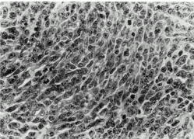

Spread
- propensity to dissemination via CSF (one of most feared complications of medulloblastoma!!!) – found in 11-43% clinical cases (found in 50-93% autopsy cases).
- systemic metastases (esp. to long bones - 80%) have been recognized in < 5% patients.

A) Nodules of medulloblastoma in cisterna magna (arrow); hemorrhage is present in medulla.
B) Sections of medulla and spinal cord - metastatic medulloblastoma in subarachnoid space; tumor is partially hemorrhagic and has invaded neural tissue to variable extent at different levels.
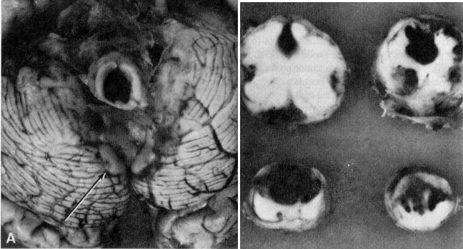

Staging
Chang (1969) staging system for medulloblastoma:
STAGE | DEFINITION
Tumor
T₁ | Tumor < 3 cm, limited to midline position in vermis, roof of 4th ventricle, and less frequently to cerebellar hemispheres
T₂ | Tumor > 3 cm, further invading one adjacent structure or partially filling 4th ventricle
T_{3a} | Tumor invading two adjacent structures or completely filling 4th ventricle with extension into aqueduct of Sylvius, foramen of Magendie or Luschka, thus producing marked internal hydrocephalus
T_{3b} | Tumor arising from floor of 4th ventricle or brain stem and filling 4th ventricle
T₄ | Tumor further spreading through aqueduct of Sylvius to involve 3rd ventricle or midbrain, or tumor extending to upper cervical cord
Metastases
M₀ | No evidence of metastasis
M₁ | Tumor cells in CSF
M₂ | Gross nodules in cerebellar / cerebral subarachnoid space or in 3rd or lateral ventricles
M₃ | Gross nodules in spinal subarachnoid space
M₄ | Extra-neuraxial metastasis

Clinical Features
- insidious onset (symptom duration ≥ 3 months is common):
- signs of ICP↑ (hydrocephalus – 4th ventricle obstruction)
- cerebellar dysfunction (truncal ataxia, disturbed gait)
- lower cranial nerve palsies
- spread to spinal cord (back pain, leg weakness, etc)

- a subset of cases present with intra-tumor hemorrhage; according to one study of pediatric medulloblastomas, only wingless (WNT) subtype presented with bleeding (at 54% incidence) – their conclusion was: “significant hemorrhage in fourth ventricle childhood tumors is suggestive of WNT medulloblastoma and should lead to a less aggressive attempt for total resection in this prognostically favorable tumor type”

Diagnosis
PNT

Medulloblastoma
MRI (imaging technique of choice) – solid heterogeneous intensely contrast-enhancing mass with ill-defined margins arising from vermis, which fills 4th ventricle.
- moderate ÷ intense enhancement (homogeneous; in adults, more heterogeneous pattern).
- marked hydrocephalus is common.
- cystic changes can occur.
- calcifications are very rare!!! (vs. ependymoma, choroid plexus papilloma)
- medulloblastoma with extensive nodularity shows diffuse nodular architecture - nodular, “grape-like” pattern on MRI.
- tumors in peripheral cerebellar hemispheres in adults may occasionally appear as extra-axial lesions simulating meningiomas or vestibular nerve schwannomas

CSF-borne metastases (present in 1/3 of patients at presentation):
- foci of nodular or diffuse contrast enhancement in leptomeninges or on ventricular surface.
- entire neuraxis should be imaged to detect spinal drop metastases!!!
Preop MRI of craniospinal axis (postop blood may give artefacts)

A Grape-like appearance of medulloblastoma with extensive nodularity in 18-month-old child.
B MRI appearance of desmoplastic/nodular medulloblastoma in adult patient. Note hemispheric location and well-circumscribed appearance.
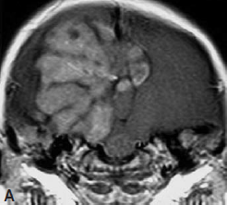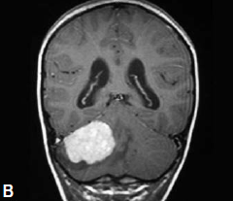
Source of picture: “WHO Classification of Tumours of the Central Nervous System” 4th ed (2007), ISBN-10: 9283224302, ISBN-13: 978-9283224303 >>

T1-MRI - enhancing tumors within fourth ventricle:
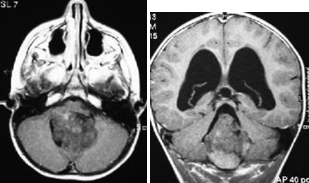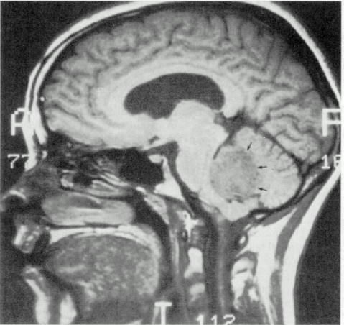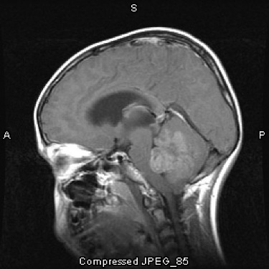
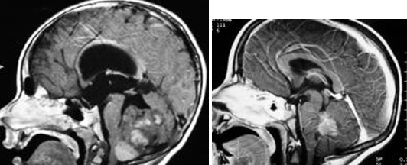

Contrast T1-MRI: large multifocal tumour in posterior fossa causing hydrocephalus; multiple smaller, contrast-enhancing tumors along surface of cerebellum and in cerebrum:
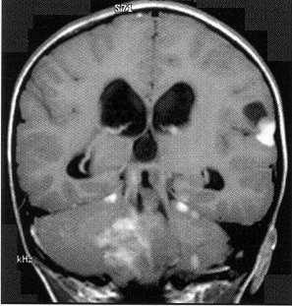

Contrast T1-MRI: spinal canal shows large mass (arrow) in junction of cervical and thoracic spine with syrinx; multiple small enhancing nodules (arrowheads) over spinal cord surface:
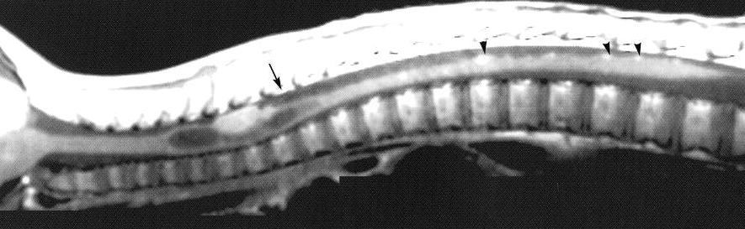

Medulloblastoma with leptomeningeal dissemination (T1-MRI with contrast):
A) residual medulloblastoma involving posterior 4th ventricle.
B) metastatic disease producing leptomeningeal enhancement (arrows); large metastatic deposits within suprasellar cistern and within ventricular system.
C) extensive disease involving lateral ventricles.
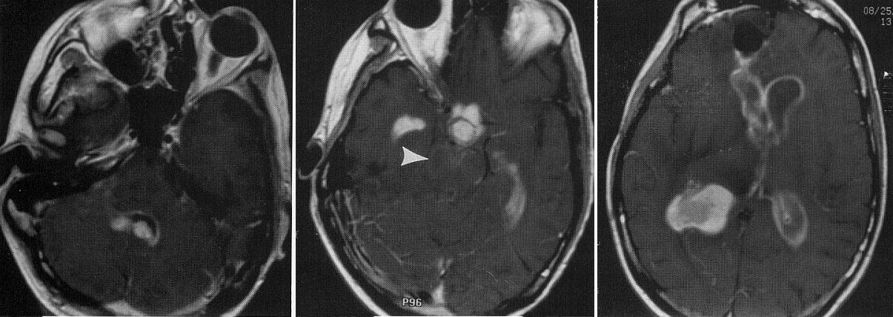

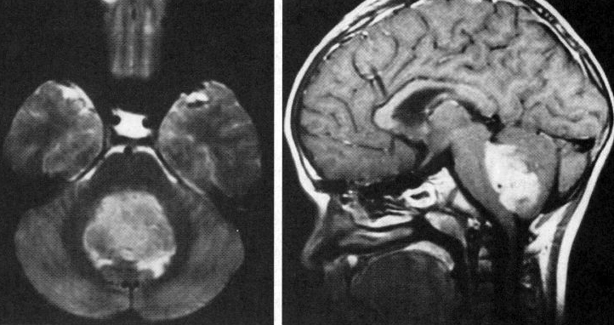

T1-MRI - contrast-enhancing gross nodular medulloblastoma.
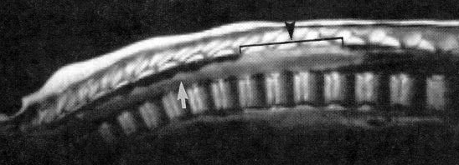

Postoperative medulloblastoma (metastatic subarachnoid spread):
A. MRI - removal leaves enlarged 4th ventricle.
B. MRI following gadolinium - enhancement in subarachnoid space outlines posterior fossae structures, esp. pons.
C. MRI following gadolinium - subarachnoid spread outlines medulla, brachium pontis, cerebellar folia, and midbrain.
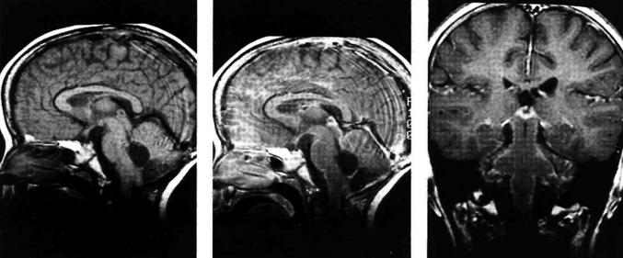

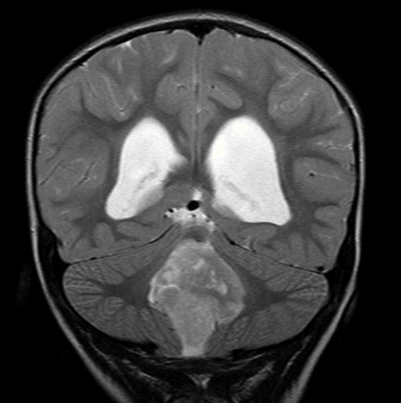

CT without contrast – solid, homogenous, isodense ÷ hyperdense midline tumor (vs. cerebellar astrocytoma – hypodense):
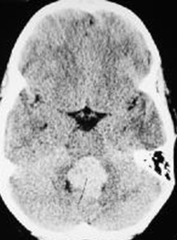

CT with contrast – marked enhancement:
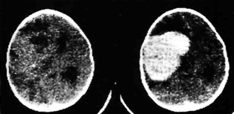

Differential
ependymoma, choroid plexus papilloma - commonly contain calcifications.

Treatment
Dexamethasone is very effective - can even alleviate hydrocephalus by reopening CSF pathways in posterior fossa!

Surgery
Radical tumor resection with restoration of natural CSF pathways.
Resection of > 75% tumor mass is considered “gross total resection”
- midline suboccipital craniectomy with C₁ laminectomy.
- at time of surgery, extent of subarachnoid spread can be assessed - when involved with tumor, surrounding subarachnoid space is opaque, with granular appearance (“sugar coating”).
- CSF drainage:
Avoid ventriculostomy / lumbar puncture preoperatively - risk of herniation!
    - occipital burr hole is placed at surgery (before posterior fossa exposure is done) to allow cannulation of ventricles for CSF drainage to lower ICP so that dura can be opened safely.
    - postoperative drainage is maintained for 3 days → drain is clamped and connected to pressure monitoring:
      - if patient tolerates 24 hours of clamped drain, ventriculostomy is removed.
      - mental status↓ → open ventriculostomy and continuing drainage (clamping can be reattempted after additional 5 days).
    - if repeated drainage fails to relieve symptoms, ventriculoperitoneal shunt or third ventriculostomy must be placed (required in 15-30% cases).
- one of most commonly cited complications after surgery is cerebellar mutism, s. posterior fossa syndrome (anatomic origin - deep cerebellar nuclei): apathy, minimal-to-absent speech, pseudobulbar emotional lability, refusal to initiate movement, cerebellar dysfunction, hemiparesis, swallowing apraxia;
    - become apparent 12-48 hours after surgery.
    - persists for several weeks, usually resolving completely.
- within 2 days repeat MRI; for persistent lesion (seen on MRI), second-look surgery is questionable (may effectively treat with chemoradio; vs. ependymoma – second-look surgery is a must).
- 2 weeks after surgery, do CSF cytology; some also recommend examining bone marrow.

Radiotherapy
Exquisitely radiosensitive tumor!
Postoperative radiotherapy (clear, dose-dependent response) – 50-56 Gy (35 Gy whole brain plus 15-20 Gy boost to posterior fossa) + 30-40 Gy to remainder of neuraxis; reduce doses by 10 Gy in children < 2-3 years.
- radiotherapy is most effective adjunct - used in children despite its consequences!!! (try to avoid for ages < 3 years – risk of IQ↓)

Chemotherapy
One of most chemosensitive tumors!
Prognosis improved over ependymomas!
Chemotherapy with varying combinations of drugs:
      - as adjunctive therapy for more advanced stages (incomplete resection, Chang T3b-4, M1-4) or for children < 3 yrs
      - for recurrences.
- one of most aggressive is “8 drugs in 1 day” protocol (vincristine, carmustine, procarbazine, hydroxyurea, cisplatin, cytarabine, prednisone, cyclophosphamide).
- Children's Cancer Group reported better results with VCP protocol (vincristine, lomustine, prednisone).

Prognosis
- medulloblastoma (the most common malignant brain tumor in the pediatric population) was an incurable disease some 50 yr ago; now 70% of children with medulloblastoma are long-term survivors following intensive craniospinal irradiation and multiagent chemotherapy.
    - 5-year survival 60-80% (90% for WNT group)
- factors that worsen prognosis: histologic subtyping is of no prognostic significance!
  - metastases!!! bone metastases can occur as only evidence of recurrence years after initial presentation
  - younger age (esp. < 4 years)!! (may relate to restricted radiotherapy doses or higher incidence of disseminated disease)
  - incomplete resection!
  - diploid DNA content
  - loss of 17p13.3
  - TP53 mutation
  - ErbB2expression
- see also genetics for prognostic groups.
- recurrence is common; Collin law – all* tumors relapse at period equal to age at diagnosis plus 9 months.
*several late recurrences (> 10 years after diagnosis) have been reported.
- prognosis due to exquisite sensitivity to adjuvant therapy is better than of ependymoma.

Bibliography for ch. “Neuro-Oncology” → follow this link >>

Viktor’s Notes℠ for the Neurosurgery Resident
Please visit website at www.NeurosurgeryResident.net

