Neuronal and Mixed Tumors
Last updated: December 22, 2020
(Central) Neurocytoma 1
Pathology 1
Location 2
Clinical Features 2
Diagnosis 2
Treatment 2
Dysembryoplastic Neuroepithelial Tumor (DNET) 2
Pathology 2
Clinical Features 4
Diagnosis 4
Treatment 4
Ganglioglioma, Gangliocytoma 4
Genetics 5
Pathology 5
Clinical Features 5
Diagnosis 5
Treatment 7
Prognosis 7
Lhermitte-Duclos disease (s. dysplastic gangliocytoma of cerebellum) 7
Desmoplastic Infantile Ganglioglioma and Astrocytoma (DIG/DIA) 7
Pathology 7
Histology 7
Clinical Features 8
Diagnostics 8

(Central) Neurocytoma
- benign tumor of slowly growing well-differentiated neurons.

- young adults (15-40 yrs).

Pathology
Light microscopy - monomorphic small cells with evenly spaced, round, uniform nuclei (often mistaken for oligodendroglioma or ependymoma), and no anaplastic features.
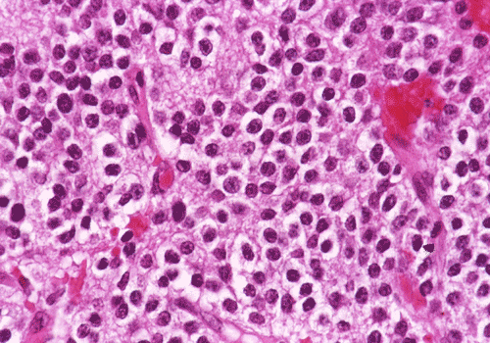
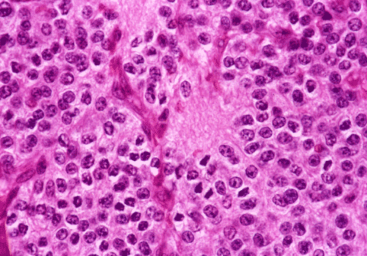
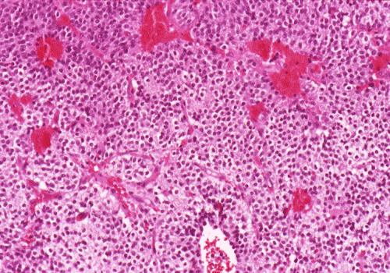
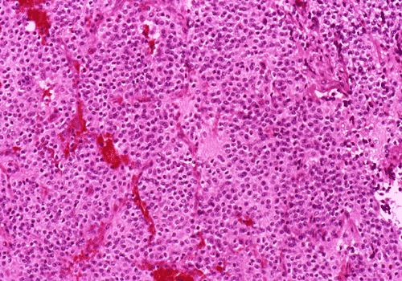

Neuronal lineage must be confirmed:
- Immunohistochemical stains for neurons (neuron-specific enolase, S100, synaptophysin).
- Electron microscopy - true neuronal nature of neoplasm (neuritic processes, neurosecretory granules, neurofilaments, well-formed synapses).

Location
- grow from septum pellucidum - 3rd or lateral ventricles (probably commonest lateral ventricular masses in this age group).
- typical location - frontal horns and bodies of lateral ventricle, frequently attached to septum pellucidum and sometimes extending through foramen of Monro.

Clinical Features
- ICP↑ caused by ventricular obstruction.

Diagnosis
CT - calcification and small cysts, obstructive hydrocephalus.
MRI - isodense intraventricular mass, related to septum pellucidum, with variable cyst formation and contrast enhancement.

Contrast MRI - right lateral ventricular neurocytoma producing obstruction of foramen of Monro:
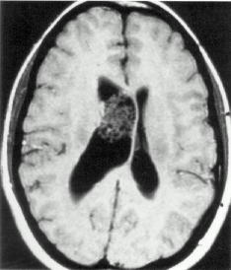

Contrast MRI - partly cystic, multi-septated, enhancing mass, related to septum pellucidum, fills bodies of both lateral ventricles, causes hydrocephalus:
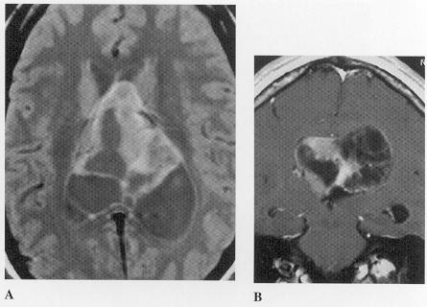

Treatment
Surgical resection is often curative (± radiotherapy).

Dysembryoplastic Neuroepithelial Tumor (DNET)
- extremely slow-growing benign mixed glial-neuronal tumor (neurons, astrocytes, and oligodendrocytes).
- may have germinal origin.
- patients’ ages range 3-35 years (mean 21.5 yrs).

Vignette: kid with seizures + bubbly lesion in temporal lobe

Pathology
- intracortical nodular-appearing neoplasm (features similar to cortical dysplasia) enlarging gyrus (forming megagyrus).
DNET and cortical dysplasia often go together!
- 2/3 (62%) in temporal cortex, 1/3 (31%) in frontal cortex.
- cystic changes, frequent association with dysplastic cortex.
- hypocellular lesion - well-differentiated normal neurons "floating" in pool of mucopolysaccharide-rich fluid (stains with alcein blue) and surrounded (but NOT tightly*) by neoplastic oligodendroglial-like cells without anaplastic features.
*main difference from oligodendroglioma (perineural satellitosis)
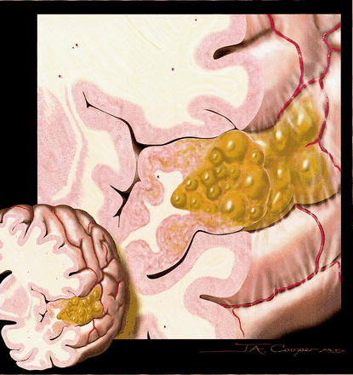

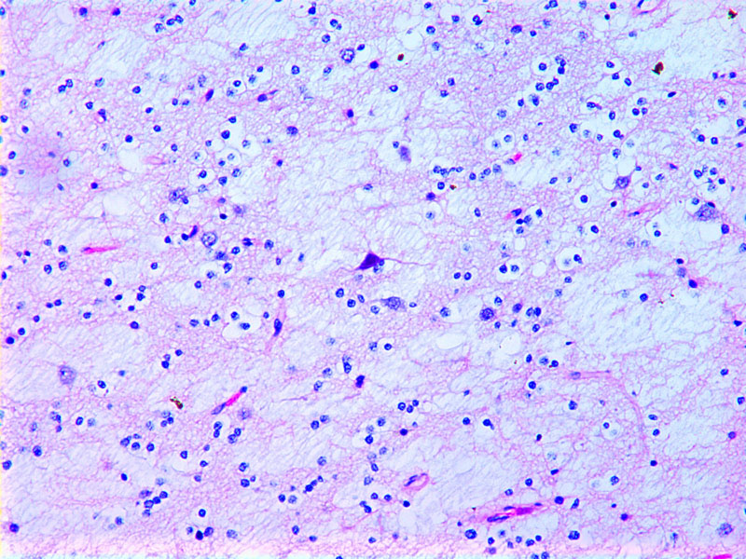

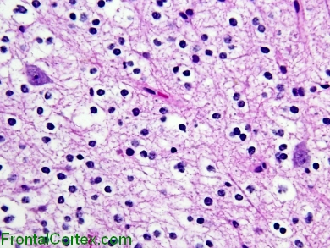

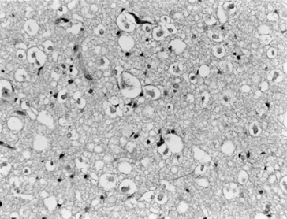

Note absence of perineuronal satellitosis (i.e. neurons are NOT tightly surrounded by other cells), which is typically seen in oligodendroglial tumors;
Perivascular and perineuronal satellitosis is characteristic of oligodendroglioma spread into grey matter:
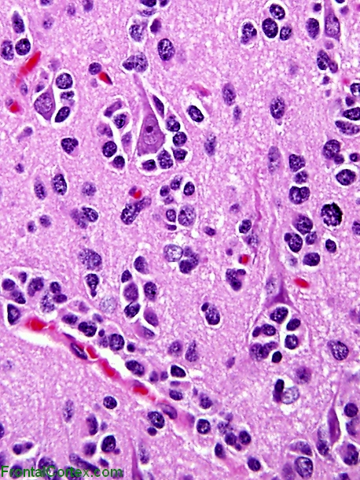

Clinical Features
- often presents as intractable partial seizures.
- no neurological deficits (or stable congenital deficit).

Diagnosis
MRI - variable signal and enhancement characteristics (≈ low-grade astrocytoma).

T2-MRI - right-sided temporal abnormality (arrow) with thickened cortex, poorly demarcated from white matter:
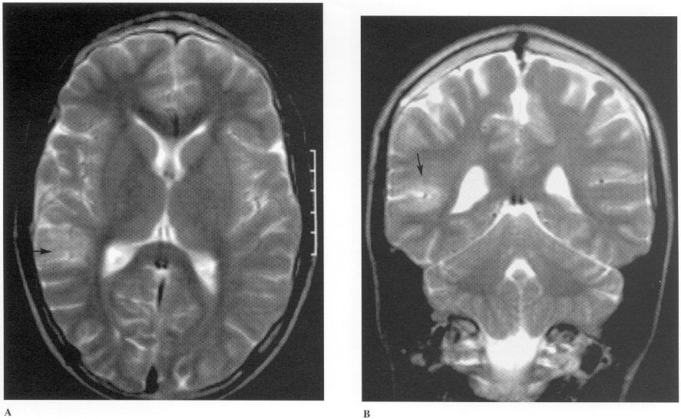

T1-MRI - well-circumscribed neoplasm originating in cortical region (arrows); inner table of skull has been remodeled (suggesting slow-growing neoplasm):
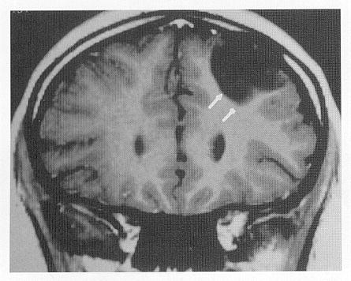

Treatment
- good prognosis after surgical extirpation.
- DNET is benign histologically and indication to operate is intractable epilepsy (total tumor removal cures epilepsy).
- radiation and chemotherapy have no clear benefit.

Ganglioglioma, Gangliocytoma
- rare benign slowly growing CNS tumors:
Ganglioglioma (95%) - contains both astrocytic and neuronal components; glial component is most commonly astrocytic, but it may be oligodendroglial.
gangliocytoma (5%) - only neuronal component without glial component.
(its counterpart in PNS is ganglioneuroma).

- 1.3% brain tumors; 1% intramedullary spinal neoplasms.
- 10% primary brain tumors in children.
- age: 2 months ÷ 70 years (most < 30 yrs).

Genetics
- BRAFV600E mutation can be detected in up to 50% of gangliogliomas

Pathology
- biphasic: neoplastic mature ganglion cells + neoplastic glial cells
  - neoplastic ganglion cells - large dysplastic/dysmorphic mature-appearing neurons, often binucleated (important diagnostic feature!!!); irregularly clustered; apparently random orientation of neurites.
  - neoplastic astrocytes (in ganglioglioma)
  - relatively acellular fibrovascular stroma.
desmoplastic infantile ganglioglioma and closely related desmoplastic infantile astrocytoma, have abundant mesenchymal component; predilection for infants and young children; good prognosis.
- anywhere in CNS (esp. superficial temporal cortex; rarely, in spinal cord).
50% are located in temporal lobes, and only 3.7% and 3.5% located in brainstem and spinal cord, respectively
- firm grayish tumor that may have cystic components and calcification.
- mild-to-moderately cellular; slightly pleomorphic with rare mitotic figures.
- biologic behavior is not predicted by histology (many anaplastic gangliogliomas do not demonstrate clinically aggressive behavior).
- metastatic spread is extremely rare (isolated report of leptomeningeal spread).
- glial component occasionally becomes frankly anaplastic → rapid progression (malignant ganglioglioma).

Markers: CD34 positivity

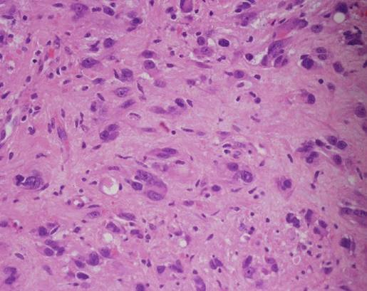

Clinical Features
– as DNET – often presents as intractable partial seizures.
gangliogliomas are most common tumor cause of pediatric seizures
- most gangliogliomas are nonaggressive.
- no neurological deficits (or stable congenital deficit).

Diagnosis
CT – nonspecific: hypo- or iso-dense, well circumscribed mass located superficially.
- ≈ 50% show cystic areas (esp. in cerebellum; single large cyst ÷ cyst with mural nodule ÷ multicystic mass)
- ≈ 50% show contrast enhancement (solid tumors have more contrast enhancement).
- punctate or fleck-like calcification is seen in ≈ 33-50% tumors.
- surrounding edema is unusual.
- no mass effect.

MRI – nonspecific.

MR spectroscopy – choline-to-creatine ratio is lower and N-acetyl aspartate-to-creatine ratio* is higher than in gliomas.
*N-acetyl aspartate↑ is due to neuronal component

Solid enhancing tumor in temporal lobe with no surrounding edema in younger patient with intractable seizures

Partly cystic ganglioglioma in left temporal lobe with abnormal signal (arrow), without contrast enhancement:
A) Axial T1 with gadolinium.
B) Axial FLAIR.
C) Axial T2.
D) Coronal T2.
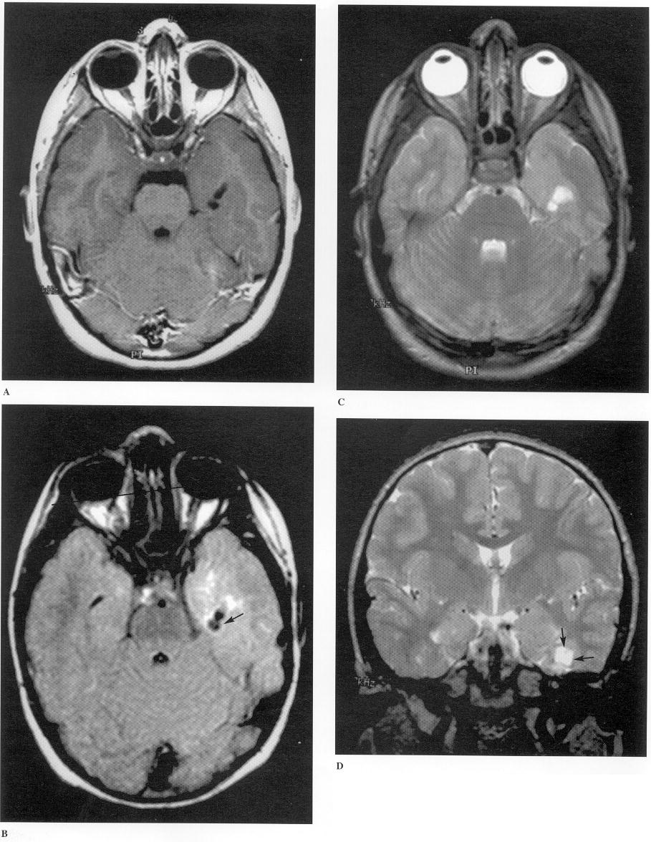

Gadolinium-enhanced T1-MRI - enhancing tumor involving hippocampus, uncus, and amygdala:
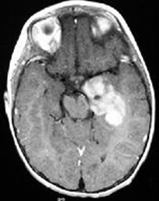

Exophytic temporal lobe ganglioglioma (T1-MRI with contrast) - large mass originating from medial aspect of left temporal lobe; both solid and cystic components; large exophytic component extends through tentorial incisura into superior cerebellar cistern; tumor has also compressed atrium of left lateral ventricle:
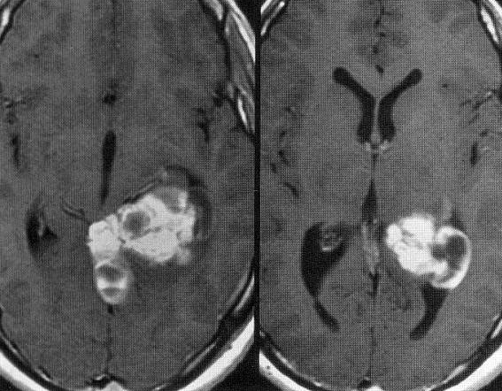

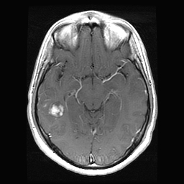

Treatment
- complete resection is generally curative (radiation is rarely indicated); may have good prognosis even when untreated (but incomplete removals are associated with local recurrence).
- use of chemotherapy has not been reported.

Prognosis
- poor prognosis factors – age < 1 yr, brainstem involvement.

Lhermitte-Duclos disease (s. dysplastic gangliocytoma of cerebellum)
- rare (221 known cases), benign, slowly growing tumor of cerebellum, sometimes considered as hamartoma
- described by Jacques Jean Lhermitte and P. Duclos in 1920.
- most common in the third and fourth decades.
- often associated with Cowden syndrome (mutations of PTEN gene) and is pathognomonic for this disease (also includes multiple growths on skin).
- histology: diffuse hypertrophy of stratum granulosum of cerebellum
  - enlarged circumscribed cerebellar folia
  - internal granular layer is focally indistinct and is occupied by large ganglion cells
  - myelinated tracks in outer molecular layer
  - underlying white matter is atrophic and gliotic

Right cerebellar mass with linear striations. No pathological enhancement:
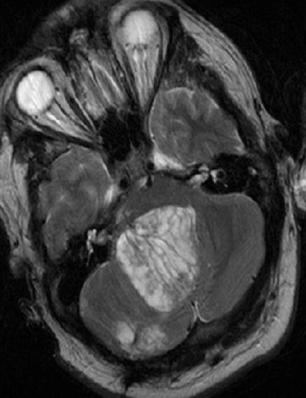

- treatment:
asymptomatic → observe
symptomatic → debulking (complete removal is not usually needed and can be difficult due to location).

Desmoplastic Infantile Ganglioglioma and Astrocytoma (DIG/DIA)
DIA first described in 1982 by Taratuto et al (J Neurosurg. 1987;66:58)
DIG first described in 1987 by VandenBerg et al

- rare (< 0.1% of CNS tumors) supratentorial neuroepithelial tumors of infancy (most < 1 year).

Pathology
- WHO grade I
- involve superficial cerebral cortex and leptomeninges (focally attached to overlying dura).
- cystic with solid area/mural nodule
- large – usually involve more than one lobe.

Histology
- prominent desmoplasia with neoplastic glial component (DIA) or neoplastic glioneuronal component (DIG) - similar radiological and clinical presentation.
- well-delineated from normal brain
- calcification common, chronic inflammatory cells uncommon.
- exceptionally, frank anaplastic features are encountered (high mitotic rate, vascular proliferation, palisading necrosis, and high proliferation index)

- Desmoplastic leptomeningeal component
    - Involve the subarachnoid space and extends into Virchow-Robin spaces
    - Neoplastic neuroepithelial cells in desmoplastic spindled stroma arranged in fascicular and storiform patterns with pericellular reticulin deposition lending a mesenchymal appearance
    - Neoplastic neuroepithelial cells:
      - Astrocytic cells - the only component in DIA; spindled or gemistocytic neoplastic astrocytes
      - Neuronal component - seen in DIG in addition to neoplastic astrocytes; small ganglion cells, uncommonly large ganglion cells or areas resembling ganglioglioma
- Immature small cell component (unclear prognostic significance)
    - hypercellular poorly differentiated neuroepithelial cells
    - no desmoplasia
    - may show mitoses, vascular proliferation, or necrosis

DIA:
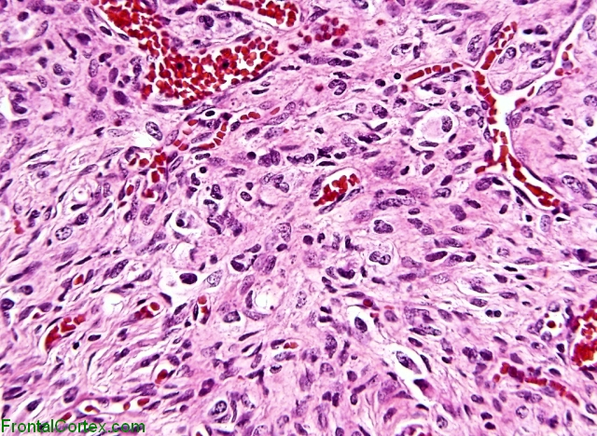

DIG:
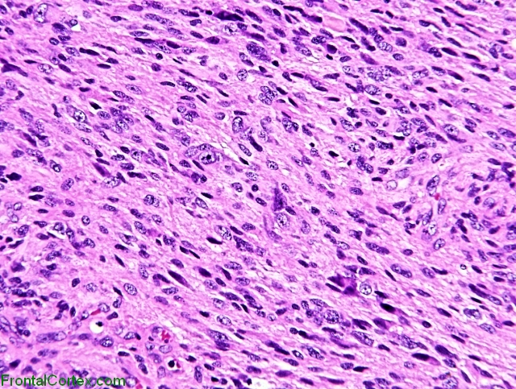

Extensive desmoplasia (trichrome):
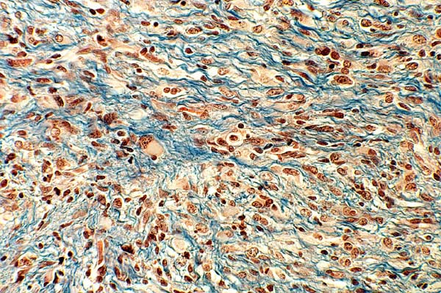

Clinical Features
- hydrocephalus, seizures

Infant with rapidly progressive macrocephaly

Diagnostics
- large cystic and solid mass (enhancing):

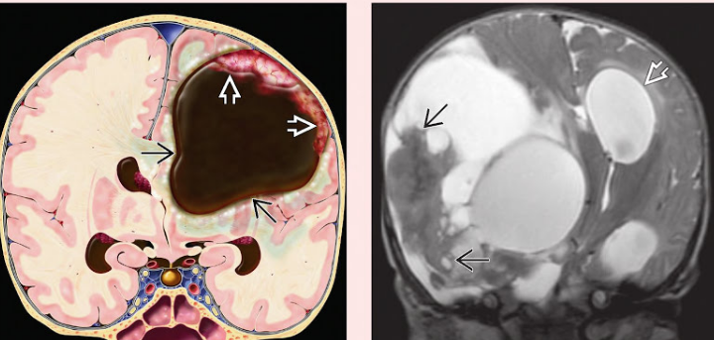
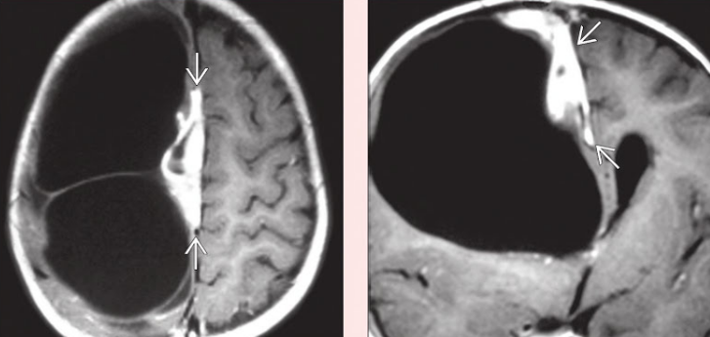
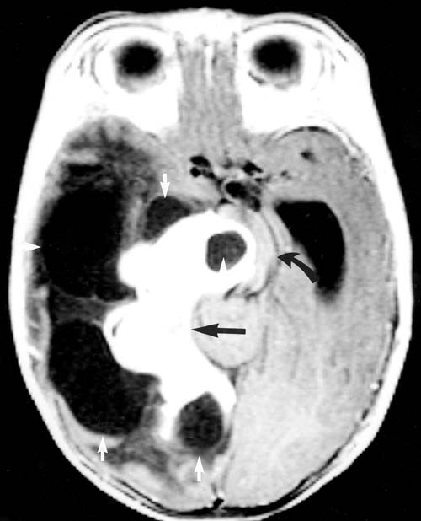
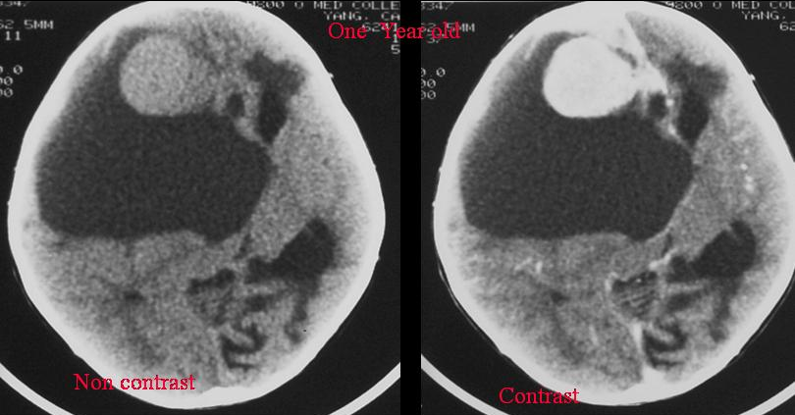

- treatment: gross total resection
    - chemotherapy if infiltrative or progressive
    - residual disease may not grow and may spontaneously regress
- despite large size and poorly differentiated cells, prognosis is excellent (but multiple cerebrospinal metastases have been reported).

Bibliography for ch. “Neuro-Oncology” → follow this link >>

Viktor’s Notes℠ for the Neurosurgery Resident
Please visit website at www.NeurosurgeryResident.net

