Vascular Tumors
Last updated: April 12, 2020
Hemangioblastoma 1
Von Hippel-Lindau (VHL) disease 1
Types 1
Diagnosis 1
Prognosis 2
Treatment 2
Pathology 2
Clinical Features 4
Diagnosis 4
Treatment 5
Prognosis 5
Solitary Fibrous Tumor (Hemangiopericytoma) 6
Spinal Hemangioblastoma → see p. Onc50 >>

Hemangioblastoma
- rare benign vascular neoplasm that arises almost exclusively in CNS.
- classified by WHO as meningeal tumors of uncertain origin.
primitive endothelial cells around 4th ventricle?
- 1-2.5% of all intracranial neoplasms, but:
  - 8-12% of posterior fossa tumors! (most common primary adult intraaxial posterior fossa tumor).
Cerebellar hemangioblastomas = Lindau tumors (Lindau first described them in 1926)
  - 3-7% of spinal cord tumors. see p. Onc50 >>
  - extremely rare in supratentorial compartment, optic nerve, brainstem, peripheral nerves.
- male-to-female ratio ≈ 2:1.
- usual age at diagnosis - third ÷ fifth decades (rarely affect children).

Von Hippel-Lindau (VHL) disease
20-25% hemangioblastomas are part of von Hippel-Lindau (VHL) disease - autosomal dominant deletion of VHL (tumor suppressor gene on 3p) with 90% penetrance and delayed expression:
  - retinal angiomatosis (von Hippel's disease) - usually in peripheral retina (vision is unaffected; exudation in region of angiomata may lead to retinal detachment); histologically identical to capillary haemangioblastoma
H: photocoagulation / cryocoagulation.
  - CNS hemangioblastomas (Lindau's syndrome); occur in 84% patients by age of 60 yrs; some may produce erythropoietin-like substances → asymptomatic polycythemia; tumors tend (94%) to occur as multiple (vs. in sporadic cases – solitary); occur in cerebellum, brainstem, spinal cord, and nerve roots (vs. in sporadic cases – cerebellum); supratentorial and PNS lesions are rare.
  - various visceral tumors - kidneys [renal cell carcinoma, cysts, angiomas], adrenal glands [pheochromocytoma], pancreas [cysts], epididymis [papillary cystadenomas, cysts], liver [angiomas, cysts], endolymphatic sac tumors.
Renal carcinoma (also very vascular) is most common cause of death!
- classified as phakomatosis, although it does not include any cutaneous manifestations!
- often presents at younger age - mean age 29 years.
- birth incidence - 1 in 30,000-45,000.
- genetics: VHL gene - tumor-suppressor gene on 3p25-26 (encodes protein pVHL that inhibits "elongation" step during RNA synthesis).
- constitutive overexpression of VEGF
- perform screening of all family members:
- analysis for germline mutations of VHL gene
- retinal examination including children during first 2 years of life; retinal angioma is indication for MRI
Positive family members → early lifetime screening by MRI (start at age > 10 years).

Types
Correlation between different VHL phenotypes and VHL mutations:
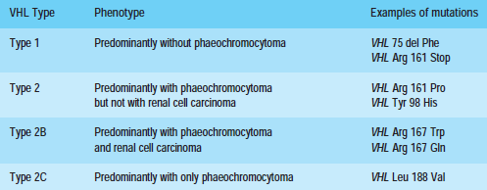

Diagnosis
- Two CNS hemangioblastomas
- At least two items present of the following:
- family history
- single CNS hemangioblastoma
- single visceral tumor associated with VHL disease

- germline VHL mutations can virtually always be identified.
- NIH surveillance: MRI of brain and C-spine.

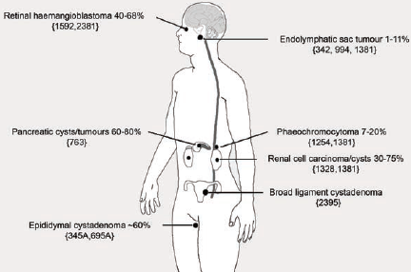

A, B Numerous renal cystic structures (arrowheads) and solid renal mass (arrows).
C, D Numerous pancreatic cysts (arrowheads).
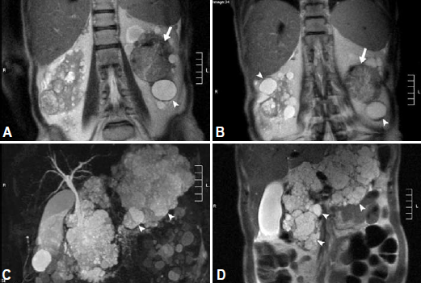
Source of picture: “WHO Classification of Tumours of the Central Nervous System” 4th ed (2007), ISBN-10: 9283224302, ISBN-13: 978-9283224303 >>

Prognosis
- patients ultimately develop multiple CNS hemangioblastomas.
- CNS hemangioblastoma and renal cell carcinoma are major causes of death.
- average life expectancy is 40–50 years.

Treatment
- medications for advanced renal cell carcinoma (do not work for hemangioblastoma):

pazopanib (Votrient) – FDGFR tyrosine kinase inhibitor
sunitinib (Sutent) – PDGFR and VEGFR tyrosine kinase inhibitor

Pathology
- cherry-red in color (highly-vascular - may simulate AVM macroscopically!!!).
- 50% in cerebellum, 50% in spinal cord.
- ≈ 30% are solid.
- ≈ 70% are as mural nodule and cyst that contains yellow proteinaceous fluid; cyst wall is glial nonneoplastic reaction to secreted fluid; mural nodule is touching pial surface of cerebellum.
- starts at pial surface - grows inside parenchyma attached to pia mater (gets rich vascular supply from pial vessels), but no dural attachment.
- not invasive (but border does not contain any particular membrane or capsule).
- no calcification.
- extramedullary and extradural hemangioblastomas have been described.
- subarachnoid dissemination is extremely rare, tumor enlarges extremely slowly.
- capable of blood island formation with potential extramedullary hematopoiesis.

Histology
- primitive vascular channels with 3 types of cells:
  - nonneoplastic relatively normal-appearing vascular endothelial cells that line capillary spaces.
  - nonneoplastic small, perivascular pericytes with dark compact nuclei and sparse cytoplasm.
  - neoplastic stromal cells with multiple vacuoles and granular eosinophilic cytoplasm (glycogen) rich in lipids*; some nuclear pleomorphism; represent abnormally differentiating mesenchymal cells of angiogenic lineage, with some morphological features of endothelium, pericytes, and smooth-muscle cells.
*”bubbly cytoplasm” - can be mistaken for xanthochromic astrocytomas
Lindau hypothesis (1931) - derived from embryonal cell types with divergent differentiation potentials.
  - brachyury protein - present in majority of hemangioblastomas (helps to differentiate from clear cell renal cell carcinoma metastases in von Hippel-Lindau syndrome).
specificity 100%, sensitivity 91%, high positive (100%) and negative (89%) predictive values and high diagnostic accuracy (95%) in the differential diagnosis between HBL and CCRCC metastatic to the CNS or meningioma.

Vascular tumor with vacuolated stromal cells
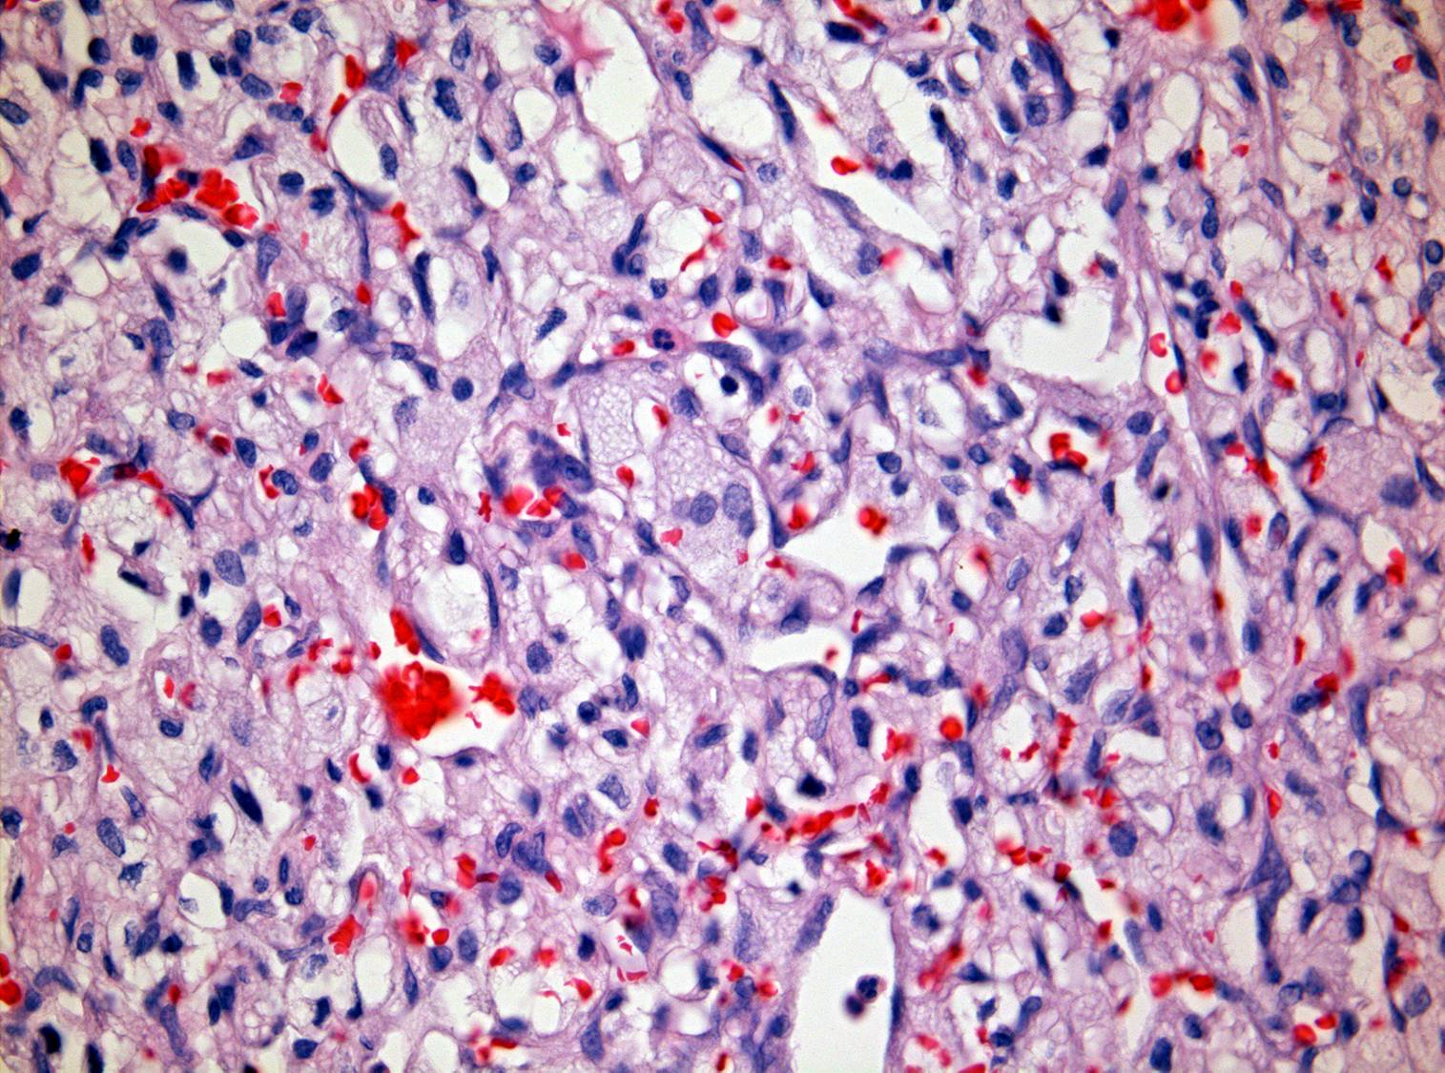

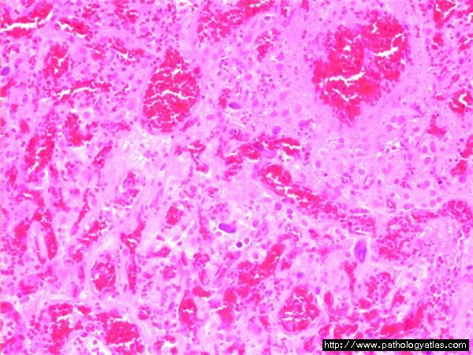

A Cellular variant showing many stromal cells. B Cellular variant showing densely packed tumour cells. C In situ hybridization showing expression of VEGF mRNA in stromal cells. D Immunostaining for VHL protein in stromal but not endothelial cells
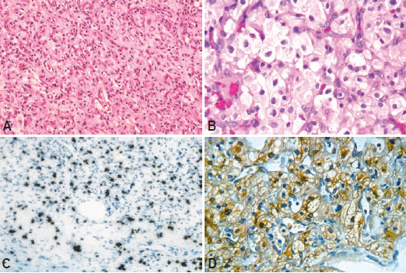
Source of picture: “WHO Classification of Tumours of the Central Nervous System” 4th ed (2007), ISBN-10: 9283224302, ISBN-13: 978-9283224303 >>

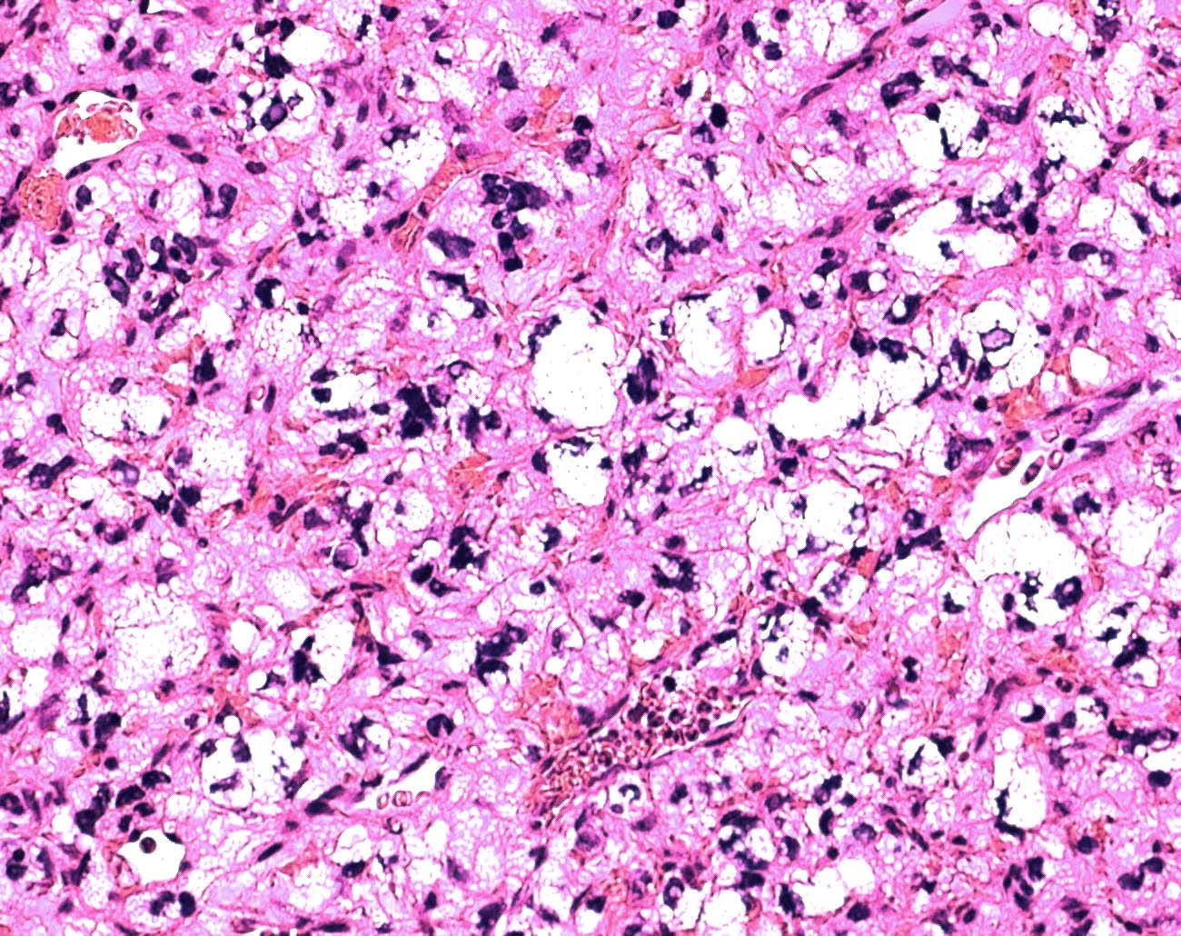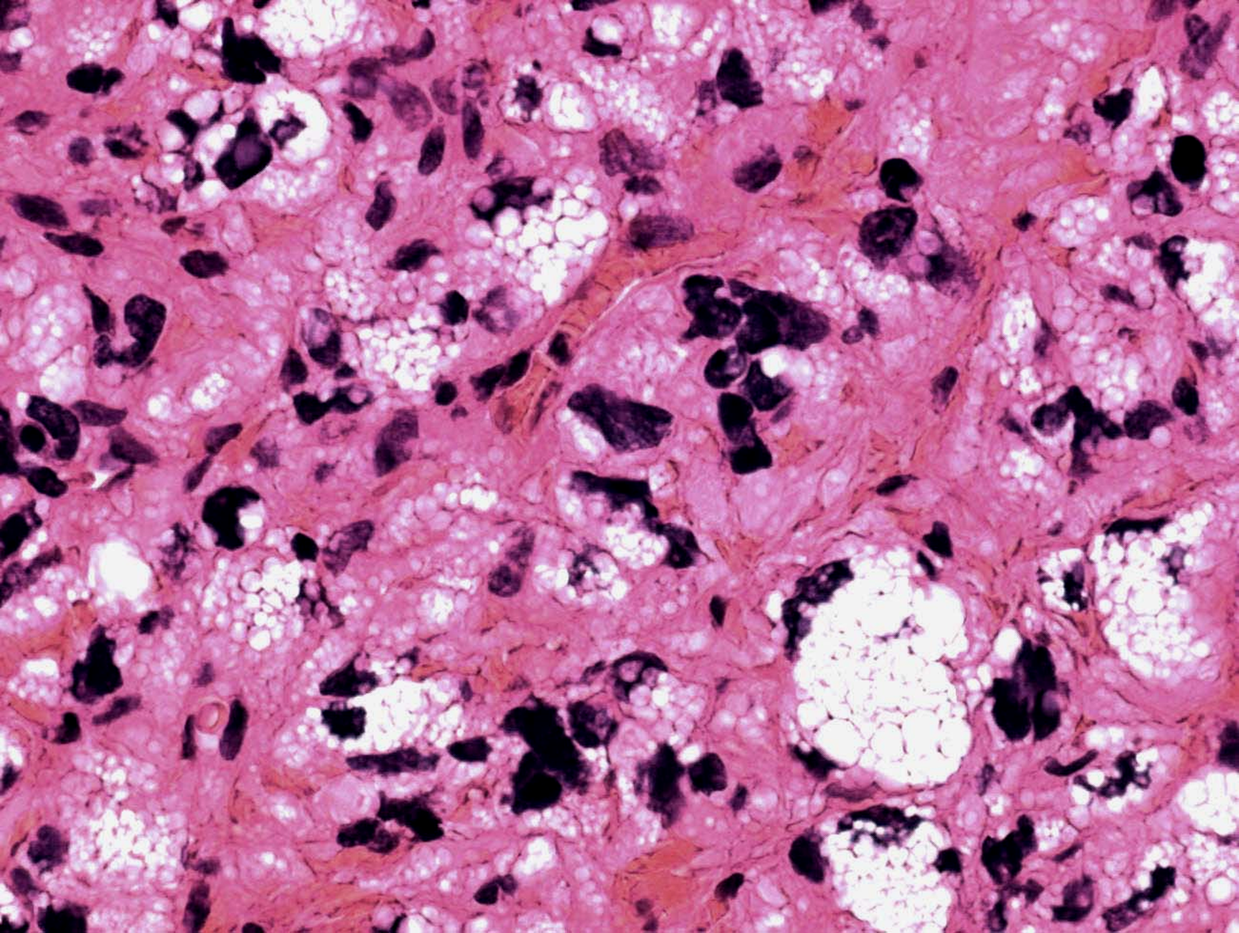

Clinical Features
Long history (≈ 1 yr) of minor neurological symptoms → sudden exacerbation.

Cerebellar lesions → cerebellar dysfunction, ICP↑ (due to hydrocephalus).
Spinal cord lesions → pain, progressive spinal cord compression.

Diagnosis
Enhances more than ependymoma or astrocytoma!
- complete neural axis imaging:
CT / MRI:
- clearly delineated intensely enhancing mass
- cyst with nonenhancing wall* + intensely enhancing mural tumor nodule.
*no need to resect vs. cystic metastases (have enhancing wall)
N.B. hemangioblastomas with enhanced cyst wall exist - rare and frequently misdiagnosed preoperatively;
- favorable tumor control could be achieved only when gross total resection of both the tumor nodule and cyst wall be performed?
- close follow-up is necessary due to high recurrence rate.
Angiography (usually done before surgery) - highly vascular tumor blush, enlarged feeding arteries and draining veins.
- detect VHL disease complex:
  - ophthalmologic evaluation: aneurysmal dilation of peripheral retinal vessels (earliest characteristic feature) → tortuous vessels marked by afferent arteriole and venule leading to raised retinal lesion.
  - abdominal CT / ultrasound

Multiple hemangioblastomas (arrows) in von Hippel-Lindau disease (T1-MRI); large cyst associated with right cerebellar hemangioblastoma:
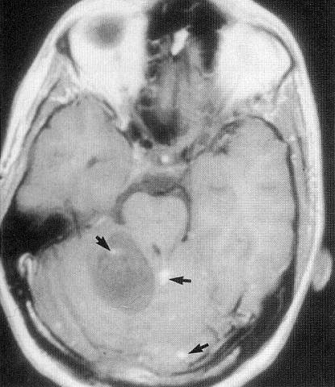
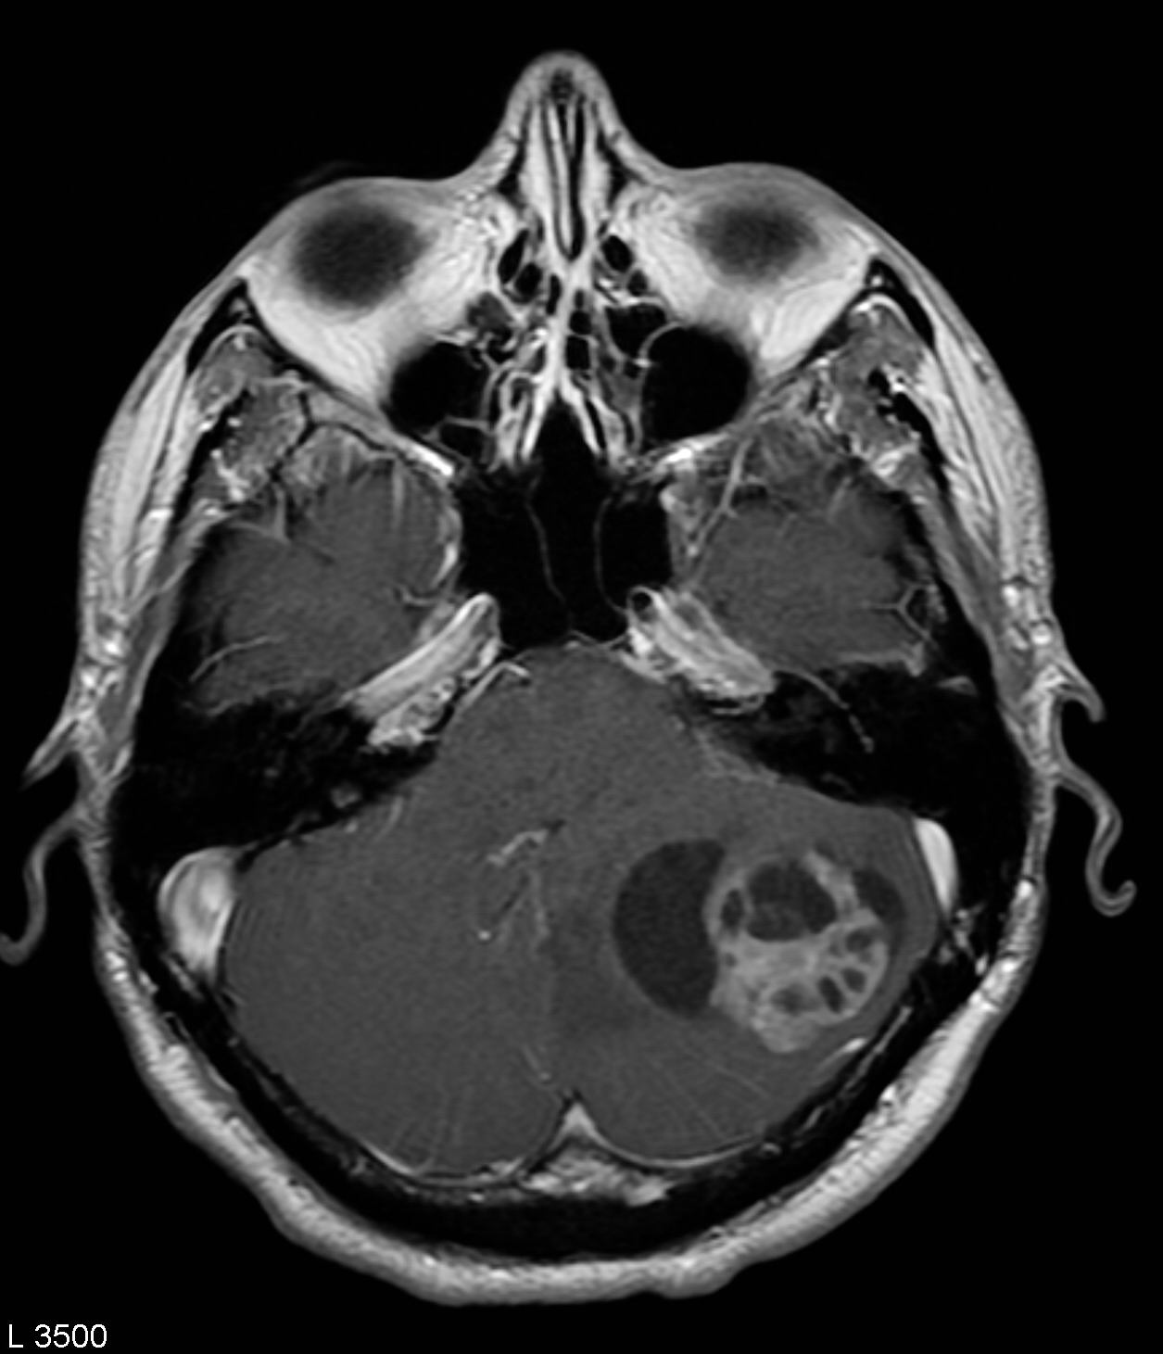
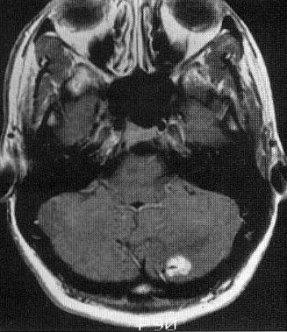

Contrast CT - cystic mass in left cerebellar hemisphere with enhancing mural nodule (arrowhead) and surrounding edema (arrow):
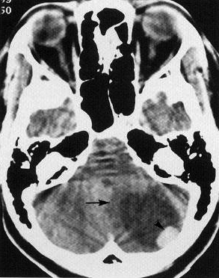

Hypervascular lesion with AV shunting; note early filling vein (arrow) indicative of hemangioblastoma:
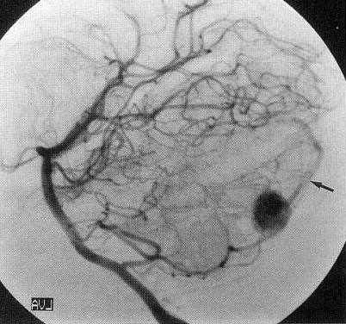

Treatment
Asymptomatic lesions may be safely observed with MRI to rule out tumor enlargement (tumor tends to progress in steps).

Symptomatic lesions → surgical removal.
brain - see p. Op340 >>
spinal cord - see p. Op260 >>
N.B. all patients must be screened for pheochromocytomas preop (may cause perioperative hypertensive crisis induced by anesthetic or analgesic agents)

Other options - endovascular embolization of solid component (tumor vascularity↓), stereotactic radiosurgery (does not work well long term – recurrences!), chemotherapy (bevacizumab).
Indications for radiotherapy (at least 50 Gy):
- unresectable
- incompletely excised
- recurrence

Prognosis
- local recurrences < 25% (esp. in VHL disease*, younger age, multiple hemangioblastomas).
Morbidity and local tumor recurrence rates are low!
*surgical treatment may not be curative in VHL

Solitary Fibrous Tumor (Hemangiopericytoma)
Solitary Fibrous Tumor is preferred term over Hemangiopericytoma

- rare dural tumor from perivascular pericytes (high percentage in torcular region); also occurs elsewhere in body.
- homozygous deletions of CDKN2/p16 gene are common.
- most all SFTs harbor an NAB2-STAT6 fusion gene, which is considered specific to this tumor type - STAT6 immunohistochemistry is a reliable surrogate for detection of the fusion gene.
- some classifying it as subtype of meningioma (but do not have mutations of NF2 gene).
- grossly - smooth, lobulated, well-encapsulated, very vascular.
- histology (similar to angioblastic meningioma and hemangioblastoma) - elongated pericytes with processes which wrap around thin-walled vascular channels of single layer of endothelial cells (i.e. cells lie external to vascular endothelium); cells are arranged in whorls or pinwheels, with rich investment of reticulin.
- locally aggressive, may metastasize (far more aggressive than ordinary meningiomas).
- imaging - lobulated (vs. meningioma - spherical) dural based mass, no calcification, no hyperostosis, multiple areas of flow void (reflect high vascularity).
- treatment – surgery → radiotherapy and/or chemotherapy.

Bibliography for ch. “Neuro-Oncology” → follow this link >>

Viktor’s Notes℠ for the Neurosurgery Resident
Please visit website at www.NeurosurgeryResident.net

