Germ Cell Tumors
Last updated: April 12, 2019
Epidemiology 1
ICD-O codes 1
Etiology 1
Classification, Pathology 1
Germinoma (s. intracranial seminoma) 2
Embryonal cell carcinoma 3
Teratoma 3
Yolk sac tumor (s. endodermal sinus tumor) 4
Choriocarcinoma 5
Clinical Features 5
Diagnosis 5
MRI 5
Serum and CSF tumor markers 7
Biopsy 7
Ventricular endoscopy 7
Treatment 7
Surgery 7
Radiotherapy 7
Chemotherapy 7
Prognosis 8

Epidemiology
Geographic incidence varies considerably:
- most prevalent in far-east Asia (2–3% of primary intracranial neoplasms), esp. Japan (0.17 cases per 100 000 person-years).
- in West, 0.3–0.6% of primary intracranial tumours (3–4% of pediatric primary intracranial tumours) with incidence of 0.09 cases per 100 000 person-years.

Age and sex distribution
- 80–90% case at age < 25 years (peak 10–14 years).
- all histologic variants exhibit predilection for males! (esp. teratomas – 89% patientas are males).
Boys in childhood or adolescence

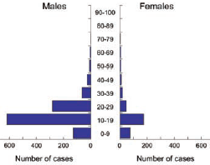

ICD-O codes
Germinoma 9064/3
Teratoma 9080/1
Mature teratoma 9080/0
Immature teratoma 9080/3
Teratoma with malignant transformation 9084/3
Yolk sac tumour 9071/3
Embryonal carcinoma 9070/3
Choriocarcinoma 9100/3

Etiology
- Neoplastic offsprings of primordial germ cells that in aberrant fashion ‘home’ to embryonic CNS rather than developing genital ridges.
- Elevated circulating gonadotropin levels:
- predilection for peripubertal subjects
- localization to diencephalic centres (regulating gonadal activity)
- ↑ incidence in Klinefelter syndrome (47 XXY - chromosome X overdosage); patients also predisposed to mediastinal germ cell tumours.

Classification, Pathology
- morphological and immunophenotypic homologues of extra-neuraxial germ cell tumors.

  - 40-65% of pineal region tumors; from residual primordial tissue derived from ectoderm, mesoderm, or endoderm.
see also p. 2626 (germ cell tumors in ovaries) >>
see also p. 2611 (germ cell tumors in testicles) >>
see also Intro (various topics) 2.jpg >>
  - found primarily in midline (like extragonadal tumors):
pineal region (55%)
most prevalent neoplasms of pineal region in children!
suprasellar cistern (32%)
pineal & suprasellar (7%)
3rd ventricle (3%)
basal ganglia/thalamus (3%)
spinal canal
  - often multifocal.
  - congenital holocranial examples may be encountered (usually teratomas).
  - histologically indistinguishable from those found extracranially (incl. mediastinum and gonads).
Often mixed histologic composition! (only germinoma and teratoma are likely to be encountered as pure types)
- pathologist should communicate relative representation of each component present.

  - germinoma (s. intracranial seminoma)
  - nongerminomatous germ cell tumors - derived from totipotential germ cells that aberrantly migrated to cranial midline during embryogenesis:
- embryonal cell carcinoma* (5%).
- teratoma (18%);
mature teratoma.
immature teratoma (s. teratoid)
- yolk sac tumor (s. endodermal sinus tumor)* (7%)
- choriocarcinoma* (5%)
- mixed germ cell tumor (e.g. teratocarcinoma - embryonal carcinoma containing elements of immature teratoma).
*highly malignant

Germinoma (s. intracranial seminoma)
(commonest histology - 60-70% of all germ cell tumors) - intermediate degree of malignancy; arise from primordial germ cells - large round cells interspersed with lymphocytes (!!!) and septae of fibrous tissue (virtually pathognomonic "two-cell" appearance - contrast between smaller, darkly staining lymphocytes and larger, pale staining cytoplasm of neoplastic cells);
mature dark lymphocytes + large pale* germinoma cells
*lipids in cytoplasm
- large undifferentiated cells (neoplastic counterparts of primordial germinal elements) with abundant cytoplasm (strikingly clear due to glycogen) in monomorphous sheets / lobules
- conspicuous mitoses but necrosis is uncommon.
- tumor cell cytoplasm is glycogen-rich (PAS–positive).
- characteristic cellular junctions (simplified desmosomes) and focal microvilli within intercellular lumina (microvilli is histologic characteristic that distinguishes intracranial lesion from its extracranial correlate).
- delicate fibrovascular septa infiltrated by small T cells
- may also contain syncytiotrophoblastic giant cells with β-HCG positivity (but no virulence of choriocarcinomas) – so called mixed germinoma (vs. pure germinoma)
- most constant immunohistochemical attributes - strong cell membrane labelling for c-kit + nuclear reactivity for OCT4
- infiltrating germinomas can elicit atypical gliosis (may be confused with malignant glioma).
- noncaseating granulomatous inflammation (with multinucleated giant cells) can be found in biopsy taken from periphery of some germinomas.
- occur in gonads, in midline CNS (pineal or suprasellar region), midline body (mediastinum or sacrococcygeal region).
- although histologically identical in all sites, germinomas in testes are called seminomas, in ovaries dysgerminomas, and in CNS germinomas (previously called atypical teratomas).
- macro: solid (necrosis and haemorrhage suggest presence of more malignant components).

Germinoma of suprasellar region in 7-year-old girl:
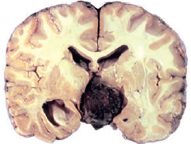
Source of picture: “WHO Classification of Tumours of the Central Nervous System” 4th ed (2007), ISBN-10: 9283224302, ISBN-13: 978-9283224303 >>

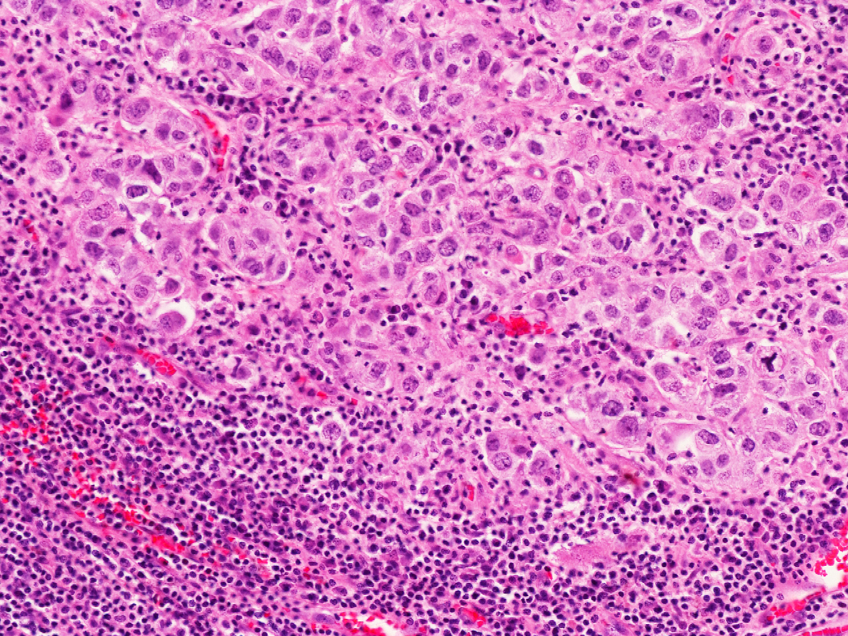
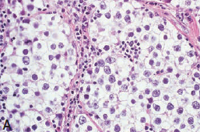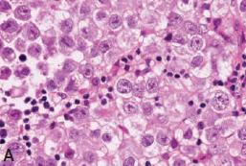
Source of picture: “WHO Classification of Tumours of the Central Nervous System” 4th ed (2007), ISBN-10: 9283224302, ISBN-13: 978-9283224303 >>

Syncytiotrophoblastic giant cell in otherwise typical germinoma with immunostaining for ß-HCG:
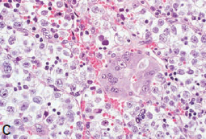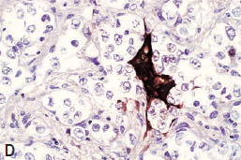
Source of picture: “WHO Classification of Tumours of the Central Nervous System” 4th ed (2007), ISBN-10: 9283224302, ISBN-13: 978-9283224303 >>

Nuclear OCT4 immunoreactivity:
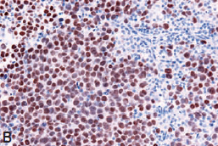
Source of picture: “WHO Classification of Tumours of the Central Nervous System” 4th ed (2007), ISBN-10: 9283224302, ISBN-13: 978-9283224303 >>

Expression of c-kit (membranes and Golgi regions):
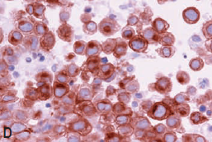
Source of picture: “WHO Classification of Tumours of the Central Nervous System” 4th ed (2007), ISBN-10: 9283224302, ISBN-13: 978-9283224303 >>

Typical germinoma:
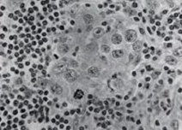

Germinoma - large cells with large nucleoli + focus of lymphocytes:
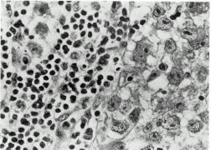

Embryonal cell carcinoma
- least differentiated tumor.
- large cells that proliferate in cohesive nests and sheets.
- abundant clear to somewhat violet-hued cytoplasm
- high mitotic rate and zones of coagulative necrosis
- may exceptionally replicate structure of early embryo, forming “embryoid bodies” (germ discs and miniature amniotic cavities).
- dense and diffuse cytoplasmic labelling for cytokeratins!!!
- positive PLAP and OCT 4 immunoreactivity.
- absent c-kit expression.

Large epithelial cells forming abortive papillae and glandular structures with macronuclei:
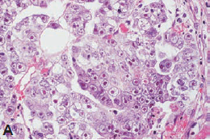
Source of picture: “WHO Classification of Tumours of the Central Nervous System” 4th ed (2007), ISBN-10: 9283224302, ISBN-13: 978-9283224303 >>

Teratoma
- result from maturation along embryonic cell lines;

Mature teratoma - exclusively fully differentiated, ‘adult-type’ tissue elements - well encapsulated, noninvasive mixture of tissues (mucous-laden cysts, fat, chondroid nodules or bony spicules; rarely, teeth or well-formed hairs) derived from all 3 germinal layers.
vs. dermoid – only ectoderm & mesoderm; epidermoid – only ectoderm
- mitotic activity is low / absent.
- ectodermal components are most common (skin, brain, choroid plexus); then mesodermal (cartilage, bone, fat and muscle); then endodermal (cysts lined by epithelia of respiratory or enteric type).
- advanced organogenesis and somatic organization may result in intracranial fetus-in-fetu (vs. incorporation of dizygotic twin via neural tube defect)

Immature teratoma (s. teratoid) - contains incompletely differentiated components (even in minimal amounts) resembling fetal tissues (small round cells resemble hypercellularity of medulloblastoma).
- hypercellular and mitotically active “stroma” (reminiscent of embryonic mesenchyme).
- reports of spontaneous differentiation into fully mature tissues over time (but usually in tumours subjected to therapy - “maturation” reflects selective radio- or chemoablation with continued enlargement of residual, differentiated lesions = “growing teratoma syndrome”).
- rhabdoid tumor - atypical teratoid tumor; universal presence of rhabdoid (rod-shaped) cells; characteristic monosomy 22; occurs in infancy and early childhood; clinically aggressive.

Teratoma with malignant transformation - teratomatous neoplasm that contains malignant component of conventional somatic type (most often rhabdomyosarcoma or undifferentiated sarcoma)

Large teratoma of cerebellum in 4 week-old infant, with characteristic cysts and chondroid nodules:
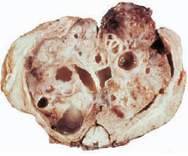
Source of picture: “WHO Classification of Tumours of the Central Nervous System” 4th ed (2007), ISBN-10: 9283224302, ISBN-13: 978-9283224303 >>

Mature teratoma (well-differentiated tissue from all 3 germinal layers):
nonkeratinizing squamous epithelium alternating with areas of ciliated columnar epithelium:  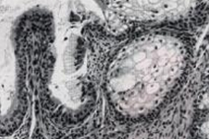 | osteoid bone with surrounding periosteal tissue and mesenchymal stroma:  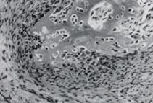
cartilaginous tissue:
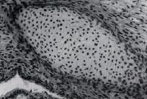

Mature teratoma - differentiated glands, smooth muscle bundles and nodule of moderately hypercellular cartilage:
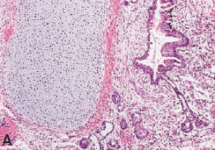
Source of picture: “WHO Classification of Tumours of the Central Nervous System” 4th ed (2007), ISBN-10: 9283224302, ISBN-13: 978-9283224303 >>

Immature teratoma - highly cellular primitive elements resembling fetal neural tube structure:
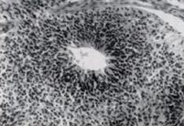

Immature teratoma with fetal-type glands and embryonic mesenchyme-like stroma.
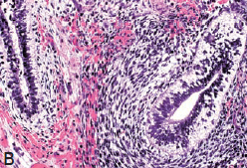
Source of picture: “WHO Classification of Tumours of the Central Nervous System” 4th ed (2007), ISBN-10: 9283224302, ISBN-13: 978-9283224303 >>

Malignant transformation into enteric-type adenocarcinoma:
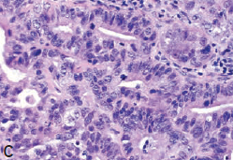
Source of picture: “WHO Classification of Tumours of the Central Nervous System” 4th ed (2007), ISBN-10: 9283224302, ISBN-13: 978-9283224303 >>

Yolk sac tumor (s. endodermal sinus tumor)
- result from maturation along extraembryonic cell lines towards yolk sac
- primitive-appearing epithelial cells (representing yolk sac endoderm) in loose, myxoid matrix (resembling extra-embryonic mesoblast)
- contains endodermal sinuses with distinctive papillae (Schiller-Duval bodies - pathognomonic glomeruloid structure - tumor cell–lined space with invaginated vascular pedicle covered by single layer of tumor cells).
- diagnostic, though inconstant, feature - hyaline globules (brightly eosinophilic, PAS-positive and diastase resistant) within cytoplasm or free in adjoining stroma.
- mitotic activity may be conspicuous, but necrosis is uncommon.
- characteristic immunoreactivity for AFP (cytoplasm and hyaline globules).
- macro: gelatinous appearance (accumulation of myxoid material).

Schiller-Duval body:
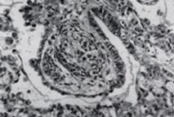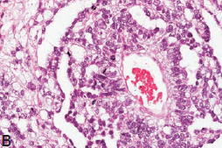
Source of picture: “WHO Classification of Tumours of the Central Nervous System” 4th ed (2007), ISBN-10: 9283224302, ISBN-13: 978-9283224303 >>

Sinusoidal growth pattern and numerous mitoses:
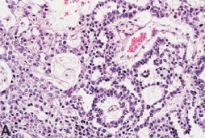
Source of picture: “WHO Classification of Tumours of the Central Nervous System” 4th ed (2007), ISBN-10: 9283224302, ISBN-13: 978-9283224303 >>

Numerous hyaline globules:
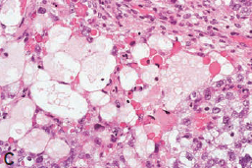
Source of picture: “WHO Classification of Tumours of the Central Nervous System” 4th ed (2007), ISBN-10: 9283224302, ISBN-13: 978-9283224303 >>

AFP immunolabelling:
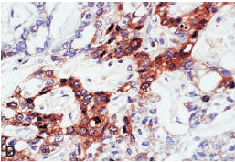
Source of picture: “WHO Classification of Tumours of the Central Nervous System” 4th ed (2007), ISBN-10: 9283224302, ISBN-13: 978-9283224303 >>

Choriocarcinoma
- result from maturation along extraembryonic cell lines towards trophoblast
- large cytotrophoblastic mononucleated cells + giant syncytiotrophoblastic cells.
- ectatic stromal vascular channels, blood lakes and extensive haemorrhagic necrosis (“menstruation in brain”) are rule.
- staining for β-HCG and HPL are characteristic.

Syncytiotrophoblastic giant cells and cytotrophoblasts:
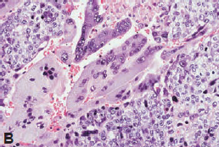
Source of picture: “WHO Classification of Tumours of the Central Nervous System” 4th ed (2007), ISBN-10: 9283224302, ISBN-13: 978-9283224303 >>

Clinical Features
See p. Onc28 >>
- more protracted symptomatic interval than other CNS tumors.
- CNS germ cell tumors may also cause pseudoprecocious* puberty:
*pseudo because hypothalamic-gonadal axis is not mature
- tumor secretion of hCG [properties of LH] → testosterone production by neoplastic syncytiotrophoblasts in boys.
- tumor expression of cytochrome P450 aromatase → conversion of C19 steroids to estrogens → precocious puberty in girls.

Diagnosis
MRI
- largely non-specific.

Useful generalizations (except teratomas):
- solid masses
- iso- / hyperdense relative to grey matter
- prominent homogenous contrast enhancement
- intratumoral hemorrhage is particularly characteristic of choriocarcinoma.

Teratoma
- teratomas can contain tissue from all 3 germinal layers → well-circumscribed benign tumor with multicystic markedly heterogenous MRI signals (fat* and calcification are typical; can demonstrate ring enhancement).
*areas of low attenuation (adipose tissue) help to distinguish it from other pineal region tumors.

- MRI of spine - for drop metastasis (perform before and after surgery). see p. Onc3 >>

Contrast T1-MRI (germinoma) - homogenous enhancement:
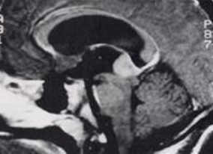

MRI of solid, contrast-enhancing germinoma of pineal region, with smaller CSF-borne metastasis in suprachiasmatic cistern:
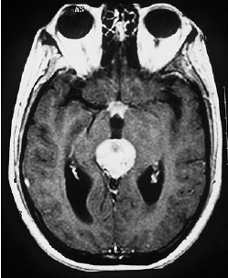
Source of picture: “WHO Classification of Tumours of the Central Nervous System” 4th ed (2007), ISBN-10: 9283224302, ISBN-13: 978-9283224303 >>

MRI with gadolinium - multicentric germinoma involving pineal region, infiltrating mammillary bodies, optic chiasm, and pituitary stalk:
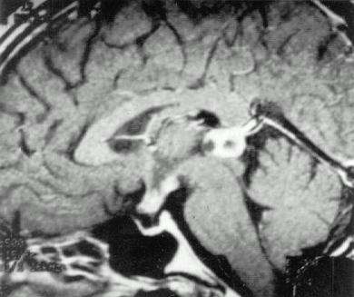

MRI with gadolinium - mixed dermoid/germinoma:
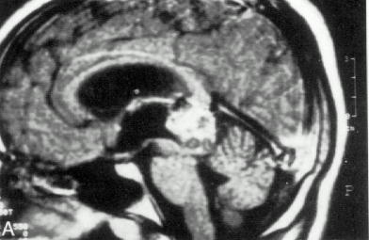

Contrast MRI - pineal and suprasellar germinoma, with spread along walls of 3rd ventricle; obstructive hydrocephalus:
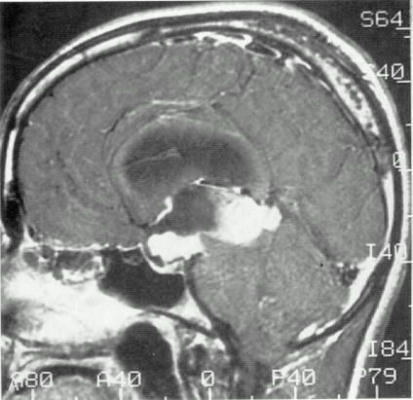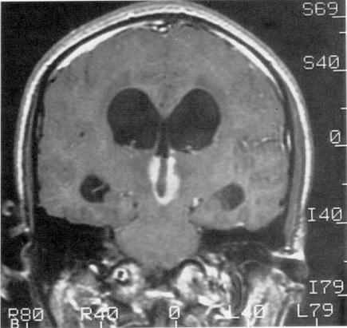

Pineal teratoma (T2- and T1-MRI) - large, mixed signal intensity tumor infiltrates midbrain and causes hydrocephalus; cystic component projects into left thalamus:
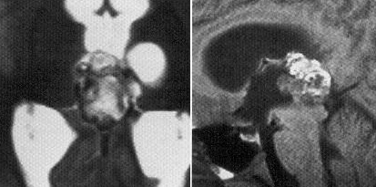

Sagittal T1-weighted MRI of teratoma in the pineal region, occupying dorsal aspect of third ventricle: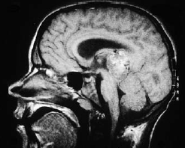
Source of picture: “WHO Classification of Tumours of the Central Nervous System” 4th ed (2007), ISBN-10: 9283224302, ISBN-13: 978-9283224303 >>

Serum and CSF tumor markers
(extremely important prior to surgical resection - provides reference point for follow-up – response to therapy and recurrence)
Presurgical assessment: AFP and ß-HCG in serum and CSF
- CSF levels tend to be more sensitive and should be compared with serum levels; see p. 1707a >>
Absence of AFP or β-hCG does not rule out mixed germ cell tumor!
N.B. AFP and β-hCG may also be elevated in other conditions! see p. 1707a >>

    - alpha-fetoprotein (AFP) indicates presence of fetal yolk sac elements – endodermal sinus tumors, embryonal cell carcinomas, immature teratomas (mature teratomas do not secrete AFP)

    - β-hCG produced by trophoblastic elements – choriocarcinomas, embryonal cell carcinomas, mixed germinomas with syncytiotrophoblastic giant cells (pure germinomas are nonsecretory).

Tumor | AFP | β-hCG
pure germinoma
mixed germinoma with syncytiotrophoblastic giant cells |  | +
mature teratomas
immature teratomas | ±
endodermal sinus tumors | +
choriocarcinomas |  | +
embryonal cell carcinomas | + | +
    - germinomas also secrete lactic dehydrogenase (LDH) isoenzyme and placental alkaline phosphatase (PLAP) – but useful only on immunohistochemical slides; some use also for follow up in serum!s

Biopsy
- recommended whenever possible! (except in markedly elevated AFP and β-hCG)

Ventricular endoscopy
- especially sensitive to disclose minute tumour nodules on or beneath ependyma that are not detectable on MRI

Treatment
Therapy is based on tumor pathology;
e.g. markedly elevated AFP and β-hCG (pathognomonic for germ cell tumors) → chemotherapy or radiotherapy without tissue biopsy (initial surgical intervention may become obsolete for germinomas)

Germinomas – radiation.
Nongerminomatous germ cell tumors – chemotherapy → restaging → radiation.

Surgery
See p. Onc28 >>
- some centers give trial dose of radiation to pineal tumor – radiation “melts” germinomas.

Radiotherapy
- depends upon tumor histology:
- mature teratomas – cured with surgery alone (no adjuvant radiation) → follow with serial MRIs.
- malignant germ cell tumors: 40 Gy to ventricular system → 15 Gy to tumor bed (in 1.8 Gy daily fractions).

N.B. germinomas are among most radiosensitive tumors (vs. nongerminomatous malignant germ cell tumors) and tend to spread along ventricular walls
5-year survival rates > 75% and 10-year survival rates 69% have been reported with radiation 50 Gy.

nongerminomatous malignant germ cell tumors (whether localized or disseminated) → chemotherapy → restaging:
localized tumors → 54-60 Gy to tumor → 24 Gy to ventricular field.
disseminated tumors → craniospinal irradiation (54-60 Gy to tumor, 45 Gy to ventricular system, 35 Gy to spinal cord, 45 Gy to any localized spinal cord lesions).

- prophylactic spinal irradiation is controversial (current trend is to administer spinal irradiation 35 Gy only for documented seeding); rate of drop metastases is highest for endodermal sinus tumors.
- radiosurgery has no role (germinomas have excellent long-term response to fractionated radiation, and it is unlikely that radiosurgery can improve on these results).

Chemotherapy
- means of minimizing amount of radiation for children.

Germ cell tumors are sensitive
Although systemic germ cell tumors are very chemosensitive, CNS germ cell tumors are less responsive!
- nongerminomatous germ cell tumors benefit most - chemotherapy prior to radiation!
Einhorn regimen = cisplatin + vinblastine + bleomycin
Most common regimen: cisplatin (or carboplatin) + etoposide
- germinomas are so radiosensitive that chemotherapy is not required (platinum-based chemotherapy first-line treatment only in very young children in order to avoid radiation).

- delayed surgery after radiation therapy and chemotherapy is indicated for residual tumors whose germ cell markers have normalized (residual tumor is likely to be benign germ cell elements that are resistant to radiotherapy and chemotherapy).

Prognosis
Prognosis – mostly depends on histology:
mature teratomas (potentially curable) > germinomas (excellent prognosis; > 90% 5-yr survival; 85% 10-year survival following craniospinal irradiation alone) > nongerminomatous germ cell tumors (patients rarely survive beyond 2 years)

- local recurrence and CSF-borne dissemination are usual patterns of disease progression.
Metastases within CNS and vertebral column are most common causes of death!
ICH is most common cause of death in choriocarcinoma!

Can recur locally / distally as late as 5 yrs after diagnosis! – regular follow-up:
- MRI
- tumor marker* follow-up: q 1-2 months for 1 year → q 3 months for 1 year → less frequently.
*even if markers were not abnormal at diagnosis

Bibliography for ch. “Neuro-Oncology” → follow this link >>

Viktor’s Notes℠ for the Neurosurgery Resident
Please visit website at www.NeurosurgeryResident.net

