Intradural Extramedullary Spinal Tumors
Last updated: April 12, 2020
Pathology 1
Frequency 1
Clinical Features 1
Diagnosis 1
Treatment 1
Specific Tumor Types 1
Meningioma 1
Lipoma 3
Neurofibroma, Schwannoma 3
Leptomeningeal metastases 4
Spinal Cysts 4

Pathology
- most are slow-growing and benign (vs. epidural tumors).
- usually involve only few spinal segments.
- if tumor occludes spinal arteries → myelomalacia.

Frequency
- Neurofibromas
- Schwannomas (Schwann cells form covering of spinal nerve roots)
- Meningiomas
- Other rare cases - lipoma, dermoid, epidermoid, teratoma.
- Metastases (relatively uncommon):
  - leptomeningeal metastases of systemic tumors (esp. breast carcinoma, melanoma, leukemia, lymphoma)
  - drop metastases of intracranial tumors (e.g. ependymoma, medulloblastoma).

Clinical Features
myelopathy & radiculopathy - Extramedullary Cord / Root Compression see p. Spin1 >>
- initial symptoms of nerve sheath tumors – prominent focal pain and paresthesias (involvement of dorsal roots). i.e. tend to cause radiculopathy before becoming large enough to cause myelopathy
- initial symptoms of meningiomas – myelopathy (radiculopathy develops later).
- compression first interrupts functions of pathways that lie at periphery of spinal cord.
- eccentrically placed tumors may cause typical Brown-Sequard syndrome.
- if untreated → complete loss of function below level of lesion (complete spinal cord transection).
- large cervical tumors (esp. with extradural component) may be palpated.

Diagnosis
Plain X-ray - occasionally enlarged intervertebral foramen, localized widening of spinal canal.
- calcification is rare (heavily calcified intraspinal mass is usually extruded disc material).

MRI with gadolinium - enhance brightly.
- features of nerve sheath tumors - prominent CT/MRI enhancement, characteristic tumor extension through enlarged neural foramen!

Myelography:
- filling defect in subarachnoid space (meniscus corresponding to outline of tumor)
- filling defect displaces cord away from ipsilateral dura → widening ipsilateral subarachnoid space while narrowing contralateral space; plane of cleavage is usually visible between tumor and spinal cord.
(vs. intramedullary tumors - fusiform cord enlargement and circumferential narrowing of adjacent subarachnoid space; extradural tumors - displace cord, but result in narrowing of both ipsilateral and contralateral subarachnoid spaces)
- leptomeningeal metastases - small nodules attached to surface of cord or cauda equina nerve roots.

CSF – cytology is key diagnostic test for leptomeningeal metastases; for other tumors, LP is not diagnostic (and relatively contraindicated)!
- in complete subarachnoid block, CSF is xanthochromic (due to high protein content); some tumors secrete large amounts of proteins (values > 1000 mg/dl may lead to communicating hydrocephalus → brain dysfunction!).
- slight pleocytosis in 30% patients.
- glucose content is normal (unless tumor of meninges is present).

Angiography is performed for surgical planning if tumor is in lower thoracic region – to locate artery of Adamkiewicz – must be preserved during surgery (supplies spinal cord!).

Treatment
Spinal cord compression – see p. Onc56 >>
Total surgical excision is main treatment for benign tumors.
- steroids in perioperative period.
- laminectomy is adequate approach (certain tumors require lateral or even anterior approach).
- extraspinal tumor extensions can be removed by extending initial laminectomy exposure laterally (some may require separate operation through thoracotomy, costotransversectomy, or retroperitoneal approach).
- sectioning of dentate ligament ensures access to tumor; dorsal roots can also be sectioned.
- excise involved portion of dura (meningioma) or involved nerve root* (neurofibroma, schwannoma). *frequently nonfunctional at time of surgery
- after extensive surgery, spinal deformities (which may have been present preoperatively) may appear or increase; H: fixation, laminoplasty.

Leptomeningeal Metastases are not treated surgically! see below >>

Specific Tumor Types
Meningioma
also see p. Onc38 >>
- 70-80% located in thoracic cord, 10-20% in cervical spine, 3% in lumbar spine, 2% in foramen magnum.
- 5-10 times more frequent in women than in men.
- 7% meningiomas are purely extradural, 6% - intradural and extradural.
N.B. lesion with both intradural and extradural components is most likely to be nerve sheath tumor!
- 2% are multiple (associated with neurofibromatosis-2).
- typically globoid.
- myelopathy > radiculopathy; high incidence of Brown-Sequard syndrome (> 50% meningiomas are positioned laterally).
- MRI - broad-based attachment to dura.
- dural base should be resected if it is easily accessible (if not → cauterize and scrape with microdissector).
- very high 5-year survival rate - 99.5%.

A. T1-MRI - sharply circumscribed low-intensity mass (arrows).
B. Contrast T1-MRI - intense enhancement of well-circumscribed extramedullary mass (arrows) which displaces spinal cord to left, widening cistern adjacent to mass:
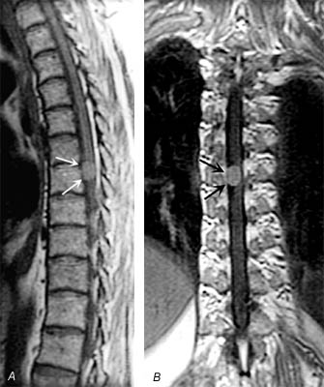

AP thoracic myelogram (via C1-2 puncture) - leftward displacement of cord (arrows), widening of ipsilateral subarachnoid space, narrowing of contralateral space, and rounded intradural filling defect (arrowheads):
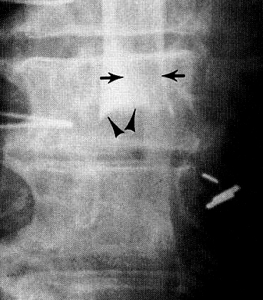

A. Contrast T1-MRI - large intradural mass at C₁₋₂.
B. Contrast T1-MRI - large meningioma, marked spinal cord compression.
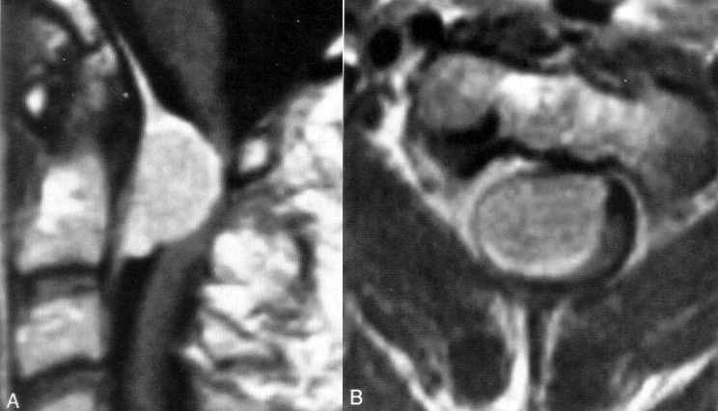

Recurrent cervical meningioma (contrast T1-MRI) - extensive intradural tumor (white signal - black arrows) partly surrounding spinal cord:
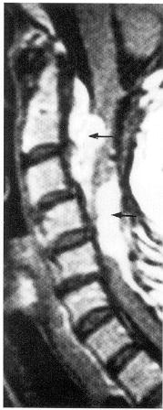

A) Contrast T1-MRI - uniformly enhancing, dorsal intradural extramedullary mass compressing cord at cervicothoracic junction.
B) T2-MRI - low signal intensity within mass, common in meningiomas:
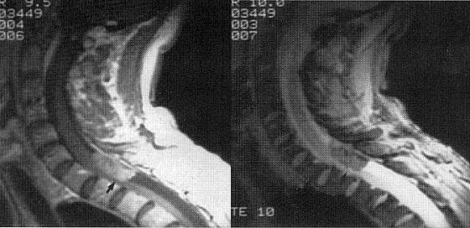

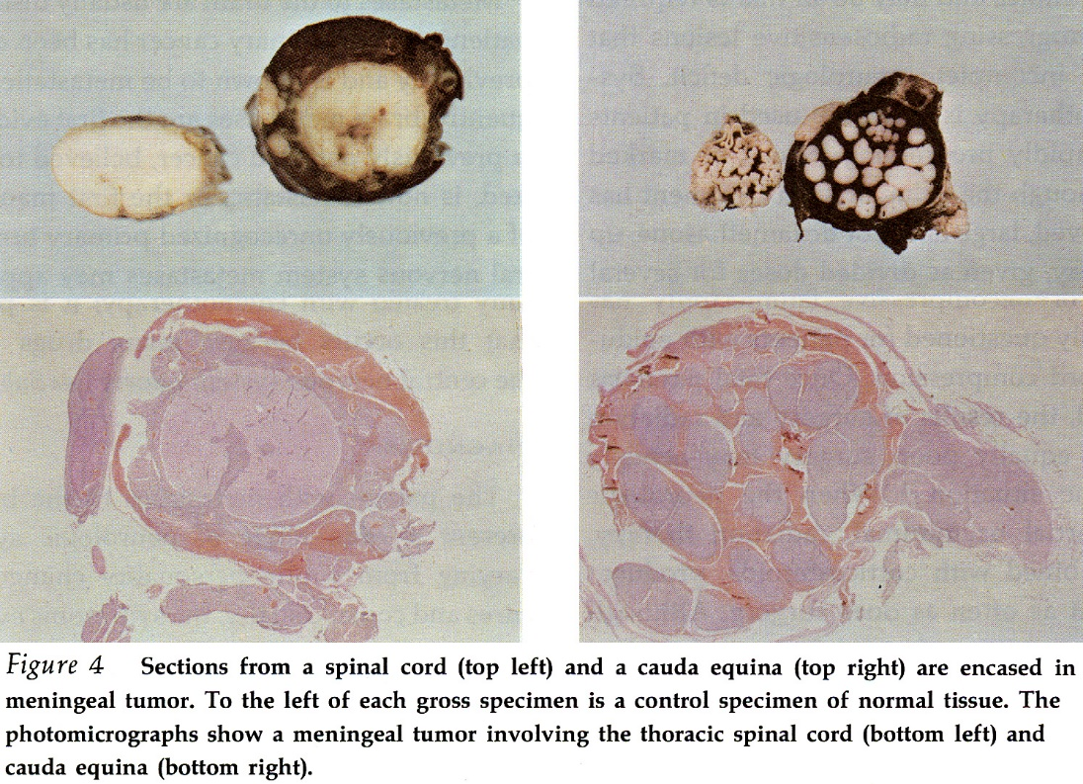

Lipoma
- as lesions of filum terminale, spinal cord, or lipomeningomyeloceles.
- contain variable amounts of fibrous connective tissue (often adherent to cord, meninges, or cauda equina).
- CT - low-density fatty mass with mass effect on adjacent cord.
- bright on T1 and dark on T2.

Neurofibroma, Schwannoma
- benign tumors of nerve sheath.
- typically arise from dorsal roots - radicular pain is often first symptom (radiculopathy → ≈ 2 years → myelopathy).
- neurofibromas - often fusiform and multiple (esp. in neurofibromatosis); schwannomas - tend to be solitary and arise eccentrically from nerve sheath.
- 30% have extradural component (“hourglass” or “dumbbell” shape)
- prominent CT/MRI enhancement.
- CSF protein is elevated (because of protein secretion by tumor) vs. meningiomas.
- surgical resection.

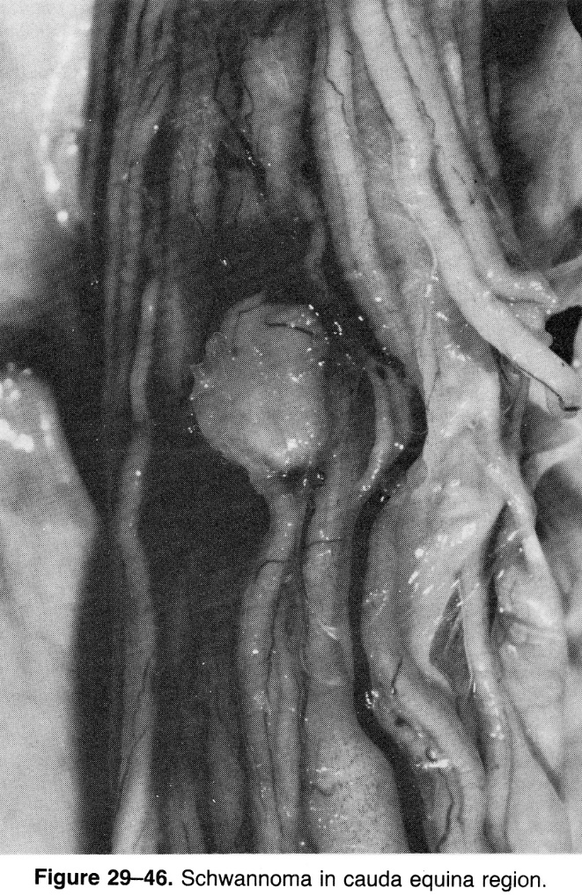

Right C3 neurofibroma:
A, B (AP X-ray) - apparent enlargement of right C2-C3 nerve root foramen (arrowheads); preservation of sharp cortical margins indicates slow growth.
C, D (precontrast T1-MRI, contrast T1-MRI) - largely extradural, densely enhancing soft-tissue mass within right C2-C3 foramen (arrowheads); only small component of tumor is intradural:
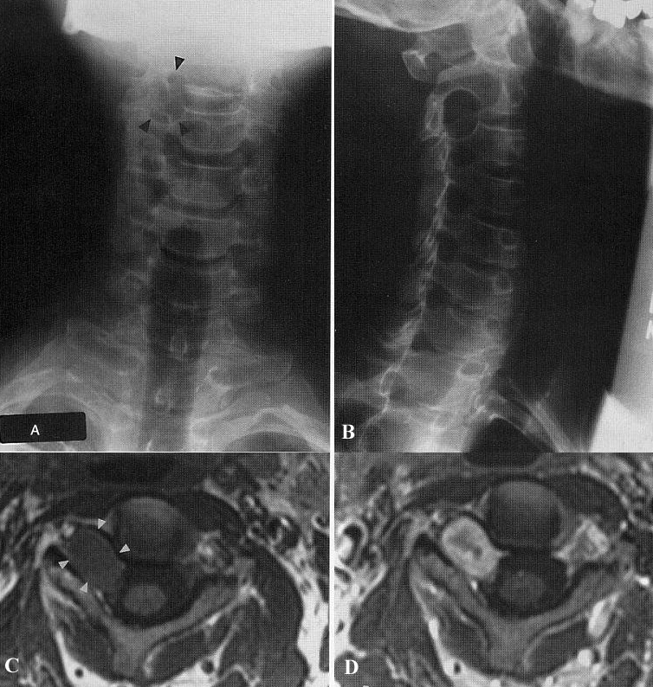

Neurofibromatosis (CT myelography) - two neurofibromas, mainly intradural, distend thecal envelope, severely compressing spinal cord (arrow):  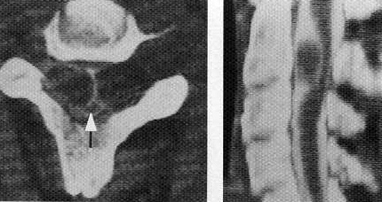 | Neurofibroma (CT myelogram) - pronounced posterolateral displacement and compression of spinal cord (crescentic filling defect surrounded by contrast medium - arrowheads); large round filling defect:  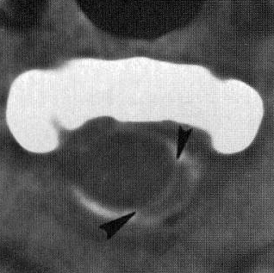
Schwannoma:
A. Contrast T1-MRI - large intradural tumor at L₅ level.
B. Intraoperative photograph - large intradural schwannoma (arrow) that displaces cauda equina dorsally.
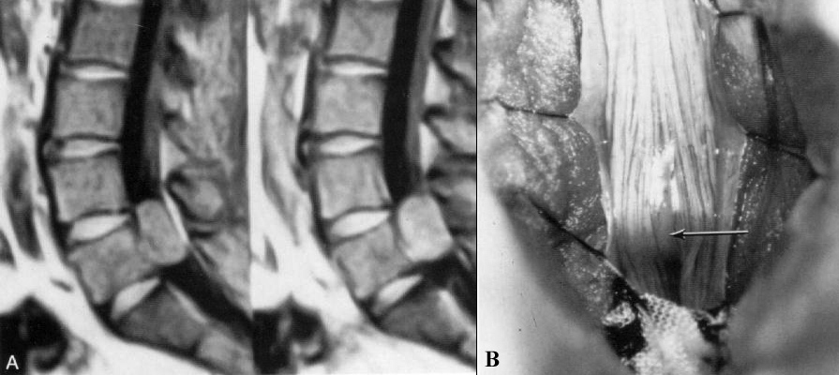

Leptomeningeal metastases
- spinal cord compression develops rapidly.
- frequently multiple.
- CSF - malignant cells, glucose↓, protein↑.
- treatment (complete surgical removal is almost never possible):
  - radiotherapy + chemotherapy
  - radiotherapy to entire neuraxis

Subarachnoid "drop metastases" of cranial malignancy (myelography, frontal view): one large, rounded, intradural filling defect (arrows) as well as more subtle nodular enlargement of nerve roots in cauda equina:  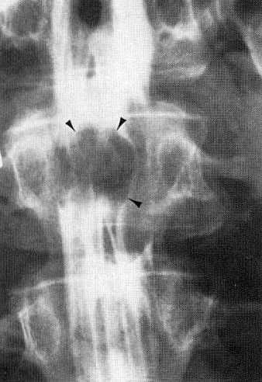 | Intradural metastases (contrast T1-MRI):  A) Metastatic medulloblastoma - tumor aggregation in termination of caudal sac (arrows), and coating of spinal cord.  B) Cord encasement by metastatic breast carcinoma (arrow).  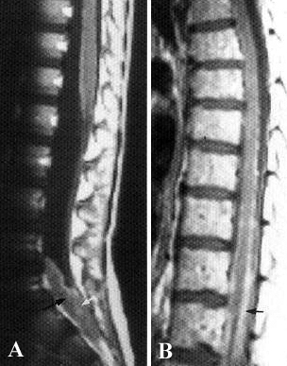

Spinal Cysts
- rare congenital, developmental mass lesions (intramedullary or extramedullary intradural).
- found predominantly in cervical and thoracic regions.
- present clinically by 4-5th decade of life.
  - Arachnoid cyst - most-common intraspinal cyst; single-layered arachnoid cell lining, without epithelium or cilia.
  - Ependymal cyst has ciliated, cuboidal, or columnar epithelial lining.
  - Enterogenous cyst (derived from neurenteric canal or primitive endoderm) lined by ciliated, secretory columnar epithelium and can produce mucin; may be associated with GI tract duplication and dysraphic vertebral abnormalities. also see p. Onc30 >>
  - Branchiogenic cyst has respiratory epithelial lining and congenital vertebral anomalies in thoracic spine as well.
- treatment:
    - microsurgical excision
    - cyst fenestration
    - cysto-subarachnoid, cysto-pleural, or cysto-peritoneal shunting.

Bibliography for ch. “Neuro-Oncology” → follow this link >>

Viktor’s Notes℠ for the Neurosurgery Resident
Please visit website at www.NeurosurgeryResident.net

